INDUSTRIAL TRAINING
at
SOMAYU INFOTECH, Pune
ON
Full Stack development with AI

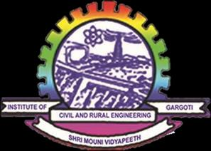
Submitted to
Shree Mouni Vidyapeeth’s
Institute of Civil and Rural Engineering, Gargoti
Submitted by
Dhanaraj Udaysinh Patil
Under the guidance of
Mr. O.S.Suryawanshi
In Partial Fulfilment of
Diploma in Computer Engineering
(2026-27)


Maharashtra State Board of Technical Education
Certificate of Completion of Industrial Training
(By respective Head of the Department & Head of the Institute)
This is to certify that “Dhanaraj Udaysinh Patil”, with Enrollment No 24210370030 has successfully completed his Industrial Training (315004) at “Somayu Infotech, Pune” on “Fullstack Development with AI” from 25/05/2026 to 15/08/2026 for partial fulfillment towards completion of Diploma in Computer Engineering from Institute of Civil and Rural Engineering, Gargoti. Institute code (0012).
Signature of  Head of Institute | Signature of  Head of Department | Signature of  Internship Mentor | Signature of  Industry Mentor

ABSTRACT
I carried out my industrial training at Somayu Infotech, Pune to gain practical knowledge about Full Stack Development and related frontend, backend, database, and API technologies. The training helped me connect classroom concepts with real-world software development and understand the working environment of the IT industry.
During the training, I developed practical skills in HTML, CSS, JavaScript, React, MySQL, Python, Node.js and Express.js. I also gained exposure to Figma AI and GitHub Copilot and practiced connecting frontend, backend, APIs, and databases while working on web application features, testing, and debugging. I also explored aspects of data visualization and deployment, guided by our training facilitator, Mr. Yuvraj Hande Sir.
The training also helped me improve Communication, Presentation, Time Management, Teamwork, Problem Solving, Design, and Implementation skills. Overall, this industrial training provided valuable practical experience and strengthened my understanding of Full Stack Development.

ACKNOWLEDGMENT
For a strong tree a strong root is prime requirement, similarly for any training to be a great success, good guidance and support are required. I would like to express my sincere gratitude to my guide Mr. O. S. Suryawanshi Sir for his valuable guidance and constant motivation throughout my industrial training.
I would like to thank Mr. A. P. Kadam Sir, Principal of Institute of Civil and Rural Engineering, Gargoti, and Mr. S. G. Mane Sir, Head of the Department of Computer Engineering, for their encouragement and for providing the necessary facilities for successfully completing my training.
I would also like to express my sincere thanks to Mr. Yuvraj Hande Sir and Mr. Shreenivas Desai Sir for their valuable guidance and support during my training at Somayu Infotech, Pune. Their guidance helped me gain practical knowledge and improve my understanding of Full Stack Development and related technologies.
I am also thankful to my family members, friends, and colleagues for their continuous support and encouragement throughout my training.
Lastly, I sincerely thank all the persons who guided and helped me directly or indirectly in successfully completing my industrial training.
Sincerely,
Dhanaraj Udaysinh Patil

Company Certificate
[ Attach Scanned / Original Copy of Somayu Infotech Certificate Here ]

CONTENTS
Sr. No. | Content Name | Page no.
1. | Chapter 1: Organizational Structure of Industry | 1 - 4
2. | Chapter 2: Introduction of Industry | 5 - 6
3. | Chapter 3: Practical Experiences in Industry | 7
4. | Chapter 4: Roles and Responsibilities | 8
5. | Chapter 5: Processes of developing software in industry | 9 – 11
6. | Chapter 6: Safety Procedures followed | 12
7. | Chapter 7: Prerequisite Learning for Assigned Tasks | 13 - 19
8. | Chapter 8: Minor Task Assigned & Mini Projects | 20 – 25
9. | Chapter 9: Major Projects (Employee Management System) | 26 – 38
10. | Chapter 10: Special Challenges Experiences in Industry | 39
11. | Conclusion | 40
12. | References | 41

Chapter 1: Organizational Structure of Industry
1.1 Name of Industry: Somayu Infotech ,Pune.
1.2 About Somayu:
Somayu Infotech is a technology-driven organization established on 2 June 2012 with the objective of providing industry-oriented technical education and practical technology solutions.
The company began its journey with a primary focus on Industrial Training, helping students and aspiring technology professionals gain practical exposure to software development and real-world IT environments. Over the years, Somayu Infotech expanded its capabilities from technical training into Full Stack Development, Web Development, Application Development, Mobile Application Development and AI-oriented technology projects.
The organization has evolved from a training-focused initiative into a technology ecosystem combining education, software development, digital products and emerging technologies.
Through its experience and continuous adoption of modern technologies, Somayu Infotech aims to bridge the gap between academic learning and industry requirements while simultaneously developing technology products and customized software solutions.
1.3 Facilities:
1. Project Management & Business Analysis
This team handles project planning, requirement analysis, client communication, project coordination, sprint planning, and delivery management.
2. Full Stack / Web Development Team
This team works on frontend, backend, Full Stack development, REST APIs, database integration, web applications, and performance optimization.
3. Mobile & Application Development
This team develops mobile and application solutions, including application architecture, API integration, mobile UI development, testing, and deployment.
4. AI/ML & Data Development
This team works on AI-based applications, machine learning, data processing, AI integrations, intelligent automation, and recommendation systems.
5. UI/UX & Creative Design
This team handles UI and UX design, wireframes, prototypes, design systems, and product graphics.
6. QA & Software Testing
This team performs functional, regression, API, and other software testing activities and manages bug tracking and quality assurance.
7. Digital Marketing & SEO
This team manages SEO, digital marketing, content strategy, social media, website performance, and lead generation.

1.4 Employee Structure:
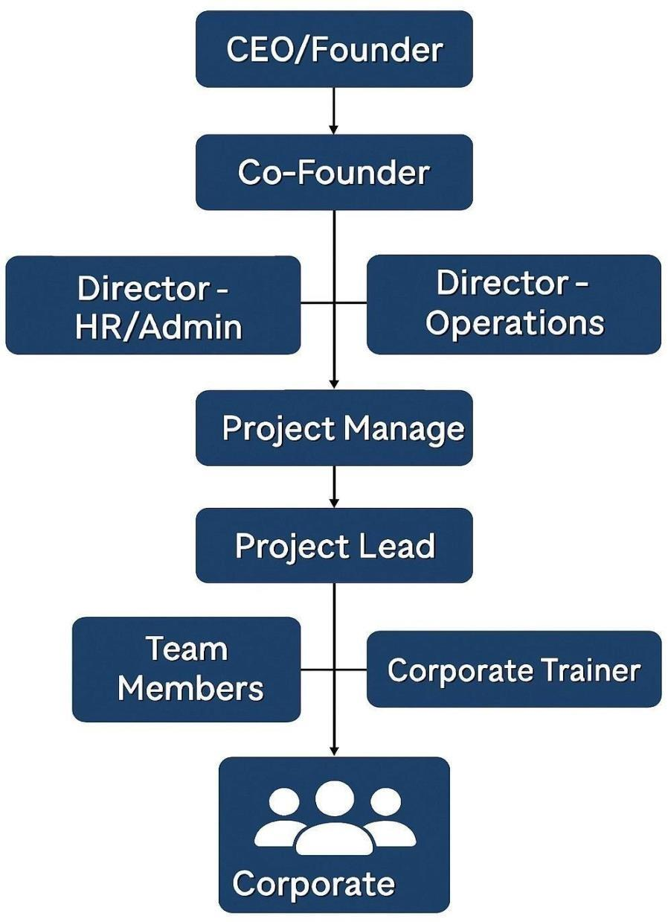

1.5 General Layout of Company:

Fig : Company Logo

