Docker Multi-Container Production Optimized

-Dhanaraj Rajkumar


Folder Setup: Root project folder contains separate backend and frontend folders

Create Dockerfile: Make “Dockerfile” (without any extension) on each folder
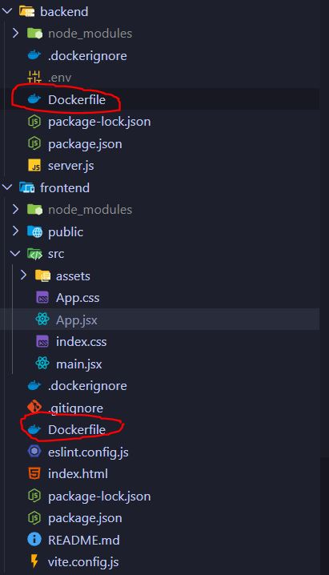

  - Backend Dockerfile:
# Build stage
FROM node:20-alpine AS build
WORKDIR /app
COPY package*.json ./
RUN npm ci
COPY . .
RUN npm prune --production #npm prune removes all devDependencies from node_modules and keep only minimal necessary dependencies

# Production stage (Backend)
FROM node:20-alpine
WORKDIR /app
COPY --from=build /app ./
EXPOSE 5000
CMD ["node", "server.js"]

  - Frontend Dockerfile:
#Build Stage
FROM node:20 AS build
WORKDIR /app
COPY package*.json ./
RUN npm ci
COPY . .
RUN npm run build

# Prodction Stage(Frontend)
#Copy the build(dist) from Stage 1 to the WORKDIR of nginx env
FROM nginx:alpine
WORKDIR /usr/share/nginx/html
COPY --from=build /app/dist ./
EXPOSE 80
#Vite(after built, nginx default port is 80)
#By default, nginx runs CMD ["nginx", "-g", "daemon off;"]

Create .dockerignore: Make “.dockerignore” on each frontend and backend folder.
  - node_modules
  - .env

Exclude node_modules and .env while COPY . .

NOTE: Dockerfile is the instruction to docker build on how and what to contain in Docker Image

Frontend Dockerfile —--creates—--> Frontend Docker Image
Backend Dockerfile —--creates—--> Backend Docker Image

Create docker-compose.yml: Make “docker-compose.yml” file on the root the project.

Basically it is a blueprint that tells Docker how to run your entire MERN app as a multi-container system — instead of manually starting backend and frontend containers one by one.

Think of it like: “Start these services, using these images, on these ports, with these environment variables — and make sure they can talk to each other.”
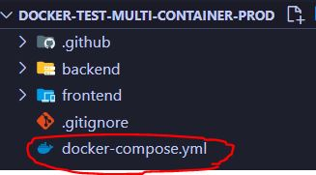
version: '3.8'

services:

backend:
image: mleonel51/mern-backend:latest #use frontend image pushed in dockerHub
container_name: mern-backend-container
restart: always
ports:
- "5000:5000"
env_file:
- .env #considering i manually ssh into ec2 and insert .env file inside ~/mern-deploy folder so that backend docker container can use it

frontend:
image: mleonel51/mern-frontend:latest #use frontend image pushed in dockerHub
container_name: mern-frontend-container
restart: always
ports:
- "80:80"
depends_on:
- backend

We directly pull the frontend and backend image from DockerHub using image:
This way, we can replace build: to prevent building the image inside EC2 Instance because inorder to build latest image inside EC2 we need to copy our latest repo build files ino the EC2 Instance storage which is a lot complex way since its using linux shell command.

So in later steps we’ll build the image and push to DockerHub using github action workflow so that EC2 Instance and just pull it and run docker-compose.
That means we need to put docker-compose.yml inside the EC2 project folder ~/mern-deploy/ which we’ll later create during Github Action Workflow

Also we need to put .env file inside the EC2 project folder since backend: container need it to connect to MONGO_URI and we told docker-compose.yml to get it from env_file:- .env which is the EC2 project folder ~/mern-deploy/

Create EC2 instance and Copy backend .env file to its project folder:

  - Create EC2 instance first with below settings:

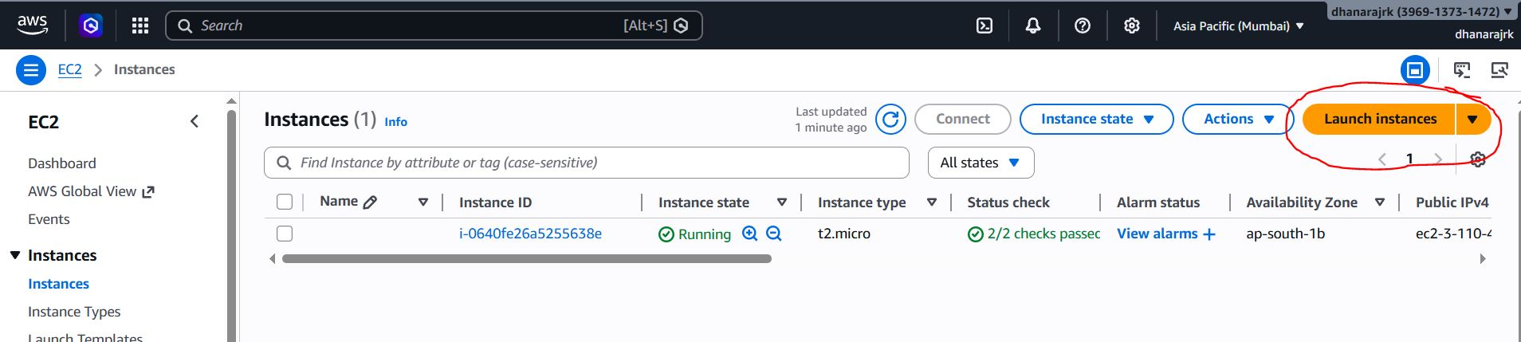

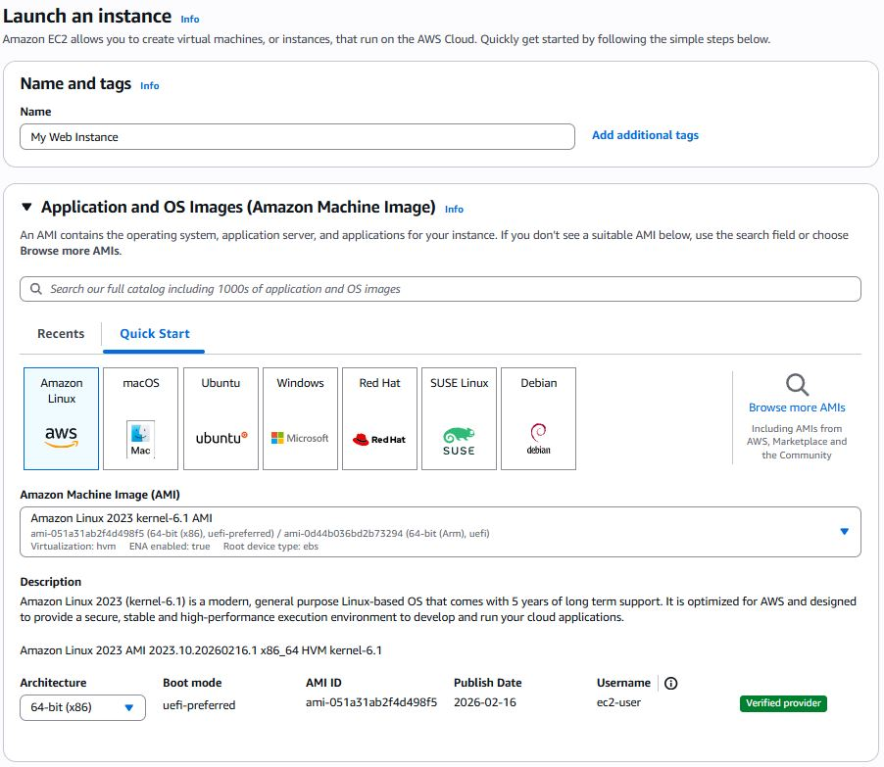
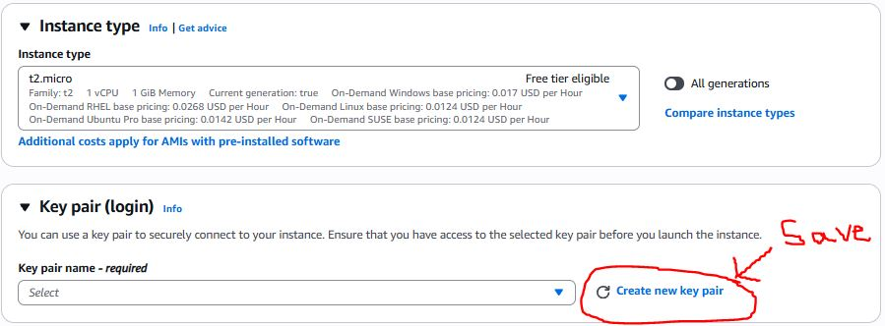
*Key pair will create ec2_instance_key.pem which is a key to ssh login into our EC2 instance(VM) from our local PC

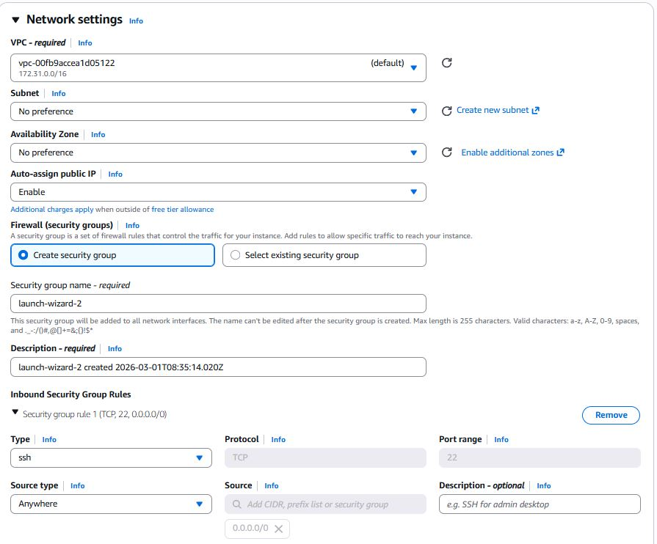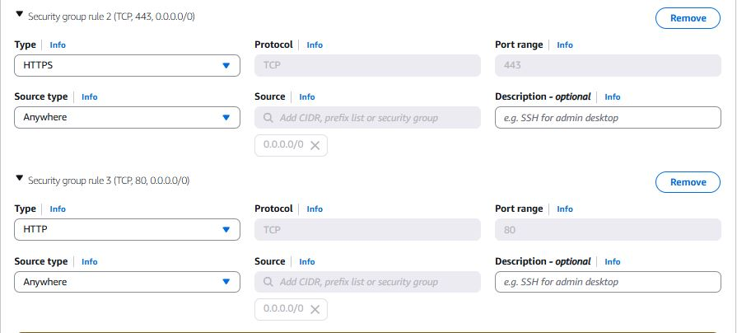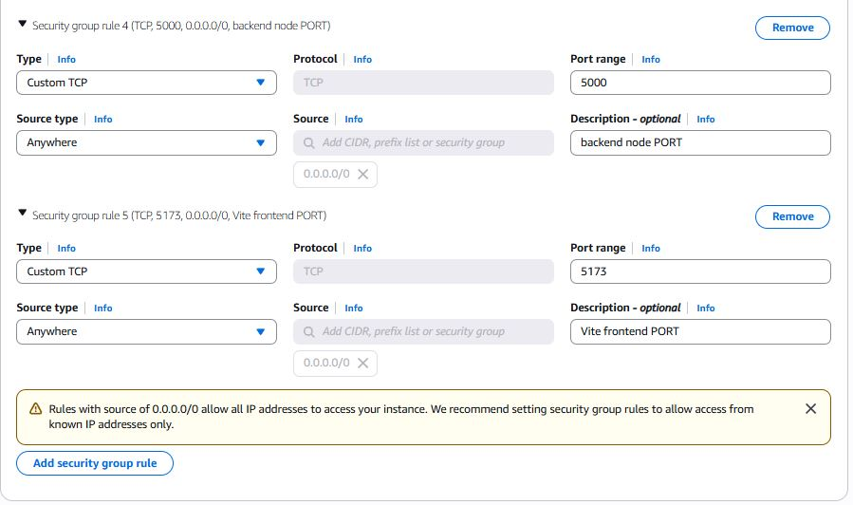
*Make TCP PORT range accessible from Anywhere

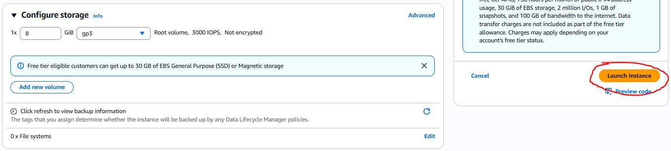

  - SSH(login) into to EC2 instance and insert the backend .env file into the EC2 machine :

- Open Gitbash from the directory where .env is present in local PC
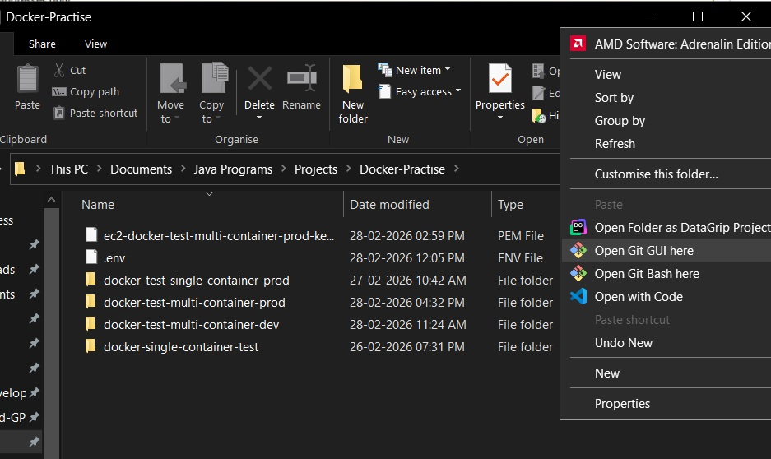

- In Gitbash, type
chmod 400 your_ec2_key.pem Changes file permission: Only file owner can read

ssh -i your_ec2_key.pem ec2-user@your_ec2_instance_public_ip
Connect to EC2 instance

- After loggin in EC2 virtual machine, type:
mkdir ~/mern-deploy Creates project folder called “mern deploy” inside the EC2 machine

- Open another Gitbash and type:
scp -i your-key.pem .env ubuntu@<EC2_IP>:~/mern-deploy/.env Copies .env from Local PC to EC2 machine root/mern-deploy/ folder
You can verify by typing cat ~/mern-deploy/.env in EC2

Create Docker Token Access: Login Docker on Browser, and go to Settings>Personal access token>Generate new token

Give any name token name eg. “github-actions”
Give Read, Write, Delete permission

Note down the Docker username and Access token key somewhere. We will be using it to login to docker during github action workflow and also inside EC2 script to pull image from DockerHub into EC2 instance

Put Docker and EC2 login credentials to Github Secret Variable:
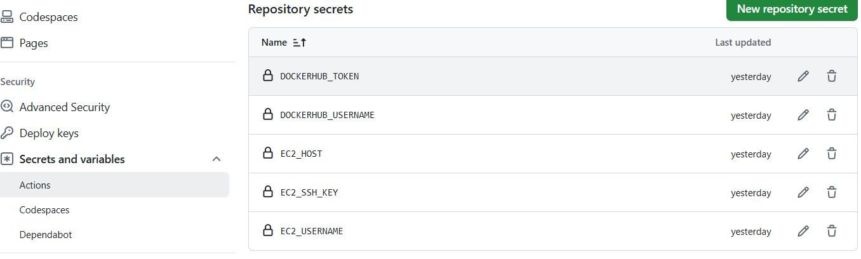

Create github workflow: in Local Project folder, create .github/workflows/deploy.yml

name: Build Docker Image, Push Image to Dockerhub & Docker Pull Compose on EC2

on:
push:
branches:
- main

workflow_dispatch:

jobs:
build-and-push:
runs-on: ubuntu-latest

steps:
- name: Checkout code
uses: actions/checkout@v3

- name: Login to Docker Hub #use github docker login plugin (which is easier)
uses: docker/login-action@v3
with:
username: ${{ secrets.DOCKERHUB_USERNAME }}
password: ${{ secrets.DOCKERHUB_TOKEN }}

- name: Build Backend Image #i dont use github plugin for building and pushing image cause docker normal command feels easier to me
run: docker build -t ${{ secrets.DOCKERHUB_USERNAME }}/mern-backend ./backend

- name: Push Backend Image
run: docker push ${{ secrets.DOCKERHUB_USERNAME }}/mern-backend

- name: Build Frontend Image
run: docker build -t ${{ secrets.DOCKERHUB_USERNAME }}/mern-frontend ./frontend

- name: Push Frontend Image
run: docker push ${{ secrets.DOCKERHUB_USERNAME }}/mern-frontend

- name: SSH to EC2 & Deploy #use appleboy plugin to ssh into AWS EC2 instance and then pull the image and run compose
uses: appleboy/ssh-action@v1
with:
host: ${{ secrets.EC2_HOST }}
username: ${{ secrets.EC2_USERNAME }}
key: ${{ secrets.EC2_SSH_KEY }}
script: |
# ~ means home directory of ec2, then we cd /mern-deploy OR create one if not exist before
cd ~/mern-deploy || mkdir ~/mern-deploy && cd ~/mern-deploy

# Login to DockerHub on EC2 (needed for private images). We use stdin to hide password in Github action. Docker will use the stdout password before the echo pipe | symbol
echo ${{ secrets.DOCKERHUB_TOKEN }} | docker login -u ${{ secrets.DOCKERHUB_USERNAME }} --password-stdin

# Pull latest docker-compose.yml from github repo
echo "Pulling latest docker-compose..."
curl -O https://raw.githubusercontent.com/dhanarajrk/docker-test-multi-container-prod/main/docker-compose.yml

# Pull latest images from DockerHub
docker-compose pull

# Destroy old containers
docker-compose down

# Start new containers (this is not building cause we already built and uploaded image to Dockerhub. This is just downloading image and running as Docker Container inside EC2 VM)
docker-compose up -d

# Removes old unused images from EC2 after running the new images TO SAVE SPACE
docker image prune -a -f

Update API endpoints to EC2 instance IP address: Replace “localhost” to “EC2_Public_IPv4” because EC2 is the new hosting PC now.
Example:
useEffect(()=>{
//fetch("http://localhost:5000/") //works for Local Dev
fetch("http://3.110.42.127:5000/") //Replaced localhost with EC2 instance Public ipv4 address cause that VM is a PC now and its name is identified as 3.110.42.127 not as localhost.
.then(res => res.text())
.then(data => setBackendMsg(data));
}, []);

Run the github workflow: push our updated project to github repo, it will automatically trigger the workflow and deploy our app to EC2 instance.
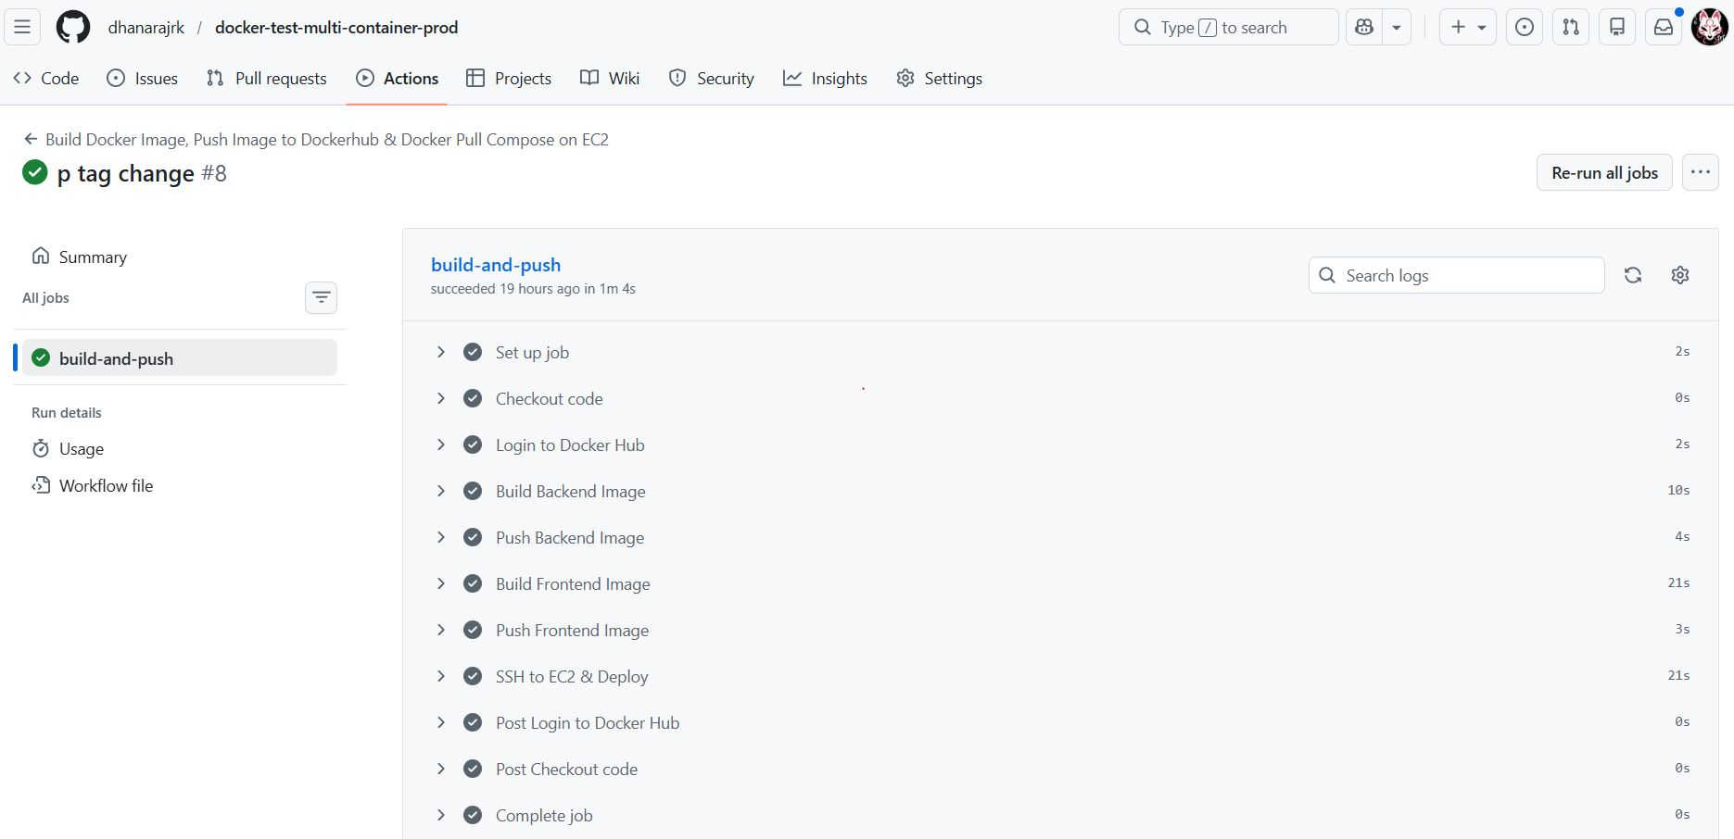

Visit EC2 instance Public Address on the browser: The App is Live!!

