**Phase 2: Innovation**

**Consider incorporating data segmentation by time periods or countries for deeper insights**

**1. Time Period Segmentation:**

a. Daily, Weekly, or Monthly Analysis:

Analyzing data on a daily, weekly, or monthly basis can help identify trends and spikes in cases, enabling a better understanding of the disease's progression.

Insights can be gained regarding the effectiveness of various interventions and policies over time.

b. Seasonal Patterns:

Segmentation by seasons (e.g., spring, summer, fall, winter) can reveal any seasonal variations in COVID-19 cases.

Understanding seasonal patterns can inform preparedness and resource allocation.

**2. Country Segmentation:**

a. Regional Analysis:

Grouping countries by regions or continents can provide insights into how different parts of the world have been affected.

Variations in infection rates, mortality rates, and healthcare infrastructure can be studied.

b. Policy and Response Comparison:

Comparing countries with different response strategies (e.g., strict lockdowns vs. more relaxed measures) can help assess which approaches have been more effective.

Lessons can be learned from countries with successful containment strategies.

c. Vaccination Progress:

Analyzing data by country can reveal the impact of vaccination campaigns on reducing cases, hospitalizations, and deaths.

Understanding vaccine distribution and uptake is crucial for managing the pandemic.

d. Economic and Sociodemographic Factors:

Segmentation by country allows for the examination of the role of economic and sociodemographic factors in COVID-19 outcomes.

Factors such as income levels, population density, healthcare systems, and social behaviors can be explored.

**3. Combined Analysis:**

It's often beneficial to combine time period and country segmentation for a more comprehensive analysis. For example, you can compare how different regions or countries have fared during specific time periods.

**Insights you can gain:**

Identify spikes and trends in cases, enabling better resource allocation and preparedness.

Assess the impact of interventions and policies on controlling the virus.

Understand seasonal variations and their implications for healthcare capacity.

Compare the effectiveness of different countries' response strategies.

Evaluate the influence of vaccination campaigns on reducing cases and deaths.

Investigate the role of economic and sociodemographic factors in COVID-19 outcomes.

Remember that data quality, consistency, and accuracy are essential for meaningful analysis. Additionally, it's important to consider factors like testing capacity and reporting practices, which can vary widely between countries and over time. Advanced statistical and data visualization techniques can be employed for a more in-depth analysis.

**Program:**

import numpy as np

import pandas as pd

import matplotlib.pyplot as plt

data = pd.read_csv('covid_19_cases4.csv')

data.head()

re=data.iloc[:30,5].values

de=data.iloc[:30,4].values

co=data.iloc[:30,3].values

x=list(data.iloc[:30,0])

plt.figure(figsize=(25,10))

ax=plt.axes()

ax.set_facecolor('black')

ax.grid(linewidth=0.4, color='#8f8f8f')

plt.xticks(rotation='vertical',

size='20',

color='white')#ticks of X

plt.yticks(size='20',color='white')

ax.set_xlabel('\nDistrict',size=25,

color='#4bb4f2')

ax.set_ylabel('No. of cases\n',size=25,

color='#4bb4f2')

plt.tick_params(size=20,color='white')

ax.set_title('Maharashtra District wise breakdown\n',

size=50,color='#28a9ff')

plt.bar(x,co,label='re')

plt.bar(x,re,label='re',color='green')

plt.bar(x,de,label='re',color='red')

for i,j in zip(x,co):

ax.annotate(str(int(j)),

xy=(i,j+3),

color='white',

size='15')

plt.legend(['Confirmed','Recovered','Deceased'],

fontsize=20)

**output:**

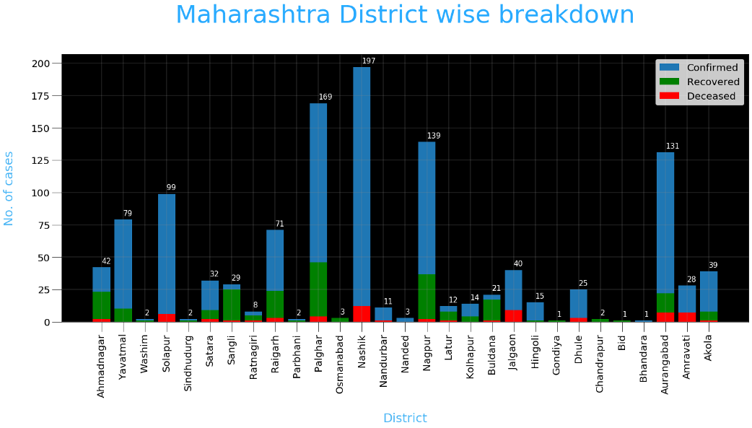 **covid-19 cases analysis**