**Phase3 : Development Part 1**

**In this part you will begin building your project by loading and preprocessing the dataset.Start building the COVID-19 cases analysis using IBM Cognos for visualization.Define the analysis objectives and obtain the COVID-19 cases and deaths data file.Process and clean the data to ensure its accuracy and reliability.**

**Covid-19 cases analysis visualization:**

**Countries and Territories**

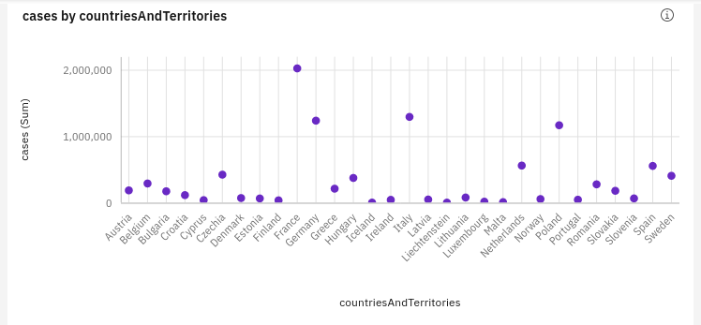

* **cases is unusually high when countriesAndTerritories is France.**
* **It is projected that by 2021-06-19, France will exceed Germany in cases by over 14 thousand.**
* **From 2021-03-29 to 2021-03-30, France's cases increased by 937%.**
* **Over all values of countriesAndTerritories, the sum of cases is nearly 10.0 million.**
* **cases ranges from 437, when countriesAndTerritories is Liechtenstein, to over 2.0 million, when countriesAndTerritories is France.**

**Cases by Data Rep**

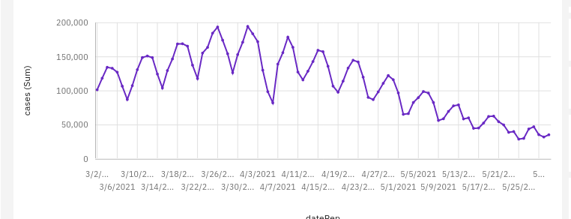

* **cases has a strong weekly trend. The largest values typically occur on Thursday, whereas the smalest values on Monday.**
* **cases has a moderate downward trend.**
* **Based on the current forecasting, cases may reach over 44 thousand by dateRep 2021-06-19.**
* **cases has most unusual values at time points 2021-04-07 and 2021-04-06.**
* **From 2021-04-06 to 2021-04-07, cases increased by 69%.**
* **Over all values of dateRep, the sum of cases is nearly 10.0 million.**
* **cases ranges from almost 29 thousand, when dateRep is 2021-05-25, to over 194 thousand, when dateRep is 2021-04-01.**
* **For cases, the most significant values of dateRep are 2021-04-01 and 2021-03-26, whose respective cases values add up to over 387 thousand, or 3.9 % of the total.**

**Cases by Months**

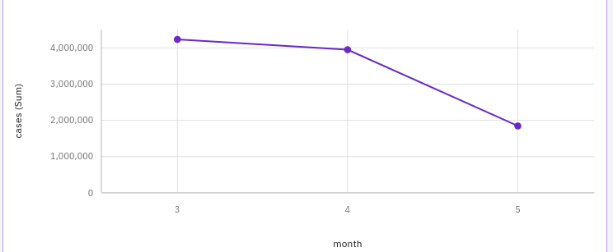

* **cases is unusually low when month is 5.**
* **month 4 has the highest Total deaths but is ranked #2 in Total cases.**
* **month 3 has the highest Total cases but is ranked #2 in Total deaths.**
* **Over all months, the sum of cases is nearly 10.0 million.**
* **cases ranges from over 1.8 million, when month is 5, to over 4.2 million, when month is 3.**
* **For cases, the most significant values of month are 3 and 4, whose respective cases values add up to almost 8.2 million, or 81.7 % of the total.**

**Cases by Day**

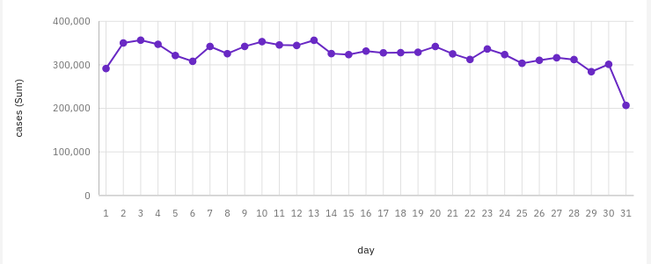

* **cases has a weak downward trend.**
* **Based on the current forecasting, cases may reach over 270 thousand by day 38.**
* **The value of cases at the last observed time point 31 is unusual. This may indicate incomplete data or a recent event that might require investigation.**
* **cases has an unusually low value at time point 31.**
* **Over all days, the sum of cases is nearly 10.0 million.**
* **cases ranges from almost 206 thousand, when day is 31, to nearly 356 thousand, when day is 3.**
* **For cases, the most significant values of day are 3, 13, 10, 2, and 4, whose respective cases values add up to nearly 1.8 million, or 17.6 % of the total.**

**Cases by deaths**

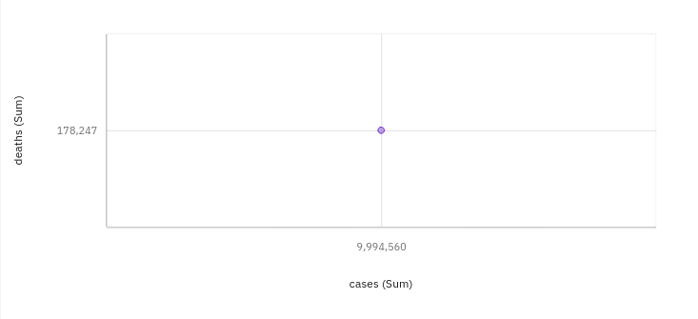

* **cases has a strong weekly trend. The largest values typically occur on Thursday, whereas the smalest values on Monday.**
* **cases has a moderate downward trend.**
* **Based on the current forecasting, cases may reach over 44 thousand by dateRep 2021-06-19.**
* **cases has most unusual values at time points 2021-04-07 and 2021-04-06.**
* **The total number of results for deaths, across all cases, is over 2500.**

**Process and clean the data to ensure its accuracy and reliability :**

**Program:**

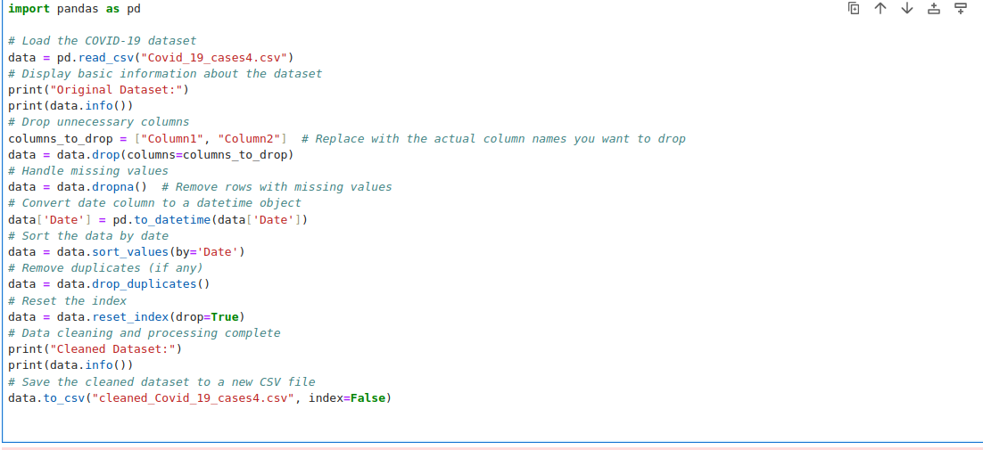

**Output:**

