**Phase 5: Project Documentation & Submission**

**COVID-19 cases analysis**

**Design Thinking Process:**

**1.Empathize:**

Understand the needs and concerns of the target audience, which could include policymakers, healthcare professionals, and the general public.

Identify the key questions and objectives of the analysis to address these needs.

**2. Define:**

Clearly define the scope and goals of the analysis, such as understanding the spread of the virus, assessing the effectiveness of interventions, and predicting future trends.

Determine the data sources and methodologies to be used.

**3. Ideate:**

Brainstorm and explore various data sources, models, and analytical tools that can aid in achieving the project's goals.

Consider how to structure the analysis, including segmentation, timeframes, and visualization techniques.

**4. Prototype:**

Develop a preliminary plan for data collection, analysis, and visualization.

Create mock-ups or prototypes of data dashboards or reports to convey how insights will be presented.

**5.Test:**

Review the prototype with stakeholders and gather feedback to refine the project plan and objectives.

**6.Develop:**

Proceed to data collection, analysis, and visualization using the finalized plan.

**Development Phases:**

**1.Data Collection:**

Gather COVID-19 data from reliable sources, such as government health agencies, research institutions, and global databases.

Collect a wide range of data, including infection rates, mortality rates, testing data, vaccination rates, and socio-economic factors.

**2. Data Cleaning and Preprocessing:**

Clean and preprocess the data to remove outliers, missing values, and inconsistencies.

Standardize data formats and ensure data quality.

**3.Data Analysis:**

Employ statistical, machine learning, and epidemiological models to analyze the data.

Explore trends, correlations, and predictive insights.

**Data Visualization using IBM Cognos:**

Utilize IBM Cognos or similar data visualization tools to create interactive and informative dashboards.

Visualize key metrics, trends, and geographical distributions.

Generate charts, graphs, and maps for better understanding.

**1. Insights Generation:**

Interpret the analysis results to generate insights regarding COVID-19 trends and impacts.

Identify patterns, hotspots, and areas of concern.

Evaluate the effectiveness of different interventions and policies.

**How Insights Aid in Understanding COVID-19 Trends and Impacts:**

**1.Monitoring and Early Warning:**

Insights can provide real-time information about infection rates and hotspots, aiding in early warning systems to respond to outbreaks.

**2.Policy Decision Support:**

Policymakers can use insights to make data-driven decisions about lockdowns, travel restrictions, and vaccine distribution.

**3.Healthcare Resource Allocation:**

Hospitals and healthcare organizations can plan for resource allocation based on insights into the severity and location of COVID-19 cases.

**4. Vaccine Rollout:**

Insights can guide the prioritization of vaccination efforts by identifying high-risk areas and vulnerable populations.

**5. Public Awareness:**

Clear, visualized insights can inform the public about the state of the pandemic, encouraging responsible behavior and vaccination.

**data visualization using IBM Cognos:**

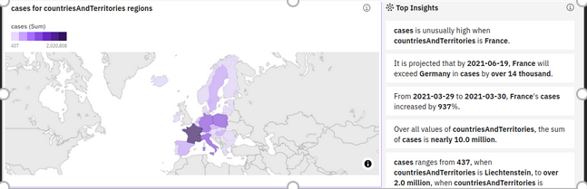

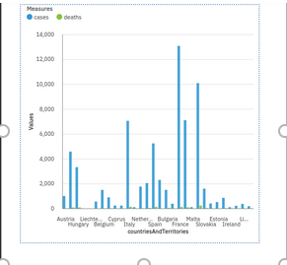

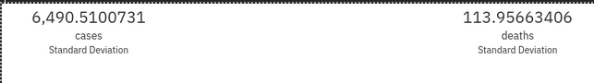

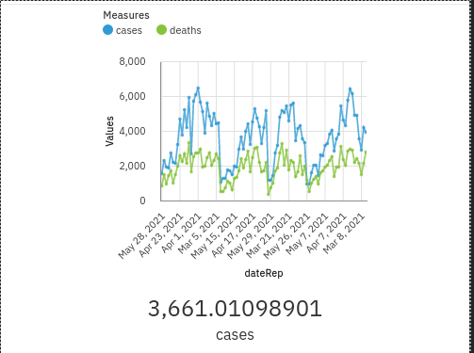

**Program:**

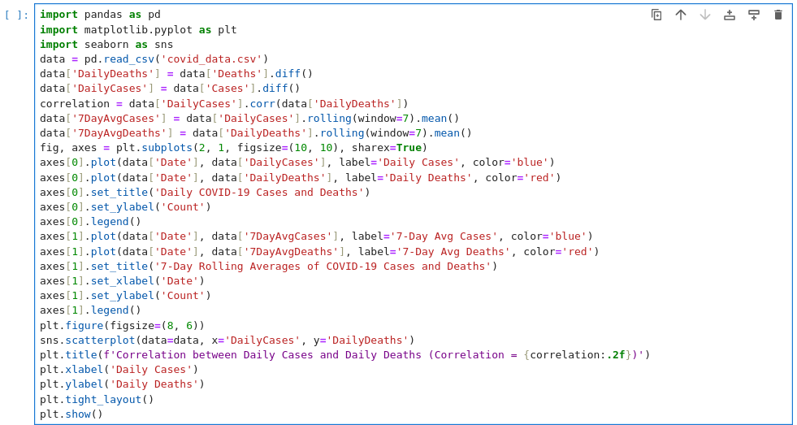

**Output:**

