**Government Polytechnic, Malvan**

**Department of Computer Engineering**

### CERTIFICATE

Certified that the project report entitled **“BRIDGE FULL WAVE RECTIFIER“** has been successfully completed by:-

1. Priyanka Subhash Parab

2. Dhanashree Suryakant Mhaskar

3. Manasi Vilas Mayekar

4. Runal Vijay Patil

5. Om Vaman Nikharge

As a partial fulfillment of Diploma Course in Computer Engineering under the ***Maharashtra State Board of Technical Education, Mumbai*** during the academic year 2017-2018

The said work has been assessed by us & we are satisfied that the same is up to standard envisaged for the course, and the said work may be presented to the external examiner.

Prof. Miss S.B.Anantkar

Project Guide H.O.D. Principal

**A**

**Project Report**

**Bridge full wave rectifier**

**Submitted to**



**Maharashtra State Board of Technical Education, Mumbai**

For the Partial fulfillment of

Diploma in Computer Engineering

**Submitted by,**

### 1.Priyanka Parab Roll No. 1219

### 2.Dhanashree Mhaskar Roll No. 1216

### 3.Manasi Mayekar Roll No. 1213

### 4.Runal Patil Roll No. 1220

### 5.Om Nikharge Roll No. 1217

### Under The Guidance of

### Name of Guide:- Miss S.B.Anantkar



**Department of Computer Engineering**

**Government Polytechnic, Malvan**

**A/P- Kumbharmath, Tal- Malvan, Dist- Sindhudurg 416606**

**Academic Year 2017-2018**

**TABLE OF CONTENT**

1] Abstract…………………………………………………………………..1.

2] Introduction……………………………………………………………...2.

3] Components used…………………………………………………….…..3.

4] Components……………………………………………………………...4.

5] Circuit diagram……………………………………………………………5.

6] Output…………………………………………………………………….6.

7] Advantages………………………………………………………………..7.

8] Disadvantages…………………………………………………….………7.

9] Conclusion……………………………………………………………......8.

**ACKNOWLEDGEMENT**

I would like to express my special thanks of gratitude to my teacher Mis. Anantkar Mam as well as our principal Mr. Mahajan Sir who gave me the golden opportunity to do this wonderful project on the topic “Bridge full wave rectifier”, which also helped me in doing a lot of Research and I came to know about so many new things.

I am really thankful to them.

Secondly I would also like to thank my parents and my friends who helped me a lot in finishing this project within the limited time.

I am making this project not only for marks but to also increase my knowledge.

THANKS AGAIN TO ALL WHO HELPED ME.

**ABSTRACT**

Rectification is the process of converting the alternating voltage or current into the corresponding (dc) Quantity.

The input to a rectifier is an alternating(ac) voltage where as its output is unidirectional or dc voltage.

The electronic circuit which carries out rectification is called “**Rectifier**”.

**INTRODUCTION**

Rectifier is an electronic device which is used for converting an alternating current(ac) or voltage into a unidirectional(dc) current or voltage.

A step down transformer is used to reduce the ac mains voltage to an adequately small value. The turns ratio of the transformer is adjusted to obtain a stepped down ac voltage.

This voltage is converted into a pulsating dc voltage by the rectifier. The type of rectifier mostly used are half wave rectifier, center tapped full wave rectifier, bridge full wave rectifier.

**COMPONENTS USED:-**

|  |  |  |  |  |  |
| --- | --- | --- | --- | --- | --- |
| Sr.  No. | Component | image | Specifications | Quantity | Price  (Rs.) |
| 1 | Resistor |  | 1.5k | 1 | 2 |
| 2 | Diode |  | 1N4007 | 4 | 20 |
| 3 | Transformer |  | (9-0-9)volt  500mA | 1 | 50 |
| 4 | PCB |  | (5x7)cm  Ceramic body | 1 | 38 |
| 5 | Connecting Wires |  | Single stranded  TOTAL = 120Rs. | 1meter | 10 |

**Components:-**

**1] Resistor**= Resistor is a electronic component which provides specified amount of opposition to the flow of current. Here we use resistor of 1.5K which opposes to the flow of ac current in circuit .

**2] Diode**=Diode means a device with two elements namely anode and cathode. The biasing of diode can be of two types forward biasing and reverse biasing.

If p-region is connected to positive terminal of external DC supply and n-region is connected to positive terminal of DC supply then diode is in “Forward bias”. If p-region is connected to negative terminal of DC supply and n-region is connected to positive terminal of DC supply then diode is in “Reverse bias”.

Here we use diode of 1N4007 which passes electric current through it. We use four diodes when diode is in forward bias it passes current and when in reverse bias it make barrier to the flow of current.

**3] Transformer**= Here we use (9-0-9) volt and 500mA current rating. We use simple step down transformer which reduce the AC mains voltage to small value.

**4] PCB**= Here we use Printed Circuit Board of ceramic body and its dimensions are (5x7) cm.

**5] Connecting Wires**= We use single stranded connecting wires that are easy to connect circuit.

**Circuit Diagram:-**

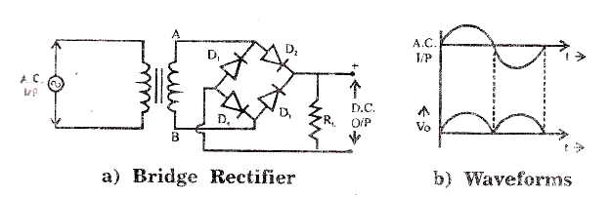

Operation of bridge full wave rectifier can be divided in two half cycles of the AC supply voltage as follows:

1. Operation in positive half cycle:-

In positive half cycle of AC supply the secondary voltage VAB  is positive. Therefore diodes D1 and D2 are in forward bias whereas D3 and D4 are in reverse biased.

Then current flows through the path= A+ -> D1 -> RL -> D2 -> B-

1. Operation in negative half cycle:-

In negative half cycle of the AC supply the secondary voltage VAB becomes negative. Diodes D3  and D4 are in forward biased and starts conducting. D1 and D2 are in reverse biased hence do not conduct.

Then current flows through the path= A- -> D3 -> RL -> D4 -> B+ .

**OUTPUT**

**Theoretically waveforms:-**

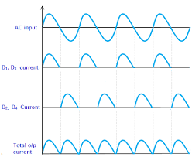

**Project’s Output:**-

Output waveforms from project:-

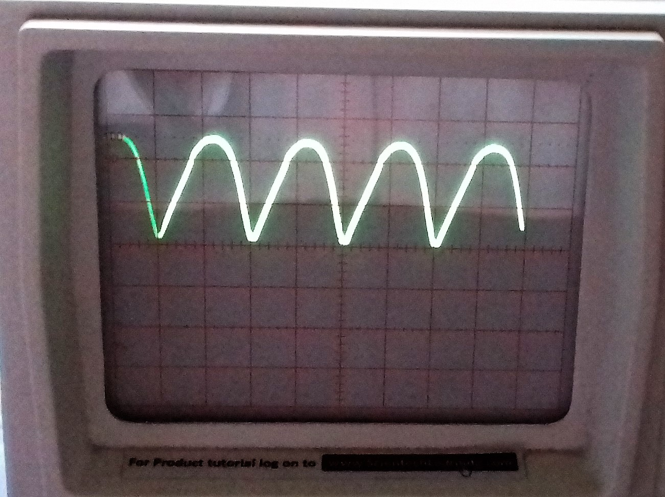

Project Setup:-

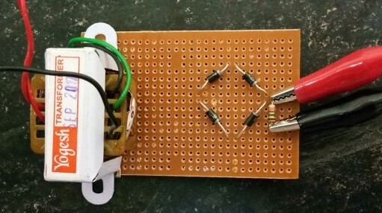

**ADVANTAGES**

1] It requires a small size transformer .Center tap transformer is not required. This makes the bridge rectifier cost effective.

2] The input transformer is not a must. It is possible to operate the bridge rectifier directly on the 230V ac supply.

3] This circuit is most suitable for the high voltage applications.

This is because the maximum negative voltage that appears across each diode is –Vm. Therefore the diodes with PIV rating of –Vm volts are required to be selected. (PIV in full wave rectifier is -2Vm).

4] Core saturation does not take place. Therefore transformer losses are reduced. Core saturation is avoided because equal and opposite current flow through the transformer in each cycle.

5] The PIV is only Vm volts which is half the PIV of full wave rectifier with center tap.

6] High average output voltage.

7]Rectifier efficiency is high.

8] Transformer utilization factor TUF is high.

**DISADVANTGES**

1] The number of diodes used is four instead of two for FWR.

2] As two diodes conduct simultaneously, the voltage drop across them increases and the output voltage reduces.

**CONCLUSION**

A bridge rectifier circuit is common part of the electronic power supplies. Many electronic circuits require rectified DC power supply for powering the various electronic basic components from available AC mains supply.

We can find this rectifier in a wide variety of electronic AC power devices like home appliances, motor controllers, modulation process, welding applications.