PROJECT REPORT

Name of Student: Dhanashri Raut
Roll No: 37
Reg. ID: 24030192
Semester & Subject: V – DAA LAB
Batch: A2
Branch: CSE (IoT)

Title of the Project:
Sorting Algorithm Visualizer in C

Aim of the Project:
To design and implement a program that visualizes the working of various sorting algorithms such as Bubble Sort, Insertion Sort, and Selection Sort by displaying step-by-step changes in the array during sorting.

Introduction:
Sorting is one of the most fundamental and widely used operations in computer science and programming. It plays a crucial role in data organization, searching, and optimization problems. By arranging elements in a particular order (ascending or descending), sorting algorithms enhance the efficiency of other algorithms that rely on sorted data. This project aims to help students understand how sorting algorithms work internally by visualizing each step of the sorting process. The program allows users to input an array of numbers, select a sorting algorithm, and observe how elements are rearranged to achieve a sorted order. The step-by-step visualization demonstrates how comparisons, swaps, and iterations take place within the algorithm, offering an intuitive way to grasp abstract algorithmic concepts. Through this project, students gain practical experience in analyzing algorithm complexity, understanding time and space efficiency, and developing a deeper appreciation for algorithmic design.

Technology Used:
Component | Technology
Programming Language | C
IDE | Code::Blocks / Dev-C++ / Turbo C
OS | Windows / Linux
Algorithm Concepts | Bubble Sort, Insertion Sort, Selection Sort

Results (Output):

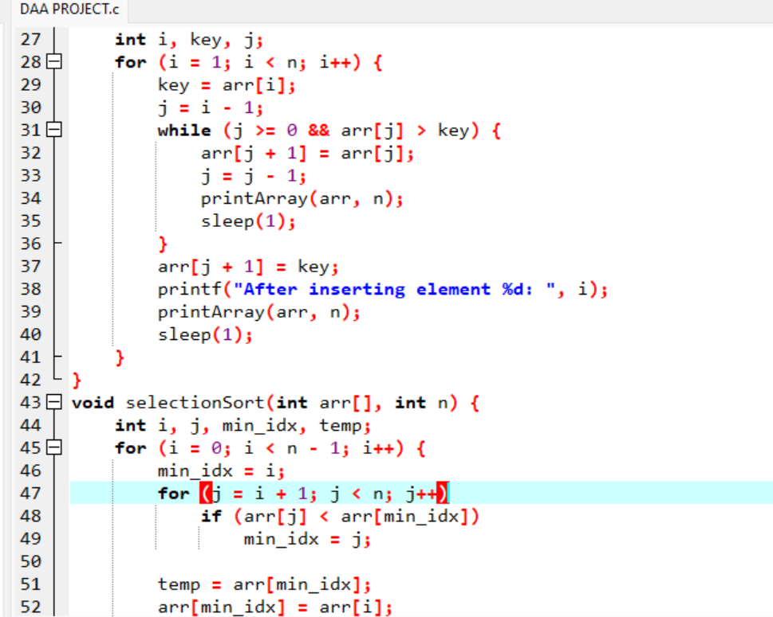
CODE : 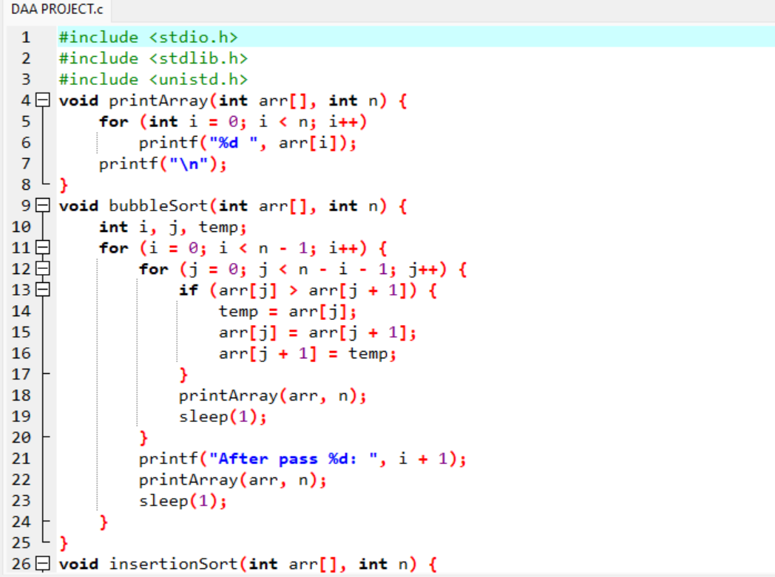

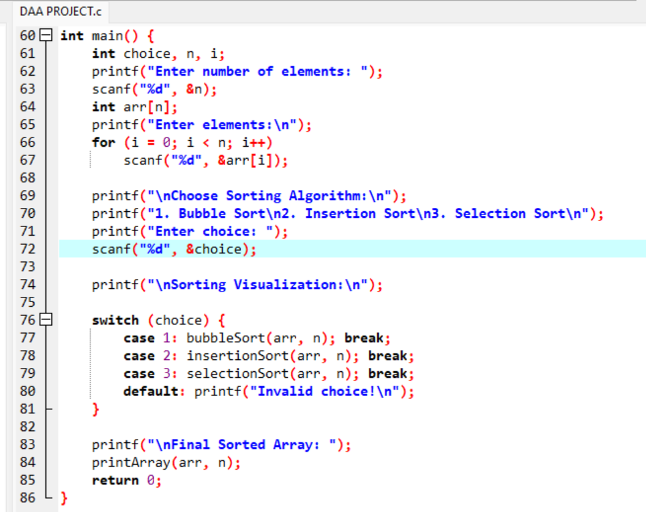

OUTPUT:

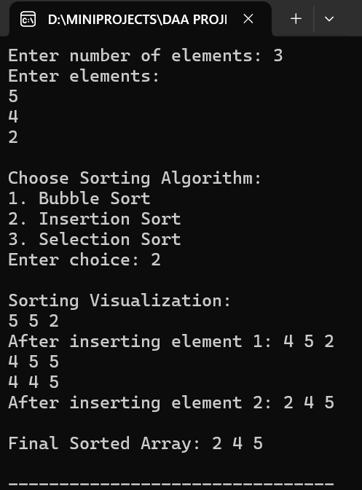
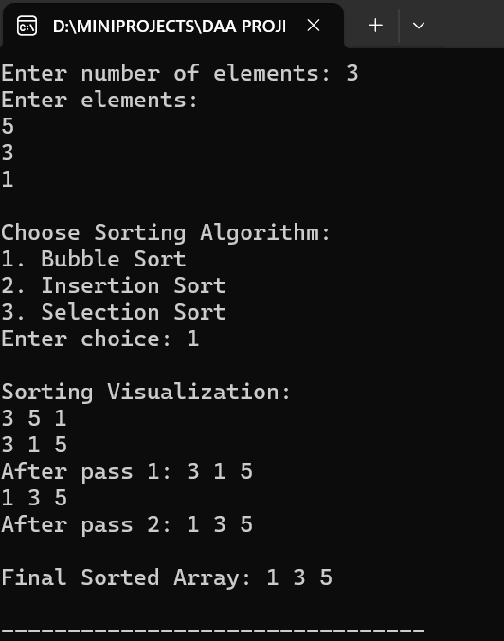
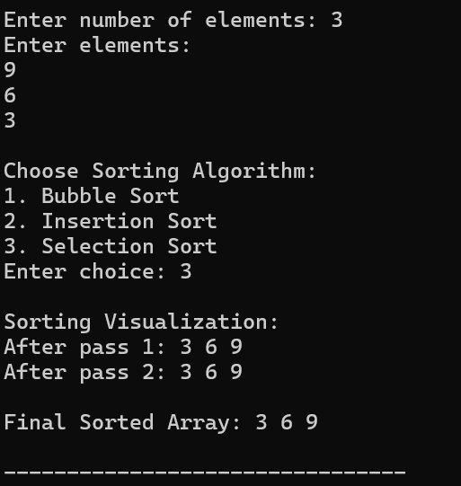

Conclusion:
This project successfully demonstrates the working and internal mechanics of commonly used sorting algorithms such as Bubble Sort, Insertion Sort, and Selection Sort using the C programming language. By providing a step-by-step visualization of how data is rearranged during sorting, it offers students an intuitive understanding of algorithmic logic, comparisons, and data manipulation.Through this practical implementation, learners can observe how different algorithms behave under various conditions, including their performance on best, average, and worst-case inputs. Moreover, it strengthens logical thinking, debugging skills, and the ability to break complex problems into smaller computational steps.In conclusion, the Sorting Algorithm Visualizer serves as a simple yet powerful educational tool that encourages curiosity and experimentation with algorithm design and analysis, forming a strong foundation for exploring advanced topics such as divide and conquer, dynamic programming, and optimization techniques in future studies.
Faculty Signature: ___________________________
Student Signature: ___________________________

