EXPERIMENT NO. 06

#include<stdio.h>
#include<stdlib.h>
#include<malloc.h>

struct node{
int data;
struct node *left;
struct node *right;
};

struct node *tree;
void create(struct node *);
struct node *insert(struct node *, int);
void inorder(struct node *);
void preorder(struct node *);
void postorder(struct node *);

void main()
{
int choice, x;
struct node *ptr;
create(tree);
do
{
printf("\n Operations available are : ");
printf("\n 1. Insert a node");
printf("\n 2. Display inorder traversal");
printf("\n 3. Display preorder traversal");
printf("\n 4. Display postorder traversal");
printf("\n 5. Exit \n");
printf("\n Enter your choice\t");
scanf("%d", &choice);

switch (choice){

case 1:
printf("\n Enter data to be inserted\t");
scanf("%d",&x);
tree = insert(tree, x);
break;

case 2:
printf("\n Elements in the inorder traversal are\t");
inorder(tree);
printf("\n");
break;

case 3:
printf("\n Elements in the preorder traversal are\t");
preorder(tree);
printf("\n");
break;

case 4:
printf("\n Elements in the postorder traversal are");
postorder(tree);
printf("\n");
break;

case 5:
printf("\n Exit: program finished !!!");
break;
default:
printf("\n Please enter a valid option from 1,2,3,4,5. ");
break;
}
}
while (choice != 5);
}

void create(struct node *tree)
{
tree = NULL;
}
struct node *insert(struct node *tree, int x)
{
struct node *p, *temp, *root;
p = (struct node *)malloc(sizeof(struct node));
p->data = x;
p->left = NULL;
p->right = NULL;
if (tree == NULL)
{
tree = p;
tree-> left = NULL;
tree-> right = NULL;
}
else
{
root = NULL;
temp = tree;
while (temp != NULL)
{
root = temp;
if (x < temp->data)
temp = temp->left;
else
temp = temp->right;
}
if(x < root->data)
root->left = p;
else
root->right = p;
}
return tree;
}
void inorder(struct node *tree)
{
if (tree != NULL)
{
inorder(tree->left);
printf("%d \t", tree->data);
inorder(tree->right);
}
}

void preorder(struct node *tree){
if (tree != NULL)
{
printf("%d \t", tree->data);
preorder(tree->left);
preorder(tree->right);
}
}

void postorder(struct node *tree){
if (tree != NULL)
{
postorder(tree->left);
postorder(tree->right);
printf("%d \t", tree->data);
}
}

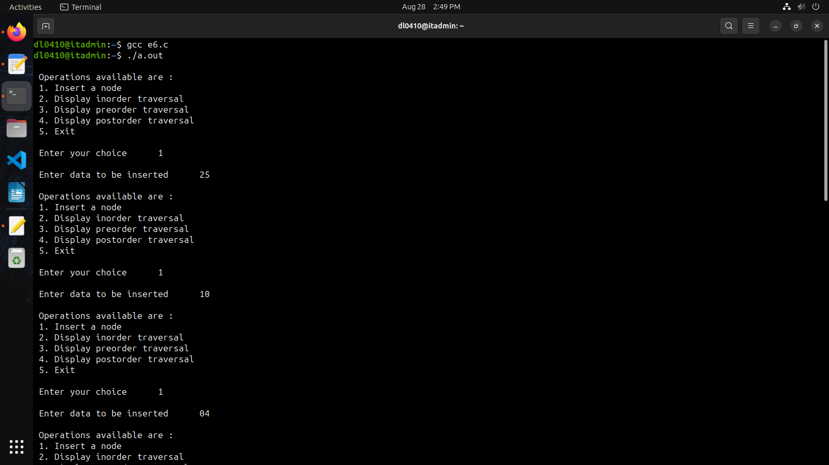
1

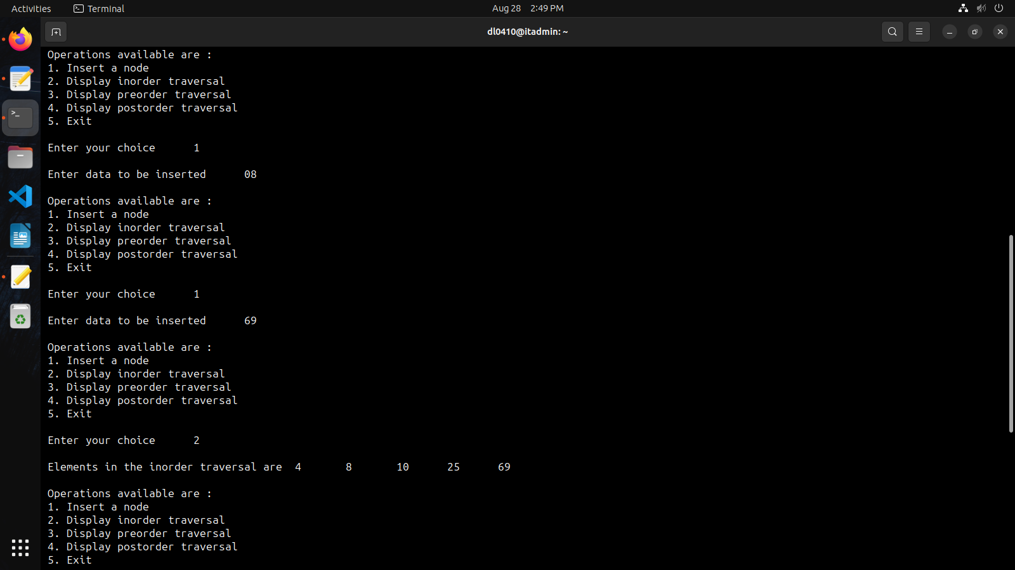
2.

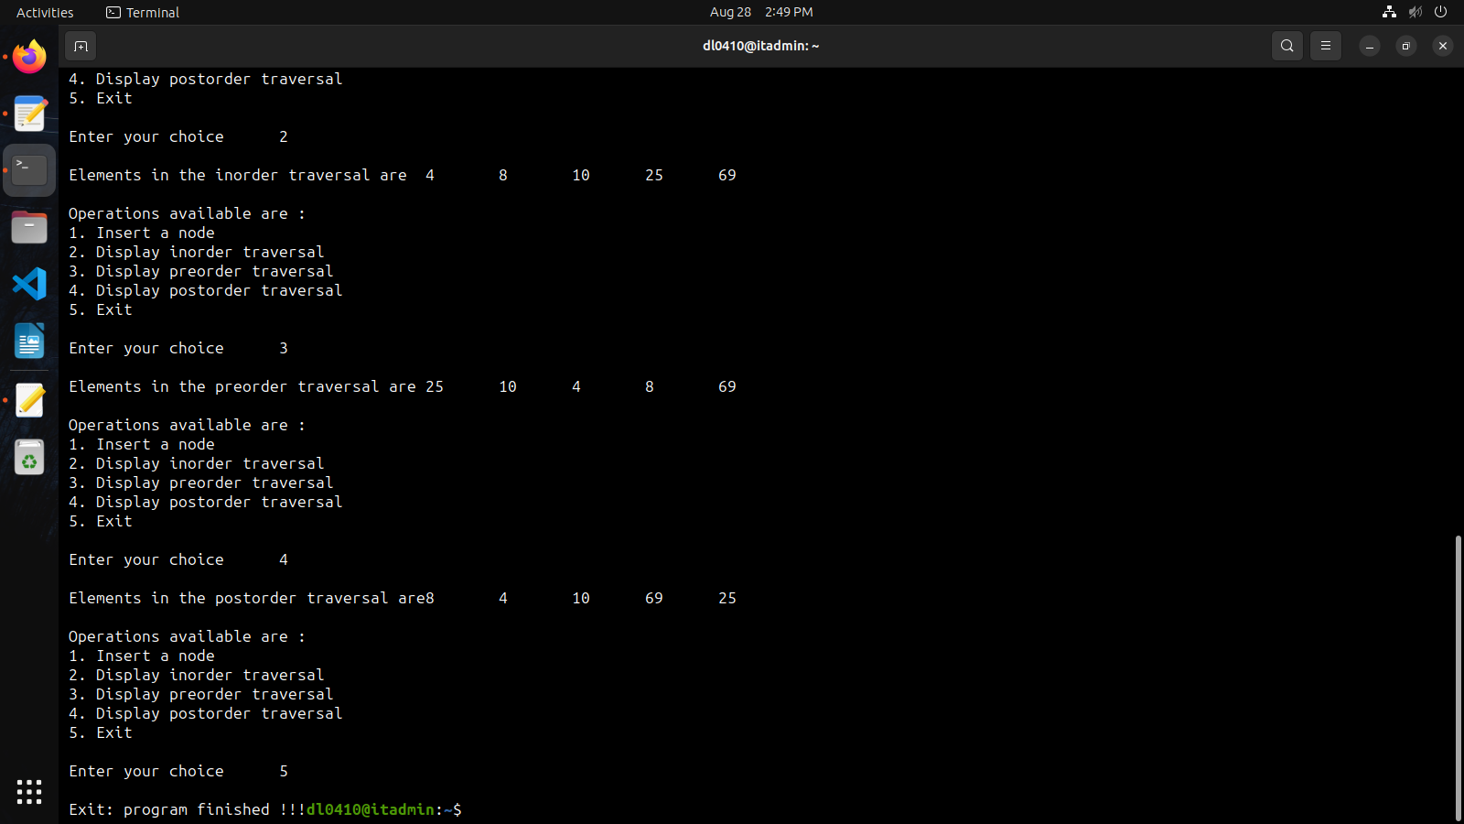
3.

