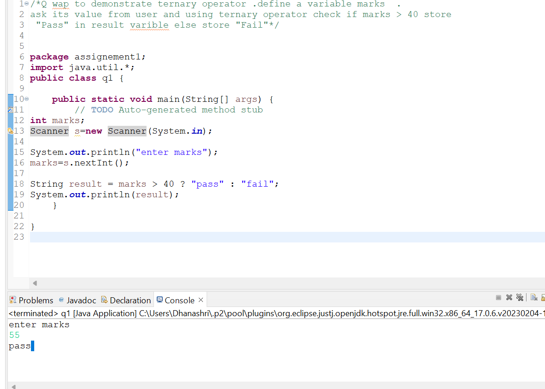

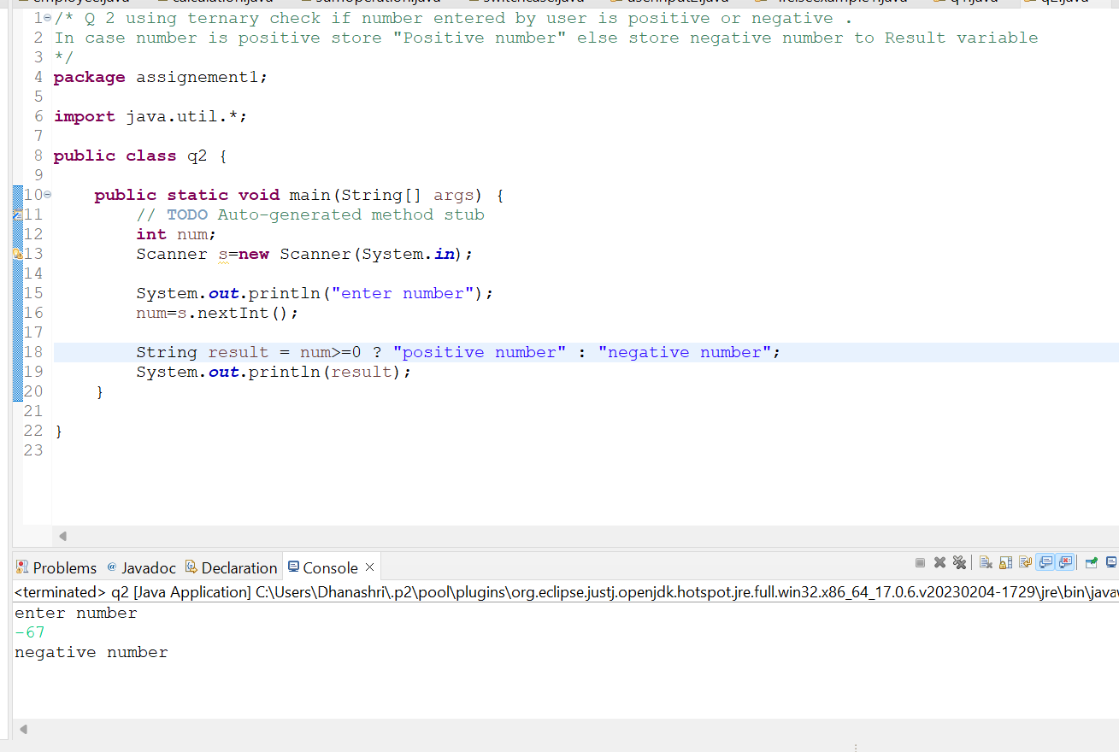

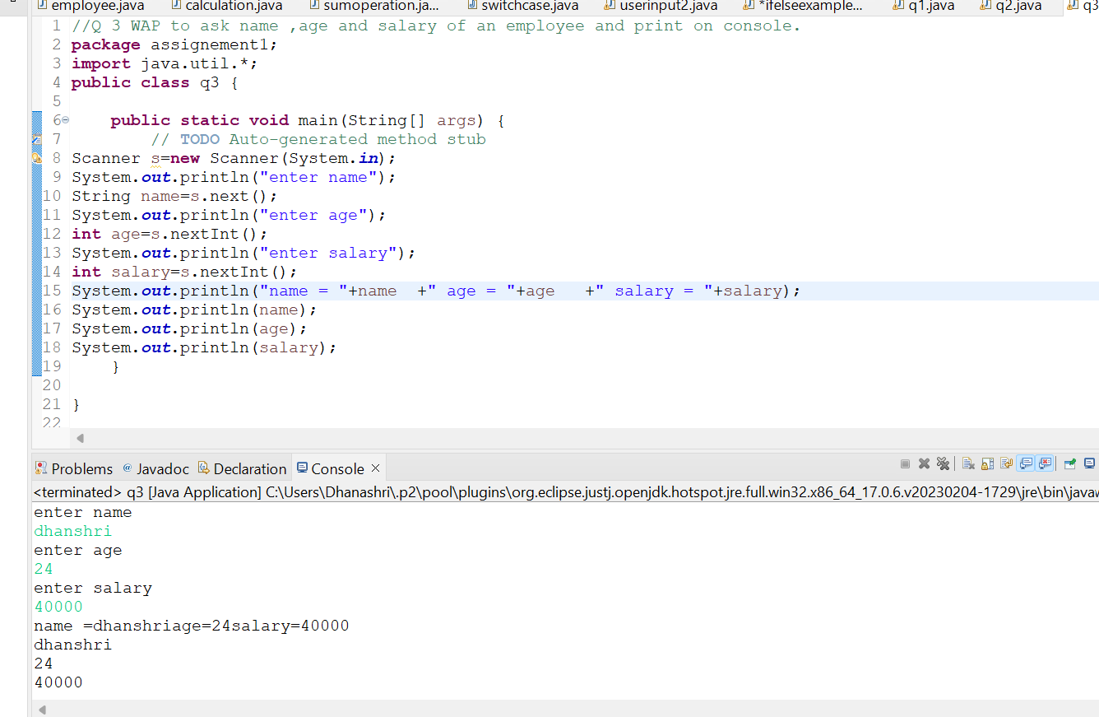

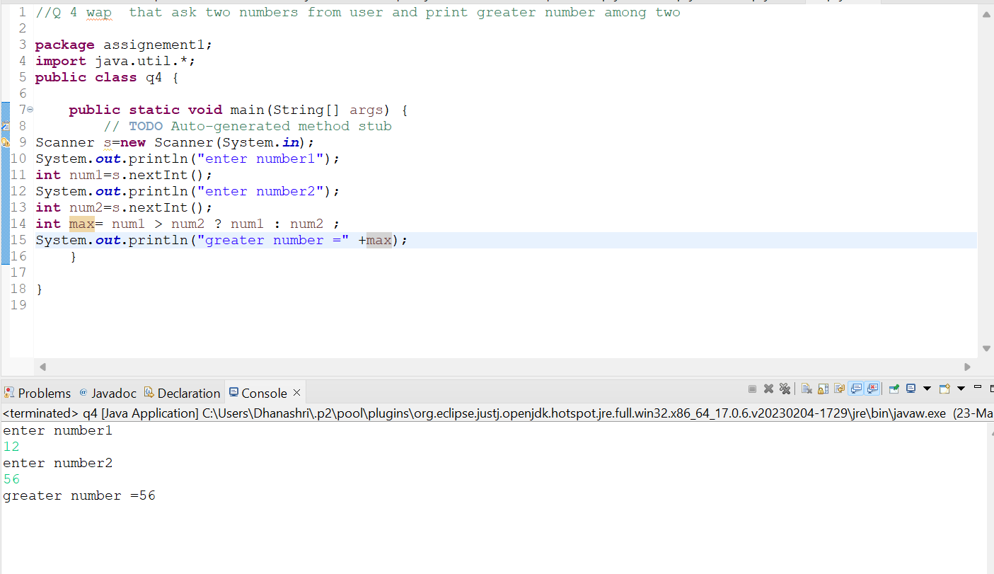

Q 5 wap to ask product name and price of product from user and calculate discount i.e

if price > 2000 then discount is 10 percent of price

else

discount is 7 % of price*/

**package** assignement1;

**import** java.util.*;

**public** **class** q5discount {

**public** **static** **void** main(String[] args) {

// **TODO** Auto-generated method stub

Scanner s=**new** Scanner(System.***in***);

System.***out***.println("enter product name");

String pname=s.next();

System.***out***.println("enter price");

**float** price=s.nextFloat();

**float** discount;

**float** finalprice;

**if** (price>=2000)

{

discount = price*10/100;

}

**else**

{

discount= price*7/100;

}

finalprice = (price-discount);

System.***out***.println("pname=" +pname);

System.***out***.println("price=" +price);

System.***out***.println("discount="+discount);

System.***out***.println("finalprice="+finalprice);

}

}

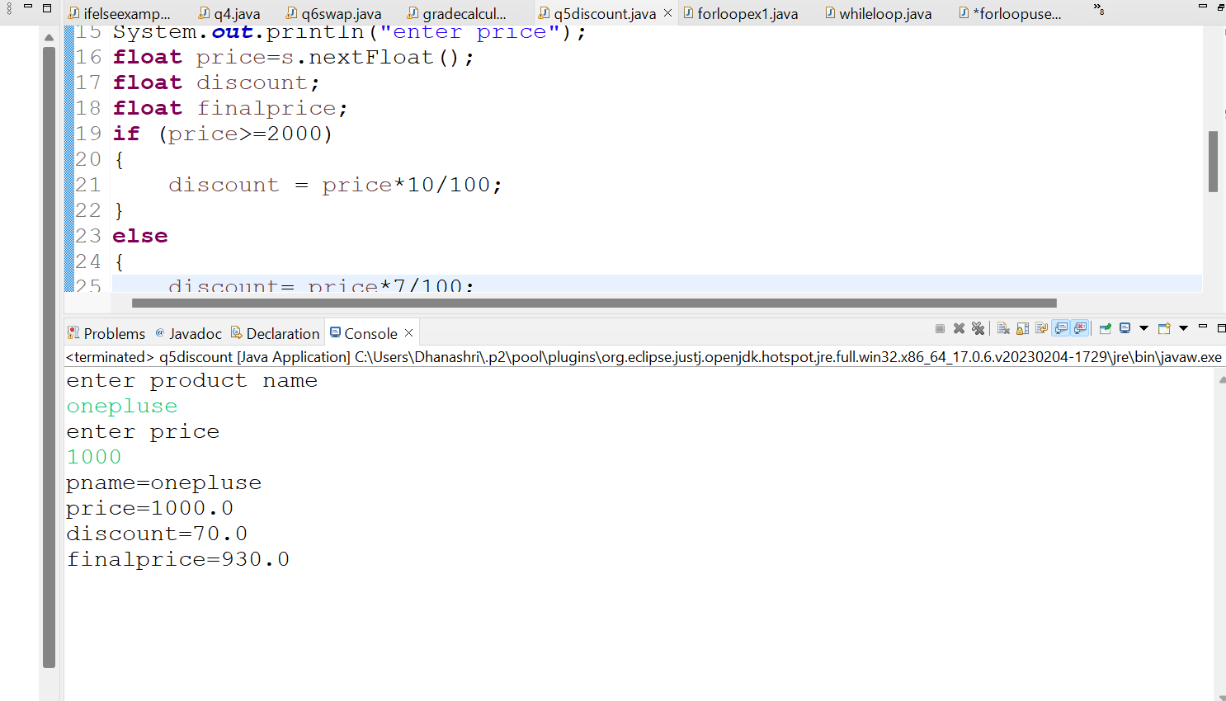



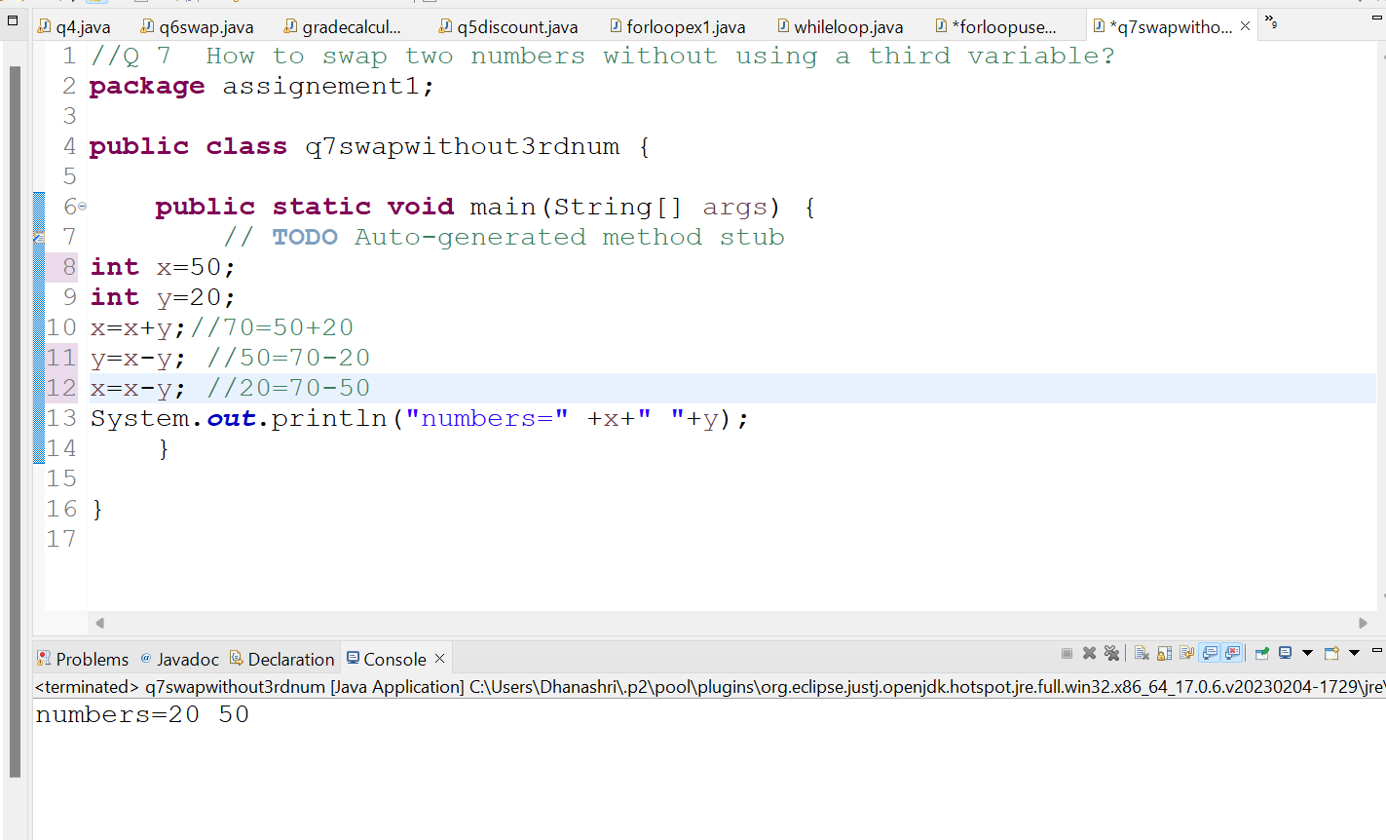

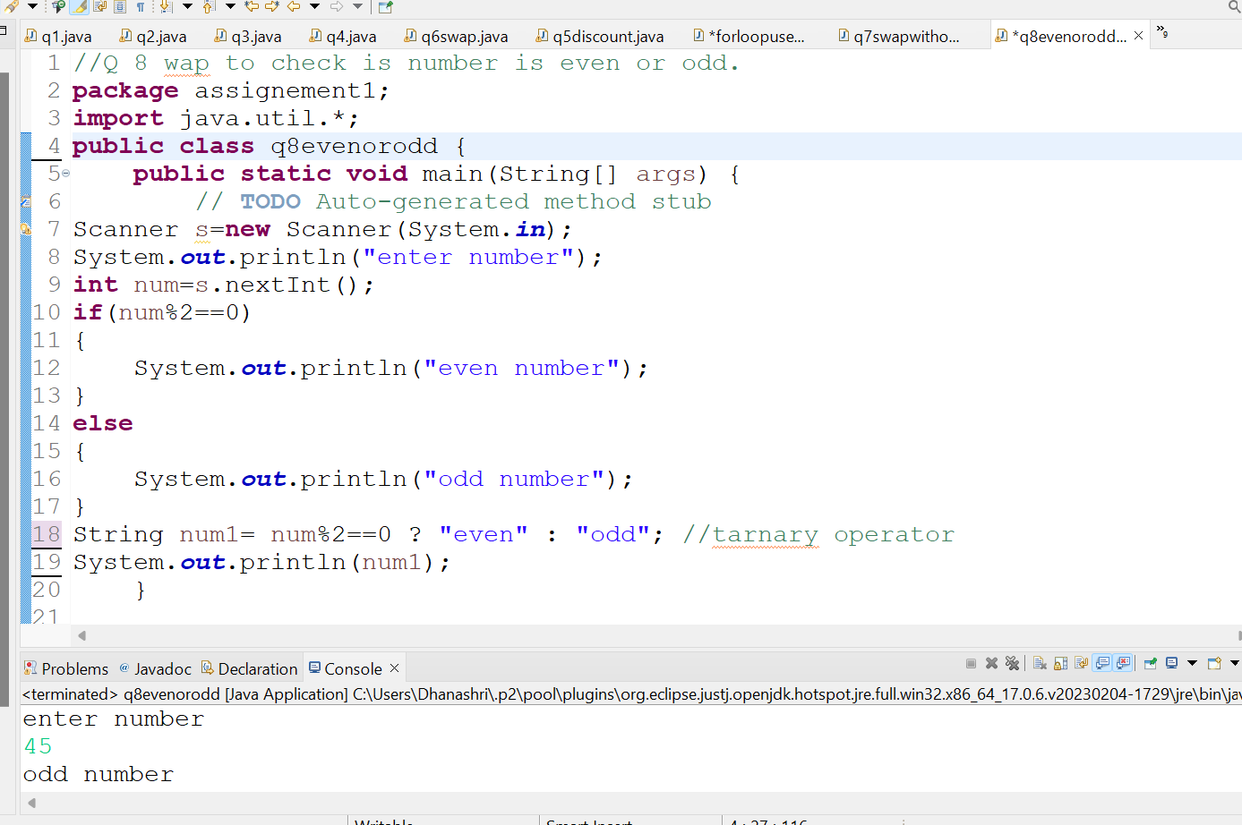

/*Q 9 A school has following rules for grading system

a). Below 25 – F b). 25 to 45 – E c). 45 to 50 - D

d). 50 to 60 – C e). 60 to 80 - B f). Above 80 - A

Ask user to enter marks and print the corresponding grade*/

**package** assignement1;

**import** java.util.*;

**public** **class** q9ifelsegrade {

**public** **static** **void** main(String[] args) {

Scanner s=**new** Scanner(System.***in***);

System.***out***.println("enter marks");

**int** marks=s.nextInt();

**if**(marks<=100)

{

**if**(marks>80)

{

System.***out***.println("A");

}

**else** **if** (marks<=80 && marks>60)

{

System.***out***.println("B");

}

**else** **if** (marks<=60 && marks>50)

{

System.***out***.println("C");

}

**else** **if** (marks<=50 && marks>45)

{

System.***out***.println("D");

}

**else** **if** (marks<=45 && marks>25)

{

System.***out***.println("E");

}

**else** **if** (marks<=25)

{

System.***out***.println("F");

}

**else**

{

System.***out***.println("fail");

}

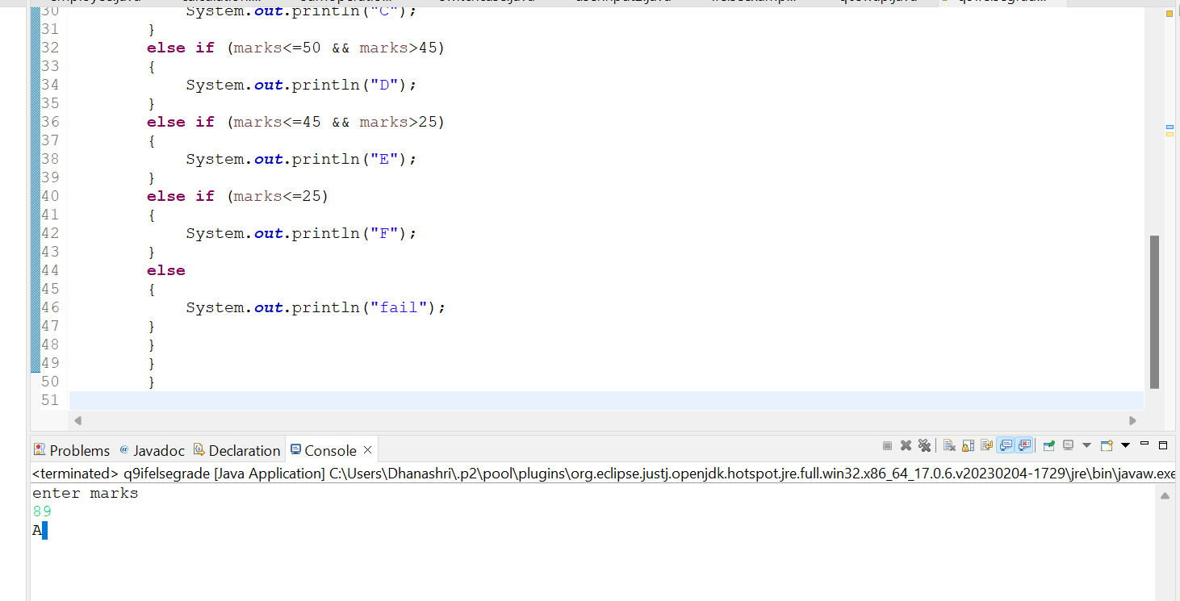

//Q 10 wap to check greater number among three numbers

**package** assignement1;

**import** java.util.*;

**public** **class** q10greaternum3 {

**public** **static** **void** main(String[] args) {

// **TODO** Auto-generated method stub

Scanner s=**new** Scanner(System.***in***);

System.***out***.println("enter number");

**int** num1=s.nextInt();

System.***out***.println("enter number");

**int** num2=s.nextInt();

System.***out***.println("enter number");

**int** num3=s.nextInt();

**if**(num1>num2 && num1>num3)

{

System.***out***.println(" greater number="+num1);

}

**else** **if**(num2>num3 && num2>num1)

{

System.***out***.println(" greater number="+num2);

}

**else**

{

System.***out***.println(" greater number="+num3);

}

}

}

