MKSSS's Cummins College of Engineering for Women, Pune
Department of Information Technology
Academic Year 2026-27

DESIGN AND ANALYSIS OF ALGORITHMS
Mini Project Report

Financial Scenario Analysis:
Sequential vs OpenMP Parallel Evaluation

TY B.Tech, Division B

Submitted by
Name | Roll No.
Dhanashri Keskar | UIT2024925
Gauri Kondawar | UIT2024929
Parnavi Khambayat | UIT2024926
Asmita Merya | UIT2024935

Faculty Guide: Harshad Wadkar
Date of submission: 6 October 2026

1. Introduction
Financial decisions are often tested by evaluating many possible scenarios, each with different values for the investment amount, expected return, risk, duration and inflation. Evaluating one scenario is quick, but evaluating a very large number of them takes a long time on a single processor core. Since scenarios do not depend on each other, the work can be divided among several cores.
This project builds a computational system that generates and evaluates a large number of independent financial scenarios, classifies each scenario against fixed criteria, and measures how execution time changes with the number of scenarios, the number of threads and the OpenMP scheduling strategy. A sequential version is the baseline, and an OpenMP version is compared against it for speedup, efficiency and correctness.
The same set of scenarios is solved in two ways. A sequential program evaluates them one after another on a single thread, and an OpenMP parallel program shares them among p threads. The two programs are compared for different numbers of scenarios (N) and for different numbers of threads (1, 2, 4 and 8), so that the report shows both how execution time grows with N and how much each extra thread helps.

2. Problem Statement
“Develop a computational system for evaluating a large number of financial scenarios according to specified criteria. Investigate how execution time changes with the number of scenarios.”

3. Objectives
- Define a financial scenario and the criteria used to evaluate it.
- Implement a sequential version of the evaluation as the baseline.
- Implement a parallel version using OpenMP, and justify the choice of parallel programming model.
- Verify that the parallel version produces the same results as the sequential version.
- Measure execution time against the number of scenarios, the number of threads and the scheduling strategy.
- Calculate speedup and parallel efficiency, and analyse possible bottlenecks using the measured data.
- Run the OpenMP version with 1, 2, 4 and 8 threads and analyse how time, speedup and efficiency change with the number of threads.
- Compare the sequential and parallel algorithms side by side (work done, memory, shared data and extra code) and state which thread count is suitable on the test machine.

4. System Design
The program follows the same pipeline in both versions. Only the evaluation loop is timed.
1. Generate N scenarios from a fixed seed (not timed)
2. Validate scenarios and allocate results array (not timed)
3. Start timer
4. Evaluate every scenario (timed)
5. Stop timer
6. Summarise: class counts, mean score, sums (not timed)
7. Print summary / optionally write CSV (not timed)

Both versions call the same function, evaluate_scenario(), defined once in common/scenario.h. This guarantees that the sequential and parallel programs perform exactly the same calculation; only the loop that calls it differs.
File | Purpose
common/scenario.h | Scenario and result structures, generator, validation, classification, evaluate_scenario()
sequential/sequential.cpp | Sequential baseline program
sequential/test_sequential.cpp | 17 unit tests for the shared evaluation code
parallel/parallel.cpp | OpenMP program (threads and schedule from command line)
verify/verify.cpp | Correctness check, sequential vs OpenMP, uses reduction
benchmark/benchmark.cpp | Runs the three experiments and writes CSV files
results/ | Final benchmark CSV files and graphs

Scenario generation uses a fixed seed (12345), so the same dataset is produced every time and is shared by the sequential and parallel runs. Generation is sequential because a shared random generator is not thread-safe and the dataset must be identical on every run.

5. Financial Scenario Model
Assumption: this project uses the team's Monte Carlo design recorded in docs/project_notes.md. It does not use a Net Present Value or Future Value model.

5.1 Scenario parameters
Parameter | Meaning | Generated range
P | Initial investment | 10,000 to 1,000,000
r | Expected annual return | 2% to 20%
sigma | Risk: volatility of yearly log-returns | 5% to 40%
T | Duration in whole years | 1 to 30
inflation | Annual inflation rate | 2% to 8%

5.2 Evaluation of one scenario
For every scenario, M Monte Carlo paths are simulated. In each path the yearly log-return is drawn from a Normal distribution with mean log(1 + r) − sigma²/2 and standard deviation sigma. The T yearly returns are added, the exponential gives the final value, and the result is divided by (1 + inflation)^T to obtain the real (inflation-adjusted) final value. A running mean and variance are kept with Welford's method.
Outputs per scenario: mean real final value, profit, ROI (profit / P), annual real return = (mean / P)^(1/T) − 1, probability of loss (fraction of paths ending below P), and score = ROI / standard deviation (set to 0 when the standard deviation is 0). The cost of one scenario is about M × T random numbers, so scenarios with larger T cost more. This makes the work per scenario uneven, which matters for scheduling.

5.3 Decision criteria
The thresholds are constants at the top of common/scenario.h and can be changed in one place.
Class | Probability of loss | Annual real return
RECOMMENDED | ≤ 0.20 | ≥ 3%
ACCEPTABLE | ≤ 0.40 | ≥ 0%
REJECTED | otherwise | otherwise

6. Sequential Algorithm

6.1 Sequential Approach
The sequential program (sequential/sequential.cpp) first generates N financial scenarios from the fixed seed and validates them. It then processes the scenarios one after another, in index order, on a single thread. For every scenario it calls evaluate_scenario() from common/scenario.h, which runs the M Monte Carlo paths and classifies the scenario, and the returned result is stored in results[i]. The overall steps are:
scenarios = generate_scenarios(N, seed)
results = array of N results
start timer
for i = 0 to N-1:
results[i] = evaluate_scenario(scenarios[i], M, seed)
stop timer
count RECOMMENDED / ACCEPTABLE / REJECTED, sum scores

The main loop in sequential.cpp is:
for (long long i = 0; i < N; i++) {
results[static_cast<size_t>(i)] =
evaluate_scenario(scenarios[static_cast<size_t>(i)],
static_cast<int>(M), seed);
}

The loop contains no OpenMP code. The same evaluate_scenario() function is later called by the parallel version, so both versions use identical evaluation logic and only the loop differs.

6.2 Complexity Analysis
Time complexity: approximately O(N × M × T), where N is the number of scenarios, M is the number of Monte Carlo paths per scenario and T is the number of years simulated. The factors multiply because the loop visits N scenarios; each scenario simulates M paths; and each path draws one random yearly return for each of the T years. A scenario with a longer duration T therefore costs more, which is why the work per scenario is uneven (Section 5.2). The cost of the final classification and summary steps is small in comparison, and we do not claim a more precise bound.
Space complexity: O(N), because the program stores the N generated scenarios and the N results. The evaluation of a single scenario keeps only a running mean, variance and loss count (Welford's method) and does not store the M paths, so it needs no additional memory that grows with M or T.

6.3 Baseline Timing
The execution time of this sequential version is denoted Ts. The timer (std::chrono::steady_clock) is started immediately before the scenario-evaluation loop and stopped immediately after it, so Ts measures the main evaluation workload only. Scenario generation, validation, allocation of the results array, the summary and printing are outside the timed region (Section 4).
Ts is the baseline for the parallel results. With Tp as the execution time of the parallel version on the same dataset,
Speedup = Ts / Tp
so speedup cannot be calculated without a measured sequential baseline. The measured values of Ts for different N are given in Section 12 (for example 10.698849 s for N = 100,000).

6.4 Correctness and Testing
The shared evaluation code is covered by 17 unit tests in sequential/test_sequential.cpp, which include the relevant edge cases such as zero risk, the case where r equals inflation, M = 1 and invalid inputs. All 17 tests passed. A fixed seed (default 12345) makes the scenario generation and the Monte Carlo simulation reproducible, and repeated runs of the sequential program with the same configuration gave identical results (Section 9).
This sequential baseline is the reference against which the OpenMP parallel implementation, described next, is checked for correctness and evaluated for speedup and efficiency.

7. Parallel Algorithm
scenarios = generate_scenarios(N, seed) // same dataset
results = array of N results
set number of threads, set schedule
start timer
#pragma omp parallel for schedule(runtime)
for i = 0 to N-1:
results[i] = evaluate_scenario(scenarios[i], M, seed)
stop timer
count classes, sum scores (same order as sequential)

The loop body is identical to the sequential one. The schedule (static, dynamic or guided) is passed on the command line and applied with omp_set_schedule(), so one loop supports all three strategies. Dynamic and guided use chunk size 1.

7.1 Sequential and parallel algorithm side by side
The two programs are shown side by side below. Apart from setting the number of threads, the only change is the single OpenMP line above the loop.
Sequential (baseline) | OpenMP parallel
generate N scenarios (seed 12345)  start timer  for i = 0 to N-1:  results[i] =  evaluate_scenario(scenarios[i])  stop timer  count classes, sum scores | generate N scenarios (seed 12345)  set number of threads p  start timer  #pragma omp parallel for  for i = 0 to N-1:  results[i] =  evaluate_scenario(scenarios[i])  stop timer  count classes, sum scores

Point | Sequential | OpenMP parallel
Who runs the loop | One thread runs all N scenarios in index order | p threads share the N scenarios
Time (ideal) | O(N × M × T) | About O(N × M × T / p)
Memory | O(N) for scenarios and results | O(N), same arrays
Shared data | Not applicable | None changed: iteration i reads scenarios[i] and writes only results[i]
Random numbers | Own generator per scenario, seeded with (seed + id) | Same, so results do not depend on the thread count
Scheduling | Not applicable | static, dynamic or guided
Time symbol | Ts | Tp
Extra code | None | One pragma, the schedule and the thread count
Result | Reference | Identical to the sequential result (Section 9)

7.2 Setting the number of threads
The number of threads p is not fixed inside the program. parallel.cpp reads it from the command line, passes it to OpenMP with omp_set_num_threads() and applies the schedule with omp_set_schedule(). The same executable therefore runs with any thread count without being recompiled. The relevant part of parallel/parallel.cpp is:
// usage: parallel <N> <M> <threads> <schedule> [seed]
omp_set_num_threads(static_cast<int>(threads)); // p from command line
omp_set_schedule(...); // static | dynamic | guided
auto t_start = std::chrono::steady_clock::now();
#pragma omp parallel for schedule(runtime)
for (long long i = 0; i < n_total; i++) {
results[static_cast<size_t>(i)] =
evaluate_scenario(scenarios[static_cast<size_t>(i)],
M_int, seed);
}
auto t_end = std::chrono::steady_clock::now();

For the thread study the same dataset (N = 10,000, M = 200) is run with 1, 2, 4 and 8 threads:
parallel.exe 10000 200 1 static
parallel.exe 10000 200 2 static
parallel.exe 10000 200 4 static
parallel.exe 10000 200 8 static

The arguments are N, M, threads and schedule. The default seed (12345) gives the same scenarios in every run, so results must match for every thread count (Section 9).

7.3 Code for the different-thread-count experiment
The results in Section 12.2 come from benchmark/benchmark.cpp. Its time_parallel() function calls omp_set_num_threads(threads) and times the same parallel for loop, and run_threads() calls it for each thread count and calculates speedup and efficiency (abridged below; full code in the project repository).
static void run_threads(int M, int repeats, std::vector<Row>& rows) {
const long long N = 10000; // fixed workload
auto sc = generate_scenarios(N, SEED); // not timed
double ts = measure_sequential(sc, M, repeats, c); // Ts
for (int t : usable_threads()) { // 1, 2, 4, 8
double tp = measure_parallel(sc, M, repeats, t,
"static", c); // Tp
double sp = ts / tp; // speedup
double eff = 100.0 * sp / t; // efficiency (%)
}
}

usable_threads() returns those of 1, 2, 4, 8 and 16 not above omp_get_max_threads(), which is 8 on the test laptop. Each configuration has one discarded warm-up run and seven timed runs (median reported); the experiment is started with benchmark.exe threads 200 7.

8. OpenMP Parallelization

8.1 Choice of parallel programming model
OpenMP was selected because of the characteristics of the problem and the available hardware:
- Every scenario is independent and needs no data from any other scenario. This is data parallelism: the same operation is applied to different data.
- The target machine is one shared-memory CPU with 4 cores and 8 hardware threads, which is what OpenMP is designed for.
- A single pragma parallelizes the loop, so the sequential and parallel programs stay almost identical. This makes the comparison fair and the verification simple.
MPI is intended for distributed memory, with separate processes or machines exchanging messages. It was not used because only one machine is available and the data per scenario is very small. CUDA was not used because the laptop has Intel UHD Graphics, which does not support CUDA. MPI and CUDA were not implemented or tested in this project, so no performance claim is made about them.

8.2 Why the loop is safe to parallelize
- Iteration i reads only scenarios[i] and writes only results[i]. Different iterations touch different array elements.
- Each scenario creates its own random generator seeded with (seed + id). Its result therefore depends only on that scenario, not on thread count, thread order or timing.
- There is no shared mutable variable inside the timed loop, so there is no race condition and no critical section is needed. Critical sections would force threads to wait and reduce performance.

8.3 Reduction
A reduction is needed when many threads add into shared totals. verify/verify.cpp demonstrates this with reduction(+: rec, acc, rej, sum_score, sum_final) for the class counts and sums. Each thread keeps private copies and OpenMP combines them at the end of the loop, so there is no race and no critical section. The timed loops in parallel.cpp and benchmark.cpp write per-index results and therefore need no reduction.

9. Correctness Verification
Correctness was checked in four ways.
- Unit tests. test_sequential ran 17 tests with 0 failures. They cover a zero-risk closed-form check, r equal to inflation, a Monte Carlo mean within 3% of the closed form (M = 20000), determinism, order independence, generator reproducibility, three classification cases, input validation and the M = 1 case.
- Repeatability. The sequential program run three times with N = 1000 and M = 1000 gave identical output: RECOMMENDED 321, ACCEPTABLE 209, REJECTED 470, mean score 0.5399064918 and sum of mean finals 2290916375.263458.
- Same results in parallel. Parallel runs with 4 threads static, 8 threads dynamic, 8 threads guided and 1 thread static gave the same counts and sums. Per-scenario CSV files from the sequential and parallel programs (N = 1000, M = 1000) were compared with fc.exe, which reported no differences.
- verify program. verify.exe compared the sequential result with the OpenMP result for 1, 2, 4 and 8 threads with static, dynamic and guided schedules, which is 12 configurations, on three datasets (N = 1000 with M = 1000, N = 5000 with M = 200, and N = 1 with M = 10). All 12 configurations passed in every run.

Dataset | Class counts | Individual results | Configs passed
N=1000, M=1000 | All match | All match exactly | 12 of 12
N=5000, M=200 | All match | All match exactly | 12 of 12
N=1, M=10 | All match | All match exactly | 12 of 12

9.1 Why a floating-point tolerance is needed
Floating-point addition is not associative: (a + b) + c can differ from a + (b + c) in the last digits. A reduction adds partial sums in a different order from the sequential loop, so the totals can differ slightly. Class counts and individual scenario results are compared exactly, because each scenario has its own random generator and is computed identically. Sums are compared with a relative tolerance of 1e-9. The largest relative difference observed between the reduction sums and the in-order sums was 2.081e-16 (N = 1000), 1.661e-15 (N = 5000) and 0 (N = 1), many orders of magnitude below the tolerance.
This shows correctness on the datasets tested. It does not prove correctness for every possible input, but the design (no shared mutable data in the loop) is the reason the results are independent of thread count.

10. Experimental Setup
Item | Value
CPU | Intel Core i5-10210U, 4 cores, 8 logical processors, base speed 2.11 GHz
Cache | L1 256 KB, L2 1.0 MB, L3 6.0 MB
Memory | 8 GB DDR4-2667
Operating system | Windows 11 Home 25H2 (build 26200.9457)
Compiler | g++ 13.2.0 (MSYS2), flags -O2 -std=c++17 -fopenmp
Power | Plugged in, Windows power mode “Best performance”
Workload | M = 200 paths per scenario, seed 12345
Thread counts tested | 1, 2, 4 and 8 threads (static schedule) for the thread study; 8 threads for the scenario-count study
Method | 1 discarded warm-up run, then 7 timed runs (9 for the schedule experiment); median reported

Other applications were closed during the runs, but memory usage was still about 85% because of background applications, which is a likely source of timing noise. Compiler flags: -O2 enables standard optimizations and is kept identical for all builds, -std=c++17 selects the language standard, and -fopenmp enables OpenMP.
Only the evaluation loop is timed, using std::chrono::steady_clock. Scenario generation, validation, memory allocation, summaries and printing are outside the timed region. Individual scenario results are never printed during benchmarking.
The assignment suggested up to millions of scenarios. Here N goes up to 100,000 with M = 200, because every scenario runs M Monte Carlo paths of T years; N = 100,000 already takes about 10.7 seconds sequentially.

11. Performance Metrics
- Execution time: Ts for the sequential version and Tp for the parallel version, in seconds (median of repeated runs).
- Speedup = Ts / Tp. How many times faster the parallel version is.
- Parallel efficiency (%) = Speedup / number of threads × 100. How well the threads are used. 100% means ideal scaling.

12. Experimental Results

12.1 Experiment 1: effect of the number of scenarios (8 threads, static)
N | Sequential (s) | Parallel (s) | Speedup | Efficiency
100 | 0.015594 | 0.004141 | 3.77 | 47.1%
1,000 | 0.176033 | 0.029706 | 5.93 | 74.1%
5,000 | 0.670556 | 0.131998 | 5.08 | 63.5%
10,000 | 1.081042 | 0.265394 | 4.07 | 50.9%
50,000 | 5.429856 | 1.269995 | 4.28 | 53.4%
100,000 | 10.698849 | 2.631627 | 4.07 | 50.8%

The class counts matched between the sequential and parallel runs for every N (for example N = 100,000: 33903 RECOMMENDED, 20752 ACCEPTABLE, 45345 REJECTED).

12.2 Experiment 2: effect of the number of threads (N = 10,000, static)
Sequential time for this experiment: 1.120088 s.
Threads | Time (s) | Speedup | Efficiency
Sequential | 1.120088 | 1.0000 | 100%
1 | 1.115225 | 1.0044 | 100.44%
2 | 0.606436 | 1.8470 | 92.35%
4 | 0.406853 | 2.7531 | 68.83%
8 | 0.270914 | 4.1345 | 51.68%

Efficiency slightly above 100% at 1 thread is measurement noise, not a real gain, because one OpenMP thread performs the same work as the sequential code.

12.3 Experiment 3: effect of the scheduling strategy (N = 10,000, 8 threads)
Schedule | Median time (s), 9 runs
static | 0.227398
dynamic | 0.272288
guided | 0.265851

13. Graphs
All graphs are plotted from the final results in results/benchmark_scale.csv, results/benchmark_threads.csv and results/benchmark_schedule.csv.
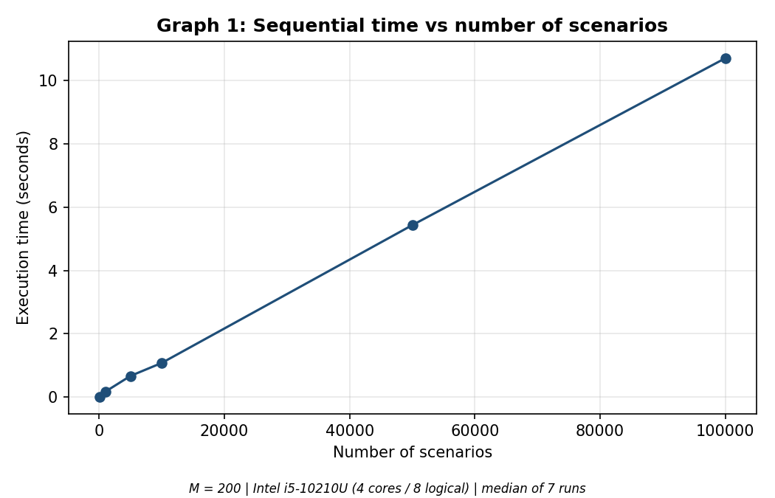  Figure 1: Sequential execution time vs number of scenarios (M = 200, Intel i5-10210U, median of 7 runs) | 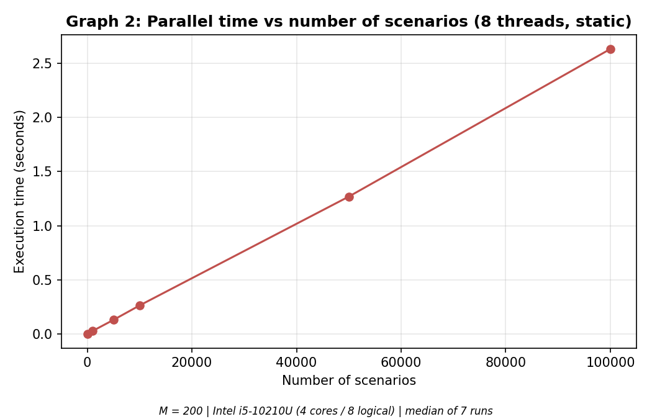  Figure 2: Parallel execution time vs number of scenarios, 8 threads (M = 200, Intel i5-10210U, median of 7 runs)
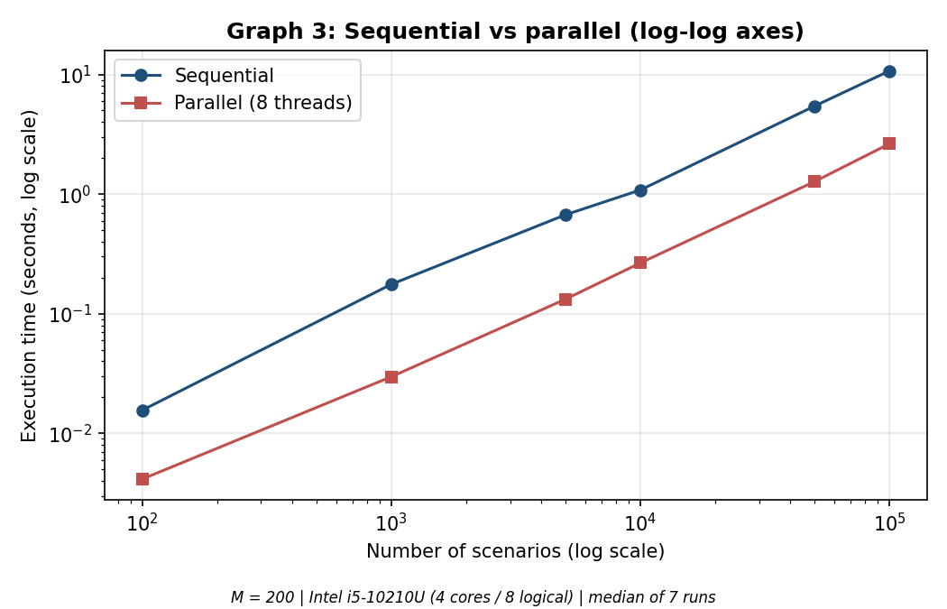  Figure 3: Sequential vs parallel execution time, log-log axes (M = 200, Intel i5-10210U, median of 7 runs) | 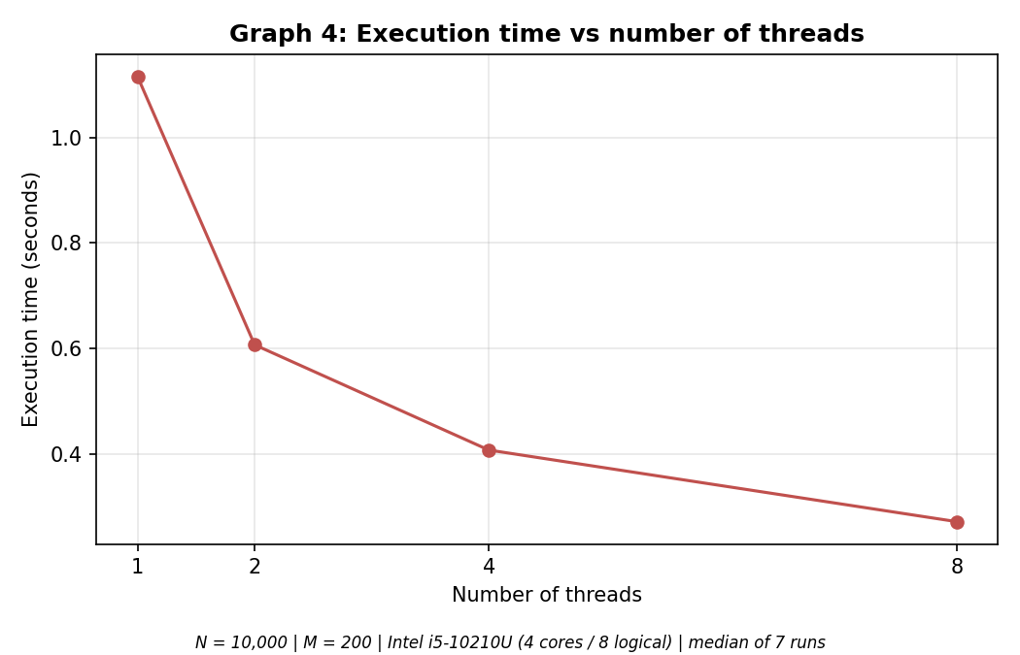  Figure 4: Execution time vs number of threads, N = 10,000 (M = 200, Intel i5-10210U, median of 7 runs)
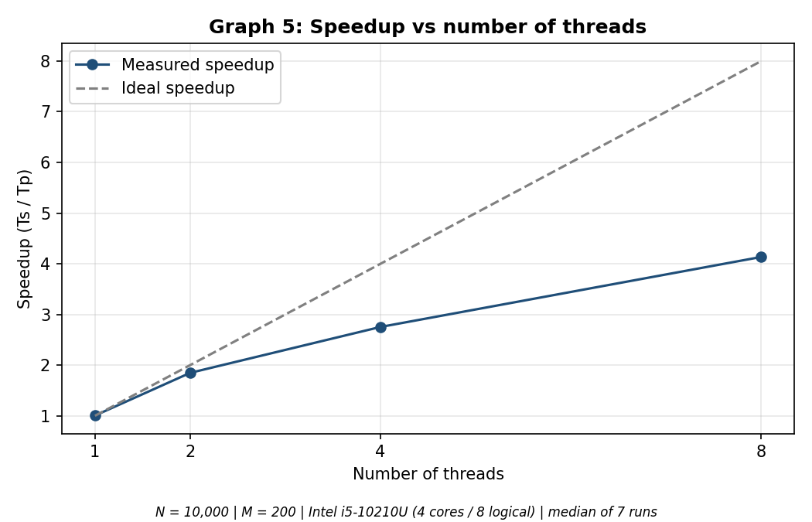  Figure 5: Speedup vs number of threads with ideal line, N = 10,000 (M = 200, median of 7 runs) | 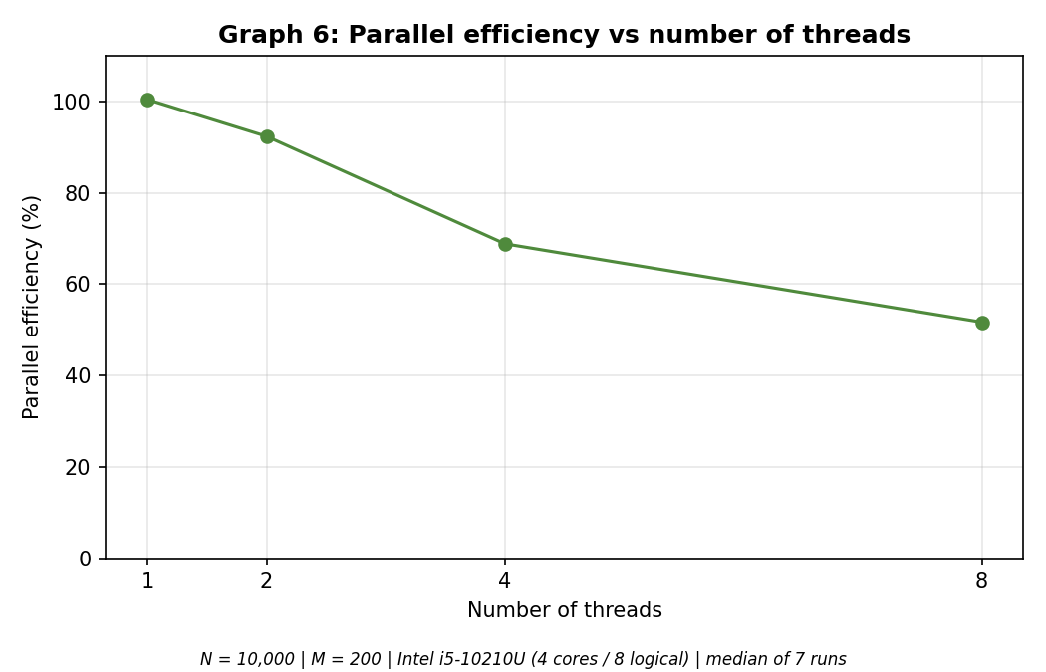  Figure 6: Parallel efficiency vs number of threads, N = 10,000 (M = 200, median of 7 runs)
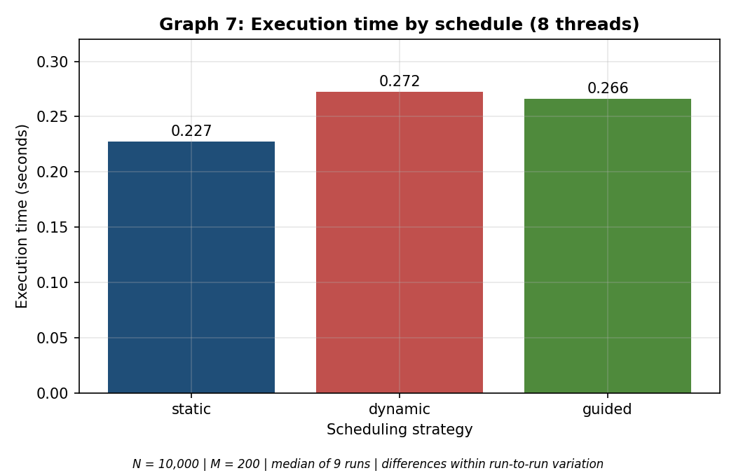
Figure 7: Execution time by schedule, N = 10,000, 8 threads (M = 200, median of 9 runs)

14. Speedup Analysis
- Execution time grows roughly linearly with the number of scenarios. Sequentially, 50,000 scenarios took 5.43 s and 100,000 took 10.70 s, about twice as long for twice the work. The parallel times (1.27 s and 2.63 s) show the same pattern.
- For N of 10,000 and above, the speedup on 8 threads is about 4.1 to 4.3 times (4.07, 4.28, 4.07). These three values are close together, so this figure looks stable.
- The speedup for smaller N is higher in some rows (5.93 at N = 1,000, 5.08 at N = 5,000). We did not investigate why, and with run-to-run variation this large, it should not be over-interpreted.
- Parallel execution was faster at every tested size, including N = 100 (3.77 times). Each scenario is expensive, so the cost of starting threads is small compared with the work. Only N of 100 and above was tested, so a point where parallel execution becomes slower may exist for much smaller N. This was not tested.
- The 1-thread OpenMP run took 1.115 s against 1.120 s sequentially, a difference of about 0.4%. The overhead of the OpenMP loop itself is therefore small in this program.

14.1 Sequential vs parallel at N = 10,000
The table compares the two versions on the same 10,000 scenarios, using the sequential time and the 8-thread time from the thread experiment (Section 12.2).
At N = 10,000 | Sequential | Parallel, 8 threads
Execution time | 1.120 s | 0.271 s
Speedup | 1.00 | 4.13 times faster
Parallel efficiency | 100% | 51.7%
Time saved | — | 0.849 s (75.8% less)
Class counts (REC / ACC / REJ) | 3333 / 2102 / 4565 | 3333 / 2102 / 4565
Individual results | Reference | Identical

15. Parallel Efficiency Analysis
Efficiency fell as threads were added: 100% at 1 thread, 92% at 2, 69% at 4 and 52% at 8 threads. Scaling is close to ideal up to 2 threads and weakens afterwards. Doubling from 4 to 8 threads reduced the time from 0.407 s to 0.271 s, a gain of about 1.5 times, not 2 times. Figure 5 shows the gap between measured and ideal speedup. Possible causes are discussed in Section 17.

15.1 Analysis with different numbers of threads (N = 10,000)
The table extends Section 12.2 with columns calculated from the measured times (sequential time 1.120088 s).
Threads | Time (s) | Time saved vs sequential | Gain over previous count | Speedup | Efficiency
1 | 1.115225 | 0.005 s (0.4%) | — | 1.00 | 100.4%
2 | 0.606436 | 0.514 s (45.9%) | 1.84 times | 1.85 | 92.4%
4 | 0.406853 | 0.713 s (63.7%) | 1.49 times | 2.75 | 68.8%
8 | 0.270914 | 0.849 s (75.8%) | 1.50 times | 4.13 | 51.7%

- 1 thread: The time equals the sequential time within about 0.4%, so the OpenMP loop itself adds almost no overhead.
- 2 threads: Doubling from 1 to 2 threads gives a gain of 1.84 times, close to the ideal 2 times (efficiency 92%).
- 4 threads: Doubling from 2 to 4 threads gives only 1.49 times (efficiency 69%). The drop starts here, although the CPU has 4 physical cores, so hyper-threading is not the only effect involved. The cause was not measured (Section 17).
- 8 threads: Doubling from 4 to 8 threads gives 1.50 times instead of 2. The extra four threads are hyper-threads that share the execution units of the four physical cores, so a gain of about 50% is consistent with the 4-core, 8-thread layout.
- Compared with the core count: The 8-thread speedup of 4.13 is only slightly above the 4 physical cores, consistent with the hardware limit (not directly proven).

15.2 Overhead fraction (Karp–Flatt metric)
To describe the loss of scaling with one number per thread count, the Karp–Flatt metric e = (1/S − 1/p) / (1 − 1/p) was calculated from the measured speedups S. It is derived from the table above and is not a separate measurement. A value of 0 means ideal scaling, and a larger value means a larger share of the run that does not get faster with more threads. The values are 0.083 at 2 threads (S = 1.847), 0.151 at 4 threads (S = 2.753) and 0.134 at 8 threads (S = 4.134).
The value rises from 2 to 4 threads and does not rise further at 8 threads, so adding hyper-threads did not make the scaling worse than at 4 threads. The timed loop has no critical sections or shared writes, so this share is not a serial section of code. It is consistent with the hardware effects listed in Section 17 (shared cores, clock speed and background load), but the data does not prove which of them is the cause.

15.3 Choosing the number of threads
On this machine 8 threads give the shortest time (0.271 s, 4.13 times faster) and use all logical processors, so they are best when the aim is minimum execution time. 4 threads (one per physical core) give a speedup of 2.75 at 69% efficiency, a reasonable choice if the processor must stay partly free for other work. 2 threads are the most efficient (92%) but leave most of the CPU idle, and 1 thread gives no benefit over the sequential program.

16. Scheduling Analysis

16.1 The three strategies
- static: iterations are divided into equal blocks before the loop starts. It has the lowest overhead and works well when every iteration costs about the same.
- dynamic: a thread takes the next chunk when it finishes its current one. It balances uneven work better but has more scheduling overhead. Here the chunk size is 1.
- guided: chunks start large and shrink as the loop progresses, which gives a balance between overhead and load balancing. Here the minimum chunk size is 1.

16.2 Result
Because T varies from 1 to 30 years, the cost of scenarios is uneven, so dynamic or guided scheduling might have helped. In our measurements static was fastest (0.227 s) compared with guided (0.266 s) and dynamic (0.272 s).
However, the same configuration (N = 10,000, 8 threads, static) measured 0.265 s, 0.271 s and 0.227 s in three separate experiment runs, and an earlier noisy attempt varied by up to about 35%. The differences between schedules are therefore comparable to run-to-run variation. We cannot claim that any schedule is better, and our data does not show that dynamic or guided balanced the load better. Chunk sizes other than 1 were not tested.

17. Bottleneck Analysis
The speedup on 8 threads (about 4 times) is well below 8. We separate what the data supports from what it does not.

17.1 Observed
Efficiency decreases as threads increase, and speedup flattens at about 4 times on 8 threads.

17.2 Consistent with the data, but not proven
- The CPU has 4 physical cores and 8 logical processors (hyper-threading). Two threads on one core share its execution units, so 8 threads cannot give 8 times the speed of one. A speedup of about 4 on 8 threads is consistent with this.
- The i5-10210U is a low-power laptop processor, and its clock speed can drop under sustained load on all cores. The clock speed was not recorded during the runs.
- Background applications (memory usage about 85%) compete for the CPU and add run-to-run noise.

17.3 Considered unlikely, with reasoning
- Synchronization: the timed loop has no critical sections or shared writes.
- Thread creation overhead: the 1-thread OpenMP run matches the sequential time within about 0.4%, and parallel was faster even at N = 100.
- False sharing: threads write whole result structures to different array slots, so only elements at chunk boundaries could share a cache line. This was not measured directly.

17.4 Not measured
Load imbalance, memory bandwidth, cache behaviour and the CPU clock speed during runs were not measured. Without a profiler or hardware counters, we do not claim any of these as the cause. Experiments that would help: a run with 4 threads pinned to physical cores, dynamic and guided with larger chunk sizes, and a profiler such as Intel VTune.

18. Limitations
- Only one machine (a laptop with 8 GB RAM) was tested.
- Laptop timings vary from run to run because of power, thermal behaviour and background applications. An earlier benchmark attempt gave unreliable rows (an impossible efficiency of 114% at N = 50,000 and inconsistent sequential times). It was discarded and rerun with the laptop plugged in, “Best performance” power mode and more repeats.
- N goes up to 100,000 and M is 200, not millions of scenarios, because each scenario runs M paths over T years.
- The cause of the efficiency drop was not separated into hyper-threading, clock speed or other factors.
- The thread study (1, 2, 4 and 8 threads) was done at N = 10,000 only, and the scenario-count study at 8 threads only, so thread scaling at other values of N was not measured.
- Schedule differences are within measurement noise, and dynamic and guided were only tested with chunk size 1.
- N below 100 was not tested, so a possible crossover where parallel is slower was not found.
- MPI and CUDA were not tested.

19. Conclusion
We built a Monte Carlo based system that evaluates many independent financial scenarios and classifies each as RECOMMENDED, ACCEPTABLE or REJECTED. A sequential version and an OpenMP version were implemented using the same evaluation function. The parallel version produced identical class counts and identical individual results to the sequential version in all 12 tested thread and schedule configurations on three datasets, and the floating-point sums differed only in the last digits.
Execution time grew roughly linearly with the number of scenarios. On the 4-core, 8-thread laptop, OpenMP gave a speedup of about 4.1 to 4.3 times with 8 threads for N of 10,000 and above, with efficiency falling from 100% (1 thread) to 52% (8 threads). This is consistent with the CPU having 4 physical cores, though this was not directly proven. Parallel execution was faster at every size tested (N from 100 to 100,000). No scheduling strategy was shown to be better than the others, because the differences were within run-to-run variation.
OpenMP data parallelism suits this problem because scenarios are independent and the machine uses shared memory.

19.1 How the problem statement is solved
The table links each part of the problem statement to the section that addresses it and the result obtained.
Requirement | Where | Result
Evaluate a large number of scenarios by specified criteria | Sections 5, 6 | Monte Carlo evaluation, classified as RECOMMENDED, ACCEPTABLE or REJECTED (N = 100,000: 33,903 / 20,752 / 45,345)
Sequential solution (baseline) | Section 6 | Time O(N × M × T); Ts = 10.70 s for N = 100,000
Parallel solution and choice of model | Sections 7, 8 | OpenMP data parallelism with one parallel for loop; MPI and CUDA not used, with reasons
Same results from both versions | Section 9 | 12 of 12 configurations identical on three datasets
Time against the number of scenarios | Sections 12.1, 14 | Roughly linear growth; speedup about 4.1 to 4.3 on 8 threads for N of 10,000 and above
Time against the number of threads (1, 2, 4, 8) | Sections 12.2, 15 | Time 1.115 s to 0.271 s; efficiency 100% to 52%
Scheduling strategy | Sections 12.3, 16 | Differences within run-to-run variation
Bottlenecks | Section 17 | Consistent with 4 physical cores and 8 logical processors; not directly proven

In short, the OpenMP version solves the same problem as the sequential baseline with identical results, about 4.1 to 4.3 times faster on 8 threads for N of 10,000 and above.

20. Future Scope
- Test N below 100 to look for a point where parallel execution becomes slower.
- Measure thread scaling (1, 2, 4 and 8 threads) at several values of N, not only at N = 10,000, to see whether the efficiency curve changes with problem size.
- Use a larger M and larger N on a machine with more memory.
- Tune chunk sizes for dynamic and guided scheduling.
- Use a profiler or hardware counters to identify the real bottleneck.
- Run on a machine with more physical cores.
- Compare with an MPI or CUDA implementation on suitable hardware.

21. References
- OpenMP Architecture Review Board, OpenMP Application Programming Interface specification, https://www.openmp.org
- GNU Compiler Collection (GCC) documentation, https://gcc.gnu.org/onlinedocs/
- Project repository: https://github.com/dhanashriukeskar/Financial-Scenario-Analysis

22. LLM Usage
An AI assistant was used during development for drafting code, explaining concepts, debugging help and documentation. Every piece of AI-generated code was compiled, tested and verified against the sequential output (17 unit tests, fc.exe comparison of per-scenario results, and the 12-configuration verify program) before it was used.
Two examples of AI suggestions that were not used as given: a closed-form NPV model was suggested, but it was not used because the team's Monte Carlo design was kept; and an fc command for comparing CSV files failed in PowerShell (where fc is an alias for Format-Custom), so it was replaced with fc.exe.

