CSA02 – ASSIGNMENT 1
Grama Jyothi Rural Electricity Co-operative
Name: S Dhana Sri
Register Number: 19252620062
Course: CSA0209
GitHub Repository Link:

TASK 1 – Understand the Problem and Identify the Data (4 Marks)

1.1 Problem Analysis
Grama Jyothi calculates electricity bills using previous and current meter readings. The program calculates consumption, applies the correct tariff slabs, adds the fixed charge, and produces an accurate bill. It must also handle a 16-bit meter register rolling over from 65535 to 0.

Input Data
Data item | Description and justification
Household number | Unique identifier used to connect readings and the bill to the correct household.
Previous reading | The earlier meter reading, needed to calculate units consumed.
Current reading | The latest reading, used with the previous reading to calculate consumption.
Category | Identifies the consumer or tariff category if categories have different rates.
Tariff rates and fixed charge | Required to calculate the energy charge and final bill.

Output Data
Data item | Description and justification
Units consumed | Electricity used during the billing period.
Energy charge | Charge calculated using the slab rates.
Fixed charge | Fixed amount added to the energy charge.
Total bill | Final payable amount: energy charge plus fixed charge.

Constants
- SLAB1_UNITS = 100: the first 100 units are free.
- SLAB2_UNITS = 200: marks the end of the second slab.
- RATE1_PAISE = 0, RATE2_PAISE = 225, RATE3_PAISE = 450.
- FIXED_CHARGE_PAISE = 5000, equal to Rs 50.00.

Values and Correctness Rules
- Valid consumption must not be negative. A negative result may indicate incorrect rollover handling.
- Money can contain fractional rupees, so store it as integer paise to avoid floating-point rounding.
- District totals can be large with 800,000 households; use a sufficiently wide integer type and check for overflow.
- The total bill must equal the energy charge plus the fixed charge.
- The correct tariff must be applied to each slab, and bills must be accurate to the paisa.
- Invalid readings and categories should be rejected instead of silently producing an incorrect bill.

Assumptions
- The meter is a 16-bit unsigned counter with readings from 0 to 65535.
- The meter may roll over from 65535 to 0; readings are assumed to span at most one rollover.
- The first 100 units are free, units 101–200 cost Rs 2.25 each, and units above 200 cost Rs 4.50 each.
- The fixed charge is Rs 50 per billing period.
- All monetary calculations use integer paise.
- The examples use one common tariff; if categories have different tariffs, rates must be selected by category.

Alternative Concept: Store Readings as Strings
A reading such as 01530 can be stored as the string "01530". The program converts each digit into an integer before arithmetic. This preserves leading zeros but adds conversion work.
char reading[] = "01530";
int value = 0;
for (int i = 0; reading[i] != '\0'; i++) {
value = value * 10 + (reading[i] - '0');
}
printf("%d\n", value); /* 1530 */
Feature | Integer representation | String representation
Conversion time | No conversion needed | O(d), where d is the number of digits
Comparison | O(1) for fixed-width integers | O(d) worst case
Space per reading | Fixed size; commonly 2 bytes for 16-bit reading | Approximately d + 1 bytes including terminator
Arithmetic | Direct arithmetic | Convert before arithmetic
Leading zeros | Not preserved | Preserved

Conclusion: Integer storage is preferable for billing calculations. Strings are useful when the original text format or leading zeros must be preserved.

TASK 2 – Choose the Data Types (4 Marks)

2.1 Data Type Selection
Data item | Suggested type | Reason
Household number | unsigned int | Non-negative identifier.
Previous/current reading | typedef unsigned short meter_t | Suitable for a 16-bit register, commonly 0–65535.
Units consumed | unsigned int | Consumption is non-negative.
Category | enum | Represents a fixed set of categories.
Tariff rate | long or unsigned int | Stores integer paise rates.
Fixed charge | long | Stores the fixed charge in paise.
Energy charge / total bill | long long | Provides additional range for monetary totals.
District-wide total | long long | Can accumulate large totals, subject to overflow checks.

2.2 Typical Sizes and Ranges
Exact sizes depend on the compiler and platform. Common sizes are: char 1 byte; short and unsigned short 2 bytes; int and unsigned int 4 bytes; long 4 bytes on Windows and commonly 8 bytes on 64-bit Linux; long long 8 bytes; float 4 bytes; double 8 bytes. float usually has 6–7 decimal digits of precision and double about 15–16. Check your own system with sizeof, limits.h, and float.h.
#include <stdio.h>
#include <limits.h>
#include <float.h>
int main(void) {
printf("char: %zu byte\n", sizeof(char));
printf("short: %zu bytes\n", sizeof(short));
printf("unsigned short: %zu bytes\n", sizeof(unsigned short));
printf("int: %zu bytes\n", sizeof(int));
printf("unsigned int: %zu bytes\n", sizeof(unsigned int));
printf("long: %zu bytes\n", sizeof(long));
printf("long long: %zu bytes\n", sizeof(long long));
printf("float: %zu bytes\n", sizeof(float));
printf("double: %zu bytes\n", sizeof(double));
printf("USHRT_MAX = %u\n", (unsigned)USHRT_MAX);
printf("INT_MAX = %d\n", INT_MAX);
printf("UINT_MAX = %u\n", UINT_MAX);
printf("LLONG_MAX = %lld\n", LLONG_MAX);
printf("FLT_DIG = %d, DBL_DIG = %d\n", FLT_DIG, DBL_DIG);
return 0;
}
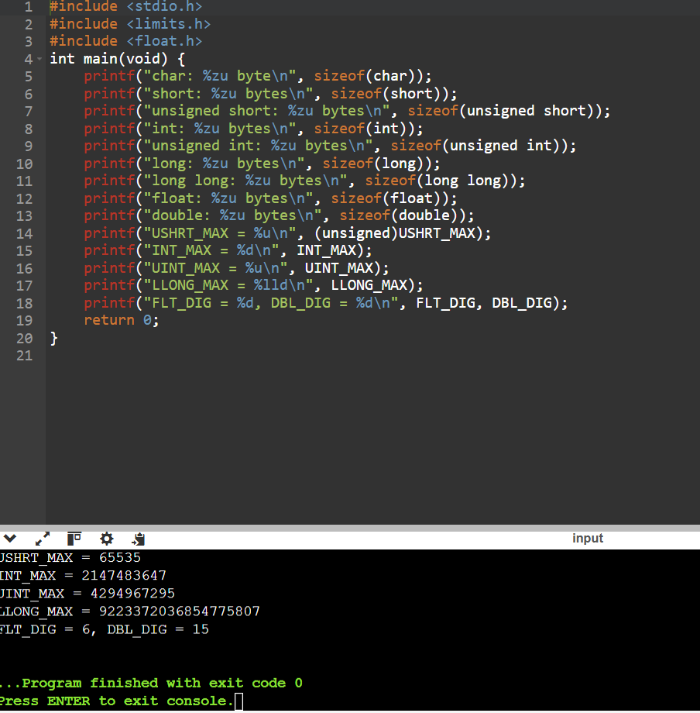
Compile: gcc -std=c11 -Wall -Wextra types.c -o types. Run with ./types (or types.exe on Windows). Record the actual output from your computer.

2.3 Complete the Code: Meter Rollover
#include <stdio.h>
#include <limits.h>
typedef unsigned short meter_t;
unsigned int consumption(meter_t previous, meter_t current)
{
return (meter_t)(current - previous);
}
int main(void)
{
printf("sizeof(meter_t) = %zu bytes, maximum reading = %u\n",
sizeof(meter_t), (unsigned)USHRT_MAX);
printf("Consumption: %u units\n", consumption(1200, 1530));
printf("Consumption: %u units\n", consumption(65400, 120));
return 0;
}

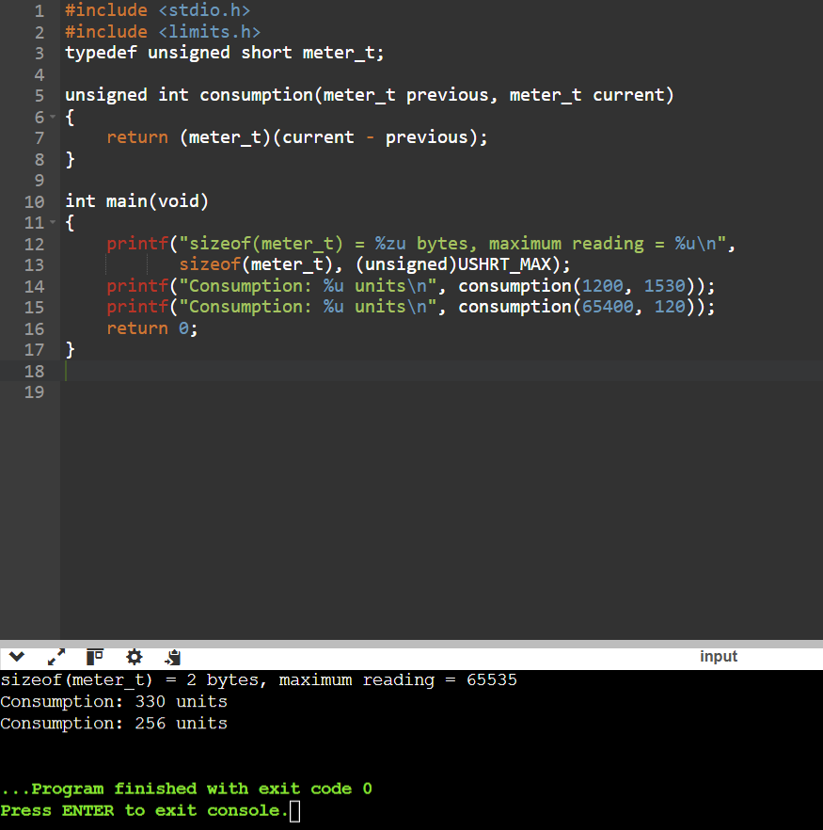

Expected Output
sizeof(meter_t) = 2 bytes, maximum reading = 65535
Consumption: 330 units
Consumption: 256 units
For the first example, 1530 − 1200 = 330. For the rollover example, (65535 − 65400) + 1 + 120 = 256. Conversion to the unsigned 16-bit meter type applies arithmetic modulo 65536, so the result is not negative. This assumes no more than one rollover between readings.

2.4 Why Not Store Money as float?
#include <stdio.h>
int main(void)
{
float total = 0.0f;
long total_paise = 0;
for (int i = 0; i < 4000; i++) {
total += 0.1f;
total_paise += 10;
}
printf("Float total: %.7f rupees\n", total);
printf("Integer total: %ld paise\n", total_paise);
printf("Integer total: Rs %ld.%02ld\n",
total_paise / 100, total_paise % 100);
return 0;
}

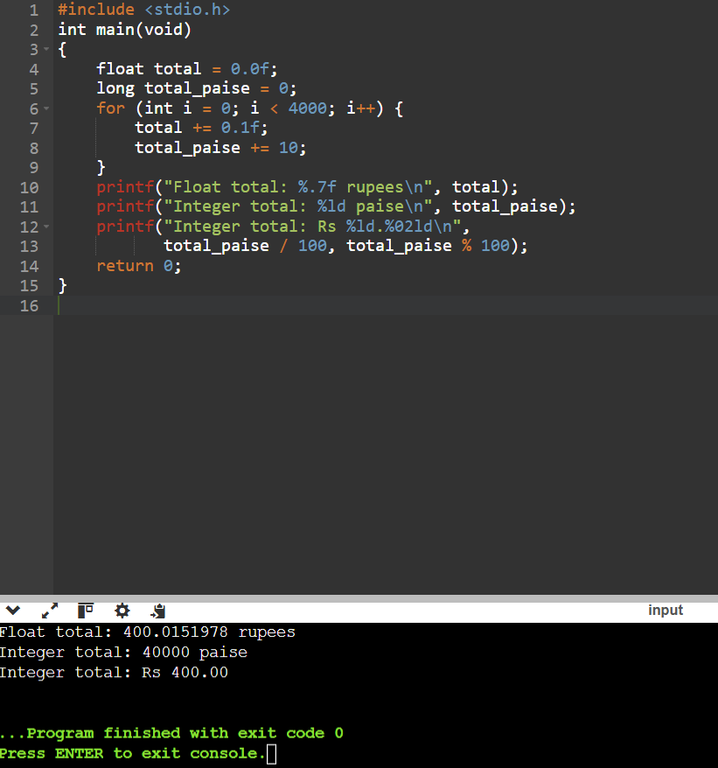
The integer calculation gives exactly 40000 paise, or Rs 400.00. A float may give a slightly different result because decimal fractions such as 0.1 cannot generally be represented exactly in binary floating-point.

Alternative Concept: double Rupees
Feature | Integer paise | double rupees
Addition time | O(1) | O(1)
Typical space | long long: 8 bytes | double: 8 bytes
Exact whole-paisa values | Yes, within integer range | Not guaranteed for every decimal fraction
Rounding | Usually not needed during calculation | May be needed when finalizing/displaying a bill
Accumulated error | No fractional rounding error if no overflow occurs | Small floating-point errors may accumulate

Adding n bills to a running total takes O(n) time and O(1) extra space. Storing all n bills requires O(n) space.

TASK 3 – Define the Constants (3 Marks)

3.1 Completed Billing Program
#include <stdio.h>
#define SLAB1_UNITS 100
#define SLAB2_UNITS 200
#define RATE1_PAISE 0
#define RATE2_PAISE 225
#define RATE3_PAISE 450
#define FIXED_CHARGE_PAISE 5000L
long compute_bill(int units)
{
long paise = FIXED_CHARGE_PAISE;
if (units > SLAB2_UNITS) {
paise += (long)(units - SLAB2_UNITS) * RATE3_PAISE;
units = SLAB2_UNITS;
}
if (units > SLAB1_UNITS) {
paise += (long)(units - SLAB1_UNITS) * RATE2_PAISE;
}
/* The first 100 units are free. */
return paise;
}
int main(void)
{
int tests[] = {0, 100, 150, 200, 350};
int n = sizeof tests / sizeof tests[0];
for (int i = 0; i < n; i++) {
long p = compute_bill(tests[i]);
printf("%3d units -> Rs %ld.%02ld\n",
tests[i], p / 100, p % 100);
}
return 0;
}
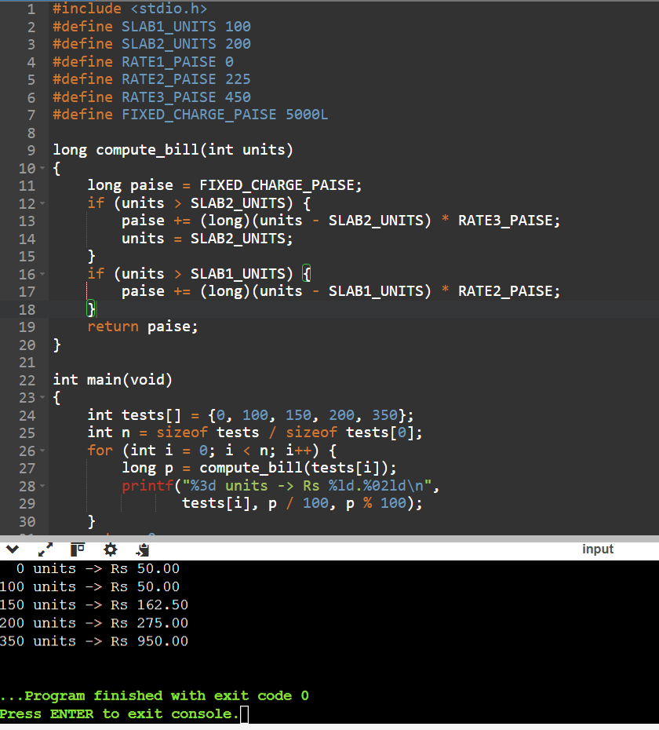

Expected Output
0 units -> Rs 50.00
100 units -> Rs 50.00
150 units -> Rs 162.50
200 units -> Rs 275.00
350 units -> Rs 950.00

3.2 Tariff Revision
Change #define RATE2_PAISE 225 to #define RATE2_PAISE 230, then recompile and run. Expected revised output:
0 units -> Rs 50.00
100 units -> Rs 50.00
150 units -> Rs 165.00
200 units -> Rs 280.00
350 units -> Rs 955.00

3.3 #define, const, and enum
Feature | #define | const | enum
Purpose | Preprocessor replacement | Read-only object | Named integer constants
Type checking | No inherent type | Declared type | Integer constant
Scope | Preprocessor-controlled | C scope rules | C scope rules
Debugger visibility | Usually no separate object | May be visible as an object | Depends on compiler debug information
Storage | Macro itself uses no storage | Stored object may use memory | Enumerator values need no separate objects
Runtime overhead | None from replacement itself | Usually none for simple constant | None for enumerator itself

For tariff configuration, #define allows values to be revised in one place. const is useful for a typed read-only object. enum is suitable for named integer options such as consumer categories. Production code should validate input and check for overflow.

TASK 4 – Use Macros Safely (4 Marks)

4.1 Program Using Macros
#include <stdio.h>
#define RUPEES_TO_PAISE(r) ((r) * 100)
#define SQUARE(x) ((x) * (x))
#define MAX(a, b) (((a) > (b)) ? (a) : (b))
int main(void)
{
int a = 5;
int b = 8;
printf("5 rupees = %d paise\n", RUPEES_TO_PAISE(5));
printf("Square of 5 = %d\n", SQUARE(a));
printf("Square of a + 1 = %d\n", SQUARE(a + 1));
printf("Maximum value = %d\n", MAX(a, b));
return 0;
}
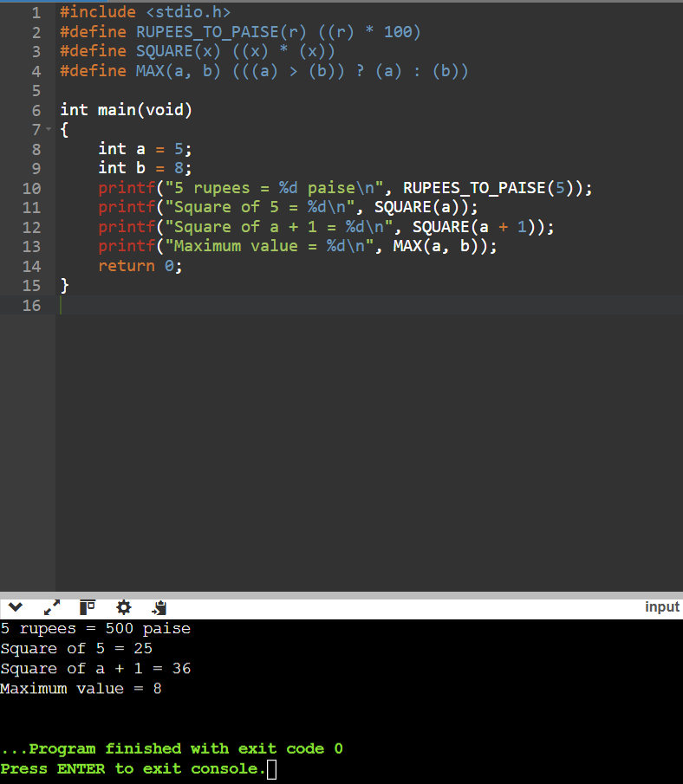

Expected Output
5 rupees = 500 paise
Square of 5 = 25
Square of a + 1 = 36
Maximum value = 8

4.2 Macro Parentheses and Pitfalls
An unsafe definition, #define SQUARE(x) x * x, called as SQUARE(5 + 1), expands to 5 + 1 * 5 + 1 and evaluates to 11 because multiplication has higher precedence than addition. The safe definition #define SQUARE(x) ((x) * (x)) expands to ((5 + 1) * (5 + 1)) and returns 36.
MAX(a, b) can evaluate an argument more than once. For example, MAX(i++, j) expands with i++ in both the comparison and the selected expression. This can change i unexpectedly. Prefer a function when arguments may have side effects.

4.3 View Preprocessor Output
Run these commands in the folder containing macros.c:
gcc -E macros.c -o macros.i
cat macros.i # Linux
type macros.i # Windows Command Prompt
# Or print preprocessed source directly:
gcc -E -P macros.c
The preprocessed output contains expressions similar to ((5) * 100), ((a + 1) * (a + 1)), and (((a) > (b)) ? (a) : (b)). Capture a screenshot of your own terminal output.

4.4 Alternative: static inline Functions
#include <stdio.h>
static inline int rupees_to_paise(int rupees) { return rupees * 100; }
static inline int square(int x) { return x * x; }
static inline int max_value(int a, int b) { return (a > b) ? a : b; }
int main(void)
{
int a = 5, b = 8;
printf("5 rupees = %d paise\n", rupees_to_paise(5));
printf("Square of 5 = %d\n", square(a));
printf("Square of a + 1 = %d\n", square(a + 1));
printf("Maximum value = %d\n", max_value(a, b));
return 0;
}
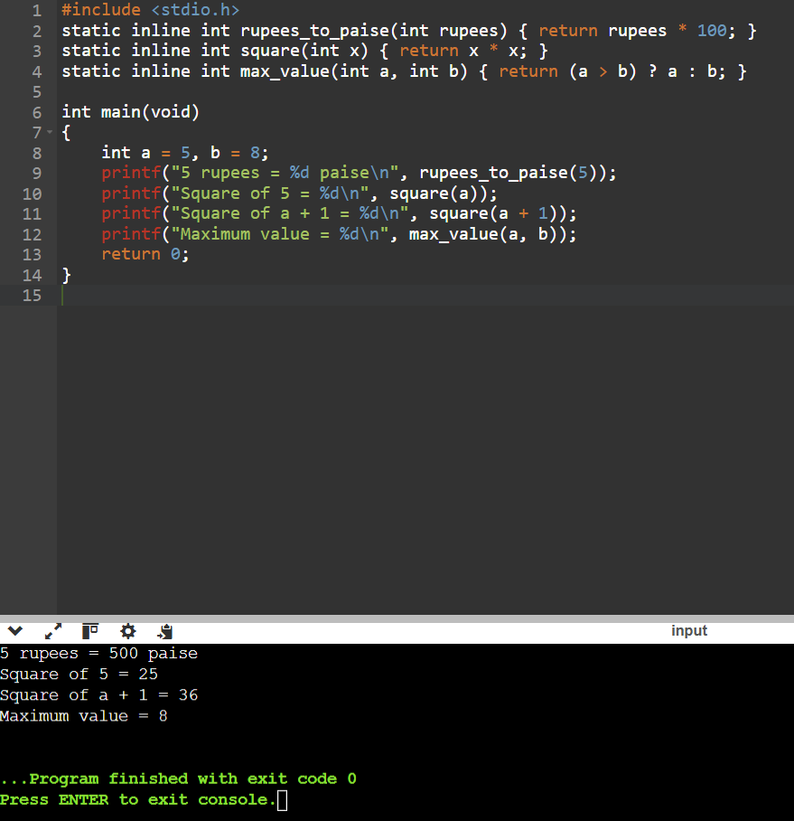
Feature | Macro | static inline function
Time per simple calculation | Usually O(1) | Usually O(1)
Type checking | No inherent parameter type checking | Parameter types are checked
Argument evaluation | May evaluate arguments multiple times | Each argument expression is evaluated once per call
Code size | Expansion may duplicate code at each use | Compiler may reuse the body or inline it
Debugging | Can be harder | Usually easier

If a macro is used k times, expanded code can occupy O(k) total space for a fixed-size expression. A function may keep one copy of its body, although compiler optimization can change the final code size. static inline functions are generally safer for typed calculations and arguments with side effects.

GitHub Submission Checklist
- Create repository named CSA02-<RegisterNumber>-Assignment1.
- Create one folder for each task, such as Task01, Task02, Task03, and Task04.
- Include source code, input files if applicable, and actual output screenshots.
- Include README.md with name, register number, compiler/version, compile commands, run steps, and a short result note for each task.
- Make at least one commit for each task and push commits progressively.
- Share the repository with faculty as public or private with faculty added as a collaborator.
- Put the working GitHub link on the report cover page and in README.md.

Suggested README.md Template
# CSA02 – Assignment 1
## Student Details
- Name: [Your Name]
- Register Number: [Your Register Number]
- Course: CSA02
- Submission Date: 27-10-2026
- GitHub Repository: [Paste link]
## Compiler Details
- Compiler: GCC
- Version: [Output of gcc --version]
- Language: C
## Task 1 – Problem Analysis
Analysed inputs, outputs, constants, rules, assumptions, and string representation.
## Task 2 – Data Types
Tested type sizes, limits, integer paise, and meter rollover.
Compile: gcc -std=c11 -Wall -Wextra meter.c -o meter
Run: ./meter (Windows: meter.exe)
## Task 3 – Constants
Tested slab-based billing and tariff revision.
Compile: gcc -std=c11 -Wall -Wextra billing.c -o billing
Run: ./billing (Windows: billing.exe)
## Task 4 – Safe Macros
Tested macro expansion and compared macros with inline functions.
Compile: gcc -std=c11 -Wall -Wextra macros.c -o macros
Run: ./macros (Windows: macros.exe)
Preprocess: gcc -E -P macros.c
## Results
- Task 1: Analysed electricity billing data and rules.
- Task 2: Tested types and meter rollover.
- Task 3: Tested tariff slabs and tariff changes.
- Task 4: Tested safe macros and inline functions.
Final note: Replace all placeholders with your details. Run each program on your computer, verify the outputs, record your actual GCC version and sizeof results, and insert your own screenshots before submitting.

