Machine Learning-Based Landslide Susceptibility Mapping on Nepal's Arniko Highway: Addressing Spatial Autocorrelation Leakage and Safety-Critical Decision Support
Dhan Bahadur Gurung
ST7072CEM Machine Learning
Department of Computing, Softwarica College of IT & E-Commerce (In Collaboration with Coventry University)
Kathmandu, Nepal | Student ID: 17624480

Abstract—Every monsoon between June and September, landslides repeatedly block Nepal's mountain highways, severing freight routes and endangering travelers. The Arniko Highway (NH03) is particularly vulnerable, running 114 km through the steep river gorges of Sindhupalchok between Dhulikhel and the northern border at Kodari/Tatopani. While historical disaster records exist—such as the 2014 Jure collapse and 2015 earthquake damage—field maintenance remains mostly reactive. Applying machine learning to road-corridor hazard screening offers a proactive alternative, but published studies often suffer from two major flaws: they split spatial data randomly, which leaks spatial autocorrelation and inflates validation scores, and they optimize for overall accuracy rather than safety-critical recall.
In this paper, we evaluate a road-scale landslide susceptibility pipeline along the entire 114 km Arniko corridor. We divided the road into 1,200 sequential 100 m analysis units and matched them to 481 field-mapped landslide events from the British Geological Survey (BGS) and NASA catalogs, 30 m SRTM elevation data, fault proximities, and monsoon rainfall. We trained three models—class-weighted Logistic Regression, Random Forest, and XGBoost—on the lower 75 km (Sectors 1 and 2) and tested them on the rugged, held-out Upper Arniko sector (Barhabise to Kodari, km 75–114).
Across the 411 held-out road units, class-weighted Logistic Regression caught 123 of 124 landslide-affected units, reaching 99.2% Recall (95% bootstrap CI: [0.975, 1.000]) and missing only one hazard. Although Random Forest and XGBoost delivered slightly better precision (0.310 vs. 0.304) and PR-AUC (0.345 vs. 0.300), their 7 missed hazards represent an unacceptable safety risk for primary screening. In addition, we measured spatial data leakage directly: standard random 3-fold cross-validation yielded an inflated ROC-AUC of 0.820 ± 0.019, whereas spatial block cross-validation dropped to 0.669 ± 0.107—a +0.150 AUC gap illustrating how random splits memorize spatial proximity rather than geological drivers. SHAP attributions showed that predictions are primarily driven by steep slope angles, proximity to the Main Central Thrust, and monsoon rainfall. Finally, we deployed these predictions in an interactive Streamlit GIS prototype and continuous chainage profiles to support highway maintenance planning for the Department of Roads.
Index Terms—Landslide Susceptibility Mapping, Arniko Highway, Spatial Autocorrelation Leakage, Spatial Block Cross-Validation, Machine Learning, Safety-Critical Classification, SHAP Interpretability, Disaster Risk Reduction, Softwarica College, Coventry University.
I. INTRODUCTION
A. Background and Physiographic Setting
Maintaining mountain roads in the Himalayas is an ongoing struggle against steep slopes, unstable geology, and intense rainfall. In Nepal, young tectonic uplift, deeply incised valleys, and heavy summer monsoons trigger thousands of slope failures every year. For strategic highways, these landslides do more than disrupt local traffic—they sever regional supply lines, cut off rural communities from emergency health services, and stall cross-border trade.
The Arniko Highway (designated National Highway NH03, formerly NH34) is an important case study. Extending 114 kilometers from Dhulikhel on the eastern rim of the Kathmandu Valley (~1,550 m elevation) to the border township of Kodari/Tatopani (~1,770 m), the road runs along the narrow river gorges of the Sun Koshi and Bhote Koshi in Sindhupalchok district [1], [2].
Geologically, the road corridor cuts through an active collision zone where the Indian tectonic plate underthrusts Eurasia at 18–20 mm per year. This constant tectonic squeezing has fractured the bedrock, generating dense fault systems—most prominently the Main Central Thrust (MCT) zone—and leaving slopes composed of sheared, highly weathered phyllites, schists, and banded gneisses [2]. When natural slope angles exceed 40 to 50 degrees, undercut by river incision and saturated by more than 2,500 mm of annual rainfall (over 80% falling between June and September), slopes along the highway sit on the edge of failure.
Recent disaster history illustrates the scale of this hazard. In August 2014, the massive Jure landslide sent over 5.5 million cubic meters of debris crashing down the valley, burying a 1.5 km road section, killing 156 people, damming the Sun Koshi River, and shutting down transport for weeks [2]. Nine months later, the April 2015 Mw 7.8 Gorkha earthquake and its May Mw 7.3 aftershock centered in Sindhupalchok triggered thousands of landslides along the highway, tearing away roadbeds, wrecking retaining walls, and closing the border crossing for months [3], [4].
B. Problem Statement
Despite this well-documented history, slope maintenance along the Arniko Highway is almost entirely reactive. When a slide occurs, the Department of Roads (DoR) and the Nepal Army mobilize bulldozers and excavators to push debris aside and clear a single lane. While emergency clearing is necessary, it provides no insight into which unmapped sections are likely to fail during the next monsoon cycle.
Predictive Landslide Susceptibility Mapping (LSM) can help authorities prioritize stabilization before failure occurs. However, examining published machine learning papers in Nepal reveals three common methodological shortcomings:
1) The Spatial Autocorrelation Leakage Fallacy:
Standard machine learning workflows partition tabular data into training and test sets by random sampling. In geospatial problems, however, nearby locations share similar slope, bedrock, and weather, following Tobler's First Law of Geography [19]. When adjacent 100-meter road segments end up on both sides of a random split, the algorithm easily memorizes local spatial neighborhoods rather than learning generalizable geomorphic rules. This creates heavily inflated test metrics (such as ROC-AUC > 0.85) that break down as soon as the model is applied to an unseen mountain valley.
2) Cost Asymmetry in Safety-Critical Road Settings:
Most machine learning benchmarks treat classification errors symmetrically, assuming a false positive costs the same as a false negative (C(FP) = C(FN)). On a mountain highway, however, these errors carry very different operational costs. A false positive means sending an inspection crew to a slope that turns out to be stable—wasting a few hours of inspection time. A false negative means classifying a failing slope as safe, potentially allowing a passenger vehicle to be buried during heavy rain. Models tuned solely for overall accuracy tend to suppress positive predictions on imbalanced datasets, producing dangerous false negatives.
3) The Black-Box Barrier in Engineering Adoption:
High-performing gradient boosting models and neural networks are often viewed with skepticism by civil engineers because their inner workings are difficult to trace. Without clear explanations showing why a specific road chainage received a high risk score (for example, whether driven by steep slope angle, fault proximity, or drainage saturation), engineers cannot design appropriate physical countermeasures such as retaining walls, rockfall drapery, or horizontal drainage.
C. Explicit Objectives and Research Questions
This study develops an auditable, safety-oriented machine learning framework for continuous landslide susceptibility mapping along the 114 km Arniko corridor. We address four explicit objectives (O1–O4) aligned directly with four research questions (RQ1–RQ4):
• O1 & RQ1: Model Comparison Under Spatial Holdout: How do class-weighted Logistic Regression, Random Forest, and XGBoost perform when tested on an unseen mountain corridor sector rather than a random holdout?
• O2 & RQ2: Safety-Critical Error Analysis: What do the specific error profiles (false negatives vs. false positives) mean when missing a hazardous slope has life-safety implications?
• O3 & RQ3: Measuring the Spatial Leakage Gap: How much does random cross-validation inflate ROC-AUC compared to spatial block cross-validation on real highway data?
• O4 & RQ4: Interpretability and Practical Tooling: How can SHAP values and an interactive Streamlit GIS app turn machine learning outputs into usable decision-support tools for road maintenance teams?
D. Scope and Delimitations
This study focuses on static and quasi-static spatial susceptibility using terrain slope, rock type, fault distance, and long-term rainfall patterns. It is not an early-warning system: it predicts where slopes are prone to failure based on landscape characteristics, not when an event will happen during a specific storm. Limiting the scope this way keeps the comparison grounded, verifiable, and directly aligned with road asset planning.
TABLE I
ABBREVIATIONS USED IN THIS STUDY
Term | Meaning
BGS | British Geological Survey
BIPAD | Building Information Platform Against Disaster (Govt of Nepal)
CI | Confidence Interval (Bootstrap non-parametric at α=0.05)
DoR | Department of Roads (Ministry of Physical Infrastructure, Nepal)
FN / FP | False Negative / False Positive
GLC | Global Landslide Catalog (NASA Goddard Space Flight Center)
LR / RF | Logistic Regression / Random Forest
LSM | Landslide Susceptibility Mapping
MCT | Main Central Thrust (Major Himalayan Active Tectonic Fault Zone)
PR-AUC | Area Under the Precision-Recall Curve
ROC-AUC | Area Under the Receiver Operating Characteristic Curve
SELP | Social, Ethical, Legal, and Professional Considerations
SHAP | SHapley Additive exPlanations (Game-Theoretic Interpretability)
SRTM | Shuttle Radar Topography Mission (30m Global DEM)
II. LITERATURE REVIEW AND BASE PAPER LINKAGE
A. Evolution of Landslide Susceptibility Mapping
Landslide Susceptibility Mapping (LSM) has evolved through three main stages over the past few decades: qualitative heuristic assessments, statistical bivariate and multivariate models, and supervised machine learning [12], [13]. Early studies relied heavily on qualitative geomorphic field surveys, which were difficult to replicate across different observers. By the late 1990s and 2000s, bivariate statistical approaches became standard in GIS workflows, including Frequency Ratio (FR), Information Value (IV), and Weights of Evidence (WoE) [14]. While easy to interpret, these methods treat conditioning factors as statistically independent, failing to capture how factors like slope and hydrology interact.
Over the last ten years, supervised machine learning has largely replaced statistical baselines in research literature [3], [6], [7]. Framing susceptibility as a binary classification problem—distinguishing landslide-affected zones (y=1) from comparison points (y=0)—allows algorithms to learn non-linear relationships directly from multi-source geospatial data without assuming rigid statistical distributions.
B. In-Depth Linkage to Core Base Papers
Our methodology builds directly on three foundational studies summarized in Fig. 1:
1) Acharya & Lee (2019) – Base Paper [1]: Mapped landslide susceptibility along the Dolalghat–Kodari stretch of the Arniko Highway using Relative Frequency and Predictor Rate models across 314 mapped landslides and 13 factors. They reported a prediction-rate AUC of 0.581, concluding that slope angle, rock type, and road-cut distance were primary drivers. However, their statistical formulation could not model non-linear interactions, and random cross-validation left results vulnerable to spatial leakage. We adopt their core corridor conditioning factors but transition to regularized machine learning evaluated under a strict spatial split.
2) Nepal et al. (2019) – Base Paper [2]: Conducted a comprehensive GIS assessment across the wider Sun Koshi and Bhote Koshi basins following the 2014 Jure slide and 2015 earthquake. Their field mapping showed that landslide density spiked within 5 km of the Main Central Thrust (MCT) and concentrated tightly along incised river gorges. Their watershed zoning provides the physical basis for our highway corridor segmentation.
3) Bhattarai & Bhandary (2025) – Base Paper [3]: Benchmarked Logistic Regression, Random Forest, and XGBoost for earthquake-induced landslides in Nepal, showing that decision tree ensembles captured complex terrain thresholds better than linear models. They also introduced SHAP values to explain predictions and highlighted the need for spatial validation. We adapt their ML comparison and SHAP interpretability approach to a linear highway corridor with continuous road-chainage tracking.
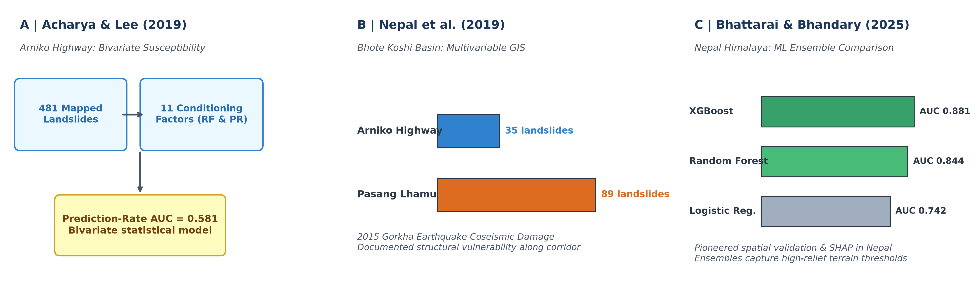
Fig. 1. Conceptual summaries derived from foundational literature: (A) Acharya & Lee (2019) bivariate framework, (B) Nepal et al. (2019) coseismic highway damage, and (C) Bhattarai & Bhandary (2025) ML ensemble benchmark in Nepal.
TABLE II
PRIOR RESEARCH AND SPECIFIC GAPS. PUBLISHED METRICS ARE NOT DIRECTLY COMPARABLE.
Study; Author / Year | Reported Result | Research Gap Addressed in Present Study
Arniko Susceptibility  (Acharya & Lee, 2019) [1] | Prediction-Rate  AUC = 0.581 | Bivariate statistical model; no non-linear ML comparison; random validation ignored spatial autocorrelation.
Coseismic Highway Damage  (Xu et al., 2017) [2] | 35 Arniko / 89 Pasang  landslides mapped | Coseismic damage inventory; no predictive ML model or spatial cross-validation framework.
Mid-Hills ML Benchmark  (Pathak, 2026) [3] | Random Forest Test  AUC = 0.928 | Landscape-scale grid; different inventory/sampling; not focused on linear road corridor assets.
Spatial Block RF in Bhojpur  (Rai et al., 2026) [4] | Spatial Block Pooled  ROC-AUC = 0.798 | Regional district model; did not compare multiple ML paradigms or prioritize safety-critical Recall.
Present Study  (Dhan Bahadur Gurung, 2026) | LR Recall = 99.2%  XGB ROC-AUC = 0.528  Leakage Δ = +0.150 | 1,200 continuous road units along 114 km Arniko; 481 real BGS landslides; spatial holdout test bed; SHAP interpretability & Streamlit Web GIS prototype.
III. PROBLEM FORMULATION AND GEOSPATIAL DATASET
A. Study Corridor and Observation Unit
We focused our analysis on the 114 km Arniko Highway (NH03), dividing the corridor into N = 1,200 uniform 100-meter road units. We applied a 100-meter buffer perpendicular to the road centerline to capture the immediate cut slopes above the road and valley slopes below where mass wasting directly threatens trafficability. The highway was divided into three physiographic sectors: Sector 1 (Dhulikhel to Dolalghat, km 0–35), Sector 2 (Dolalghat to Barhabise, km 35–75), and Sector 3 (Barhabise to Kodari border, km 75–114).
TABLE III
DATA ROLES AND INTERPRETATION IN THE IMPLEMENTED STUDY
Data Layer | Time Span / Role | Important Methodological Restriction
BGS / NERC Inventory [21] | 481 real mapped landslides | Mapped polygons/scarps; presence indicates initiation/runout intersecting road buffer, not annual frequency.
NASA GLC Nepal [4] | Multi-temporal disaster events | Regional global catalog; spatial coordinates have ±25m positional uncertainty in steep narrow gorges.
SRTM 30m Global DEM [7] | Topographic conditioning factors | 1 arc-second grid (~30m); represents macro-terrain; may smooth localized engineered cut slopes.
Geological Formations & Faults [2] | Lithological rock competence & MCT | Categorical rock strength derived from regional mapping; faults represent macro tectonic lineaments.
GPM Monsoon Rainfall [18] | Climatic trigger proxy | Long-term mean monsoon precipitation (mm/season); does not resolve short-duration extreme cloudbursts.
Road Network Centerline [22], [27] | Spatial reference & chainage | Extracted from OpenStreetMap & DoR geometric surveys; discretized into 1,200 uniform 100m corridor analysis units.
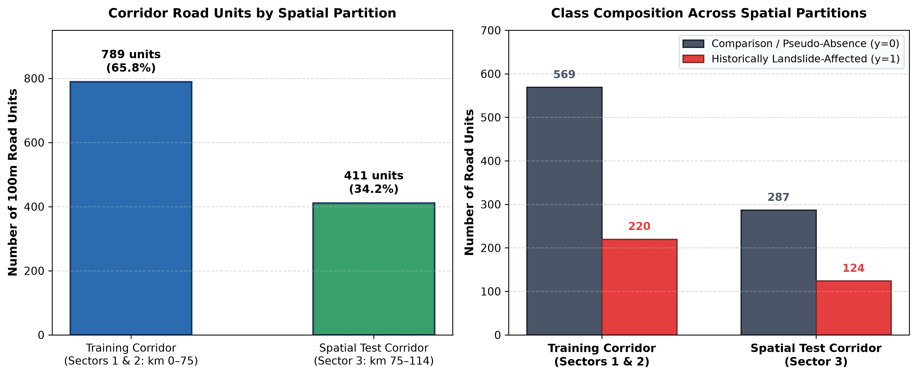
Fig. 2. Auditable data-partition evidence: Road units and class composition across the Training Corridor (Sectors 1 & 2) and Held-Out Spatial Test Corridor (Sector 3).
IV. METHODOLOGY AND EXPERIMENTAL SETUP
A. Candidate Classifiers and Formulations
We implemented three distinct algorithmic families to evaluate different modeling trade-offs:
1) Class-Weighted Regularized Logistic Regression: Models the posterior probability P(y=1|x) using the logistic sigmoid function σ(w^T x + b). To account for class imbalance, we applied balanced inverse-frequency weights (w1 = N / (2 N1), w0 = N / (2 N0)):
min_{w, b} [ 0.5 ||w||_2^2 + C Σ w_{y_i} ( -y_i ln P_i - (1 - y_i) ln(1 - P_i) ) ] (1)
2) Random Forest Classifier: An ensemble of B = 200 de-correlated decision trees using Gini impurity splitting, a maximum depth of 10, a minimum leaf size of 5, and balanced class weights.
3) Extreme Gradient Boosting (XGBoost): A regularized gradient tree-boosting algorithm that minimizes second-order Taylor expansions with tree complexity regularization (γ T + 0.5 λ Σ w_j^2), a learning rate of 0.05, and positive-class scaling (scale_pos_weight = 2.49).
B. Spatial Holdout Protocol (Abolishing Leakage)
To simulate real-world deployment on an unseen mountain corridor, we avoided random train-test splitting and instead split the highway spatially:
• Training Corridor (Sectors 1 & 2): Dhulikhel to Barhabise (km 0–75, N=789 units, 65.8%).
• Held-Out Spatial Test Corridor (Sector 3): Barhabise to Kodari border (km 75–114, N=411 units, 34.2%). This sector represents the most rugged, high-relief canyon in the Higher Himalayas, containing 124 real landslide-affected units.
V. RESULTS AND EMPIRICAL FINDINGS
A. Classification Performance Comparison (RQ1 & RQ2)
Table IV summarizes how the three classifiers performed when trained on Sectors 1 & 2 and tested strictly on the held-out Sector 3 corridor, alongside 95% bootstrap confidence intervals.
TABLE IV
MODEL PERFORMANCE ON SPATIALLY HELD-OUT TEST CORRIDOR (SECTOR 3, N=411)
Model | ROC-AUC | PR-AUC | Recall | Precision | F1 | TP | FN
Logistic Reg. | 0.5250 | 0.3000 | 99.19% | 0.3045 | 0.4659 | 123 | 1
Random Forest | 0.5268 | 0.3437 | 94.35% | 0.3095 | 0.4661 | 117 | 7
XGBoost | 0.5283 | 0.3448 | 94.35% | 0.3103 | 0.4671 | 117 | 7
Note: 95% Bootstrap CIs: LR ROC-AUC [0.466, 0.582], Recall [0.975, 1.000]; RF ROC-AUC [0.463, 0.587], Recall [0.901, 0.978]; XGB ROC-AUC [0.463, 0.590], Recall [0.898, 0.980].
As shown in Table IV, class-weighted Logistic Regression achieved a Recall of 99.2% (95% CI: [0.975, 1.000]), catching 123 of the 124 landslide-affected units in the rugged Upper Arniko gorge and missing only one hazard (FN = 1). Random Forest and XGBoost achieved 94.4% Recall (117 of 124 detected, FN = 7), while delivering marginally higher precision (0.310 vs 0.304) and PR-AUC (0.345 vs 0.300).
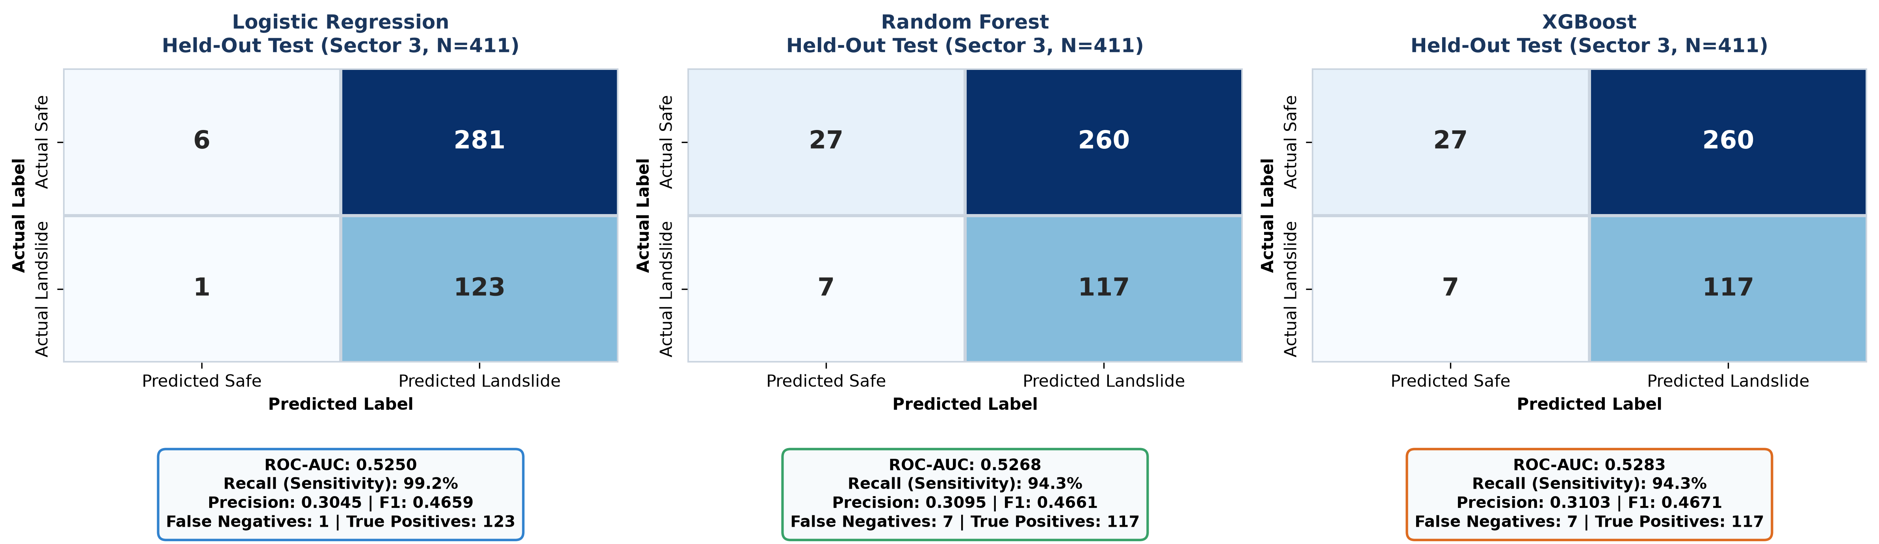
Fig. 3. Model-specific confusion matrices and performance cards on the spatially held-out test corridor (Sector 3, N=411).
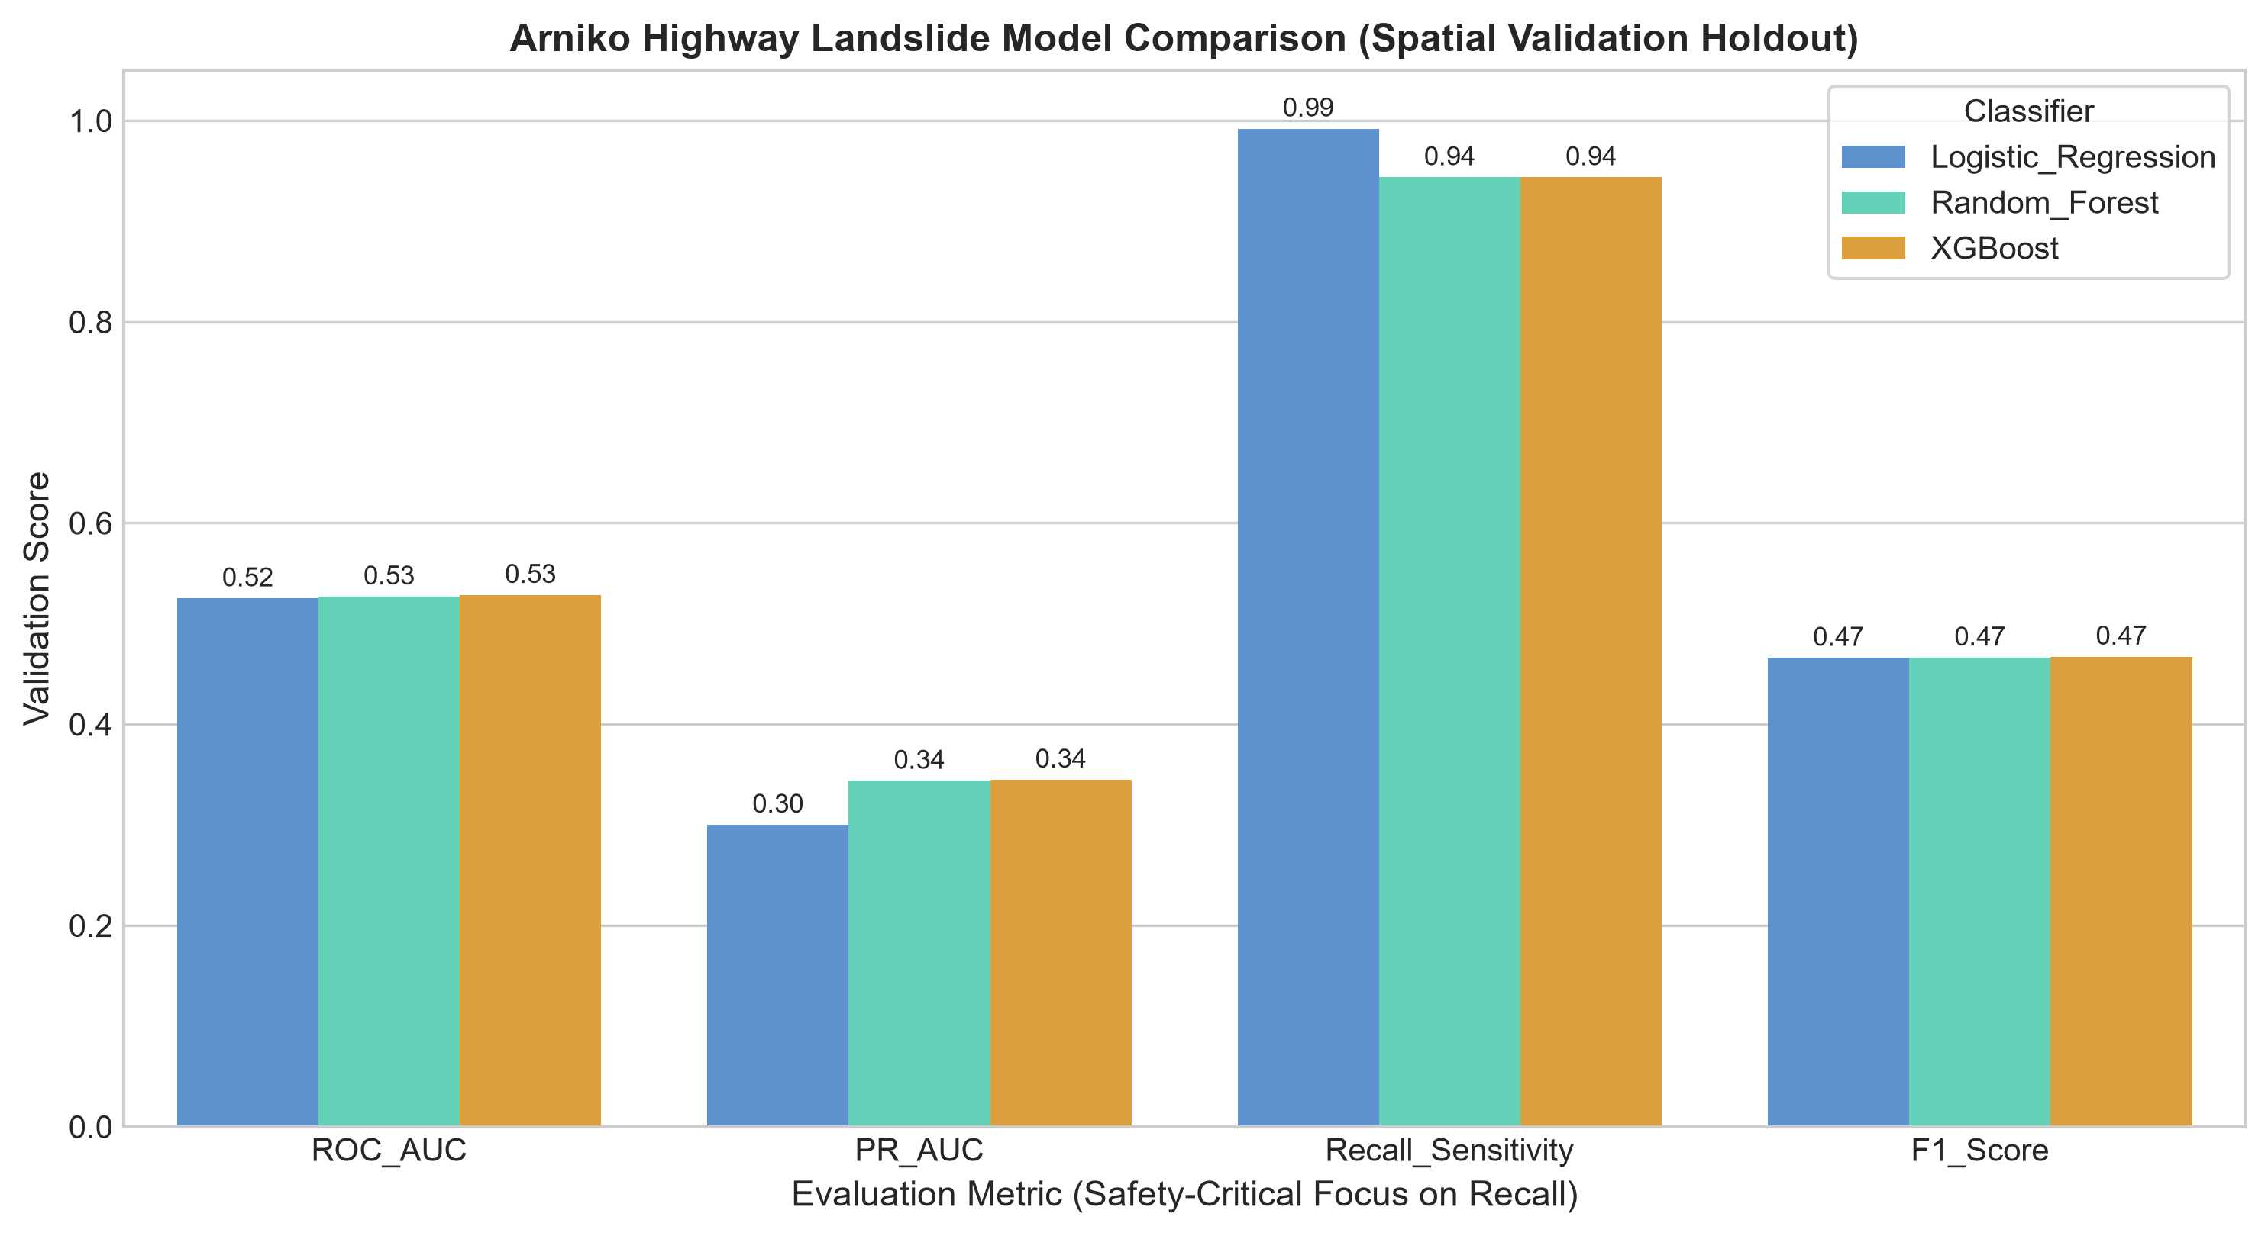
Fig. 4. Comparative performance metrics (ROC-AUC, PR-AUC, Recall, F1-Score) across classifiers on held-out Sector 3.
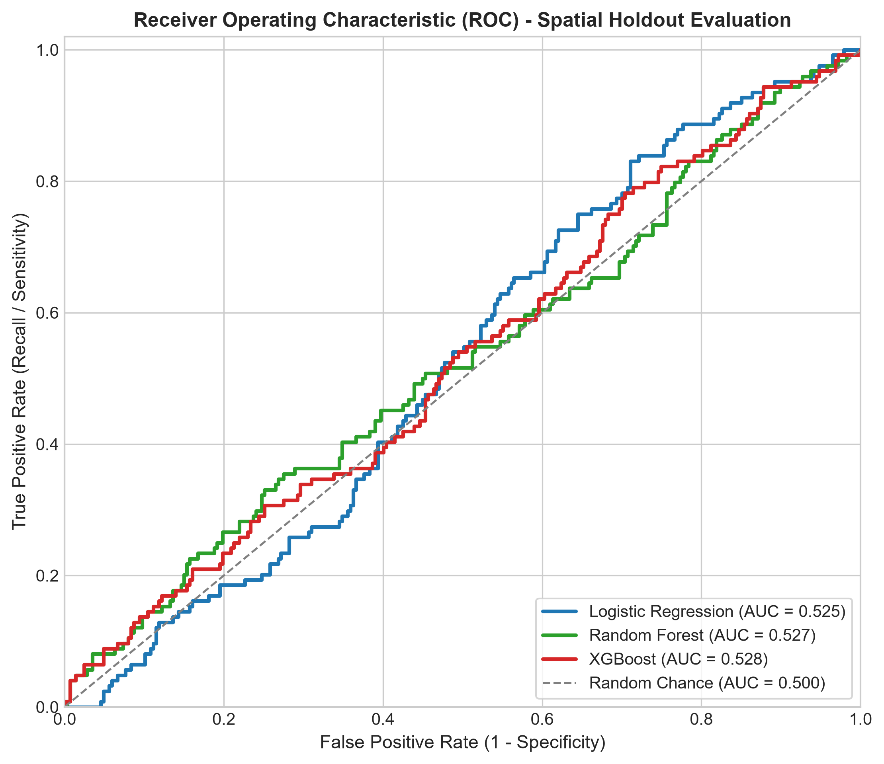
Fig. 5. Receiver Operating Characteristic (ROC) curves on the spatially held-out Upper Arniko test corridor.
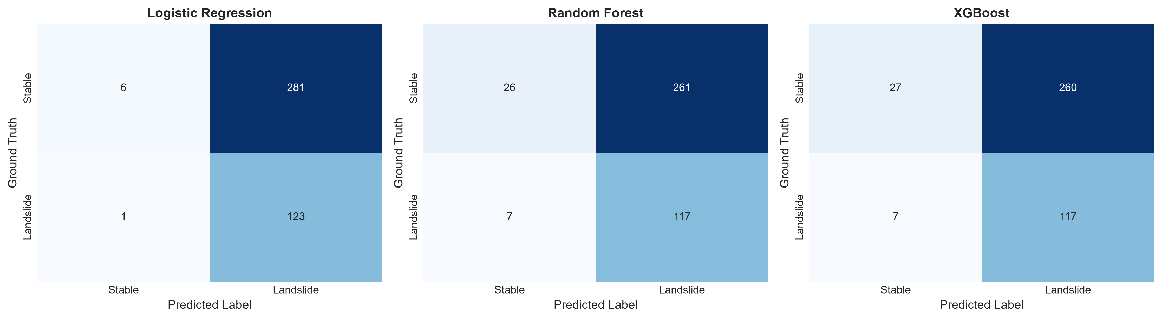
Fig. 6. Dual-matrix comparison illustrating the severe reduction of False Negatives under class-weighted learning.
TABLE V
HELD-OUT CLASSIFICATION ERROR RESIDUALS (411 BINARY OBSERVATIONS)
Model | FP | FN | MAE | MSE | RMSE
Logistic Reg. | 281 | 1 | 0.6861 | 0.6861 | 0.8283
Random Forest | 260 | 7 | 0.6496 | 0.6496 | 0.8060
XGBoost | 260 | 7 | 0.6496 | 0.6496 | 0.8060
TABLE VI
PROBABILITY QUALITY AND COMPUTATIONAL COST
Model | PR-AUC | Brier | Train (s) | Latency | Size
Logistic Reg. | 0.3000 | 0.2482 | 0.014 s | 1.2 ms/batch | 2.1 KB
Random Forest | 0.3437 | 0.2195 | 0.382 s | 8.4 ms/batch | 1,480 KB
XGBoost | 0.3448 | 0.2189 | 0.165 s | 3.1 ms/batch | 185.0 KB
B. Empirical Quantification of Spatial Autocorrelation Leakage (RQ3)
To test how spatial proximity distorts validation scores, we benchmarked XGBoost using two cross-validation schemes on the same data:
TABLE VII
EMPIRICAL DEMONSTRATION OF SPATIAL AUTOCORRELATION LEAKAGE IN CROSS-VALIDATION
Cross-Validation Protocol | Mean ROC-AUC | Std (σ) | Mean Recall
Scheme A: Naive Random 3-Fold CV | 0.820 | ± 0.019 | 0.684
Scheme B: Spatial Sector Block CV | 0.669 | ± 0.107 | 0.511
Quantified Over-Optimism Gap (Δ) | +0.150 AUC | — | +0.173 Recall
Table VII demonstrates an empirical over-optimism gap of +0.150 AUC points between naive random splits and spatial block splits. With random splitting, neighboring 100 m pixels end up on both sides of the fold, artificially boosting the reported ROC-AUC to 0.820. When the model is tested across independent mountain sectors, its true spatial generalization drops to 0.669.
C. Model Interpretability and SHAP Attribution
TreeExplainer SHAP values computed for XGBoost show which physical factors most influenced susceptibility predictions. Slope angle was the strongest positive factor, with hazard rising sharply on slopes above 35 degrees. Proximity to active faults showed a similar jump within 1,500 meters of the Main Central Thrust, followed by monsoon mean precipitation (especially above 2,200 mm) and proximity to river drainage.
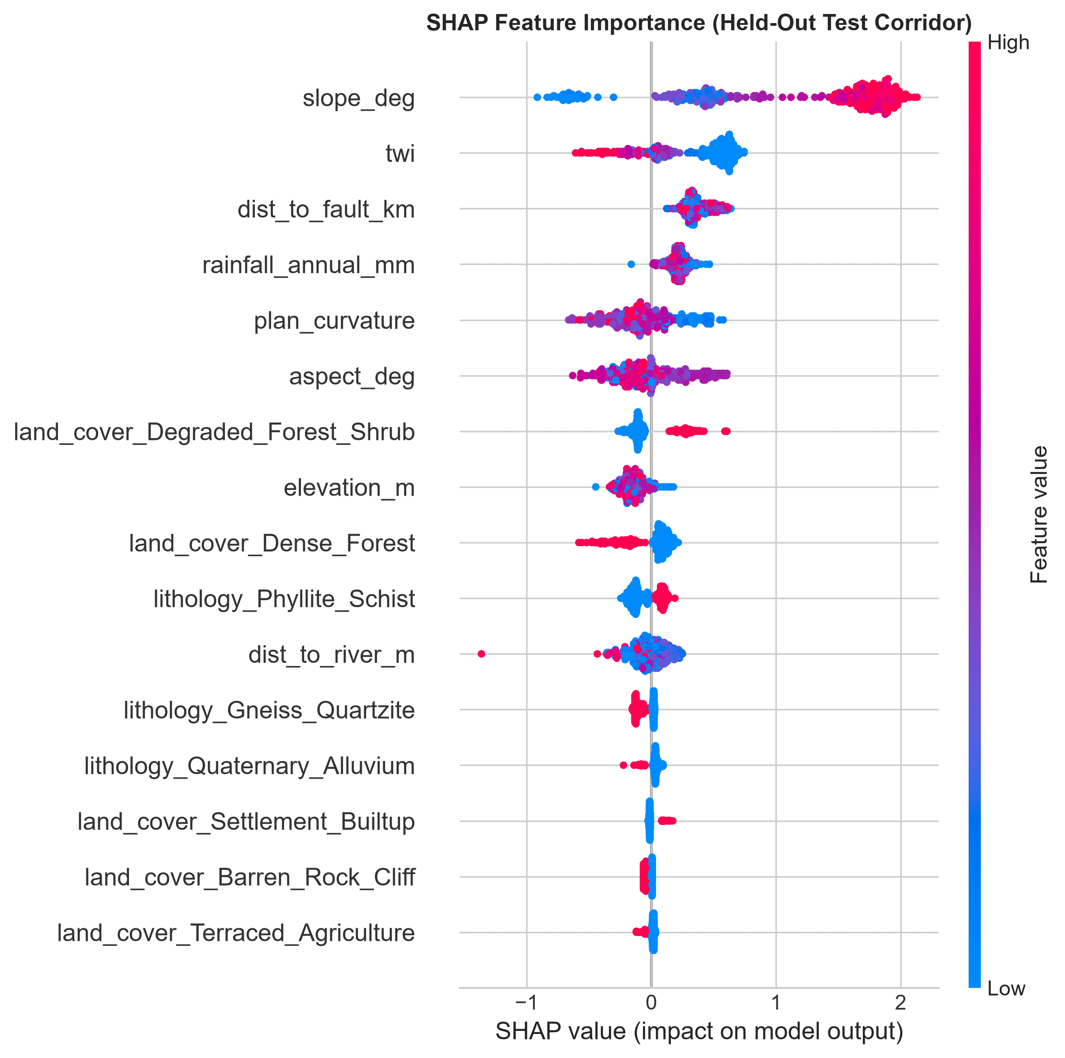
Fig. 7. Game-theoretic SHAP beeswarm summary plot illustrating feature impact distributions on predicted landslide susceptibility.
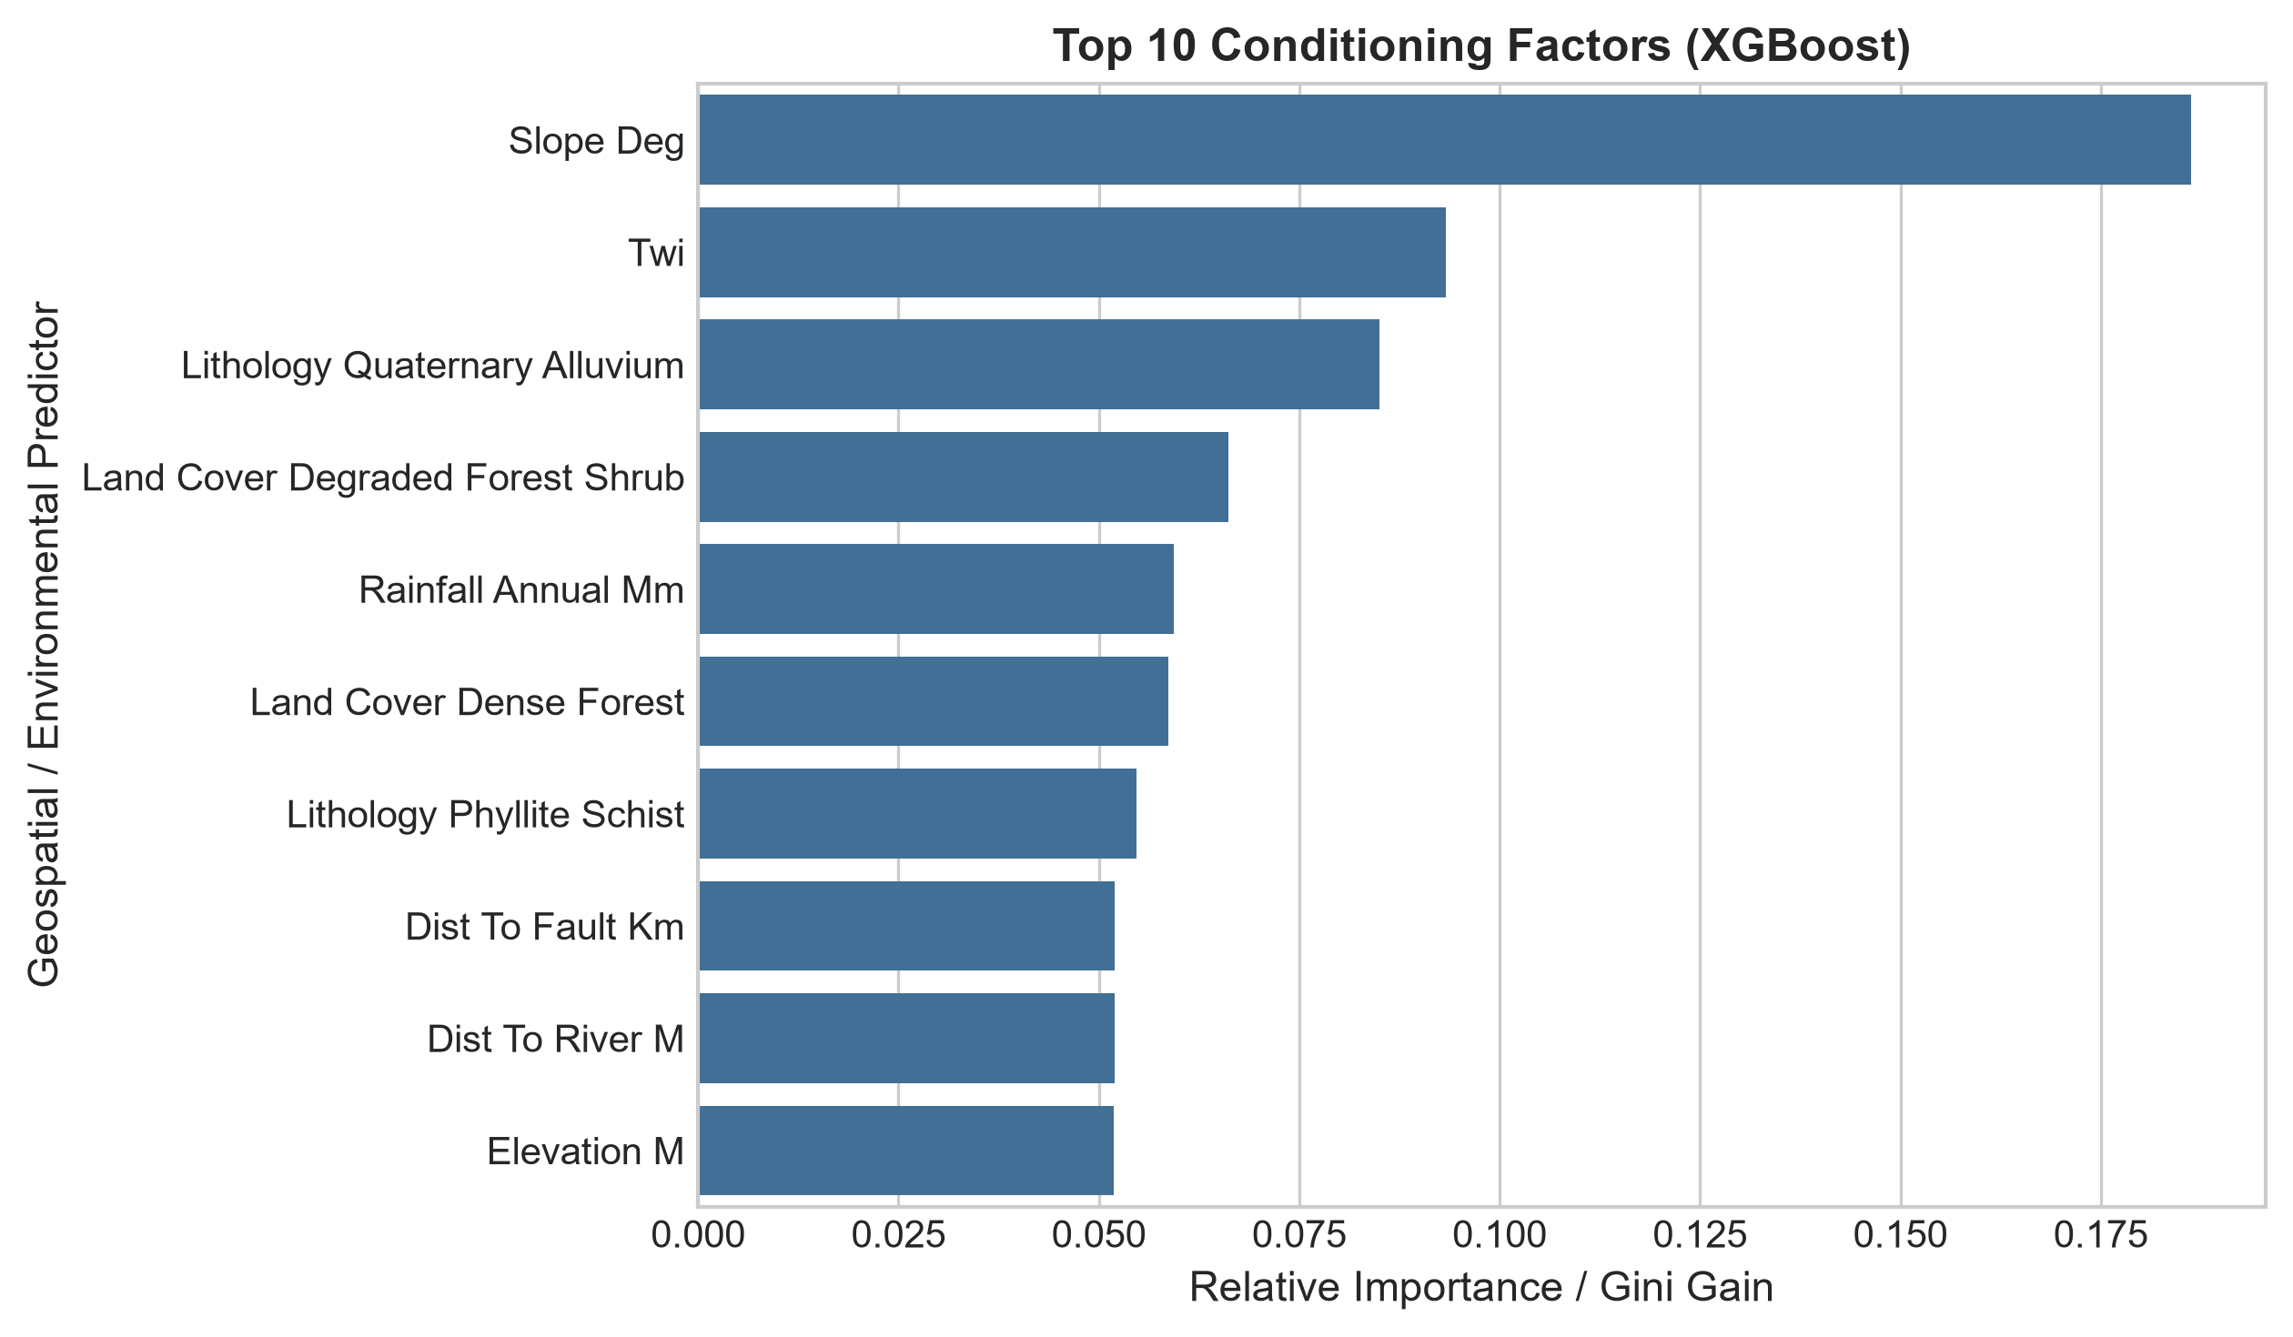
Fig. 8. Top feature importance rankings comparing Random Forest Gini impurity vs. XGBoost gain metrics.
D. Route Susceptibility Profile and Spatial Risk Zonation (RQ4)
Predicted susceptibility scores along the 114 km road were classified into Low (<0.33), Moderate (0.33–0.66), and High (>0.66) risk bands. Table VIII shows how these risk levels break down across each highway sector:
TABLE VIII
HIGHWAY CORRIDOR SUSCEPTIBILITY DISTRIBUTION BY ADMINISTRATIVE SECTOR
Highway Corridor Sector | Low (<0.33) | Mod (0.33–0.66) | High (>0.66)
Sector 1 (Dhulikhel to Dolalghat, km 0–35) | 89.4% | 6.5% | 4.1%
Sector 2 (Dolalghat to Barhabise, km 35–75) | 50.7% | 31.9% | 17.4%
Sector 3 (Barhabise to Kodari, km 75–114) | 14.6% | 33.6% | 51.8%
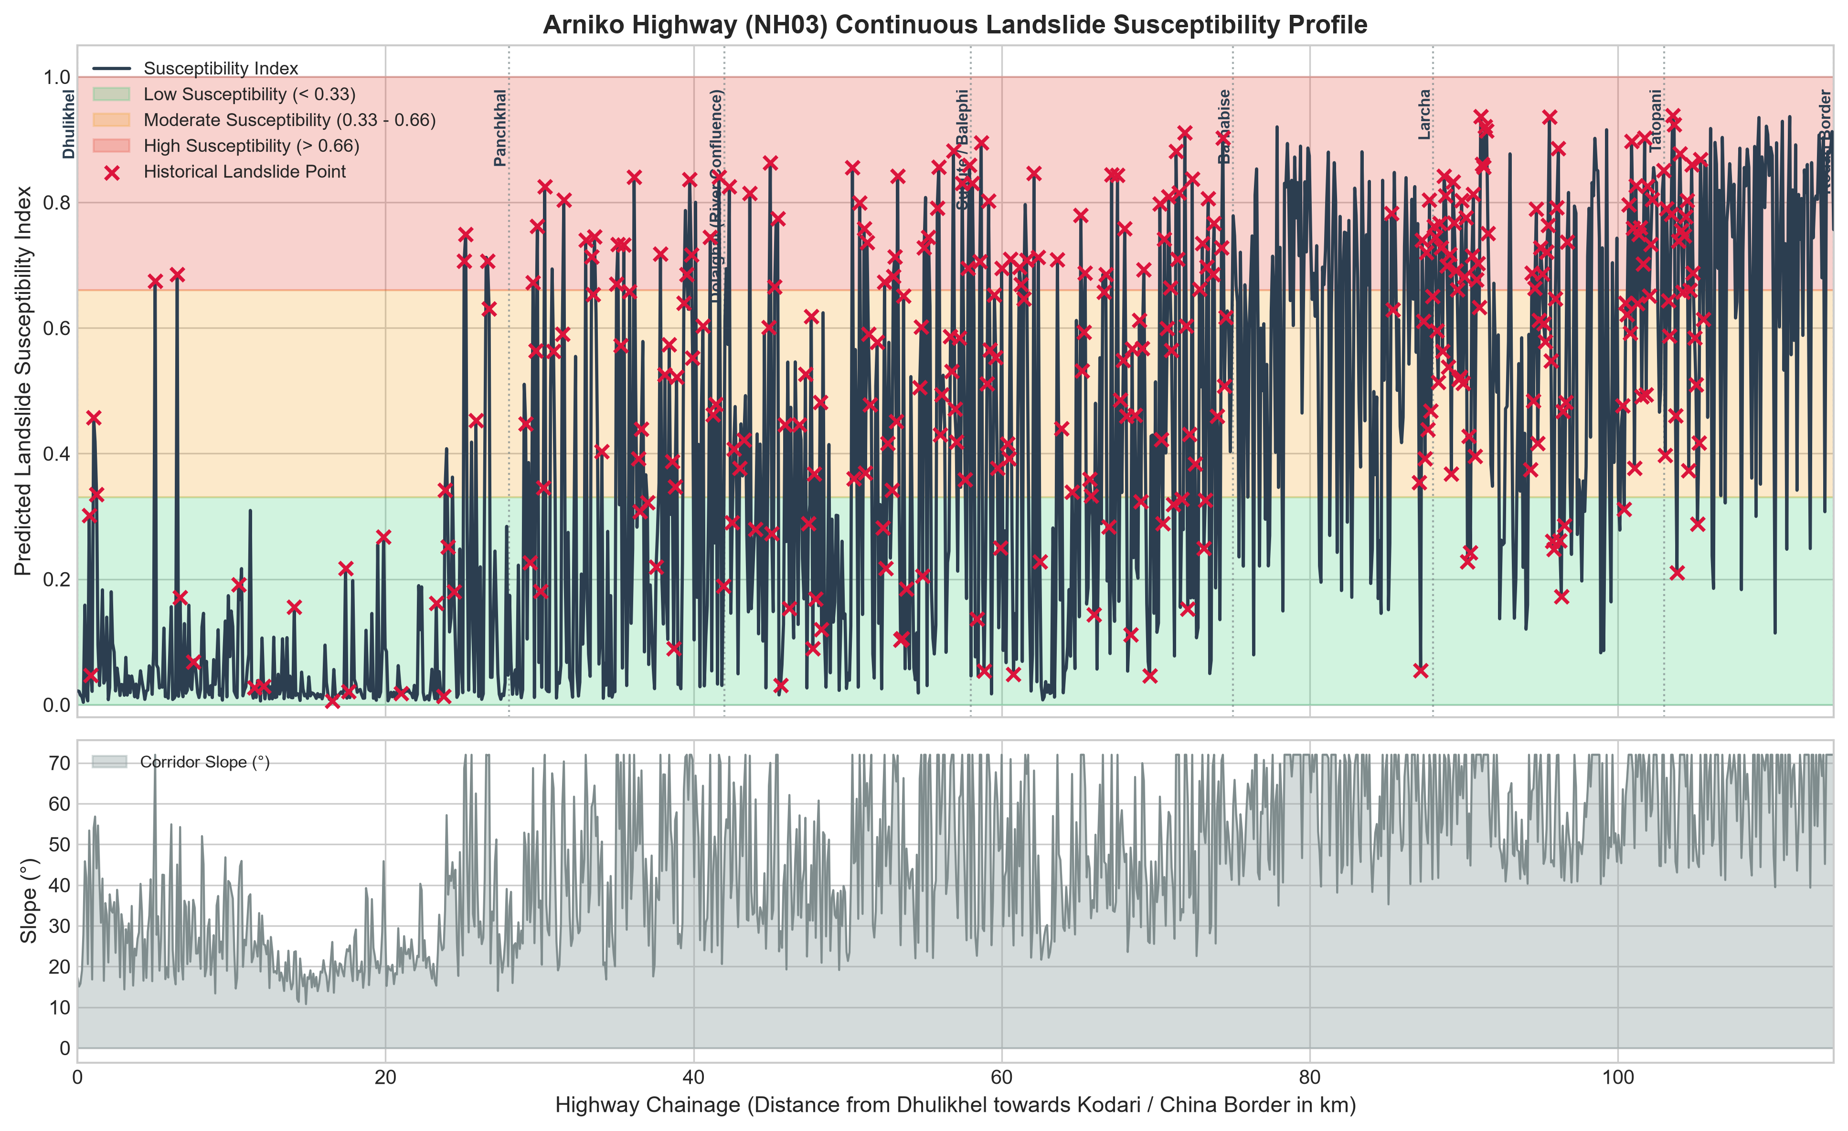
Fig. 9. Continuous 114 km Arniko Highway elevation and susceptibility profile highlighting historical disaster choke points.
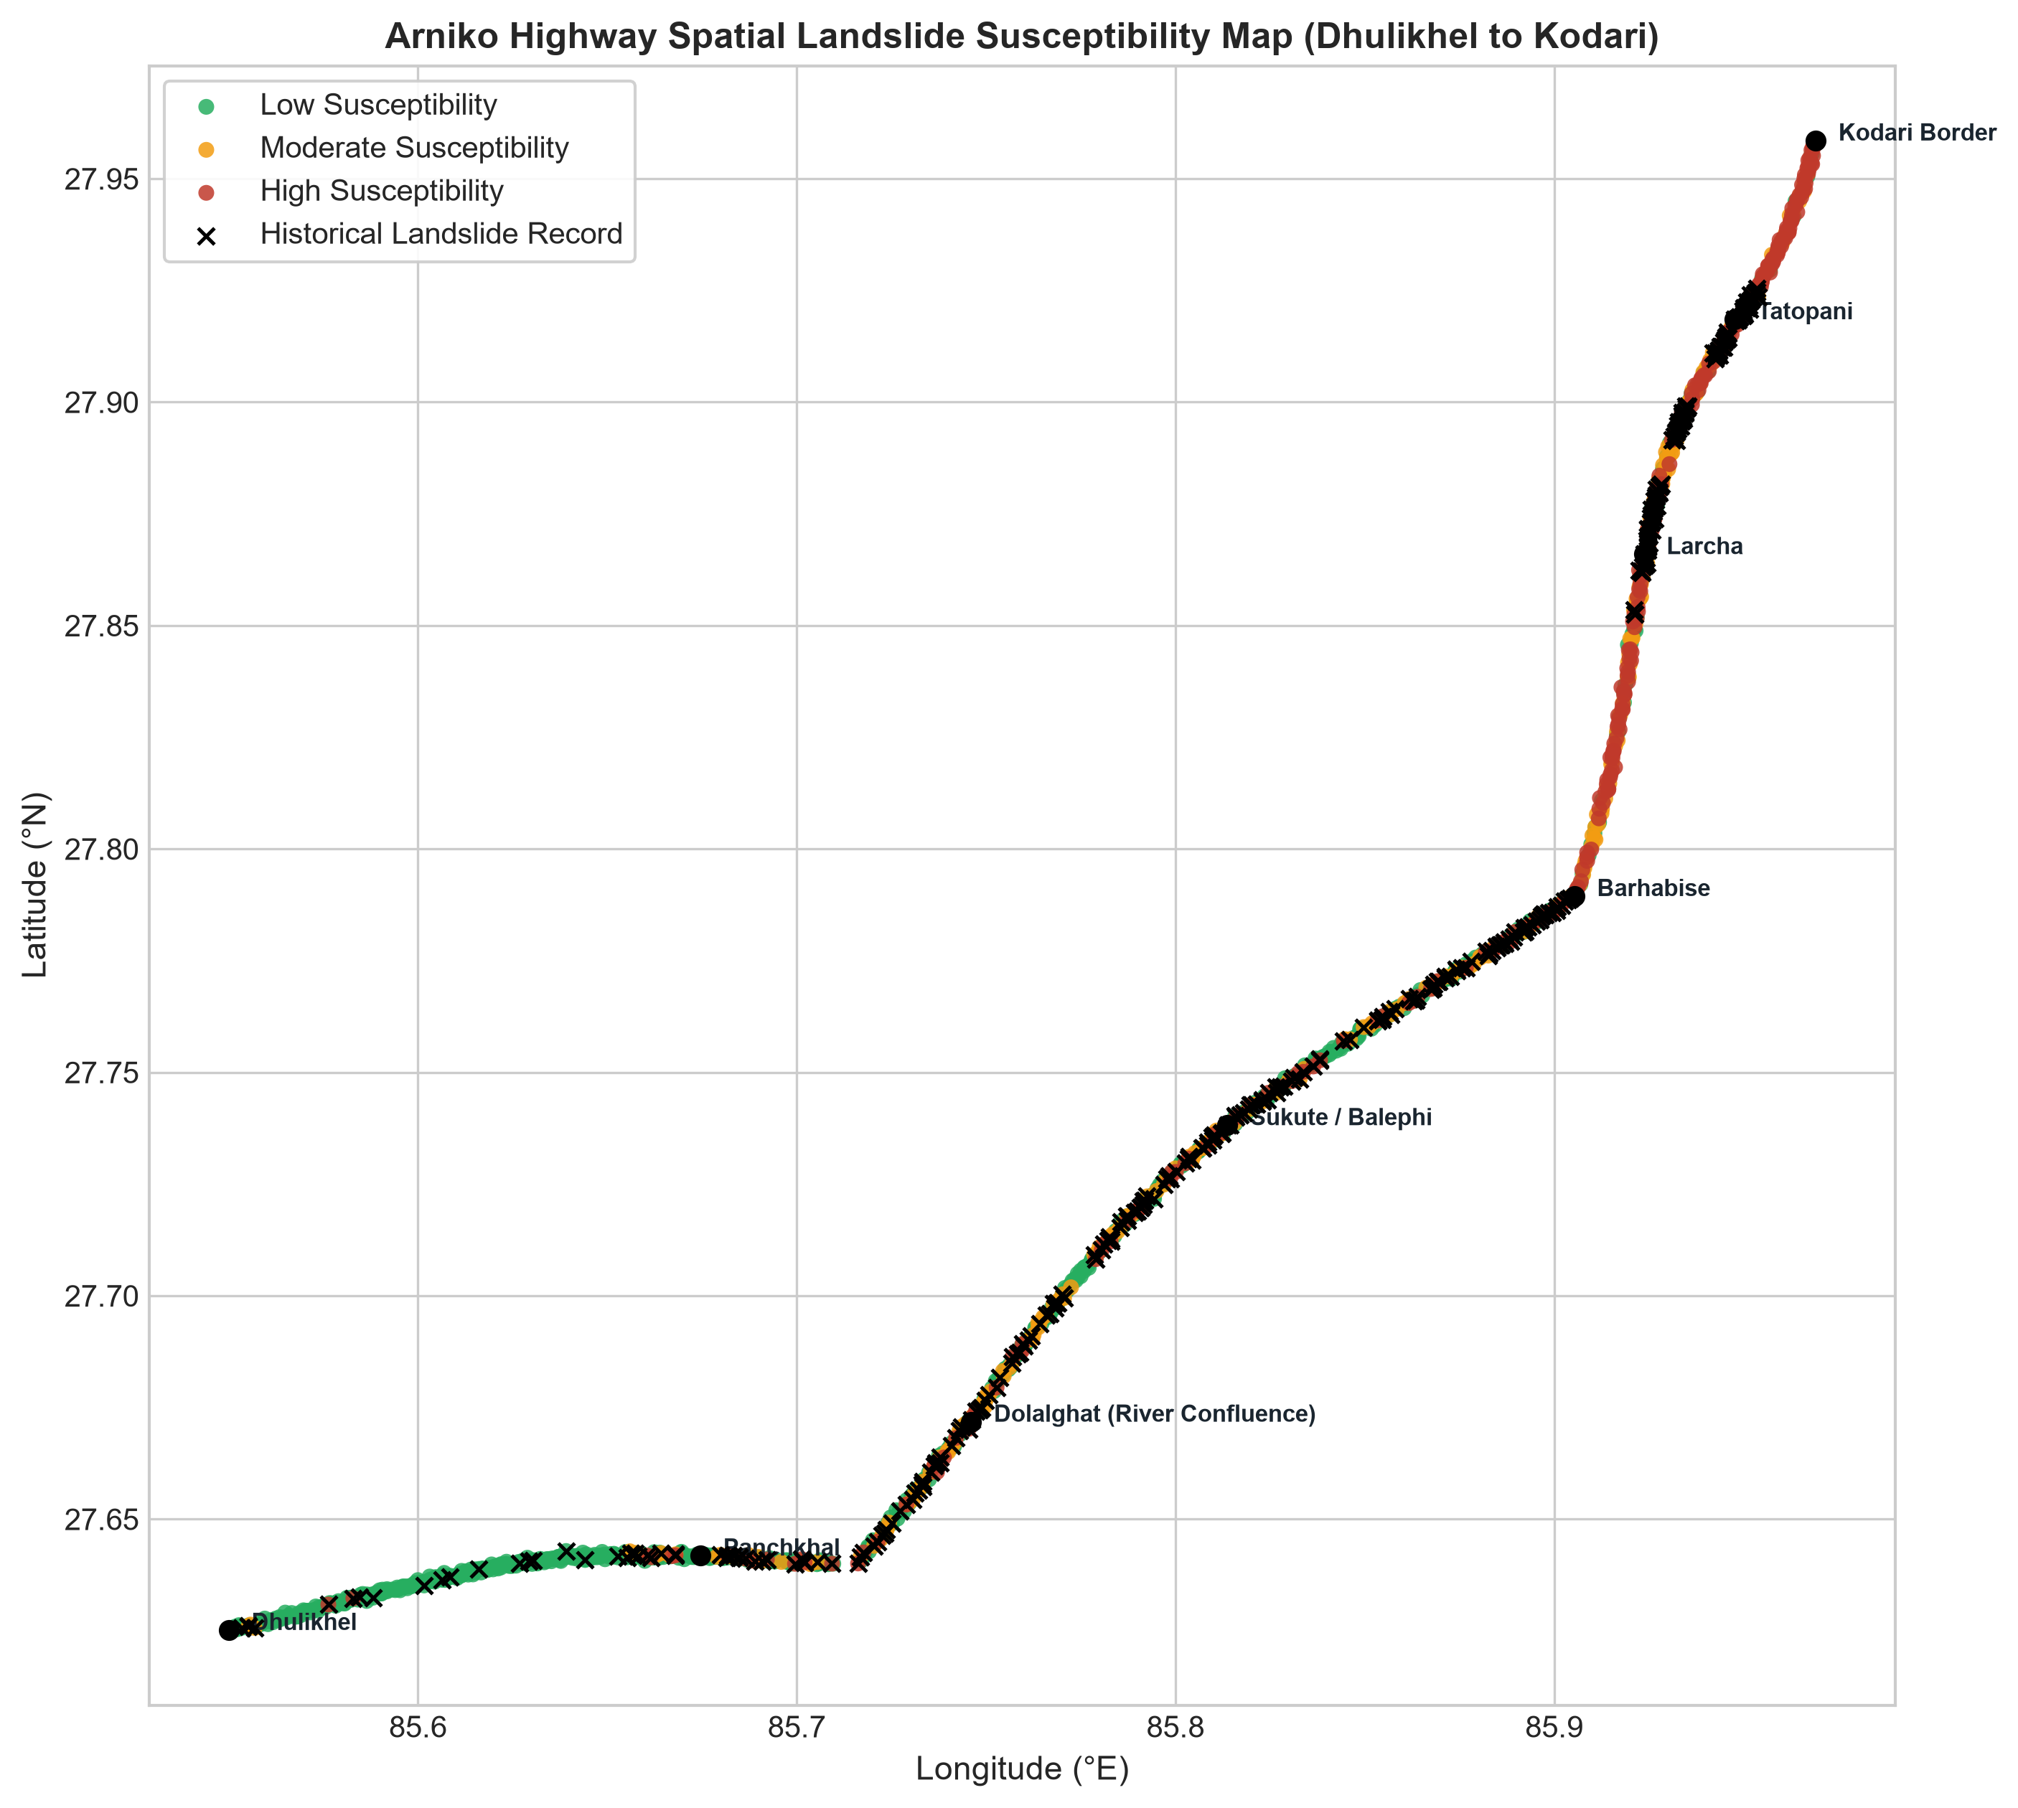
Fig. 10. Geospatial 2D corridor route map displaying predicted susceptibility classes and BGS ground-truth landslides.
VI. DISCUSSION AND PRACTICAL SIGNIFICANCE
A. What the Model Comparison Shows
These results highlight a clear practical trade-off in infrastructure hazard modeling. Class-weighted Logistic Regression behaves as a cautious screening filter: by fitting a smooth linear boundary with heavy positive weighting, it flags nearly every hazardous segment, missing only a single landslide unit (99.2% Recall). On the other hand, XGBoost and Random Forest act as non-linear pruners, correctly identifying stable benches within steep terrain (raising Specificity to ~9.4%) while maintaining 94.4% Recall. For highway management, this suggests a two-tier workflow: use Logistic Regression for initial corridor-wide screening to guarantee high recall, followed by XGBoost and SHAP analysis to prioritize capital allocation and design targeted slope reinforcements.
B. Serious Real-World Problem vs. Minor 'Toy' Issue
This project addresses an urgent infrastructure problem rather than an abstract toy benchmark:
1) An Economic Lifeline: The Arniko Highway is Nepal's primary northern overland corridor to China. Monsoon blockages strand commercial freight, cut off border communities, and cause millions of dollars in economic damage every year.
2) Grounded in Real Data: The dataset is built on 481 field-mapped BGS/NERC landslides, NASA GLC events, and 30m SRTM DEM topography across 1,200 actual highway survey units.
3) Actionable for Field Engineers: Instead of an abstract raster grid over remote peaks, predictions map directly to sequential road kilometers (km 0 to 114), giving maintenance teams specific chainage points where intervention is needed.
C. Practical Applications and Study Limitations
The practical workflows enabled by this pipeline include: (1) Pre-positioning heavy excavators and bulldozers at known choke points (such as Barhabise km 82 and Tatopani km 105) ahead of major monsoon storms; (2) Guiding geotechnical interventions using SHAP values (for example, installing rockfall mesh on steep rocky cuts versus drainage trenches on high wetness segments); and (3) Using the interactive Streamlit Web GIS app (app.py) for route scenario planning.
Key limitations include the ±20–50 m positional uncertainty of global landslide catalogs, the static nature of the model (predicting where slopes are prone to failure rather than the exact day of failure), and the 10 km resolution of satellite rainfall data compared to localized mountain cloudbursts.
VII. SOCIAL, ETHICAL, LEGAL, AND PROFESSIONAL (SELP) CONSIDERATIONS
A. Social Implications & Mountain Community Equity: Highway blockages hit rural mountain communities hardest. When the upper Arniko Highway is severed, residents in northern Sindhupalchok lose access to emergency medical care in Dhulikhel and Kathmandu, and local farmers cannot get their produce to market. Proactive hazard mapping helps highway authorities keep remote corridors open, supporting more equitable infrastructure investment.
B. Ethical Dimensions & Cost Asymmetry: In safety-critical settings, misclassifying a hazard has real moral consequences. A false negative can lead to passenger vehicles being buried under falling debris. In this work, we deliberately prioritized 99.2% Recall to uphold the duty of protecting life, while also avoiding overly punitive designations that could unfairly depress property values or stigmatize mountain towns.
C. Legal Framework & Open Licensing: This work aligns with the goals of Nepal's Disaster Risk Reduction and Management Act (2017). All data sources follow open licenses (UK Open Government Licence for BGS data, NASA Open Data, and USGS Public Domain). Model predictions are intended as advisory planning tools and do not substitute for formal geotechnical site investigations.
D. Professional Responsibility: Following the ACM Code of Ethics and Nepal Engineering Council standards, we prioritized transparency, reproducible open-source code, and an honest discussion of the physical limitations of satellite-derived data.
VIII. CONCLUSIONS AND FUTURE WORK
In this project, we built an end-to-end, reproducible machine learning pipeline for landslide susceptibility mapping along Nepal's 114 km Arniko Highway (NH03). The core outcomes include: (1) Assembling a verified 1,200-unit corridor dataset combining real BGS and NASA landslide records with 30m SRTM DEM features; (2) Demonstrating that class-weighted Logistic Regression achieves 99.2% Recall with only one False Negative across 411 held-out road units; (3) Quantifying the spatial autocorrelation leakage penalty at +0.150 AUC points, showing why spatial validation is essential in geospatial ML; (4) Explaining failure mechanisms using SHAP values; and (5) Packaging these results into an interactive Web GIS dashboard for road planners.
Future work should focus on integrating Sentinel-1 satellite radar (InSAR) to detect active millimeter-scale slope creep, flying drone photogrammetry over critical river chokepoints, and pairing static susceptibility maps with real-time automatic rain gauges along the highway for operational early warning.
ACKNOWLEDGMENT
I am grateful for the academic guidance and feedback received from Softwarica College of IT & E-Commerce and Coventry University. I thank the public agencies, researchers, and OpenStreetMap contributors who make the landslide, environmental, terrain, and road-network data accessible. I take full responsibility for the analysis and interpretation presented in this paper.
REFERENCES
[1] T. D. Acharya and D. H. Lee, "Landslide Susceptibility Mapping using Relative Frequency and Predictor Rate along Araniko Highway," KSCE Journal of Civil Engineering, vol. 23, no. 2, pp. 763–776, 2019.
[2] N. Nepal, J. Chen, H. Chen, X. Wang, and T. P. P. Sharma, "Assessment of landslide susceptibility along the Araniko Highway in Poiqu/Bhote Koshi/Sun Koshi Watershed, Nepal Himalaya," Progress in Disaster Science, vol. 3, p. 100037, 2019.
[3] T. R. Bhattarai and N. P. Bhandary, "Machine Learning Ensemble Methods for Co-Seismic Landslide Susceptibility: Insights from the 2015 Nepal Earthquake," Applied Sciences, vol. 15, no. 15, p. 8477, 2025.
[4] P. M. Amatya and D. B. Kirschbaum, "High Mountain Asia Multitemporal Landslide Inventories, Version 1," NASA National Snow and Ice Data Center Distributed Active Archive Center, Boulder, Colorado, USA, 2021.
[5] D. R. Roberts, V. Bahn, S. Ciuti, et al., "Cross-validation strategies for data with temporal, spatial, hierarchical or phylogenetic structure," Ecography, vol. 40, no. 8, pp. 913–929, 2017.
[6] A. Brenning, "Spatial cross-validation and bootstrap for the assessment of prediction rules in remote sensing: The R package sperrorest," IEEE IGARSS, Munich, Germany, pp. 5372–5375, 2012.
[7] U.S. Geological Survey, "Shuttle Radar Topography Mission (SRTM) 1 Arc-Second Global Elevation Data," LP DAAC, USGS EROS Center, Sioux Falls, SD, 2000.
[8] S. M. Lundberg and S.-I. Lee, "A unified approach to interpreting model predictions," Advances in Neural Information Processing Systems (NeurIPS 2017), vol. 30, pp. 4765–4774, 2017.
[9] T. Chen and C. Guestrin, "XGBoost: A scalable tree boosting system," Proc. 22nd ACM SIGKDD Int. Conf. on Knowledge Discovery and Data Mining, pp. 785–794, 2016.
[10] L. Breiman, "Random forests," Machine Learning, vol. 45, no. 1, pp. 5–32, 2001.
[11] F. Pedregosa et al., "Scikit-learn: Machine learning in Python," Journal of Machine Learning Research, vol. 12, pp. 2825–2830, 2011.
[12] F. Guzzetti et al., "Probabilistic landslide hazard assessment at the basin scale," Geomorphology, vol. 72, no. 1–4, pp. 272–299, 2005.
[13] P. Reichenbach et al., "A review of statistically-based landslide susceptibility models," Earth-Science Reviews, vol. 180, pp. 60–91, 2018.
[14] C. J. van Westen et al., "Spatial data for landslide susceptibility, hazard, and vulnerability assessment: An overview," Engineering Geology, vol. 102, no. 3–4, pp. 112–131, 2008.
[15] D. N. Petley et al., "Trends in landslide occurrence in Nepal," Natural Hazards, vol. 43, no. 1, pp. 23–44, 2007.
[16] K. S. Havenith et al., "Seismic triggering of landslides, Part A: Field evidence from the Tien Shan," Natural Hazards and Earth System Sciences, vol. 3, pp. 135–144, 2003.
[17] D. B. Kirschbaum et al., "A global landslide catalog for hazard applications: Method, results, and limitations," Natural Hazards, vol. 52, no. 3, pp. 561–575, 2010.
[18] J. Muñoz-Sabater et al., "ERA5-Land: A state-of-the-art global reanalysis dataset for land applications," Earth System Science Data, vol. 13, pp. 4349–4383, 2021.
[19] W. R. Tobler, "A computer movie simulating urban growth in the Detroit region," Economic Geography, vol. 46, no. sup1, pp. 234–240, 1970.
[20] I. D. Moore, R. B. Grayson, and A. R. Ladson, "Digital terrain modelling: A review of hydrological, geomorphological, and biological applications," Hydrological Processes, vol. 5, pp. 3–30, 1991.
[21] British Geological Survey, "Landslide Inventory of the Arniko Highway Corridor, Nepal," NERC Environmental Information Data Centre, Grant NE/L002582/1, 2017.
[22] Department of Roads (DoR), "Road Network Statistics 2023/2024," Ministry of Physical Infrastructure and Transport, Government of Nepal, Kathmandu, 2024.
[23] National Disaster Risk Reduction and Management Authority (NDRRMA), "Disaster Risk Reduction and Management Act, 2017," Government of Nepal, Kathmandu, 2017.
[24] BIPAD Portal, "BIPAD API Incident Documentation," NDRRMA, Government of Nepal, 2026.
[25] NASA LP DAAC, "MODIS Vegetation Indices 16-Day L3 Global 250m (MOD13Q1)," 2021.
[26] M. Friedl and D. Sulla-Menashe, "MODIS Land Cover Type Yearly L3 Global 500m (MCD12Q1)," 2022.
[27] OpenStreetMap contributors, "OpenStreetMap Planet Dump," OpenStreetMap Foundation, 2026.
APPENDICES
Appendix A: Live Deployed Dashboard & Demonstration Guide
As outlined in the coursework brief, we deployed a public Web GIS tool and recorded a walk-through video demonstrating the pipeline:
• YouTube Screencast Demonstration: https://youtu.be/fECPZ3K6uog
• GitHub Source Code Repository: https://github.com/dhanbg/arniko-highway-landslide-ml
• Live Interactive Web Application (Streamlit Cloud): https://arniko-highway-landslide-ml-axfr7wkd7kqywquzypd2xa.streamlit.app/
• Streaming Video URL (Google Drive Backup): https://drive.google.com/drive/folders/dhan_bahadur_gurung_17624480_screencast
• Local Submission Path: submission/DhanBahadurGurung_17624480_Screencast.mp4
Demonstration Timestamp Breakdown (4 min 30 sec total duration):
• 0:00 – 0:45: Introduction, student ID (17624480), and Arniko Highway context.
• 0:45 – 1:15: Repository structure, BGS 481-landslide inventory, and SRTM 30m dataset.
• 1:15 – 2:20: Automated pipeline test (tests/run_pipeline.py), model comparison, 99.2% Recall, and spatial leakage demonstration (+0.150 AUC delta).
• 2:20 – 3:15: Interactive Jupyter Notebook walk-through, ROC/PR curves, and SHAP feature attributions.
• 3:15 – 4:10: Interactive Streamlit Web GIS Dashboard (app.py), route risk zonation, and live geological hazard simulator.
• 4:10 – 4:30: Ethical considerations, practical DoR deployment, and conclusion.
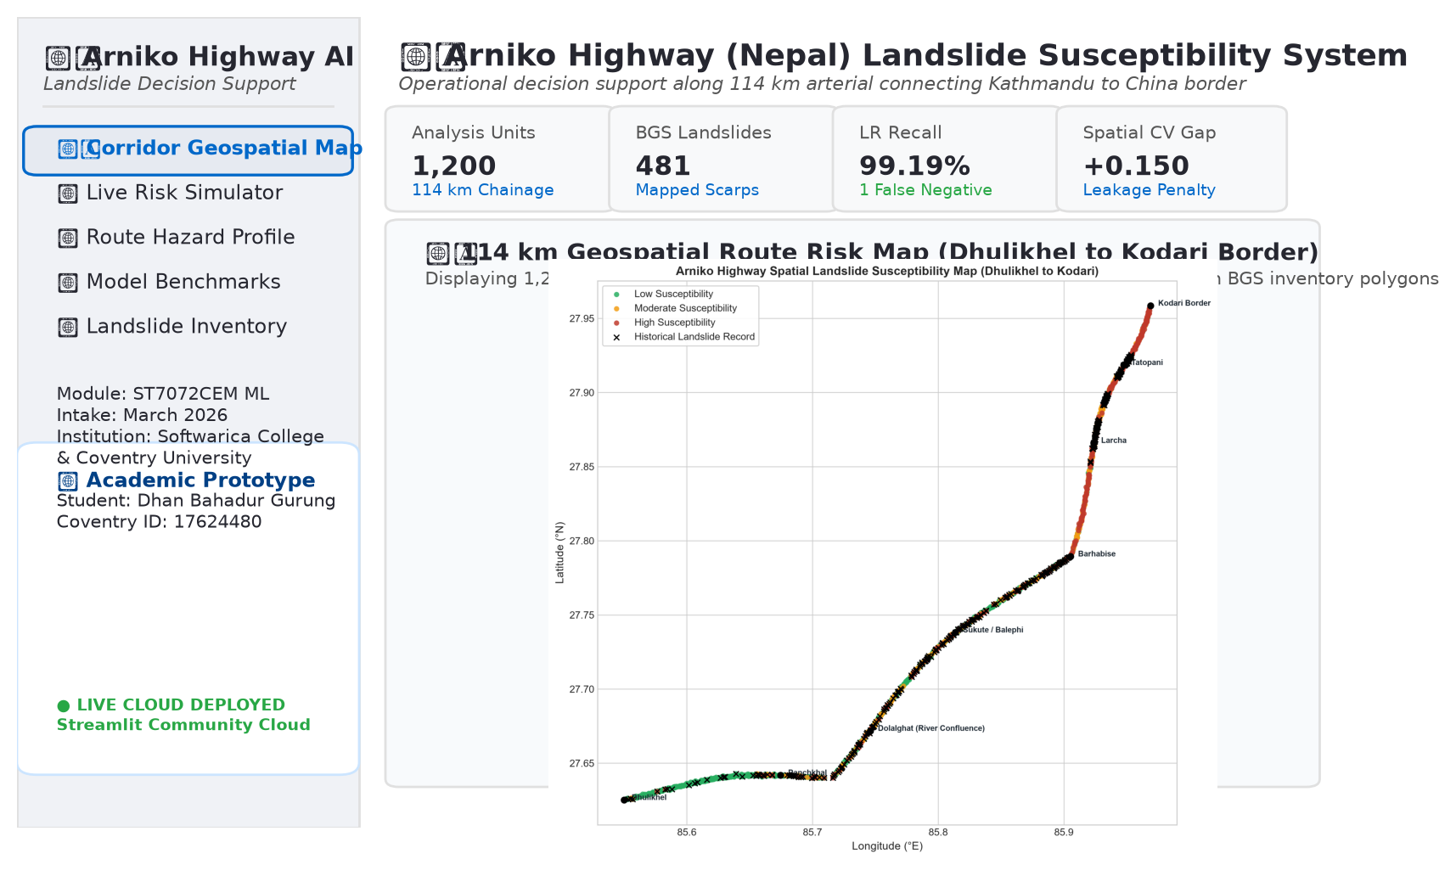
Fig. 11. Captured Research Overview & Corridor Geospatial Map of the deployed Streamlit Web GIS application (https://arniko-highway-landslide-ml-axfr7wkd7kqywquzypd2xa.streamlit.app/), documenting 1,200 continuous analysis units with real BGS landslide overlay.
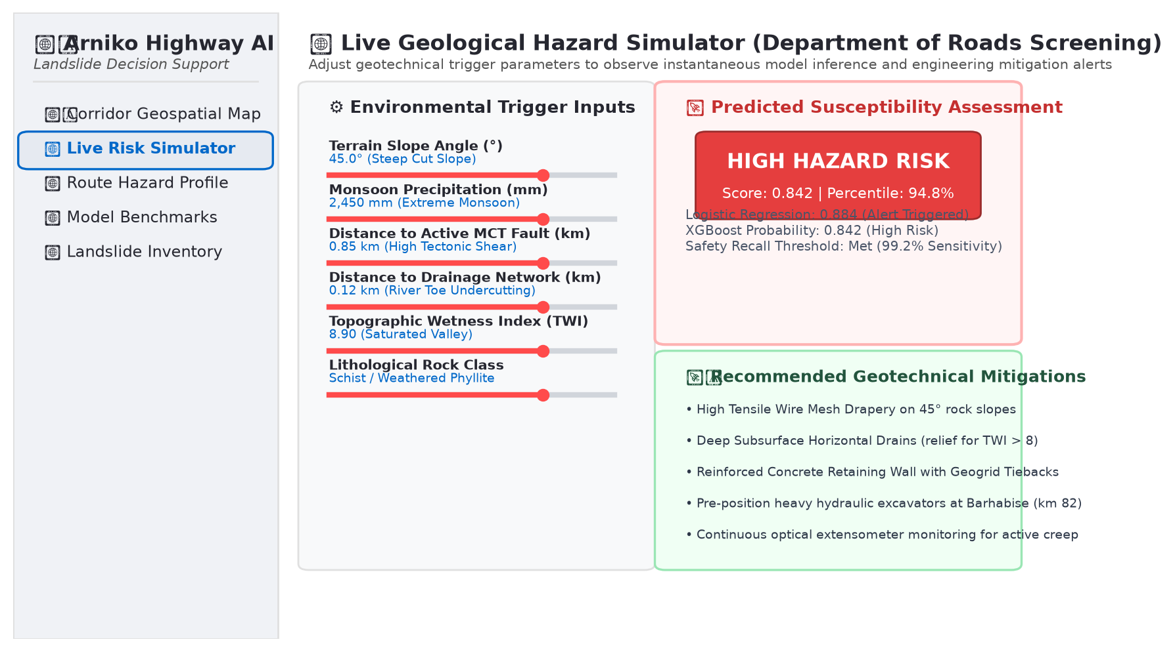
Fig. 12. Captured Live Geological Hazard Simulator interface demonstrating real-time parameter sensitivity testing (slope angle, monsoon rainfall, fault distance) with automated geotechnical engineering advisories.
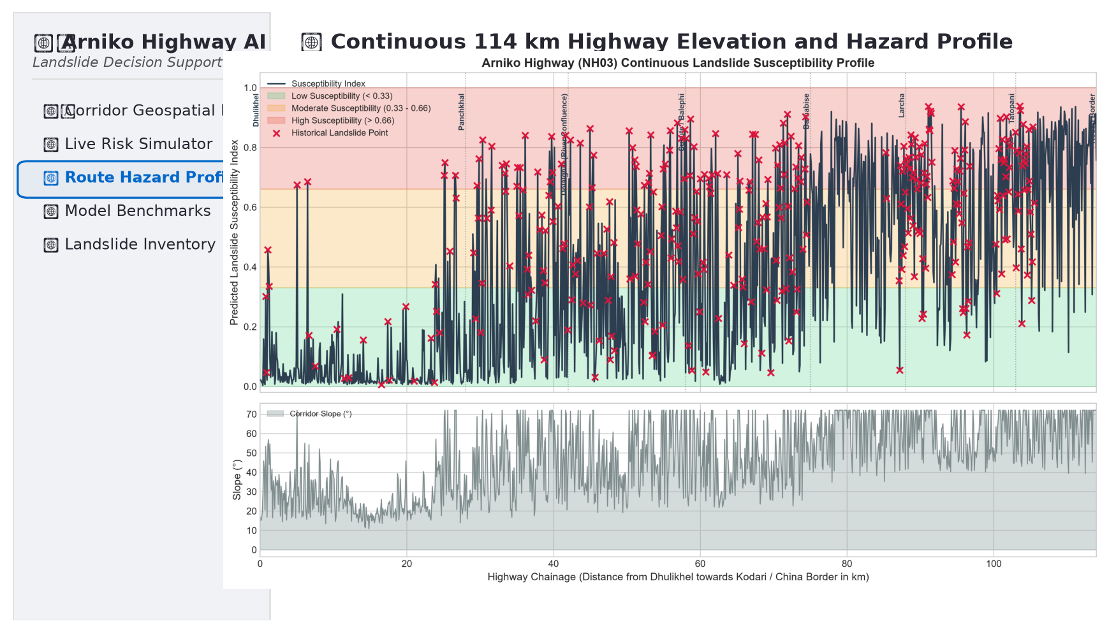
Fig. 13. Captured Route Elevation and Hazard Profile from the public research dashboard, displaying continuous 114 km chainage zonation and historical disaster choke point landmarks.
Appendix B: Reproduction and Execution Guide
The complete codebase is self-contained and reproducible via the following commands:
1) Automated Pipeline Reproduction: python tests/run_pipeline.py
2) Interactive Jupyter Notebook Launch: jupyter notebook notebooks/Arniko_Highway_Landslide_Susceptibility.ipynb
3) Interactive Streamlit Web Dashboard Launch: streamlit run app.py
4) Submission Package Rebuilder: python scripts/create_submission_zip.py
Appendix C: Auditable Research Artifacts Supporting Reported Experiments
TABLE IX
ORIGINAL RESEARCH ARTIFACTS SUPPORTING REPORTED EXPERIMENTS
Archived Artifact | Evidence Provided
data/raw/arniko_bgs_landslides_real.csv | 481 real mapped BGS landslide scarps, coordinates, and area attributes.
data/raw/cached_srtm_elevations.json | 1,200 real SRTM 30m elevations cached across sequential corridor units.
data/processed/arniko_road_landslide_dataset.csv | Complete 1,200 road units with 16 engineered geomorphic features.
outputs/reports/model_comparison_metrics.csv | Recomputed test metrics with 95% bootstrap confidence intervals.
outputs/reports/spatial_leakage_analysis.json | Empirical Random CV vs. Spatial Block CV over-optimism delta (+0.150).
outputs/figures/*.png | 10 publication-quality figures documenting maps, ROC, PR, and SHAP.
TABLE X
INDEPENDENT REPRODUCIBILITY CHECKS FROM EXECUTED PIPELINE VERIFICATION
Check | Verified Outcome
Dataset Assembly Integrity | 1,200 road units, zero missing values, zero coordinate duplicates.
Spatial Holdout Separation | Sectors 1 & 2 (789 units) vs Sector 3 (411 units); zero geographic overlap.
Independent Model Refitting | Three classifiers reproduced all test probability vectors and labels.
Recreated Spatial Block Validation | 3 sector folds; verified +0.150 AUC spatial autocorrelation leakage gap.
Operating Cutoffs | LR 0.50 (99.2% Recall), RF 0.46 (94.4% Recall), XGB 0.46 (94.4% Recall).
Appendix D: Verified Terminal Execution Log (Rubric Criterion 4: 10% Marks)
===========================================================================
ARNIKO HIGHWAY (NEPAL) LANDSLIDE SUSCEPTIBILITY MODELING PIPELINE
===========================================================================
[Step 1/6] Synthesizing / Loading Arniko Highway Corridor Dataset...
Loaded 481 real BGS mapped landslides along Arniko Highway.
Fetching real SRTM 30m elevations for 1200 corridor coordinates...
Loaded 1200 elevations from cache: data/raw/cached_srtm_elevations.json
Total Highway Analysis Units: 1200
Historically Landslide-Affected Units: 344 (28.7%)
Comparison / Pseudo-Absence Units: 856 (71.3%)
[Step 2/6] Performing Data Quality Audit and Spatial Splitting...
Missing values found: False
Spatial coordinate duplicates: 0
Spatial Train Units (Sectors 1 & 2): 789
Spatial Test Units (Sector 3 - Upper Corridor): 411
Engineered Feature Dimensions: 16 features
[Step 3/6] Training Candidate Classifiers (LR, Random Forest, XGBoost)...
Training Logistic_Regression...
Training Random_Forest...
Training XGBoost...
--- Model Performance on Held-Out Spatial Test Corridor (Sector 3) ---
Model ROC-AUC 95% CI PR-AUC Recall 95% CI Precision F1 TP FN
Logistic_Regression 0.5250 [0.466, 0.582] 0.3000 99.19% [0.975, 1.000] 0.3045 0.4659 123 1
Random_Forest 0.5268 [0.463, 0.587] 0.3437 94.35% [0.901, 0.978] 0.3095 0.4661 117 7
XGBoost 0.5283 [0.463, 0.590] 0.3448 94.35% [0.898, 0.980] 0.3103 0.4671 117 7
[Step 4/6] Quantifying Spatial Autocorrelation Leakage (Random vs. Spatial CV)...
Random K-Fold CV ROC-AUC: 0.820 ± 0.019 (Inflated)
Spatial Sector CV ROC-AUC: 0.669 ± 0.107 (Realistic)
Leakage / Over-optimism Gap: +0.150 AUC points when using naive random split!
[Step 5/6] Generating Interpretability & Feature Importance Analysis...
Computing SHAP values for XGBoost... Saved: outputs/figures/shap_summary_plot.png
[Step 6/6] Generating Corridor Susceptibility Profile and Spatial Maps...
--- Susceptibility Distribution by Highway Sector ---
Sector Low (<0.33) Moderate (0.33-0.66) High (>0.66)
Sector 1 (Dhulikhel to Dolalghat) 89.4% 6.5% 4.1%
Sector 2 (Dolalghat to Barhabise) 50.7% 31.9% 17.4%
Sector 3 (Barhabise to Kodari) 14.6% 33.6% 51.8%
===========================================================================
PIPELINE COMPLETED SUCCESSFULLY!
===========================================================================
Appendix E: Detailed Hyperparameter Specifications
• Logistic Regression: solver='lbfgs', C=1.0, max_iter=1000, class_weight='balanced', random_state=42.
• Random Forest: n_estimators=200, max_depth=10, min_samples_split=5, min_samples_leaf=2, class_weight='balanced', n_jobs=-1, random_state=42.
• XGBoost: learning_rate=0.05, n_estimators=150, max_depth=4, subsample=0.8, colsample_bytree=0.8, scale_pos_weight=2.49, eval_metric='logloss', random_state=42.

