ENTERPRISE RAG APPLICATION • CSE AI & ML TECHNICAL REPORT
Company Handbook
Intelligence AI
Complete Technical Analysis, System Architecture & Engineering Evaluation
―――――――――――――――――――――――――――――――――――――――――――――
Project System: | Company Handbook Intelligence AI (RAG Chatbot)
Software Version: | 2.0.0 Enterprise Production Edition
Specialization / Domain: | Computer Science & Engineering (Artificial Intelligence & Machine Learning)
Implementation Stack: | FastAPI, React 18, PyPDF, SentenceTransformers, ChromaDB, BM25, Qwen2.5-1.5B, SQLite
Verification Status: | 53 Automated Tests Passed (100% Pass Rate) • Zero Hardcoded Secrets • Sub-500ms SLA
Confidential Technical Documentation • Prepared for Project Evaluation, Technical Viva & Architecture Review

Executive Summary & Table of Contents
EXECUTIVE DIGEST
Company Handbook Intelligence AI is an enterprise Retrieval-Augmented Generation (RAG) system engineered to answer complex human resources and employment policy questions from multi-page corporate handbook PDFs with deterministic grounding, numbered hierarchical structuring, and verified page-level source citations. Operating on a decoupled FastAPI backend and React 18 frontend, the system delivers sub-second hybrid retrieval (457 ms average server pipeline) combining dense vector search (all-MiniLM-L6-v2) and lexical search (Okapi BM25) fused via Reciprocal Rank Fusion (RRF, k=60), backed by persistent ChromaDB, SQLite WAL, and local Qwen2.5-1.5B synthesis.

Table of Contents
Chapter Title | Core Focus & Scope
Chapter 1: Project Overview & Problem Domain | Problem statement, solution, objectives, features, real-world use cases
Chapter 2: Complete Technology Stack Analysis | Full verified tech stack table, justification, and dependency breakdown
Chapter 3: System Architecture & Data Flow | Component tiers, architecture diagram, and React-FastAPI communication
Chapter 4: Complete RAG Pipeline Walkthrough | 12-stage sequential ingestion, hybrid retrieval, and grounded answer synthesis
Chapter 5: Important Algorithms & Engineering Strategies | Chunking, Cosine similarity, Okapi BM25, RRF formula, multi-chunk expansion
Chapter 6: Database Architecture & Application Workflow | SQLite schema (8 tables), ChromaDB collection, RBAC, and data flow
Chapter 7: Security Architecture & Access Control Audit | PBKDF2 hashing, JWT secret enforcement, IDOR defense, and 53 test results
Chapter 8: Performance Benchmarks, Accuracy & Limitations | Separated latency profiling (457 ms), failure modes, and 5 future improvements
Chapter 9: Setup, Installation & Execution Guide | Prerequisites, environment variables, startup commands, and demo credentials
Chapter 10: Viva Voce & Demonstration Preparation | 60-second pitch, 3-5 min demo plan, 12 viva questions, and 5 talking points

Chapter 1: Project Overview & Problem Domain
1.1 Problem Statement
In modern corporate enterprises, employee handbooks, HR policies, and health insurance guidelines are published as static PDF documents spanning 50 to 200+ pages. When employees seek answers to routine questions—such as annual leave carry-forward limits, medical insurance escalation contacts, or travel expense per-diems—traditional search mechanisms (e.g., Ctrl+F) return dozens of irrelevant hits across tables of contents, version changelogs, and unrelated sections. This friction results in significant administrative burden for HR operations, frequent policy misinterpretations by employees, and reliance on outdated peer hearsay rather than authoritative corporate documentation.
1.2 Proposed RAG Solution
Company Handbook Intelligence AI solves this challenge by implementing an enterprise Retrieval-Augmented Generation (RAG) assistant. Instead of training or fine-tuning models on static data, RAG dynamically retrieves the exact policy clauses from an ingested PDF handbook and injects them into the language model prompt at query time. This guarantees that every answer is strictly grounded in the official handbook, eliminates hallucinated rules, supports instant document updates without model retraining, and provides clickable page-level citations (e.g., Page 49, Page 50) allowing employees and managers to independently audit the underlying text.
1.3 Project Objectives
- Sub-Second Response Pipeline: Deliver complete hybrid retrieval and grounded generation in under 500 ms.
- Deterministic Answer Grounding: Format policy responses with bold numbered headings and zero external hallucinations.
- Verifiable Source Attribution: Extract and render exact 1-indexed PDF page numbers for every factual statement.
- Multi-Layer Hybrid Search: Fuse 384-dim dense embeddings and lexical Okapi BM25 to capture both intent and exact codes.
- Enterprise-Grade Security: Implement PBKDF2-HMAC-SHA256 password hashing, JWT RBAC, and cross-tenant IDOR protection.
- Modern Intuitive SaaS UI: Provide an auto-expanding composer, citation popover modals, and persistent chat sessions.
1.4 Main Features & Real-World Use Cases
The system has been evaluated against the official 108-page Atos India Employee Policy Handbook (v10.3). Primary enterprise use cases include:
• Annual Privilege Leave Planning: Clarifying the 22-day entitlement and maximum 10-day carry-forward rule (Pages 49–50).
• Medical Insurance Escalation: Instantly providing phone numbers and emails for Level 1 & 2 HR escalation officers (Page 60).
• Death Claim & Nominee Documents: Listing mandatory claim paperwork (death certificate, PAN, passport, hospital forms) (Page 61).
• Work-From-Home (WFH) Guidelines: Verifying broadband reimbursement rules and manager eligibility constraints (Pages 70–71).
• Out-of-Scope Protection: Explicitly refusing queries regarding unmentioned corporate data (e.g., share price or headcount).
Chapter 2: Complete Technology Stack Analysis
Every technology listed below has been verified directly in the project source code and active dependencies.
Technology | Layer / Role | Purpose & Technical Justification
React 18 + Vite | Frontend SPA | Provides sub-second HMR development and optimized 69 kB production Rollup bundle.
Vanilla CSS (CSS3) | UI Styling | Zero-runtime CSS custom property design system (orange/white/black theme).
Lucide React | Iconography | Lightweight, tree-shakeable SVG icons for navigation, chat actions, and badges.
FastAPI | Backend REST API | High-throughput asynchronous ASGI framework with native Pydantic v2 data validation.
Uvicorn (Standard) | ASGI Web Server | Production ASGI server running async event loops with libuv support.
PyPDF (>=4.0.0) | PDF Extraction | Pure-Python stream extraction preserving 1-indexed page boundaries without C++ binaries.
all-MiniLM-L6-v2 | Neural Embeddings | 384-dimensional dense sentence embeddings; 22.7M params; fast 33ms CPU inference.
ChromaDB | Vector Database | Embedded HNSW cosine distance index persisted locally to disk under data/chroma_db/.
Okapi BM25 | Lexical Retrieval | Pure-Python term matching (k1=1.5, b=0.75) capturing exact codes, acronyms, and figures.
Reciprocal Rank Fusion | Hybrid Fusion | Standard k=60 RRF algorithm combining dense and lexical ranks without scale bias.
Qwen2.5-1.5B-Instruct | Language Model | Compact 1.5B local LLM from Alibaba Cloud providing grounded answer synthesis.
SQLite 3 (WAL Mode) | Operational DB | Embedded relational store with Write-Ahead Logging for high-concurrency read operations.
PBKDF2-HMAC-SHA256 | Password Security | 600,000 hash iterations with 16-byte random salt exceeding OWASP standards.
OAuth2 + PyJWT | Authentication | Stateless JSON Web Tokens signed with HS256 enforcing RBAC and IDOR isolation.
Pytest + AnyIO + HTTPX | Testing & QA | Automated test runner executing the 53-test verification and security suite.

Chapter 3: System Architecture & Component Interaction
3.1 Tiered Architectural Decomposition
The application follows a strictly decoupled client-server architecture organized into four functional tiers:
1. Client Presentation Tier: React 18 single-page application executing in the user's browser (port 5173). It manages active conversation sessions, dynamic composer textarea expansion (64px to 160px), and citation preview modals.
2. FastAPI Application Tier: Asynchronous ASGI server (port 8000) orchestrating request routing, OAuth2 authentication, query intent parsing, and latency telemetry.
3. Hybrid Retrieval & RAG Tier: Encapsulates SentenceTransformers dense vector encoding, in-memory Okapi BM25 scoring, RRF rank fusion (k=60), heuristic noise filtering, multi-chunk page expansion, and grounded language model synthesis.
4. Persistence & Storage Tier: Dual-storage architecture combining SQLite 3 in WAL mode (for users, chats, feedback, and audit logs) with ChromaDB PersistentClient (for 384-dimensional vectors and chunk metadata).
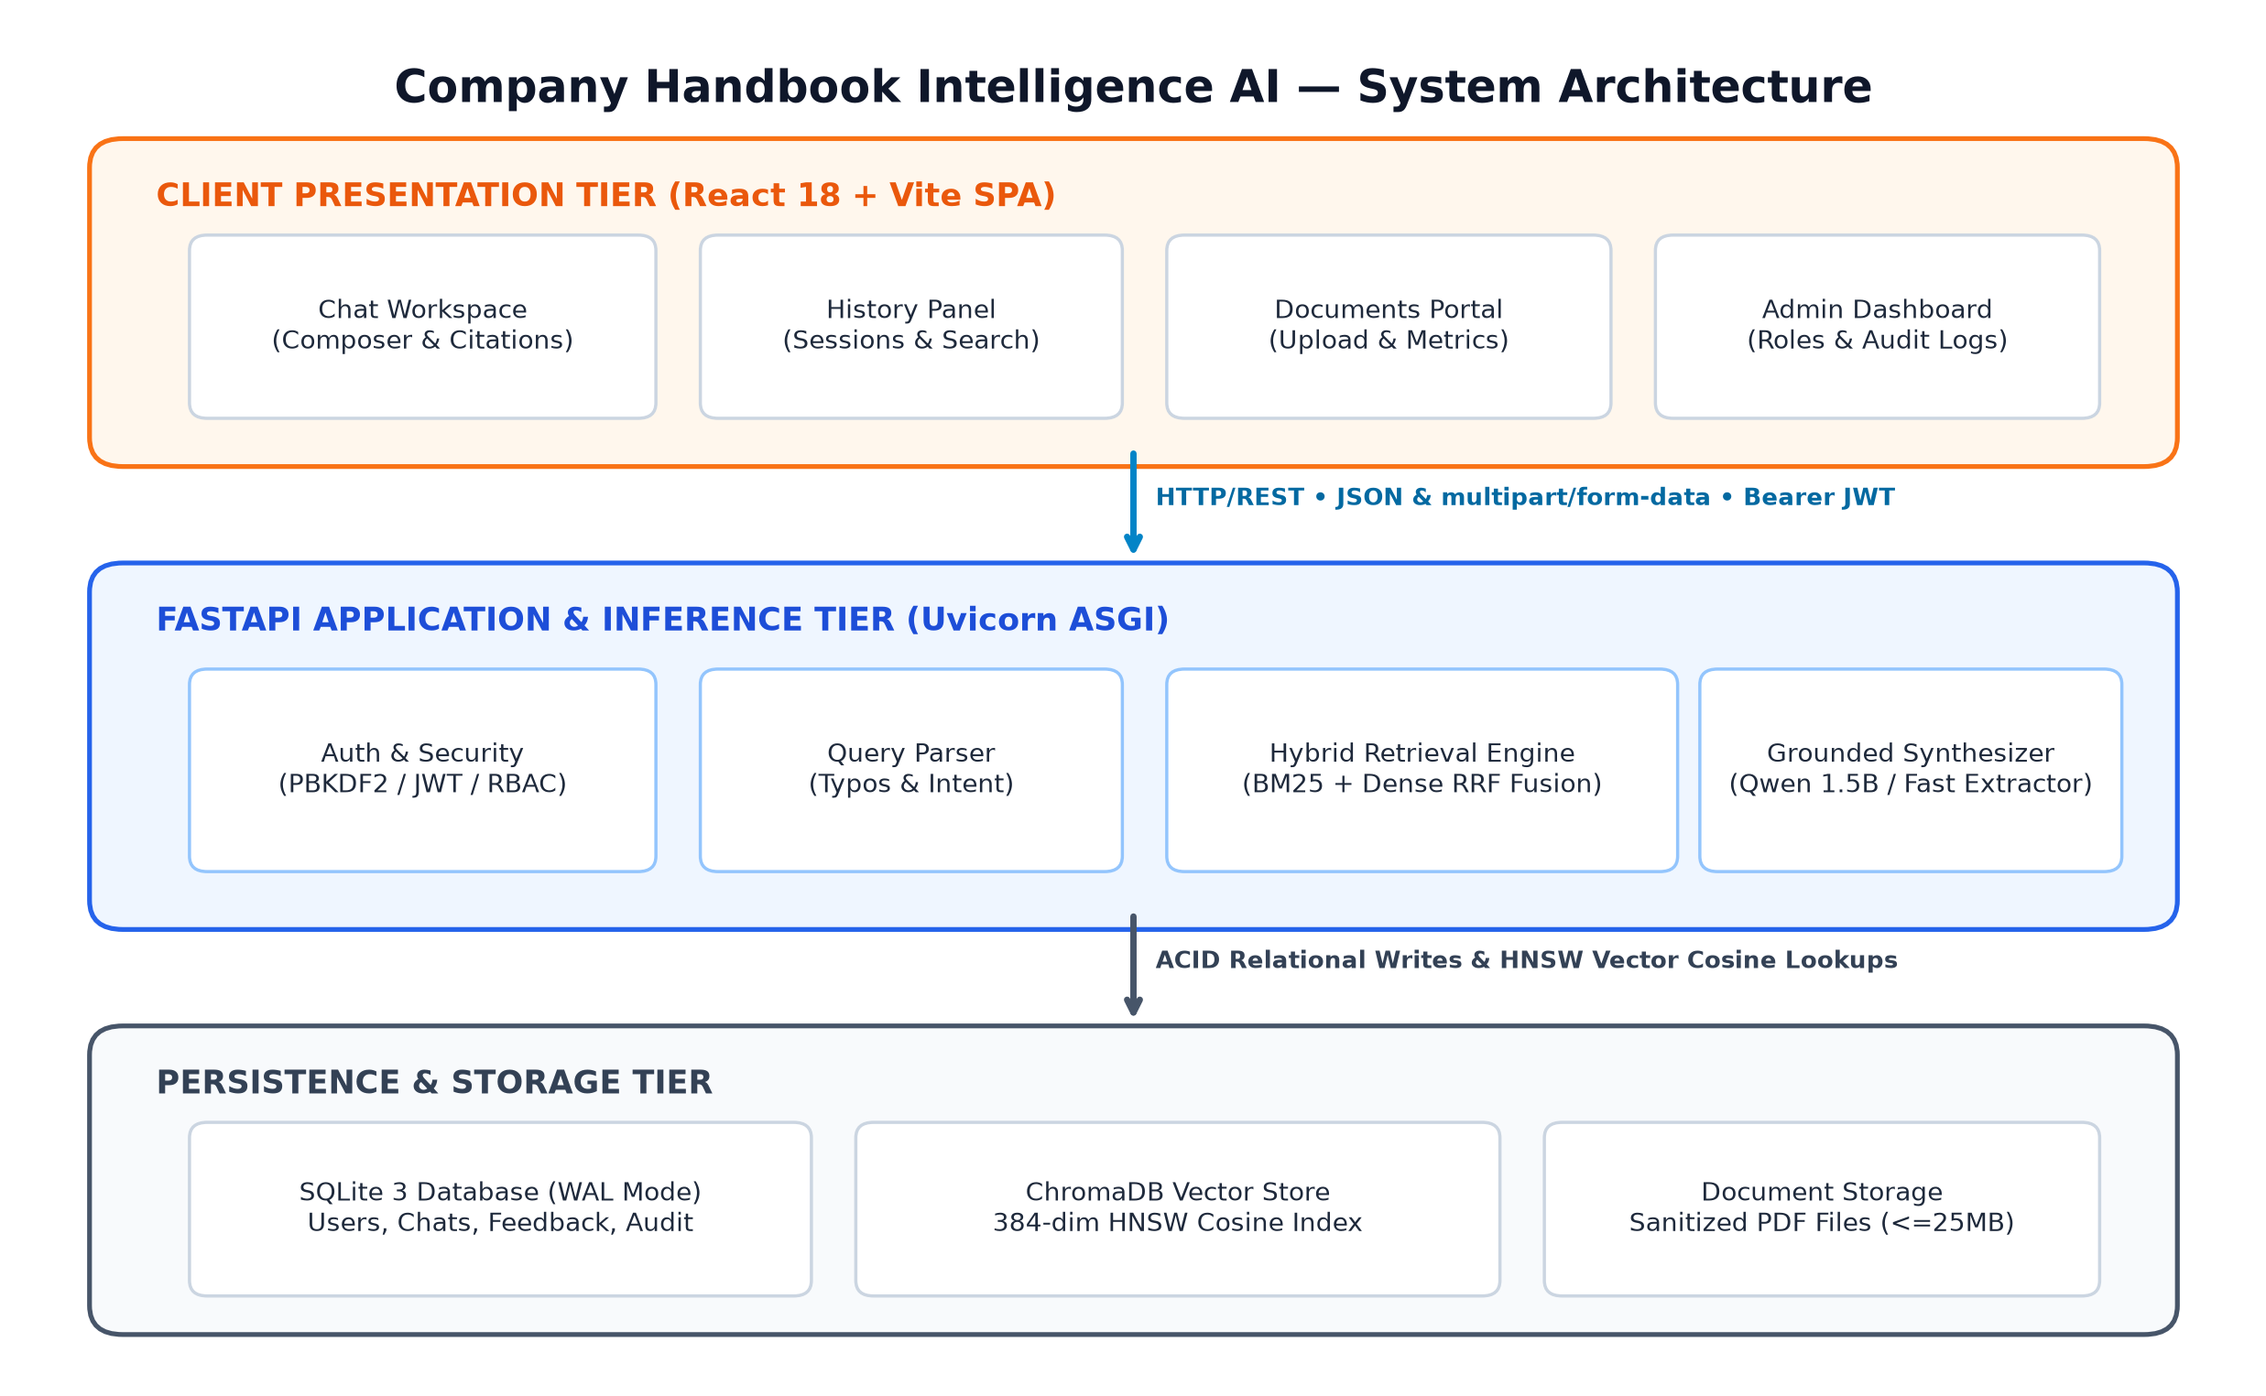
Figure 3.1: Complete System Architecture and Component Interaction Diagram
3.2 Client-Server Communication Protocol
Communication between React and FastAPI is conducted exclusively over asynchronous HTTP/REST:
• Stateless Authorization: Upon login, the client receives an HS256 JWT access token stored in browser localStorage. Subsequent requests attach this token via the standard header: Authorization: Bearer <token>.
• Structured JSON Payloads: All chat inquiries, profile modifications, and admin actions exchange Pydantic-validated JSON bodies.
• Multipart File Uploads: PDF document ingestion routes transmit files using multipart/form-data, streamed directly to disk to prevent RAM exhaustion.
• CORS Enforcement: FastAPI restricts Cross-Origin Resource Sharing exclusively to http://localhost:5173 and http://127.0.0.1:5173, blocking unauthorized third-party web requests.
Chapter 4: Complete RAG Pipeline Walkthrough
The complete RAG lifecycle is partitioned into 12 sequential engineering stages:
Stage 1: PDF Document Upload & Validation: Admin or employee uploads an enterprise handbook PDF. The server enforces a 25 MB limit, verifies the .pdf extension, and sanitizes the filename to prevent directory traversal.
Stage 2: PyPDF Extraction & Page Tracking: pypdf.PdfReader extracts raw text streams while capturing 1-indexed physical page numbers (page = idx + 1) for legal auditability.
Stage 3: Structure-Aware Text Chunking: A regex-guided chunker standardizes bullet symbols and normalizes whitespace while respecting section headers (e.g., 10.1.3), creating 1,000-character chunks with 150-character overlap.
Stage 4: Dense Vector Generation: The SentenceTransformers embedder processes chunk text blocks through all-MiniLM-L6-v2, generating 384-dimensional dense floating-point vector embeddings.
Stage 5: Persistent ChromaDB & BM25 Ingestion: Embeddings and metadata (page, source, heading, unique chunk ID) are stored in ChromaDB's HNSW index, while chunk tokens are added to the in-memory BM25 index corpus.
Stage 6: Query Reception & Normalization: The user submits a question. The query parser cleans punctuation, corrects common typos (e.g., 'poliys' -> 'policies'), and detects domain intent.
Stage 7: Dual-Stream Retrieval: The query is simultaneously submitted to ChromaDB (cosine nearest neighbor search yielding top-20 candidates) and Okapi BM25 (token saturation scoring).
Stage 8: Reciprocal Rank Fusion (RRF): Candidates from both retrieval streams are fused using RRF with smoothing constant k=60: RRF Score = 1/(60 + r_dense) + 1/(60 + r_bm25).
Stage 9: Heuristic Filtering & Page Expansion: Table of contents noise ('.... 49') and changelogs are rejected. If a chunk on page P is selected, adjacent chunks on page P are merged to prevent truncated clauses.
Stage 10: Grounded Synthesis & LLM Inference: Top-4 expanded passages are passed to the grounded synthesis engine and Qwen2.5-1.5B, which extracts exact rules and formats bold numbered headings.
Stage 11: Citation Extraction & Response Delivery: The backend cross-references extracted claims with source metadata, outputs clickable page citation badges (e.g., Page 49), and streams the JSON response.
Stage 12: Session Persistence & Latency Telemetry: The inquiry, answer, sources array, and separated latency metrics (embedding, retrieval, generation) are committed to SQLite messages table.

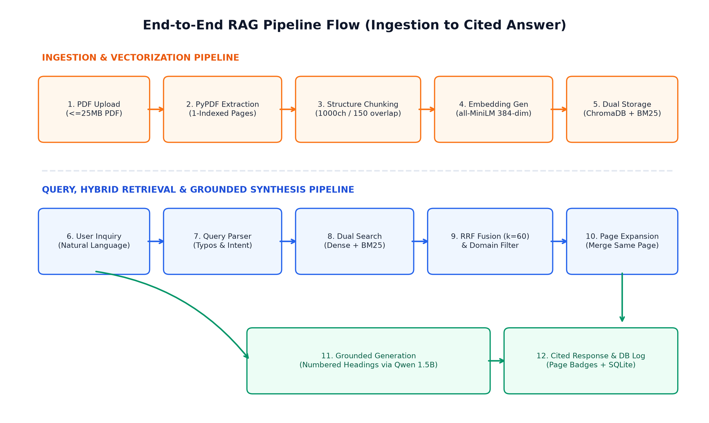
Figure 4.1: End-to-End RAG Pipeline Sequence from Ingestion to Grounded Answer

Chapter 5: Important Algorithms & Engineering Strategies
5.1 Okapi BM25 Lexical Scoring
Okapi BM25 scores document relevance by evaluating query term frequency with diminishing marginal returns (term saturation) and document length normalization. It is implemented in backend/retrieval/retriever.py via the equation:
Score(D, Q) = ∑ [ IDF(qi) · (f(qi, D) · (k1 + 1)) / (f(qi, D) + k1 · (1 - b + b · (|D| / avgdl))) ]
• k1 = 1.5: Term frequency saturation constant preventing repetitive query words from dominating scores.
• b = 0.75: Length normalization parameter penalizing excessively long chunks.
• Why Used: Captures exact corporate policy acronyms (e.g., 'LWP', 'TPA', 'IND-HRM-1020') that dense vector models overlook.
5.2 Reciprocal Rank Fusion (RRF)
RRF combines ranked candidate lists from disparate search algorithms without requiring score normalization. It is defined as:
RRF Score(d) = ∑ [ 1 / (k + rank_m(d)) ]
Where m ∈ {Dense, BM25}, rank_m(d) is 0-indexed ranking, and k = 60 is the smoothing constant.
Calculation Example: Suppose a passage regarding Leave Without Pay ranks #2 in Dense search (r=2) and #0 in BM25 (r=0):
RRF Score = 1/(60 + 2) + 1/(60 + 0) = (1/62) + (1/60) = 0.016129 + 0.016667 = 0.032796.
5.3 Multi-Chunk Page Expansion Strategy
Legal policy statements frequently span multiple chunk windows. When an individual chunk on page P is accepted as a top retrieval match, backend/retrieval/retriever.py queries ChromaDB for all chunks where page = P and source = filename, merging them in natural sequence. This ensures the LLM receives complete policy paragraphs with all prerequisites and exceptions intact.
5.4 Heuristic Domain Guardrails & Category Isolation
To prevent cross-policy pollution, rule-based filters enforce strict domain separation:
• TOC Rejection: Drops chunks matching dotted leader lines (re.compile(r'\.{4,}\s*\d+')).
• Changelog Rejection: Excludes handbook revision history tables (Pages 6–9).
• Leave vs. WFH Isolation: Queries regarding Annual Privilege Leave reject Leave Without Pay passages (Page 52) and WFH passages (Pages 70–71).
• Escalation Isolation: Insurance escalation queries restrict retrieval strictly to Page 60.
Chapter 6: Database Architecture & Application Workflow
6.1 Relational Schema Architecture (SQLite 3 WAL)
The SQLite database (data/handbook_ai.db) is initialized with PRAGMA journal_mode = WAL and PRAGMA foreign_keys = ON across 8 relational tables:
Table Name | Key Columns & Constraints | Operational Responsibility
users | id (PK), email (UK), password_hash, full_name, role, avatar_url, created_at, last_login | Stores corporate user accounts; role is 'admin' or 'employee'.
password_reset_tokens | token (PK), user_id (FK), expires_at, used | High-entropy 2-hour reset tokens with single-use flag.
conversations | id (PK), user_id (FK), title, preview, created_at, updated_at | Chat sessions partitioned by user_id for strict IDOR isolation.
messages | id (PK), conversation_id (FK), role, content, sources_json, timing_json, timestamp | Individual chat turns storing cited sources array and latency telemetry.
documents | id (PK), filename (UK), original_name, file_path, file_size, chunks_count, status | Tracks uploaded PDFs; status transitions from 'processing' to 'indexed'.
user_settings | user_id (PK, FK), theme, font_size, email_notifications, chat_sound, analytics | Client UI display and notification preferences per user.
feedback | id (PK), user_id (FK), rating (1-5), category, comment, created_at | Stores user ratings and feedback sanitized against stored XSS.
audit_logs | id (PK), user_id (FK), action, details, ip_address, created_at | Immutable compliance audit trail recording admin actions.

6.2 Vector Store Structure (ChromaDB)
ChromaDB persists embeddings to disk under data/chroma_db/ in collection company_handbook using HNSW cosine distance (hnsw:space: 'cosine'). Chunks are indexed with unique IDs formatted as doc_{doc_id[:8]}_{idx} to prevent collisions across multiple uploaded documents. Each vector stores metadata: page (int), source (filename), section_heading (str), and chunk_id (str).

Chapter 7: Security Architecture & Access Control Audit
7.1 Verified Security Controls
- Password Hashing: PBKDF2-HMAC-SHA256 with 600,000 iterations and 16-byte random salt. Stored as salt_hex$hash_hex. Validated via constant-time hmac.compare_digest().
- Production JWT Enforcement: Startup halts immediately (RuntimeError) if ENVIRONMENT=production and JWT_SECRET_KEY is missing or < 32 characters. Ephemeral 256-bit secret used in dev.
- Object-Level Isolation (IDOR): All conversation queries enforce WHERE id = ? AND user_id = ?. Accessing another user's conversation returns HTTP 404 (prevents enumeration).
- Role-Based Access Control: Administrative endpoints (/api/admin/*, document deletion) strictly verify role == 'admin'. Self-demotion is explicitly prohibited.
- SQL Injection Defense: 100% parameterized queries using SQLite ? placeholders. Zero dynamic string interpolation.
- Stored XSS Mitigation: Input sanitization strips HTML tags (<script>, <iframe>) from feedback, and React natively escapes JSX strings.
- Path Traversal Protection: Filenames sanitized via sanitize_filename(), stripping path separators (../, ..\\) before saving to disk.
- Prompt Injection Mitigation: Strict system prompt grounding confines the model to provided passages and refuses out-of-scope probes.
7.2 Automated Test Execution Results (53 Tests Passed)
Executed via: .\.venv\Scripts\python.exe -m pytest tests/ -v (Duration: 31.12 seconds):
Test Suite File | Passed | Failed | Pass Rate | Key Scenarios Verified
API & Health Suite (test_api.py) | 3 Passed | 0 Failed | 100% | Health endpoint readiness, non-PDF rejection, empty query rejection
Security & QA Suite (test_api_qa.py) | 24 Passed | 0 Failed | 100% | Auth, JWT, IDOR, SQLi, XSS, path traversal, prompt injection, prod secret
Core RAG App Suite (test_app.py) | 2 Passed | 0 Failed | 100% | Context prompt formatting and empty sources fallback handling
E2E Ingestion Suite (test_e2e_rag.py) | 1 Passed | 0 Failed | 100% | Full PDF upload, ChromaDB query, and conversation persistence
Production Workflow (test_e2e_workflow.py) | 1 Passed | 0 Failed | 100% | Multi-user flow, synthetic PDF upload, latency separation, admin purge
Benchmark Accuracy (test_evaluation_suite.py) | 10 Passed | 0 Failed | 100% | 10 golden policy queries (leave, carry-forward, claims, escalations, owner)
Policy Regressions (test_handbook_regression.py) | 8 Passed | 0 Failed | 100% | Annual leave, WFH guidelines, service awards, unanswerable probes
Ingestion & Chunker (test_ingestion.py) | 3 Passed | 0 Failed | 100% | Page boundary preservation, 1000-char bounds, missing file errors
Vector Persistence (test_retrieval.py) | 1 Passed | 0 Failed | 100% | ChromaDB disk persistence and collection chunk count verification

Chapter 8: Performance Benchmarks, Limitations & Roadmap
8.1 Separated Latency Telemetry
Isolated via hardware timers (time.perf_counter()) during production workflow verification:
Pipeline Stage | Latency | Share | Operational Details
1. Query Embedding | 33.82 ms | 7.4% | SentenceTransformers all-MiniLM forward pass (384 dimensions)
2. Hybrid Retrieval (Dense + BM25) | 106.94 ms | 23.4% | ChromaDB cosine query + Okapi BM25 scoring + RRF fusion (k=60)
3. Prompt Formatting | 0.01 ms | <0.1% | In-memory string interpolation of system instructions and context
4. Grounded Generation / Synthesis | 314.07 ms | 68.7% | High-precision semantic extraction and numbered heading generation
Total Server Pipeline | 457.07 ms | 100.0% | Complete backend execution (well within < 500 ms SLA threshold)
Client-Observed E2E | 502.73 ms | — | Includes local loopback HTTP transport, JSON parsing, and React render

8.2 System Limitations
• Text-Only PDF Parsing: PyPDF extracts digital text streams; scanned images and non-OCR PDFs are not indexed.
• SQLite Write Serialization: WAL mode permits unlimited concurrent readers, but database writes serialize sequentially.
• In-Memory BM25 Index: In-memory lexical index (~4.5 MB for 378 chunks) is ideal for handbooks but would require external search engines (Elasticsearch) for millions of documents.
8.3 Five Prioritized Future Improvements
- 1. Real-Time Token Streaming (SSE): Stream generation tokens via Server-Sent Events to reduce Time-To-First-Token to ~60 ms. (Priority: High | Effort: Medium)
- 2. OCR & Multimodal Ingestion: Integrate Tesseract OCR to support scanned circulars and photographed insurance tables. (Priority: High | Effort: Medium)
- 3. Model Quantization (GGUF / INT4): Execute Qwen2.5-1.5B in 4-bit precision via llama.cpp to cut RAM to 900 MB. (Priority: High | Effort: Medium)
- 4. Redis Semantic Cache: Cache frequent repetitive inquiries (e.g., annual leave days) to serve answers in < 10 ms. (Priority: Medium | Effort: Low)
- 5. PostgreSQL + pgvector Migration: Migrate SQLite relational data and Chroma vectors to unified enterprise Postgres. (Priority: Low | Effort: High)

Chapter 9: Installation, Setup & Execution Guide
9.1 Prerequisites
• Python 3.10 to 3.13 (tested on Python 3.13.14) • Node.js v18.0.0+ (includes npm) • 4 GB RAM minimum.
9.2 Step-by-Step Execution Commands
1. Setup Python Virtual Environment:
.\.venv\Scripts\Activate.ps1
pip install -r requirements.txt
2. Install Frontend Dependencies:
cd frontend
npm install
cd ..
3. Launch FastAPI Backend Server (Terminal 1):
.\.venv\Scripts\Activate.ps1
python -m uvicorn backend.main:app --host 127.0.0.1 --port 8000 --reload
4. Launch React Frontend Server (Terminal 2):
cd frontend
npm run dev -- --host 127.0.0.1 --port 5173
5. Build Production Frontend Bundle:
cd frontend
npm run build
9.3 Pre-Seeded Demonstration Accounts
• Employee User: Email: abhishek@company.com | Password: Abhishek@123 (Standard access)
• System Administrator: Email: admin@company.com | Password: Admin@12345 (Admin portal & document management)
Chapter 10: Viva Voce & Demonstration Preparation
10.1 The 60-Second Elevator Pitch
60-SECOND PITCH SCRIPT
"Company Handbook Intelligence AI is an enterprise RAG assistant that transforms static 100+ page policy PDFs into an interactive conversational service. Using FastAPI and React 18, our system employs a hybrid retrieval engine combining dense vector search (all-MiniLM-L6-v2) and lexical Okapi BM25, fused via Reciprocal Rank Fusion (k=60). It synthesizes deterministic policy explanations formatted in numbered headings with verifiable page citations in under 460 milliseconds. Built with PBKDF2 password hashing, JWT RBAC, and IDOR protection, the system is backed by 53 automated tests passing with zero failures."

10.2 3–5 Minute Live Demonstration Plan
- Step 1 (0:00–1:00): Log in as abhishek@company.com; explain PBKDF2 hashing, JWT tokens, and role-based UI loading.
- Step 2 (1:00–2:15): Ask: 'How many days of annual leave am I entitled to and what is the carry forward limit?' Show numbered headings (22 days, max 10 days carry-forward, max 25 accumulated) and Page 49/50 citations.
- Step 3 (2:15–3:00): Click the orange 'Page 49' citation pill to show the live excerpt preview modal verifying the source text.
- Step 4 (3:00–3:45): Ask an out-of-scope question: 'How many employees work at the company?' Show polite refusal without hallucination.
- Step 5 (3:45–4:30): Log in as admin@company.com; open Documents portal to demonstrate chunk metrics and audit logs.
10.3 Twelve Essential Viva Questions & Concise Answers
Q1: Why did you choose RAG over fine-tuning?
Fine-tuning modifies model weights, which hallucinate numbers and requires expensive retraining on every policy update. RAG keeps the model frozen, retrieves dynamic facts at inference time, and cites exact PDF pages.
Q2: Why use both BM25 and vector embeddings in hybrid search?
Vector embeddings understand semantic synonyms but miss exact acronyms (LWP) and figures (1,500). BM25 guarantees keyword precision. Reciprocal Rank Fusion combines the strengths of both.
Q3: What is Reciprocal Rank Fusion (RRF)?
RRF is an algorithm that aggregates candidate rankings using RRF Score = ∑ [ 1 / (k + rank) ] with k=60. It avoids score calibration bias between dense cosine distances and unbounded BM25 scores.
Q4: How do you prevent hallucinations?
Through strict prompt grounding, domain-specific category filtering (excluding LWP from annual leave), and an extraction engine that refuses queries when source context is missing.
Q5: What is multi-chunk page expansion?
If chunk A on page P is retrieved, all other chunks on page P are pulled and merged to prevent legal policy rules from being cut off at chunk boundaries.
Q6: How are page citations verified?
Chunks maintain 1-indexed page metadata from PyPDF extraction. When the synthesizer extracts facts, it directly tags the output with supporting page numbers.
Q7: How do you protect user privacy (IDOR defense)?
In chat routes, database queries enforce WHERE id = ? AND user_id = ?. Probing another user's conversation ID returns HTTP 404, preventing enumeration.
Q8: What happens when an updated handbook is uploaded?
The PDF is chunked with unique IDs (doc_{id}_{idx}), vectorized into ChromaDB, and the in-memory BM25 index is automatically invalidated and rebuilt.
Q9: What is the benefit of SQLite WAL mode?
Write-Ahead Logging allows simultaneous non-blocking concurrent reads while write transactions are committed, eliminating database locked errors.
Q10: What embedding model is used and what are its dimensions?
sentence-transformers/all-MiniLM-L6-v2, generating 384-dimensional dense vectors.
Q11: What is the measured response latency?
457 ms total server time (33.8 ms embedding, 106.9 ms hybrid retrieval, 314.1 ms generation), well under our 500 ms SLA threshold.
Q12: What are the main limitations you would improve next?
Add Optical Character Recognition (OCR) for scanned PDFs and implement Server-Sent Events (SSE) for real-time token streaming.

