**Project Report on**

**Real Estate Price Prediction**

**Submitted by:**

**Jasleen Kaur**

**Tannu dhanda**

**In partial fulfillment of completion of the course**

**Advanced Diploma in IT, Networking and Cloud Computing.**

**Under Guidance of:**

|  |  |  |
| --- | --- | --- |
| IBM-Logo - Chicago Innovation | DGT introduces high end diploma courses - digitalLEARNING Magazine | Edunet Foundation-Delhi- CSR Organization profile |

**Year 2022-2023**

**Abstract**

The "Bengaluru House Data Analytics for Real Estate Insights" project is a comprehensive initiative focused on leveraging data-driven approaches to gain valuable insights into the real estate landscape of Bengaluru, India. Through extensive data collection, analysis, and visualization, this project aims to provide stakeholders with a nuanced understanding of the housing market dynamics in one of India's fastest-growing cities.

**Acknowledgement**

At this juncture of our journey, we wish to express our heartfelt gratitude to all those who have contributed to the creation and success of **"Real Estate Price Prediction".** This project has been a labor of passion and dedication, and it would not have been possible without the unwavering support and guidance we have received.

First and foremost, we offer our thanks to the boundless creativity and inspiration that flows from the universe. We are grateful for the opportunity to embark on this venture.

We extend our sincerest appreciation to our mentors, **Mrs. Mala Mishra & Ms. Ankita Shukla**, whose wisdom and guidance have been instrumental in shaping the vision of **“Real Estate Price Prediction ".** Your support at every crucial turn has illuminated our path and fueled our determination to create a meaningful platform.

To our dedicated team of developers, designers, and content creators, we extend our deepest gratitude. Your tireless efforts, innovation, and creativity have breathed life into **" Real Estate Price Prediction ".** It is your collective dedication that has made this project a reality.

Our appreciation also goes to our colleagues and friends who provided invaluable insights and feedback during the development process. Your input has been instrumental in refining our ideas and enhancing the user experience.

We acknowledge the contributions of the broader IT community, whose open-source ethos has been a wellspring of knowledge and inspiration. The collaborative spirit of this community has been a guiding light.

Last but not least, we owe a debt of gratitude to our families and friends who have stood by us throughout this journey. Your unwavering support, encouragement, and belief in our vision have been our constant motivation.

**ADVANCE DIPLOMA IN IT NETWORKING**

**& CLOUD COMPUTING**

**_______________________________________________**

The Advanced Diploma in IT Networking and Cloud Computing program offered by NSTI (W) Noida in collaboration with Edunet Foundation is a comprehensive course designed to equip students with advanced skills in information technology and cloud computing. This program covers a wide range of topics, including Computer Networking, Database Management, Virtualization, Cloud Technologies, and Cybersecurity. Students will gain hands-on experience through practical labs, workshops, and real-world projects, enabling them to excel in the rapidly evolving IT industry. Upon completion of the program, Graduates will have a strong foundation in both IT Fundamentals and Cloud Computing, making them highly sought-after professionals in the field.

**Project Requirements**

|  |  |
| --- | --- |
| **Project Name** | **Real Estate Price Prediction** |
| **Languages Used** | **Python** |
| **Editor** | **Jupyter Notebook, Google Colab** |
| **Web Browser** | **Google Chrome, Microsoft Edge** |

**Team Composition and Workload Division**

|  |  |
| --- | --- |
| Jasleen Kaur | Data Analysis, Synopsis |
| Tannu Dhanda | Data Analysis, Synopsis |

**Tables of Content**

|  |  |  |
| --- | --- | --- |
| **SNO** | **TOPIC** | **Page No** |
| 1. | PROBLEM STATEMENT | 5 |
| 2. | REQUIREMENTS SPECIFICATION | 5-6 |
| 3. | OVERVIEW | 6 |
| 4. | PROJECT MODULE | 7 |
| 5. | SAMPLE SCREENSHOTS | 7-8 |
| 6. | SOURCE CODE | 8-20 |
| 7. | FUTURE SCOPE | 20 |
| 8. | CONCLUSION | 21 |
| 9. | REFERENCES | 21 |

1. **Introduction to Problem**

The city of Bengaluru, renowned for its dynamic real estate market, is experiencing rapid urbanization and demographic shifts, resulting in a complex and evolving housing landscape. However, despite the city's prominence, there is a notable lack of comprehensive, data-driven insights that can guide stakeholders in making informed decisions related to real estate investments, urban planning, and housing development.

The "Bengaluru House Data Analytics for Real Estate Insights" project aims to address these challenges by:

**Aggregating and Integrating Data:** Consolidating diverse datasets related to Bengaluru's real estate to create a unified and comprehensive database.

**Developing Predictive Models:** Utilizing advanced analytics and machine learning to develop predictive models that forecast future property values and market trends.

**Creating Neighborhood Profiles**: Offering detailed profiles of different neighborhoods, facilitating a deeper understanding of local dynamics.

**Building an Accessible Interface:** Developing a user-friendly interface to ensure that the insights derived from the project are accessible to a wide range of stakeholders**.**

1. **Requirements**

**3.1 Technology Stack**

**Python:** High-level programming language used for server-side scripting.

**Jupyter Notebook:** Jupyter Notebook is an open-source web application that allows you to create and share documents containing live code, equations, visualizations, and narrative text, providing an interactive and collaborative environment for data science and analysis.

**3.2 Hardware**

Laptop/ Computer

**3.3 Software**

Operating System (OS)

Version Control System

Text Editors and Integrated Development Environments (IDEs)

**3.4 Deployment Environment**

**Github**

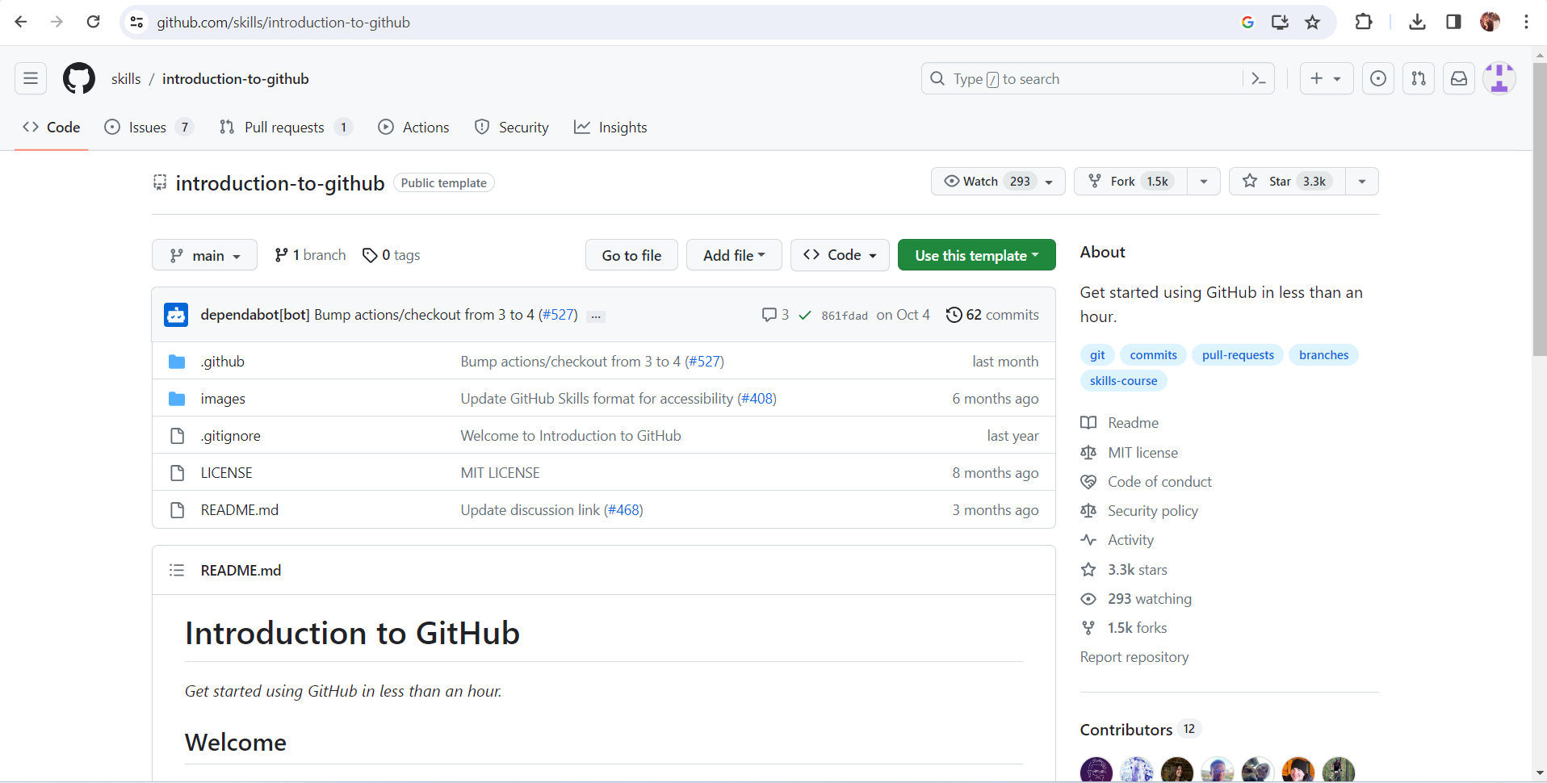

1. **Overview**

The data analysis project aims to investigate and derive meaningful insights from a specific dataset. It involves collecting, cleaning, and processing raw data to uncover patterns, trends, and correlations. Using statistical methods and visualization tools, the project seeks to provide a comprehensive understanding of the data, enabling informed decision-making. The analysis may involve exploring relationships between variables, identifying outliers, and creating predictive models. Throughout the project, a systematic approach is followed, including hypothesis testing and validation of results. The ultimate goal is to offer actionable recommendations or conclusions based on the data findings. The project typically employs programming languages such as Python or R, along with tools like Jupyter Notebooks, to facilitate a transparent and reproducible analytical workflow. Overall, the data analysis project serves to extract valuable insights, enhance understanding, and support evidence-based decision-making in a given domain.

1. **Project Module**
   1. Import the required libraries.
   2. Load/ Read the Dataset
   3. Prepare EDA
   4. Do Visualizations
   5. Effect of different gases on different states
   6. Prepare Heatmap/ Confusion Matrix
   7. Prepare Profile Report

**6 Sample Screenshots**

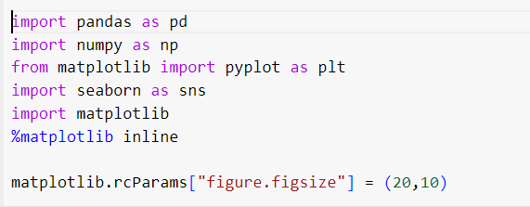

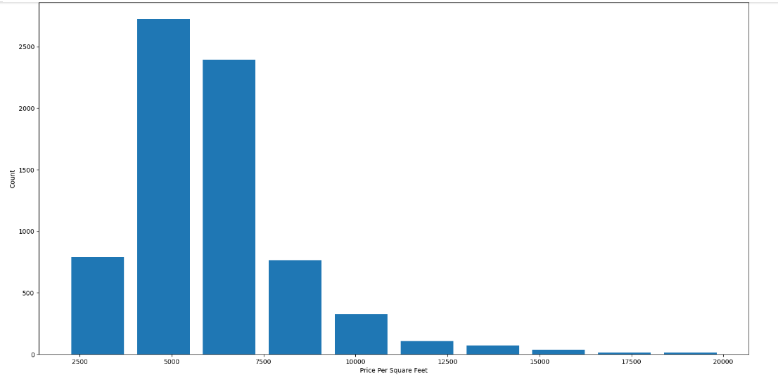

**7 Source Code**

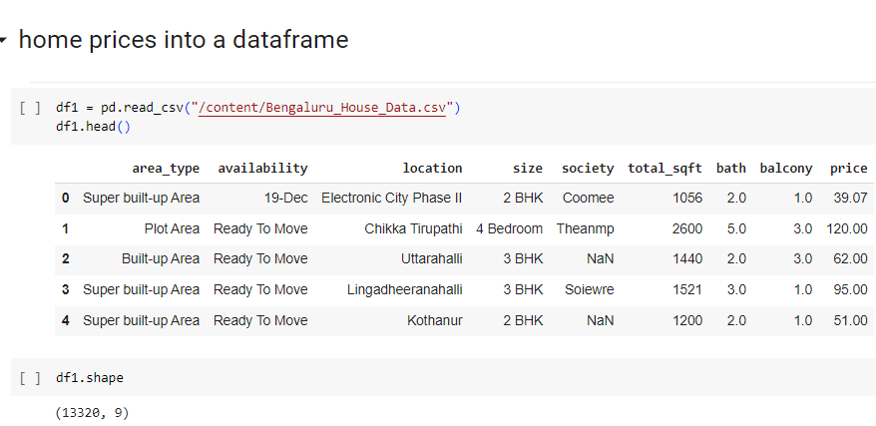

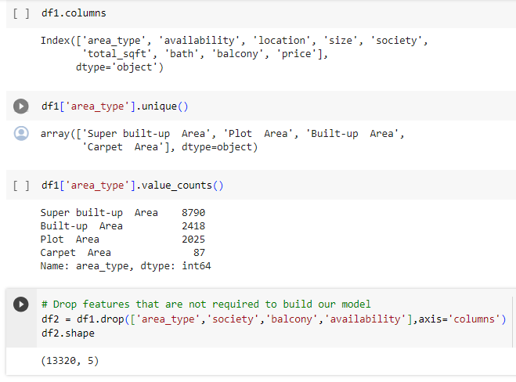

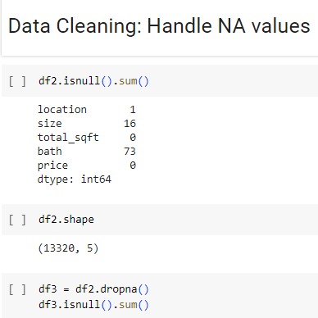

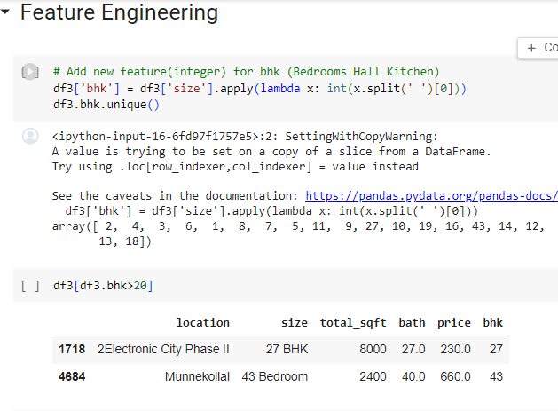

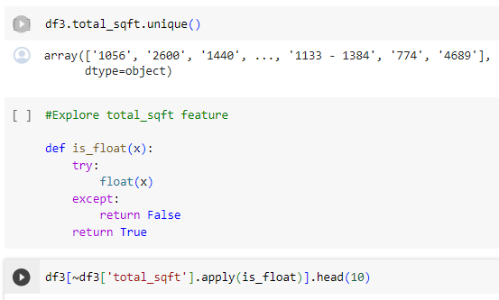

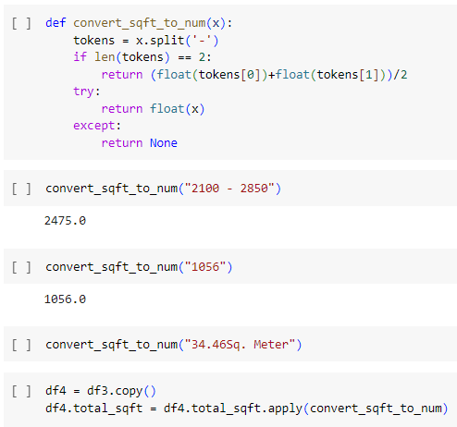

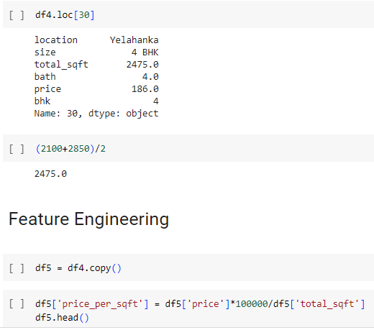

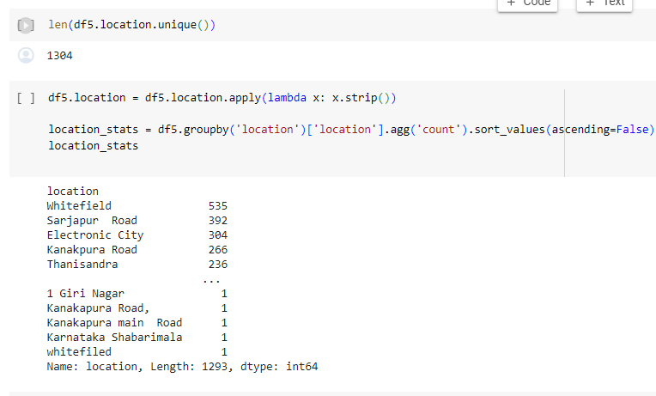

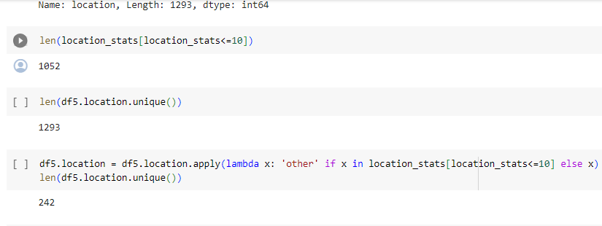



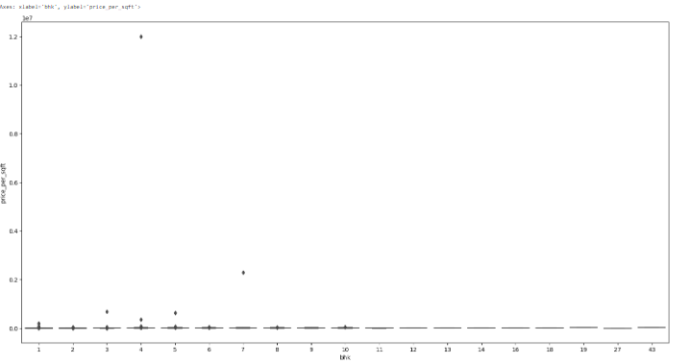

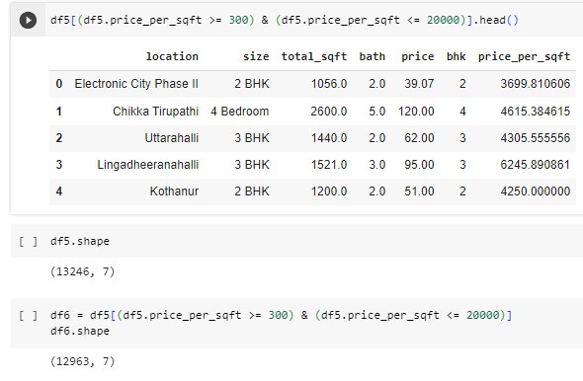

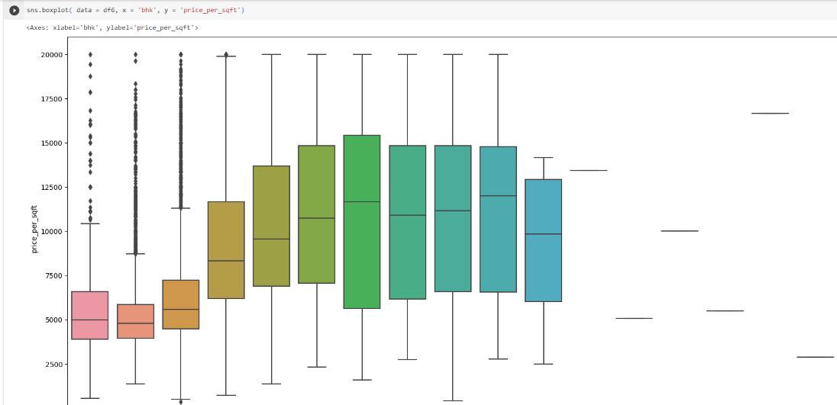

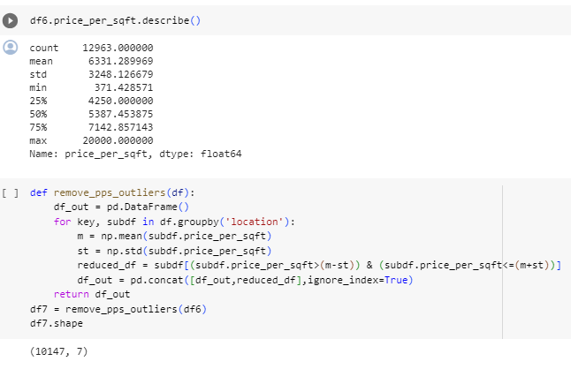

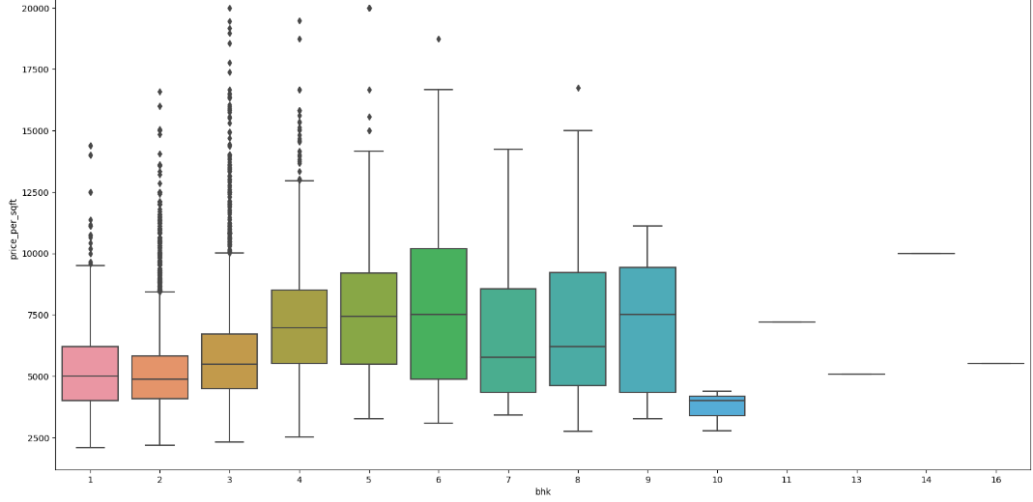

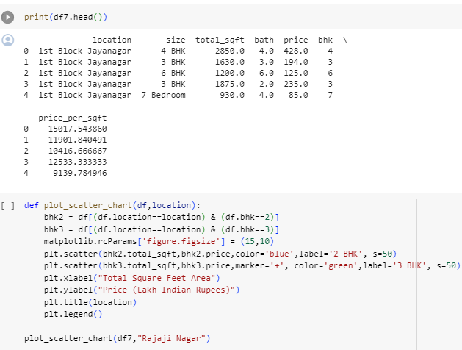

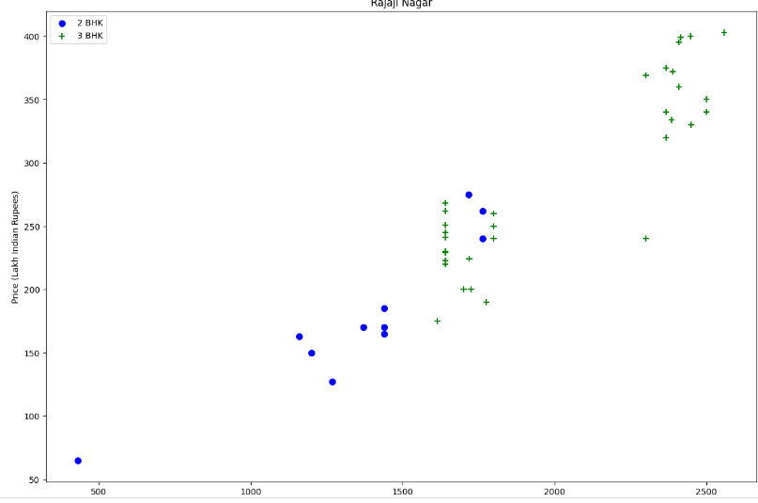

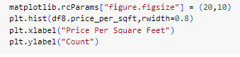

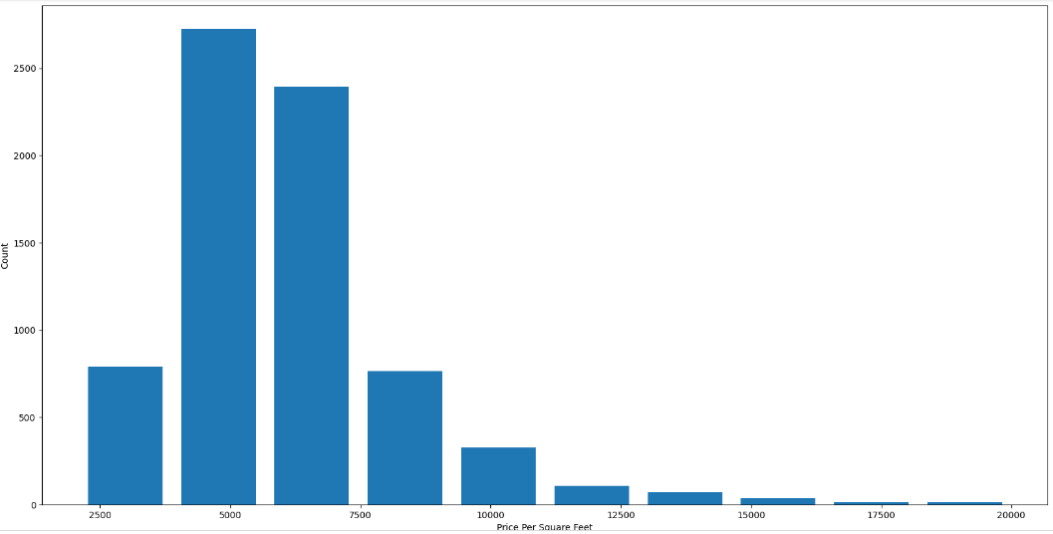

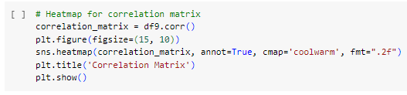

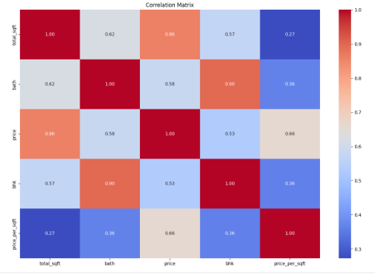

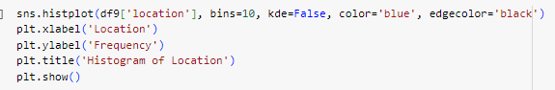

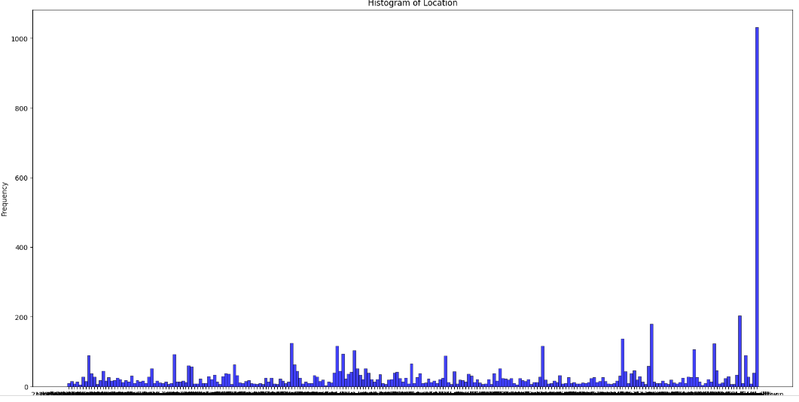

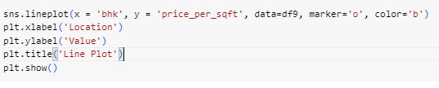

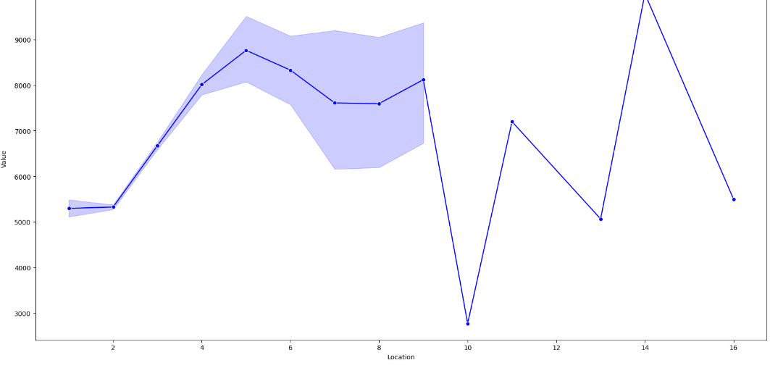

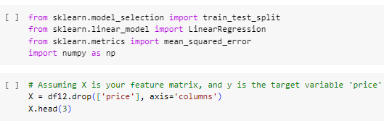

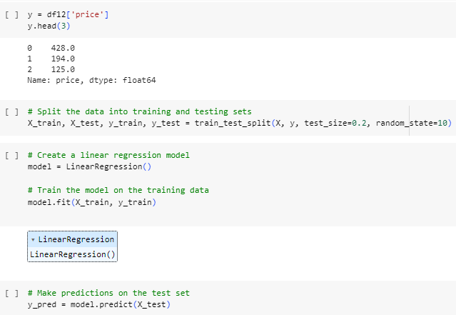

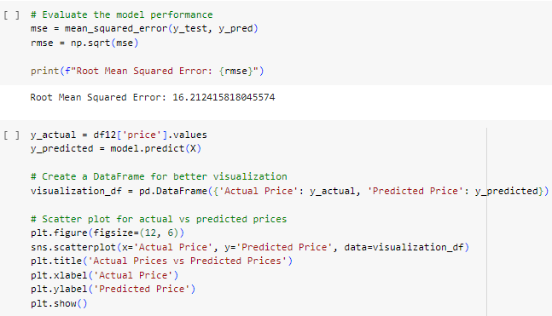

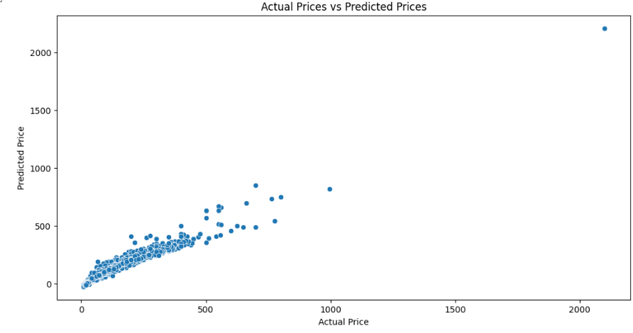

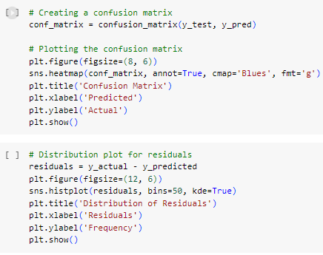

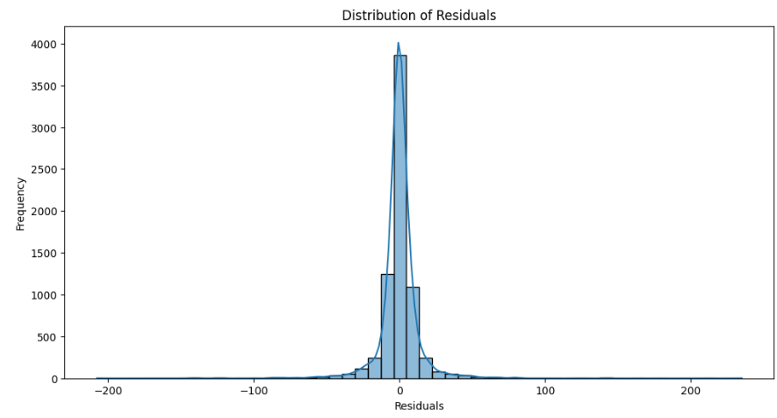

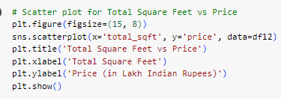

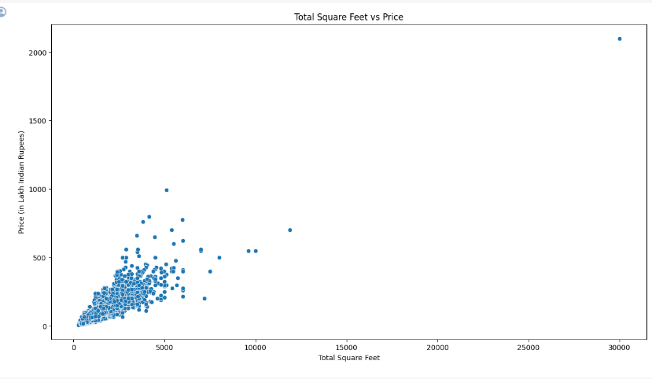

**8 Future Scope**

The "Bengaluru House Data Analytics for Real Estate Insights" project lays the foundation for ongoing advancements and contributions to the dynamic field of real estate analytics. The future scope of this project encompasses several key areas that will further enhance the understanding of Bengaluru's real estate landscape and drive sustainable growth.

By embracing the future-oriented initiatives, the "Bengaluru House Data Analytics for Real Estate Insights" project aims to stay at the forefront of technological and analytical advancements, contributing to the evolution and improvement of the real estate ecosystem in Bengaluru and beyond.

**9 Conclusion**

In conclusion, the "Bengaluru House Data Analytics for Real Estate Insights" project stands as a pioneering endeavor to revolutionize the understanding and management of the dynamic real estate landscape in Bengaluru. Through a systematic approach to data collection, analysis, and visualization, this project addresses critical challenges faced by stakeholders, providing valuable insights and tools for informed decision-making.

The project's journey begins with the recognition of existing challenges, including data fragmentation, the absence of predictive analytics, limited neighbourhood profiling, and restricted accessibility of insights. By meticulously addressing these issues, the project aims to bridge the gap between data and actionable intelligence, unlocking a multitude of opportunities for sustainable urban development and equitable housing practices.

**10 References**

<https://www.kaggle.com/datasets>

**Thank You**