This exercise will show the react work with good quality code and nicely designed React architecture separated into ES6 modules.

This exercise is concentrating on following sections:

1. It will focus on setting up React application architecture for this app.
2. It will focus on Redux related code to provide UI component with content data coming from a mock API.
3. It will focus on Redux-saga to make WEB API call and get the content for the application.
4. It will also include test driven framework Jest.

**What’s done?**

1. Implemented expected app behaviour with react architecture. Used Create-react-app command to create this project.
2. Implemented Redux to store the data in redux state which will be shared by all the components in future.
3. Implemented redux-saga to call API and on the basis of API call which can be either success or failure returning the required data or error respectively.
4. Implemented Jest to write test case for react application.
5. Use typescript to make application safer and include all the benefits provided by typescript.

**What’s Future?**

1. Implement authentication in application using OAuth.
2. Use React hooks.
3. Write more test cases.
4. Include React Routing.
5. Extend this application to include meal planner by selecting particular items and making a complete meal plan.

Folder Structure:

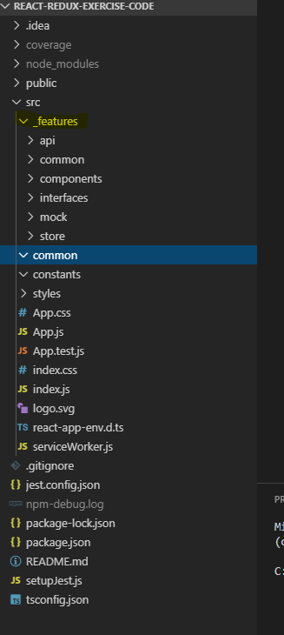

Current UI:

