**Abstract**

The goal of this project is to create an efficient attendance system which uses face recognition rather than biometric methods. The goal is to make the frontend for teachers as abstract and user friendly as possible. When the teacher starts the attendance procedure, the backend script runs which uses a web camera or any other image capturing device and identifies the person present in the frame, if the person is presented in the frame is also present in the database at the backend then attendance is made. Local binary pattern histograms are used for its high efficient results. Users of the application can take a picture under different circumstances, the used image recognition algorithm has to identify faces in frame under different conditions like low light, image blur etc.

For the frontend, NodeJS is used due to its asynchronous execution, which helps with a user -friendly front end for teachers which is easy to understand.

# Chapter 1: Introduction

#### (1.1) Project Introduction:

Face recognition is characterized as finding the situation of the substance of a person. At the end of the day it very well may be characterized as finding the face area in a picture. In the wake of identifying the substance of humans its facial highlights are separated and have a wide scope of utilizations like outward appearance acknowledgment, face acknowledgment, perception frameworks, human PC interface, etc… Detecting faces in a picture of a solitary individual is simple yet when we consider a gathering picture of a picture containing numerous countenances, the undertaking gets troublesome. For the use of face acknowledgment, location of face is significant and the initial step. Subsequent to distinguishing face the face acknowledgment calculation must be utilitarian. Face recognition itself includes a few complexities for instance environment, stances, illumination and so on. There are some current techniques for recognition of face. Some of them are skin shading based, trademark or highlight based (including mouth, nose and eyes) and neural system based. Face identification and acknowledgment isn't new in our general public we live in. The limit of the human personality to perceive specific people is amazing. It is astounding how the human personality can in any case endure in the ID of specific people even through the progression of time, in spite of slight changes in appearance.

#### (1.2) Statement of Problem:

This task is being done because of the worries that have been featured on the strategies which talks use to gauge participation during addresses. The utilization of clickers, ID cards swiping and physically recording names on a sheet of paper as a strategy to follow understudy orderlies has incited this undertaking to be done. This isn't in any capacity to censure the different strategies utilized for understudy participation, however to manufacture a framework that will distinguish the quantity of faces present in a homeroom just as remembering them. Likewise, an educator will have the option to tell if an understudy was straightforward as these techniques referenced can be utilized by anybody for participation records, however with the face discovery and acknowledgment framework set up, it will be anything but difficult to discern whether an understudy is really present in the homeroom or not. This framework won't just improve homeroom control during addresses, it will likewise conceivably recognize faces for understudy participation purposes. We will utilize Python and NodeJS with its various libraries to assemble and actualize this framework

#### (1.3) Objective:

Recognize students stored on a database of faces by matching them to images on a database with an accuracy within 50%. The system should be able to match detected students' faces cropped from an image to those on a database on the system. The system should be able to process an image within 10 minutes to be able to achieve the objective of recognition by the end of a lecture. i.e. 5 names per hour per lecture. The algorithm implemented for the system’s functionality will achieve system accuracy within 50%.The positive prediction should be within 50%. The system designed will be user friendly with a Graphical User Interface that will serve as an access to the functionalities of the system

#### (1.4) Methodology:

In our proposed system, the system is instantiated by the computer. After it initiates then the system starts processing the image of the students for which we want to mark the attendance. Image Capturing phase is one in which we capture the image of the students. This is the very basic phase from which we start initializing our system. We capture an image from our camera which predominantly checks for certain constraints like lightning, spacing, density, facial expressions etc. The captured image is resolute according to our requirements.

Once it is resolute, we make sure it is either in .png or .jpeg format. We take different frontal postures of an individual so that the accuracy can be attained to the maximum extent. For the captured image, from every object we detect only frontal faces. This detects only faces and removes every other part. These detected faces are stored somewhere in the database for further enquiry.

Features are extracted in the extraction phase.

# Chapter 2: Literature Survey

#### (2.1) Face identification:

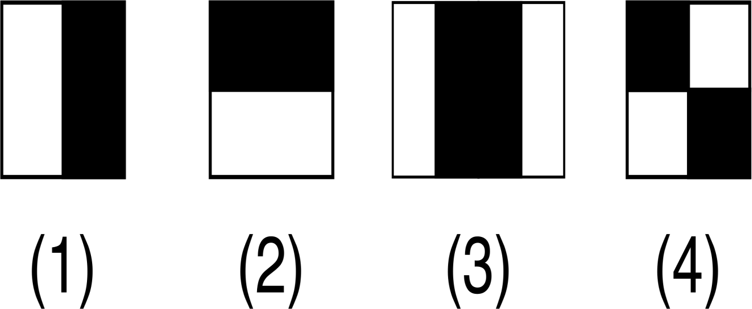

**Fig 2.1 Haar features**

Object recognition is one of the PC advances, which is associated with the picture handling and computer vision, alliance with different occurrences of an object, for e.g. faces, structures, trees, vehicles, and etc. The crucial part of face coordinate computation is to decide whether there is a human face in the image or not.

Face identification is a procedure of finding face inside a picture outline, paying little mind to the personality of that face. Before perceiving a face, it is the first fundamental to recognize and remove the appearances from the first pictures. Face Identification/detection focuses on discovering the faces in a picture and concentrating them to be used by the detection of face acknowledgment calculation. Lately, numerous techniques are preferred for identification of a face in an image. In face detection techniques, the individuals who are relying upon preparing sets to catch the immense unevenness in facial highlights have allured a lot of consideration and given the best outcomes. For the most part these strategies filter the info image and give the output of a presence of face or its absence. Viola and Jones displayed a successful location method utilizing Haar-like highlights and AdaBoost as a brisk preparing algorithm. For identifying a face, the computations look at only the faces present. Another constituent in the image that is not part of a face are rejected or unaccountable.

Mainly Classification(Face) is based on four kinds of features:

1. Edge Feature
2. Edge Feature
3. Line Feature
4. Four Rectangle Features

Each point corresponds to each feature in **figure 2.1** above.

#### (2.1.1) Haar Cascade classifiers and Haar Features

The necessary condition of the Viola Jones face identification is to examine the finder easily with the use of a similar image. Another size is examined at each time. Regardless of whether an image ought to contain at least a single instance of face is by no doubt an unreasonable course of false condition i.e Absence of a face. This recognition signals a different problem: Instead of identifying faces, the evaluation should discard parts with absence of faces. It is quicker to discard absence of a face rather than identifying a face. In the context of a finder consisting of one (in number) classifier appears to be wasteful, the computation time is steady regardless. Subsequently the necessity for a full classifier instantiates. The full classifier is constructed of various different stages. Each stage is to conclude whether a given image part is definitely absent of face or presence of a face. When a sub image is grouped to be absent of face by a given stage, then it is being discarded. Subsequently, a sub image shows a possible face in image is provided to the subsequent stages in the course. It pursues larger the number of stages a sub image passes through, more is the probability that the sub image contains the face.

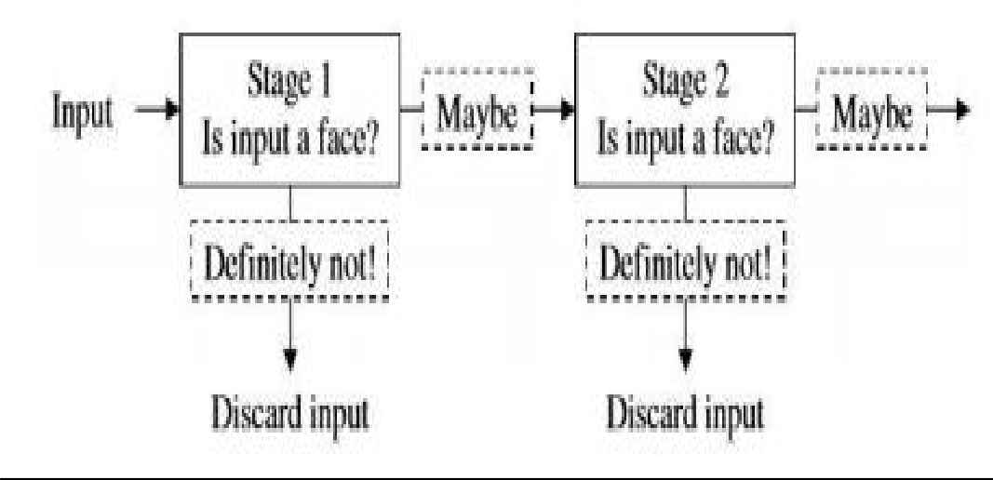

#### Fig 2.2 Face Detection

False negative cases are accepted for the sake of reducing false positive numbers and it is done at one stage of the classifier.

False positives are not considered to be a hindrance or a problem within the first stage of classifier because the following stages of the classifier will classify them. This is the reason why in the Viola Jones algorithm, false positives are accepted in initial stages of classifier. Following all the stages, in the final stage of classifier the number of false negatives are far less. Cascade classifiers are also described as attentional classifiers by Viola & Jones. Attentional is because large attention is aimed at the regions where there is high probability that face is present. Let there be n negative instances, then while training the set at any stage, all the negatives must be false negatives which are created at stage previous to n i.e.

(n-1).

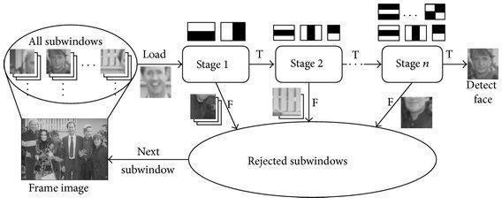

#### Fig 2.3 Channels & Sub Windows

The thought is passing these channels on the picture, investigating one bit (or window) at the time. At that point, for every window, all the pixel powers of, separately, white and dark segments are added. At last, the worth obtained by subtracting those two summations is the estimation of the element extricated. Preferably, an extraordinary estimation of a component implies it is important. A Haar-Feature is much the same as a piece in CNN, then again, actually in a CNN, the estimations of the bit are dictated by preparing, while a Haar-Feature is physically decided. When Haar highlights are applied to pictures. Each component brings about a solitary worth which is determined by subtracting the aggregate of pixels under white square shape from the whole of pixels under dark square shape. Each Haar includes a type of likeness to recognize a piece of face. Viola Jones utilizes 24*24 as base window size and ascertains the above highlights everywhere throughout the picture moving by 1 PX. On the off chance that we consider every single imaginable parameter of the haar highlights like position, scale and type we wind up figuring about 160,000+ highlights. So we have to assess tremendous arrangement of highlights for each 24*24 PX.

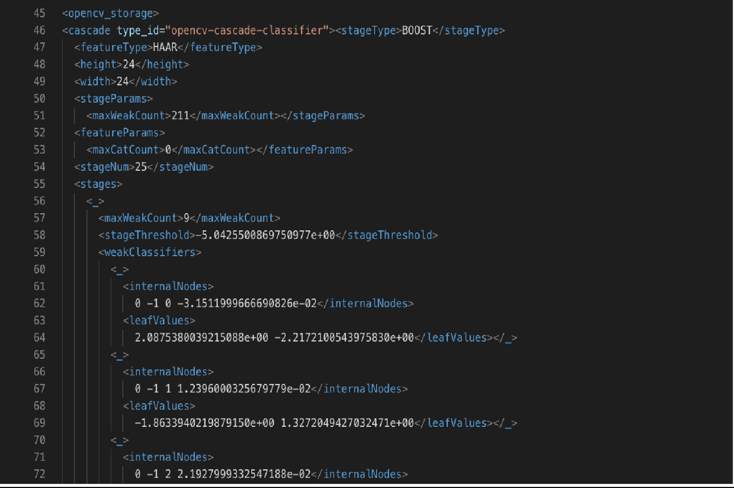

#### Fig 2.4 (haarcascade_frontal_face.xml) file code

#### (2.1.2) Local Binary Pattern Histograms(LBPH)

LocalBinaryPattern or LBP for short is a simple but productive method which names the pixels of an image by dividing the area of every pixel returns an ordered pair. Because of its simple working, local binary pattern method has become a mainstream approach in various image applications and even signal processing. The most remarkable property of the LBP method is its applications & its single computation to plane lower the high changes undertaking, for instance, by different illuminations of images. Another noteworthy feature is its simple computational effortlessness, which makes it work even for images with different setting, illuminations, rotations etc.

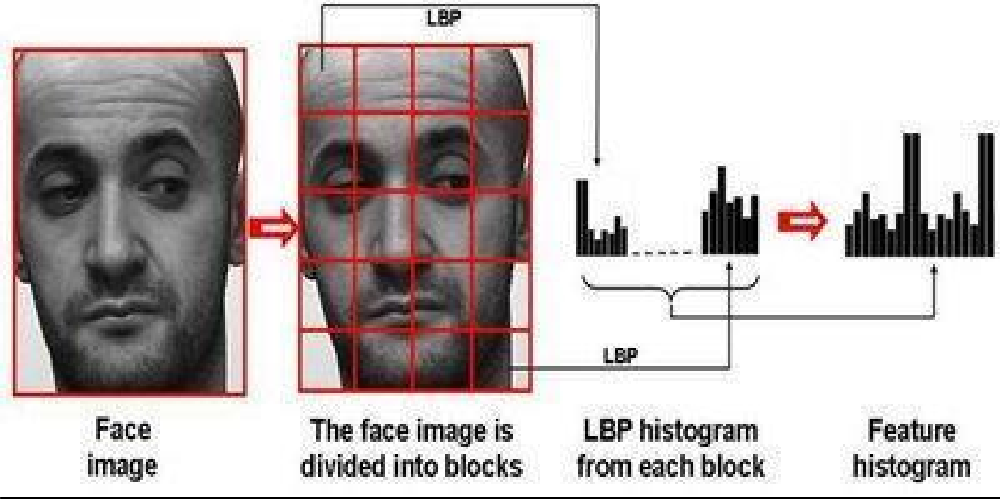

#### Fig 2.5 Histogram Generation(Blocks)

The fundamental approach of Local Binary Pattern based face identification is as follows: The face in the image is divided into neighborhood areas and its pixel identifier is released from every locale freely. The descriptors are then linked to frame a worldwide portrayal of the face, as appeared in Fig 2.5. The above histogram shows the face with 3 distinct degrees: LBP histogram from each block contains information of pixel values, names are added.

Let LBPP,Ru2 be the Local Binary Pattern operator.(P,R) ordered pair represents the neighborhood of the operator. Labelling all patterns except the uniform pattern and labelling the rest with a single label is represented by the variable u2.vThe image is stored the in the function named fl(x,y) with a label l, histogram is generated is generated using the following formula:



Where n represents count of labels generated by the Local Binary Pattern operator LBP(P,R)u2. If A is true then I=1 else I=0. Histograms are normalized using following:



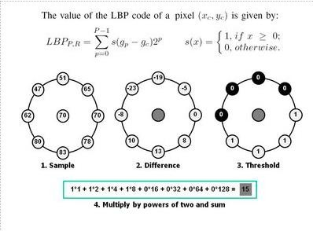

**Fig 2.6 LBP computation of a pixel**

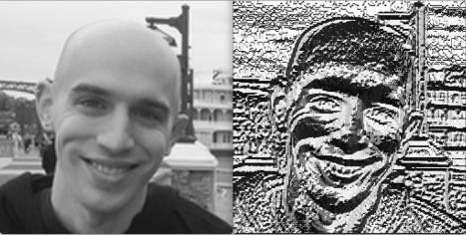

**Fig 2.7 (LBP Image)**

#### (2.2) Pre-processing:

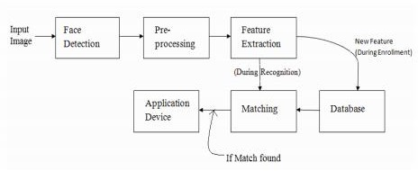

**Fig 2.8 Flow graph of Face recognition(plus identification)**

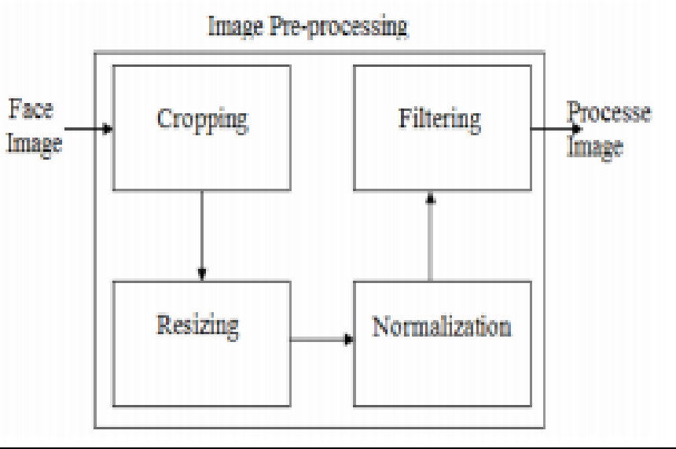

**Block diagram of Image Pre-processing**

#### Face detection and cropping:

Face cropping is additionally a significant errand to accomplish high detection rate. Editing should be possible utilizing different face discovery systems. Face identification includes recognizing a face from a picture utilizing total (picture based methodology) or by distinguishing at least one highlight from the picture (Feature based methodology, for example, nose, eyes, lips and so on. Face

discovery should likewise be possible dependent on dynamic shape models, for example, finding head limits.

#### Image Normalization

The main problem which arises in face recognition is varying light/illumination, constitutes the biggest challenges. Images that have varying lighting which are uncontrollable constitute uneven complexity. For example, the scattering of levels which are dark are indistinguishable. Histogram evening out strategy is used to cope up with this problem. Given an M x N image or a matrix, Pixel equalization value i.e h on different l levels is found using the CDF which is known as Cumulative Distribution Function.

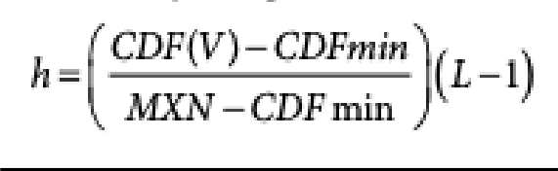

#### (2.2.3) Image Denoising and Filtering

Pictures are frequently as a matter of course have Gaussian noise because of light varieties. LPF of low pass filters is very useful to remove the frequencies of high value.

LPF passes information with a cut off.

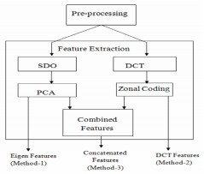

#### Fig 2.11 Block diagram for Pre-processing

#### (2.3) Detection:

To detect a face there are multiple stages, namely:

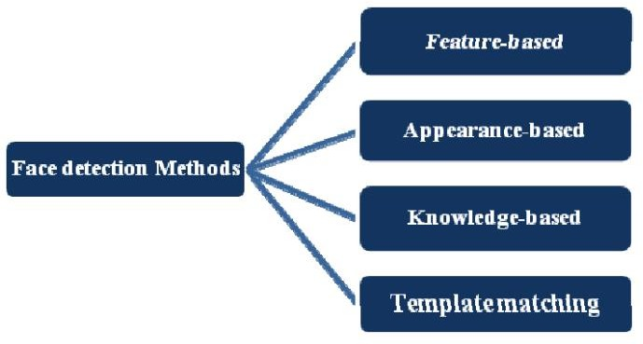

#### Knowledge-Based

This technique is dependent on the arrangement of rules. To identify a face, it requires some pre information that’s why it is called Knowledge based. It is definite that a face constitutes some common features such as eyes, mouth, nose etc. The enormous issue with these techniques is the trouble in building a fitting arrangement of rules. This technique independently is not sufficient to identify various instances of faces in multiple images.

#### Feature-Based

This technique discards auxiliary highlights of the face in the image. Initially it is defined as a classifier then used as a separator among areas with faces and not faces. The thought is to conquer the points of confinement of our natural information on faces. This technique is divided independently into different stages and also works well for images with numerous faces. This technique if applied well has an accuracy of above 85%.

#### Template Matching

This technique employs already distinguished face templates to identify the features of a face in a given image by the relationship of the formats and template images. For example, Face can be divided into different sub features such as eyes, nose, mouth etc. By employing edge identification methods, an approximate face could be found with given probability.

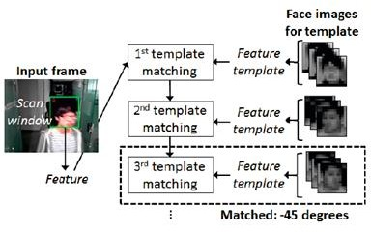

#### Fig 2.12 Template matching

1. **Appearance-Based**

This technique depends upon the training of faces from multiple images. This technique is generally better than any other technique above.

Appearance-based techniques depend on methods from accurate evaluation, AI to detect the crucial features of face images. This strategy likewise utilized in include extraction for face acknowledgment.

#### How detection works:

There are numerous systems to distinguish faces, face recognition could be done with high accuracy using these systems or techniques. All these techniques or methods are generally similar working internally. For example, OpenCV, Neural Networks etc are based on common principles but implemented differently. The main goal of face detection is to return whether a face is present or absent in an image. We have used OpenCV for our project, face recognition plus identification using OpenCV works as follows:

Image is read/ imported. Then the image is converted to grayscale from RGB(Red Green Blue). Then alignment, cropping, resizing of the image is done.

Next stage employs Haar Features which is visually described in the image below. These Haar features were defined by Viola Jones.There are many common similarities in different faces such as the area of eye is darker than rest of the area, also the nose area is lighter than other areas. This algorithm defined is called Viola Jones Algorithms and it uses Haar cascade classifier.

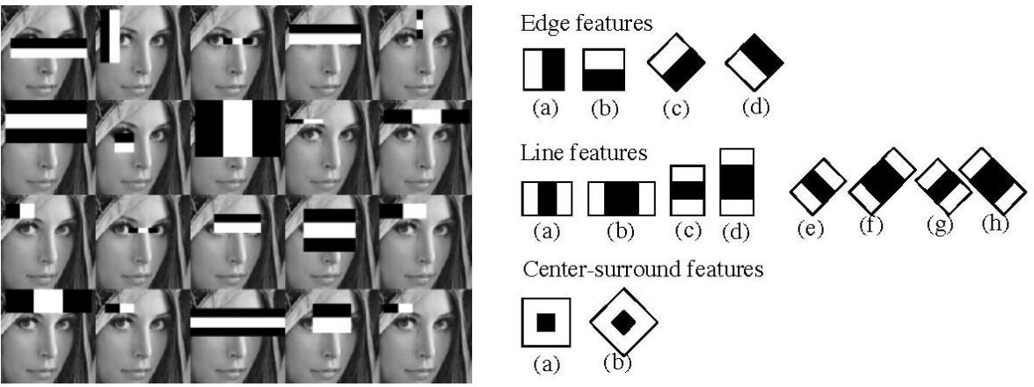

#### Fig 2.13 Haar Features Extraction

Viola Jones algorithm is likewise employed for face feature selection or feature extraction for a particular feature in the image, help of edge recognition, focus location for recognizing other common features like eyes, mouth and so on in the image. It is used to choose the fundamental highlights in a picture and concentrate these highlights for face identification.

Following stages provide the directions of other coordinates a,b,c, d which define a square shape, confine the image to show the area of the face.Then square shape is generated then limits the territory of the image where face is distinguished. Similarly, different other location methods that are utilized together for identification, for eg, smile detection, mood recognition, blink recognition, and many more.

#### (2.4) Algorithm:

**(2.4.1) LBPH(Local Binary Pattern Histogram)**

**Local Binary Pattern** (LBP) is a basic yet proficient surface administrator which marks the pixels of a picture by thresholding the area of every pixel and thinks about the outcome as a parallel number. Because of its discriminative power and computational effortlessness, the LBP surface administrator has become a well- known methodology in different applications. It tends to be viewed as a binding together way to deal with the generally dissimilar measurable and basic models of surface investigation. Maybe the most significant property of the LBP administrator in true applications is its power to monotonic dim scale changes caused, for instance, by brightening varieties. Another significant property is its computational effortlessness, which makes it conceivable to investigate pictures in testing ongoing settings.

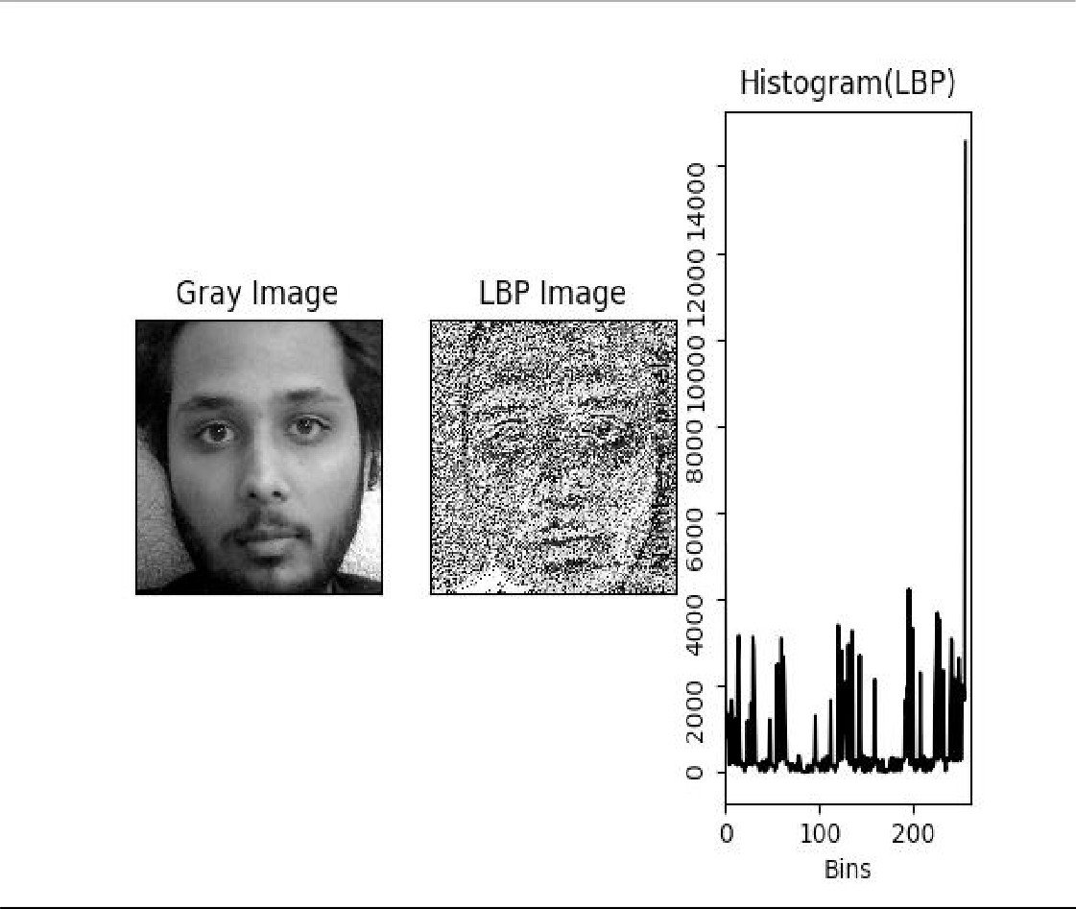

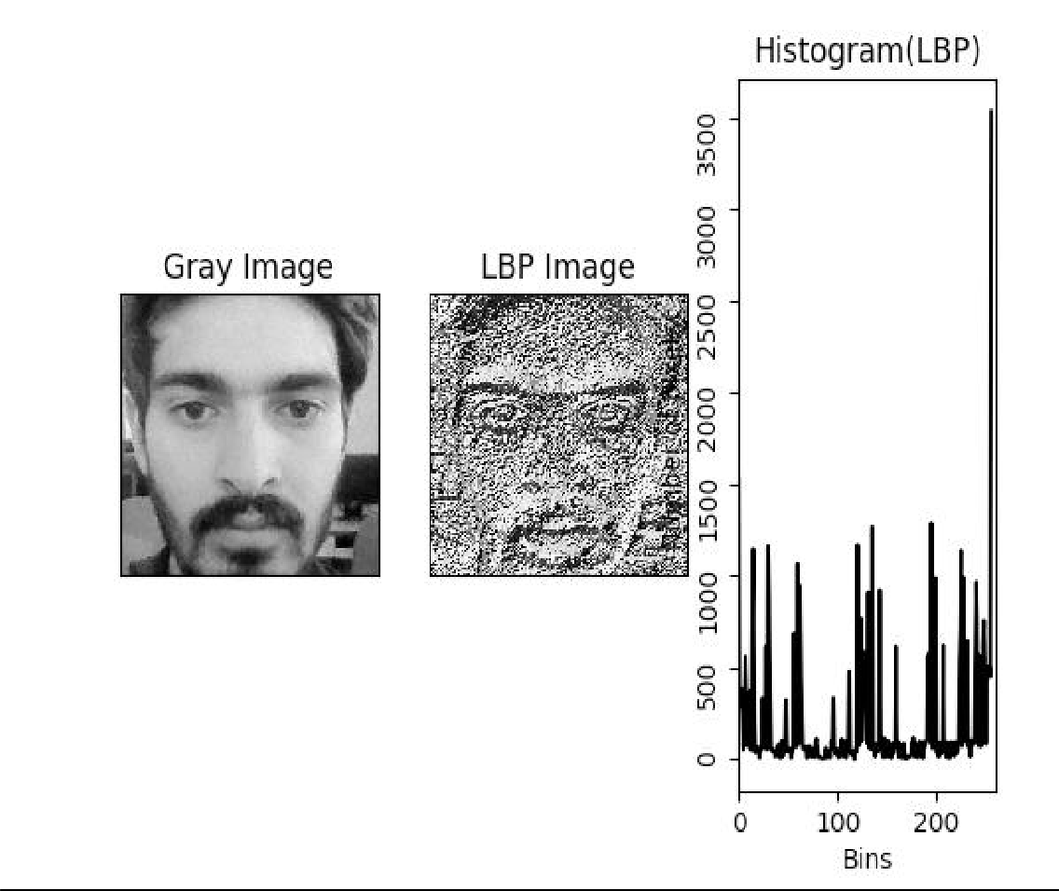

**Fig. 2.15 LBPH Image**

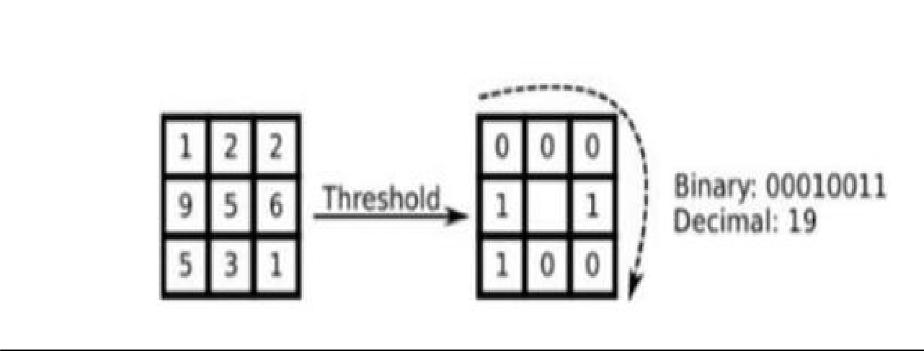

**Fig 2.16 Pixel LBP Conversion**

**Advantages of LBPH algorithm**

* LBPH Method is extraordinary compared to other performing surface descriptors.
* The LBPH administrator is robust towards increasing or decreasing changes in dark scale.
* Fisher Faces does not allow highlights of an individual to get powerful, yet despite all things, it determines enlightenment variety as a helpful component. Be that as it may, light varieties are certifiably not a helpful element to remove as it is not a part of the genuine face.
* Fisher faces demands large stockpiling of face data and information and all the more preparation time in its acknowledgment.
* In LBPH every picture is broken down easily, whereas the Eigen faces and techniques of fisher faces takes a gander at all the datasets.
* Techniques of LBPH will presumably work better to fisher faces in many different situations and different light conditions. It mostly depends upon our preparations and testing informational collection of data.
* Moreover, it can interact with nearby highlights present in the pictures.
* Both side and front countenances can be perceived by LBPH.

# Chapter 3: System Development

#### (3.1) Programming environment and framework

**Programming Languages:**

Python :

Python is an interactive and a high level object-oriented scripting language. Python language is planned to be highly readable by users. It makes use of English words frequently on the other hand other languages make use of punctuation, and it has less syntactic constructions in comparison to other languages.

Characteristics:

* It supports object oriented programming methods as well as functional and structured programming methods.
* It can be compiled as byte-code for developing large sized applications or can be utilized as a scripting language.
* It supports dynamic type checking and gives us very high-level dynamic data types.
* Automatic collection of garbage is also supported.
* It is easily integrated with java, C++, COM, ActiveX and CORBA,

Javascript (NodeJS):

JavaScript (JS) is a light, easily interpreted, or [in-time](https://en.wikipedia.org/wiki/Just-in-time_compilation) compiled programming language with [first-class functions](https://developer.mozilla.org/en-US/docs/Glossary/First-class_Function). It is mostly known as the scripting language for Web pages,it is alsouded by [many non-browser environments](https://en.wikipedia.org/wiki/JavaScript#Uses_outside_Web_pages) ,namely [Adobe](http://www.adobe.com/devnet/acrobat/javascript.html) [Acrobat](http://www.adobe.com/devnet/acrobat/javascript.html), Node.Js and Apache. JavaScript is a [prototype-based](https://developer.mozilla.org/en-US/docs/Glossary/Prototype-based_programming), multi-pattern, single-threaded, dynamic language, supporting object-oriented, vital, and functional programming styles.

XML:

XML full form is Extensible Markup Language. XML is a markup language like HTML which is used to define data. XML is understandable both by human and machine and it is scalable and easy to develop. XML tags are not predefined in XML, therefore, we have to define our own Tags. In Android XML, is used for making our layouts because it is a lightweight language which does not make our layout heavy.

#### Libraries and Frameworks:

OpenCV:

Open CV (Open Source Computer Vision) is a free graphics library generally targeted at real-time computer vision. Open CV was developed by Intel to process images. OpenCV was destined for image processing as it is pre-loaded with many functions and many algorithms. As OpenCV is pre-loaded with these functions and algorithms it helps researchers to solve vision-related problems. OpenCV provides applications that will assist in the training of cascade classifiers. We have used the openCV for developing our application.

NodeJS:

Node.js is a server-side platform built on Google Chrome's JavaScript Engine (V8 Engine). Node.js is an open source, cross-platform runtime environment for developing server-side and networking applications. Node.js applications are written in JavaScript, and can be run within the Node.js runtime on OS X, Microsoft Windows, and Linux.Node.js also provides a rich library of various JavaScript modules which simplifies the development of web applications using Node.js to a great extent.

#### (3.2) Proposed Models

Model of face recognition which suggests the location and acknowledgment of the stand-in faces for signifying their participation. The primary modules that are being utilized are :

1. Dataset Generation form training: This is the arranged principal in which the face dataset of the client is made, further in which 15-20 pictures of every client is taken and the highlights utilized are client username and ID.
2. Face Detection: LBP-based face detector is used for the face detection.
3. Pre-processing: Pre-processing involves certain steps:
   1. Resizing: After the face is detected by a detector ,face is resized to a fixed pixel resolution.
   2. Cropping: Only face frame is selected and background is removed from the image.
   3. Grayscale Conversion: The colored image is converted into a grayscale image.
4. Feature Extraction and Recognition: Calculations based on histogram principle is utilized for recognition and highlight extraction. The straightforward LBPH calculations are chosen for the right constant preparation of information as its computational multifaceted nature is less and is increasingly powerful contrasted with the other face recognition calculations.
5. Image Acquisition: Images are stored in a local directory or folder with username and roll no initials and the registered students are stored inside a MySQL database for later querying.
6. Face Detection: Face detection is being modified similarly as speed with the utilization of Haar like-features with the association of the Viola-Jones identification strategy for objects. One of the key constrains in past boosting-related approaches are the solidarity to lighting up and deficient obstruction of the face. To adjust the limitations, we make use of Local Binary Pattern (LBP) highlights for distinguishing the face on our applications.

Different steps for face Detection:

Step 1: Load the LBP cascade

Step 2: Instantiate the OpenCV Cascade Classifier

Step 3: For each video frame received, call the cascade classifier

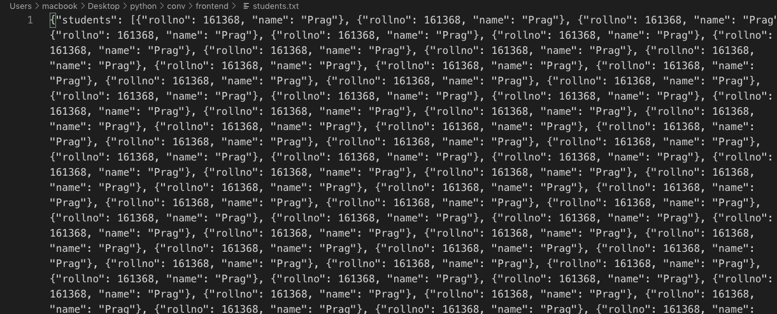

#### Fig. 3.3 Data stored in JSON format

1. Finally attendance is reviewed and locked by the teacher.

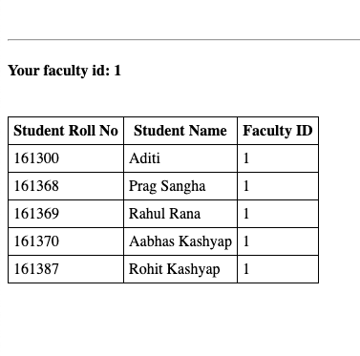

**Fig 3.4 List of Students**

**Chapter 4: Analysis Of Performance**

#### (4.1) Training activity

Local Binary Pattern calculations are utilized to prepare the framework in the way of taking the picture of countenances. XML records are made which accommodates the information regarding the face when you train the framework. This procedure is known as the prepared classifier. Identification of the face, preparing the framework and handling of the picture are done during the preparation action of the applications.



#### Fig. 4.1 Training Activity Process



**Fig 4.2 Terminal**

Executing face_datasets.py will start taking input for a particular student. Here it asks for the user ID/ roll number and then his name. After running it starts capturing the image with a webcam and associates the captured images with the student we enter. Next stage comes the training part.

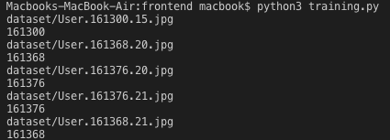

As the training procedure starts it starts throwing the roll number for which the webcam is capturing at that instance.

Recognizing Face:

The script recognizes the faces in the frame with the confidence of 70% or more. Undetected faces are not written to the JSON file hence decreasing its size and improving the read time for the file.

When the training is done of the system, the testing of the system should be possible by the perceived movement. At whatever point the face is distinguished it is right off the bat changed into a vector image from 2D to 1D. The face identified is taken as a contribution for the Boolean capacity. Being a Boolean capacity it restores a genuine at

whatever point a face gets a nearby match otherwise a false is returned. Moreover, when a nearby match is discovered the personality of the individual is removed by means of the perceived work.

Drawbacks:

The application can't distinguish and perceived if the taken face is not in the frames, as his/her face is confronting downwards consequently and we are unable to mark his/her attendance

If a photograph is pointed towards the webcam it also starts capturing it which will result in fake proxies.

As we can see, it displays Rohit with his roll number and writes his presence into the file but the catch is that a smartphone image is pointed towards the webcam which is leading to a proxy attendance.

# Chapter 5: Conclusion

#### (5.1) Conclusion

In this task, we studied various algorithms for the implementation of face recognition framework. Eigen faces and machine-learning algorithms were the main priority for preparing the system after applying few channels on the image. Besides, the Eigen faces algorithm permit the application to recognize the face in real-time. Eigen faces were not very delicate towards change in the quantity of subject during the first phases, be that as it may, an increase in the size of the training set helped the algorithm to correct its wrong predictions. An increase in the data set does not help in recognizing more subjects, still it turned correct predictions into wrong ones. Eigen faces were not precise in the second stage. Fisher faces had better result in the first phase with a larger quantity of data or information. Be that as it may, its actions were different in the subsequent stage. Sometimes with 25 pictures, the results were comparatively better, and sometimes with 40 pictures the results were similar or worse. This algorithm was more often than not the unsatisfactory in the two stages. Moreover in the second stage it had a very low accuracy. To detect a face the Local Binary design cascade classifier is used. After testing the Haar cascade classifier, the speed of the detection was very low as contrasted with LBP that always had almost 96%in the first phase and is similarly better at calculation. In second stage, this algorithm had a frequent drop in the precision or accuracy as compared to the first phase. Rise or increase in the quantity of subjects sharply changed its predictions. In every phase, rise in the training data had a positive impact or no impact.

#### (5.2)Disadvantages

We have extracted different issues in our face acknowledgment system

**Illumination Problem**: The illumination problem is that where the same face appears different because of a change in lighting. The progressions prompted by illumination are regularly bigger than the differences between people, causing frameworks based on comparing pictures to misclassify input images.

**The Pose Problem in Face Recognition:** It is not surprising that the performance of face recognition systems drops altogether when huge pose variations are present in the input images. At the point when illumination variation

is also present, the undertaking of face recognition becomes even more difficult. Here we focus on the out-of-plane rotation problem, since in-plane rotation is an unadulterated 2D problem and can be solved much more easily.

**Separation Problem:** Our face acknowledgment framework falls flat if the separation between the camera and the face surpasses multiple meters.

**Camera Problem:** Resolution of a camera assumes a significant job in perceiving the picture. Better the camera, all the more precisely it will perceive the face. For instance, we have tried our face acknowledgment framework with two webcams and we have discovered that the webcam with high resolution camera is superior to the other.

**Number of individuals:** Our face acknowledgment framework is constrained to just 7-8 individuals at a time. On the off chance that this number surpasses, our system neglects to perceive.