
RAMDEOBABA UNIVERSITY, NAGPUR
Ramdeo Tekdi, Katol Road, Nagpur – 440 013, Maharashtra, India
SCHOOL OF COMPUTER SCIENCE AND ENGINEERING
LAB PROJECT REPORT
ON
YouTube Trending Videos Analysis using Apache Spark and Cassandra
Course / Lab: Big Data Analytics Lab
Course Code: 24CS02PR0503
Submitted By
Sr. No. | Student Name | Roll No.
1 | Dhanishtha Deshpande | 06
2 | Himani Dalvi | 07
3 | Palak Bhutada | 13
Under the Guidance of
Bhagyashree Madan, Sonam Chopade
Academic Year: 2026–27

CERTIFICATE
This is to certify that the project entitled “YouTube Trending Videos Analysis using Apache Spark and Cassandra” has been successfully completed by Dhanishtha Deshpande, Himani Dalvi and Palak Bhutada, Roll No(s). 06, 07 and 13, of B.Tech Artificial Intelligence and Data Science, Ramdeobaba University, Nagpur, as part of the requirements of the laboratory course Big Data Analytics (24CS02PR0503) during the academic year 2026–27.
The work presented in this report has been carried out under the guidance and supervision of the undersigned.

DECLARATION
We hereby declare that the project work entitled “YouTube Trending Videos Analysis using Apache Spark and Cassandra” is our original work carried out for the laboratory course at Ramdeobaba University, Nagpur. The work has not been submitted elsewhere for the award of any academic qualification.
Student Name(s): Dhanishtha Deshpande, Himani Dalvi, Palak Bhutada
Roll No(s).: 06, 07, 13
Date: __________________
Place: Nagpur

ACKNOWLEDGEMENT
We sincerely express our gratitude to Ramdeobaba University, Nagpur, our faculty guide, lab in-charge, and the School/Department for providing the facilities and guidance required to complete this laboratory project. We also thank everyone who supported us during the implementation, testing, and documentation of the project.

ABSTRACT
YouTube shows a list of trending videos every day for each country. In this project we analysed that list to understand which videos trend, how fast they get there and how long they stay. We used the Trending YouTube Video Statistics dataset from Kaggle for four countries (India, USA, Great Britain and Canada), covering 14 November 2017 to 14 June 2018. The raw data had 158,098 rows.
Apache Spark (PySpark) was used to load and clean the data, and Apache Cassandra was used to store both the cleaned records and the results. We read the data back from Cassandra and answered eight questions with Spark SQL, such as the top categories, the top channels, the number of days before a video trends and how long it stays on the list. The results were saved in Cassandra summary tables and shown on a Streamlit dashboard. The project is descriptive and does not make any predictions.
Entertainment was the top category in India, the USA and Canada, while Music was first in Great Britain. In India, 74% of videos reached the trending list within one day of upload, and about three out of four left it within two days. In Great Britain a video stayed on the list for 11.8 days on average. The project shows that Spark and Cassandra together can handle the full flow from raw files to a working dashboard.

TABLE OF CONTENTS
1. Introduction ..................................................
2. Problem Statement and Objectives ..................................................
3. Requirements ..................................................
4. Methodology / Algorithm ..................................................
5. System Design ..................................................
6. Implementation ..................................................
7. Results and Discussion ..................................................
8. Conclusion and Future Scope ..................................................
References ..................................................
Appendix ..................................................

1. INTRODUCTION

1.1 Background
YouTube has a Trending page that shows popular new videos for each country. The list changes every day, so over a few months it builds up a large amount of data: the title, channel, category, tags, views, likes and comments of every video that made the list.
Data that keeps growing every day like this is a good fit for big data tools. Apache Spark can process it in parallel, and Apache Cassandra can store it and handle a large number of writes.

1.2 Motivation
Content creators, marketing teams and channel owners often want to know what kind of videos reach the trending list and when they should upload. We wanted to answer these questions from real data instead of guesses.
The project also let us connect Spark and Cassandra in one pipeline. In our lab practicals we had only used them separately.

1.3 Problem Definition
The trending data comes as one CSV file per country, with a separate JSON file for category names. Dates are written in an unusual yy.dd.mm format, categories are stored as numbers, some videos appear twice on the same day and some rows have broken video IDs.
To answer questions like “which category trends most in India” or “how long does a video stay on the list”, the data has to be cleaned, joined and grouped first. So we needed a pipeline that cleans the data, stores it in a database, runs the analysis and shows the results.

1.4 Scope
• Four countries: India, USA, Great Britain and Canada.
• Period: 14 November 2017 to 14 June 2018 (205 days of data per country).
• Descriptive analysis only. As instructed, the project does not predict views or trends.
• Spark runs in local mode and Cassandra runs as a single node, both inside Google Colab.
• Results are shown on a Streamlit dashboard that reads directly from Cassandra.

2. PROBLEM STATEMENT AND OBJECTIVES

2.1 Problem Statement
To build a big data pipeline with Apache Spark and Apache Cassandra that cleans and stores YouTube trending video data for four countries, analyses it to find patterns in categories, channels, timing and engagement, and shows the results on a Streamlit dashboard.

2.2 Objectives
1. To load and clean the trending data of four countries using PySpark.
2. To design Cassandra tables around the queries we need and store the cleaned data in them.
3. To answer eight analysis questions with Spark SQL and save each result back to Cassandra.
4. To build a Streamlit dashboard that reads from Cassandra and shows the results as charts.

2.3 Expected Outcome
A Colab notebook that runs the whole pipeline from raw files to results, a Cassandra keyspace named youtube with one main table and eight summary tables, and a dashboard where the user can pick a country to see the charts or pick a date to see what was trending that day.
We also expected clear answers on how trending behaviour differs between the four countries.

3. REQUIREMENTS

3.1 Hardware Requirements
Table 3.1: Hardware requirements
Item | Details
Computer | Any laptop or desktop with a web browser and an internet connection
Cloud runtime | Google Colab virtual machine (standard CPU runtime)
Storage | Google Drive, about 240 MB for the four CSV files

3.2 Software Requirements
Table 3.2: Software requirements
Software | Version | Used for
Google Colab | Linux runtime | Running the notebook
Python | 3 (Colab default) | All code
Apache Spark (PySpark) | 3.5.3 | Loading, cleaning and Spark SQL analysis
Apache Cassandra | 4.1.5 | Storing cleaned data and results
Spark Cassandra Connector | 3.5.1 | Reading and writing Cassandra from Spark
OpenJDK | 11 | Needed by Cassandra and Spark
cassandra-driver | Latest from pip | CQL queries from Python and the dashboard
Streamlit, Plotly, pandas | Latest from pip | Dashboard and charts
cloudflared | Latest release | Public link for the dashboard

3.3 Dataset / Input Requirements
We used the “Trending YouTube Video Statistics” dataset, published on Kaggle by the user datasnaek. It contains daily trending lists for ten countries, and we used four of them. Each country has a CSV file with 16 columns and a JSON file that maps category IDs to category names. The data covers 14 November 2017 to 14 June 2018.
Table 3.3: Dataset files used
Country | Files | Raw rows
India | INvideos.csv, IN_category_id.json | 37,352
USA | USvideos.csv, US_category_id.json | 40,949
Great Britain | GBvideos.csv, GB_category_id.json | 38,916
Canada | CAvideos.csv, CA_category_id.json | 40,881
Total |  | 158,098

The full column list and a sample record are given in Appendix B.

4. METHODOLOGY / ALGORITHM

4.1 Proposed Method
The work is done as a pipeline, where each stage uses the output of the stage before it.
1. Data collection: the four CSV files and four JSON files are downloaded from Kaggle and kept in a shared Google Drive folder.
2. Environment setup: Java 11, Cassandra 4.1.5 and PySpark are installed in Colab, and Cassandra is started as a single node.
3. Cleaning with Spark: the files are read into one Spark DataFrame, cleaned, and given three new columns.
4. Storage in Cassandra: the cleaned data is written to the table trending_by_country.
5. Analysis with Spark SQL: the table is read back from Cassandra and eight queries are run on it.
6. Saving results: each query result is written to its own summary table in Cassandra.
7. Dashboard: a Streamlit app reads the summary tables with CQL and draws the charts.

4.2 Algorithm
Step 1: Read the four CSV files with the header, multiLine and escape options, and add a country column.
Step 2: Read each category JSON file and join the category names on category_id.
Step 3: Remove rows where video_id is “#NAME?”, convert trending_date (yy.dd.MM) to a date and publish_time to a timestamp, and convert views, likes, dislikes and comment_count to numbers.
Step 4: Fill missing categories with “Unknown”, drop rows with missing key values, and remove duplicates of the same video on the same day in the same country.
Step 5: Add three columns: days_to_trend, publish_hour and publish_day.
Step 6: Create the keyspace youtube and the table trending_by_country, and write the cleaned data into it.
Step 7: Read the table back into Spark and register it as the SQL view “trending”.
Step 8: Run the eight Spark SQL queries and write each result to its summary table.
Step 9: Start the Streamlit dashboard, which queries the summary tables, and open it through a cloudflared link.

4.3 Flowchart
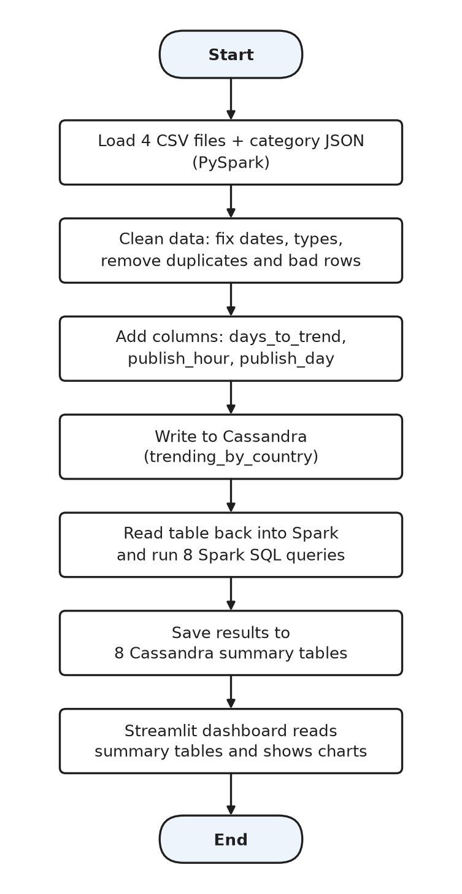
Figure 4.1: Flowchart of the project

4.4 Pseudocode
FOR each country c IN [IN, US, GB, CA]:
data_c = READ_CSV(c + "videos.csv")
categories_c = READ_JSON(c + "_category_id.json")
data_c = data_c JOIN categories_c ON category_id
data_c.country = c
data = UNION of all data_c
REMOVE rows where video_id = "#NAME?"
CONVERT trending_date, publish_time, views, likes, dislikes, comments
REMOVE duplicates on (country, video_id, trending_date)
ADD days_to_trend = trending_date - publish_date
ADD publish_hour, publish_day
WRITE data TO cassandra.youtube.trending_by_country
trending = READ cassandra.youtube.trending_by_country
FOR each (query, table) IN eight_analyses:
result = SPARK_SQL(query ON trending)
WRITE result TO cassandra.youtube.table
START dashboard:
FOR each summary table: READ rows for chosen country, DRAW bar chart
READ trending_by_country for chosen country and date, SHOW table

5. SYSTEM DESIGN

5.1 System Architecture
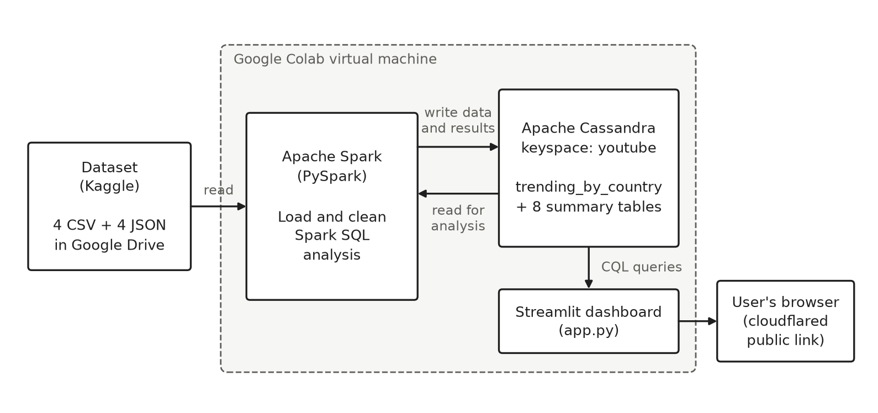
Figure 5.1: System architecture
Everything except the dataset and the user’s browser runs inside one Google Colab virtual machine. The dataset is read from Google Drive. Spark writes data to Cassandra and also reads it back for analysis. The dashboard talks only to Cassandra, never to Spark. A cloudflared tunnel gives the dashboard a public link, so it can be opened in any browser.

5.2 Modules
Module 1: Data ingestion
Reads the four CSV files with the header, multiLine and escape options so that titles and descriptions containing commas and quotes are read correctly. It reads the category JSON files, joins the category names, adds a country column and combines all four countries into one DataFrame.
Module 2: Data cleaning and transformation
Removes rows with the broken video ID “#NAME?”, converts trending_date and publish_time to proper date and time types, converts the count columns to numbers, marks missing categories as “Unknown” and removes duplicate rows. It then adds days_to_trend, publish_hour and publish_day.
Module 3: Storage (Cassandra)
Creates the keyspace youtube with SimpleStrategy and a replication factor of 1, creates the table trending_by_country and writes the cleaned DataFrame using the Spark Cassandra Connector.
Module 4: Analysis (Spark SQL)
Reads trending_by_country back into Spark, registers it as the SQL view “trending” and runs eight queries. Each result is written to its own summary table in Cassandra.
Module 5: Dashboard (Streamlit)
Connects to Cassandra with the Python driver and lets the user choose a country. It shows four key numbers at the top and five tabs: categories, channels and tags, timing with an upload heatmap, a date search that runs a live CQL query on trending_by_country, and videos that trended in several countries.

5.3 Data Flow / Workflow
CSV and JSON files (Google Drive) → Spark DataFrame → cleaned DataFrame → Cassandra table trending_by_country → Spark SQL view → eight result DataFrames → eight Cassandra summary tables → Streamlit dashboard → user.
In Cassandra, tables are designed around the queries that will be run on them. Table 5.1 lists the tables we created and their keys.
Table 5.1: Cassandra tables in keyspace youtube
Table | Partition key | Clustering key | Used for
trending_by_country | country, trending_date | video_id | All cleaned rows; what trended on a date
category_summary | country | category | Top categories
channel_summary | country | channel_title | Top channels
time_to_trend | country | days | Days from upload to trending
trending_duration | country | days_trending | Days on the trending list
engagement_summary | country | category | Like, dislike and comment %
upload_time_summary | country | publish_day, publish_hour | Upload day and hour
tag_summary | country | tag | Most common tags
global_videos | video_id | None | Videos trending in 2+ countries

Putting country and trending_date together in the partition key keeps one day’s list for one country in a single partition. Because of this, the date search on the dashboard reads only one partition.

6. IMPLEMENTATION

6.1 Development Environment
All work was done in one Google Colab notebook kept in a shared Google Drive folder, so all three of us could open and run it. Cassandra 4.1.5 was downloaded from the Apache archive and started inside the Colab machine with the -R option, because Colab runs as the root user. Spark runs in local mode on the same machine and loads the Spark Cassandra Connector through the spark.jars.packages setting.
The Streamlit app is written to app.py from inside the notebook and started in the background, and cloudflared creates a public link for it. A small config.toml file gives the dashboard a light pink theme. Colab clears everything when a session ends, so the notebook is written to run from top to bottom with Runtime > Run all.

6.2 Module-wise Implementation
The notebook is split into cells, one small task per cell. Table 6.1 shows what each cell does.
Table 6.1: Notebook cells
Cell | What it does
1 | Installs Java 11, Cassandra 4.1.5 and the Python packages
2 | Starts Cassandra, waits until it accepts connections, mounts Google Drive
3 | Creates the SparkSession with the Cassandra connector
4 | Checks that the dataset files are in Drive
5, 6 | Loads and cleans the data, then checks rows and dates per country
7, 8 | Creates the keyspace and main table, writes the data, tests a CQL query
9 | Reads the table back into Spark as the view “trending”
10 | Creates the eight summary tables and a helper function analyse()
11 to 18 | Runs the eight analysis queries and saves each result
19, 20 | Writes app.py and starts the dashboard with a public link
21 | Applies the light dashboard theme and restarts the dashboard

6.3 Important Code Snippets
a) Spark session with the Cassandra connector
from pyspark.sql import SparkSession, functions as F
spark = (SparkSession.builder.appName("YouTubeTrending")
.config("spark.jars.packages", "com.datastax.spark:spark-cassandra-connector_2.12:3.5.1")
.config("spark.sql.extensions", "com.datastax.spark.connector.CassandraSparkExtensions")
.config("spark.cassandra.connection.host", "127.0.0.1")
.config("spark.sql.session.timeZone", "UTC")
.getOrCreate())
b) Cleaning the data (main part)
df = (raw
.filter(F.col("video_id") != "#NAME?")
.withColumn("trending_date", F.to_date("trending_date", "yy.dd.MM"))
.withColumn("publish_time", F.to_timestamp("publish_time", "yyyy-MM-dd'T'HH:mm:ss.SSSX"))
.withColumn("views", F.col("views").cast("long"))
.fillna({"category": "Unknown"})
.dropDuplicates(["country", "video_id", "trending_date"])
.withColumn("days_to_trend", F.datediff("trending_date", F.to_date("publish_time")))
.withColumn("publish_hour", F.hour("publish_time")))
c) Main Cassandra table and writing data from Spark
CREATE TABLE IF NOT EXISTS trending_by_country (
country text, trending_date date, video_id text,
title text, channel_title text, category text, views bigint, ...
PRIMARY KEY ((country, trending_date), video_id));
(df.select(cols).write.format("org.apache.spark.sql.cassandra")
.options(keyspace="youtube", table="trending_by_country").mode("append").save())
d) One analysis query: days from upload to trending
analyse("time_to_trend", """
SELECT country, first_days AS days, COUNT(*) AS videos
FROM (SELECT country, video_id, MIN(days_to_trend) AS first_days
FROM trending GROUP BY country, video_id)
WHERE first_days IS NOT NULL
GROUP BY country, first_days
""", F.desc("videos"))
e) Dashboard: reading a summary table from Cassandra and drawing a chart
@st.cache_data(ttl=600)
def query(cql, params=None):
return pd.DataFrame(list(connect().execute(cql, params)))
def table(name, code):
return query(f"SELECT * FROM {name} WHERE country = %s", (code,))
cat = table("category_summary", code)
with a: card(hbar(cat, "videos", "category", "Trending videos by category"))
The complete code is given in Appendix A.

7. RESULTS AND DISCUSSION

7.1 Experimental Setup
The pipeline was run on the standard Google Colab CPU runtime, with Spark in local mode and a single Cassandra node (replication factor 1). Table 7.1 shows the data before and after cleaning.
Table 7.1: Data before and after cleaning
Country | Raw rows | After cleaning | Unique videos | Unique channels
India | 37,352 | 32,272 | 16,306 | 1,423
USA | 40,949 | 40,899 | 6,351 | 2,207
Great Britain | 38,916 | 38,742 | 3,272 | 1,625
Canada | 40,881 | 40,881 | 24,427 | 5,076
Total | 158,098 | 152,794

In total 5,304 rows were removed. Almost all of them (5,080) were from India, where 4,894 rows were repeats of the same video on the same day and 511 rows had the broken video ID “#NAME?” (some rows had both problems).

7.2 Results
Top categories
Entertainment had the most trending videos in India (7,563), the USA (1,622) and Canada (8,252). In Great Britain, Music (877) was just ahead of Entertainment (860). News & Politics was second in both India and Canada.
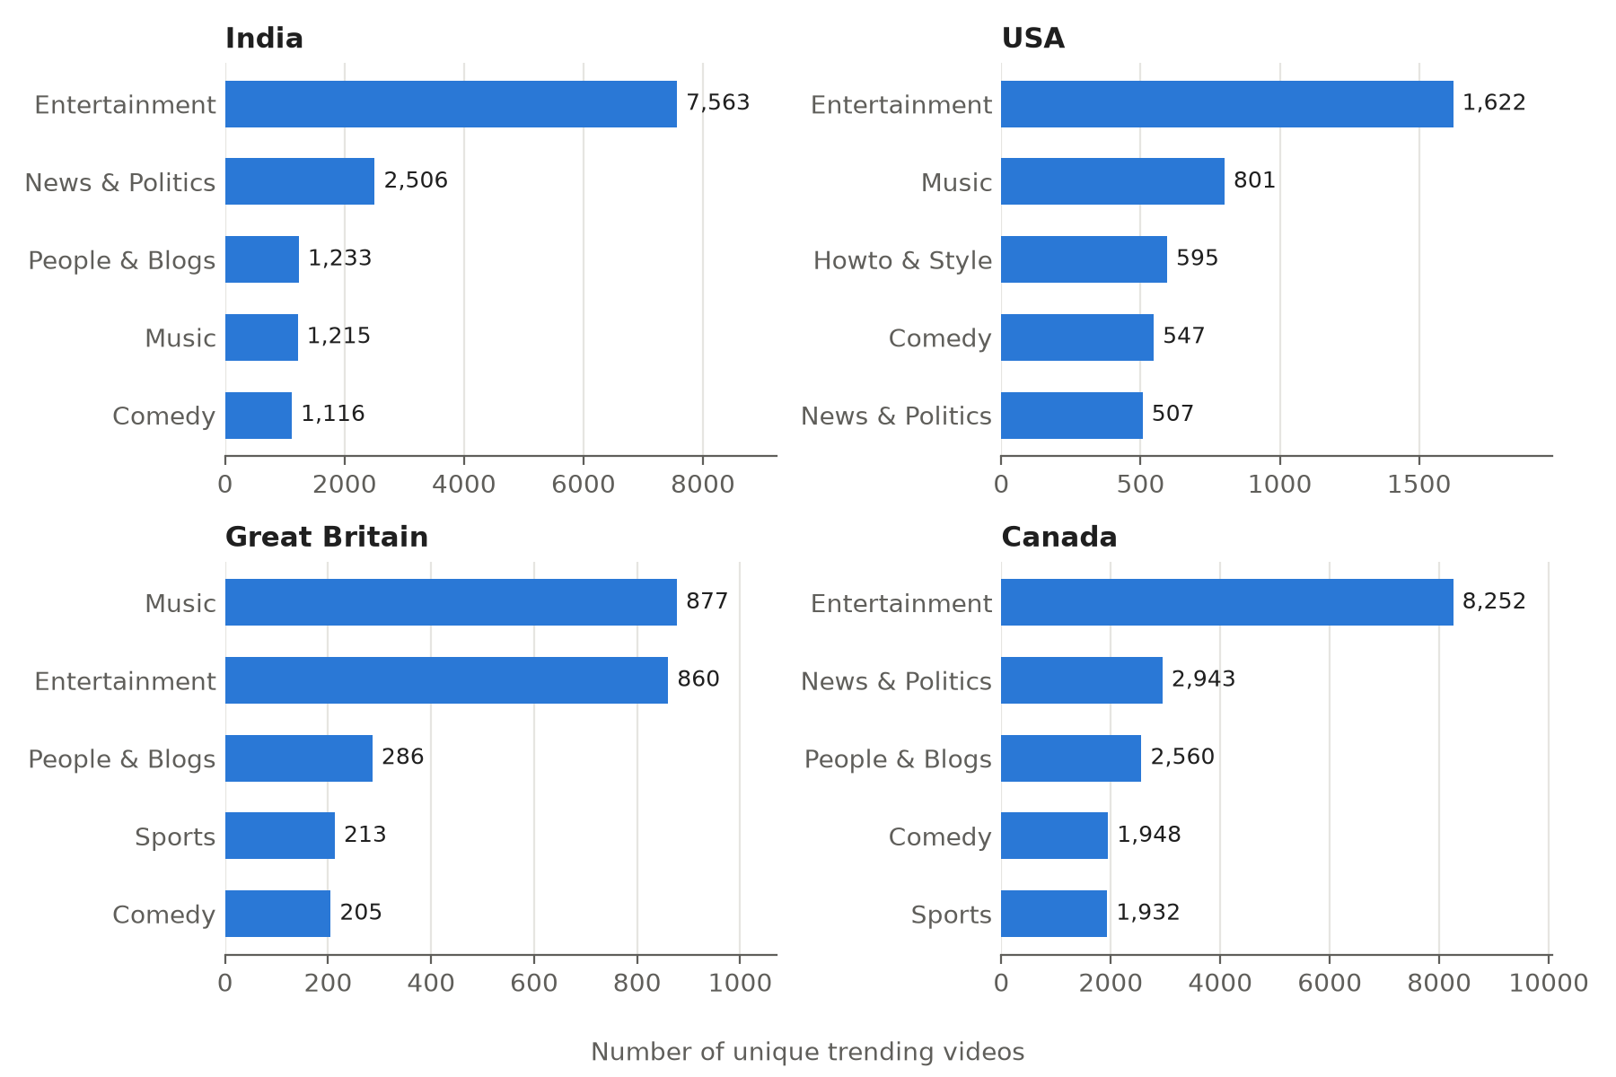
Figure 7.1: Top five categories by number of trending videos
Top channels
Table 7.2: Channels with the most trending videos
Country | 1st | 2nd | 3rd
India | Study IQ education (169) | Tarang TV (158) | etvteluguindia (153)
USA | ESPN (84) | TheEllenShow (74) | The Tonight Show Starring Jimmy Fallon (72)
Great Britain | The Tonight Show Starring Jimmy Fallon (51) | TheEllenShow (47) | Jimmy Kimmel Live (44)
Canada | VikatanTV (159) | SET India (154) | MSNBC (152)

Time to trend and time on the list
Table 7.3: How fast videos trend and how long they stay
Country | Median days to trend | Trended within 1 day | Average days on list | Longest run (days)
India | 1 | 73.9% | 2.0 | 9
USA | 2 | 45.0% | 6.4 | 29
Great Britain | 2 | 39.4% | 11.8 | 38
Canada | 1 | 86.9% | 1.7 | 8

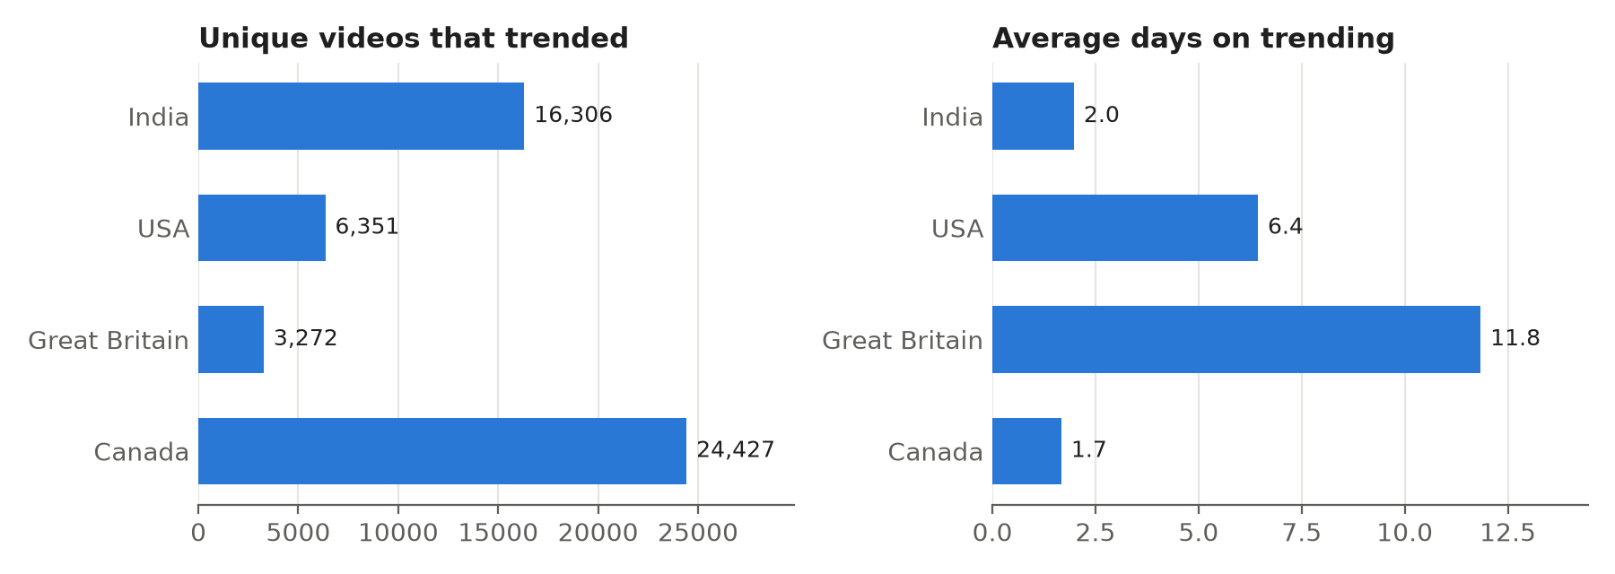
Figure 7.2: Unique trending videos and average days on the list
Engagement
In India, Science & Technology had the highest likes per view (7.78%), followed by Pets & Animals (7.64%) and Comedy (5.35%). Shows (0.63%) and News & Politics (0.85%) had the lowest. In the USA, Music had the highest like rate (4.76%) and News & Politics the lowest (1.27%). Music also had the highest average views per video in the USA, Great Britain and Canada.
Upload time
About 79% of India’s trending videos were uploaded between 4:00 and 17:59 UTC, which is 9:30 AM to 11:30 PM in Indian time. The busiest single hour was 14:00 UTC (7:30 PM IST). Friday was the most common upload day in India and Canada, and Wednesday in the USA and Great Britain.
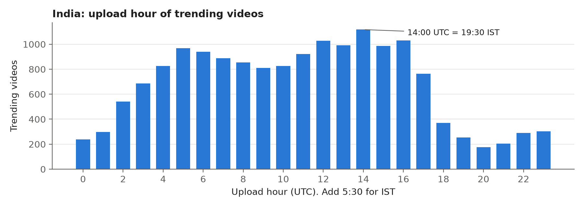
Figure 7.3: Upload hour of India’s trending videos
Tags
The most common tags in India were comedy (1,029 videos), television (998), serial (993) and full episode (984). In the USA and Great Britain the top two were funny and comedy. Canada’s top tags were funny, comedy, news, politics and donald trump.
Videos trending in more than one country
4,459 videos trended in at least two of the four countries: 3,792 in two, 590 in three and 77 in all four. Examples of videos that trended in all four countries are Ed Sheeran’s “Perfect”, the final trailer of Deadpool 2 and the Season 2 trailer of 13 Reasons Why.
Dashboard
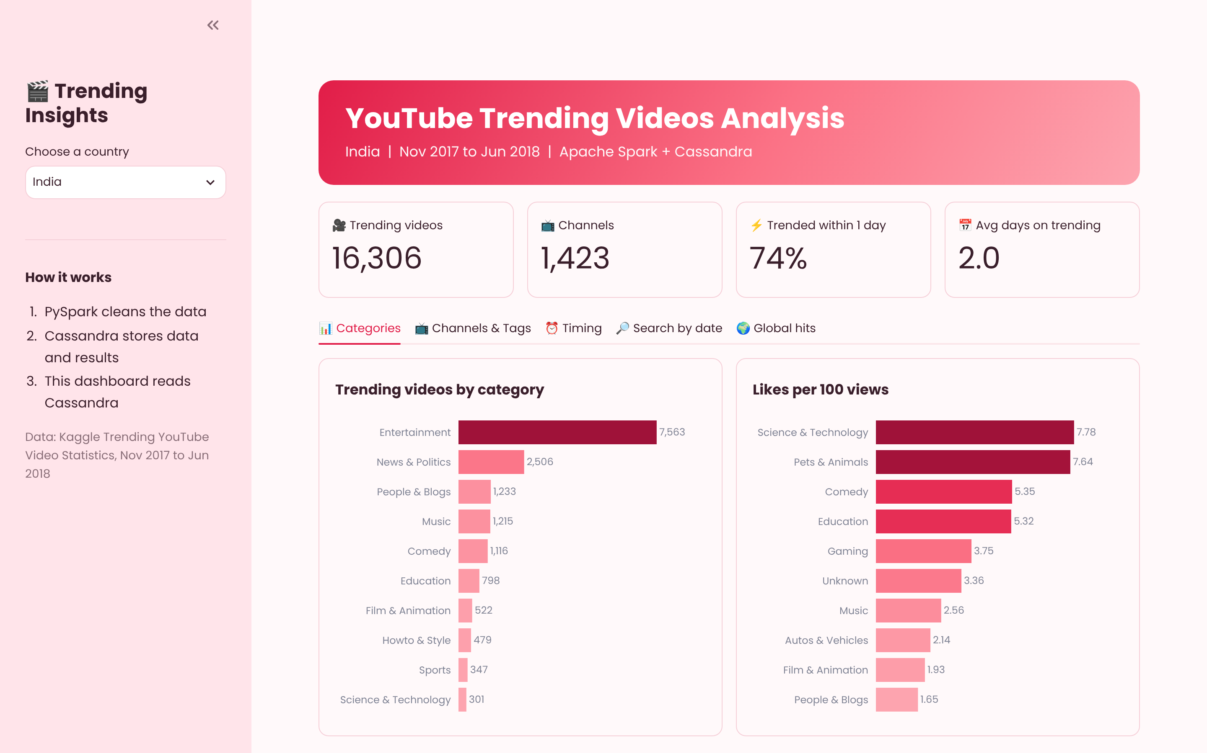
Figure 7.4: Streamlit dashboard (India, Categories tab)

7.3 Performance Analysis
This project is descriptive, so we did not compare prediction methods. Instead we looked at how our design choices change the amount of data each step has to read.
1. The main table has 152,794 rows, while most summary tables are very small: category_summary has 66 rows, trending_duration 84 and time_to_trend 332 for all four countries together. The dashboard reads only these summary tables, so the charts load quickly.
2. Because the partition key of trending_by_country is (country, trending_date), the date search on the dashboard reads one partition of about 150 to 200 rows instead of the whole table.
3. In Spark, the cleaned DataFrame and the view “trending” are cached, so the eight queries do not read the files or Cassandra again for every query.
4. A CQL query on a column outside the key, such as channel_title, would need ALLOW FILTERING and would scan the whole table. This is why channel results are stored in their own summary table with country as the partition key.

7.4 Discussion
The four countries behave in two different ways. India and Canada have many unique videos (16,306 and 24,427), and each one stays on the list for about two days or less. Great Britain and the USA have far fewer unique videos (3,272 and 6,351), but each stays much longer: 11.8 and 6.4 days on average. So the Indian and Canadian lists change almost completely every couple of days, while the British list stays nearly the same for more than a week.
The top tags in India (television, serial, full episode, daily soap) show that a large part of the Indian list is daily TV episodes. A new episode comes out every day and replaces the old one, which may explain why videos in India trend fast and leave fast. Canada’s top channels include Indian channels such as VikatanTV and SET India, along with the US news channel MSNBC.
Entertainment has the most trending videos in three of the four countries, but Music gets the highest average views per video in the USA, Great Britain and Canada. News & Politics has many trending videos in India and Canada but one of the lowest like rates, so people watch these videos but rarely like them. In India, very few trending videos were uploaded late at night, between about 11:30 PM and 9:30 AM IST.

8. CONCLUSION AND FUTURE SCOPE

8.1 Conclusion
We built a complete pipeline for YouTube trending data using Apache Spark and Apache Cassandra on Google Colab. Spark cleaned 158,098 raw rows from four countries down to 152,794 rows and stored them in Cassandra. Eight Spark SQL queries ran on the data read back from Cassandra, and their results were saved in eight summary tables. A Streamlit dashboard reads these tables and also runs a live query by country and date.
The analysis showed that Entertainment leads the trending list in India, the USA and Canada, that videos in India and Canada trend within a day and leave quickly, and that videos in Great Britain stay on the list for almost 12 days on average. All four objectives listed in Chapter 2 were met.

8.2 Future Scope
1. Use the YouTube Data API to collect fresh trending data, since this dataset ends in June 2018.
2. Run Spark and Cassandra on a real multi-node cluster with a higher replication factor.
3. Use Spark Structured Streaming to update the results as new data arrives every day.
4. Add the remaining six countries from the dataset.
5. Host the dashboard permanently, so the link does not change after every Colab session.

REFERENCES
[1] Apache Software Foundation, “Spark SQL, DataFrames and Datasets Guide (Spark 3.5.3),” Apache Spark Documentation. [Online]. Available: https://spark.apache.org/docs/3.5.3/sql-programming-guide.html (accessed Oct. 2026).
[2] Apache Software Foundation, “Apache Cassandra Documentation,” cassandra.apache.org. [Online]. Available: https://cassandra.apache.org/doc/latest/ (accessed Oct. 2026).
[3] Apache Software Foundation, “Apache Cassandra Spark Connector,” GitHub repository. [Online]. Available: https://github.com/apache/cassandra-spark-connector (accessed Oct. 2026).
[4] datasnaek, “Trending YouTube Video Statistics,” Kaggle dataset. [Online]. Available: https://www.kaggle.com/datasets/datasnaek/youtube-new (accessed Oct. 2026).
[5] Snowflake Inc., “Streamlit Documentation,” docs.streamlit.io. [Online]. Available: https://docs.streamlit.io (accessed Oct. 2026).

APPENDIX

Appendix A – Source Code
The full notebook code is given below, cell by cell. The notebook is kept in the shared Google Drive folder BDA_Project.
Cell 1: Install Java, Cassandra and Python packages
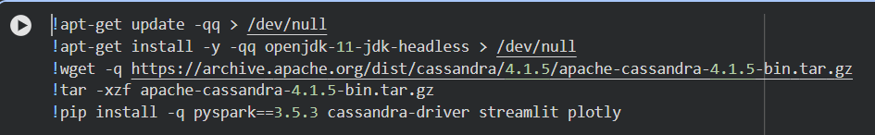Cell 2: Start Cassandra and mount Google Drive
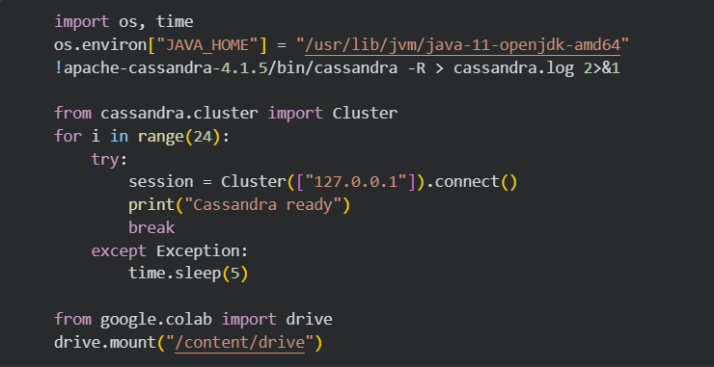Cell 3: Create the Spark session
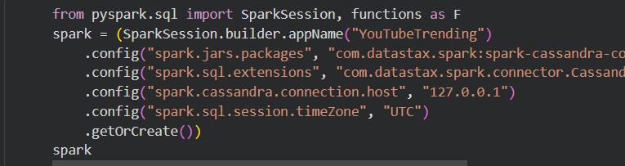Cell 4: Check the dataset files
Cell 5: Load and clean the data
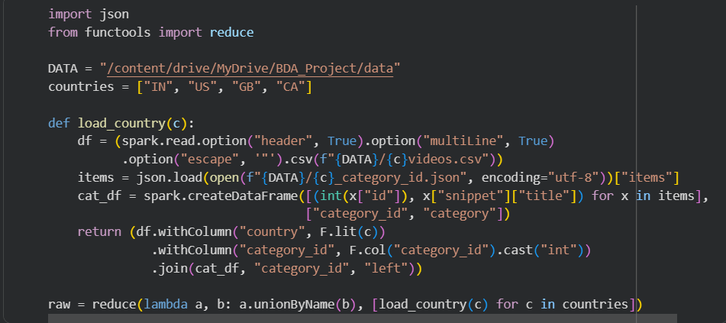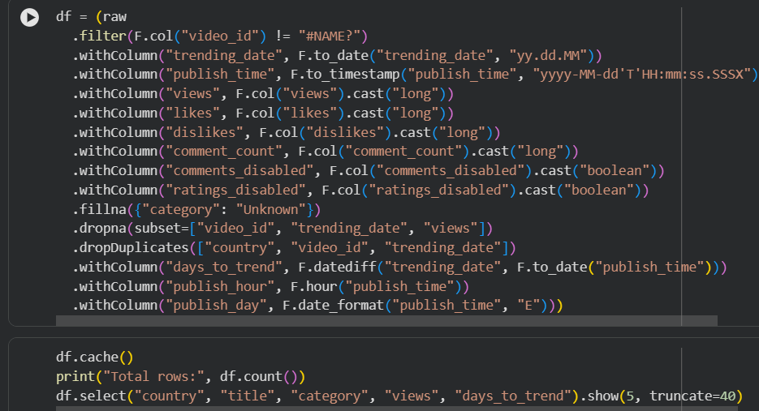Cell 6: Check rows and dates per country
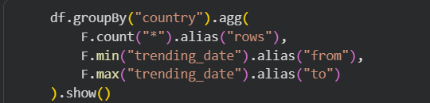

Cell 7: Create keyspace and main table, write data
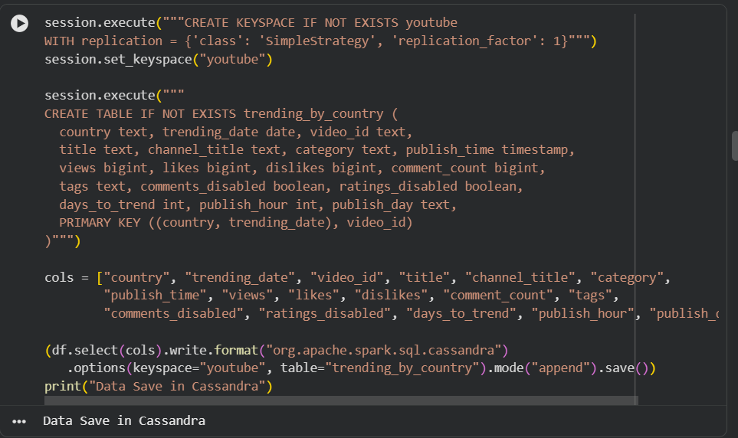Cell 8: Test a CQL query
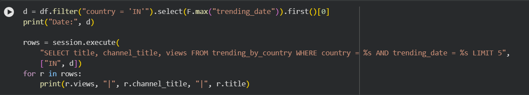Cell 9: Read the table back into Spark
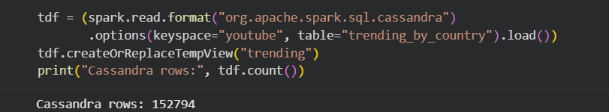Cell 10: Summary tables and helper function
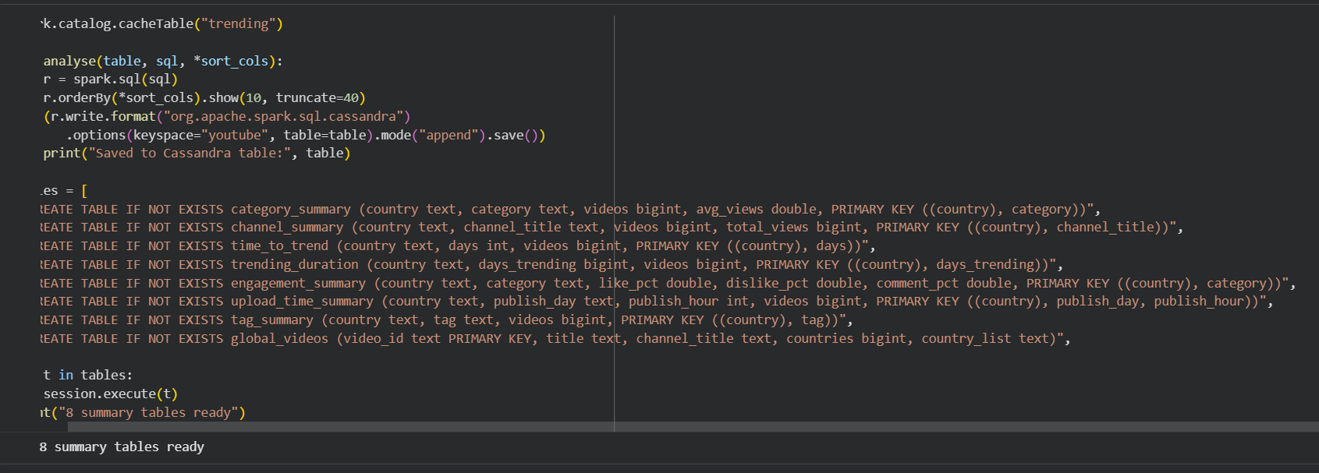Cells 11 to 18: The eight analysis queries
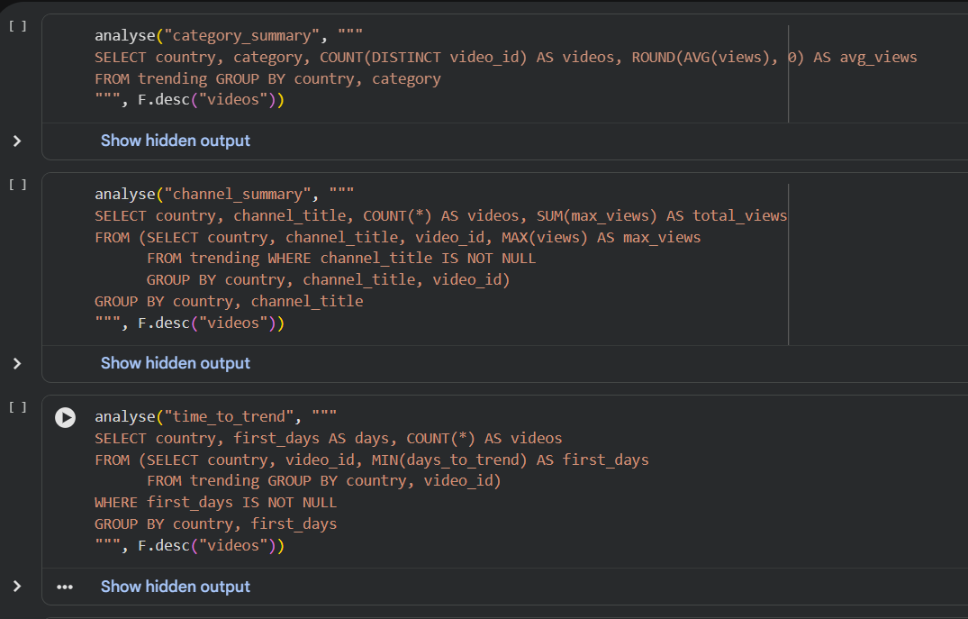
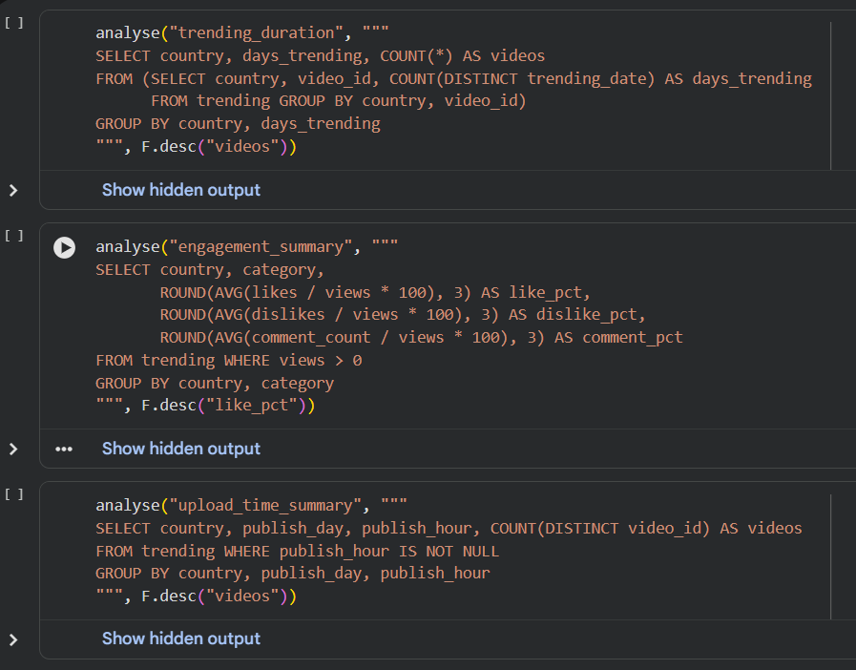
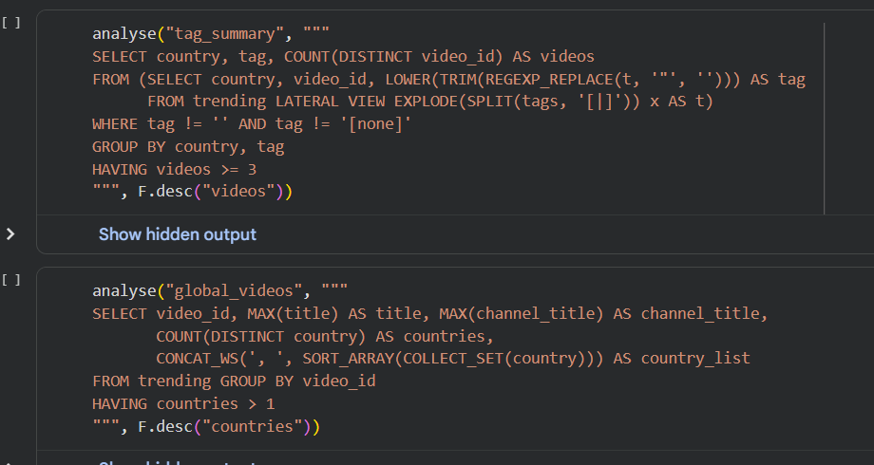

Cell 19: Streamlit dashboard (app.py)
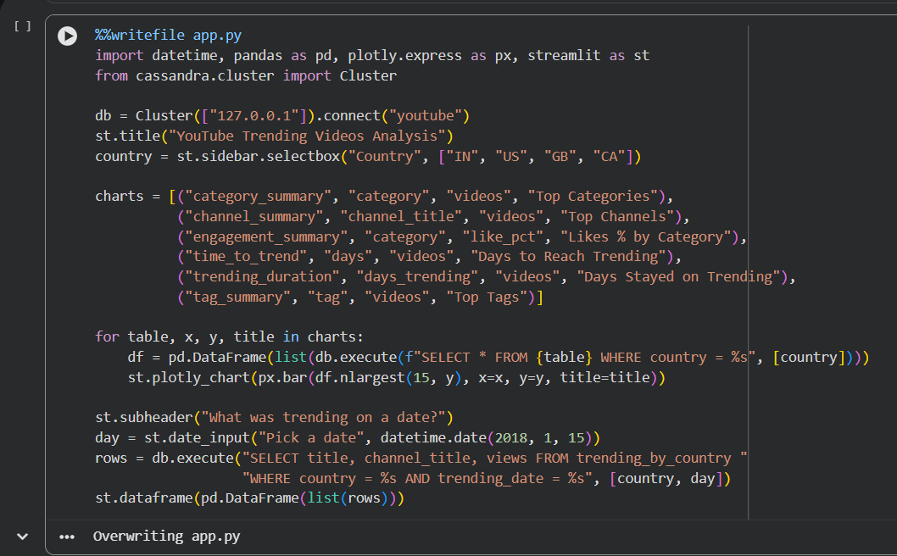
Cell 20: Start the dashboard with a public link
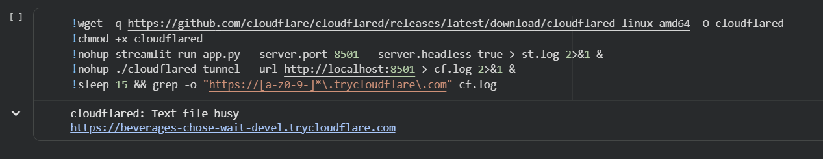

Appendix B – Dataset
Each CSV file has the 16 columns below. The example values are from the first row of INvideos.csv, before cleaning.
Table B.1: Dataset columns
Column | Meaning | Example (raw)
video_id | Unique ID of the video | kzwfHumJyYc
trending_date | Date the video was on the list (yy.dd.mm) | 17.14.11
title | Video title | Sharry Mann: Cute Munda ( Song Teaser) | ...
channel_title | Channel name | Lokdhun Punjabi
category_id | Category number (name is in the JSON file) | 1 (Film & Animation)
publish_time | Upload date and time in UTC | 2017-11-12T12:20:39.000Z
tags | Tags separated by | | sharry mann|"sharry mann new song"|...
views | Views on that day | 1096327
likes | Likes on that day | 33966
dislikes | Dislikes on that day | 798
comment_count | Comments on that day | 882
thumbnail_link | Link to the thumbnail image | https://i.ytimg.com/vi/kzwfHumJyYc/default.jpg
comments_disabled | Comments turned off | FALSE
ratings_disabled | Likes and dislikes turned off | FALSE
video_error_or_removed | Video removed or has an error | FALSE
description | Video description | Presenting Sharry Mann latest Punjabi Song ...

After cleaning, trending_date 17.14.11 becomes 2017-11-14 and the row gets three new values: days_to_trend = 2, publish_hour = 12 and publish_day = Sun.

Appendix C – Additional Screenshots
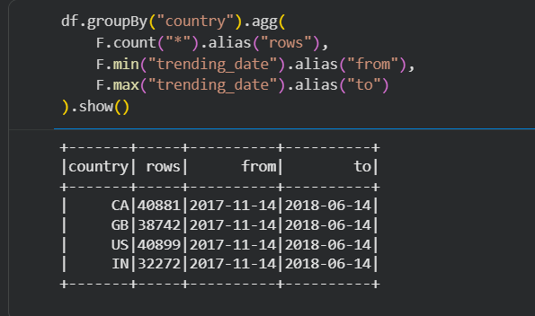
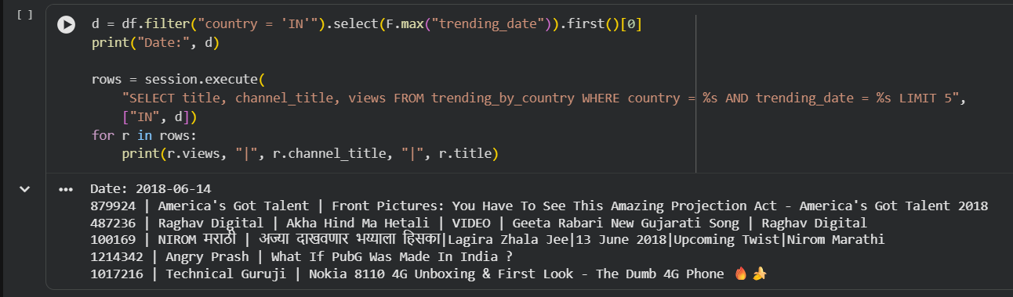
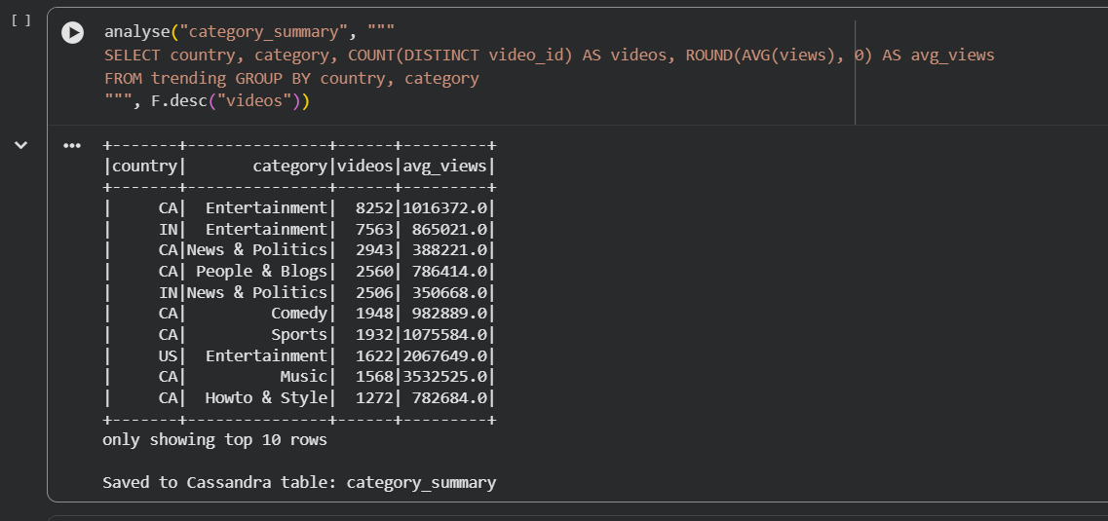
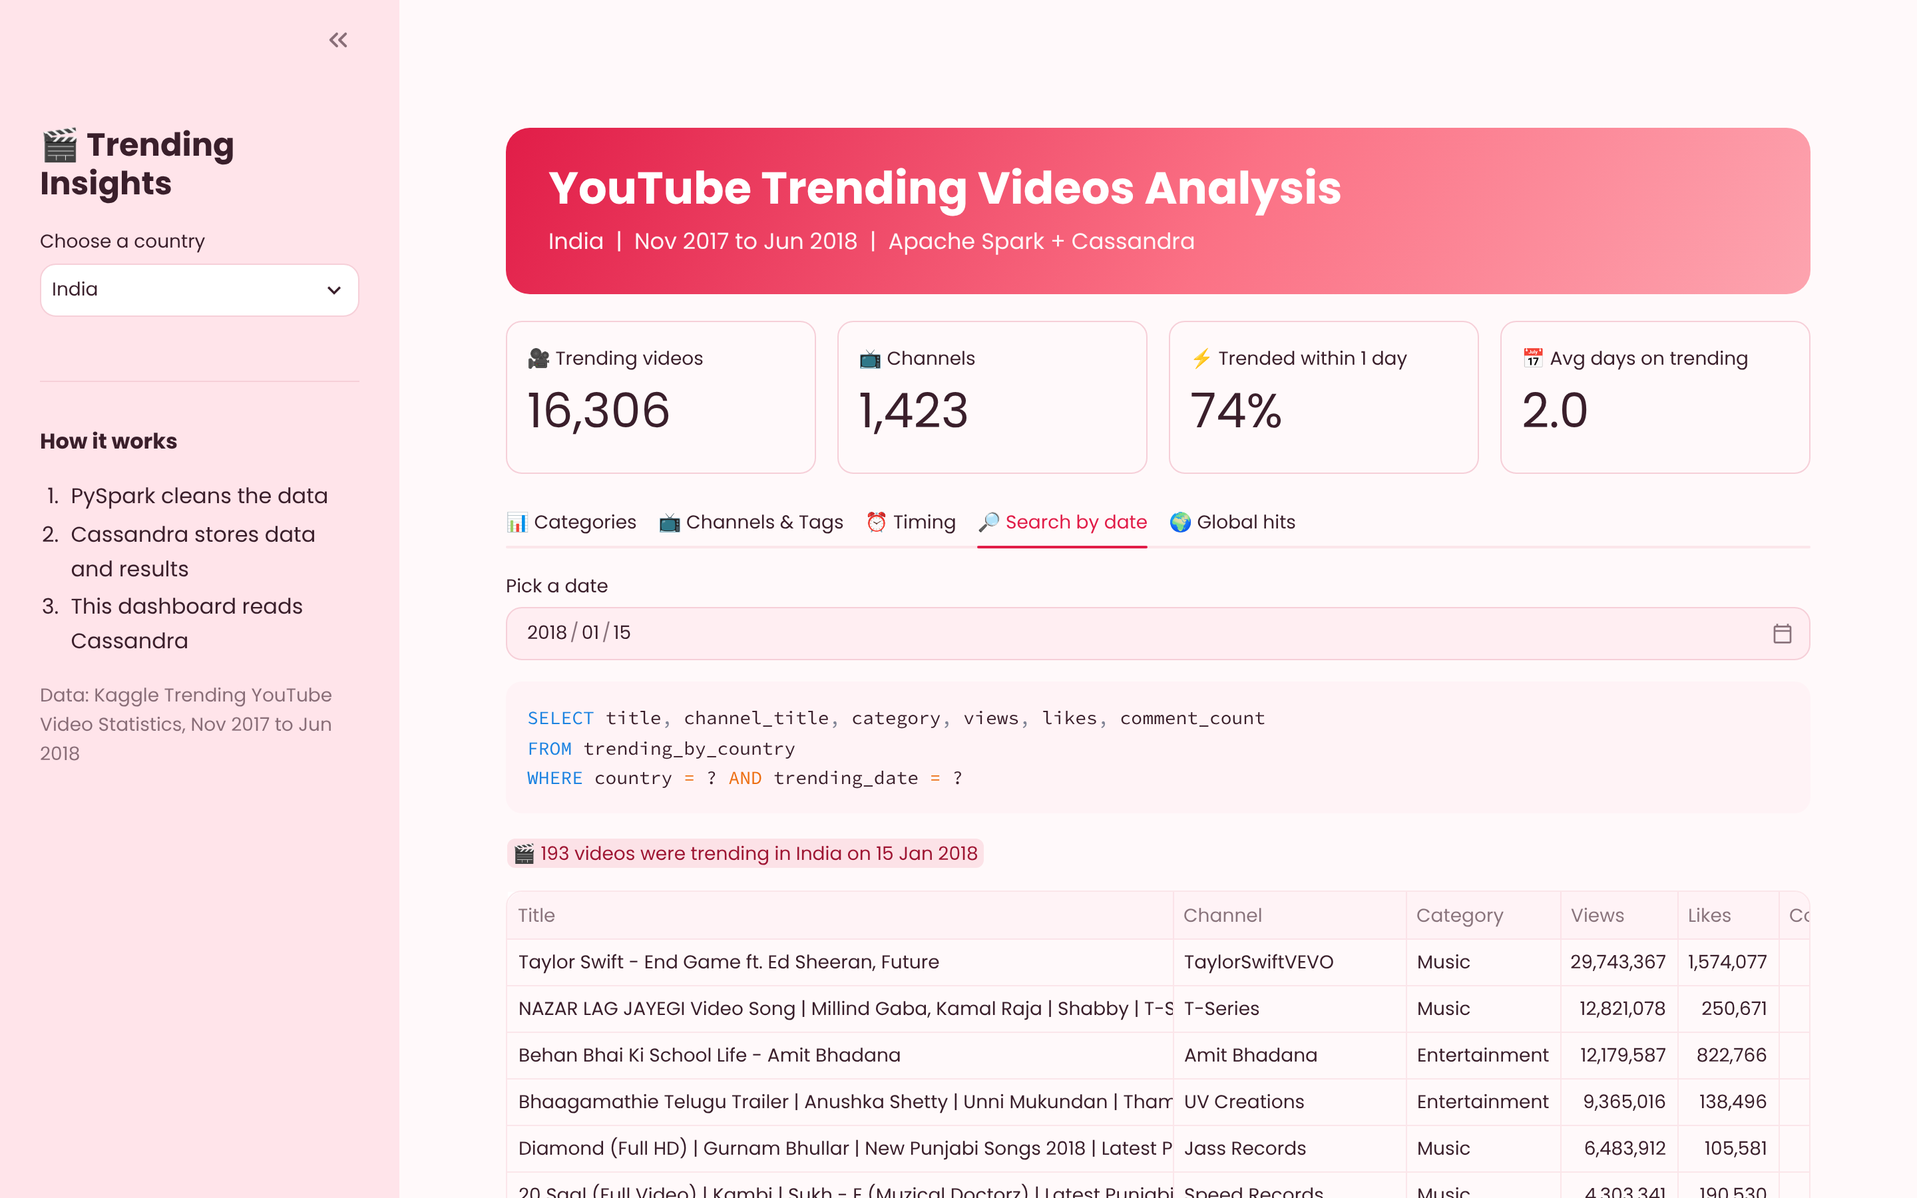
Figure C.1: Dashboard date search with the live CQL query
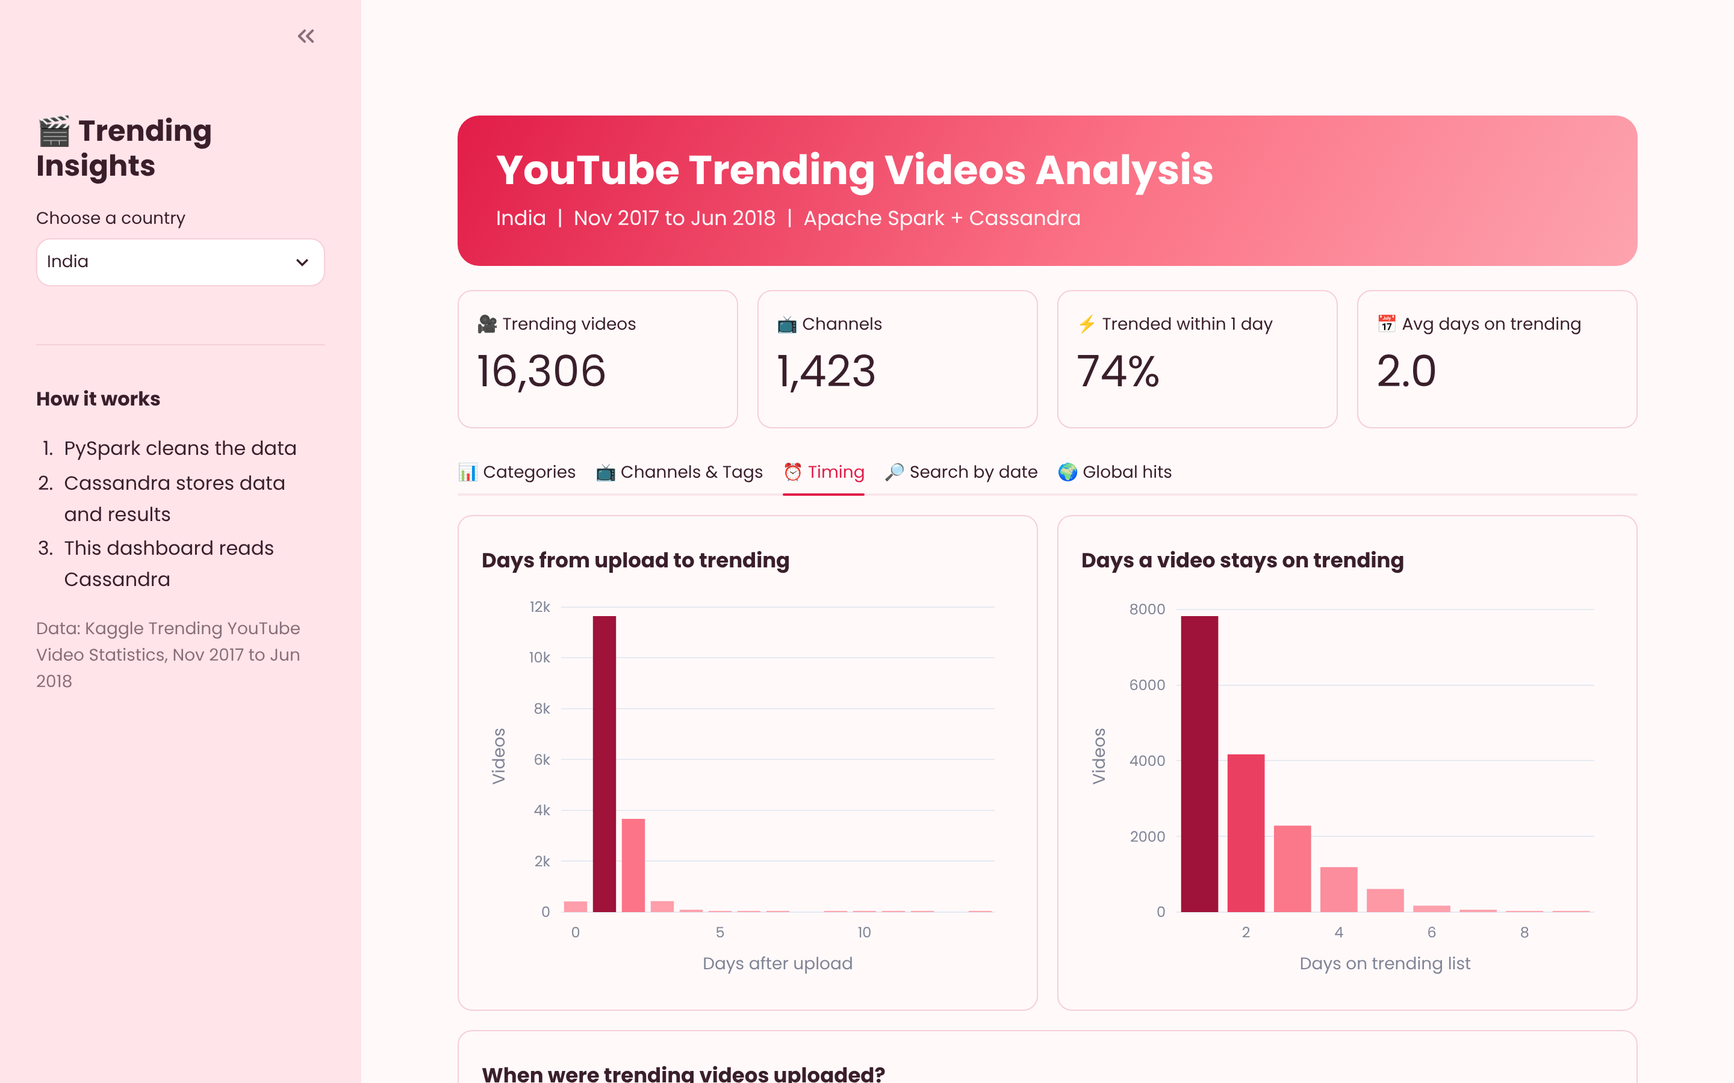
Figure C.2: Dashboard Timing tab

