Dhanwant Singh Gill

3111131

ACS-1809-001

Web Design and Development

Project Report

Introduction:

I had created a website on Lyrics of some English songs of some of the very popular stars of the industry. I have been very closely attached to music since few years, I don’t know how few years ago I just developed a habit of reading books about my regional poems and novels. Due to this I also have a habit of writing some poems and this reason motivated me to develop a website on lyrics of music. I decided to include lyrics of three singers i.e. Eminem, Snoop Dogg and Beyoncé. The songs that I selected from each singers album were based on the suggestions of my friends and top charts.

Planning:

Target and goals:

* The website’s main target is music enthusiasts, poets, writers and music critics.
* The target audience would surf through the website to gain some information about the singers and to know the lyrics of songs they might like. Some people may not be good in catching up the lyrics of the song so they would browse the website to read the lyrics.
* The major goal of the website is to distribute knowledge about singers and their song’s lyrics.
* The website also aims to rate some top songs in trend nowadays and make a chart according to their reviews.

|  |  |  |
| --- | --- | --- |
| USER GROUP | FUNCTIONS PERFORMED | PURPOSE |
| Music enthusiasts | Read lyrics  Read about singer | To enhance their knowledge about music |
| Poets, Writer | Carefully read lyrics | Understand lyricist’s view and take ideas |
| Music critics | Read the meaning of lyrics | To write their views about lyricists |

Site Structure:

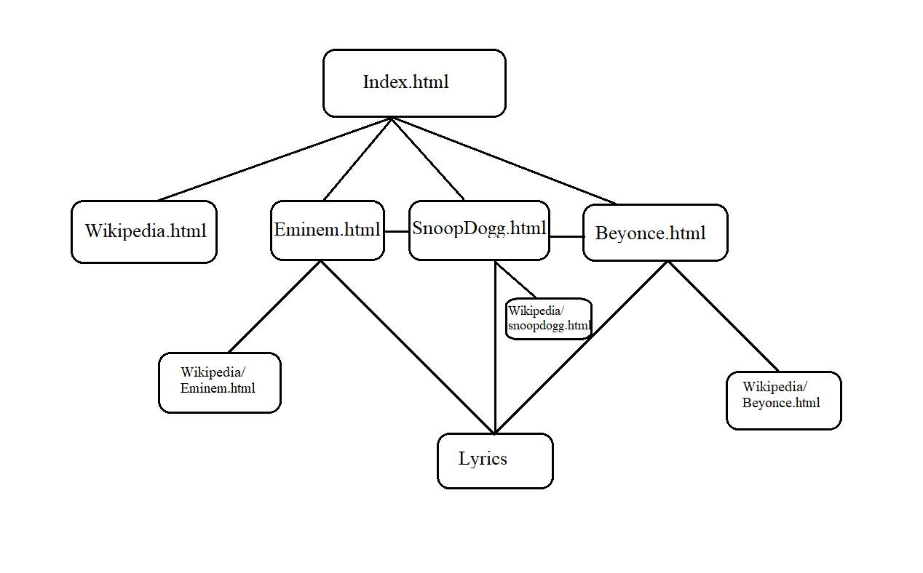

* The homepage i.e. Index.html has various links to different websites;
* It has a link to Wikipedia about lyrics, lyrics of songs of Eminem, Snoop Dogg and Beyoncé.
* Each singer’s page has a link to his/her Wikipedia and other links to various songs sung by him.

Organization of content:

The content is organized in an indented manner, as the website progresses with the link the files also progress with folders.

Each folder has various subfolders that contain various webpages.

For Instance,

|  |  |
| --- | --- |
| Link Name | Folder Name |
| Eminem | Project/Eminem |
| Secrets | Project/SnoopDogg/Secrets |
| Boss | Project/Beyoncé/Boss |

Navigation:

* The website has a sticky top navigation bar that has link to the index page, contact information and other information about the creator;
* The second bar from the top i.e. header bar has website’s logo that is linked to the index page;
* There are two fixed sidebars, one of them has a link to Wikipedia and the another one has links to different singer’s webpage;
* There is a footer an the bottom of the page that has copyright claims of the webpage.

Problems encountered :

1. The positioning of sidebars was a major difficulty as all of the divisions continued to be displayed in subsequent rows.

To the solution, I used the attribute display: flex which just made it look like it is now.

1. Usage of image map on the index page was really a difficult task because firstly the positioning of image in the centre of page was tough, secondly, finding coordinates of each circle in the image was difficult.

Highlights:

The navigation bar on the top sticks to its position even when the page is scrolled which makes it easier for user to jump to the main page at any point on any page; and user can also click on contact me which automatically redirects to email app and my email address in the reciever’s address.

Conclusion:

This website took a lot of hard work and about a week to be finalised, I have tried to use all the aspects that I have learned in this course instead of forms, because I found that of no use in my website right now.

References:

<https://en.wikipedia.org/wiki/Main_Page> : This website help me find information about the lyrics, singers biography and his tracks.

<https://www.azlyrics.com/> : This website helped me with the lyrics of songs, because it is difficult for me to remember each and every lyrics so i just read lyrics from this website for help.