PROJECT TILE : MARKET BASKET INSIGHTS

Certainly! Association analysis is a data mining technique used to discover interesting relationships and patterns in large datasets. One of the most common methods for performing association analysis is the Apriori algorithm. Here are the general steps to perform association analysis and generate insights:

1. *Data Preparation*:

- Collect and preprocess your data, ensuring it's in a suitable format for analysis.

- Remove duplicates and handle missing values.

2. *Transaction Identification*:

- In association analysis, you typically work with transaction data, where each transaction contains a set of items. For example, in a retail dataset, each transaction might represent items purchased together in a single shopping cart.

3. *Support and Confidence*:

- Define support and confidence thresholds. Support measures the frequency of occurrence of a set of items, while confidence measures the likelihood of one item being purchased when another item is purchased.

4. *Algorithm Selection*:

- Choose an association rule mining algorithm, such as Apriori, FP-Growth, or Eclat, to discover itemsets that meet your support and confidence thresholds.

5. *Mining Association Rules*:

- Apply the selected algorithm to the data to find frequent itemsets and association rules. Frequent itemsets are sets of items that occur together frequently, and association rules specify relationships between items.

6. *Rule Evaluation*:

- Evaluate the discovered association rules based on their support and confidence levels. You can also consider lift and conviction to assess the strength and interestingness of the rules.

7. *Insight Generation*:

- Once you have the association rules, you can generate insights. These insights might include product recommendations, cross-selling opportunities, or understanding customer behavior.

- Visualize the results through graphs, charts, or reports to make the insights more understandable.

8. *Iterate and Refine*:

- Refine your analysis by adjusting support and confidence thresholds or considering additional factors based on the insights you've generated.

9. *Implement Actions*:

- Implement business actions based on the insights gained. For example, you can optimize product placement, marketing strategies, or inventory management.

10. *Monitor and Improve*:

- Continuously monitor the impact of your actions and refine your association analysis as new data becomes available.

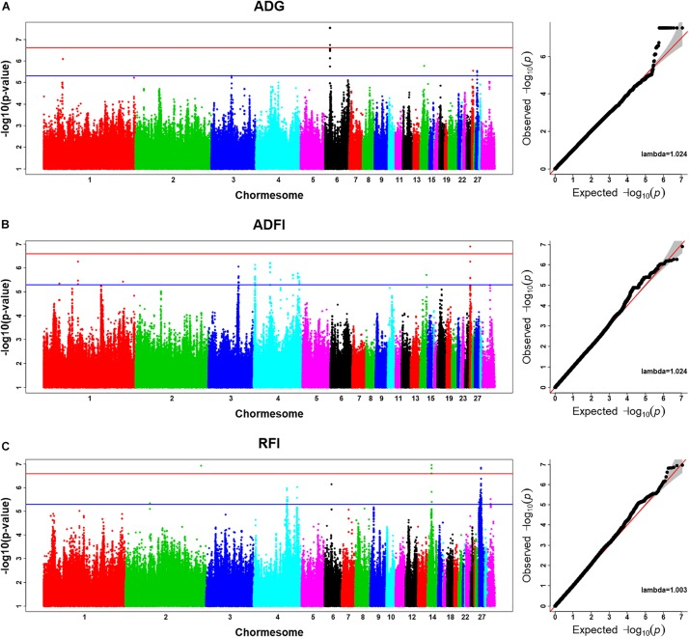

Remember that association analysis can be applied to various domains, such as retail, e-commerce, healthcaCertainly, to perform association analysis and generate insights, you typically use programming languages like Python and specific libraries or packages. One of the most popular libraries for this task is Apriori in Python. Here's a simplified example of how you might perform association analysis using Python:

python

# Import necessary libraries

import pandas as pd

from mlxtend.frequent_patterns import apriori

from mlxtend.frequent_patterns import association_rules

# Load your dataset

data = pd.read_csv('your_dataset.csv')

# Preprocess your data (e.g., removing duplicates, handling missing values)

# Perform one-hot encoding to convert items into binary values

data_encoded = pd.get_dummies(data)

# Use Apriori to find frequent itemsets

frequent_itemsets = apriori(data_encoded, min_support=0.1, use_colnames=True)

# Generate association rules

association_rules = association_rules(frequent_itemsets, metric="lift", min_threshold=1.0)

# Filter and sort the rules based on confidence and other metrics

filtered_rules = association_rules[(association_rules['confidence'] > 0.5) & (association_rules['lift'] > 1.0)]

sorted_rules = filtered_rules.sort_values(by='lift', ascending=False)

# You can then print or visualize the resulting association rules

print(sorted_rules)

In this code:

- You start by importing the necessary libraries, like pandas for data handling and mlxtend for association analysis.

- You load your dataset, preprocess it, and perform one-hot encoding to prepare it for association analysis.

- You use the Apriori algorithm to find frequent itemsets in your data based on a minimum support threshold.

- Then, you generate association rules based on these frequent itemsets, using a specific metric like "lift" as a threshold to measure the strength of rules.

- You can filter and sort the rules based on various criteria like confidence and lift.

- Finally, you print or visualize the resulting association rules to gain insights.

Please note that you would need to adapt this code to your specific dataset and analysis goals. Additionally, there are other Python libraries and tools available for association analysis, and you can explore them based on your requirements.re, and more, to uncover valuable patterns and relationships within your data.