SOFTWARE ENGINEERING LAB

NAME: Dhanisha Sethupathy

REG.NO: 23BCE5068

UML Diagrams
CLASS DIAGRAM
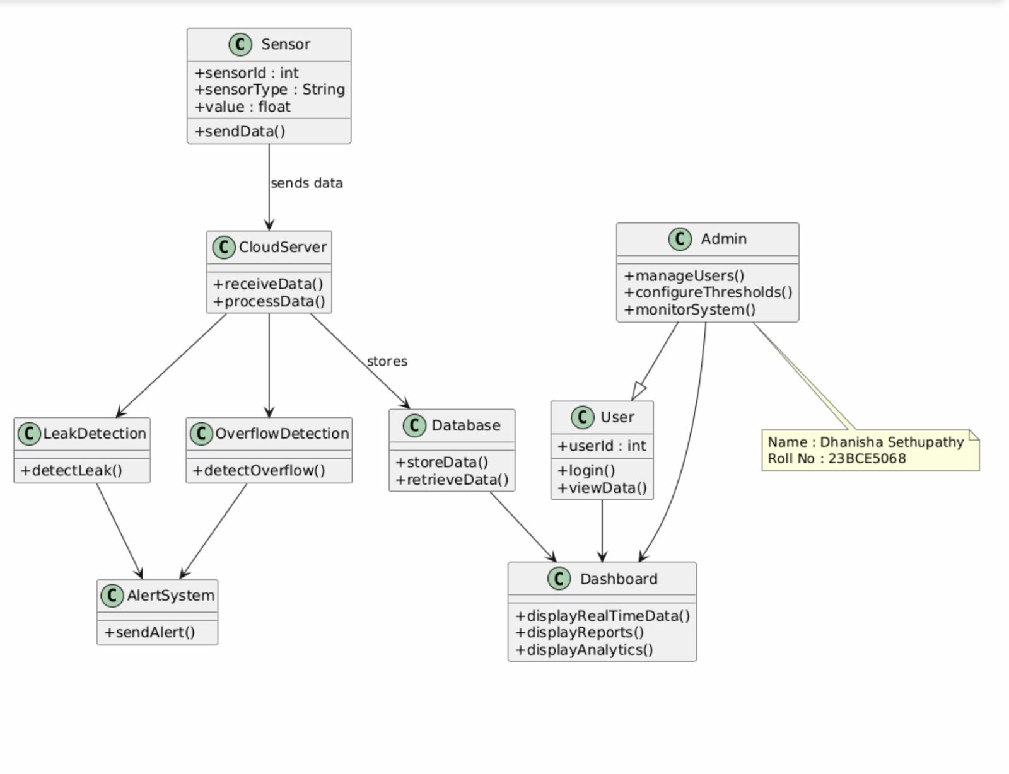

The system collects real-time water data from sensors and sends it to the cloud for processing. The data is analyzed to detect problems such as leakage or overflow, stored in a database, and displayed on a dashboard. Alerts are triggered when any abnormal condition occurs, and both users and admins can manage and monitor the system.

Sensor – Collects water parameters such as level or pressure and sends data to the cloud using sendData().
CloudServer – Receives and processes sensor data through receiveData() and processData().
LeakDetection – Checks for leakage conditions using detectLeak().
OverflowDetection – Identifies high water levels using detectOverflow().
AlertSystem – Sends notifications to users via sendAlert().
Database – Stores and retrieves sensor data for reports and analysis.
Dashboard – Displays real-time data, reports, and analytics to users.
User – Logs in and views water information.
Admin – Manages users, configures thresholds, and monitors the system.

Data Flow
- Sensors send data to the Cloud Server.
- The Cloud Server processes the data.
- Leak and overflow detection modules analyze the values.
- If an issue is found, the Alert System notifies users.
- Data is stored in the Database.
- The Dashboard displays real-time information and reports.
- Admin and users access the system for monitoring and control.

USECASE DIAGRAM
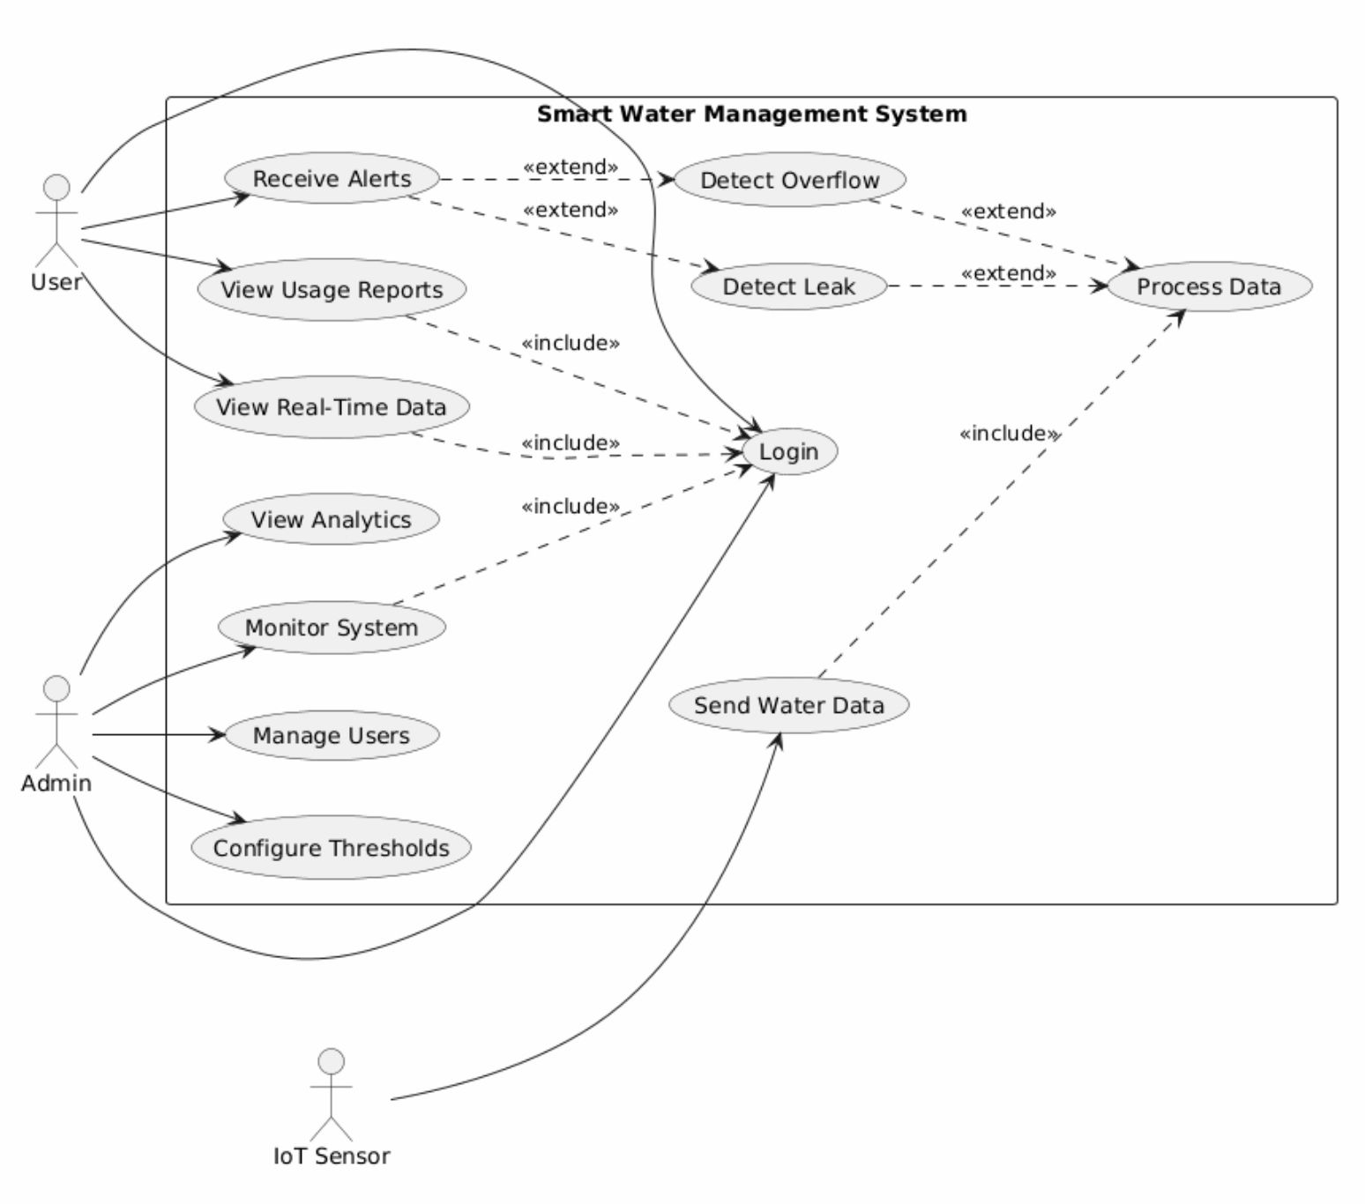
The Use Case Diagram represents the interaction between users and the Smart Water Management System. It defines the major functionalities provided by the system and the roles of different actors such as User, Admin, and IoT Sensor.
The User can log in to the system to view real-time water data, usage reports, and analytics. The user also receives alerts when the system detects abnormalities such as water leakage or overflow. The Admin is responsible for monitoring the system, managing user accounts, and configuring threshold values for leak and overflow detection. All user and admin operations include the Login use case to ensure secure access.
The IoT Sensor sends real-time water parameters to the system through the Send Water Data use case. The system processes this data using Process Data and checks for abnormal conditions through Detect Leak and Detect Overflow. These detection use cases extend the Receive Alerts function, which notifies the user whenever a problem occurs.

