SOFTWARE ENGINEERING LAB

NAME: Dhanisha Sethupathy

REG.NO: 23BCE5068

SEQUENCE DIAGRAM
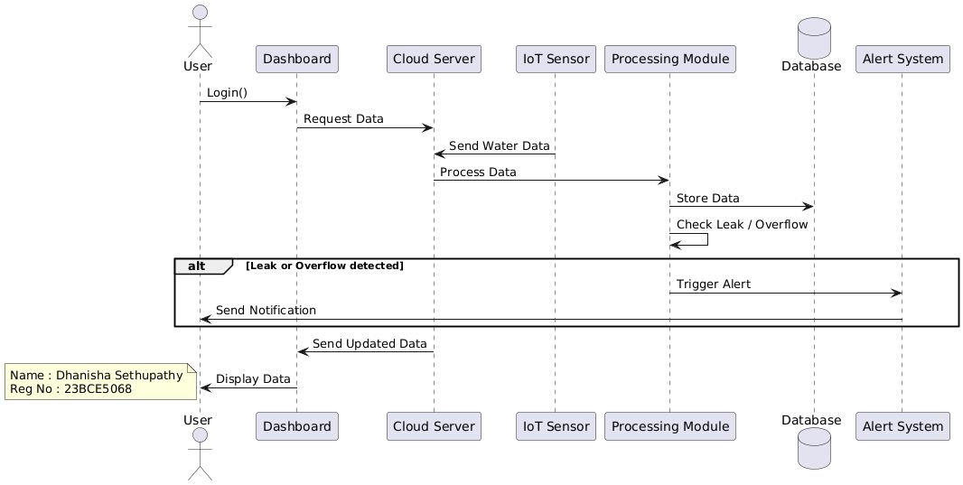

ACTIVITY DIAGRAM
