MODULE:

* SE : Overview of I.T industry

# 1.What is software ?

Software is a set of instructions that tells a device how to perform specific tasks. It allows users to interact with a device in ways that would otherwise be impossible, such as creating graphics, editing videos, and playing games.

# 2.What is software engineering ?

Software engineering is a branch of computer science that involves the design, development, testing, and maintenance of software applications. It's a technical career path that combines programming skills with engineering principles to create software solutions for end users.

# 3.Explain types of software.

### Application software :

Also known as apps, these programs help users complete tasks and are the most interactive part of technology.

### Operating system :

Controls hardware and establishes the user interface between the hardware and the user.

# 4.What is SDLC ?

SDLC stands for Software Development Life Cycle, a structured process that helps development teams design and build software. The SDLC is a generic framework that helps ensure software is developed efficiently and consistently. It's used to plan, design, develop, test, and deploy software.

# 5.Explain each pase of sdlc.

**1. Planning & Analysis**

The first phase of the SDLC is the project planning stage where you are gathering business requirements from your client or stakeholders. This phase is when you [evaluate the feasibility of creating the product](https://theproductmanager.com/topics/how-to-do-a-feasibility-study/), revenue potential, the cost of production, the needs of the end-users, etc.

To properly decide what to make, what not to make, and what to make first, you can use a [feature prioritization framework](https://theproductmanager.com/topics/feature-prioritization/) that takes into account the value of the software/update, the cost, the time it takes to build, and other factors.

**2. Define Requirements**

This phase is critical for converting the information gathered during the planning and analysis phase into clear requirements for the development team. This process guides the development of several important documents: a software requirement specification (SRS) or [product specification](https://theproductmanager.com/topics/product-specification/), a Use Case document, and a Requirement Traceability Matrix document.

**3. Design**

The design phase is where you put pen to paper—so to speak. The original plan and vision are elaborated into a software design document (SDD) that includes the system design, programming language, templates, platform to use, and application security measures. This is also where you can flowchart how the software responds to user actions.

**4. Development**

The actual development phase is where the development team members divide the project into software modules and turn the software requirement into code that makes the product.

This SDLC phase can take quite a lot of time and [specialized development tools](https://theproductmanager.com/tools/product-development-software/). It’s important to have a set timeline and milestones so the software developers understand the expectations and you can keep track of the progress in this stage.

In some cases, the development stage can also merge with the testing stage where certain tests are run to ensure there are no critical bugs.

**5. Testing**

Before getting the software product out the door to the production environment, it’s important to have your quality assurance team perform validation testing to make sure it is functioning properly and does what it’s meant to do. The testing process can also help hash out any major user experience issues and security issues.

In some cases, software testing can be done in a simulated environment. Other simpler tests can also be automated.

**6. Deployment**

During the deployment phase, your final product is delivered to your intended user. You can automate this process and schedule your deployment depending on the type. For example, if you are only deploying a feature update, you can do so with a small number of users (canary release). If you are creating brand-new software, you can learn more about the different [stages of the software release life cycle](https://theproductmanager.com/topics/software-release-life-cycle/) (SRLC).

**7. Maintenance**

The maintenance phase is the final stage of the SDLC if you’re following the [waterfall](https://theproductmanager.com/topics/agile-vs-waterfall-methodology/) structure of the software development process. However, the industry is moving towards a more agile software development approach where maintenance is only a stage for further improvement.

In the maintenance stage, users may find bugs and errors that were missed in the earlier testing phase. These bugs need to be fixed for better user experience and retention. In some cases, these can lead to going back to the first step of the software development life cycle.

# 6.What is DFD ?

a data flow diagram (DFD) is a visual representation of how data flows through a system or process.

# 7.create a DFD diagram on flipkart.

# 

# 8.What is flow chart?

A flowchart is a diagram that uses symbols and arrows to show the steps, sequences, and decisions of a process or workflow. Flowcharts are used in many fields for planning, visualizing, documenting, and improving processes.

# 9.Create a flow chart to make addition of two numbers.

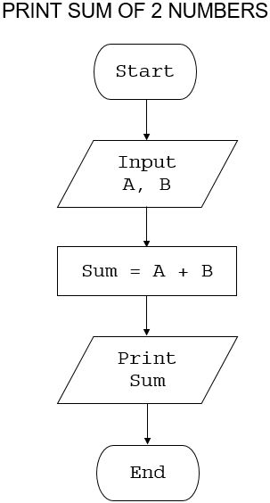

# 10.What is use case diagram?

A use case diagram is a visual representation of how users interact with a system, and is a key tool in the early stages of system design and development. It shows the different ways a system can be used, and the paths users might take to achieve their goals.

# 11.Create a use-case on bill payment on paytm.

