**Design to Micro Frontend using Angular.**

**Author: Gurdeep Singh**

**Email:** [**dhanjal.gurdeep@gmail.com**](mailto:dhanjal.gurdeep@gmail.com)

**Abstract:**

This article is based on the Micro frontend designs which helps provide the guidelines to how to create scaffolding, solutioning the design pattern using Angular Element, Web component framework. Github sample details the solution how to implement the Mirco frontend and using this approach you can avoid the **Monolithic Single page applications**.

**Design:**

It is to avoid the monolithic implementation as couple of year back backend started with micro services design which resolved the dependencies and service can function independently and that is self-contained and manages its own resources, similar approach Thoughworks started to try for frontend to keep the part on web page independent from the other parts.

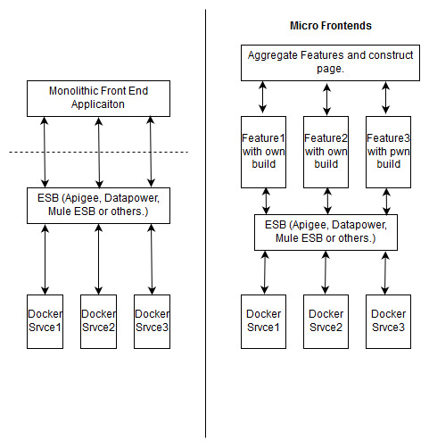

Fig1. (Monolithic vs Micro Frontend Design Comparison).

Above figure is comparing the monolithic single page application and micro frontends.

* Micro frontend each feature is like an element which is getting bootstrapped independently.
* All the features are interacting with microservices and getting the data.
* Using the micro frontend design different features can be implemented by different teams with different frontend technology stacks and different elements can compose the page.
* Implemented the Routes in the example which can provide the flexibility to move back and forth in the angular elements.