With the help of the admin panel, we can update, delete, and create a new Page's content. To login to the admin panel, write **/admin**

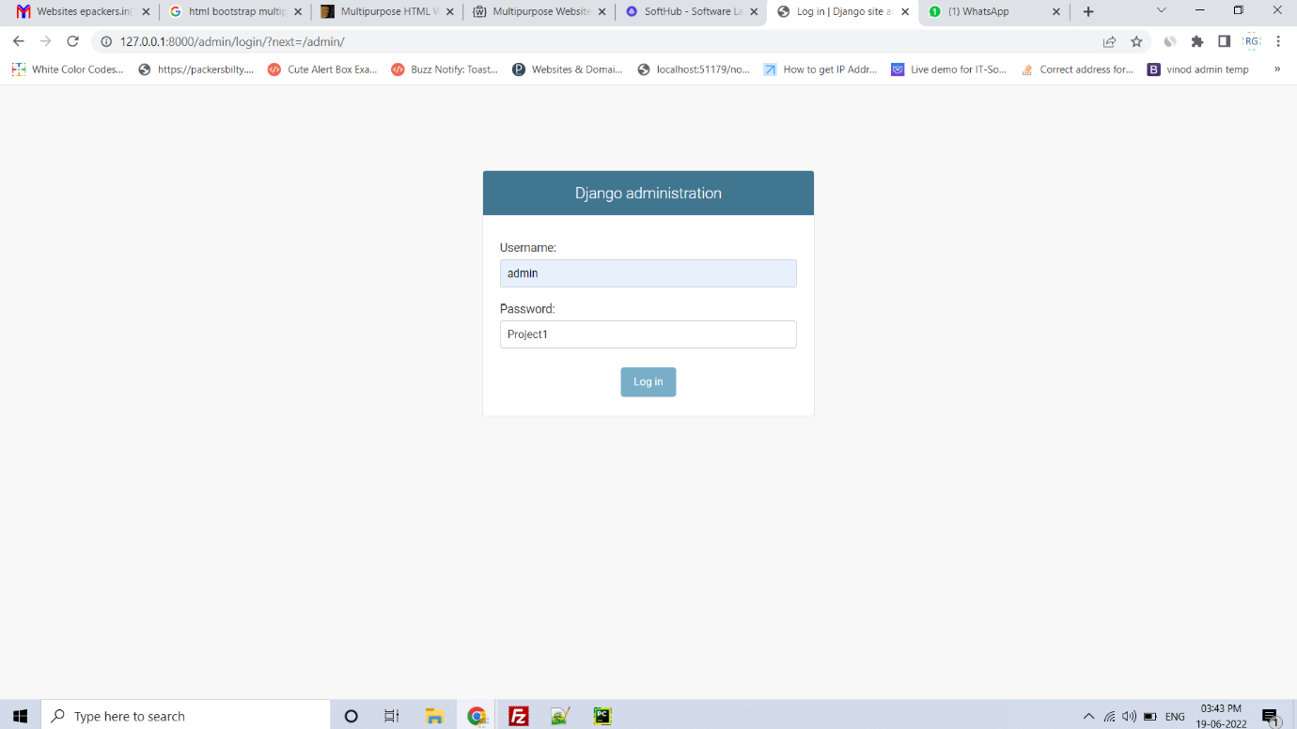

After login, you will be redirected to the dashboard. You will also see the recent actions on the dashboard.

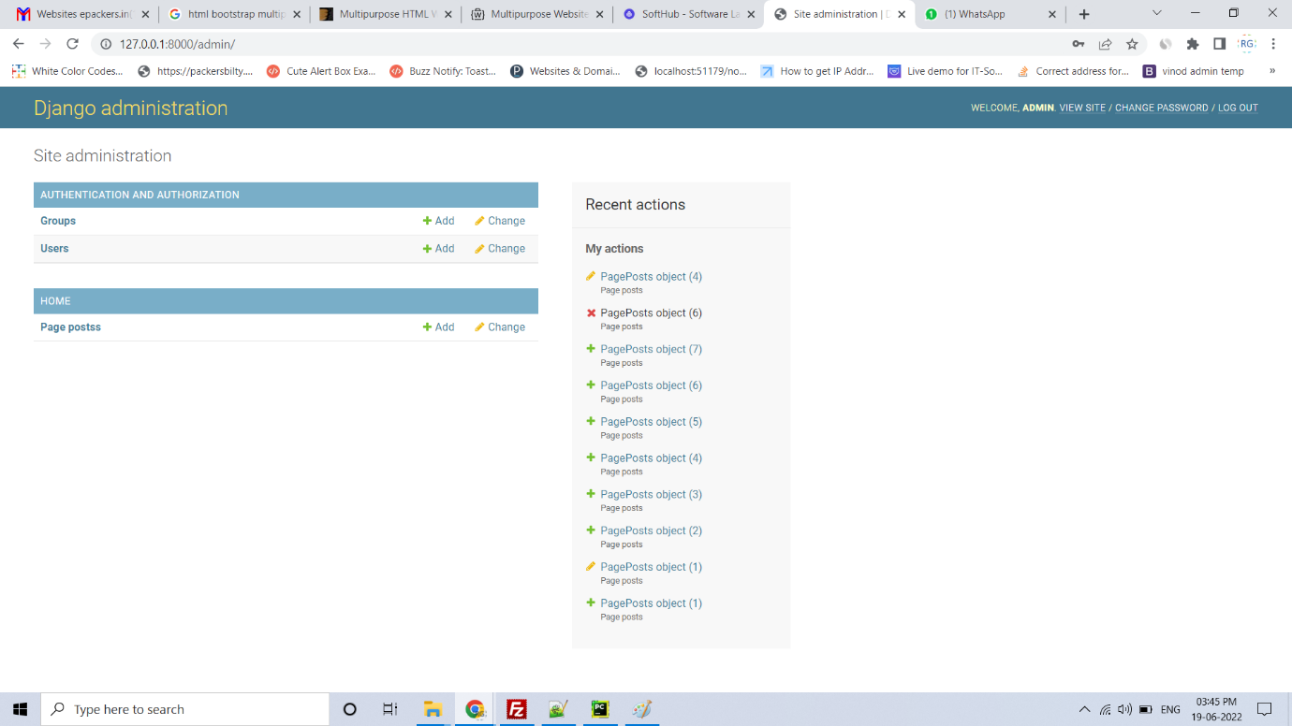

You will get a list of all the pages created with the help of admin panel.

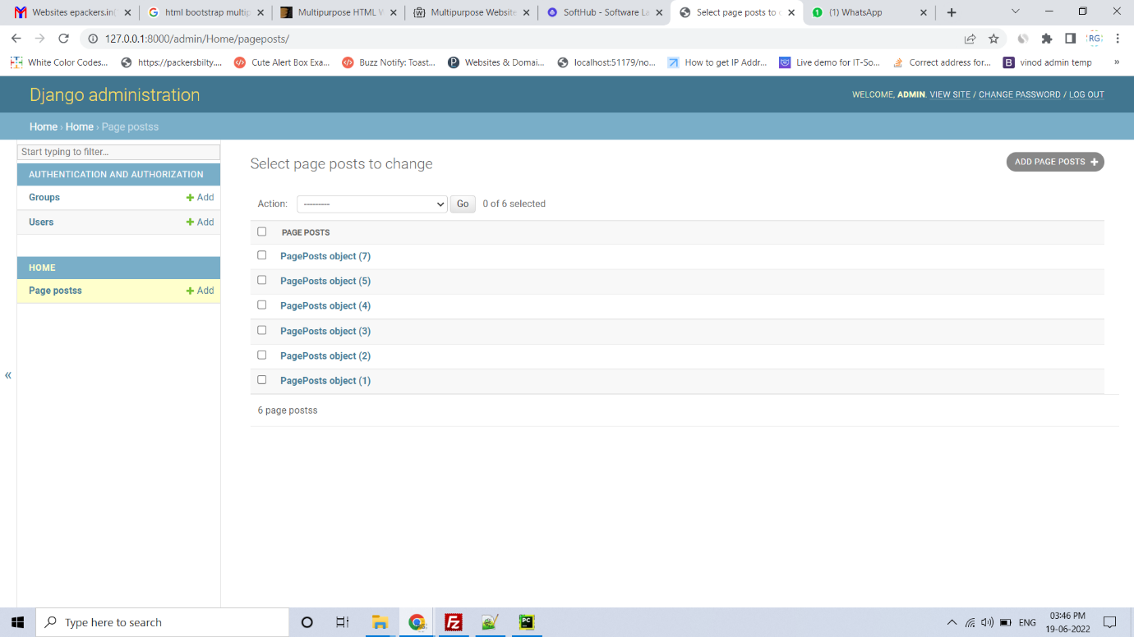

Click on the **ADD PAGE POSTS +** button to add a new page. You will get a form like the screenshot shown below. A tinymce has been added to the form, with the help of the tinymce you can bold, italic, underline, zoom, search, align, heading your text.

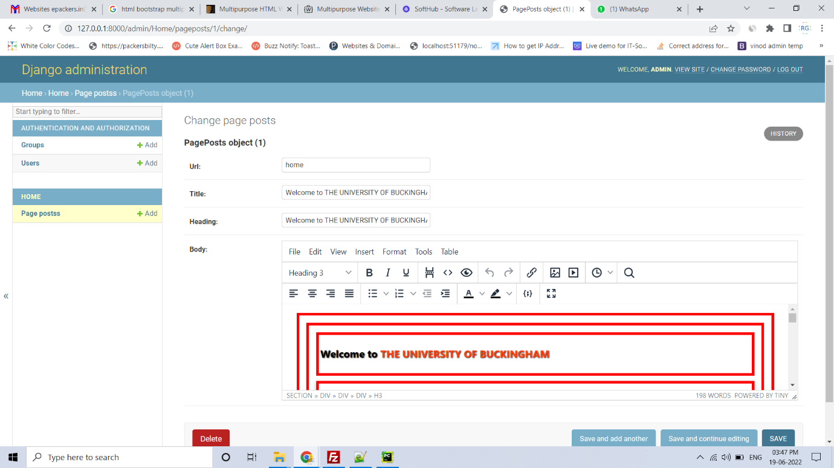

The password can be changed from the password change page.

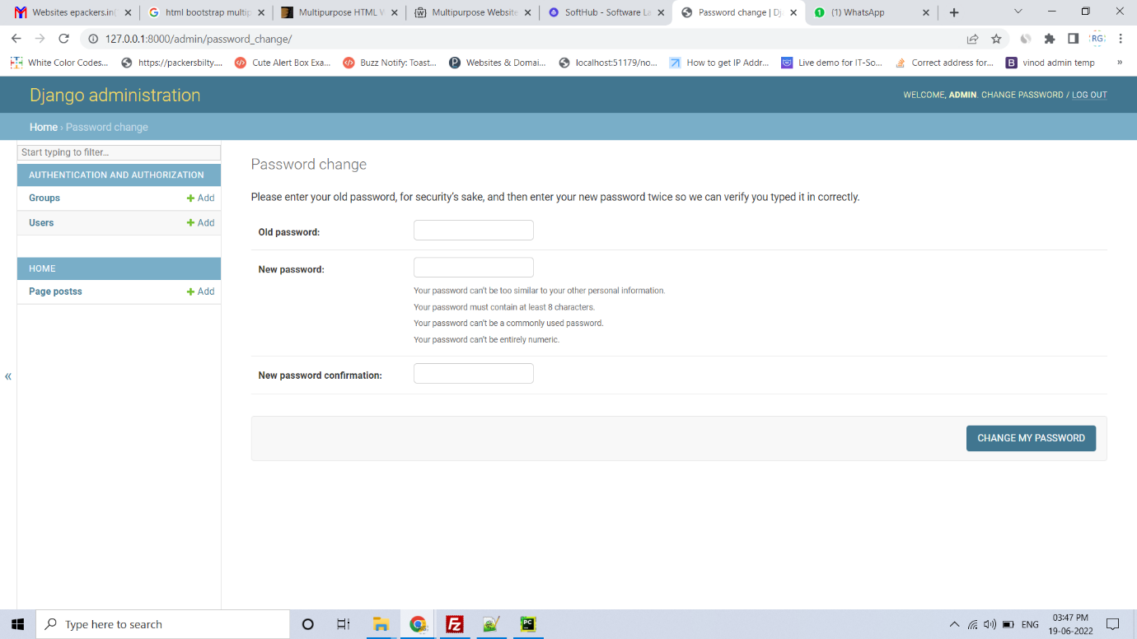

You can press the logout button to close the login session.

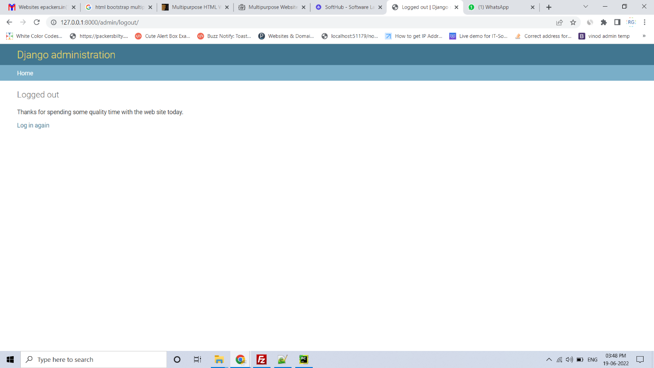

There are 6 navigation menus on the front which are as follows:

home

library

IT Services

office 365

Microsoft Teams

university email

**Screenshots of all the pages are given below.**

About Page

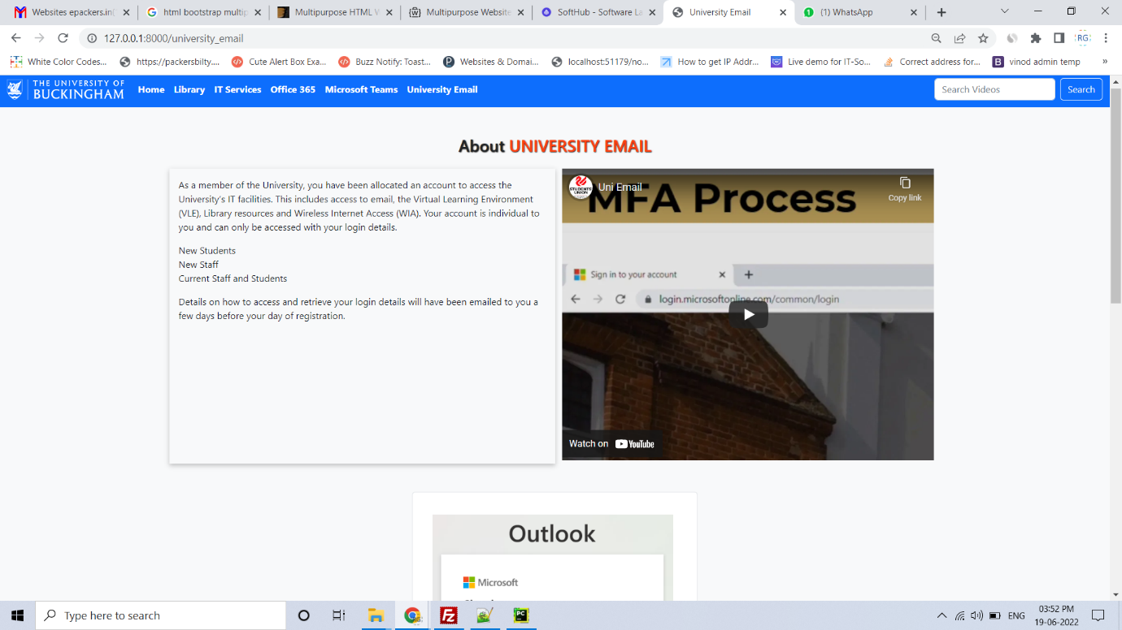

About page

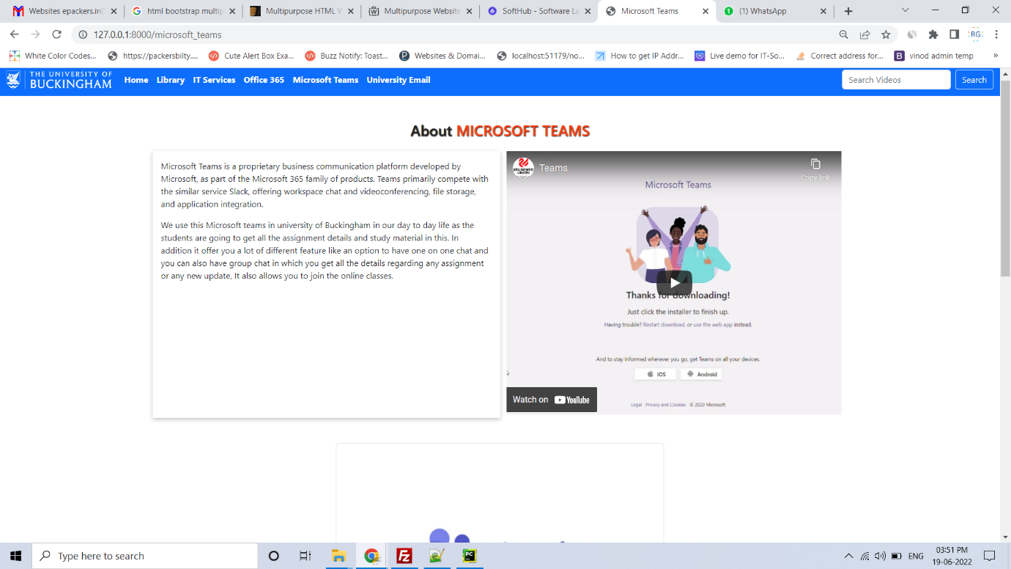

Office 365 page

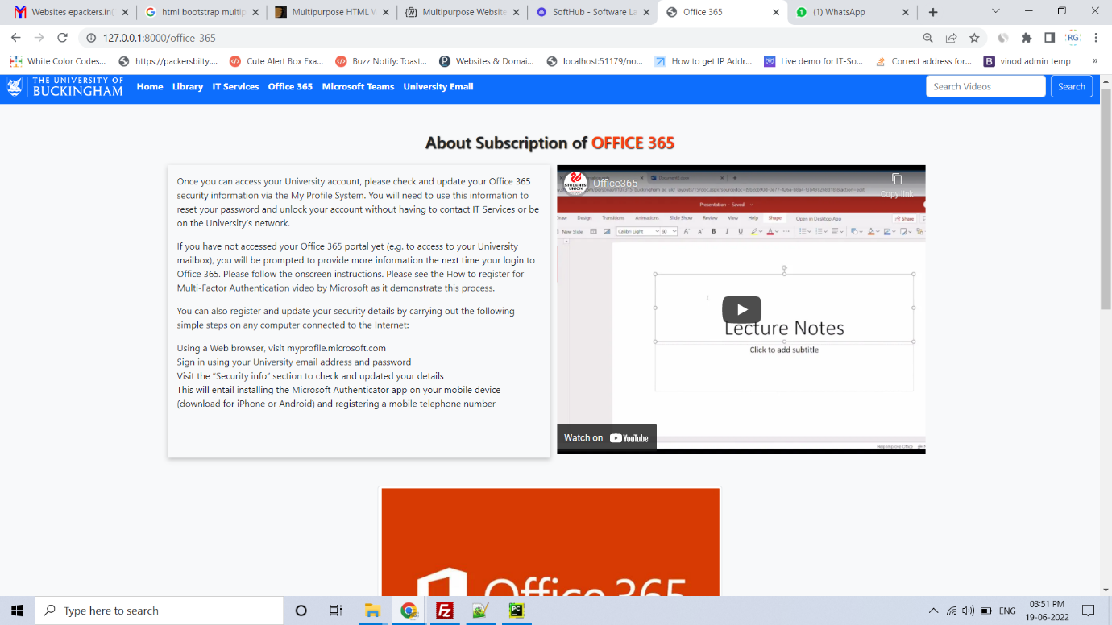

IT Services page

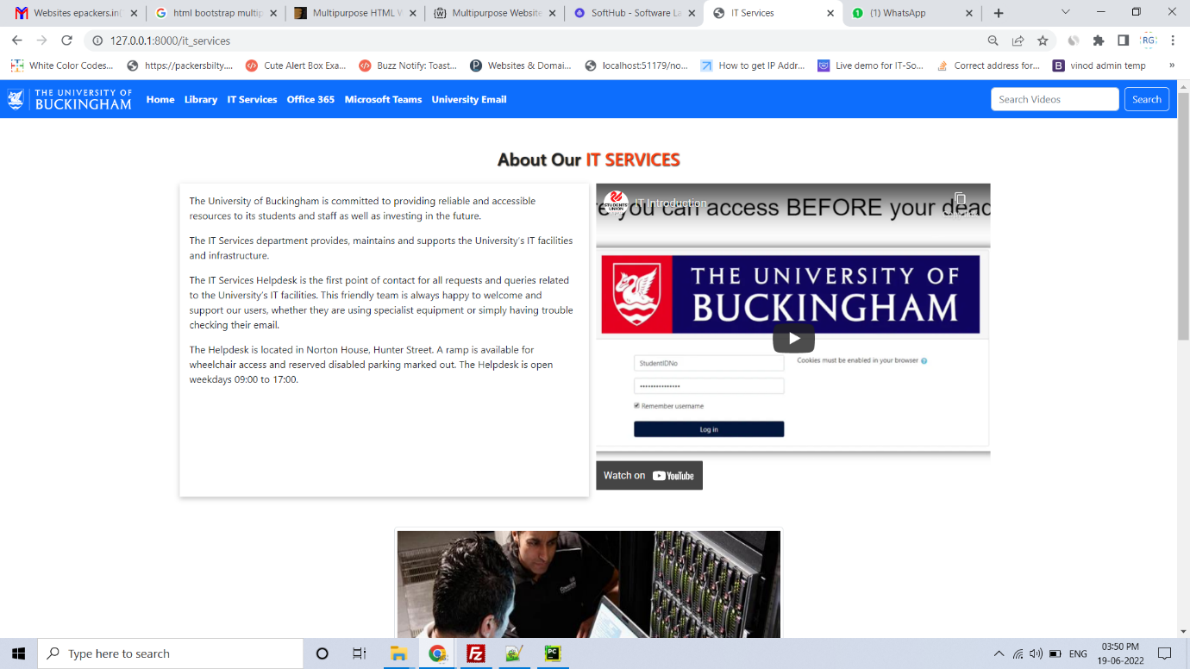

About Page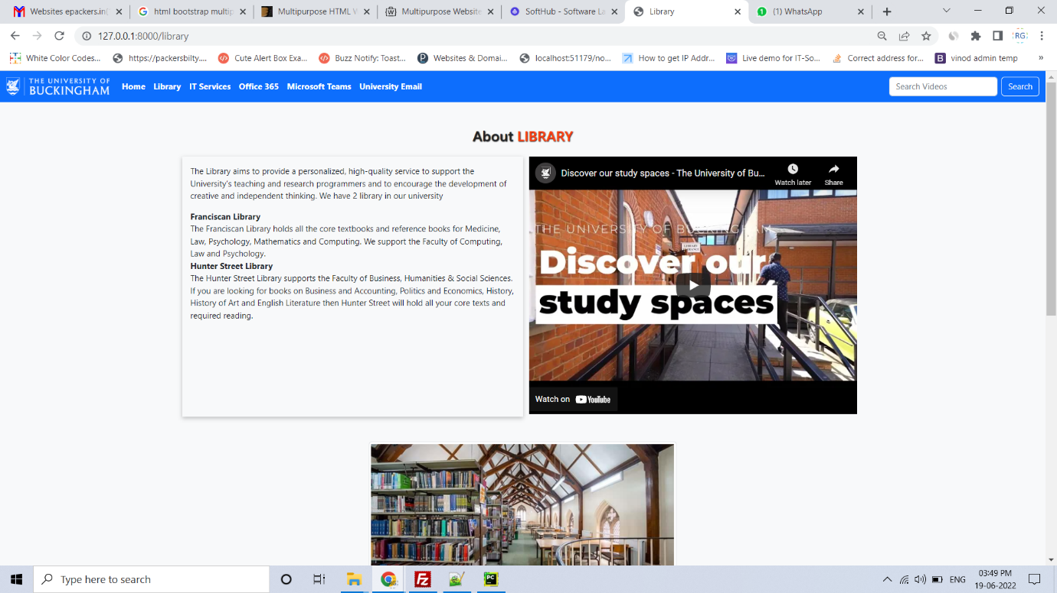

Home page

