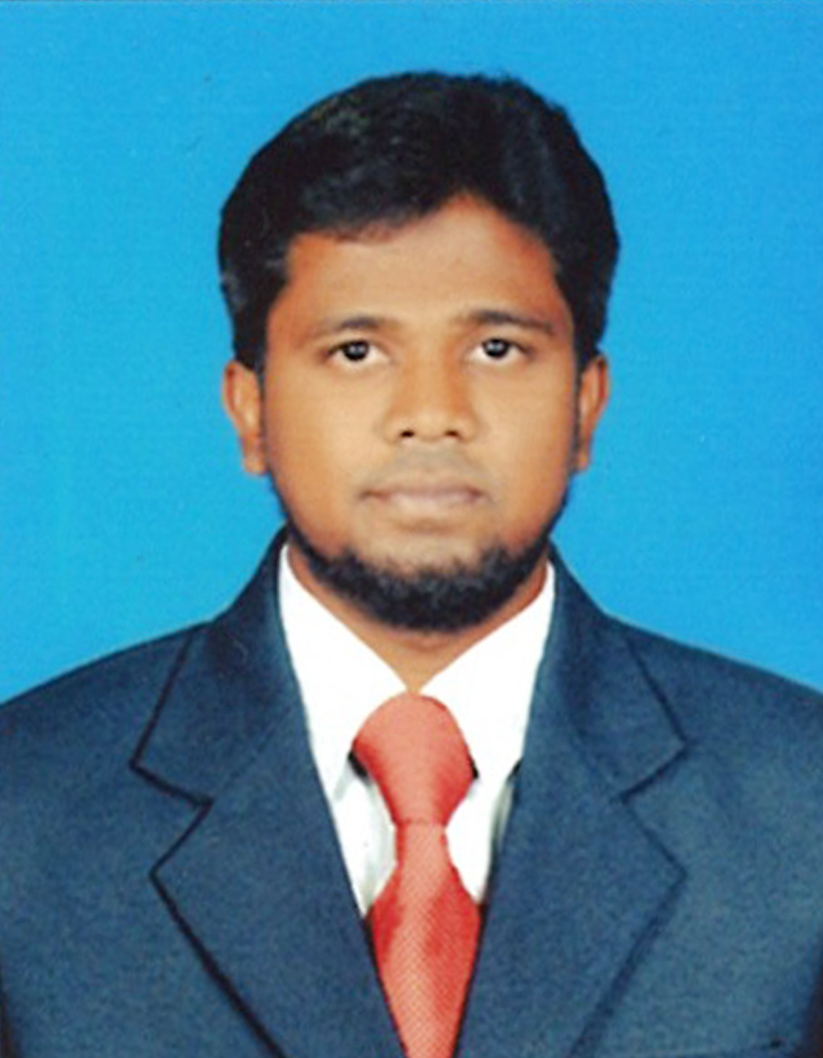

**SADHAM HUSSAIN. A**

**Mobile : +91 8807624010**

**E-mail :** [**msc.sadham@gmail.com**](mailto:msc.sadham@gmail.com)

**skype Id : sadham.hussain33**

**PROFESSIONAL SUMMARY**

* 4 + years of experience in the field of Software Development and Information Technology.
* Expert in application development using PHP, Python, Angular(Basics), HTML,CSS ,JavaScript , Jquery, MYSQL, MS SQL, Mongodb.
* Knowledge in MVC Architecture Framework CodeIgniter, Laravel , Flask.
* Hands on experience in SQL queries. Strong skills in SQL Development.
* Excellent logical and analytical skills with the ability to work under pressure as individual and as part of team.
* Having strong communication skills and an ability to work individually and as part of a team.
* Self-motivated individual and a good team player.
* Quick learner and efficient multitasker.

**EXPERIENCE**

* Currently Working as **Application Developer** in **Pinnacle Infosys Pte Ltd**., Singapore from Apr 2020 to till date.
* Worked as **Web Developer** in **Propel Soft**., Trichy from Apr 2016 to April 2020.
* Worked as **Web Developer** in **Usis Technologies Pvt. Ltd**., Coimbatore from Nov 2014 to Apr 2016.

**TECHNICAL SKILLS**

Databases : MS SQL , MYSQL, Mongo DB, MS Access,

Languages : PHP, HTML, CSS, JAVA SCRIPT, JQUERY , Angular( basics ), Python

Framework : Codeigniter, Laravel, Angular(basics), Flask(Python)

Opensource : CMS Basics

Payment Gateways : PayPal, Instamojo, ccAvenue

**PROJECT EXPERIENCE**

**# Project - 1:**

**Title :** MShip websit : http://cb.mypropelsoft.com

**Role :** Software Developer &Tester

**Technology :**  Angulrar JS, Laravel Framework , MySQL

**Team Size :** 3

**Description:**

**MShip** is a systematic approach to maintain the church membership money collection, accounts details, family details and Etc. Church have group of leaders, each leaders under having some families they collect the information.

Accordingly Super admin to maintain the each Group leader information.

**# Project - 2:**

**Title :** Propel ERP website: http://mypropelsoft.com

**Role :** Software Developer &Tester

**Technology :**  PHP Laravel Framework, MySQL

**Team Size :** 5

**Description:**

**Propel ERP** is a full-scale web based ERP application, with Accounts, CRM, HRM, Project Management and so on. The application is intended to work for multiple kinds of businesses. It targets both business and its customer, so they can track their business with organization.

**# Project - 3:**

**Title :** Reliance Supply Inc. website: [www.reliancesupply.com](http://www.reliancesupply.com)

**Role :** Software Developer

**Technology :** PHP CodeIgniter, Apache, MySQL

**Team Size :** 2

**Description:**

**Reliance Industrial Supplies** project provide complete solution of managing the automobile goods in the warehouse. It provides a set of computerised procedures to handle the receipt of stock and returns into a warehouse facility, model and manage the logical representation of the physical storage facilities (e.g. racking etc.), manage the stock within the facility and enable a seamless link to order processing and logistics management in order to pick, pack and ship product out of the facility. Reliance Industrial Supplies will also control the movement and storage of materials within a warehouse – you might even describe it as the legs at the end-of-the line which automates the store, traffic and shipping management.

**# Project - 4:**

**Title :**  Amnesty International India website: [www.amnesty.org.in](http://www.amnesty.org.in)

**Role :** Software Developer &Tester

**Technology :**  Expression Engine, PHP Code Igniter,Mysql

**Team Size :** 3

**Description:**

**Amnesty** International is a worldwide movement of people campaigning to protect human rights. We have a vision of a world in which every person enjoys all of the rights stated in the Universal Declaration of Human Rights and other international human rights standards.

**# Project - 5:**

**Title :** Blood Bank India website: www.bloodbankindia.net

**Role :** Software Developer &Tester

**Technology :** PHP Laravel Framework,Mysql

**Team Size :** 3

**Description:**

Despite the increase in the number of donors, blood remains in short supply during emergencies, mainly attributed to the lack of information and accessibility. We positively believe this tool can overcome most of these challenges by effectively connecting the blood donors with the blood recipients

**# Project - 6:**

**Title :** Sharjah Girls Guide website: http://www.uaegg.ae/

**Role :** Software Developer & Tester

**Technology :** CodeIgniter, SQL, jQuery

**Team Size :** 3

**Description:**

**Sharjah Girls and Guide** is a nonprofit volunteer driven organization that offers extra-curricular activities and programs for girls runs under the vision of Her Highness Sheikha Jawaher Bint Mohammed Al Qasimi.

**# Project - 7:**

**Title :** Accenture Quiz website: <https://www.accenture.com/gb-en/Careers/powerful-minds>

**Role :** Software Developer & Tester

**Technology :** PHP, jQuery, LocalStorage

**Team Size :** 3

**Description:**

We are Accenture, one of the world's largest consulting and technology companies, and we're constantly on the lookout for powerful minds like yours. We pride ourselves on the diversity of strengths and thinking that our people bring to the organization and all its different functions. No matter the background or skill set, there's opportunities for you to add value to our business, and change the way we work and live.

**Overall Project Responsibilities:**

* Understanding the application thoroughly with help of Customer Requirement Specification document.
* Designing UI while achieving Admin/user Friendliness
* Testing the application and redesigning the User Interface
* Implementing the project Design, Development and Deployment
* Involved in user manual documentation of system functionalities.
* Learning and Using Framework Code Igniter , Laravel , flask
* Designed databases, stored procedures, reports, and data input interfaces using SQL Server.

**EDUCATION**

|  |  |  |  |
| --- | --- | --- | --- |
| **Stream of Education** | **Institution** | **Percentage** | **Year** |
| M.Sc.,(Computer Science)  B.Sc.,(Computer Science) | MIET Arts & Science College  Jamal Mohamed College | 78%  69% | 2013  2011 |
| Higher Secondary | Ponniah Hr.Sec.School | 78% | 2008 |
| S.S.L.C | Ponniah Hr.Sec.School | 80% | 2006 |
|  |  |  |  |

**CERTIFICATION**

* Certification in ASP.NET - Apr 2013 - Shalom Info Tech.
* Certification in C, C++ - Sep 2011 - Incedo Software Solution Pvt. Ltd.
* Certification in Hardware - Jan 2010 - SysTech.

**PERSONAL INFORMATION**

Date of Birth : 02-Oct-1990

Nationality : Indian

Gender : Male

Religion : Muslim

Marital Status : Married

Passport : K3739278

Linguistic proficiency(written) : English, Tamil and Arabic

Linguistic proficiency(spoken) : English, Tamil

Present Address : No.11, Kalaivanar Street,

Sangiliyandapuram,

Trichy Dt., Pin code- 620001.

**DECLARATION**

I assure that the information furnished above is true to the best of knowledge and belief.

Place: Trichy  
Date: (**SADHAM HUSSAIN. A**)