**FireResQ system.**

Prof. Jyoti Madake, Pratik Dhane, Dhanraj Shelke,

**Department of Electronics and Telecommunication Engineering**

**Vishwakarma Institute of Technology, Pune, 411037, Maharashtra, India**

**Abstract- This paper introduces an advanced Fire Detection and Rescue System (FDRS) that combines various sensors and communication technologies to enhance fire incident detection and emergency response. FDRS utilizes gas and flame sensors alongside LM35 temperature sensors to detect fires and monitor environmental conditions. In the event of a fire hazard, the system employs GSM communication for real-time alerts, including emergency calls and SMS messages, facilitating swift response and minimizing damage. The FDRS's multi-sensor approach reduces false alarms, ensuring precise fire detection. Its adaptability and potential to revolutionize fire safety across residential and industrial settings make it a significant contribution to addressing safety concerns.**

**Keywords-Fire detection, GSM, Embedded C, fire rescue, LPC2148.**

I. Introduction

In a world where urbanization and industrialization are on the rise, the safety and protection of lives and property are of paramount concern. Fires, whether accidental or intentional, pose a significant threat, often resulting in devastating consequences. To address this ever-present danger, our project presents an innovative and integrated solution: the Fire Detection and Rescue System (FDRS). This comprehensive system employs cutting-edge sensor technologies and advanced communication tools to revolutionize fire detection, monitoring, and emergency response.

The urgency of enhancing fire detection and rescue mechanisms cannot be overstated. Traditional fire detection systems, while valuable, sometimes lack the speed and precision required to mitigate the destructive impact of fires. This project sets out to bridge this gap by introducing a holistic approach that combines multiple sensors and real-time communication to create a robust, efficient, and adaptable solution.

A key strength of the FDRS lies in its multi-sensor approach, which significantly reduces the likelihood of false alarms and enhances the overall accuracy of fire detection. Furthermore, the utilization of GSM communication guarantees that the alert promptly reaches the appropriate authorities and responders, thus expediting emergency response times and minimizing potential damage.

This project is not just a theoretical concept; it is a tangible, technically advanced system that combines hardware and software elements to ensure the safety of individuals and property. The following sections will delve into the technical specifications, sensor selection, data acquisition, and communication protocols of the FDRS. It will also explore the system's versatility and adaptability across various applications, from residential settings to industrial complexes.

In essence, this project represents a significant stride towards enhancing fire safety and emergency response procedures in the dynamic landscape of urban and industrial environments. The integration of gas sensors, flame sensors, LM35 temperature sensors, and GSM technology into a single, cohesive system holds the promise of revolutionizing the way we detect and respond to fires. With the potential to save lives and protect property, the FDRS is a testament to the continuous evolution of technology in addressing critical safety concerns.

II. Motivation

The motivation behind the development of the Fire Detection and Rescue System (FDRS) is rooted in the critical need to enhance fire safety measures and emergency response capabilities in a rapidly evolving and increasingly urbanized world. Several key factors and considerations have driven the creation of this innovative project:

Safety and Life Protection:

The primary motivation for this project is to safeguard lives and property from the devastating consequences of fires. Fires are one of the most destructive and life-threatening disasters, and early detection and rapid response are paramount in mitigating their impact.

Urbanization and Industrialization:

The increasing pace of urbanization and industrialization has led to higher population densities and a rise in complex infrastructure. This, in turn, has elevated the risk of fire incidents, necessitating advanced fire detection and response systems.

III. Limitations of others

**Shortcomings of Traditional Systems:**

Conventional fire detection systems, while valuable, often suffer from limitations related to false alarms, response times, and precision in early fire detection. The motivation stems from the need to overcome these shortcomings with a more advanced and reliable solution.

**Technological Advancements:**

Rapid advancements in sensor technology, microcontrollers, and communication systems have provided the tools and capabilities to create a sophisticated and integrated fire detection and rescue system. The motivation arises from the potential to harness these technologies for enhanced safety.

IV. Features of the project

Multi-Sensor Integration: The system combines multiple sensors to detect various aspects of a potential fire, enhancing its accuracy and reliability.

Early Warning: It can provide early warnings for fire-related incidents by detecting temperature rise, flames, and smoke presence.

Real-time Monitoring: The system continuously monitors the environment, enabling real-time data collection and immediate response.

Remote Notification: Utilizing GSM, it can send notifications to the owner or relevant authorities, allowing for quick response and action.

Modular Design: The project employs modular sensor components, making it easy to expand, customize, or replace sensors as needed.

Alarm and Alert: In addition to notifying the owner, the system can trigger alarms, such as sirens or lights, for on-site alerts.

V. Methodology

Fire detection and rescue systems are of paramount importance in safeguarding lives and property against the devastating consequences of fires. This paper presents a comprehensive study and design of an integrated Fire Detection and Rescue System (FDRS) that employs a combination of sensors and communication technologies to efficiently detect, monitor, and respond to fire incidents.

Upon detecting a fire or fire hazard, the FDRS initiates immediate response measures. The integration of Global System for Mobile Communications (GSM) technology allows the system to send real-time alerts and notifications to designated recipients. These notifications may include emergency calls and SMS messages, providing critical information about the fire incident and its location.

The FDRS's multi-sensor approach significantly reduces the likelihood of false alarms, ensuring reliable and accurate fire detection. Furthermore, its use of GSM communication ensures that the alert reaches the appropriate authorities and responders swiftly, expediting emergency response times and minimizing damage.

VI. Technology and Sensors Used

* **Microcontroller -** The LPC2148 is an ARM7-based microcontroller manufactured by NXP Semiconductors (formerly Philips). It features a 32-bit ARM7TDMI-S CPU, flash memory, RAM, and a range of peripherals, making it suitable for various embedded systems. With high performance and low power consumption, it is used in applications such as robotics, industrial control, and consumer electronics. It offers a robust development environment and ample connectivity options, including UART, SPI, I2C, and USB, making it a versatile choice for embedded system designers.
* **LM35 -** The LM35 is an analog temperature sensor with a linear voltage output, commonly used for accurate temperature measurement. It's easy to interface with microcontrollers, making it ideal for applications like weather stations and thermostats. Its wide temperature range and simplicity make it a choice in various electronic systems.This paper outlines the technical specifications of the FDRS, including sensor selection, data acquisition, and communication protocols. It discusses the system's hardware and software architecture, emphasizing its versatility and adaptability for a range of applications, from residential buildings to industrial complexes.
* **Gas Sensor -** A gas sensor is a device that detects and measures the presence of specific gases in the environment. It is commonly used for monitoring air quality, safety in industrial settings, and detecting hazardous gas leaks. These sensors offer early warning and play a crucial role in ensuring safety and environmental control.
* **Global System for Mobile Communications (GSM) -** GSM, or Global System for Mobile Communications, is a widely used digital cellular technology for mobile phones and communication devices. It enables voice and data services, including text messaging and internet connectivity, making it a standard for mobile communication worldwide. GSM networks have broad coverage and facilitate global roaming, supporting the modern mobile communication ecosystem.
* **Keil uVision -** Keil is a integrated development environment (IDE) used for embedded system software development. It provides a comprehensive set of tools for writing, compiling, and debugging code for microcontrollers and other embedded systems. Keil supports a wide range of microcontroller architectures, making it a versatile choice for embedded software development. It also offers features for simulation, hardware debugging, and flash programming.
* **Proteus -** Proteus is a powerful simulation and design software used for electronic circuit and microcontroller-based system development. It enables engineers and developers to design, test, and debug electronic circuits before building physical prototypes, saving time and resources. Proteus features a vast library of electronic components, including microcontrollers, sensors, and displays, making it suitable for a wide range of applications. It offers real-time simulation, PCB design, and 3D visualization, making it an invaluable tool for the electronics industry.

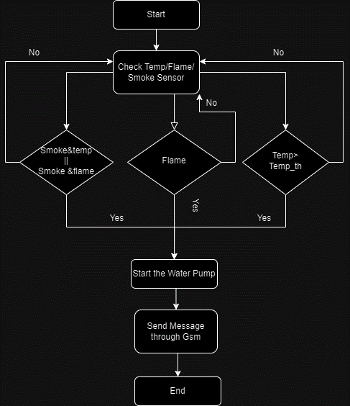

Fig 1.Flow chart of project

Fig 1 is giving idea about how will be the flow of the system. According to the scenario if sensor recognize the smoke and temperature or smoke and flame above threshold GSM will glow up. As the fire is detected system firstly starts water pump for

The integration of gas sensors, flame sensors, LM35 temperature sensors, and GSM technology into a single, cohesive system holds the potential to revolutionize fire detection and response, ultimately saving lives and property. The FDRS is a testament to the ongoing evolution of technology in addressing critical safety concerns and is poised to make a substantial contribution to fire safety and emergency response procedures in both urban and industrial settings.

VII. Registers configured

**Analog to Digital Convertor (ADC)-**

1. **AD0CR - A/D Control Register**:
   * **AD0CR** is used for configuring the operation of the ADC. The following bits are utilized:
     + Bit 21 (**PDN**): This bit is set to 1 to enable the A/D converter.
     + Bit 0-7 (**SEL**): These bits are used to select the analog input channel. In this code, bit 0 is set to 1, indicating channel 0 (AD0.0).
2. **PINSEL0 and PINSEL1 - Pin Select Registers**:
   * **PINSEL0** and **PINSEL1** registers are used to configure the functionality of individual pins. In this code, **PINSEL1** is set to **0x00400000**, which configures pin P0.28 as an ADC input (specifically, AD0.1).
3. **AD0GDR - A/D Global Data Register**:
   * **AD0GDR** is used to read the result of an ADC conversion. It's utilized as part of the data retrieval process. The lower 10 bits of this register contain the result of the conversion.
4. **AD0INTEN - A/D Interrupt Enable Register** (Not explicitly used in the provided code):
   * The **AD0INTEN** register is used to enable interrupts for the ADC. In the provided code, interrupts are not explicitly enabled or handled.
5. **AD0STAT - A/D Status Register** (Not explicitly used in the provided code):
   * The **AD0STAT** register can be used to check the status of the ADC, including the conversion start and done status.

**LCD (Liquid Crystal Display) –**

1. **Lcd_InputPins: -** Configured to take data and command.
2. **Resistor Set (RS): -** The Resistor Set (RS) in the context of an LCD configuration is responsible for defining the mode of data transmission on the LCD's data pins. When set to command mode, the pins accept commands to control the display, while in data mode, they receive actual data to be displayed on the screen. This setting is crucial for instructing the LCD on how to interpret the incoming signals, allowing it to display characters or execute commands as needed.
3. **Enable: -** The Enable (EN) pin is a control input in many electronic devices, including LCDs. It is used to trigger or enable specific actions or operations. In an LCD, the Enable pin often signals the display to process and execute commands or data provided on other pins, allowing the screen to update or change as needed.
4. **Function Set Register:**

The Function Set Register is used to configure the display's properties, including the number of lines (1 or 2), character font (5x8 or 5x10), and display on/off settings.

1. **Entry Mode Set Register:**

The Entry Mode Set Register is used to set the cursor's movement direction and display shift behavior.

1. **Display Control Register:**

The Display Control Register is used to control the display, including turning it on or off, displaying the cursor, and blinking the cursor.

1. **Clear Display Command:**

A specific command used to clear the display screen and return the cursor to the home position.

1. **Set Cursor Position Command:**

A command used to set the cursor to a specific position on the display.

**UART (Universal Asynchronous Receiver/Transmitter)-**

1. **U0THR (Transmit Holding Register) - U0THR Register (U0THR)**:
   * This register is used for writing data to be transmitted. It holds the data that will be transmitted over the UART communication.
2. **U0RBR (Receiver Buffer Register) - U0RBR Register (U0RBR)**:
   * This register is used for reading received data. It contains the data that has been received over the UART.
3. **U0LCR (Line Control Register) - U0LCR Register (U0LCR)**:
   * The Line Control Register is used to configure the UART communication parameters, including data word length, stop bits, and parity settings.
4. **U0IER (Interrupt Enable Register) - U0IER Register (U0IER)**:
   * The Interrupt Enable Register is used to enable or disable specific UART-related interrupts, such as transmit and receive interrupts.
5. **U0FCR (FIFO Control Register) - U0FCR Register (U0FCR)**:
   * The FIFO Control Register is used to configure the UART's FIFO (First-In-First-Out) buffer. It enables or disables the FIFO and controls its trigger levels.
6. **U0LSR (Line Status Register) - U0LSR Register (U0LSR)**:
   * The Line Status Register provides information about the status of the UART communication, such as the presence of data in the receive buffer or the transmitter holding register's empty status.
7. **U0MCR (Modem Control Register) - U0MCR Register (U0MCR)**:
   * The Modem Control Register is used for controlling modem-related signals, which may not be applicable in many applications.
8. **U0LSR (Line Status Register) - U0LSR Register (U0LSR)**:
   * The Line Status Register is used to check the status of the UART, including checking for data availability, transmitter and receiver empty conditions, and more.
9. **U0DLL (Divisor Latch LSB) and U0DLM (Divisor Latch MSB)**:
   * These registers are used to set the baud rate of the UART communication by configuring the division factor. The DLL and DLM registers determine the clock rate for the UART.
10. **U0LCR (Line Control Register) - U0LCR Register (U0LCR)**:
    * The Line Control Register is also used for setting the baud rate and configuring various UART parameters. The DLAB (Divisor Latch Access Bit) within this register is typically set to enable access to the DLL and DLM registers for baud rate configuration.

The system leverages gas sensors, flame sensors, LM35 temperature sensors, and GSM communication to create a robust solution for early fire detection and emergency response.

The system incorporates gas sensors capable of detecting noxious gases such as carbon monoxide (CO) and methane (CH4), which are common byproducts of fire. Flame sensors further enhance the system's accuracy by identifying the presence of flames, even in early stages. To monitor ambient conditions and the potential for fire, LM35 temperature sensors are deployed, enabling the system to identify unusual temperature spikes that may indicate a fire hazard.

VIII. Interfacing Diagram

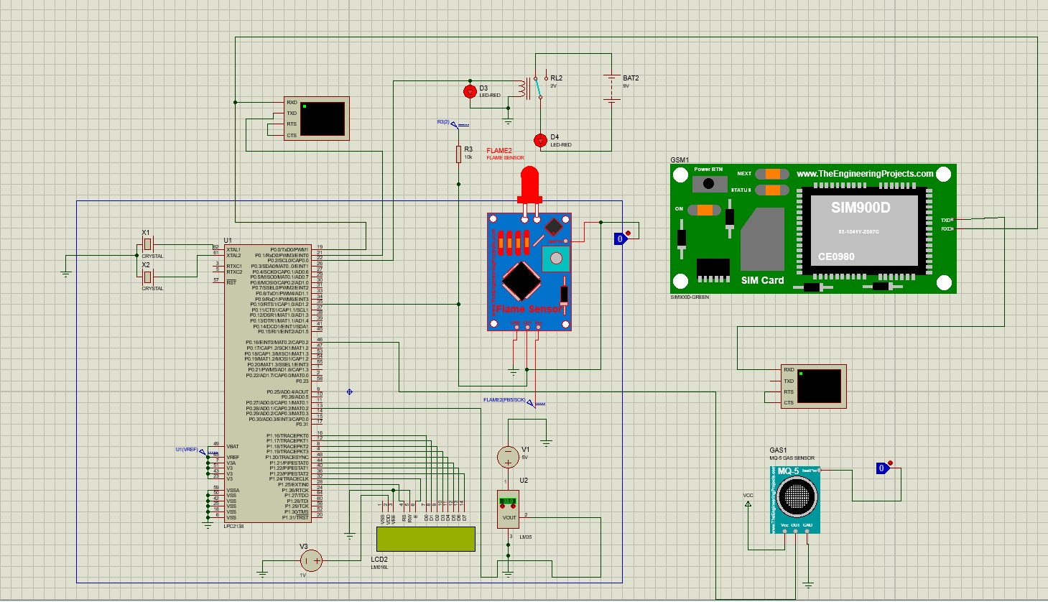

Fig 2. Interfacing Diagram

Above fig 2 gives brief idea about the circuit diagram. We have implemented flame sensor, gas sensor and LM 35 in this circuit. Along with sensors we have implanted GSM for the alarm purpose.

IX. Result

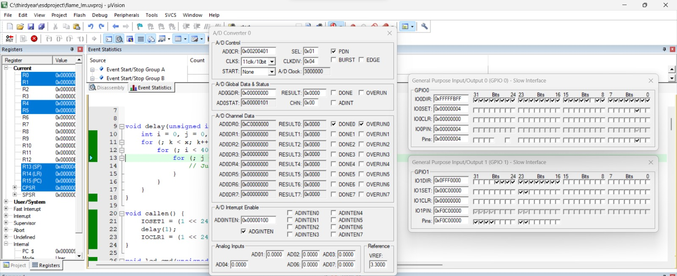

Fig 3. Keil uVision Result

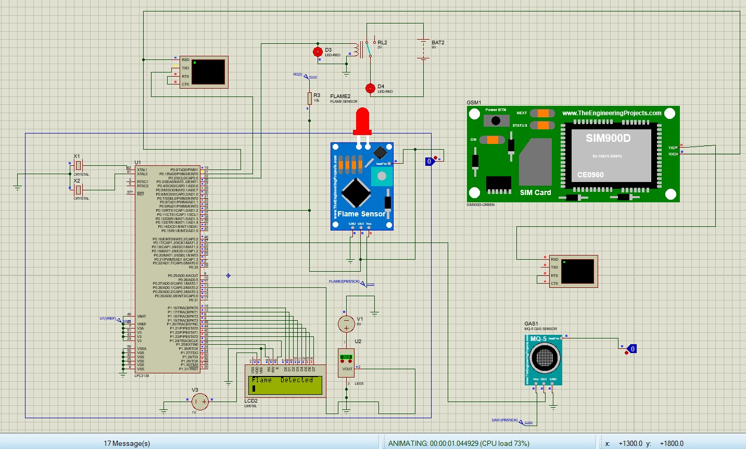

Fig 4. Proteus Result

X. Advantages

Multi-Sensor Integration: The system combines multiple sensors to detect various aspects of a potential fire, enhancing its accuracy and reliability.

Early Warning: It can provide early warnings for fire-related incidents by detecting temperature rise, flames, and smoke presence.

Real-time Monitoring: The system continuously monitors the environment, enabling real-time data collection and immediate response.

Remote Notification: Utilizing GSM, it can send notifications to the owner or relevant authorities, allowing for quick response and action.

Modular Design: The project employs modular sensor components, making it easy to expand, customize, or replace sensors as needed.

Alarm and Alert: In addition to notifying the owner, the system can trigger alarms, such as sirens or lights, for on-site alerts.

XI. Conclusion

In conclusion, the Fire Detection and Rescue System (FDRS) is a groundbreaking solution designed to address the critical need for enhanced fire safety and emergency response in a world marked by rapid urbanization and industrialization. Fires pose a constant threat to lives and property, and traditional fire detection systems often fall short in terms of accuracy and response times. The FDRS overcomes these limitations by harnessing cutting-edge technology, including gas and flame sensors, LM35 temperature sensors, and GSM communication.

By adopting a multi-sensor approach, the FDRS significantly reduces the risk of false alarms and improves the precision of fire detection. Real-time monitoring and data collection, combined with immediate response measures, ensure that fire incidents are detected and addressed swiftly, minimizing potential damage. The project's modular design allows for flexibility and expansion, making it adaptable to various applications.

The FDRS not only addresses the challenges of today but also offers future potential in gas leak detection in industrial settings. It represents a remarkable step forward in the ongoing evolution of technology for fire safety, promising to save lives and protect property in both urban and industrial environments.

XII. Future Scope

The system presented in the code can play a vital role in enhancing safety by detecting the presence of potentially hazardous gases before they reach lethal levels. One practical application is in the realm of gas leakage detection in industrial settings, where safety is of paramount importance. By incorporating a smoke detector, this system becomes highly versatile and capable of identifying a range of gases, including LPG and natural gas, when they leak into the environment. The early detection of gas leaks can prevent accidents, fires, and explosions. Moreover, the system can be integrated with notification mechanisms to alert the fire department or other emergency response organizations promptly, allowing for swift and coordinated actions to mitigate potential disasters. This proactive approach to gas leak detection can significantly reduce risks, save lives, and protect valuable industrial assets.

System Integration for Fire Detection and Alarm System

In the software integration of our fire detection and alarm system, our primary focus is on prioritizing fire detection and a rapid response. The system is designed to be robust and efficient, and it employs an RTOS (ucos) for task management. Here's how the software components come together:

The flame sensor task holds the highest priority, continuously monitoring for the presence of flames.

Upon detecting flames, it initiates an immediate response.

When flames are detected, this task triggers the following actions:

Activation of the water pump (motor) for fire suppression.

Display of a real-time alert message on the LCD screen, conveying "Flame Detected."

Dispatch of an alert message via the GSM module to relevant parties.

The gas sensor task follows, providing an additional layer of safety.

It offers binary gas detection, signaling the presence or absence of gas.

The gas sensor task cross-references gas detection with the flame sensor status.

The flame sensor and gas sensor tasks communicate seamlessly to assess fire-related risks.

Cross-referencing allows for a comprehensive evaluation, where the presence of both gas and flames triggers heightened vigilance.

The system employs UART as a communication protocol for exchanging information between the microcontroller and external devices.

UART ensures reliable and real-time data transfer for alerts and monitoring.

The RTOS (ucos) coordinates task execution, ensuring timely and efficient responses.

Priority scheduling ensures that the flame sensor task takes precedence, swiftly followed by the gas sensor task.