**Project Report**

**Title: FireResQ System**

**Subject: Embedded System Design**

**Project Guide: Prof. Jyoti Madake**

**Authors :**

**Pratik Dhane [01]**

**Dhanraj Shelke[02]**

**Date of Completion: 20/10/2023**

**Abstract :**

Fire detection and rescue systems are of paramount importance in safeguarding lives and property against the devastating consequences of fires. This paper presents a comprehensive study and design of an integrated Fire Detection and Rescue System (FDRS) that employs a combination of sensors and communication technologies to efficiently detect, monitor, and respond to fire incidents. The system leverages gas sensors, flame sensors, LM35 temperature sensors, and GSM communication to create a robust solution for early fire detection and emergency response.

In the wake of increasing urbanization and industrialization, fire incidents have become a prevalent threat. Traditional fire detection systems often fall short in providing rapid and accurate responses, leading to substantial losses. The FDRS introduced in this paper aims to mitigate these challenges by utilizing an array of advanced sensors and communication tools.

The system incorporates gas sensors capable of detecting noxious gases such as carbon monoxide (CO) and methane (CH4), which are common byproducts of fire. Flame sensors further enhance the system's accuracy by identifying the presence of flames, even in early stages. To monitor ambient conditions and the potential for fire, LM35 temperature sensors are deployed, enabling the system to identify unusual temperature spikes that may indicate a fire hazard.

Upon detecting a fire or fire hazard, the FDRS initiates immediate response measures. The integration of Global System for Mobile Communications (GSM) technology allows the system to send real-time alerts and notifications to designated recipients. These notifications may include emergency calls and SMS messages, providing critical information about the fire incident and its location.

The FDRS's multi-sensor approach significantly reduces the likelihood of false alarms, ensuring reliable and accurate fire detection. Furthermore, its use of GSM communication ensures that the alert reaches the appropriate authorities and responders swiftly, expediting emergency response times and minimizing damage.

This paper outlines the technical specifications of the FDRS, including sensor selection, data acquisition, and communication protocols. It discusses the system's hardware and software architecture, emphasizing its versatility and adaptability for a range of applications, from residential buildings to industrial complexes.

The integration of gas sensors, flame sensors, LM35 temperature sensors, and GSM technology into a single, cohesive system holds the potential to revolutionize fire detection and response, ultimately saving lives and property. The FDRS is a testament to the ongoing evolution of technology in addressing critical safety concerns and is poised to make a substantial contribution to fire safety and emergency response procedures in both urban and industrial settings.

**Table of Contents:**

|  |  |
| --- | --- |
| **1** | **Introduction** |
| **2** | **Project Overview** |
| **3** | **Design and Architecture** |
| **4** | **Methodology**  **a) Hardware Development**  **b) Software Development**  **c) System Integration**  **d) Testing and Validation**  **e) Performance Evaluation.** |
| **5** | **Conclusion** |
| **6** | **Future Scope** |
| **7** | **References** |

**Introduction**

In a world where urbanization and industrialization are on the rise, the safety and protection of lives and property are of paramount concern. Fires, whether accidental or intentional, pose a significant threat, often resulting in devastating consequences. To address this ever-present danger, our project presents an innovative and integrated solution: the Fire Detection and Rescue System (FDRS). This comprehensive system employs cutting-edge sensor technologies and advanced communication tools to revolutionize fire detection, monitoring, and emergency response.

The urgency of enhancing fire detection and rescue mechanisms cannot be overstated. Traditional fire detection systems, while valuable, sometimes lack the speed and precision required to mitigate the destructive impact of fires. This project sets out to bridge this gap by introducing a holistic approach that combines multiple sensors and real-time communication to create a robust, efficient, and adaptable solution.

The FDRS integrates gas sensors capable of detecting hazardous gases, such as carbon monoxide (CO) and methane (CH4), which are common byproducts of fire incidents. It also incorporates flame sensors, designed to identify the presence of flames, even in their early stages. Additionally, LM35 temperature sensors are employed to monitor ambient conditions and to detect unusual temperature spikes, which often serve as early warning signs of potential fire hazards.

Beyond detecting fires and fire hazards, the FDRS is engineered to initiate rapid and effective response measures. The cornerstone of its response mechanism is the integration of Global System for Mobile Communications (GSM) technology. This technology enables the system to transmit real-time alerts and notifications to designated recipients, including emergency calls and SMS messages. Such notifications are crucial in delivering vital information about the fire incident, its precise location, and the immediate steps required for a coordinated response.

A key strength of the FDRS lies in its multi-sensor approach, which significantly reduces the likelihood of false alarms and enhances the overall accuracy of fire detection. Furthermore, the utilization of GSM communication guarantees that the alert promptly reaches the appropriate authorities and responders, thus expediting emergency response times and minimizing potential damage.

This project is not just a theoretical concept; it is a tangible, technically advanced system that combines hardware and software elements to ensure the safety of individuals and property. The following sections will delve into the technical specifications, sensor selection, data acquisition, and communication protocols of the FDRS. It will also explore the system's versatility and adaptability across various applications, from residential settings to industrial complexes.

In essence, this project represents a significant stride towards enhancing fire safety and emergency response procedures in the dynamic landscape of urban and industrial environments. The integration of gas sensors, flame sensors, LM35 temperature sensors, and GSM technology into a single, cohesive system holds the promise of revolutionizing the way we detect and respond to fires. With the potential to save lives and protect property, the FDRS is a testament to the continuous evolution of technology in addressing critical safety concerns.

**Project Overview**

The project presents an Integrated Fire Detection and Rescue System (FDRS) designed to address the pressing need for efficient fire detection and emergency response. In the face of increasing urbanization and industrialization, the risk of fire incidents has grown substantially. Traditional fire detection systems have proven inadequate in providing swift and accurate responses, leading to significant losses. The FDRS introduces a comprehensive solution that combines advanced sensors and communication technologies to enhance fire detection and response capabilities.

Key components of the FDRS include gas sensors for detecting hazardous gases like carbon monoxide and methane, flame sensors for early flame detection, and DHT11 temperature sensors to monitor temperature variations, which may indicate potential fire hazards. Upon detecting a fire or hazard, the system uses GSM communication to send real-time alerts and notifications to designated recipients, ensuring that emergency response measures are initiated promptly.

The multi-sensor approach significantly reduces the occurrence of false alarms, enhancing the system's reliability and accuracy. The integration of GSM technology expedites emergency response times and minimizes damage by ensuring that alerts reach the appropriate authorities and responders quickly.

The paper outlines the technical specifications of the FDRS, including sensor selection, data acquisition, and communication protocols. It highlights the system's adaptability for use in various settings, from residential buildings to industrial complexes.

The system is designed for proactive intervention. When the moisture sensor detects soil moisture levels falling below a predefined threshold, an automated response is triggered. The servo motor, under precise control, activates the watering mechanism. This ensures that the plant receives adequate water, vital for its growth and sustenance. Furthermore, the system employs the GSM module to disseminate SMS notifications to users. These notifications contain detailed information about the fire status, encompassing temperature, smoke levels. By enabling timely alerts, users can respond promptly to the fire environment.

In our case, UART (Universal Asynchronous Receiver/Transmitter) enables the microcontroller to send data to the GSM Module, ensuring that crucial information about the farm's conditions can be shared via SMS alerts. This seamless communication is what keeps the people informed, allowing them to keep their property safe.

The system's operation doesn't cease; it continuously monitors the environment in real-time. Regular updates are sent periodically, guaranteeing constant vigilance. This ongoing surveillance enables immediate intervention if the conditions deviate from the desired range. By ensuring continuous monitoring and prompt notifications, the system empowers users with the knowledge and means to provide optimal care, thus enhancing the overall well-being of the plants.

The Fire Detection and Management System operates in a cyclical manner. The DHT11 sensor continuously captures temperature data, which is relayed to the user through SMS notifications and displayed on the LCD screen. Simultaneously, the gas sensor detects gas levels. If the temperature and smoke level goes above the desired threshold, indicating high temperature and smoke , the water pump is activated to protect property.

By integrating gas sensors, flame sensors, LM35 temperature sensors, and GSM communication into a single system, the FDRS has the potential to revolutionize fire detection and response. It represents a technological advancement that can save lives and protect property. The FDRS is poised to make a substantial contribution to fire safety and emergency response procedures in both urban and industrial environments, addressing a critical safety concern in today's world.

**Design and Architecture**

Flowchart:

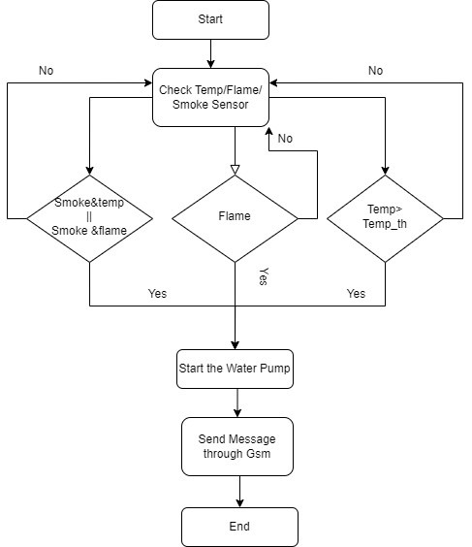

Fig.no 1 flowchart

**Methodology:**

**Hardware components:**

1. DHT11 (Temperature and Humidity Sensor):

The DHT11 sensor is selected for its ability to measure temperature and humidity, two crucial environmental parameters that can aid in early fire detection and safety. The selection process involves the following considerations:

**Sensor Accuracy**: The DHT11 is chosen for its reasonable accuracy and affordability, making it suitable for most fire detection applications. It can provide temperature readings with a resolution of 1°C and humidity readings with a resolution of 1%.

**Interface Compatibility**: The DHT11 communicates via a one-wire digital interface, making it compatible with microcontrollers like the LPC214x used in this project.

**Range**: The DHT11 has a temperature range of 0°C to 50°C which is sufficient for indoor fire detection applications.

**Calibration**: The sensor may require calibration to ensure accurate readings. The calibration process is integrated into the software to adjust for any sensor-specific biases.

The DHT11 is integrated into the system by connecting it to specific pins on the microcontroller. The data from the sensor is read and processed in the software to monitor the environment for any abnormal temperature or humidity changes that could indicate a fire risk.

**Selection**:

The DHT11 is chosen for its affordability and reliability in measuring temperature and humidity. It features a single-wire digital interface, making it suitable for microcontroller-based projects. The selection is based on the project's requirements for monitoring environmental conditions. The DHT11 offers a temperature range of 0°C to 50°C and a humidity range of 20% to 90%, which is adequate for many indoor applications.

**Integration**:

The DHT11 is integrated into the system by connecting it to the microcontroller, such as an LPC2148. The sensor's data pin is linked to a specific GPIO pin on the microcontroller. The software is developed to read data from the DHT11 and process it for temperature and humidity values. The microcontroller continuously queries the sensor and interprets the data to monitor the environment.

Working:

**Sensing Elements**: The DHT11 sensor contains two sensing elements – one for temperature and one for humidity. These elements are made from materials that change their electrical properties (resistance) with variations in temperature and humidity.

**One-Wire Digital Interface**: The DHT11 uses a single-wire digital interface for communication with a microcontroller. It sends data to the microcontroller in a binary format.

**Internal Processing**: Inside the sensor, a microcontroller processes the signals from the two sensing elements and converts them into digital data.

**Data Transmission**: The digital data, representing temperature readings, is transmitted serially via the one-wire interface to the microcontroller.

**Checksum**: The sensor also sends a checksum value to verify the integrity of the data.

**Role in Project**:

Temperature Monitoring: The DHT11 can provide temperature readings within a range. An abrupt increase in temperature beyond normal room conditions may be indicative of a fire. While it cannot directly detect flames, a significant temperature rise can trigger an alarm or alert in the fire detection system.

**2. Flame Sensor:**

The flame sensor is crucial for the detection of an open flame or fire. The selection process for the flame sensor involves the following considerations:

**Sensitivity**: The sensor is chosen for its sensitivity to the infrared (IR) spectrum emitted by flames. It can detect the presence of flames or high-temperature heat sources, making it suitable for fire detection.

**Response Time**: The sensor's response time is critical for early fire detection. The selected sensor has a rapid response time, ensuring quick detection and response to flames.

**Output Signal**: The sensor typically provides a digital output signal that is easy to interface with microcontrollers. This digital signal simplifies integration into the system.

**Selection**:

The flame sensor is chosen for its sensitivity to the infrared (IR) spectrum emitted by flames, making it suitable for fire detection. Selection criteria include its responsiveness, range, and compatibility with the project's needs. The sensor's quick response time and ability to detect the presence of flames or high-temperature heat sources are key factors in its selection.

**Integration**:

The flame sensor is integrated into the system by connecting it to a microcontroller, such as an LPC2148, which serves as the central processing unit. The sensor typically provides a digital output signal, simplifying integration. The system software continuously monitors the sensor's output.

When the sensor detects a flame or a significant temperature increase, it triggers an alarm or alert in the system. The software interprets the sensor's digital output, processes it, and initiates a response, such as activating fire suppression mechanisms or alerting authorities.

**3. Gas Sensor:**

The gas sensor is essential for detecting harmful gases, such as carbon monoxide or other gases that may be produced during a fire. The selection process for the gas sensor includes the following considerations:

**Gas Detection Range**: The sensor is chosen based on its ability to detect a range of gases commonly associated with fires. It should be sensitive to the relevant gases while being selective to avoid false alarms.

**Sensor Technology**: Various sensor technologies, such as electrochemical, semiconductor, or infrared, are available. The selection is based on the specific gases to be detected and the sensor's performance characteristics.

**Calibration and Maintenance**: Gas sensors often require calibration and periodic maintenance to ensure accurate readings. The system includes provisions for calibration and maintenance routines.

**Selection**:

The gas sensor is chosen based on its ability to detect specific gases commonly associated with fires or other hazardous situations. Selection criteria include the sensor's sensitivity, selectivity, and range. It should be able to identify target gases while minimizing false alarms. The sensor technology, whether electrochemical, semiconductor, or infrared, is chosen based on the types of gases to be detected.

**Integration**:

The gas sensor is integrated into the system by connecting it to a microcontroller, such as an LPC2148, which serves as the central control unit. The sensor provides data, typically in analog or digital form, which the microcontroller continuously monitors. The system software interprets the sensor's output and compares it to predefined threshold values. If gas levels exceed these thresholds, the system triggers an alarm or initiates safety protocols, such as ventilation or emergency response procedures.

**Software Development**

**System Integration**

**Testing and Validation**

**Performance Evaluation**

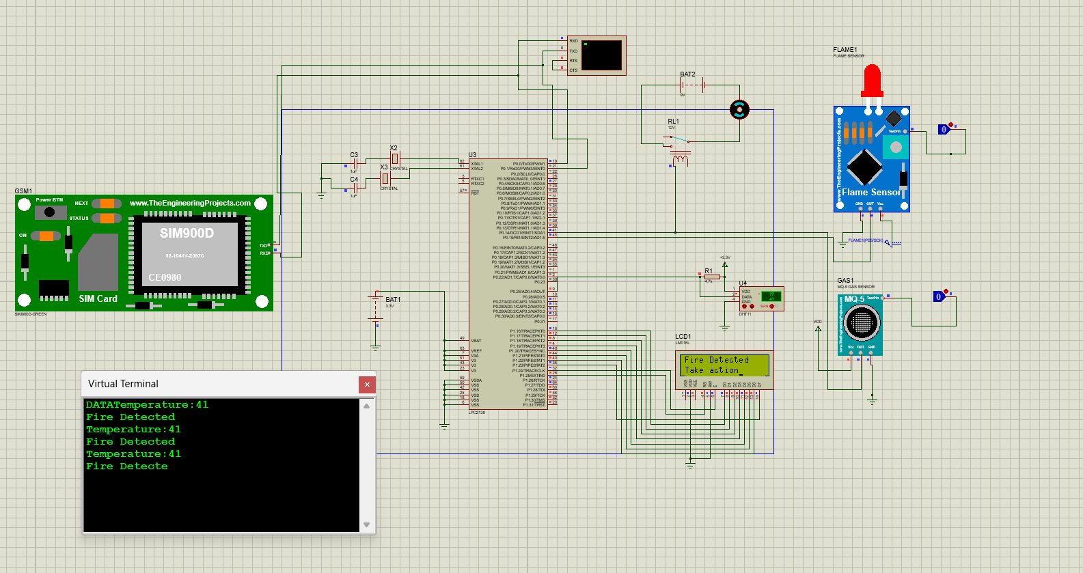

Fig.no Output 1

The project's outcome is a fire detection and alarm system that delivers a critical safety function. When the temperature surpasses the predefined threshold of 40 degrees Celsius, the system promptly responds by triggering both a GSM (Global System for Mobile Communications) alert and displaying a warning message on the LCD (Liquid Crystal Display). This functionality serves as a pivotal component in safeguarding lives and property by proactively alerting individuals to potential fire hazards.