LOGISTICS DATA ANALYST INTERNSHIP
WEEK 3 REPORT
Advanced Data Analysis and Visualization in Logistics
Dataset: logistics_orders.csv
Records: 60
Variables: 8
Tools: Python, Pandas, Matplotlib, Seaborn

1. Introduction
This report presents an exploratory analysis of a logistics delivery-order dataset using Python. The analysis examines delivery performance, traffic conditions, route distance, shipment volume, planned versus actual delivery time, and relationships among operational variables.

2. Objective
- Conduct exploratory data analysis (EDA) on logistics delivery records.
- Calculate central tendency and descriptive statistics.
- Examine correlations among key numerical variables.
- Create visualizations showing trends, distributions, and relationships.
- Interpret operational efficiency and potential bottlenecks.
- Provide practical recommendations based on the observed patterns.

3. Dataset Description
The dataset contains 60 delivery-order records and 8 columns. It includes order identification, distance, parcel volume, traffic level, delivery hour, vehicle capacity, planned delivery time, and actual delivery time.
Variable | Type | Logistics relevance
order_id | Identifier | Unique order reference
distance_km | Numerical | Travel distance
parcel_count | Numerical | Parcel volume
traffic_level | Categorical | Traffic condition
hour | Numerical | Delivery/dispatch hour
vehicle_capacity | Numerical | Available vehicle capacity
planned_time_min | Numerical | Planned delivery time
actual_time_min | Numerical | Actual delivery time
The dataset does not contain a transportation-cost column, so transportation-cost analysis is not presented as a measured result.

4. Methodology
The analysis used pandas for data loading and descriptive analysis, followed by grouped comparisons, correlation analysis, and visualization with Matplotlib. The workflow was implemented in the completed week3_logistics_analysis.py script.
- Inspect dataset structure and descriptive statistics.
- Compare average actual delivery time by traffic level.
- Analyze distance versus actual delivery time.
- Study the distribution of actual delivery times.
- Calculate and visualize correlations among numerical variables.

5. Exploratory Data Analysis

5.1 Descriptive Statistics
Variable | Mean | Median | Min | Max
distance_km | 13.20 | 13.55 | 2.10 | 24.70
parcel_count | 36.78 | 36.50 | 5.00 | 66.00
hour | 13.00 | 13.00 | 8.00 | 19.00
vehicle_capacity | 74.58 | 75.00 | 50.00 | 100.00
planned_time_min | 50.08 | 50.05 | 13.60 | 88.20
actual_time_min | 54.43 | 53.45 | 24.10 | 85.80
Average actual delivery time is 54.43 minutes and the median is 53.45 minutes. Average route distance is 13.20 km.

6. Visualizations and Interpretation

6.1 Average Delivery Time by Traffic Level
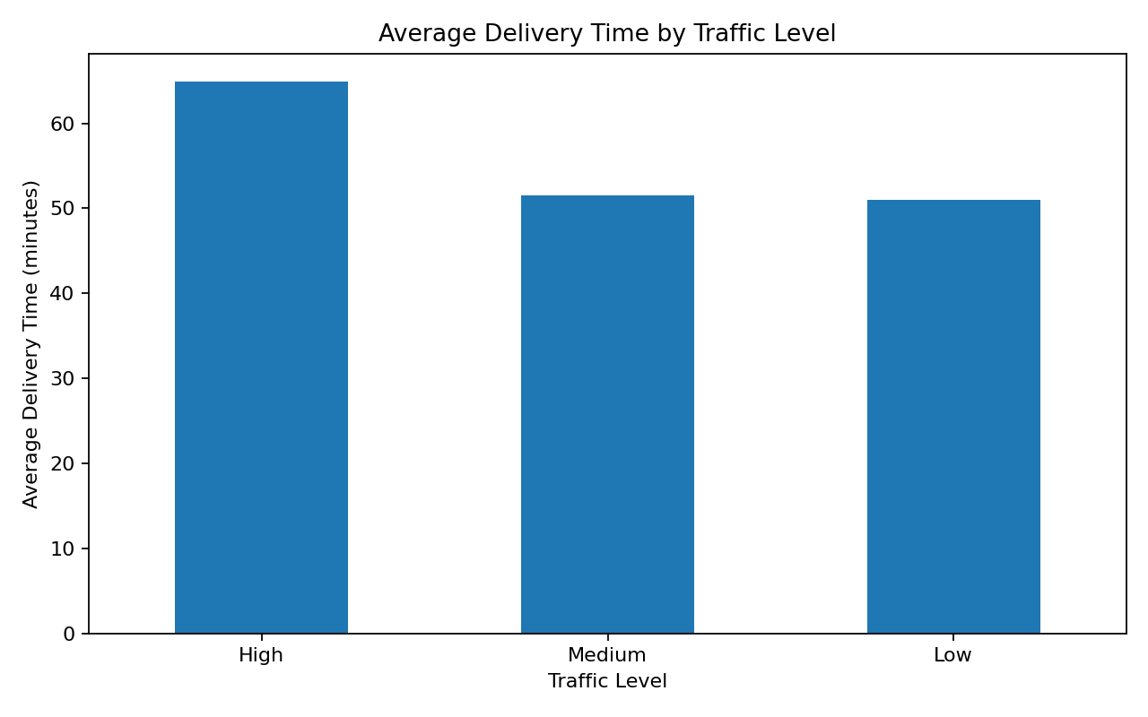
Figure 1. Average delivery time by traffic level.
High traffic has the highest average actual delivery time at 64.96 minutes, compared with 51.48 minutes for Medium traffic and 51.03 minutes for Low traffic.
Justification: A bar chart is appropriate for comparing a numerical measure across categorical traffic groups.

6.2 Distance vs Actual Delivery Time
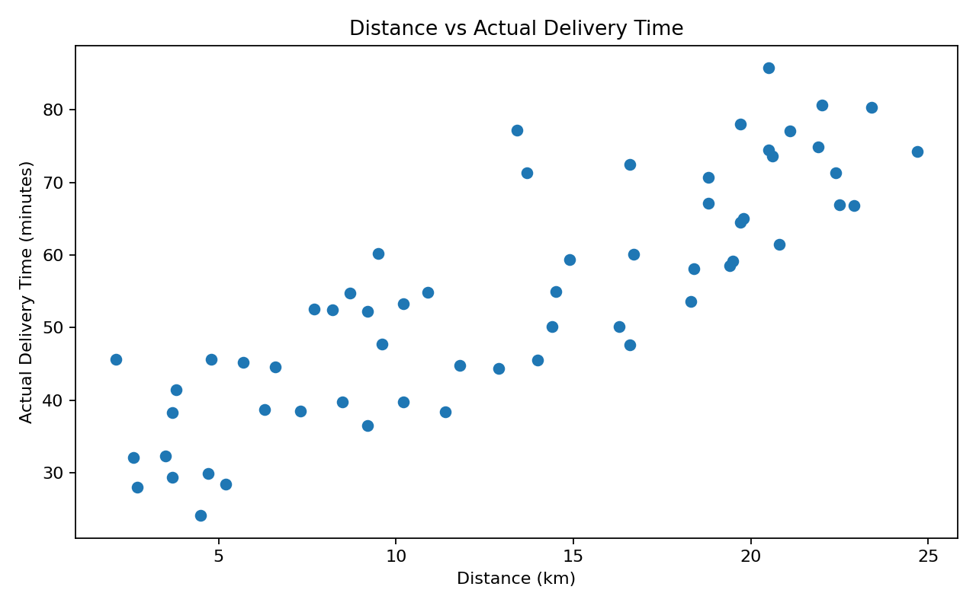
Figure 2. Distance versus actual delivery time.
Distance and actual delivery time show a strong positive correlation of approximately 0.85. Longer routes generally require more delivery time, although individual observations vary.
Justification: A scatter plot is appropriate for examining the relationship between two numerical variables.

6.3 Distribution of Actual Delivery Time
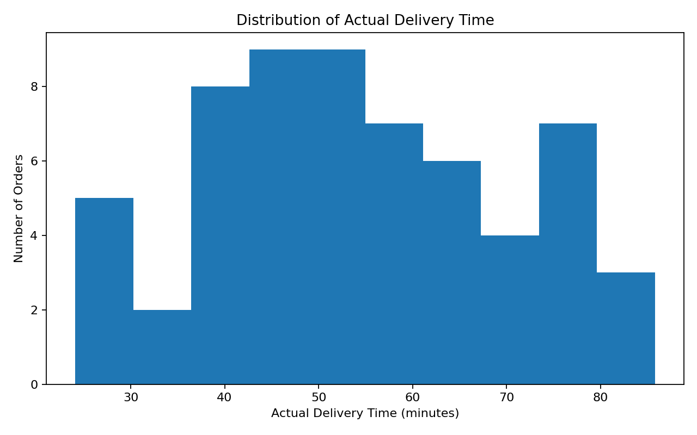
Figure 3. Distribution of actual delivery time.
Actual delivery times range from 24.1 to 85.8 minutes. The histogram shows where delivery times are concentrated and how widely performance varies.
Justification: A histogram is suitable for understanding the distribution of a continuous numerical variable.

6.4 Correlation Heatmap
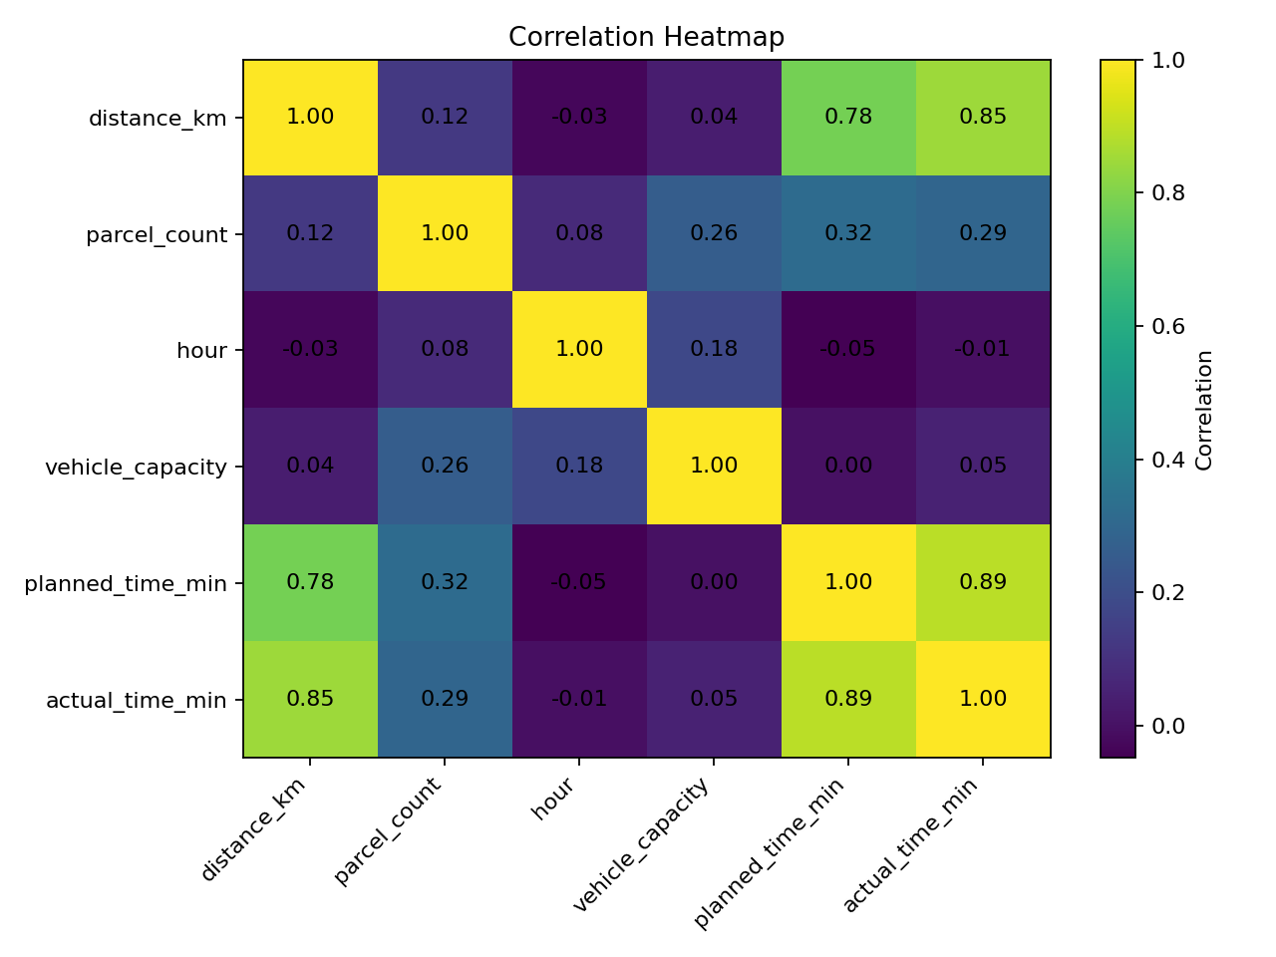
Figure 4. Correlation heatmap of numerical logistics variables.
Planned delivery time and actual delivery time have a strong correlation of approximately 0.89. Distance and actual delivery time also show a strong correlation of approximately 0.85.
Justification: A heatmap provides a compact comparison of pairwise numerical relationships.

7. Key Analytical Insights
- High traffic is associated with the highest average delivery duration (64.96 minutes).
- Distance is a major associated factor, with a distance-to-actual-time correlation of 0.85.
- Planned and actual delivery time are strongly related (correlation 0.89).
- Parcel count has a smaller positive relationship with actual delivery time (correlation 0.29).
- Hour and vehicle capacity have weak linear correlations with actual delivery time in this sample.

8. Potential Operational Bottlenecks
- High-traffic conditions may increase route duration and delay exposure.
- Long-distance routes require more travel time and deserve closer monitoring.
- Differences between planned and actual delivery time indicate opportunities to improve planning buffers.
- Higher parcel volumes can increase handling workload and may affect delivery duration.

9. Recommendations
- Use traffic-aware planning and add appropriate time buffers for high-traffic routes.
- Prioritize monitoring of long-distance deliveries because distance is strongly associated with delivery time.
- Regularly compare planned versus actual delivery time to improve future estimates.
- Track parcel volume with delivery duration to identify handling-intensive order patterns.
- Add cost, fuel, driver, route, and timestamp fields in future datasets to enable direct cost-efficiency analysis.

10. Python Tools and Code Excerpt
import pandas as pd
import matplotlib.pyplot as plt
df = pd.read_csv("logistics_orders.csv")
print(df.shape)
print(df.describe())
traffic_avg = df.groupby("traffic_level")["actual_time_min"].mean()
print(traffic_avg)
print(df.corr(numeric_only=True))
plt.bar(traffic_avg.index, traffic_avg.values)
plt.title("Average Delivery Time by Traffic Level")
plt.show()
plt.scatter(df["distance_km"], df["actual_time_min"])
plt.title("Distance vs Actual Delivery Time")
plt.show()
plt.hist(df["actual_time_min"], bins=10)
plt.title("Distribution of Actual Delivery Time")
plt.show()

11. Conclusion
The Week 3 analysis demonstrates how Python-based EDA and visualization can support logistics performance analysis. The results show clear relationships between delivery time, route distance, traffic conditions, and planned delivery duration. These visual findings can support better scheduling, route monitoring, and delay management. The conclusions are specific to this dataset and should be validated with larger operational datasets before real-world deployment.

12. Visualization Summary
Visualization | Purpose | Main takeaway
Bar chart | Compare traffic groups | High traffic has the highest average delivery time.
Scatter plot | Assess distance/time relationship | Longer distance is strongly associated with longer delivery time.
Histogram | Show delivery-time distribution | Actual delivery time varies across a broad range.
Correlation heatmap | Compare numerical relationships | Planned time and distance have strong relationships with actual time.

