WEEK 4
Predictive Modeling and Optimization in Logistics Systems
Logistics Data Analyst Internship
Python-based predictive analysis of actual delivery time

Dataset | logistics_orders.csv
Records | 60
Predictors | 6
Target | actual_time_min (Actual Delivery Time)

1. Introduction
This Week 4 project applies predictive modeling techniques to a logistics delivery-time problem. The objective is to use operational variables such as distance, parcel volume, traffic, delivery hour, vehicle capacity and planned delivery time to estimate actual delivery time. The analysis also translates model findings into practical logistics optimization strategies.

2. Problem Definition
The prediction problem is defined as: given the known characteristics of a logistics order, predict the actual time required to complete the delivery. Accurate delivery-time forecasts can support dispatch planning, route prioritization, capacity allocation and proactive delay management.

3. Dataset and Variables
The project uses the logistics_orders.csv dataset developed and used across the internship tasks for consistency. The dataset contains 60 logistics orders and 8 columns. The order identifier is excluded from modeling because it does not provide predictive operational information.
Variable | Role | Description
distance_km | Feature | Delivery distance in kilometres
parcel_count | Feature | Number of parcels in the order
traffic_level | Feature | Traffic category; encoded as Low=0, Medium=1, High=2
hour | Feature | Hour associated with the delivery
vehicle_capacity | Feature | Vehicle capacity available for the delivery
planned_time_min | Feature | Planned delivery time in minutes
actual_time_min | Target | Actual delivery time in minutes

4. Data Preparation and Simulation Approach
The dataset was prepared for supervised regression. The categorical traffic variable was converted to an ordered numeric representation (Low=0, Medium=1, High=2). The target variable was actual_time_min. The data was divided into 80% training data and 20% testing data using random_state=42, producing 48 training observations and 12 testing observations.
X = df[["distance_km", "parcel_count", "traffic_level",
"hour", "vehicle_capacity", "planned_time_min"]].copy()
X["traffic_level"] = X["traffic_level"].map(
{"Low": 0, "Medium": 1, "High": 2}
)
y = df["actual_time_min"]
X_train, X_test, y_train, y_test = train_test_split(
X, y, test_size=0.2, random_state=42
)

5. Model Selection
Two regression techniques were implemented: Linear Regression and Random Forest Regression. Linear Regression provides a transparent baseline and captures approximately linear relationships between predictors and delivery time. Random Forest was included as an ensemble model capable of capturing non-linear relationships and interactions without requiring a single linear functional form.

6. Model Training and Prediction
# Linear Regression
linear_model = LinearRegression()
linear_model.fit(X_train, y_train)
linear_predictions = linear_model.predict(X_test)
# Random Forest
random_forest_model = RandomForestRegressor(
n_estimators=100, random_state=42
)
random_forest_model.fit(X_train, y_train)
rf_predictions = random_forest_model.predict(X_test)

7. Evaluation Metrics
The models were evaluated using Mean Absolute Error (MAE), Root Mean Squared Error (RMSE), and R-squared (R²). MAE expresses the average absolute prediction error in minutes. RMSE gives greater weight to larger errors. R² indicates how much variation in the target is explained by the model on the test data.
Model | MAE (min) | RMSE (min) | R²
Linear Regression | 4.0272 | 5.3542 | 0.5317
Random Forest | 6.0899 | 6.8618 | 0.2309
On the recorded 20% test split, Linear Regression produced lower MAE and RMSE and a higher R² than the Random Forest model. This indicates that, for this particular dataset and split, the simpler linear model generalized better on the held-out observations.
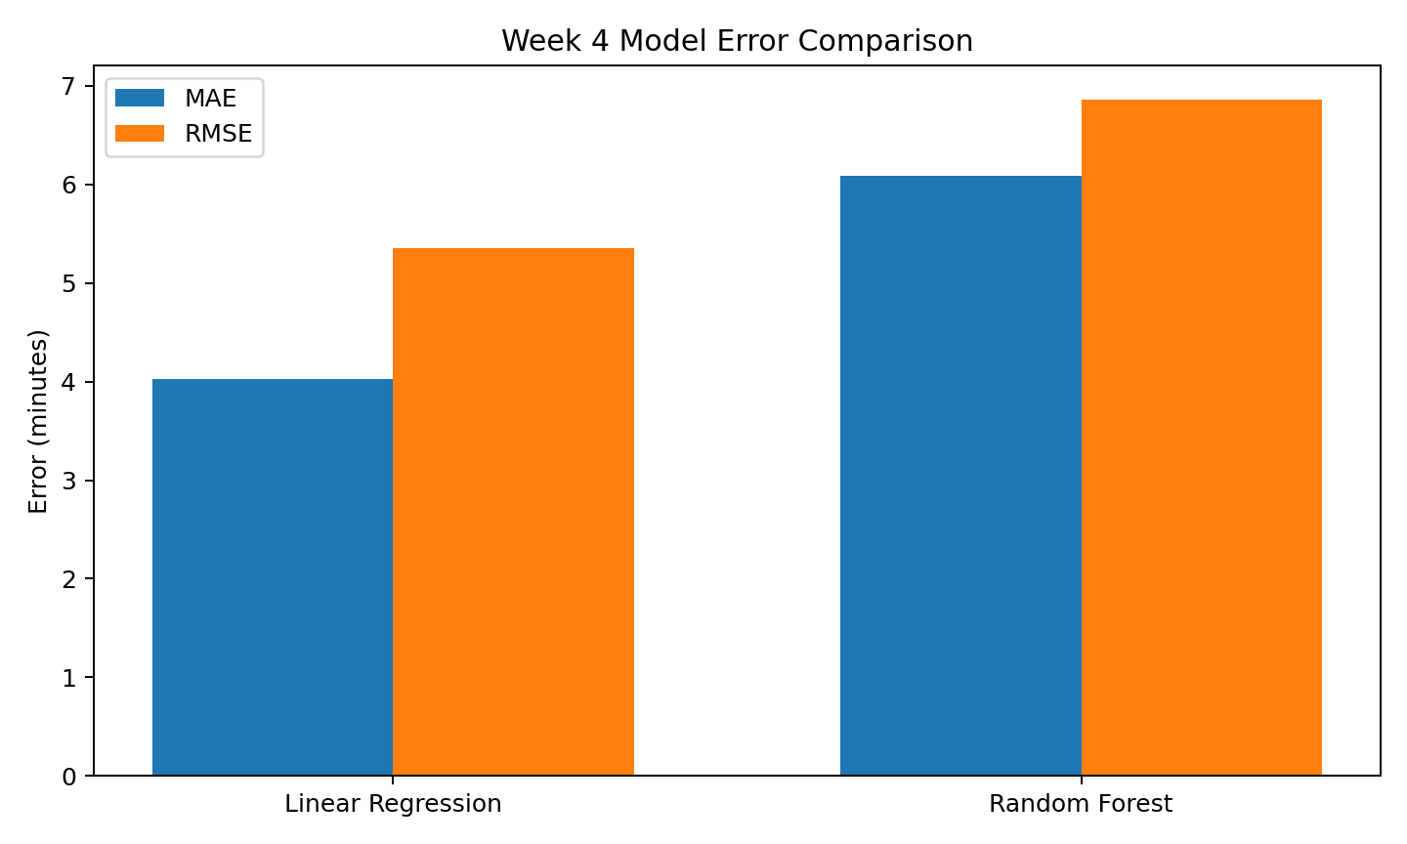
Figure 1. Comparison of test-set MAE and RMSE.

8. Cross-Validation and Validation Strategy
Five-fold cross-validation was used as an additional validation check. The dataset was divided into five folds, with each fold used once as validation data while the remaining folds were used for training. The mean R² across the five folds was approximately 0.900 for Linear Regression and 0.789 for Random Forest on the available dataset. Cross-validation provides a broader view of model stability than a single train-test split.
Model | 5-fold R² scores | Mean CV R²
Linear Regression | 0.925, 0.962, 0.857, 0.946, 0.812 | 0.900
Random Forest | 0.798, 0.901, 0.520, 0.894, 0.831 | 0.789

9. Model Performance Interpretation
The Linear Regression model achieved an MAE of about 4.03 minutes, meaning the average absolute error on the test observations was roughly four minutes. Its RMSE was about 5.35 minutes and its R² was approximately 0.532. The Random Forest model achieved an MAE of about 6.09 minutes, RMSE of about 6.86 minutes and R² of about 0.231 on the same test split.
The results suggest that the relationships represented by the six operational features are sufficiently structured for a linear model to provide a useful baseline. The Random Forest model did not improve the held-out test performance in this experiment, so adding model complexity alone did not produce better predictions.

10. Logistics Insights
- Distance is an important operational driver of delivery time and should be considered during route and dispatch planning.
- Planned delivery time provides useful predictive information because it summarizes expected travel and service duration.
- Traffic level should be incorporated into delivery-time forecasting because congestion can increase operational variability.
- Vehicle capacity and parcel count can support resource planning by indicating load requirements before dispatch.
- A prediction error of several minutes can still be operationally meaningful when used for delivery-slot planning and proactive exception management.

11. Optimization Strategies
Dynamic dispatch prioritization: Use predicted delivery time to identify orders likely to require additional time and prioritize dispatch decisions accordingly.
Traffic-aware planning: Use traffic category as an input to planning and create alternative dispatch windows for high-traffic periods.
Route planning improvements: Combine predicted delivery duration with distance information to identify routes where travel time is likely to exceed the planned duration.
Capacity allocation: Use parcel count and vehicle capacity together to assign suitable vehicles and reduce inefficient under-utilization or overloading.
Delay-risk alerts: Create a simple threshold-based alert when predicted delivery time exceeds the planned time by a predefined operational margin.
Model monitoring: Track MAE, RMSE and R² periodically as new delivery records become available and retrain the model when operational patterns change.
The current dataset does not contain a transportation-cost column. Therefore, cost minimization is discussed as an operational recommendation rather than reported as a measured numerical result. A future version of the model could include fuel cost, driver cost, tolls or vehicle operating cost to optimize delivery decisions directly against cost.

12. Optimization and Future Model Improvements
- Collect more historical delivery records to improve model robustness.
- Add richer traffic variables such as congestion duration or real-time traffic index.
- Add geographic variables such as source/destination zone, road type and route length.
- Add weather, delivery-slot and driver/vehicle history when available.
- Tune Random Forest hyperparameters such as max_depth, min_samples_split and max_features.
- Evaluate additional models such as Gradient Boosting or XGBoost when the dataset becomes larger.
- Use time-aware validation for future production data if records represent a chronological stream.

13. Python Code for Evaluation
from sklearn.metrics import mean_absolute_error, mean_squared_error, r2_score
import numpy as np
# Linear Regression evaluation
mae = mean_absolute_error(y_test, linear_predictions)
rmse = np.sqrt(mean_squared_error(y_test, linear_predictions))
r2 = r2_score(y_test, linear_predictions)
# Random Forest evaluation
rf_mae = mean_absolute_error(y_test, rf_predictions)
rf_rmse = np.sqrt(mean_squared_error(y_test, rf_predictions))
rf_r2 = r2_score(y_test, rf_predictions)

14. Conclusion
This Week 4 project demonstrated a complete predictive-modeling workflow for a logistics delivery-time problem: problem definition, feature preparation, train-test splitting, model training, prediction, evaluation, cross-validation and operational optimization recommendations. Both Linear Regression and Random Forest were implemented. On the available test split, Linear Regression achieved lower prediction error and higher R² than Random Forest, while the cross-validation results also showed stronger average R² for the linear model on this dataset. The analysis therefore demonstrates how a relatively simple predictive model can support practical logistics planning while also providing a foundation for future model improvements as more operational data becomes available.

