Name – Dhanraj Babasaheb Bhosale

ASU ID - 1225506620

# Q1.

Ans -

Yes, the MeatyVegetable topping class came out as inconsistent.

This is so that this class can inherit from the VegetableTopping and MeatTopping classes. Then, however, we separated the classes for MeatTopping and VegetableTopping. It appeared inconsistent since MeatyVegetableTopping connected the two of them.

We may delete the MeatyVegetableTopping as a child of either the VegetableTopping class or the MeatTopping class to fix this discrepancy. There wouldn't be any contradiction in such scenario.

# Q2.

Ans.

I added an Indian pizza named ChickenTikkaPizza which has the following toppings :

1. ChickenTopping
2. MozzarellaTopping
3. OreganoTopping
4. TomatoTopping

I also added a SausagePizza which originates in Italy. The toppings for these pizza were :

1. SausageTopping
2. MozzarellaTopping
3. TomatoTopping

# Q3.

Ans.

I added two pizza bases namely :

1. WholeWheatBase
2. MixedGrainBase

# Q4.

Ans

I added multiple topping classes.They are :

1. OreganoTopping
2. PineappleTopping
3. SausageTopping
4. CottageCheeseTopping
5. BlackGarlicTopping

# Q5.

Ans

I added four more properties to the ones showed in the tutorial. They are :

1. hasCheeseAmount - This shows how much cheese is in a pizza
2. hasShape - Pizzas come in different shapes like rectangular and round. This property helps distinguish between round and rectangular
3. hasNationality - This property lets us know what nation did the pizza originate from.
4. hasCrust - This tells us what type of crust does the pizza have. Mainly there are two types of crust , thin and thick.

# Q6.

Ans

For instance, a person who like tomatoes a lot would prefer to eat pizza that contains them. In order to achieve so, I ran a query that locates all the pizzas with tomatoes. As a result, the inquiry contains some tomato topping. This search determines which classes have the hasTopping attribute with the value TomatoTopping. A limitation of the hasValue type is hasTopping. The link between the PizzaTopping and NamedPizza subclasses is reflected in the hasTopping method. When this query is executed, the reasoner uses the hasTopping limitation to identify classes that are connected to the TomatoTopping class.

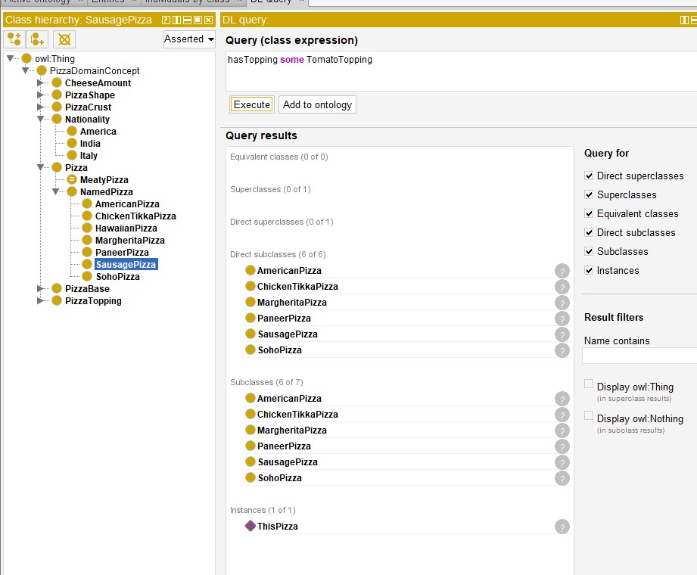

# Q7

Ans. The second query I ran was to find all the pizzas which have Italy as nationality. This query uses hasNationality property of the Pizza class. The query is

hasNationality some Italy.

The reasoner tries to find all the classes where the Pizza is a subclass of “hasNationality some Italy” class. All the pizzas which are connected to the hasNationality property through the value Italy are selected.

