TMUX

- TMUX is a terminal multiplier. It gives seperate logical windows for doing different tasks simultaneously.
- It also gives acess to remote servers.
- We can start a tmux session in a server, and can set tasks or some processess running on it.If it’s a time consuming process we can safely detach from the session( without disturbing the initiated process/task), and carry on with other tasks in a seperate session or we can shutdown our computer & do some other work (while the process is still running on the server).
- Each session can be split into many windows and each windows into many panes horizontally and vertically.
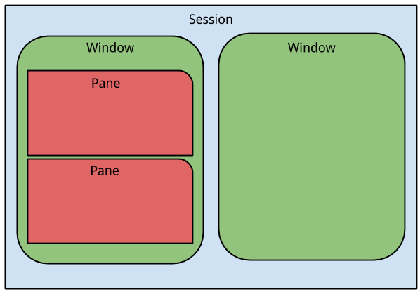

Command Line Operation
- To install tmux
“sudo apt-get install tmux”
- To start tmux
“tmux”
- To list the tmux sessions running on a machine
“tmux ls”
- To create new tmux sessions
“tmux new” (create session with name session0)
“tmux new -s sessionname” (create session with aprticular name)
- To detach from a session
“tmux detach”
- To attach to a session
“tmux attach” (attach to first available session)
“tmux attach -t sessionname ( attach to a particular session)
- To kill session
“tmux kill-session -t sessionname” (kill a particular session)
“killall tmux” to kill all tmux sessions

Shortcut Keys of Operation

- Ctrl-b + c ==> Create new window
- Ctrl-b + p ==> display previous window
- Ctrl-b + n ==> display next window
- Ctrl-b + % ==> split window to vertical panes
- Ctrl-b + “ ==> split window to horizontal panes

