.Q2) script to copy history of every hour in specific file located in s3 bucket

Step1:

Launch an instance

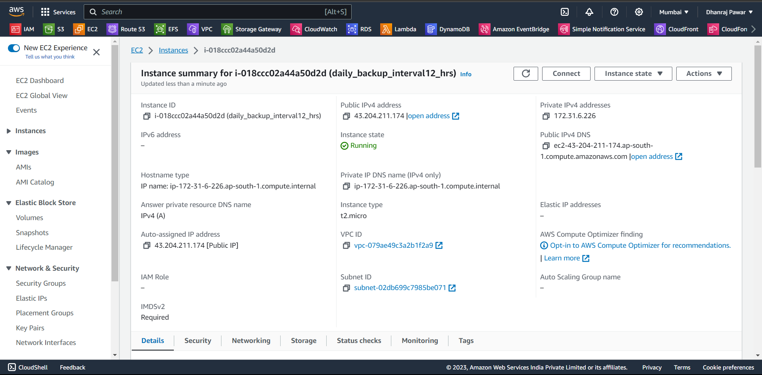

Step2:

Create a s3 bucket and folder in wich you want to take the backup of history

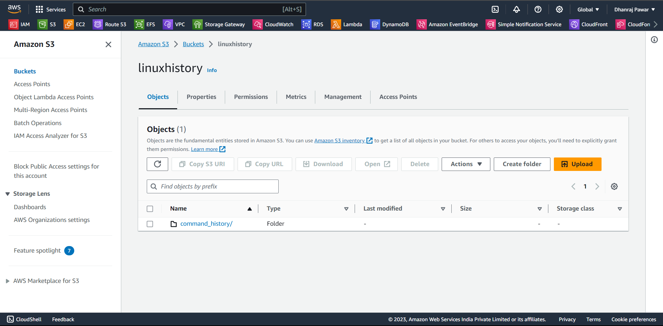

Then take access of your instance to do the further configuration

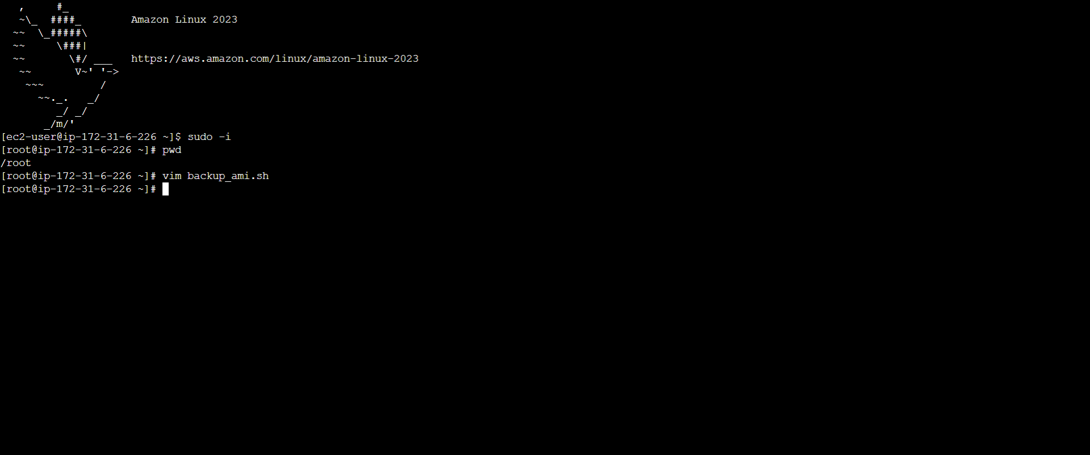

Make sure that you have permission

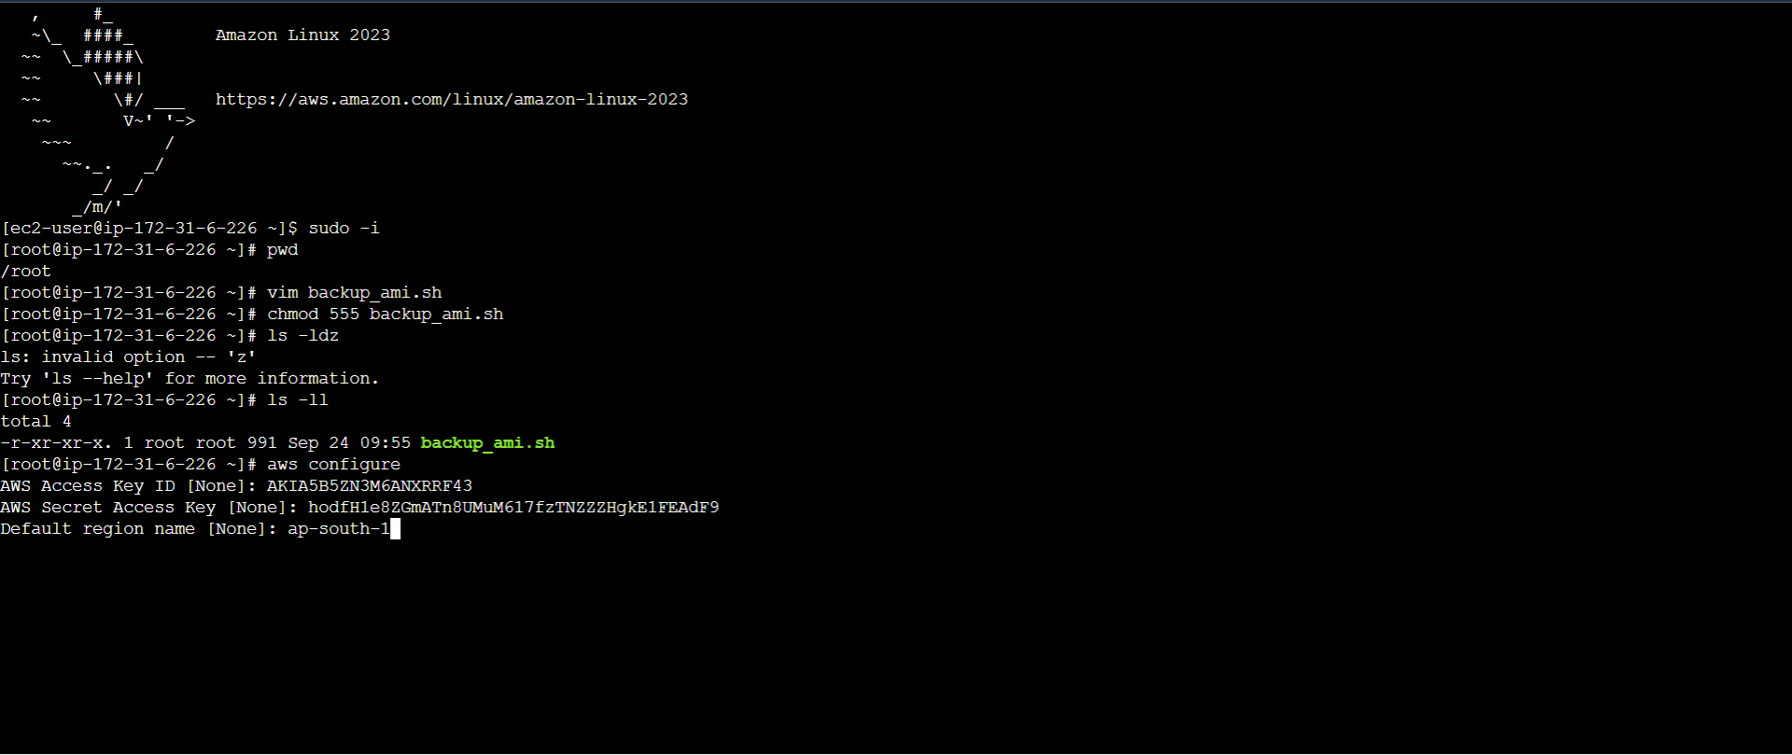

Step3: Create a New Bash Script

Open a text editor on your Linux machine (e.g., vim).

Create a new file and save it with a .sh extension, such as copy_history_to_s3.sh.

Make sure that your .sh file has execute permission



Also create a file to copy history



Step4 : Edit the Script

Open the copy_history_to_s3.sh file in your text editor.

Copy and paste the following script into the file

#!/bin/bash

# Replace with your S3 bucket name and destination folder

S3_BUCKET="linuxhistory"

S3_DESTINATION="s3://linuxhistory/command_history/"

# Path to the history file you want to copy

HISTORY_FILE="/root/history"

# Function to copy the history file to S3

copy_to_s3() {

local timestamp=$(date +\%Y\%m\%d\%H)

local s3_key="$S3_DESTINATION/history-$timestamp.txt"

aws s3 cp "$HISTORY_FILE" "s3://$S3_BUCKET/$s3_key" --profile "$AWS_PROFILE"

}

# Main loop

while true; do

copy_to_s3

echo "History file copied to S3 at $(date)."

# Sleep for 1 hour (in seconds)

sleep $((60 * 60))

done

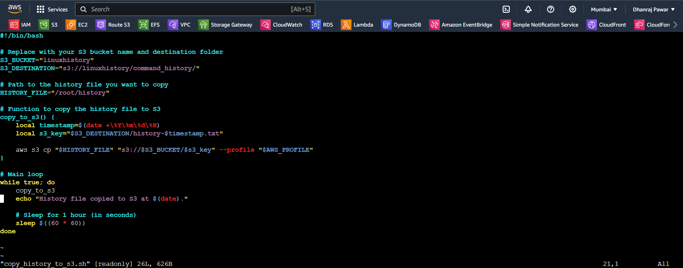

Step5:

Schedule a crontab job

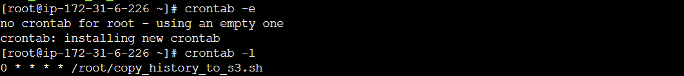



Step 6: Run the Script

Run the script by executing the following command



Now You have now successfully created a Bash script to automate the copying of a history file to an Amazon S3 bucket every hour

