Q.3) script for bash create a backup of rds mariadb database every 2nd and 4th of each month Friday?

Step1:

Launch an instance

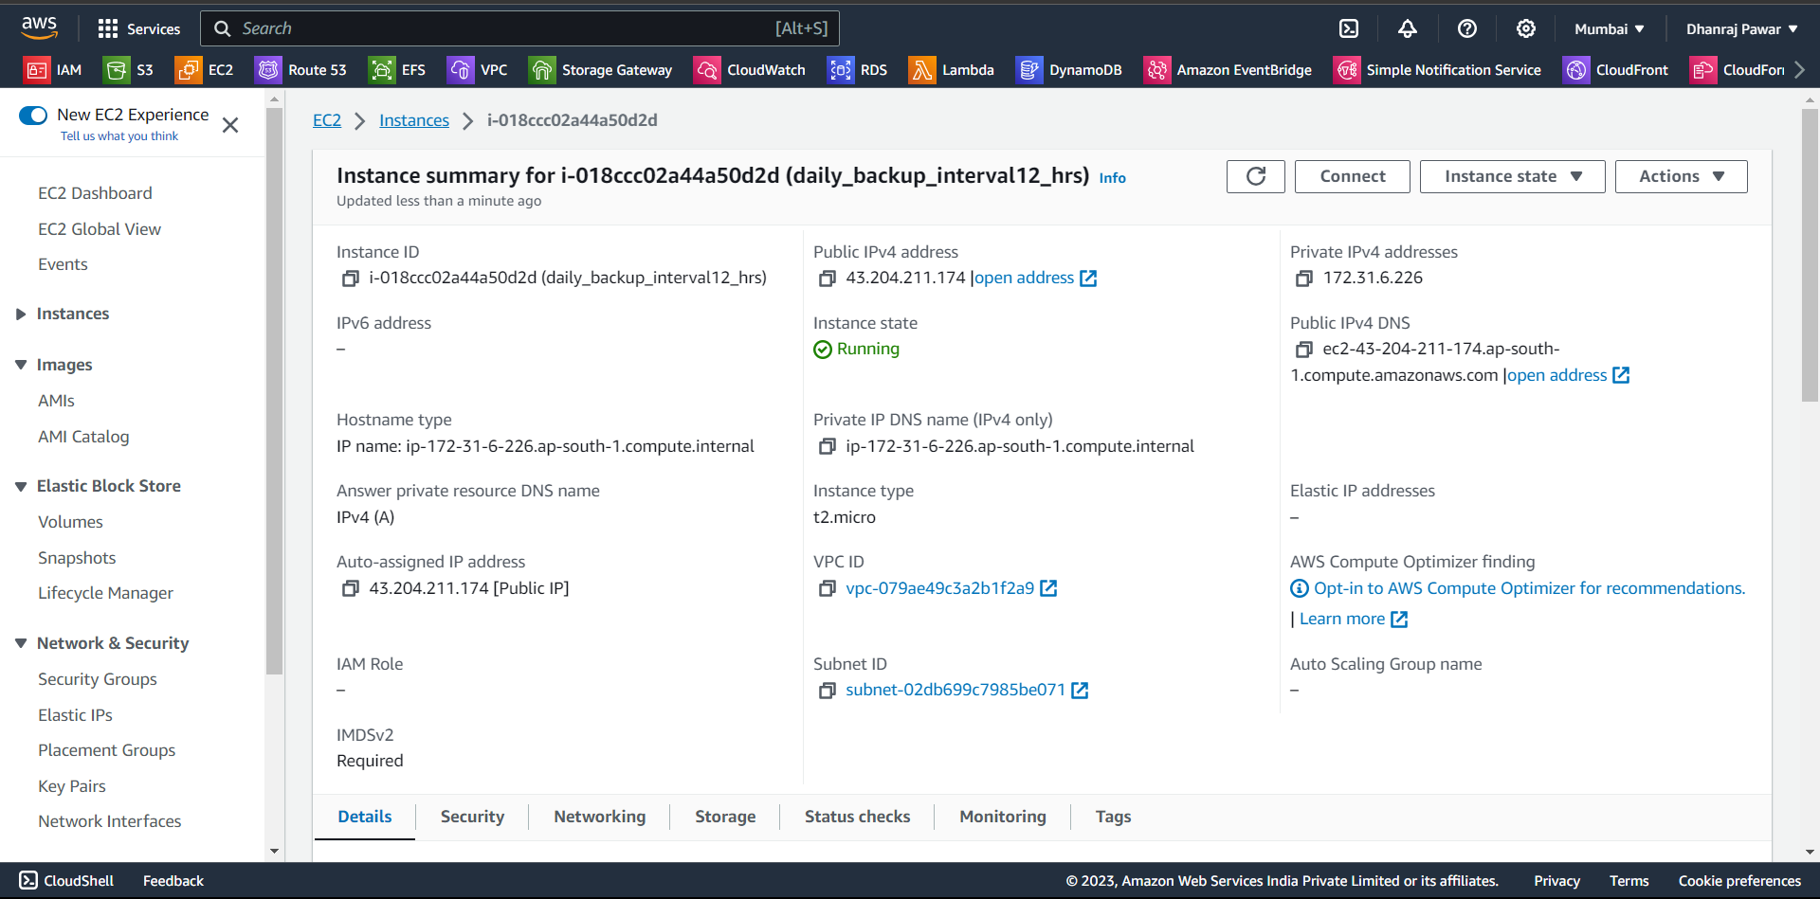

Step2:

Make sure that you have RDS database instance so we can take backup of it

Step3:

Take access of your instance to schedule a job

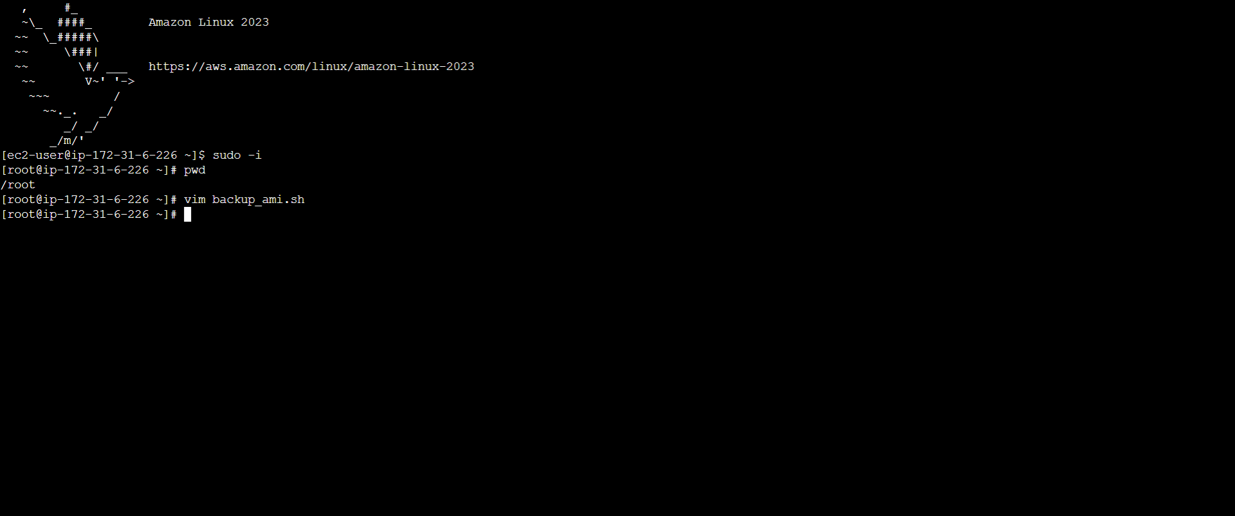

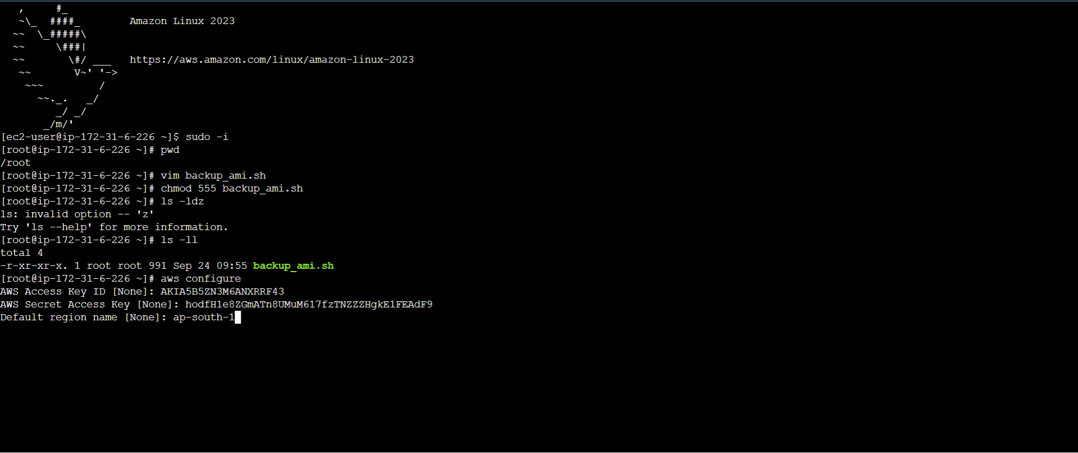

Step3:

Now write below script in database-db.sh to take backup

Make sure that it has permission to execute

AWS region

RDS_INSTANCE_IDENTIFIER="my-database"

AWS_REGION="eu-west-1"

SNAPSHOT_IDENTIFIER="Snapshot-$(date +\%Y\%m\%d\%H\%M\%S)"

aws rds create-db-snapshot --db-instance-identifier "$RDS_INSTANCE_IDENTIFIER" --db-snapshot-identifier "$SNAPSHOT_IDENTIFIER" --region "$AWS_REGION"

# Print a message

echo "RDS snapshot created: $SNAPSHOT_IDENTIFIER"e I write following script.

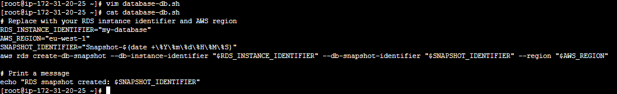

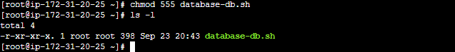

Step4:

Now we just have to schedule a crontab job

