Q.1) Taking backup of AMI instance on daily basics interval of 12 hrs in bash script ?

->

Step 1

Launch an instance

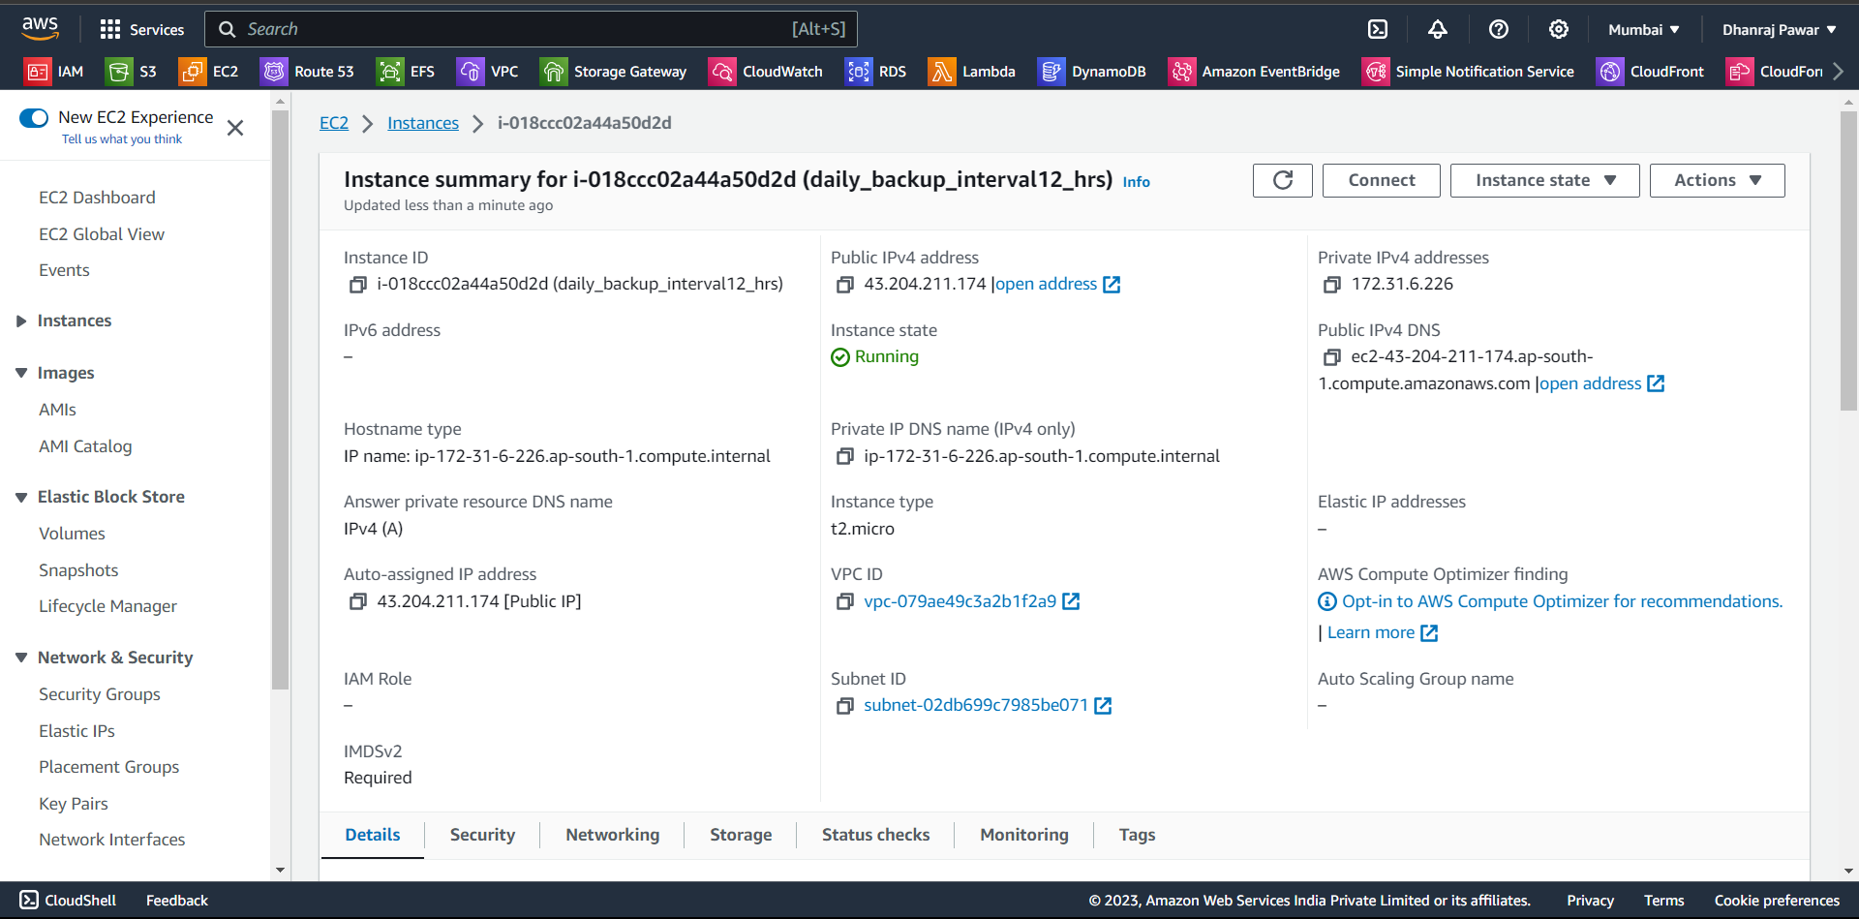

Step 2: Create a New Bash Script

1.Open a text editor on your Linux machine (e.g., nano, vim).

2.Create a new file and save it with a .sh extension, such as backup_ami.sh.

3. Copy and paste the following script into the file

#!/bin/bash

# Replace with your actual instance ID

INSTANCE_ID="i-018ccc02a44a50d2d"

# Log file for recording the backup operations

LOG_FILE="/var/log/ami_backup.log"

# Function to log messages

log() {

echo "$(date +'%Y-%m-%d %H:%M:%S') - $1" >> "$LOG_FILE"

}

# Check if the log file exists, and create it if not

if [ ! -f "$LOG_FILE" ]; then

touch "$LOG_FILE"

filog "AMI backup script started."

# Loop indefinitely to create AMIs every 12 hours

while true; do

log "Creating an AMI for instance $INSTANCE_ID"

# Create an AMI using AWS CLI directly

if aws ec2 create-image --instance-id "$INSTANCE_ID" --name "Backup-AMI-$(date +\%Y\%m\%d\%H\%M)" --description "Daily backup" --no-reboot >> "$LOG_FILE" 2>&1; then

log "AMI creation initiated successfully."

else

log "Error creating AMI."

fi

# Sleep for 12 hours (in seconds)

sleep $((12 * 60 * 60))

done



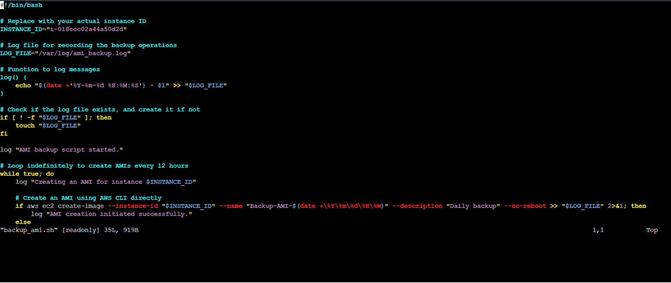

Step 3: Make the Script Executable

Open a terminal and navigate to the directory where you saved the backup_ami.sh file.

Run the following command to make the script executable:

chmod 555 backup_ami.sh

and also Ensure that the AWS CLI is correctly configured on your Amazon Linux instance with the necessary permissions to create AMIs.



Step 4: install crontab to schedule a job

Yum install cronie

Systemctl start crond

Systemctl enable crond

Then schedule a job by entering command crontab -e Schedule a job for 0 */12 * * * so the script will start running and will create AMI backups of your EC2 instance at 12-hour intervals.

To check job use command crontab -l



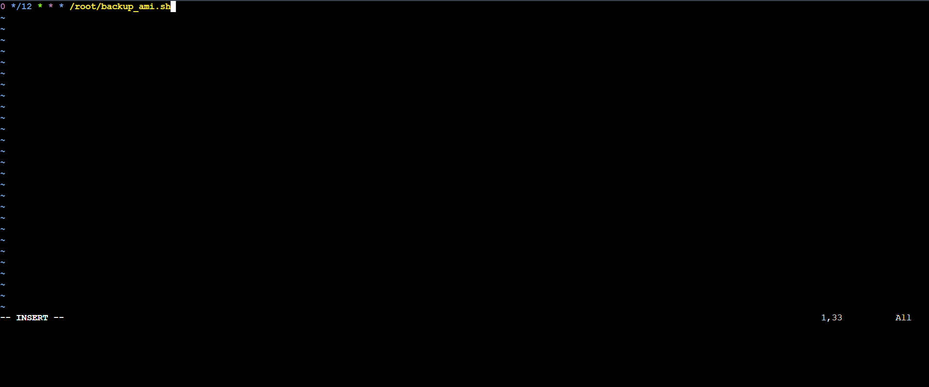



You can check logs for your job



You have now successfully created a Bash script to automate the creation of daily AMI backups with 12-hour intervals



If you want to delete the job use command crontab -r

