Assignment 6
Name:-Ankita Masal
Div:-CS_H2_03
PRN No:-12410426

7) Write a program using UDP Berkeley Sockets for wired/wireless network to enable file transfer (Script, Text, Audio and Video one file each) between two machines. Demonstrate the packets captured traces using Wireshark/Fiddler for traffic analysis tool in peer to peer mode.

Server to receiver text file sent and receiver recieved
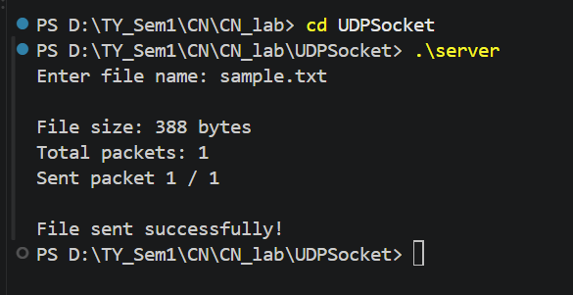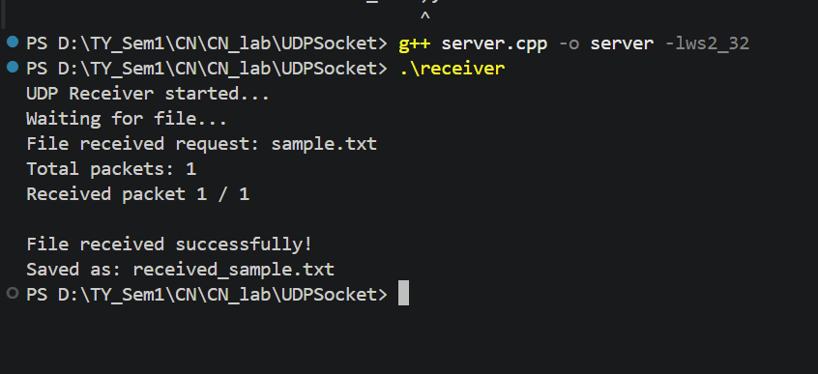

Sent sample.py from server to reciever
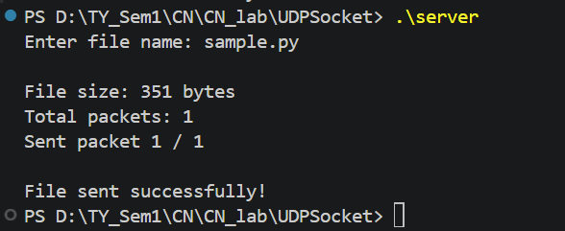
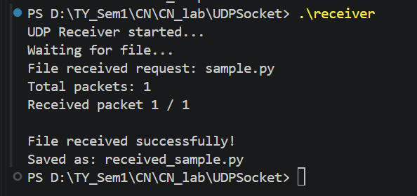

Audio file sent to receiver from server
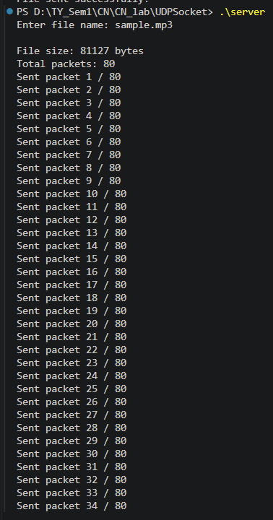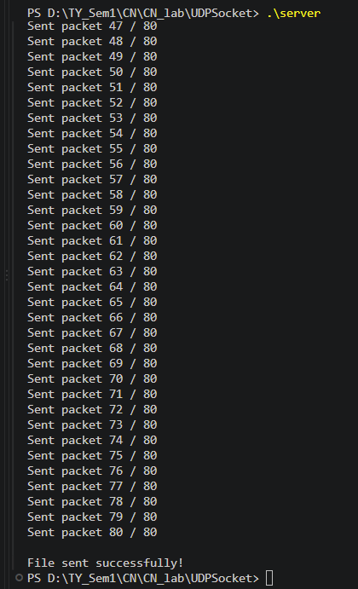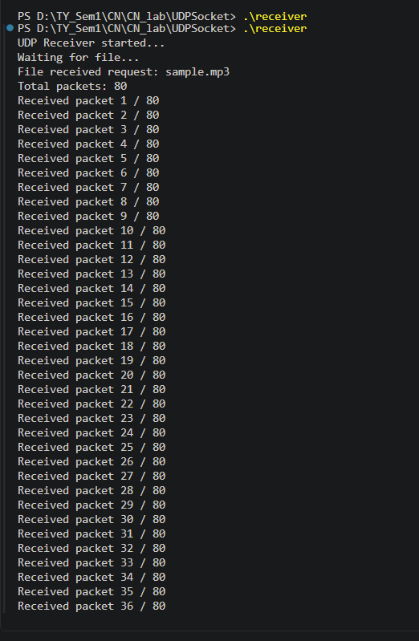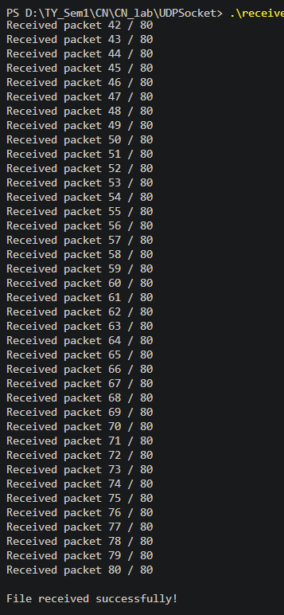

Video file sent from sender to receiver
