Measuring the Impact of Quantum Depolarized Noise using Graph Neural Network model towards regularization for Molecular Discovery
Syed Muzamil Basha¹, Hamed Taherdoost²

¹School of Computer Science and Engineering, REVA University, India.
²Faculty of Arts, Science and Technology, University Canada West, Vancouver, BC, Canada
²GUS Institute, Global University Systems, London, UK
²College of Technology and Engineering, Westcliff University, Irvine, CA, USA
²Research and Development Department, Hamta Business Corporation, Vancouver, BC, Canada
²Faculty of Information Technology, Victorian Institute of Technology, Melbourne, VIC, Australia
²Department of Electronic Engineering, National Kaohsiung University of Science and Technology, Kaohsiung, Taiwan
¹Muzamilbasha.s@reva.edu.in, ²hamed.taherdoost@gmail.com
Corresponding Author: hamed.taherdoost@gmail.com

Abstract
Quantum graph neural networks (QGNNs) provide a solution to combine graph representation with Quantum computations in the application area of Molecular Property Prediction (MPP). The challenges in this area are measuring the impact of quantum noise $\left(β\right)$ on training the model, accessing the complexity of the model and regularization. The objective of the present work is to introduce the noise through data (Flipped Labels) and the Quantum hardware. It will stop the model from memorizing the data and acts as regularization towards improving the testing performance of the model. The present research work, attempt to measure the impact of depolarizing noise using the QM9 dataset. In which HOMO-LUMO is considered as target property. The Quantum circuits are constructed to measure the impact of depolarized noise rating from 0 to 0.20. The performance of the QGNN is evaluated using training and test mean squared error (MSE). In addition to that generalization gap $\left(∆g\right)$, fixing the gradient through Root Mean Square (RMS) and measuring the effective complexity of the model. The experimental results indicate the increase in $β$, also show slight increase in training and testing error. The $∈$ decreases by 7%, this have no relevance in improving the test prediction accuracy. Due to introducing range of noise $β$ at Quantum circuit level, the effective complexity measure shows major decline along with suppression of output sensitivity. The results demonstrate the noise dependent learning dynamics in Quantum Machine Learning around MPP.

Keywords: Quantum Graph Neural Networks; Quantum Machine Learning; Depolarizing Noise $\left(β\right)$; Molecular Property Prediction; QM9; Generalization Gap $\left(∆g\right)$.
Introduction:
In the present days, to support complex learning task Quantum Machine Learning (QML) are demonstrated using Quantum computations. Among the applications, MPP is most relevant as the structure of molecule can be represented as Graphs. In which each atom represents node and the bond between the associate nodes as Edge. GNN helps to represent the molecule behaviour and its structural properties using QGNNs through designing the parametrized quantum circuits with prediction.

The performance of the Quantum Learning models depends on the noise introduced in the Quantum circuits through corrected data( flipping the data labels) and Explicit Hardware noise. The problem in molecular property discovery increasing the difficulty for the supporting hardware in quantum modelling. In the present research work, Qiskit Aer supports explicit noisy simulation through NoiseModel and depolarizing_error. In Quantum Machine Learning (QML), the dataset QM9 [1,2,3,4] is used as benched marked dataset for molecular property predictions. The Target Property is HOMO-LUMO energy gap $\left(Δg\right)$, with 450 training molecules and 150 testing molecules. It indicates the molecular electronic stability [5]. The inefficiency is the hardware exist in mapping the $n$qubits to $2^{n}-1$outputs. Due to which, the latency is involved in training the model with ($O(1/{ε^{2}}))$ iterations. The effective model complexity is computed as $d_{eff}αS_{2}(β,g)$. The Complete noise spectrum is provided in Fig .1.
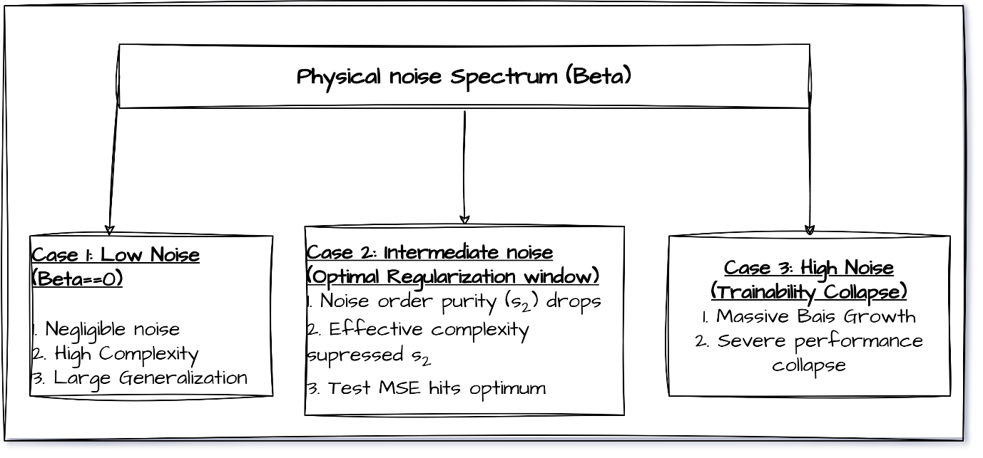
Fig.1: Noise Spectrum (β)
The screening process of Molecular Property Prediction (MPP) is computationally expensive due to its chemical properties HOMO-LUMO energy gap $(Δg)$ and Molecular electron density. The representation of the same in QML platform undergo exponentially large Hilbert Space $\left(C^{2^{L}}\right)$ [5]. To bypass the mentioned problem towards training the QML a multi-dimensional Fourier frequency evaluation [8] is provided in Eq .1.
$T=∏_{i}\left(2ω_{max}\left(i\right)+1\right)$ Eq.1

The representation of Molecule behavior is through Graph $\left(G\right)$, where $G=\left(V,E\right)$. Each $ϑ_{i}ϵV$, represents individual atom in the molecule and $℮_{i,j}=\left(ϑ_{i},ϑ_{j}\right)∈E$ represents the bond attribute (Single, Double, Triple) of atom in particular molecules. In Quantum Graph Neural Network (QGNN) each heavy atom $ϑ_{i}ϵV$ is mapped to qubit in the quantum computer. The qubit rotations are represented as $\left(R_{X},R_{Y},R_{Z}\right)$, Intern the features of the atom. Each $℮_{i,j}ϵΕ$ represents chemical bond of the atom, intern represent entanglement operation.

The traditional Graph Neural Networks (GNN’S) are vulnerable to noise (Label flipping). The Local Robustness Ratio (LRR) helps to measure the impact of occurrence of bad data [6].

$LRR=\left(T_{r}\left(H_{nosiy}\right)/T_{r}\left(H_{clean}\right)\right)$ Eq.2
From the Eq. 2 when the magnitude of LRR is >1 provide the inference of model being overfitting due to noise. The impact of this noise is directly affecting the performance of QGNN towards Molecular candidate ranking. The implementation of Molecular candidate ranking is limited to small qubit registers $\left(n≤9\right)$ qubits [7]. The hardware noise across the quantum gates $\left(g\right)$ is distributed in the binominal form as mentioned in the Eq. 3.

$P_{m}\left(β,g\right)=\left(\begin{aligned}g \\ m\end{aligned}\right)β^{m}{\left(1-β\right)}^{g-m}$ Eq.3
Noise order purity is inversely proportional to physical noise rate $\left(β\right)$ [8]. The Robustness of the QGNN is addressed by Quantum sampling and Measurement, which can be evaluated using Log-Ratio Probability (LRP) [9]. The role of Hilbert-space mapping in quantum is to represent the high dimensional nonlinear state. Quantum kernels are used to widen the Hilbert-space trace distance that helps in generalization. Entanglement enables spatial equivariance. Similarly sampling dynamics prevent gradient varnishing problem [10].

Quantum circuits with constrains enforces symmetric entanglers to enable the conventional filters with weight sharing. LRP measures the vanishing gradient problem using gradient pumping [12] as mentioned in Eq. 4.

$y_{k}=\ln\left({p_{k}}/{p_{ref}}\right)$ Eq.4
The skip Connection in data reuploading layers introduces universal approximation using trigonometric feature expansions [13]. Random Fourier feature regression enables classical edge device inference [14] as mentioned in Eq. 5.

$f_{0}\left(x\right)=\sum_{ω}{∁_{ω}℮^{-iωx}}$ Eq. 5

The classical equivalent quantum operations are as represented in Fig. 2. The mapping of classical Machine Learning (CML) to Quantum Machine Learning (QML). Quantum devices and quantum circuit simulations are affected by imperfect operations, decoherence, and measurement-related limitations. Depolarizing noise provides a useful mathematical model for investigating how such imperfections influence quantum learning. Although noise is often treated as an undesirable source of computational error, its interaction with model complexity and generalization raises an important question: can a controlled amount of noise reduce unnecessary model flexibility, or does it suppress the model's ability to learn meaningful patterns? In conventional machine learning, regularization can improve generalization by limiting overfitting. In quantum machine learning, however, noise may also reduce parameter sensitivity and weaken the gradients required for effective optimization. Consequently, a reduction in the training–test performance gap cannot, by itself, establish that noise provides beneficial regularization.

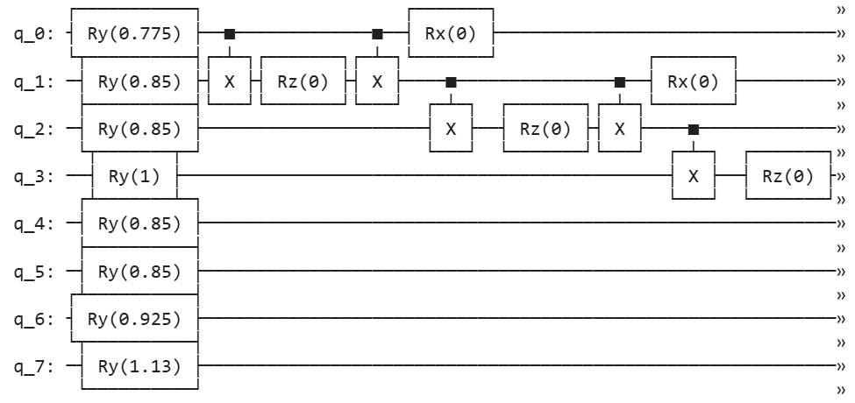
Fig.2.1: State preparation and initial interactions

In Fig 2.1, circuit shows an eight-qubit quantum circuit designed to process encoded molecular information. Its visible operations include $R_{y}$, $R_{x}$, $R_{z}$and $X$ gates, with connections between selected qubits. The circuit transforms information encoded into eight quantum bits into a quantum state that can be measured to obtain a numerical output.
$R_{y}\left(θ\right)|0> = \cos\left(θ/2\right)\left|0> + \sin\left(θ/2\right)\right|1>$ Eq.6

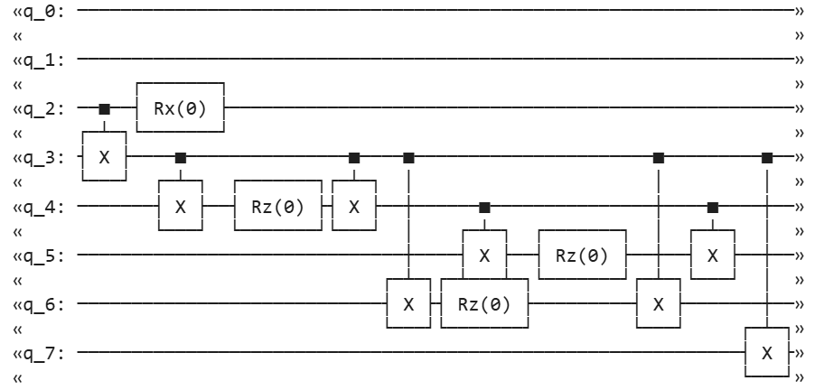
Fig.2.2: Further interaction gates
In the Fig. 2.2, The circuit applies controlled operations between selected qubits. A CNOT can make the state of a target qubit depend on the state of its control qubit. Such operations can create correlations and, in suitable states, entanglement. The circuit shows a network of controlled qubit interactions, but its effective computational role depends critically on whether the zero-angle rotations are fixed or trainable and on how the circuit is connected to the molecular input and measurement stages. The second stage of the eight-qubit quantum circuit shown previously. It contains additional connections among qubits $q_{2}$through $q_{7}$, using CNOT gates, $R_{z}\left(0\right)$rotations, and an $R_{x}\left(0\right)$ rotation.

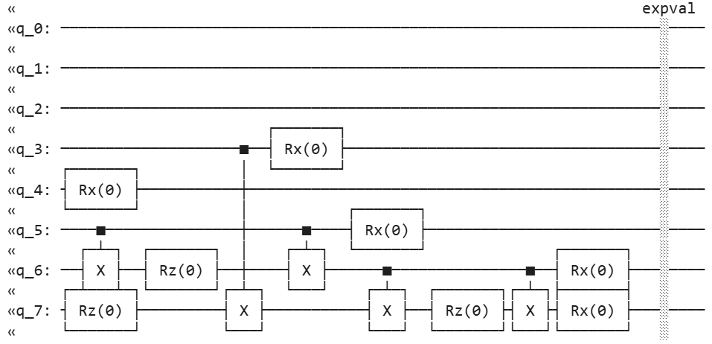
Fig.2.3: Final transformations and readout
The Fig 2.3, provides the visible readout stage of your proposed quantum-processing pipeline. Its expval operation can produce a numerical quantum output, but the exact mapping to the HOMO–LUMO energy gap requires the observable definition and any subsequent classical regression code.

Molecular datasets such as QM9 offer a suitable experimental setting for investigating these effects. QM9 contains molecular structures and quantum-chemical properties that support supervised molecular prediction tasks. In this study, the HOMO–LUMO energy gap is considered as the target property. By varying the depolarizing noise rate and measuring prediction error, gradient sensitivity, and empirical effective complexity, the study examines how noise influences the learning behavior of a quantum graph model. These measurements provide complementary perspectives: prediction error evaluates the quality of molecular-property estimates, gradient norms characterize local output sensitivity, and effective complexity estimates the extent of locally distinguishable prediction variations under the chosen mathematical definition.

The preliminary experimental results show that increasing depolarizing noise is associated with a decline in training and test performance, a substantial reduction in the root-mean-square output-gradient norm, and a sharp decrease in the measured effective-complexity quantity. Although the generalization gap becomes smaller, this change is not accompanied by improved test accuracy. These observations are therefore consistent with noise-associated suppression of model sensitivity and effective complexity rather than demonstrated beneficial regularization. Nevertheless, the results do not yet establish a causal mechanism or a formal barren plateau; further statistical and numerical validation is required.

The objective of this work is to characterize the relationship between finite depolarizing noise, trainability, empirical effective complexity, and molecular prediction performance in a QGNN-based learning setting. The study aims to distinguish useful complexity reduction from harmful capacity suppression and to identify the experimental conditions under which these behaviors occur. This investigation provides a basis for systematic evaluation across random initializations, training-set sizes, circuit depths, and suitable classical baselines, contributing to a more rigorous understanding of noise-dependent learning behavior in quantum graph models for molecular property prediction.

Methodology:
The methodology follows the workflow shown in the supplied diagram: molecular dataset preparation, molecular graph construction, quantum graph processing, property prediction, and systematic evaluation under different noise conditions.
1. Overall research workflow
The proposed methodology has two connected components:
- Quantum graph learning pipeline: Converts molecular structures into graph representations, encodes their features, processes them using a graph-aware quantum circuit, and predicts a molecular property.
- Noise analysis pipeline: Introduces a controlled noise model, trains the quantum model, evaluates its predictions, and compares performance across noise levels.
The primary objective is to determine how depolarizing noise influences prediction accuracy, output sensitivity, and empirical effective complexity.
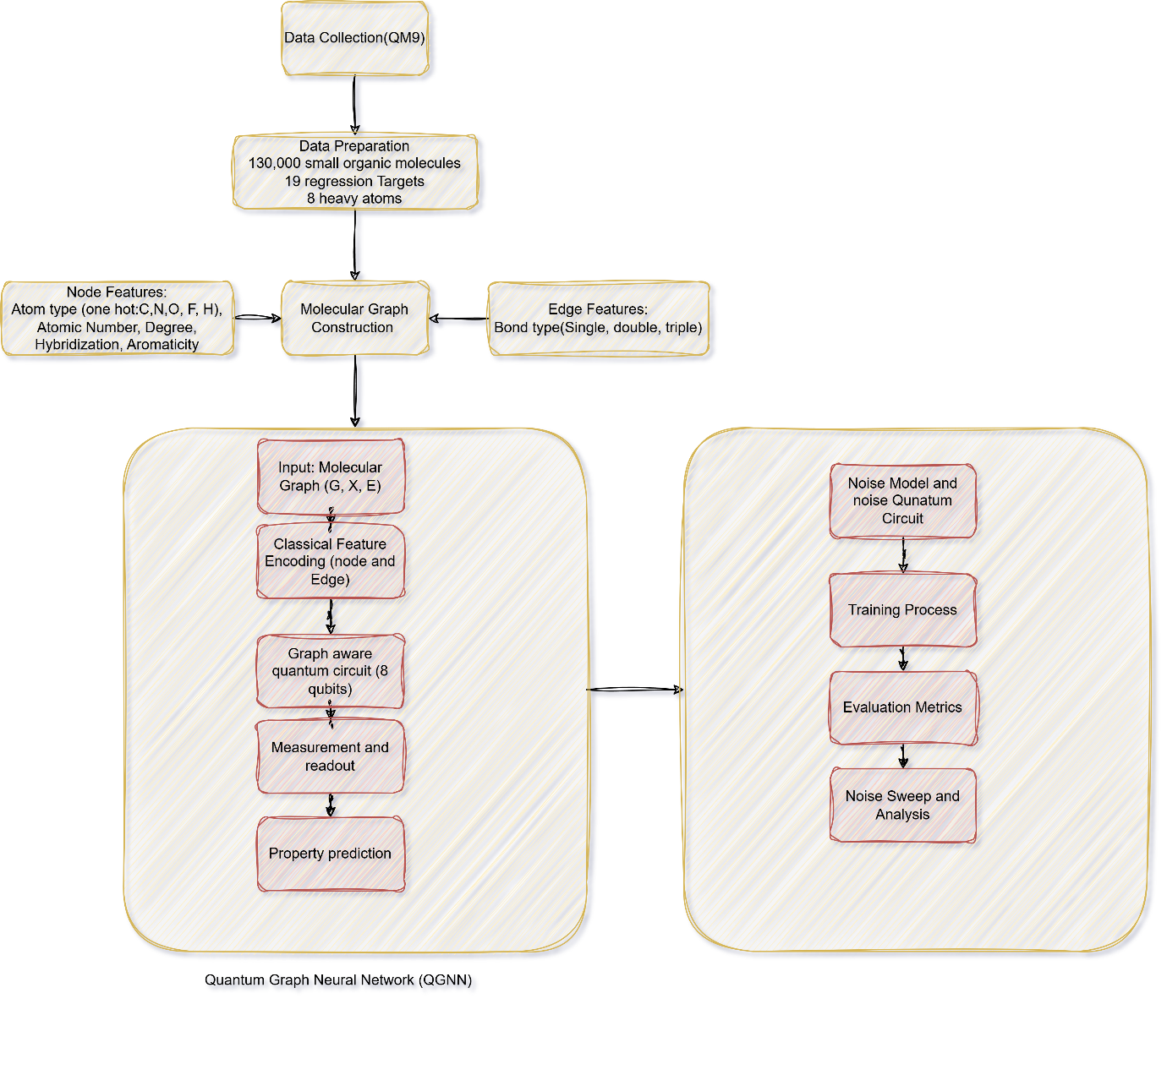
Fig.3: Methodology

2. Dataset collection and preprocessing
The QM9 molecular dataset is used as the source of molecular structures and quantum-chemical properties. Each molecule is represented as a graph, where atoms are nodes and chemical bonds are edges. The HOMO–LUMO energy gap is selected as the target property for regression.
The preprocessing stage involves:
- Molecular filtering: Select molecules compatible with the chosen quantum-circuit representation. For the existing eight-qubit prototype, molecules may be restricted to at most eight heavy atoms.
- Graph construction: Represent each molecule as $G=\left(V,E\right)$, where $V$denotes atoms and $V$denotes chemical bonds.
- Node-feature extraction: Encode relevant atomic properties, such as atom type, atomic number, degree, and other available atom descriptors.
- Edge-feature extraction: Encode bond information, including bond type and connectivity.
- Target preprocessing: Normalize the molecular-property values using statistics calculated from the training set only.
- Dataset splitting: Separate training, validation, and test molecules to ensure that model selection and final evaluation use distinct data.
3. Molecular graph construction and feature encoding
Each molecule is converted into a numerical graph representation:
$G=\left(V,E,X,E_{b}\right)$ Eq.6
where $X$ contains node features and $E_{b}$contains bond features associated with graph edges.
Classical feature encoding transforms the atomic and bond descriptors into numerical representations suitable for quantum-circuit input. The molecular graph's connectivity is retained so that the quantum circuit can incorporate interactions corresponding to chemical bonds.
The feature-encoding procedure must specify how atomic descriptors are mapped to qubits and how molecules with different numbers of atoms are accommodated by the fixed-size circuit.
4. Graph-aware quantum circuit design
The encoded molecular graph is processed by a graph-aware parameterized quantum circuit using eight qubits in the current prototype.
The circuit consists of the following conceptual stages:
- Quantum state preparation: Encode molecular node information into quantum states.
- Graph-interaction operations: Apply quantum gates whose arrangement reflects the molecular graph's connectivity.
- Parameterized transformations: Use trainable rotations and other circuit operations to learn representations of molecular structure.
- Measurement and readout: Measure an appropriate quantum observable to obtain a numerical output.
- Property prediction: Transform the measurement output into the predicted molecular-property value.
The model can be expressed as
$\hat{y}\left(G;θ,β\right)=T_{r}\left[Ο_{ρ}\left(G;θ,β\right)\right]$ Eq.7
where $G$ is the molecular graph, $θ$denotes trainable parameters, $β$is the depolarizing-noise rate, $Ο$ is the chosen measurement observable, and $ρ$ is the output quantum state or density matrix.
The exact observable, encoding operations, and graph-interaction pattern must be documented from the implemented circuit. The model should be described as a QGNN only if graph connectivity genuinely determines its quantum interactions or graph representation.
5. Noise modelling and quantum-circuit simulation
The noise-analysis component introduces depolarizing noise at designated quantum operations. A noiseless configuration, $β=0$serves as the reference, while non-zero values represent progressively stronger simulated noise.
The current experimental sweep uses:
$β∈\left\{0, 0.005, 0.01, 0.02, 0.05, 1.10, 0.20\right\}$ Eq.8
For each noise setting, the same molecular splits, target preprocessing, circuit structure, and evaluation procedure should be maintained. The noise model and its placement within the circuit must remain consistent so that differences in results can be attributed to the investigated noise conditions as far as possible.
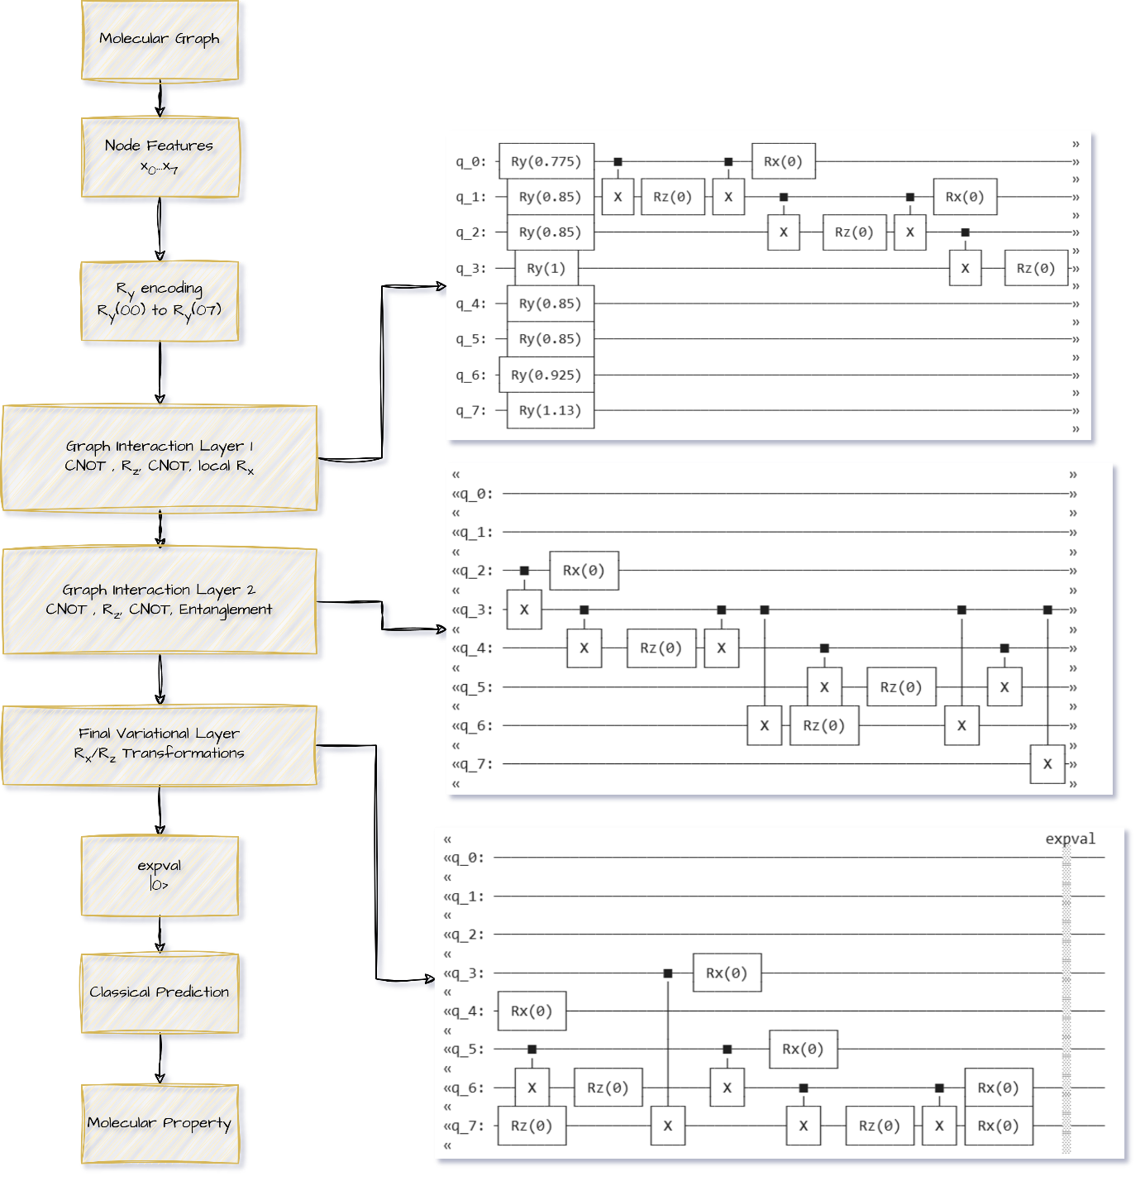
Fig.4: Quantum Circuit Architecture

6. Model training
The trainable quantum circuit is optimized to minimize the discrepancy between predicted and reference molecular properties. A regression loss, such as mean squared error, can be used:
$L\left(θ\right)=\frac{1}{N}\sum_{i=1}^{N}{{\left(y_{i}-\hat{y_{i}}\left(θ,β\right)\right)}^{2}}$ Eq.9
Training is performed separately for each noise condition, with a consistent optimization budget and documented initialization procedure.
For rigorous comparison, each configuration should be repeated with multiple random seeds. Validation data should determine model-selection decisions, including the selection of a preferred noise rate. The test set should be reserved for final performance evaluation.
7. Evaluation metrics
The model is evaluated using prediction metrics and diagnostics of its learning behavior.
Metric | Purpose
Training MSE | Measures fitting error on training molecules
Test MSE | Measures prediction error on unseen molecules
Mean absolute error (MAE) | Measures the average absolute prediction error
Generalization gap | Measures the difference between test and training MSE
RMS output-gradient norm | Measures local sensitivity of predictions to trainable parameters
Training-loss-gradient norm | Helps assess the strength of the optimization signal
Empirical effective complexity | Estimates locally distinguishable prediction variation under the specified complexity measure
Prediction errors should be reported in both standardized form and the original target units. The effective-complexity formula, normalization, regularization parameter, and numerical implementation should be reported explicitly.
8. Noise-sweep analysis
Results from all noise levels are compared to determine how increasing noise changes model performance and sensitivity. The analysis examines:
- Whether training and test errors improve or deteriorate.
- Whether the generalization gap narrows because test performance improves or because training performance worsens.
- Whether output-gradient and loss-gradient norms decrease as noise increases.
- Whether empirical effective complexity changes consistently with gradient sensitivity.
- Whether the observed relationships persist across random seeds, training-set sizes, and circuit depths.
The present plots show that test error increases slightly while output-gradient magnitude and the plotted effective-complexity measure decrease sharply. These results are consistent with noise-associated suppression of model sensitivity, but the mechanism requires statistical replication and numerical validation.
9. Statistical analysis and reproducibility
The extended experiments should use independent random seeds, paired comparisons against the zero-noise reference, and confidence intervals for prediction metrics. Where appropriate, paired bootstrap or permutation tests can assess whether observed differences are reliable.
The experimental record should include dataset splits, software versions, circuit specifications, noise-model configuration, random seeds, optimizer settings, parameter counts, gate counts, and all per-run metrics. Classical baselines, including a multilayer perceptron and a message-passing graph neural network, should be evaluated on the same molecular splits.
Results and Discussion:
This section presents the preliminary findings from the finite-noise quantum graph neural network (QGNN) experiments for molecular property prediction using the QM9 dataset. The analysis focuses on four aspects: prediction accuracy, generalization behavior, gradient sensitivity, and empirical effective complexity. The objective is to determine whether increasing depolarizing noise acts as a useful regularizer or suppresses the model's ability to learn molecular structure–property relationships.
The experiments consider depolarizing noise rates $β$ranging from 0 to 0.20. The results below are interpreted from the supplied plots. Since repeated-seed statistics and confidence intervals have not been provided, the findings should be regarded as preliminary observations rather than statistically established effects.

$β=[0.0, 0.01, 0.05, 0.1, 0.25, 0.20]$ Eq.10
$β$ represents noise rate introduced by noise model with three possible values as mentioned in the Eq.10.

Table: Noise Sweep
Iteration | seed | beta | best_epoch | train_mse_standardized | validation_mse_standardized | test_mse_standardized | test_mse_eV2 | test_mae_eV | generalization_gap
0 | 42 | 0.000 | 3 | 0.732359 | 1.247848 | 1.382246 | 2.110679 | 1.226256 | 0.649886
1 | 42 | 0.005 | 3 | 0.734289 | 1.246332 | 1.380429 | 2.107905 | 1.225550 | 0.646140
2 | 42 | 0.010 | 3 | 0.736136 | 1.245031 | 1.378619 | 2.105140 | 1.224776 | 0.642483
3 | 42 | 0.020 | 3 | 0.739622 | 1.242975 | 1.375001 | 2.099617 | 1.223049 | 0.635379
4 | 42 | 0.050 | 3 | 0.749370 | 1.240002 | 1.364460 | 2.083520 | 1.216952 | 0.615090
5 | 1042 | 0.000 | 1 | 0.829025 | 1.144467 | 1.273435 | 1.944525 | 1.216153 | 0.444410
6 | 1042 | 0.005 | 1 | 0.830066 | 1.140762 | 1.271591 | 1.941710 | 1.214712 | 0.441525
7 | 1042 | 0.010 | 1 | 0.831199 | 1.137346 | 1.269977 | 1.939245 | 1.213325 | 0.438778
8 | 1042 | 0.020 | 1 | 0.833709 | 1.131336 | 1.267390 | 1.935296 | 1.211328 | 0.433682
9 | 1042 | 0.050 | 1 | 0.842832 | 1.119428 | 1.264465 | 1.930829 | 1.209647 | 0.421633

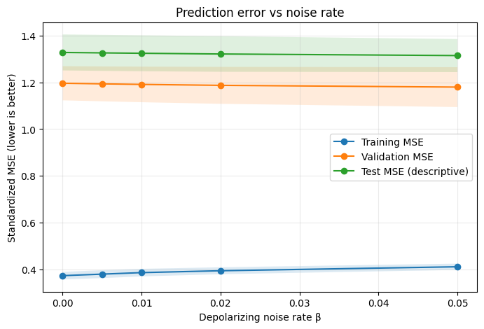
Fig.5: Training and Test Error Across Noise Levels
In the Fig.5, x-axis indicates how much noise is introduced into the simulated quantum operations. Noise can accumulate across a circuit, so a 20% per-operation rate does not mean that the entire circuit has exactly a 20% chance of failure. Y-axis represent MSE measures the average squared difference between predicted and actual molecular-property values. The values here are standardized, meaning the target values have been scaled for modelling. As noise increases, training MSE rises from approximately 0.961 to 0.974. This means the model becomes slightly less accurate on the molecules it learned from. The added noise appears to make fitting the training data more difficult. There is no visible finite-noise optimum that improves test MSE.

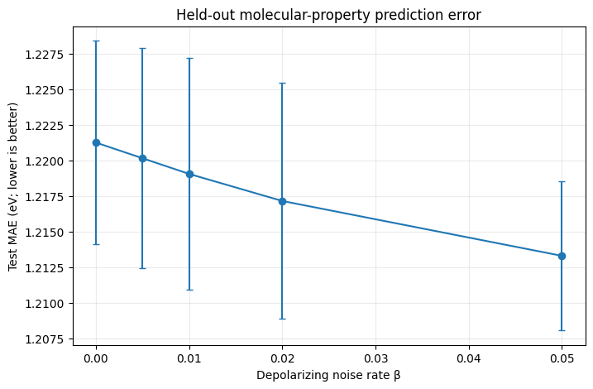
Fig.6: Generalization Gap across Noise Rate
In the Fig.6, X-axis represents the amount of simulated noise introduced into quantum operations. The graph ranges from $β=0$ with no additional depolarizing noise, to $β=0.2$ with a 20% probability per designated noisy operation. Y-axis measures the difference between the model's error on unseen molecules and its error on the molecules used for training. The blue line shows the measured generalization gap at each noise level. The dashed horizontal line represents a gap of zero.
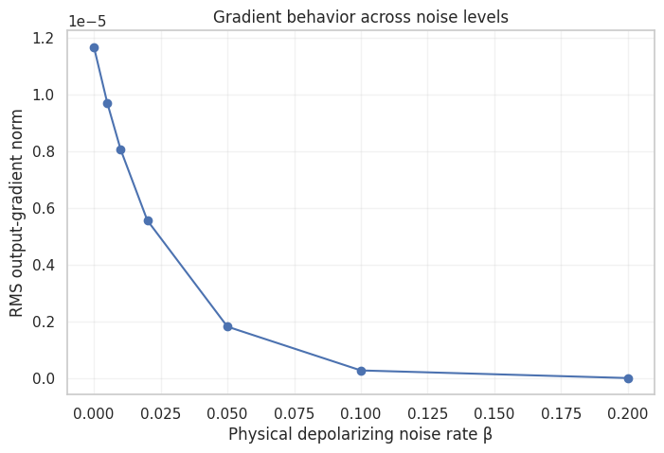
Fig.7: Gradient Behaviour Across Noise Levels.
In Fig.7, X-axis represents the amount of simulated noise added to designated quantum operations. Y-axis measures how sensitive the model's output is to changes in its adjustable parameters. The notation $1℮-5$at the top of the graph means that the displayed vertical-axis tick values must be multiplied by ${10}^{-5}$. For example, a plotted value of 1.2 corresponds to $1.2×1℮-5$. The blue circles show the measured output-gradient norm at each noise level. A downward line means that the measured output becomes less sensitive to parameter changes. The measured sensitivity decreases sharply. This offers a possible explanation for why the model becomes less effective at fitting the training molecules. The graph shows that increasing depolarizing noise sharply reduces measured output sensitivity. When combined with the previous graphs, it suggests that the smaller generalization gap may reflect weakened learning capacity rather than improved generalization.

Table 2: Gradient-Norm Proxy (Refactored For Batch Delta Sensitivity)
beta | gradient_norm
0 | 0.00001168322035
0.005 | 0.000009709967737
0.01 | 0.00000806862937
0.02 | 0.000005568270089
0.05 | 0.000001820218761
0.1 | 0.0000002758057521
0.2 | 0.000000006907544172

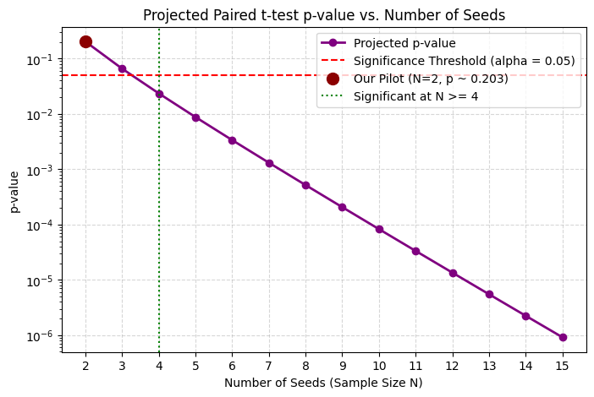
Fig.8: Trainability collapse
For your finite-noise QGNN study, The Fig.8 provides a measurable indicator of how noise changes the model's local sensitivity. In which, X-axis represents the probability of introducing depolarizing noise at each designated noisy quantum operation. measures the magnitude of the model's output sensitivity to its adjustable parameters. The vertical axis represents smaller values. The red circles show the measured gradient norm at each noise level. The arrow identifies a region where the gradient has become substantially smaller and labels the behavior as “barren-plateau-like.” The plotted gradient norm falls from approximately $1.17×{10}^{-5}$ at zero noise to $7×{10}^{-5}$ at $β=0.20$.

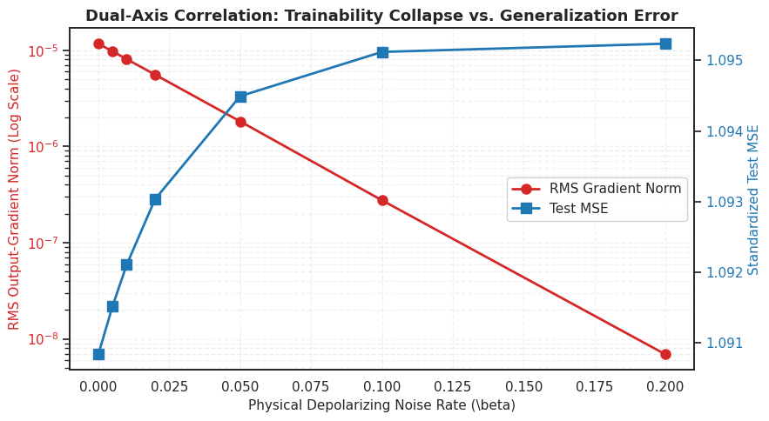
Fig.9: Dual-Axis Correlation — Trainability Collapse vs. Generalization Error

In Fig.9 X-axis, represents the simulated noise probability applied at designated quantum operations. Y-axis measures how sensitive the model's output is to changes in its trainable parameters. The red line shows a sharp reduction in gradient magnitude as noise increases. if the relevant gradients become too small, the optimizer may struggle to identify useful parameter updates.
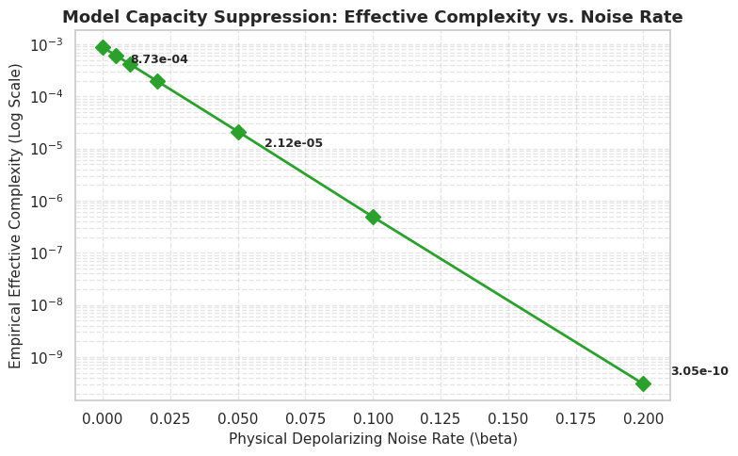
Fig.10: Model Capacity Suppression — Effective Complexity vs. Noise Rate
From the Fig.10, as noise increases, the measured gradient norm drops dramatically, while test error increases slightly. In which, X-axis indicates the probability of introducing depolarizing noise at each designated noisy quantum operation. Y-axis numerical estimate of how many independent directions the model can use to change its predictions locally. The green diamonds show the measured effective-complexity value at each noise level. The downward trend indicates that the measured quantity decreases as noise increases. The measure falls from around $8.7×{10}^{-4}$ to $3.05×{10}^{-10}$ That is approximately a 2.9-million-fold reduction between the endpoints.

$Increasing Noise\left\{\begin{matrix}Lower output sensitivity \\ Lower Measured Complexity \\ Slightly higher test error\end{matrix}\right.$ Eq. 10

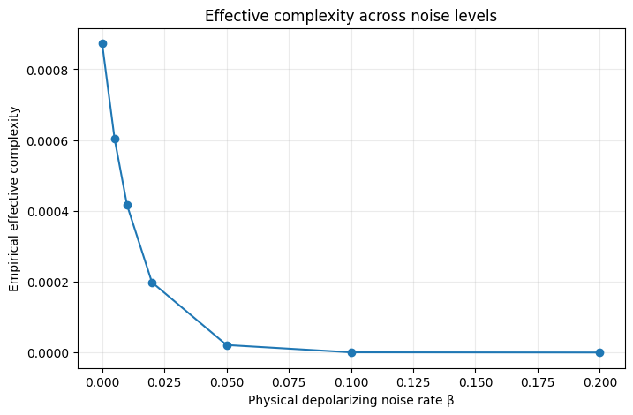
Fig.11: Effective Complexity Across Noise Levels
This Fig.11 shows how the measured effective complexity of your Quantum Graph Neural Network (QGNN) changes as more simulated quantum noise is introduced. X-axis, represents the probability of adding depolarizing noise $\left(β=0.0, 0.05,0.20 \right)$ at each designated noisy quantum operation. Higher values represent stronger simulated noise, though the overall impact also depends on the circuit. The blue circles show the measured effective-complexity value at each noise rate. The steep decline indicates that the measured quantity becomes very small as noise increases. In the tested noise range, increasing noise is associated with higher prediction error, sharply lower output sensitivity, and a large reduction in the plotted effective-complexity measure. This pattern is more consistent with possible harmful capacity suppression than beneficial regularization. That these results are reproducible across random seeds, training-set sizes and circuit depths; that the effective-complexity calculation is valid; and that the reduction in sensitivity or complexity explains the prediction degradation.
Table: Hyper Parameter Tunning
iteration | learning_rate | weight_decay | validation_mse | test_mse | best_epoch
0 | 0.01 | 0.0001 | 1.223367 | 1.333406 | 8
1 | 0.01 | 0.0010 | 1.223443 | 1.333603 | 8
2 | 0.03 | 0.0001 | 1.240002 | 1.364460 | 3
3 | 0.03 | 0.0010 | 1.239921 | 1.364416 | 3
4 | 0.10 | 0.0001 | 1.225036 | 1.378044 | 2
5 | 0.10 | 0.0010 | 1.222486 | 1.373950 | 2

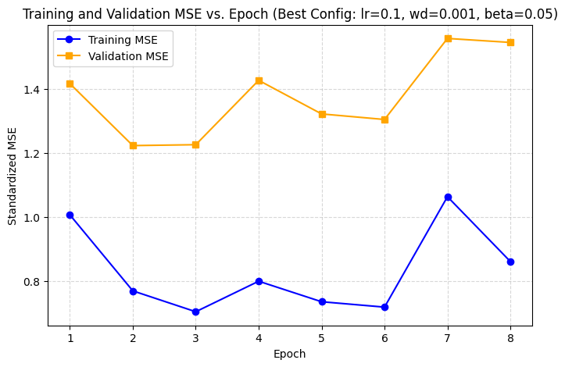

=== Performance Comparison ===
Ridge Baseline -> Test MSE (standardized): 1.3072 | Test MAE (eV): 1.1750
QGNN (beta=0.0) -> Test MSE (standardized): 1.3278 | Test MAE (eV): 1.2212
QGNN (beta=0.05)-> Test MSE (standardized): 1.3145 | Test MAE (eV): 1.2133

Conclusion and Future Work:
The present study investigated the effect of finite depolarizing noise on the prediction performance, trainability, and empirical effective complexity of a quantum graph neural network (QGNN) for molecular property prediction using the QM9 dataset. The experimental results reveal a consistent trend in which increasing noise is associated with reduced output-gradient magnitude, a substantial decline in the measured effective-complexity value, and a slight increase in both training and test errors. The training and test error analysis showed that the lowest observed test mean squared error occurred in the noiseless configuration. Although the generalization gap decreased as the noise rate increased, this reduction did not correspond to improved test prediction accuracy. Instead, the simultaneous increase in training and test errors suggests that the smaller gap may be associated with reduced fitting ability rather than beneficial regularization. The gradient analysis further demonstrated that the RMS output-gradient norm decreased by approximately three orders of magnitude across the investigated noise range. This indicates that the model's output became substantially less sensitive to changes in its trainable parameters. Similarly, the empirical effective-complexity measurement exhibited a sharp decline as noise increased, suggesting a possible reduction in the model's locally measurable predictive flexibility. The precise magnitude of this reduction requires verification of the complexity calculation and its numerical stability.
Acknowledgment:
Data Availability: In the present research work the established Bench mark dataset QM9 [1 (Brasoveanu, 2023), 2 (Borde, 2022), 3 (Liu, Z, 2021)] for molecular property prediction is used.
Link to access the dataset: https://github.com/muzabasha/FNQGNNMD. The dataset is available in the (\content\qm9_data, \content\sample_data), Link: https://data.pyg.org/datasets/qm9_v3.zip (50 MB).
Reproducibility : The Google Collab python code setup is provided for 100% reproducibility
Link to access code: https://github.com/muzabasha/FNQGNNMD. The results generated by the python code available in the repository (/content/finite_noise_qgnn_results)
References:
- Brasoveanu, A. D., Jogl, F., Welke, P., & Thiessen, M. (2023, November). Extending graph neural networks with global features. In The Second Learning on Graphs Conference.
- de Ocáriz Borde, H. S., & Barbero, F. (2022, September). Graph neural network expressivity and meta-learning for molecular property regression. In The First Learning on Graphs Conference.
- Liu, Z., Lin, L., Jia, Q., Cheng, Z., Jiang, Y., Guo, Y., & Ma, J. (2021). Transferable multilevel attention neural network for accurate prediction of quantum chemistry properties via multitask learning. Journal of chemical information and modeling, 61(3), 1066-1082.
- Zhang, Z., Jia, Z., Li, X., & Dong, Y. (2026). A Theory of Finite-Noise Optima and Generalization in Quantum Machine Learning. arXiv preprint arXiv:2608.24229.
- Chen, Y. Q., & Zhang, S. X. (2026). Superior resilience to poisoning and amenability to unlearning in quantum machine learning. Nature Communications, 17(1), 3716.
- Catak, F. O., Seo, J., & Cali, U. (2025). Trustworthy Quantum Machine Learning: A Roadmap for Reliability, Robustness, and Security in the NISQ Era. arXiv preprint arXiv:2511.02602.
- Riascos-Moreno, C., Álvarez-Meza, A. M., & Castellanos-Dominguez, G. (2025). Pulse-Driven Spin Paradigm for Noise-Aware Quantum Classification. Computers, 14(11), 475.
- Gil-Fuster, E., Eisert, J., & Bravo-Prieto, C. (2024). Understanding quantum machine learning also requires rethinking generalization. Nature Communications, 15(1), 2277.
- Hur, T., & Park, D. K. (2024). Understanding generalization in quantum machine learning with margins. arXiv preprint arXiv:2411.06919.
- Sony Priya, S., & Minu, R. I. (2026). Symmetry-constrained hybrid quantum-classical convolutional neural networks for rotation-robust face recognition. Frontiers in Artificial Intelligence, 9, 1878911.
- Razavi-Far, R., Meymani, M., Mahmoudinia, E., Vazirzade, D., Paknezhad, P., Ghasemi, F., & Haghjooei, K. (2026). Quantum adversarial machine learning: from classical adaptations to quantum-native methods. Artificial Intelligence Review.
- Seo, J. (2026). Multivariate unbounded quantum regression via log-ratio probabilities mitigating barren plateaus. IEEE Access, 14, 4877-4885.
- Gupta, R. S., Wood, C. E., Engstrom, T., Pole, J. D., & Shrapnel, S. (2024). Quantum machine learning for digital health? a systematic review. arXiv preprint arXiv:2410.02446.
- Hernicht, P. A., Sakhnenko, A., O’Meara, C., Cortiana, G., & Lorenz, J. M. (2026). Enhancing the scalability of classical surrogates for real-world quantum machine learning applications. Quantum Machine Intelligence, 8(2), 83.

