**Task 1:**

1. Install Jupyter notebook and run the first program and share the screenshot of the output.

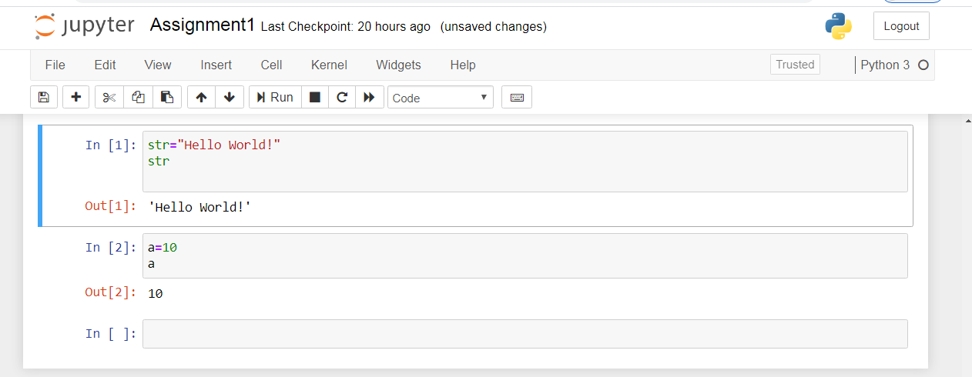

1. Write a program which will find all such numbers which are divisible by 7 but are not a multiple

of 5, between 2000 and 3200 (both included). The numbers obtained should be printed in a

comma-separated sequence on a single line.

m=[]

for i in range(2000,3200):

if i%7==0:

if i%5!=0:

m.append(i)

print(m,end=" ")

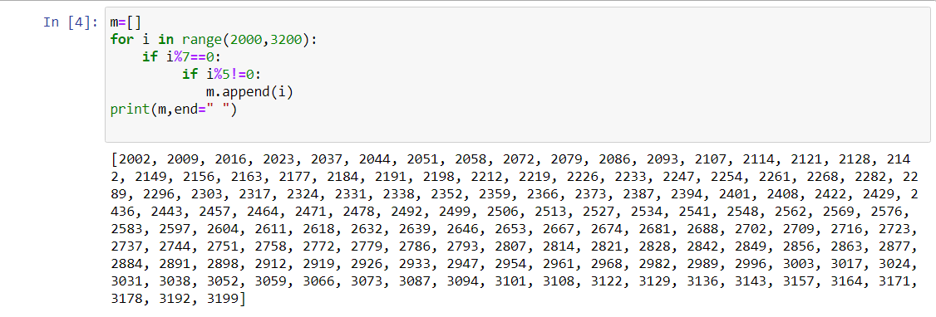

3. Write a Python program to accept the user's first and last name and then getting them printed in

the the reverse order with a space between first name and last name.

first=input("Enter first name")

last=input("Enter last name")

f=first[::-1]

l=last[::-1]

print(f, end=" ")

print(l)

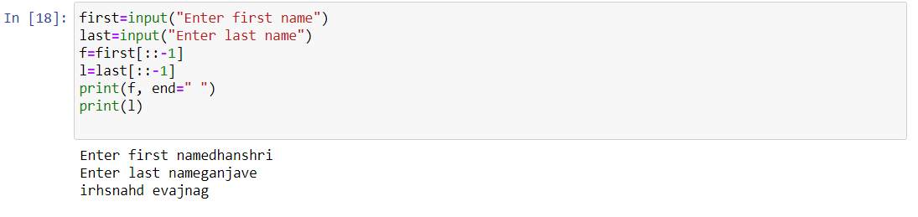

4. Write a Python program to find the volume of a sphere with diameter 12 cm.

Formula: V=4/3 * π * r 3

d=12

r=d/2

pi=3.14

v = 4/3*pi*r*r*r

print("volume of sphere:%f"%(v))

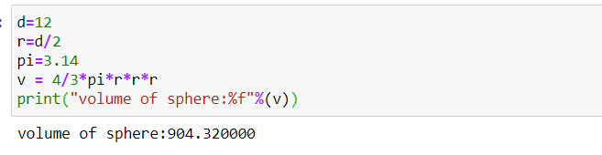

**Task 2:**

1. Write a program which accepts a sequence of comma-separated numbers from console and

generate a list.

m=[]

n=int(input("how many number you want to enter?"))

print("enter integer numbers")

for i in range(0,n):

m.append(int(input(i)))

m

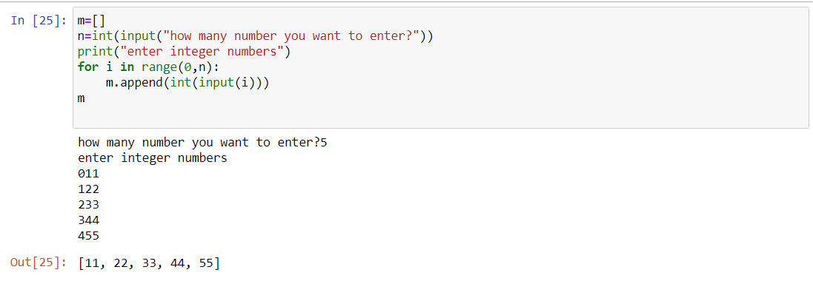

2. Create the below pattern using nested for loop in Python.

*

* *

* * *

* * * *

* * * * *

* * * *

* * *

* *

*

i,j=0,0

for i in range(0,5):

print()

for j in range(0,i+1):

print("*",end="")

for i in range(5,0,-1):

print()

for j in range(i-1,0,-1):

print("*",end="")

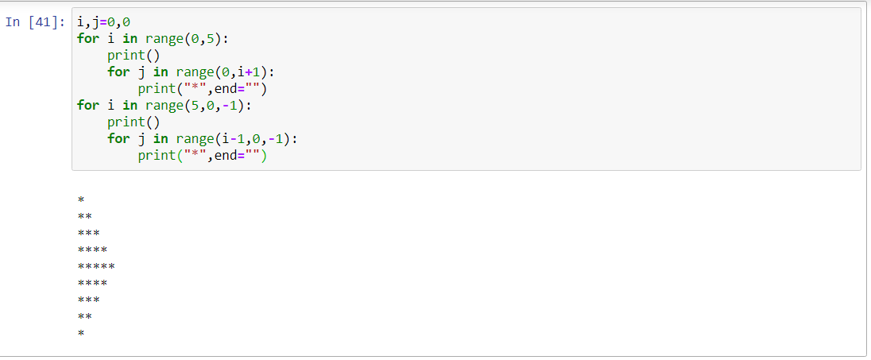

1. Write a Python program to reverse a word after accepting the input from the user.

**Sample Output:**

Input word: AcadGild

Output: dilGdacA

name=input("Input word")

name[::-1]

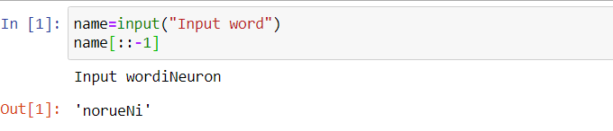

1. Write a Python Program to print the given string in the format specified in the **sample output.**

WE, THE PEOPLE OF INDIA, having solemnly resolved to constitute India into a

SOVEREIGN, SOCIALIST, SECULAR, DEMOCRATIC REPUBLIC and to secure to all

its citizens

**Sample Output:**

WE, THE PEOPLE OF INDIA,

having solemnly resolved to constitute India into a SOVEREIGN, !

SOCIALIST, SECULAR, DEMOCRATIC REPUBLIC

and to secure to all its citizens