# International and Domestic Students Fees in Institutions in British Columbia

Student Name: Minal Dhansukhlal

Student ID: 300318615

Course Name: Data Visualization

Instructors: William Tan, Bambang Sarif

## Tool Used

I used Tableau for my project, as Tableau is compatible in with different machines. Tableau is top ranked data visualization tool make interactive visualizations. Tableau can create varieties of charts such as sparkline, bar chart, line graph, scatter chart and many others. It can also be used to forecast the values for the next timeline. It allows to create Dashboards where we can connect our data with external hyperlinks. It completes a story with many functionalities that it offers.

## Dataset

I used two datasets for international fees and domestic fees for arts program in different institutions in British Columbia. These are the links to the datasets:

* <https://catalogue.data.gov.bc.ca/dataset/international-tuition-fees-at-public-post-secondary-institutions-by-economic-development-region>
* <https://catalogue.data.gov.bc.ca/dataset/tuition-fees-for-arts-programs-at-b-c-public-post-secondary-institutions>

The datasets are combined with union using Academic Year and Institution Name.

As an international student, I was interested in finding the difference between the fees paid by international student and domestic students. As international students almost pay 3 to 4 times more than students fees. The dataset contains fees in different years therefore it allowed to also analyse how much did it increased. It was categorized into sectors therefore it enabled in analysing the average fees of the sectors.

I created Years column by splitting Academic Year.

## Visualizations

The visualizations were created in regards with the sectors, institution names and years. Since it was difficult to work with value in each year I worked mostly with the average of the fees.

### Bar-in-Bar chart

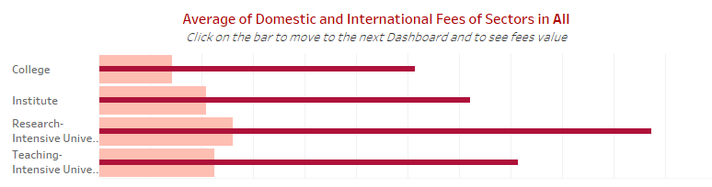

This chart contains the average value of international and domestic fees of institutions which are categorized into sectors. From the chart, the viewers can identify the very high difference in the amount of fees paid by international students and domestic students. The viewers can also identify the difference in fees paid by students in different sectors.

### Forecast Chart

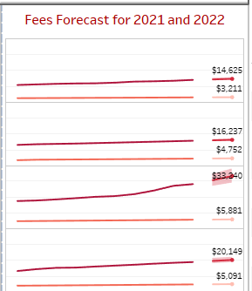

The forecast chart gives us a prediction of fees increase in 2021 and 2022. I have forecasted the values for both domestic and international students in different sectors. From the forecast, we can see that fees for Research Intensive University’s’ fee is increasing with high amount in the next 2 years. It is used to compare the forecast values in different sectors.

### Bar Chart

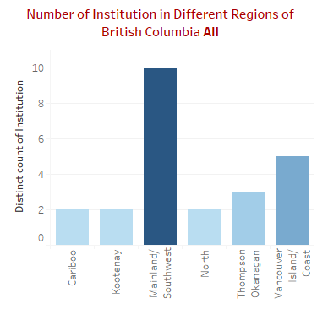

As there is economic development, I wanted to have a look on how many institutions are in different regions. The count of distinct institutions gives the us an overlook on the development regions. From the chart the viewers can identify the number of institutions in Mainland/Southwest has highest number of institutions.

### Scatter Chart

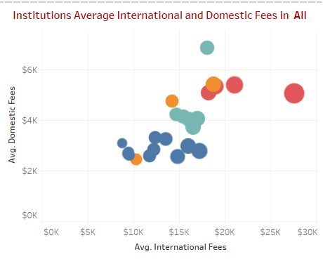

The scatter chart gives the comparison of domestic and international fees, the size of the shapes indicates the difference between international fees and domestic fees. The colors indicate different sectors. While the number of circles indicate different institutions in a sector.

### Main Dashboard

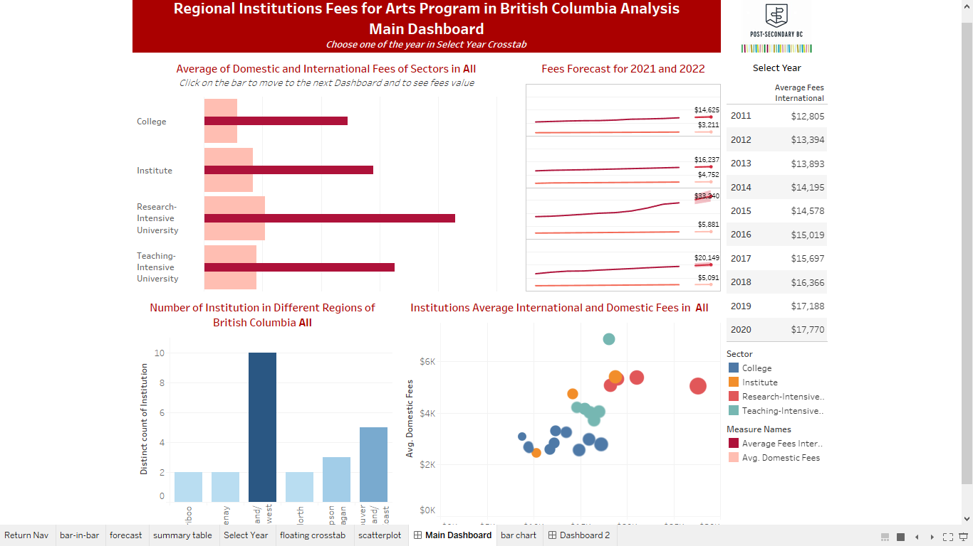

### Summary Table

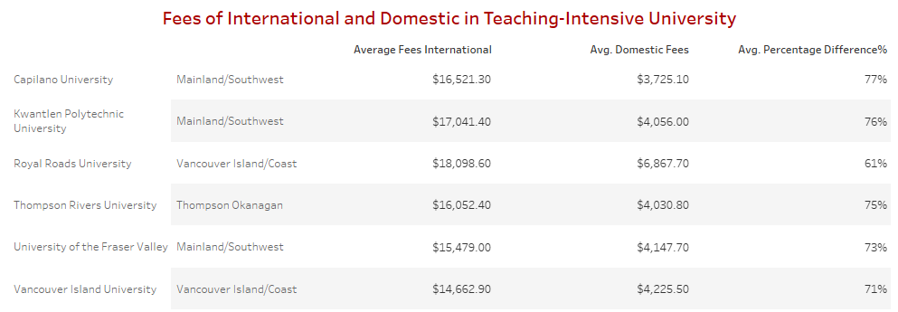

The table gives a summary of each institutions with Average of International Fees, Domestic fees, and Difference between International and Domestic fees. It also shows the regional of the institutions. The table is used to hyperlink to webpage where it searches for a particular institution where the mouse is hovering.

### Web Page

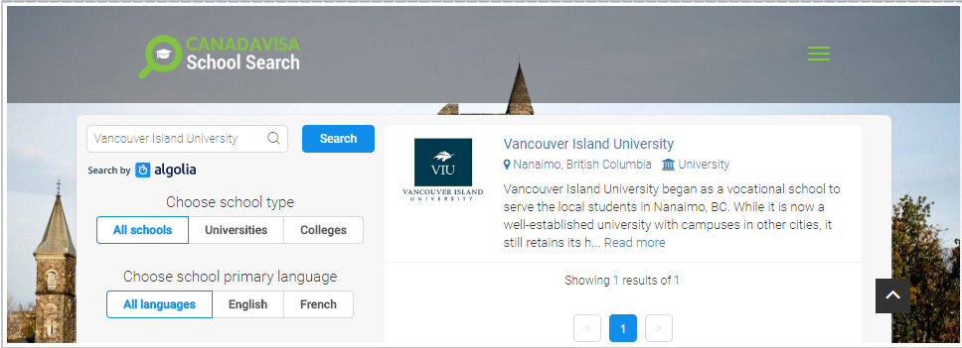

### Second Dashboard

