LabPulse
Team Knowledge Base
Everything a new team member needs to understand, explain and sell the product
No prior healthcare or laboratory background assumed
Smartronics Technology · Pune
Internal training document · version 1.0

Part 0 — Start here
Welcome. By the end of this document you will be able to walk into a hospital or a laboratory, understand what the machines in front of you actually do, explain what our product adds, and answer the questions a technical buyer will ask. You do not need a science background. Every technical term is explained the first time it appears, and there is a full glossary at the end.

How this document is organised
- The world we sell into — who the customers are and who the people in them are.
- The machines — what each instrument does, in plain language, with analogies.
- How machines fail — the concepts of wear, maintenance and FMEA.
- What LabPulse is — the monitoring layer and the digital twin layer.
- How the technology works — enough to answer questions honestly.
- The business — who pays, why, and how much.
- Selling it — discovery questions, objections, demo script, and the things we never claim.
- Glossary — every term in one place.
✓ If you only read one part before your first customer meeting, read Part 6 (the business) and Part 7 (selling it). But you will be found out quickly if you have not read Parts 2 and 3, because customers test whether you understand their machines.

Part 1 — The world we sell into
Our customers are organisations that own expensive machines which must keep working. There are four main types, and the reason they care is different in each.

1.1 The four customer types
Customer type | What they do | Why a machine failure hurts them | Who signs the cheque
Hospitals | Treat patients. Run ICUs, operating theatres, radiology. | A failed ventilator or monitor is a patient safety event, not an inconvenience. | Biomedical engineering head, with hospital administration
Diagnostic labs and chains | Run tests on blood, tissue and swabs. Produce reports. | A dead analyser means delayed reports, lost trust, and samples that may expire. | Lab director or franchise owner
Research and pharma labs | Develop and test drugs, run experiments and quality control. | A failure mid-experiment can destroy months of work and irreplaceable samples. | Lab manager, quality head, or facility head
Instrument manufacturers | Build and sell the machines, and service them under contract. | Their customers call them when anything breaks, whoever caused it. | Service business head or product head

The fourth one matters more than it looks. Manufacturers are not only potential customers, they are potential partners who can sell our product to their own installed base. Keep that in mind throughout.

1.2 The people you will meet, and what each one cares about
- Biomedical engineer (in a hospital). Responsible for keeping all medical equipment working. Usually overworked, tracking hundreds of devices on paper or a spreadsheet. Cares about: fewer emergencies, proof for audits, knowing which device is where.
- Lab manager or lab director. Runs the daily schedule of a laboratory. Cares about: will today's runs finish, are the reports going out on time, is the instrument free when I need it.
- Quality head (QA/QC). Responsible for the lab passing inspections and producing valid results. Cares about: records, calibration evidence, traceability, anything that would fail an audit.
- Service technician or engineer. The person who physically fixes machines, often employed by the manufacturer. Cares about: not being called at midnight, arriving with the right spare part the first time.
- Procurement or finance. Approves spending. Cares about: total cost, contract terms, and whether this replaces a cost they already pay.
- Nurse or lab technician (the daily user). Uses the machine. Will not log into any software you give them. This is why our instrument page opens by tapping a phone on a tag — no app, no password, no training.
Think of it like this. A hospital's biomedical department is like the maintenance team of an airline, except they have no flight data. They know a machine landed badly only when someone tells them it crashed.

Part 2 — The machines, explained simply
You do not need to operate these instruments. You need to understand what they do, what breaks, and why it matters. That is enough to hold an intelligent conversation with the person who owns them.

2.1 HPLC — the instrument you will hear about most
HPLC stands for High Performance Liquid Chromatography. Say it as ‘H-P-L-C’. It is the workhorse of pharmaceutical, chemical and diagnostic laboratories, and it is the machine our second evaluator works with.

What it is for
An HPLC answers two questions about a liquid sample: what is in it, and how much of each thing is there. A pharmaceutical company uses it to confirm a tablet contains exactly the right amount of drug and no harmful impurity. A diagnostic lab uses it to measure substances in blood. A food lab uses it to detect adulteration.

How it works
A pump pushes liquid at very high pressure through a tube packed with fine particles, called a column. A tiny amount of the sample is injected into that stream. Different substances in the sample stick to the packing material by different amounts, so they travel through at different speeds and arrive at the far end one after another. A detector at the end measures whatever comes out, and the software draws a graph.
Think of it like this. It is a race through thick mud. Everyone starts together, but heavier and stickier runners are slowed more. By the finish line they arrive spread out, one at a time — so you can identify each one by when it arrives, and count them as they cross.
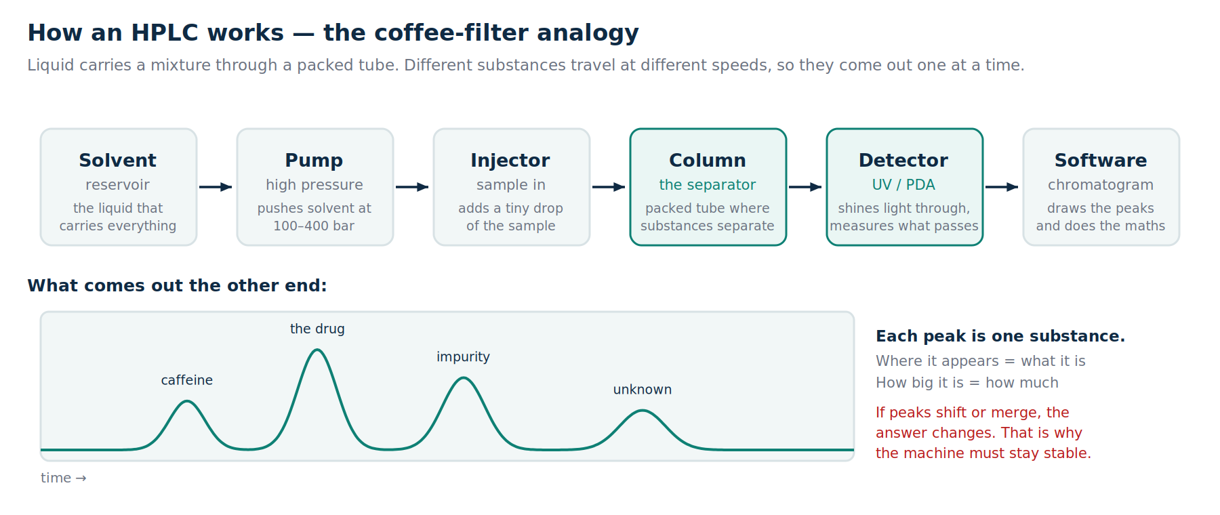
Figure 1 — the parts of an HPLC and what comes out of it

The output: a chromatogram
The graph is called a chromatogram. Each bump is called a peak, and each peak is one substance. When the peak appears tells you what the substance is; how big the peak is tells you how much there is. That is the whole idea.
These eight numbers are how a lab judges whether a result is trustworthy. You should know them, because our version compatibility product compares exactly these:
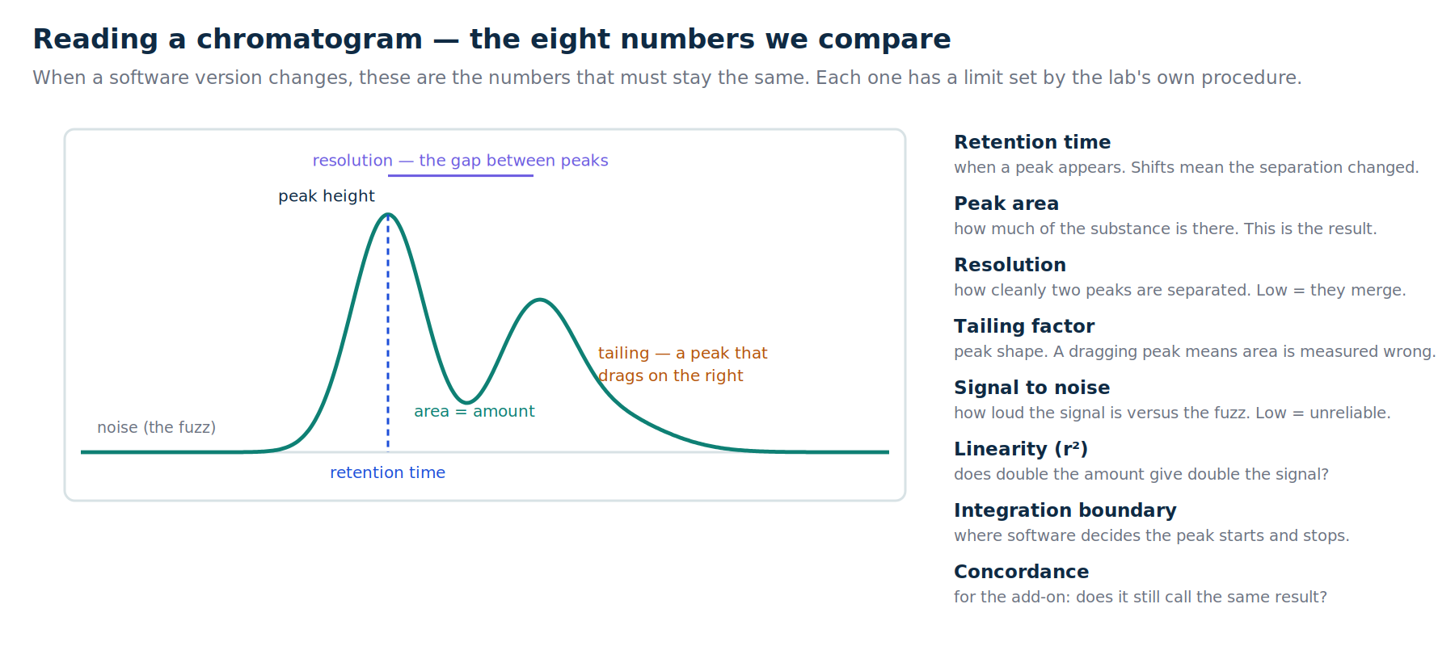
Figure 2 — the numbers a laboratory checks on every chromatogram

Why an HPLC failing is expensive
- The column wears out with use and costs anywhere from tens of thousands of rupees upward. Its life is spent by the number of injections and how harsh the samples are.
- The pump seal is a small part that fails from pressure and aggressive liquids. When it goes, the run stops and the sample may be wasted.
- The detector lamp burns out after a certain number of hours, like a bulb.
- The sample may be irreplaceable. This is the part people underestimate — see section 2.2.

2.2 The immunology profiling system, and why samples matter more than machines
An immunoassay is a test that uses antibodies — the proteins your immune system makes — to detect very specific substances in a sample. An immunology profiling system runs many such tests at once on the same sample, producing a profile: dozens of measurements describing what someone's immune system is doing. This is used in cancer research, immune disorder studies and drug trials.
These runs can last days, and the samples are usually patient samples that cannot be collected again. If the instrument fails at hour sixty of a ninety-six hour run, the loss is not a service call. It is the study.
✓ This gives us our strongest sentence in a laboratory: ‘the machine is worth lakhs; the samples inside it are worth a study that cannot be repeated.’

2.3 X-ray systems
An X-ray machine sends radiation through the body onto a detector, producing an image of what is inside. You should know its parts because a manufacturer walked our team through them, and that conversation shaped the product.
Part | What it does | How it fails
X-ray tube | Generates the X-rays. The single most expensive part, often 30 to 50% of the machine's value. | Wears out with use. Life is spent by the number of exposures, and heavy scans cost far more life than light ones.
Generator | Supplies the high voltage the tube needs. | Damaged by unstable mains power, which is common in India.
Flat panel detector | Captures the image. May be wired or wireless. | Wireless units die from battery charge cycles; all of them accumulate dead pixels and suffer drop damage.
Collimator and light beam diaphragm | Shapes the radiation to only the area being imaged, and shows the operator where it will land. | Drifts out of alignment, so the radiation field no longer matches the light field. This is a radiation safety violation.
Controller and PC | Runs the software and stores images. | Disk failures, operating system faults, and lapsed software subscriptions.

The insight from that visit, in their words: tube failure follows the number of exposures and the type of exposure. A hand X-ray is a light load. A spine or abdomen study needs far more power and stresses the tube much more. And when calibration is overdue, tube temperature climbs. This is why our product tracks counters and calibration dates before it needs any sensor at all.

2.4 The critical care machines

Ventilator
A machine that breathes for a patient who cannot breathe adequately alone. It pushes a controlled mixture of air and oxygen into the lungs at a set pressure and rate. It is life-sustaining, runs continuously for days or weeks, and sits in an oxygen-rich room where any spark or overheating is dangerous.
Think of it like this. A ventilator is a very precise air pump with a safety brain. Like any pump it has a motor, valves, filters and a battery — and all four wear out.
⚠ Ventilator and related equipment failures have caused fatal fires in Indian newborn care units on several occasions, with official inquiries repeatedly pointing to electrical short circuit or overheating. Handle this fact respectfully and factually in any conversation. Never dramatise it, never use images of an incident, and never blame a named hospital.

Patient monitor
The screen beside a hospital bed showing heart rhythm, oxygen level and blood pressure. Its most common failures are boring and constant: probes and cables wear out from repeated bending and cleaning chemicals.

Defibrillator
Delivers a controlled electric shock to restart a heart rhythm. It is used rarely but must work instantly, which makes it a special case: most defibrillator problems are discovered at the exact moment someone needs it. Most models run a self test every day and log the result. Almost nobody reads those logs. We do.

Infusion pump
Delivers fluid or medicine into a patient at a precisely controlled rate. Its failures are dosing errors, missed blockage alarms, and batteries that die during patient transport.

Nebulizer
A small compressor that turns liquid medicine into a mist a patient breathes in, commonly for asthma. Cheap, everywhere, and useful to us as a demonstration device because we can clip sensors on the outside and prove we need no access to the inside of a machine.

2.5 The laboratory machines
- Spectrometer / spectrophotometer. Shines light through a sample and measures what is absorbed, which reveals what is present and how much. A mass spectrometer instead weighs molecules, giving very precise identification.
- PCR thermocycler. Repeatedly heats and cools samples in a precise cycle to copy DNA millions of times — the machine behind COVID tests. Failure mode: the heating block drifts out of temperature, and results become unreliable without anyone noticing.
- Centrifuge. Spins samples at high speed to separate them by weight, like blood into plasma and cells. Failure mode: unbalanced load causes vibration, which destroys bearings. This is the classic spinning-machine failure and it is exactly what our motor rig demonstrates.
- Biochemistry and haematology analysers. Automated machines that run large batches of blood tests. They are the backbone of any diagnostic chain and their downtime is measured in delayed patient reports.
- CT and MRI scanners. Large imaging machines. Their failures are the most expensive in the building — a CT tube can cost tens of lakhs and an MRI helium loss can run into crores. Interestingly, the part that most often takes them down is the humble chiller or air conditioning.

Part 3 — How machines fail, and how the industry handles it

3.1 Machines do not fail suddenly
This is the single most important idea in our product. A machine that stops on Tuesday was already degrading for weeks. The bearing was getting rougher, the seal was leaking slightly more, the power supply was running a little hotter. All of that is measurable. Almost none of it is measured.
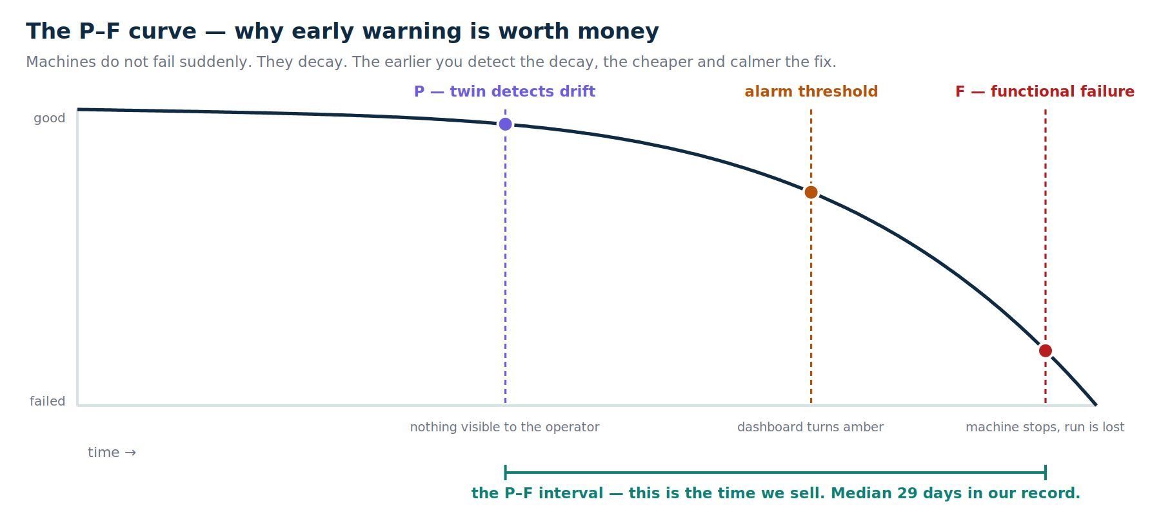
Figure 3 — the P–F curve. P is the point a problem becomes detectable; F is when the machine actually fails. The gap between them is what we sell.
The gap between P and F is called the P–F interval. A traditional alarm fires close to F, when there is little time to act. Our twin detects at P. In our own record, the median warning is 29 days — the difference between a planned service and an emergency.

3.2 The four levels of maintenance
When you meet a customer, work out which rung they are on. It tells you what to sell them and how hard the sale will be.
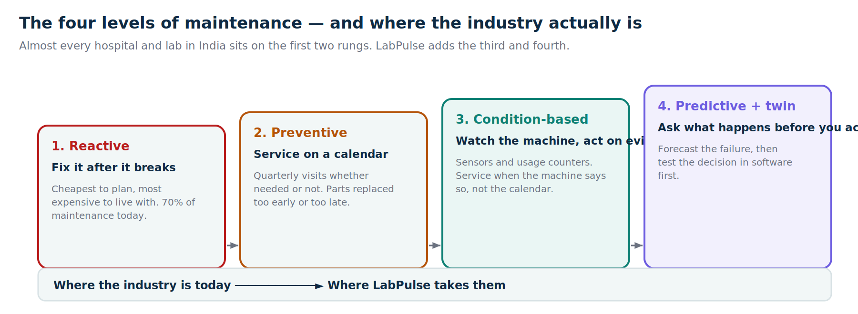
Figure 4 — almost every Indian hospital and lab sits on rungs one and two
- Reactive. Fix it when it breaks. About 70% of maintenance today. Cheapest to plan for, most expensive to live with.
- Preventive. Service on a fixed schedule, whether or not it is needed. This is what an AMC (Annual Maintenance Contract) or CMC (Comprehensive Maintenance Contract) buys: a technician visits every quarter. Between visits, nobody is watching.
- Condition-based. Watch the machine's actual condition and act on evidence. This is our monitoring layer.
- Predictive with a twin. Forecast the failure, and test the decision in software before acting. This is our twin layer.

3.3 Every machine spends its life in a different currency
Predicting failure is not one model. It is knowing what actually consumes each instrument's life, and watching that specific thing. We call it the wear currency.
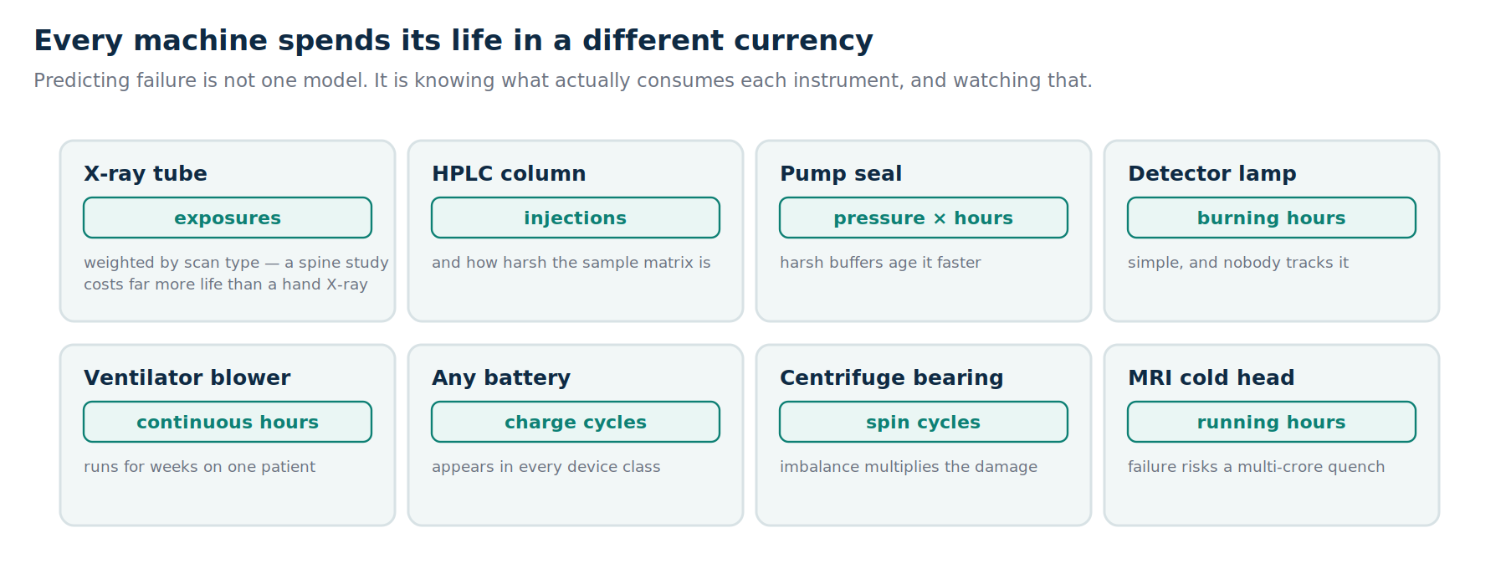
Figure 5 — what actually wears each machine out
Notice how many of these need no sensor at all. Counting exposures, injections, hours and charge cycles gets us most of the way, which is why our product can start on any instrument in a day and get smarter later.

3.4 What actually kills equipment in India
- Power quality. Voltage fluctuation, surges and short circuits are the leading documented cause of equipment fires and electronics failure.
- Heat. Machines designed for a 22°C room running in a 35°C room, with a failed air conditioner silently cooking the electronics.
- Overload. Machines rated for a certain daily workload running at two or three times that in government hospitals.
- Skipped calibration. The discipline that prevents tube burnout, dosing errors and quiet drift.
- Battery ageing and consumable expiry. Present in every device class, tracked almost nowhere.

Part 4 — FMEA, the method behind our priorities
FMEA stands for Failure Modes and Effects Analysis. It is a structured way of asking: what can go wrong, how bad would that be, how likely is it, and would we even notice? It is standard practice in manufacturing, aerospace, automotive and medical device industries. Our field visits confirmed that instrument manufacturers already use FMEA to plan spare parts.
You will hear the term in technical meetings. Knowing it well makes you credible instantly, because it signals that we did not just build software — we used the engineering method their own people use.

4.1 How an FMEA works
For each way a machine can fail, three scores are given, each from 1 to 10:
- Severity (S). How bad is the consequence? A cosmetic scratch is 1. A patient harmed is 10.
- Occurrence (O). How often does this happen? Almost never is 1. Constantly is 10.
- Detection (D). How likely are we to catch it before it causes harm? Caught easily is 1. Invisible until it fails is 10. Note this scale runs the counter-intuitive way: a high detection score is bad.
Multiply them: RPN = S × O × D. RPN stands for Risk Priority Number, and it ranges from 1 to 1000. The higher the RPN, the sooner you should do something about that failure mode.
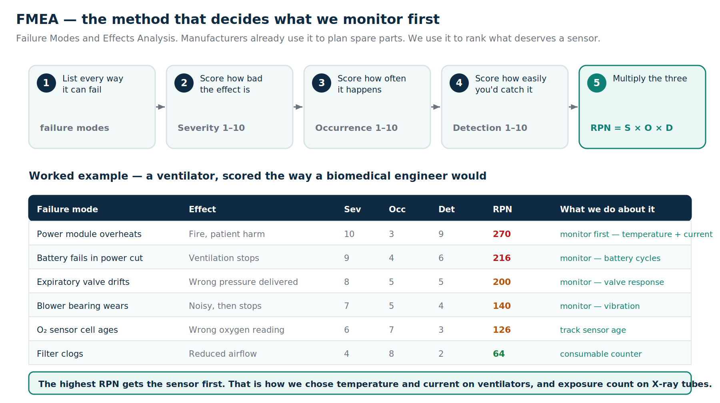
Figure 6 — how FMEA works, with a ventilator scored as a biomedical engineer would score it

4.2 How LabPulse uses FMEA — this is the part to remember
FMEA is not decoration in our product. It answers three concrete questions for us:
- What do we monitor first? We cannot sensor everything. We rank failure modes by RPN and instrument the top ones. That is exactly why we chose temperature and current on ventilators (RPN 270, the fire risk) and exposure counting on X-ray tubes, rather than something easier to measure.
- Which parts should be stocked? High RPN parts with long lead times are the ones a lab should hold in stock. Our parts and consumables view is an FMEA output in practical clothing.
- How do we attack the detection score? This is the elegant part. Severity is fixed by physics — a fire is a fire. Occurrence is hard to change without redesigning the machine. But detection is exactly what monitoring changes. A failure mode that was invisible until it happened (D = 9) becomes one caught weeks early (D = 2). The same failure mode, same severity, same frequency, but the risk number falls by more than three quarters.
✓ Say this in a technical meeting: ‘We do not reduce severity or occurrence — nobody can, without redesigning the machine. We attack detectability, and that is what collapses the RPN.’ It is true, it is precise, and it shows you understand their method.
Worked example. Ventilator power module overheating: severity 10, occurrence 3, detection 9, RPN = 270. Add a temperature and current sensor with trend alerts and detection drops to about 2. New RPN = 10 × 3 × 2 = 60. The danger did not change. Our ability to see it coming did.

Part 5 — What LabPulse actually is
Our product has two layers. Everything we have built fits into one of them, and it helps enormously to keep them straight in your head.

5.1 Layer one: monitoring — what is happening and what will happen
This is the foundation. Sensors clipped onto machines, plus their own logs and usage counters, feeding one health score per instrument. When the score falls, a ticket is raised and a WhatsApp alert goes to the named technician.
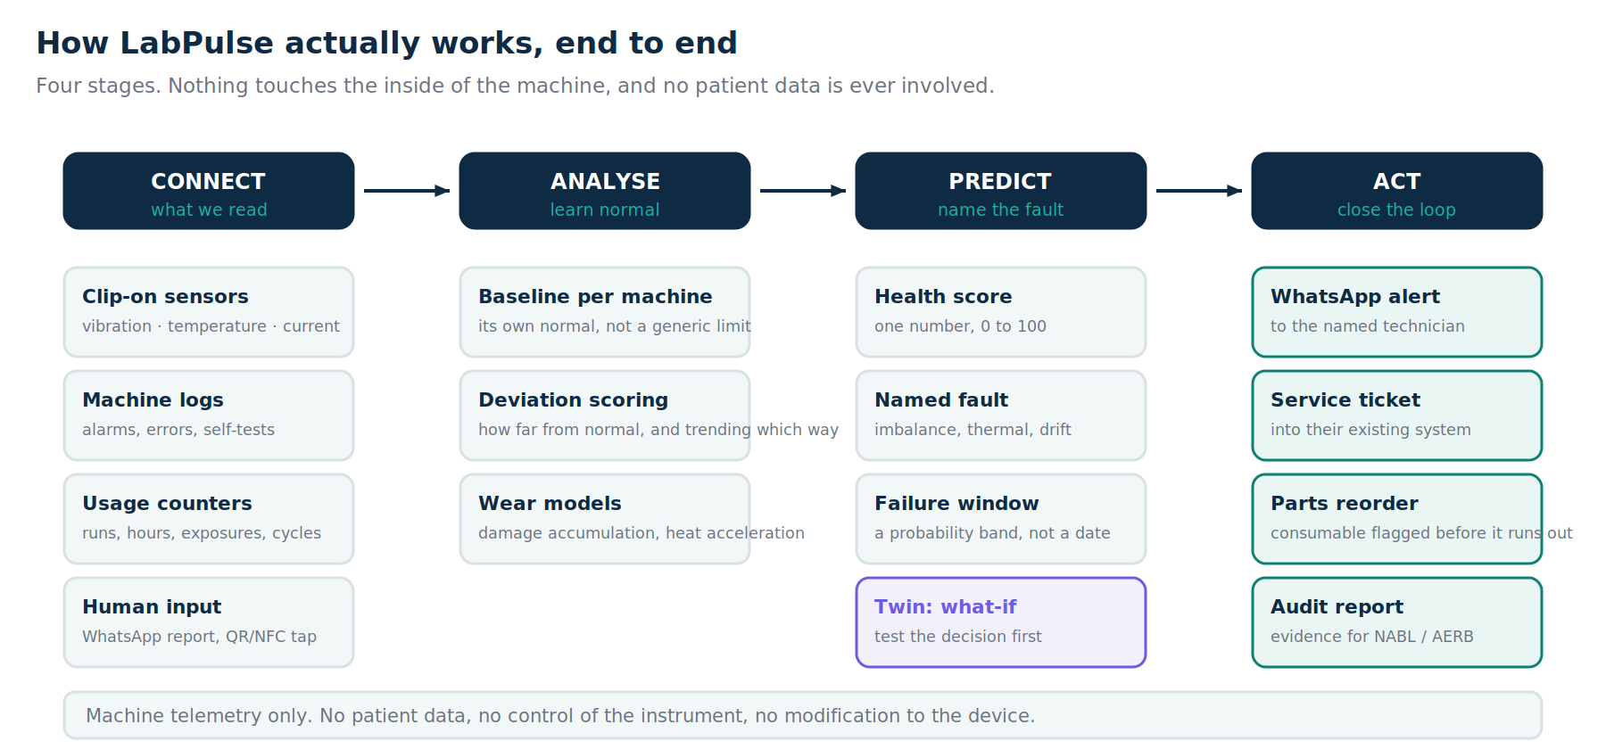
Figure 7 — the four stages, end to end

The four stages in plain words
- Connect. We read the machine from the outside: vibration, temperature and current from clip-on sensors; alarms and errors from its own logs where available; usage counters; and human reports through a WhatsApp message or a tap on the instrument's tag. We never open the machine, modify it, or void its warranty.
- Analyse. Every instrument learns its own normal within minutes. We compare against that baseline, not against a generic threshold, because a healthy machine in a hot room looks nothing like a healthy machine in a cool one.
- Predict. Deviations become a health score out of 100, plus a named cause — imbalance, thermal overload, calibration drift — and a failure window expressed as a probability range.
- Act. A WhatsApp alert, a service ticket in their existing system, a consumable flagged for reorder before it runs out, and audit evidence assembled automatically.

The two pieces users actually touch
- The instrument record page. Tap a phone on the NFC tag stuck to a machine, or scan its QR code, and its full record opens: health, install date, service history, assigned technician with one-tap call, consumables due, and two buttons — report a problem, or schedule service. Reporting a problem is two taps. This is deliberate: ward staff will never log into software, so we removed the login.
- The fleet dashboard. For the biomedical engineer or lab manager: every instrument, its health, open tickets, and what needs attention this week.

5.2 Layer two: the twin — what happens if I do this
A digital twin is a software model of a real machine that behaves the way the real one does. Ours was added after our evaluators pushed on the same weakness: monitoring tells you a machine is dying, prediction tells you when, but neither of them changes a decision. The twin does, because you can test the decision in software before committing anything real.
Think of it like this. Monitoring is the fuel gauge. Prediction is the warning light. The twin is the route planner that says: with this much fuel, this load and this route, you will run dry near Lonavala — so refuel at Talegaon, or take a lighter load.

The three questions
The question | Layer that answers it | What the customer does with it
What is happening right now? | Monitoring | Watches a dashboard. Useful, but nothing changes today because of it.
What will happen next? | Prediction | Panics earlier. Better than panicking late, but still reactive.
What happens if I do this? | The twin | Tests the decision first, and changes the plan before money or samples are committed.

The three tiers, and why each exists
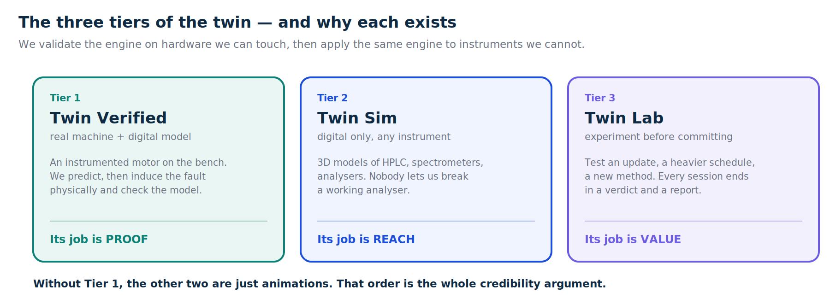
Figure 8 — the credibility argument in one picture
Remember the order, because it is the whole argument: we validate the engine on hardware we can touch, then apply the same engine to instruments we cannot. Without Tier 1, the other two are animations.

5.3 What the twin can be asked
- Can I take this vendor update? Covered in detail in section 5.4.
- Will this run actually finish? For a long run with irreplaceable samples: the probability of completing, the component most likely to stop it, and how much that probability improves if a part is replaced first.
- What does this method change cost me? Change the flow rate, the buffer or the schedule, and see how much column, seal and lamp life it consumes.
- Can one instrument carry this campaign, or do I need two? Both plans projected side by side with failure dates and total cost.

5.4 The version compatibility sandbox
This came directly from our second evaluation and it is worth understanding properly, because it is the most concrete thing we have built.

The problem, in plain words
Instruments run software, and often a third-party add-on module from another vendor sits on top. When that vendor ships a new version, results can shift slightly — a peak measured a little differently, a classification called differently. In a regulated laboratory you cannot discover that in production, because reports have already gone out. Validating properly means physically re-running known samples on every instrument: days of machine time, columns, and reference material. So labs either skip it, or freeze the version for a year and fall behind.

What we do instead
- Take the lab's archived runs from the currently approved version. This is called the golden set, and it already exists in their records.
- Replay the candidate version against those same inputs entirely in software. No instrument time, no columns, no sample consumed.
- Compare the eight metrics from Figure 2 against the laboratory's own acceptance limits — not limits we invented.
- Return a verdict per instrument, not per version. This is the key insight: compatibility depends on the machine's configuration. The same update can be perfectly safe on one instrument and wrong on the next.
- Pin the failing instruments to the previous version, and generate the evidence to send the vendor — every failing metric against its limit.
✓ The sentence that lands: ‘the failures are not random — all of them share one configuration.’ Telling a customer which instruments are affected and why is intelligence. Telling them the update failed is just an error message.

5.5 The two evidence views
- Time machine. Drag any instrument back through ninety days of stored data and watch the failure develop. Stop on the day drift began and you see a machine that looked completely normal to its operator, while the twin was already counting down. The prediction it made that day is shown next to what actually happened.
- Accuracy scoreboard. Every prediction we have made, with the outcome — including the ones we got wrong, why, and what we changed. We report a probability range rather than a single date, so we also report how often reality landed inside it: 79%, against a target of 80%.
✓ Nobody publishes their own error rate. That is exactly why we do. Volunteering four failures is what makes the thirteen successes believable, and it will disarm the most skeptical person in any room.

Part 6 — How the technology works
You will not be asked to write code. You will be asked how it works, and a vague answer loses the room. Here is enough to answer honestly.

6.1 The hardware
- An ESP32 is a small, cheap microcontroller with built-in WiFi — the brain of our sensor node, costing a few hundred rupees.
- An accelerometer measures vibration. A rough bearing or an unbalanced rotor shows up here first.
- A temperature probe taped to the housing catches thermal problems, including the ones that become fires.
- A current sensor measures electrical draw. Rising current at unchanged workload means the machine is working harder than it should — one of the most useful signals we have.
- NFC tags and QR codes identify each instrument. NFC is the same technology as a contactless card: tap a phone and a page opens.

6.2 The models, in plain language
- Baseline learning. Each machine learns its own normal, so we compare it against itself rather than a generic limit.
- Cumulative damage. Wear adds up. Each hour of use spends a fraction of a component's life, and heavier use spends more.
- Arrhenius temperature acceleration. An established chemistry principle: reactions roughly double in rate for every 10°C rise. In practice, a hot machine ages faster, and the model accounts for that.
- Weibull distribution. A standard statistical curve used in reliability engineering to describe when things fail. It converts a wear state into a probability of failure.
- Monte Carlo simulation. Run the scenario several hundred times with slightly different assumptions, and see the spread of outcomes. This is why we report a range instead of a single date.
- P10, P50, P90. The range boundaries. P50 is the most likely date; P10 and P90 are the early and late edges. About 80% of real outcomes should land between P10 and P90 — and we publish whether they do.
⚠ Never quote an accuracy percentage we have not measured. The correct answer is: seeded from manufacturer wear data, calibrated per instrument from live readings, reported as a probability band, and validated against our own instrumented hardware. Then offer to show the scoreboard.

Part 7 — The business

7.1 How we charge
Item | Figure
Price per instrument, per month | ₹10,000
Average instruments per client | 50
Revenue per client, per month | ₹5 lakh
Revenue per client, per year | ₹60 lakh
At 30 clients — annual recurring revenue | ₹18 crore
At 50 clients — annual recurring revenue | ₹30 crore

The market sizing we use: roughly 185,000 relevant facilities in the region as the total market, about 50,000 that are instrument-intensive as the realistic addressable market, and around 6,000 as our reachable first market. Learn these numbers, and be honest that they are estimates.

7.2 Why an instrument manufacturer wants this
A manufacturer does not primarily earn from selling the box. The durable revenue is service contracts and consumables. Our twin serves both:
- It forecasts consumables before they are consumed. Column, seal and lamp life are spent by workload, not by time. Tell the twin the plan and it tells you the parts. The lab stops running out mid-campaign; the manufacturer gets a demand signal per instrument instead of a reorder phone call.
- It defends the service contract. Renewal stops being an argument about visit counts and becomes a document: here is what your fleet will need next year, here is the risk if you skip it.
- It protects their brand. When a third-party add-on breaks a workflow, the customer calls the instrument maker regardless of whose software changed. Our sandbox isolates whose change caused what.
✓ The line to remember: ‘a twin that forecasts wear is also a twin that forecasts consumable demand. The same subscription that protects your customer's uptime forecasts your parts revenue.’

7.3 Where we came from
Useful context for any customer conversation: our parent company already sells maintenance management software to Indian manufacturers, with paying customers today. LabPulse is the predictive layer built on top of a product line that already exists. We are not a team attempting our first product.

Part 8 — Selling it

8.1 Discovery questions — ask these before you pitch anything
- How do you track instrument service today? (Listen for: register, spreadsheet, nothing.)
- What happened the last time a critical instrument failed unexpectedly? What did it cost you?
- Who gets called when something fails, and how do they find out?
- How do you decide when to replace a column, a filter, a battery?
- When a software update arrives for an instrument, what do you do with it today?
- What do you have to produce when an auditor or inspector visits?
Their answers become your pitch, in their words. A salesperson who repeats the customer's own sentence back to them with a solution attached wins more often than one who recites features.

8.2 Common objections and honest answers
What they say | What you say
The manufacturer already monitors our machines. | They monitor their own brand only. A hospital or lab is multi-brand, and nobody sees the whole floor. We are brand-neutral — and manufacturers are potential partners for us, not competitors.
Our machines have no data port. | We do not need one. Clip-on sensors, usage counters and human reports through WhatsApp all work without touching the machine.
Is this a medical device? Do we need approval? | No. It monitors machine health only. It never touches the patient and never controls the instrument. That is precisely why it can be deployed without device clearance.
What about our patient data? | We never see it. We read machine telemetry — vibration, temperature, current, usage counts. On-premise deployment is available if data leaving the site is a concern.
How accurate is it? | Seeded from manufacturer wear parameters, calibrated per instrument, and reported as a probability range rather than a date. Here is the scoreboard of every prediction we have made, including the failures.
We already pay for an AMC. | This does not replace it. It makes it work — the visits become evidence-based, and the failures between visits stop being invisible.
Our staff will not use another system. | They will not have to log into anything. They tap a phone on the machine and the page opens, and reporting a problem is two taps.

8.3 Demonstrating it
Run the demo in this order. It builds from proof to value, which is the direction that convinces technical people.
- Start with the live rig already running and healthy. Never boot hardware in front of an audience.
- Induce a fault physically. Let them watch the health score fall and the WhatsApp alert arrive.
- Tap the NFC tag to show what a nurse or technician actually sees.
- Switch to the twin, and let them set the scenario. Ownership of the inputs is what makes the output credible.
- Show the version sandbox if they own instruments running third-party software.
- Finish on the accuracy scoreboard, including the failures.

8.4 Things we never say
⚠ Never call LabPulse a medical device, or imply it has any role in patient care, diagnosis or treatment. It is a maintenance and asset-intelligence system. This distinction is legal, not stylistic.
⚠ Never quote an accuracy figure we have not measured, never invent a customer, and never present the synthetic demo data as real customer history. Say plainly that the golden sets and ninety-day histories in the demos are synthetic while the engine and reports are real. Then make it the ask: one set of archived runs from a real instrument family is what turns this into a validated product.
⚠ Never dramatise a fatal incident. State the facts, pause, and move to what could have been detected. No incident photographs, no named hospital blamed.

Part 9 — Glossary

Instruments and laboratory science
HPLC — High Performance Liquid Chromatography. Separates a mixture so each substance can be identified and measured.
Chromatogram — The graph an HPLC produces. Each peak is one substance.
Column — The packed tube inside an HPLC where separation happens. A consumable, and an expensive one.
Mobile phase / buffer — The liquid that carries the sample through the column. Harsher chemistry wears parts faster.
Injection — One sample introduced into the instrument. The wear currency for a column.
Retention time — When a peak appears. Identifies the substance.
Peak area — The size of a peak. Tells you how much of the substance is present.
Resolution — How cleanly two neighbouring peaks are separated. If it falls too low, they merge and the result is wrong.
Tailing factor — Peak shape. A peak that drags to one side causes the amount to be measured incorrectly.
Signal to noise — How strong the real signal is compared with background fuzz. Low values mean unreliable results.
Linearity (r²) — Whether doubling the amount doubles the signal. Should be very close to 1.
Integration boundary — Where the software decides a peak starts and ends. Move it and the measured amount changes.
Assay — A test that measures a specific substance.
Immunoassay — A test that uses antibodies to detect something very specific.
Immunology profiling — Running many immune measurements on one sample to build a profile. Often multi-day, with irreplaceable samples.
Concordance — Agreement between two sets of results. If a software update still calls the same result, concordance is high.
Spectrometer — Measures how a sample interacts with light, revealing what is present.
Mass spectrometer — Weighs molecules to identify them very precisely.
PCR thermocycler — Heats and cools samples in cycles to copy DNA. The machine behind COVID testing.
Centrifuge — Spins samples to separate them by weight.
QC (quality control) — Running known samples regularly to prove the instrument is still giving correct answers.
Calibration — Adjusting an instrument against a known reference so its readings are correct.

Medical equipment
Ventilator — Breathes for a patient who cannot breathe adequately. Life-sustaining.
Patient monitor — Bedside screen showing heart rhythm, oxygen and blood pressure.
Defibrillator / AED — Delivers a shock to restart heart rhythm. Rarely used, must work instantly.
Infusion pump — Delivers fluid or medicine at a precisely controlled rate.
Nebulizer — Turns liquid medicine into a breathable mist.
NICU / SNCU — Newborn intensive care units.
ICU / OT — Intensive care unit / operating theatre.
Flat panel detector — The digital image sensor in an X-ray system.
Collimator — Shapes the X-ray beam so radiation only reaches the intended area.

Maintenance and reliability
Preventive maintenance (PM) — Scheduled servicing, done on a calendar.
Condition-based maintenance — Servicing based on the machine's measured condition.
Predictive maintenance — Forecasting failure before it happens and acting in advance.
AMC / CMC — Annual or Comprehensive Maintenance Contract. What most facilities buy today: scheduled visits.
P–F interval — The time between a problem becoming detectable and the machine actually failing. The window we sell.
Remaining useful life (RUL) — How much life a component has left before it should be replaced.
MTBF / MTTR — Mean time between failures / mean time to repair. Standard reliability measures.
Uptime — The percentage of time equipment is available for use.
Wear currency — Our term for whatever actually consumes a machine's life — exposures, injections, hours, cycles.
FMEA — Failure Modes and Effects Analysis. A structured method for ranking what can go wrong.
RPN — Risk Priority Number. Severity × Occurrence × Detection, from 1 to 1000.
Digital twin — A software model of a real machine that behaves the way the real one does.
Golden set — Archived runs from an approved software version, used as the reference for comparison.

Regulation and systems
NABL — National Accreditation Board for Testing and Calibration Laboratories. Accredits Indian labs and requires calibration and QC records — records we automate.
CDSCO — Central Drugs Standard Control Organisation. India's medical device and drug regulator. Manufacturers hold licences and maintain a device file including post-market surveillance.
AERB — Atomic Energy Regulatory Board. Governs radiation safety, including periodic quality assurance testing of X-ray and CT systems.
GLP / GMP — Good Laboratory Practice / Good Manufacturing Practice. Quality frameworks labs and manufacturers work under.
LIMS — Laboratory Information Management System. Software that tracks samples, tests and results.
ERP — Enterprise Resource Planning. The organisation's core business software.
ITSM — IT Service Management. The ticketing system many facilities already use — we create tickets inside it rather than replacing it.
Post-market surveillance — A manufacturer's legal duty to track how their device performs in the field after sale. They need field failure data, and mostly cannot get it — which is an opportunity for us.

Part 10 — One-page cheat sheet

What we do, in one sentence
LabPulse watches expensive machines in hospitals and laboratories, warns weeks before they fail, and lets a lab test a decision in software before committing real samples, money or schedule.

The three questions
What is happening now (monitoring) · What will happen next (prediction) · What happens if I do this (the twin). Only the third changes what somebody does.

Five numbers to know
- ₹25–65 lakh — cost of one day of critical equipment downtime
- 70% — share of maintenance that happens only after failure
- 29 days — our median warning before an event
- ₹10,000 per instrument per month — our price
- 30 clients = ₹18 crore recurring revenue — we do not need scale to be a real business

Five sentences that work
- “The machine already knows. Nobody is listening.”
- “We do not open the machine, modify it, or void anything.”
- “It is not a medical device — it never touches the patient. That is why it can be deployed tomorrow.”
- “We attack detectability. That is what collapses the risk number.”
- “Here is every prediction we made, including the four we got wrong.”

Three things never to say
- Never imply it is a medical device or has a role in patient care.
- Never quote an accuracy number we have not measured, or present demo data as real customer history.
- Never dramatise a fatal incident, or blame a named hospital.

If you are asked something you do not know
Say so, and offer to find out. In this industry, a confident wrong answer ends the relationship. ‘I do not know, let me check with our engineering side and come back to you today’ costs nothing and builds trust.
— LabPulse Team Knowledge Base · Smartronics Technology · version 1.0 —

