A major project report on

SECURE SENTINEL – A FACIAL RECOGNITION SECURITY SYSTEM

Submitted in partial fulfilment of the requirement for the award of degree of
BACHELOR OF TECHNOLOGY
IN
CSE (CYBER SECURITY)
By
E. LAVANYA -215U1A6216
CH. DHANUNJAY -215U1A6212
P. PAVANI -215U1A6249
G. JETIN SAIRAM -215U1A6220
G. MADHUKAR -215U1A6222

Under the Esteemed Guidance of Mr. Krishna Reddy
(Professor)


DEPARTMENT OF CSE (CYBER SECURITY)
AVN INSTITUTE OF ENGINEERING AND TECHNOLOGY
(AFFILIATED TO JNTU UNIVERSITY, HYDERABAD)
PATELGUDA, KOHEDA ROAD, IBRAHIMPATNAM,505510 2024-2025

CERTIFICATE

This is to certify that the project work entitled SECURE SENTINEL – A FACIAL RECOGNTION SECURITY SYSTEM WEB APPLICATION submitted by
E. LAVANYA (215U1A6216), CH. DHANUNJAY (215U1A5212) P. PAVANI (215U1A6249), G. JETINSAIRAM (215U1A6220), G. MADHUKAR (215U1A6222) in partial fulfilment of the requirements for the award of the degree of Bachelor of Technology in Computer Science and Engineering (Cyber Security) to the Jawaharlal Nehru Technological University. This is a record of the Bonafide work carried out by them under my guidance and supervision during the academic year 2024-2025. The results embodied in this project report have not been submitted to any other University or Institute for the award of degree or diploma.

Internal Guide Project Coordinator HOD
Mr. K. Krishna Reddy Mr. K. Krishna Reddy _{Dr. Indira Priyadarshini}

(Professor) ^{(Professor)} (Professor)

External Examiner

ACKNOWLEDGMENT

First of all, we would like to thank everyone who have guided us, I have been able to successfully complete our project SECURE SENTINEL – A FACIAL RECOGNTION SECURITY SYSTEM WEB APPLICATION
We would like to express our deep sense of gratitude to the AVN Institute of Engineering and Technology for giving us the opportunity to take up the project work. We express my sincere thanks to Our Principal Dr. NAGESWARA REDDY Sir, for his Administration, that made us enjoy wonderful environment of education.
We gratefully acknowledge the inspiring guidance, encouragement and continuous support of DR. P. INDIRA PRIYADARSINI, HOD of CSE (CYBER SECURITY). Her helpful suggestions and constant encouragement have gone a long way in the completion of this dissertation. It was a pleasure working under her alert, human and technical supervision.
We express our deep gratitude towards our internal guide MR. KRISHNA REDDY Sir, Professor for His guidance, comments and encouragement during the course of the Present work.
We are equally thankful to the staff of Computer Science and Engineering Department and friends who directly or indirectly helped us in completing this project work.

E. LAVANYA -215U1A6216
CH. DHANUNJAY -215U1A6212
P. PAVANI -215U1A6249
G. JETIN SAIRAM -215U1A6220
G. MADHUKAR -215U1A6222

DECLARATION

We declare that the work reported in the entitled is a record of the work done by us in the Department of CSE (CYBER SECURITY), AVN Institute of Engineering and Technology, Hyderabad.
No part of the thesis is copied from books/journals/Internet and wherever referred, the same has been duly acknowledged in the text. The reported data are based on the project work done entirely by us and not copied from any other source.

E. LAVANYA -215U1A6216
CH. DHANUNJAY -215U1A6212
P. PAVANI -215U1A6249
G. JETIN SAIRAM -215U1A6220
G. MADHUKAR -215U1A6222

ABSTRACT

The project "Facial Recognition Security System App " is designed to enhance mobile device security through continuous facial monitoring. The app constantly scans for faces using the device’s front camera and cross-references detected faces against a database of registered users. When an unregistered face is detected, the system immediately locks the device screen to prevent unauthorized access. Simultaneously, the app covertly captures an image of the unregistered individual and securely sends this photo to a predefined email address, enabling the device owner to be promptly alerted of potential security breaches. This solution combines real-time biometric authentication with stealthy intrusion detection, aiming to provide robust, automated protection devices against unauthorized use.

At the heart of this Web application is its advanced facial recognition system, which employs sophisticated algorithms to accurately identify registered users. Upon setup, users can easily register their faces and those of other authorized individuals. The Web application continuously scans the environment in real-time, granting access only to recognized faces. If an unregistered face is detected, the Web application responds immediately by shutting down the device, effectively preventing unauthorized access to sensitive information. By automatically shutting down the device when it is not in use, the Web application ensures that sensitive data remains secure, even in the absence of the authorized user.

User privacy is a top priority for this Web application. It does not store facial data frames on external servers, ensuring that biometric information remains confidential. All recognition processes occur locally on the device, minimizing the risk of data breaches associated with cloud storage. The Web application also boasts a user-friendly interface, allowing users to manage registered faces and adjust settings easily. This flexibility is essential in dynamic environments, such as collaborative workspaces, where team members may change frequently.

In summary, this facial recognition security Web application offers a robust solution for protecting devices and sensitive information. With its real-time monitoring, auto shutdown feature, and commitment to user privacy, it provides a reliable and effective means of safeguarding personal and professional data in an increasingly digital world.

TABLE OF CONTENTS
S.NO | CONTENTS | P.NO
1 | INTRODUCTION | 01
2 | LITERATURE SURVEY | 04
3 | THEORETICAL BACKGROUND  3.1 INTRODUCTION  3.1.1 WHAT IS OPENCV  3.1.2 THE ORIGIN OF OPENCV  3.2. INTRODUCTION  3.2.1 FACIAL RECOGNITION TECHOLOGY  3.2.2 FACIAL RECOGNITION WITH WEBCAM  3.2.3 KEY TECHNOLOGIES  3.3 INTRODUCTION  3.3.1 FEATURES OF JAVA  3.3.2 DEVELOPMENT OF JAVA  3.4 INTRODUCTION  3.4.1 FEATURES OF ANDRIOD STUDIO  3.4.2 DEVELOPMENT OF ANDRIOD STUDIO | 08
4 | SYSTEM ANALYSIS  4.1 EXISTING SYSTEM  4.1.1 DISADVANTAGES OF EXISTING SYSTEM  4.2 PROPOSED SYSTEM  4.2.1 ADVANTAGES OF PROPOSED SYSTEM | 16
5 | SYSTEM DESIGN  5.1 INTRODUCTION  5.2 MODULES  5.2.1 PRE-PROCESSING  5.3 SYSTEM ARCHITECTURE  5.4 UML DIAGRAMS  5.4.1 USE-CASE DIAGRAM  5.4.2 SEQUENCE DIAGRAM  5.4.3 CLASS DIAGRAM  5.4.4 ACTIVITY DIAGRAM | 23
6 | SYSTEM REQUIREMENTS  6.1 SYSTEM REQUIREMENTS  6.1.1 HARDWARE REQUIREMENTS  6.1.2 SOFTWARE REQUIREMENTS | 36
7 | SYSTEM IMPLEMENTATION  7.1 INPUT DESIGN  7.2 OUTPUT DESIGN  7.3. INPUT AND OUTPUT DESIGN  7.4. PHYSICAL DESIGN  7.5. LOGICAL DESIGN  7.6 CODE | 38
8 | SYSTEM TESTING  8.1 INTRODUCTION  8.2 LEVEL OF TESTING  8.2.1 BLACK BOX TESTING  8.2.2 WHITE BOX TESTING | 57
9 | OUTPUT SCREENS | 61
10 | CONCLUSION AND FUTURE WORK | 65
11 | REFERENCES | 67

LIST OF FIGURES

S.NO | FIGURES | P.NO
1 | 5.3 SYSTEM ARCHITECTURE
2 | 5.4 UML DIAGRAM
3 | 5.4.1 USE CASE DIAGRAM | 29
3 | 5.4.2 SEQUENCE DIAGRAM | 30
3 | 5.4.3 CLASS DIAGRAM | 31
3 | 5.4.4 ACTIVITY DIAGRAM | 32
4 | 9.1 MAIN UI WINDOW | 61
4 | 9.2 WARNING WINDOW | 62
4 | 9.3 MANAGE FACES WINDOW (Empty) | 63
4 | 9.4 MAIN UI WINDOW | 64
4 | 9.5 FACE CAPTURE WINDOW | 65

CHAPTER-1 INTRODUCTION
In today's digital age, mobile devices have become an integral part of our daily lives. From storing personal photos and financial information to accessing emails and business Web applications, smartphones contain vast amounts of sensitive data. As a result, ensuring the security and privacy of mobile devices has become more important than ever.
Traditional security measures such as passwords, PINs, or pattern locks, while widely used, have notable drawbacks. They can be forgotten, guessed, or stolen, leading to potential breaches in security. Biometric authentication systems offer a promising alternative by providing a seamless and secure method of identity verification. Among various biometric methods, facial recognition stands out due to its non-intrusive nature, ease of use, and growing adoption across devices and platforms.
This project, titled "Secure Sentinel – A Facial Recognition Security System ", aims to develop an Web-based mobile security Web application that uses facial recognition technology to authenticate users. By leveraging modern machine learning techniques and device’s built-in camera functionality, this system captures and analyses facial features in real-time to verify user identity.
The proposed system not only enhances security but also improves user experience by replacing or supplementing traditional authentication methods. It ensures that only authorized users can access the protected content, Web applications, or features on a mobile device. The system operates locally on the device, offering faster response times and ensuring user privacy without relying on external servers.
Secure Sentinel represents a step forward in mobile security by combining the power of artificial intelligence with the convenience of biometric authentication, offering users a smart, efficient, and secure way to protect their digital lives.
The process begins with the webcam capturing a live image of a person's face. Advanced algorithms then detect facial features, extract relevant data points, and compare them to stored images in a database. This multi-step process includes face detection, alignment, feature extraction, and matching, all of which are powered by machine learning techniques that have significantly improved the accuracy and efficiency of these systems.
Webcams are particularly advantageous due to their widespread availability and affordability, allowing for easy integration into existing security infrastructures. This accessibility enables a broader range of Web applications, from home security systems to large-scale surveillance in public areas. The ability to utilize existing hardware reduces costs and simplifies the deployment of facial recognition technology, making it an attractive option for various users.
However, the implementation of facial recognition systems is not without challenges. Concerns regarding privacy, data protection, and the potential for misuse of surveillance data are paramount.
Additionally, there are ongoing discussions about the accuracy of these systems, particularly regarding biases that may arise from the datasets used to train the algorithms. Addressing these ethical considerations is crucial for fostering public trust and ensuring that the technology is used responsibly.
In facial recognition security systems utilizing webcams represent a significant advancement in security technology. They offer a blend of convenience and effectiveness, enhancing the ability to identify individuals quickly and accurately. As the technology continues to develop, it is essential to balance its benefits with the need for ethical considerations.
The core functionality of facial recognition systems involves capturing an image of a person's face through a webcam, processing it using sophisticated algorithms, and comparing it against a database of known faces.
This process typically involves several stages, including face detection, feature extraction, and matching, all of which are powered by advanced machine learning techniques. The integration of deep learning models has significantly improved the accuracy and speed of these systems, making them suitable for various Web applications, from securing homes and businesses to monitoring public spaces. In an increasingly interconnected and digital world, smartphones have become essential tools for communication, productivity, entertainment, and data storage.
These devices often contain sensitive personal information such as banking credentials, contact lists, emails, social media accounts, and private documents. Consequently, ensuring the security and privacy of mobile devices is of paramount importance.
Conventional authentication mechanisms like passwords, PIN codes, and pattern locks are commonly used to secure smartphones. However, these methods suffer from several drawbacks. They can be forgotten, guessed, shared, or even stolen. Moreover, repeated manual entry can be time-consuming and inconvenient for users. This has led to the growing adoption of biometric authentication systems, which offer both higher security and greater convenience.
CHAPTER- 2

LITERATURE SURVEY

Facial recognition technology has seen significant growth in recent years, primarily driven by advances in machine learning, computer vision, and the widespread availability of high-resolution cameras in mobile devices. This section reviews key studies, tools, and technologies that have contributed to the development of facial recognition systems, particularly in mobile environments.
The increasing reliance on digital devices has heightened the need for robust security measures to protect sensitive information from unauthorized access. Facial recognition technology (FRT) has emerged as a promising solution, offering a sophisticated method for user authentication. This literature survey explores the current state of research and Web applications of facial recognition technology in securing devices, particularly focusing on its implementation in security Web applications that utilize webcams for real-time monitoring.

Facial Recognition Technology Overview
Facial recognition technology involves the identification and verification of individuals based on their facial features. According to Zhang et al. (2019), FRT systems typically consist of three main stages: face detection, feature extraction, and face recognition. The advancements in machine learning and computer vision have significantly improved the accuracy and speed of these systems, making them viable for real-time Web applications (Khan et al., 2020). Later, appearance-based methods such as Principal Component Analysis (PCA), Linear Discriminant Analysis (LDA), and Independent Component Analysis (ICA) offered improved performance by representing face images in reduced-dimensional spaces. The Eigenfaces and Fisher faces approaches were among the most well-known techniques in this category.

Recent breakthroughs have been made with *deep learning-based facial recognition*, where convolutional neural networks (CNNs) automatically extract features from raw images, outperforming traditional hand-crafted features.

Web Application-Based Facial Recognition Systems
Several studies and open-source projects have explored the implementation of facial recognition web application
(Google ML Kit) *: Offers easy-to-integrate face detection features apps. It can detect face contours, landmarks, and expressions in real-time using on-device processing.
TensorFlow Lite: Provides a lightweight version of TensorFlow optimized for mobile and embedded devices. It supports deploying trained CNN models for real-time inference on many devices.
OpenCV: An open-source library for real-time computer vision. While less accurate than deep learning approaches, it is useful for image pre-processing and simple face detection tasks.

Real-Time Monitoring and Security
The Web application of FRT for real-time monitoring has been extensively studied. Research by Li et al. (2021) highlights the effectiveness of continuous face detection in enhancing security protocols. By utilizing a webcam, these systems can monitor the environment and identify authorized users, shutting down the device when an unregistered face is detected. This proactive approach not only prevents unauthorized access but also mitigates the risk of data breaches.

Auto-Shutdown Features
The implementation of auto-shutdown features in security Web applications is particularly relevant in shared or public environments. A study by Patel and Kumar (2022) discusses how configuring the Web application to shut down when no faces are detected for a specified period can significantly enhance device security. This feature addresses the vulnerabilities associated with unattended devices, ensuring that sensitive information remains protected even in high-risk settings.

User Acceptance and Privacy Concerns
While the benefits of facial recognition technology are evident, user acceptance and privacy concerns remain critical issues. Research by Smith et al. (2020) indicates that users are often apprehensive about the implications of facial recognition on their privacy. Therefore, it is essential for developers to implement transparent data handling practices and provide users with control over their data to foster trust in these security Web applications. On-Device Processing Studies advocate for local computation of biometric data to reduce security risks associated with cloud-based storage and transmission.

Comparative Analysis of Security Solutions
A comparative analysis of various security solutions reveals that facial recognition technology offers distinct advantages over traditional password-based systems. According to a study by Chen et al. (2021), FRT provides a more user-friendly experience, eliminating the need for complex passwords while enhancing security through biometric authentication. The ability to instantly shut down devices upon detecting unauthorized access further solidifies its position as a superior security measure.
This survey aims to highlight key studies and advancements in the field, focusing on the use of webcams for facial recognition in security systems.

Algorithm Development: Numerous studies have focused on the development of algorithms that enhance the accuracy and speed of facial recognition systems. For instance, deep learning techniques, particularly Convolutional Neural Networks
(CNNs), have been widely adopted to improve feature extraction and classification processes. Research by Zhang et al. (2018) demonstrated that CNNs could achieve higher accuracy rates compared to traditional methods, making them suitable for real time Web applications using webcams.

Dataset Utilization: The effectiveness of facial recognition systems heavily relies on the quality and diversity of the datasets used for training. Several researchers have emphasized the importance of using large and varied datasets to minimize biases and improve recognition rates across different demographics. For example, the work of Liu et al. (2019) highlighted the need for inclusive datasets that represent various ethnicities, ages, and genders to ensure that the algorithms perform equitably
The integration of facial recognition technology into security Web applications represents a significant advancement in protecting devices and sensitive information. The ability to continuously monitor for authorized users and implement auto-shutdown features enhances security, particularly in shared or public environments. However, addressing user privacy concerns and ensuring transparent data practices are crucial for widespread acceptance. Future research should focus on improving the accuracy of facial recognition systems and exploring user-centric approaches to enhance trust.
CHAPTER 3

THEORETICAL BACKGROUND

3.1 INTRODUCTION
3.1.1 What Is OpenCV?
OpenCV [OpenCV] is an open source (see http://opensource.org) computer vision library available from http://SourceForge.net/projects/opencvlibrary.

OpenCV was designed for computational efficiency and having a high focus on realtime image detection. OpenCV is coded with optimized C and can take work with multicore processors. If we desire more automatic optimization using Intel architectures [Intel], you can buy Intel’s Integrated Performance Primitives (IPP) libraries [IPP]. These consist of low-level routines in various algorithmic areas which are optimized.
OpenCV automatically uses the IPP library, at runtime if that library is installed.

3.1.2 The Origin of OpenCV
OpenCV came out of an Intel Research initiative meant to advance CPU-intensive Web applications. Toward this end, Intel launched various projects that included real-time ray tracing and also 3D display walls. One of the programmers working for Intel at the time was visiting universities.

3.2 INTRODUCTION TO FACIAL RECOGNITION TECHNOLOGY
3.2.1. Facial recognition technology
Facial recognition technology (FRT) is a subset of computer vision and biometric identification methods that uses machine learning algorithms to analyse and recognize human faces. The process typically involves the following stages:
Face Detection: Identifying the location of faces within an image or video stream.
Feature Extraction: Analysing key facial features like the distance between eyes, nose shape, and jawline.
Face Matching: Comparing these features to a stored database of known faces or templates.
Recognition/Verification: Identifying the individual or confirming if the person matches a previously enrolled face.
Webcams, with their widespread availability and relatively low cost, are often used as input devices in facial recognition systems.

3.2.2. How Facial Recognition Works Using Webcams
Webcams serve as the primary sensor for capturing live images or video streams in real time for facial recognition systems. Here's the typical workflow:
Capture: The webcam captures frames from a video feed or takes periodic snapshots.
Pre-processing: The captured images are pre-processed to improve quality (e.g., normalization of lighting, resolution, and alignment). This may involve techniques like histogram equalization, noise reduction, and face cropping to focus only on the face region.
Face Detection: A face detection algorithm (such as the Viola-Jones algorithm or more advanced deep learning models like CNNs) identifies regions in the image that contain faces.
Feature Extraction: Key facial landmarks (eyes, nose, mouth, and face contours) are extracted. Modern systems typically use deep learning models like Convolutional Neural Networks (CNNs) or more advanced architectures like the Face Net or Open Face models.
Matching/Recognition: Extracted features are compared against a database of known faces using various algorithms like Principal Component Analysis (PCA), Linear
Discriminant Analysis (LDA), or deep learning-based similarity measures (e.g., cosine similarity).
Decision Making: Based on the match, the system makes a decision (e.g., “This is John Doe” or “This face is not recognized”).

3.2.3. Key Technologies Involved in Facial Recognition Systems
Computer Vision: A broad field that includes algorithms and techniques for image processing, object detection, and pattern recognition, essential for face detection and tracking.
Deep Learning and Neural Networks: In modern systems, deep learning models, particularly Convolutional Neural Networks (CNNs), are employed for more accurate and efficient face recognition, improving accuracy even in challenging conditions like poor lighting or occlusions.
Feature Extraction: In facial recognition, extracting distinctive features such as the distance between eyes, nose shape, and the contour of the face is crucial. Techniques like Eigenfaces, Fisher faces, or deep CNNs are used to perform feature extraction.
Machine Learning: Supervised learning algorithms are often used to train facial recognition systems. These algorithms learn to map facial features to a known identity or classification.

3.3 INTRODUCTION TO JAVA
Java is a high-level, object-oriented programming language that is widely used for building Web applications across various platforms. It was developed by Sun Microsystems in the mid-1990s and has since become one of the most popular programming languages in the world.
3.3.1Key Features of Java
- Platform Independence: Java is designed to be platform-independent at both the source and binary levels, which means that Java programs can run on any device that has a Java Virtual Machine (JVM). This is often summarized by the phrase "Write Once, Run Anywhere" (WORA).
- Object-Oriented: Java is an object-oriented language, which means it uses objects to represent data and methods to manipulate that data. This approach helps in organizing complex programs and promotes code reusability.
- Robust and Secure: Java provides strong memory management, exception handling, and type checking, which contribute to its robustness. Additionally, Java has built-in security features, such as the Java sandbox, which helps protect against malicious code.
- Multithreading: Java supports multithreading, allowing multiple threads to run concurrently. This is useful for performing multiple tasks simultaneously, improving the performance of Web applications.
- Rich Standard Library: Java comes with a comprehensive standard library (Java API) that provides a wide range of classes and methods for tasks such as data manipulation, networking, and graphical user interface (GUI) development.
Basic Java Syntax
- Variables: int number = 10;
- Conditionals: if, else if, else
- Loops: for, while, do-while
- Classes and Objects: Fundamental building blocks in Java.
- Methods: Functions defined inside classes.

3.3.2 JAVA DEVELOPMENT
Java is a versatile and powerful programming language that is suitable for a wide range of Web applications, from web development to mobile Web applications and enterprise software. Its object-oriented nature, platform independence, and robust features make it a popular choice among developers. Whether you are a beginner or an experienced programmer, learning Java can open up many opportunities in the software development field.
Java has undergone significant developments since its inception in the mid-1990s. These advancements have contributed to its longevity and relevance in the ever-evolving landscape of software development.
Here are some key developments and trends in Java:
1. Java Versions and Updates
- Java has seen numerous versions since its initial release. Each version has introduced new features, enhancements, and performance improvements. Some notable versions include:
- Java 1.0 (1996): The first official release, which introduced the core language features.
- Java 2 (J2SE 1.2, 1998): Introduced the Swing GUI toolkit, Collections framework, and the Java 2 Platform.
- Java 5 (J2SE 5.0, 2004): Introduced generics, annotations, enumerated types, and the enhanced for loop.
- Java 8 (2014): Brought significant features like lambda expressions, the Stream API, and the new Date and Time API.
- Java 9 (2017): Introduced the module system (Project Jigsaw), which allows for better modularization of Web applications.
- Java 11 (2018): A Long-Term Support (LTS) release that included new features like the HTTP Client API and local-variable syntax for lambda parameters.
- Java 17 (2021): Another LTS release that introduced features like sealed classes, pattern matching for `instance of`, and new APIs.
2. Java Development Kit (JDK) Enhancements
The JDK has evolved to include new tools and libraries that enhance the development experience. Notable tools include:
- Java Development Kit (JDK): The core toolkit for developing Java Web applications, which includes the Java compiler, runtime environment, and various development tools.
- JavaFX: A framework for building rich internet Web applications with a modern user interface.
- GraalVM: A high-performance runtime that provides support for multiple languages and enables ahead-of-time compilation.

3. Frameworks and Libraries
The Java ecosystem has expanded with numerous frameworks and libraries that simplify development and enhance productivity. Some popular frameworks include:
- Spring Framework: A comprehensive framework for building enterprise Web applications, providing features like dependency injection, aspect-oriented programming, and web development support.
- Hibernate: An object-relational mapping (ORM) framework that simplifies database interactions and data persistence.
- Apache Maven: A build automation tool that manages project dependencies and simplifies the build process.
4. Cloud and Microservices
Java has adapted to modern architectural trends, such as cloud computing and microservices. Frameworks like Spring Boot facilitate the development of microservices, allowing developers to create scalable and maintainable Web applications that can be easily deployed in cloud environments.
5. Reactive Programming
With the rise of asynchronous and event-driven programming, Java has embraced reactive programming paradigms. Libraries like Project Reactor and RxJava provide tools for building reactive Web applications that can handle large volumes of data and events efficiently.
6. Enhanced Performance
Java's performance has improved significantly over the years, thanks to advancements in the JVM, garbage collection algorithms, and optimizations in the language itself. The introduction of features like the JIT (Just-In-Time) compiler and improvements in garbage collection have contributed to faster execution times.

7. Community and Open Source
Java has a vibrant community that contributes to its development and evolution. The OpenJDK project, which is the open-source implementation of the Java Platform, allows developers to participate in the development of the language and its ecosystem.

3.4 INTRODUCTION TO ANDRIOD STUDIO
Android Studio is the official Integrated Development Environment (IDE) for developing Web applications. It was developed by Google and is based on IntelliJ IDEA, a powerful Java IDE developed by JetBrains. Android Studio provides all the tools you need to build apps phones, tablets, TVs, and more.
3.4.1. Key Features of Android Studio
- Intelligent Code Editor
  - Offers code completion, refactoring, and real-time syntax checking.
  - Supports Java, Kotlin, and XML (for layout files).
- Flexible Build System (Gradle)
  - Automates build processes.
  - Supports different build variants and dependencies.
- Emulator
  - Simulates Android devices for testing without needing a physical phone.
- UI Design Tools
  - Layout Editor with drag-and-drop interface for creating app screens.
  - Real-time preview of UI across multiple device types and screen sizes.
- APK Analyzer
  - Helps reduce app size by inspecting your APK files.
- Performance & Debugging Tools
  - Monitor CPU, memory, and network usage.
  - Debug and test apps with logs, breakpoints, and real-time analytics.
. Components of Android Studio
- Project Structure
  - Java or Kotlin source files.
  - res/ folder for resources like images, XML layouts, and strings.
  - AndroidManifest.xml for declaring app components and permissions.
- Gradle Scripts
  - build. grade files control app compilation and dependencies.
- AVD Manager (Android Virtual Device)
  - Lets you create and manage virtual devices (emulators).

- Logcat
  - A console to view logs from your app or system.

First Steps in Android Studio
- Install
Download from https://developer.android.com/studio and follow the installation instructions.
- Start a new Project
Choose a template like "Empty Activity" and configure your project name, language (Java or Kotlin), and minimum SDK.
- Design the UI
Use the Layout Editor to drag and drop components (e.g., buttons, text views).
- Write the Code
Add functionality in MainActivity.java or Main Activity. kt.
- Run the App
Use an emulator or connect a physical Android device to run your app.

3.4.2 Developments in Android Studio
🔄 1. Regular Updates
- Frequent releases improve performance and include the latest Android features (like Jetpack Compose, Material You, etc.).
🔧 2. Jetpack Compose Integration
- A modern UI toolkit for building native UIs using Kotlin.
- Integrated directly into Android Studio with previews and real-time editing.
🧪 3. Improved Testing Tools
- Advanced testing features, including automated UI testing and test recordings.
- Firebase Test Lab integration for cloud device testing.
📱 4. Multi-device Development
- Build for phones, tablets, TVs, wearables, and foldables in one project.
- Emulators support various screen shapes and sizes.
🧩 5. Enhanced Plugin Ecosystem
- Supports plugins for Flutter, React Native, and Firebase.
- Extend functionality with tools like database browsers, UI designers, and language packs.
☁️ 6. Cloud and Firebase Integration
- Easy setup for services like authentication, cloud storage, Fire store database, and crash analytics.

CHAPTER 4

SYSTEM ANALYSIS

4.1 EXISTING SYSTEM:
Facial recognition technology has gained significant traction in various domains, including device security, due to its ability to offer personalized and non-intrusive authentication methods. Existing systems that utilize facial recognition for device security are designed to ensure that only authorized users can access sensitive data, while preventing unauthorized individuals from gaining access. These systems, typically equipped with webcams or external cameras, perform real-time monitoring of the device environment to detect and verify users' faces, offering enhanced protection against security breaches.

- Windows Hello (Microsoft)
Windows Hello is a well-known authentication system integrated into Microsoft’s Windows operating system, designed to provide secure access to a user's device. It uses facial recognition technology to authenticate users, offering a biometric login method as an alternative to traditional passwords or PINs. When users approach their device, the webcam continuously scans their face, and the system matches the captured face to the pre-registered one stored on the device.

- Apple Face ID (iOS Devices)
Apple’s Face ID technology, incorporated into recent iPhone and iPad models, utilizes a front-facing camera and specialized infrared sensors to recognize users' faces and grant device access. Face ID employs 3D facial mapping and deep learning algorithms to ensure a high level of accuracy in detecting faces under various lighting conditions, angles, and even when the user is wearing glasses or a hat.

- Lenovo ThinkPad X1 (with Windows Hello)
Many Lenovo laptops, such as the ThinkPad X1 series, offer integration with Windows Hello to provide secure facial recognition login. These devices come equipped with infrared cameras to enable accurate and fast face authentication in various lighting conditions. This type of security system is particularly useful in workplaces and shared environments, where devices may be at risk of being accessed by unauthorized individuals.

- Lenovo ThinkPad X1 (with Windows Hello)
Many Lenovo laptops, such as the ThinkPad X1 series, offer integration with Windows Hello to provide secure facial recognition login. These devices come equipped with infrared cameras to enable accurate and fast face authentication in various lighting conditions. This type of security system is particularly useful in workplaces and shared environments, where devices may be at risk of being accessed by unauthorized individuals.
4.1.1 KEY FEATURES OF SECURE SENTINEL FACIAL
RECOGNITION SYSTEMS
- Integration with CCTV Systems
  - Seamlessly connects with existing surveillance setups.
  - Provides real-time facial recognition capabilities.
  - Sends instant alerts for identified threats or persons of interest.
- Access Control Capabilities
  - Supports a large number of users and access points.
  - Can manage up to 400,000 users/events and 24 access points.
  - Offers multiple access levels and card formats for enhanced security.
- High Recognition Accuracy
  - Facial recognition accuracy exceeds 99%.
  - Capable of recognizing faces from a distance of 0.4 to 2 meters.
- User -Friendly Interface
  - Equipped with a 7-inch touch LCD screen for easy navigation.
  - Built-in NFC and EM-Marin card reader for additional access methods.
- Robust Data Protection
  - Designed with a focus on the security of personal data.
  - Complies with data processing policies to ensure user privacy.
Web applications of Secure Sentinel Systems
- Law Enforcement and Security Agencies
  - Used for identifying persons of interest with high precision.
  - Aids forensic teams in investigations.
- Data Center Security
  - Enhances cybersecurity protocols by integrating facial recognition.
  - Provides a proactive defence against unauthorized access.
- Smart Home Security
  - Offers homeowners advanced security features.
  - Allows for remote monitoring and alerts through mobile devices.

4.1.2 DISADVANTAGES OF EXISTING SYSTEM:
While facial recognition technology (FRT) provides notable benefits for securing devices and sensitive information, it also has several disadvantages:
- Privacy Concerns: Continuous monitoring raises ethical issues regarding consent and data usage, leading to discomfort among users about being constantly scanned and recorded.
- Accuracy and Reliability Issues: FRT can be affected by poor lighting, camera quality, and changes in appearance (e.g., facial hair or glasses), resulting in failures to recognize authorized users or false positives.
- Vulnerability to Spoofing: These systems can be tricked by unauthorized individuals using photos, videos, or masks. Although some systems have anti-spoofing measures, they are not foolproof.
- Dependence on Hardware: The effectiveness of FRT relies on the quality of the hardware used. Low-resolution cameras may lead to increased error rates, limiting accessibility for users with older devices.
- Environmental Limitations: FRT can struggle in varying conditions, such as changing lighting or obstructions, which can hinder accurate face detection and recognition.
- User Acceptance and Trust Issues: about privacy and security implications can hinder user acceptance, making individuals reluctant to rely on FRT for device security.
- Data Security Risks: Storing biometric data poses significant risks; if compromised, it can lead to identity theft. Unlike passwords, biometric data cannot be changed, making breaches particularly concerning.
- Regulatory and Legal Challenges: Compliance with varying legal frameworks can be complex, requiring organizations to implement additional measures to protect user data. Non-compliance can result in legal repercussions and reputational damage.
These drawbacks highlight the need for careful consideration and improvement in the implementation of facial recognition technology.

4.2 PROPOSED SYSTEM:
The proposed facial recognition security Web application offers a comprehensive solution for protecting devices and sensitive information from unauthorized access. By combining real-time monitoring, instant shutdown capabilities, and user-friendly features, the Web application addresses the growing need for enhanced security in an increasingly digital world. With a focus on privacy, data security, and adaptability, this Web application provides users with peace of mind, knowing that their devices and data are safeguarded against potential threats. As technology continues to evolve, this system can be further enhanced to meet the changing landscape of security challenges, ensuring reliable protection for individuals in various environments.

One of the key features of this proposed system is the ability to shut down the device instantly when an unregistered face is detected, preventing unauthorized individuals from accessing sensitive data. This immediate action acts as a robust safeguard, significantly reducing the risk of unauthorized access and security breaches. The face recognition algorithm compares the detected face to a pre-registered database and, if a match is not found, triggers the shutdown command, ensuring that the device remains secure.
Objectives of the Proposed System
- Provide fast and accurate face recognition
- Operate offline, without needing internet
- Enable multi-user authentication
- Offer secure and private storage of facial data
- Allow custom access control, logging, and alerts
- Work across various devices, regardless of brand or model

4.2.1 ADVANTAGES OF PROPOSED SYSTEM:
The proposed facial recognition security Web application offers numerous advantages that significantly enhance device security and user experience. By utilizing advanced facial recognition technology, the Web application ensures that only authorized users can access the device, with an instant shutdown feature that activates upon detecting an unregistered face. This robust mechanism greatly reduces the risk of unauthorized access and potential data breaches. Continuous real-time monitoring allows for immediate detection of faces, providing proactive security by addressing threats as they arise, rather than relying on reactive measures.
The Web application also incorporates an adaptive learning algorithm that improves accuracy over time by learning from user behaviour and environmental changes, thereby reducing the likelihood of false negatives and positives. Real-time alerts and notifications keep users informed about unauthorized access attempts, allowing for immediate action if a potential threat is detected. Its cross-platform compatibility ensures accessibility for a wide range of users, whether at home, in the office, or in public spaces.
- The Secure Sentinel system offers significant improvements over traditional devices facial recognition systems, particularly in terms of security, privacy, usability, and functionality.
- One of the major advantages is its high level of security and spoof resistance. Unlike older facial recognition systems that could be tricked with printed images or videos, Secure Sentinel uses machine learning-based live face detection, making it much harder to bypass. It can optionally incorporate liveness detection features such as blinking or slight movement to further verify the authenticity of a face.
- Another key benefit is its offline functionality. Secure Sentinel is designed to work entirely without an internet connection by using on-device AI models such as Google ML Kit or TensorFlow Lite. This makes it suitable for remote locations, improves response time, and eliminates privacy concerns related to cloud-based face processing.
- The system also supports multi-user functionality, allowing multiple individuals to register and be recognized. This is particularly useful in environments like schools, workplaces, or smart homes, where different users may require access at different times. Each access attempt is logged with detailed metadata (time, user ID, status), making it ideal for audit and attendance purposes.
- In terms of privacy, Secure Sentinel ensures that all facial data is stored locally and encrypted, protecting users from data leaks and complying with data protection laws such as GDPR. Unlike many third-party apps that upload facial data to remote servers, Secure Sentinel processes and stores everything on the user’s device.
- The system is also fast and accurate, even in low-light conditions or when the user's appearance slightly changes (e.g., with glasses or facial hair). This improves the reliability of access and ensures a smooth user experience.
- One of the most practical advantages is the broad device compatibility. Secure Sentinel is designed to work on any device with a basic camera, eliminating the need for specialized hardware like infrared sensors or 3D face scanners. This opens up the technology to a wider range of users.
- Furthermore, the system is highly customizable. Administrators can configure access rules, manage users, and set up alerts for unauthorized access attempts. It also supports integration with IoT and smart security systems, allowing it to interact with smart locks, alarms, or home automation tools.
- Lastly, the system offers comprehensive access logging and reporting. Every access attempt—successful or not—is recorded and can be exported in formats such as PDF or CSV for review, analysis, or compliance reporting.

CHAPTER 5

SYSTEM DESIGN

5.1 INTRODUCTION
SYSTEM DESIGN INTRODUCTION:
The System design provides a comprehensive approach to developing a facial recognition-based security Web application. By implementing robust features and security measures, the Web application can effectively protect user devices and sensitive information from unauthorized access.
5.2 MODULES
- Face Detection
- Face Encoding
- Face Matching
- Liveness Detection
- Auto-Shutdown Feature
- User Interface Module

Face Detection Module
The Face Detection Module is a cornerstone of the facial recognition security Web application, utilizing the powerful capabilities of OpenCV to identify and locate human faces in real-time video streams captured by a webcam. This module is designed to process each frame of the video feed using advanced algorithms, including traditional methods like Haar cascades and modern deep learning techniques such as Single Shot Multibox Detector (SSD) and You Only Look Once (YOLO). These algorithms are engineered to detect faces under various conditions, including different orientations, sizes, and lighting scenarios, ensuring robust performance across diverse environments.
The module operates efficiently, maintaining a high frame rate to facilitate real-time detection, which is essential for Web applications that require immediate feedback, such as security systems and interactive kiosks. Once a face is detected, the module marks the location with bounding boxes, providing a visual cue that indicates where the face is located within the frame. This visual feedback is not only useful for users but also serves as a reference point for subsequent processing tasks, such as face encoding and recognition.
Moreover, the Face Detection Module is designed to handle multiple faces simultaneously, making it suitable for environments with several individuals, such as public spaces or crowded events. By accurately identifying faces, the module enhances the overall user experience and security of the Web application, enabling seamless interaction and reliable identification. This capability is particularly valuable in scenarios where quick access control is necessary, such as in secure facilities or during identity verification processes. Overall, the Face Detection Module lays the groundwork for the entire facial recognition system, ensuring that it can effectively identify and authenticate users in real-time scenarios, thereby bolstering security and user trust.

Face Encoding Module
The Face Encoding Module is a pivotal component of the facial recognition system, responsible for transforming detected faces into numerical embeddings that serve as compact representations of unique facial features. Utilizing the face_recognition library, this module employs sophisticated deep learning techniques to analyze the geometric and photometric characteristics of each detected face. The encoding process generates a 128-dimensional vector for each face, capturing essential features such as the distances between key facial landmarks, skin texture, and overall facial structure.
These embeddings are crucial for efficient comparisons against a database of known users, as they allow for quick and accurate identification. The module is designed to handle multiple faces simultaneously, ensuring scalability in environments with numerous users, such as airports, offices, or public events. By converting faces into numerical data, the Face Encoding Module facilitates machine learning algorithms to perform similarity assessments, enabling reliable access control and identification.
The efficiency of this module is particularly valuable in security-sensitive Web applications, where accurate recognition is paramount. For instance, in a corporate environment, the ability to quickly identify employees can streamline access to secure areas, while in a banking Web application, it can enhance customer verification processes. Additionally, the module is designed to adapt to variations in user appearance over time, such as aging or changes in hairstyle, thereby improving the overall reliability of the face recognition system. By serving as a bridge between raw image data and actionable insights, the Face Encoding Module enhances the system's ability to recognize and authenticate users effectively, ensuring a seamless and secure user experience.

Face Matching Module
The Face Matching Module is integral to the identification process within the facial recognition system, as it compares the encoded facial embeddings against a database of registered users. This module employs various metrics, such as Euclidean distance, cosine similarity, or other distance metrics, to calculate similarity scores between the detected face embeddings and those stored in the database. When a match is found, the system can grant access to the user, while a lack of match triggers security protocols, ensuring that unauthorized individuals are denied entry.
Designed for efficiency, the Face Matching Module allows for rapid comparisons even in large databases, which is essential for real-time Web applications. The module incorporates thresholds to determine the level of confidence required for a match, reducing false positives and enhancing security. For example, if the similarity score falls below a certain threshold, the system may require additional verification steps, such as a secondary authentication method, to ensure that the user is indeed authorized.
Moreover, the Face Matching Module continuously refines its matching algorithms to adapt to variations in user appearance over time, such as aging, changes in facial hair, or different hairstyles. This adaptability is crucial for maintaining the integrity of the system, as it ensures that legitimate users are recognized even as their appearances change. By facilitating user identification and maintaining the system's integrity, the Face Matching Module plays a crucial role in ensuring that only authorized users can access sensitive information. This capability is particularly important in Web applications involving confidential data, such as banking, healthcare, or secure facilities, thereby enhancing overall security and user trust in the system.

Liveness Detection Module
The Liveness Detection Module is a vital security feature designed to ensure that the faces detected by the system belong to live individuals rather than static images or videos, which could be exploited in spoofing attacks. This module employs a variety of techniques to assess the authenticity of the detected faces, thereby enhancing the overall security of the facial recognition system. One common approach involves analyzing facial movements, such as blinking , smiling, or head tilting, which are difficult to replicate with photographs or videos. By requiring users to perform specific actions, such as turning their heads or making facial expressions, the module can confirm their presence and engagement with the system.
In addition to movement analysis, the Liveness Detection Module may utilize advanced technologies such as depth sensors or infrared cameras to further verify the presence of a live person. Depth sensors can measure the distance between the camera and the user's face, ensuring that the detected face is three-dimensional and not a flat image. Infrared cameras can capture heat signatures, which are unique to living beings, adding another layer of verification. This multi-faceted approach to liveness detection significantly reduces the risk of spoofing attacks, making it a critical component in Web applications where identity verification is paramount.
The module is designed to operate seamlessly within the overall facial recognition system, providing real-time feedback to users. For instance, if the system detects that a user is not performing the required actions, it can prompt them to engage more actively or deny access if necessary. This interactive element not only enhances security but also improves user experience by making the authentication process more dynamic and engaging.
Furthermore, the Liveness Detection Module can be customized to suit different Web application contexts. For example, in high-security environments such as banking or government facilities, the module may implement stricter liveness checks, while in less sensitive Web applications, it may allow for more lenient verification processes. By adapting to the specific security needs of various scenarios, the Liveness Detection Module plays a crucial role in safeguarding against unauthorized access and enhancing user trust in the facial recognition system.

Auto-Shutdown Module
The Auto-Shutdown Module is an essential feature designed to enhance security in environments where devices may be left unattended. This module continuously monitors user activity and triggers a device shutdown if no recognized faces are detected for a specified duration. By implementing this functionality, the module protects sensitive data from unauthorized access, particularly in public or shared spaces where the risk of data breaches is heightened.
Users can customize the inactivity duration according to their preferences, allowing for flexibility based on the specific context of use. For instance, in a corporate setting, a shorter duration may be appropriate to ensure that devices are secured quickly, while in a home environment, users might opt for a longer timeframe to accommodate different usage patterns. This customization feature empowers users to tailor the security measures to their specific needs, enhancing the overall effectiveness of the module.
The Auto-Shutdown Module not only safeguards information but also promotes responsible device usage by encouraging users to log out or secure their devices when not in use. This proactive approach to security is particularly valuable in Web applications involving confidential information, as it mitigates the risk of data exposure. For example, in healthcare settings, where patient data is sensitive, the module ensures that devices are automatically secured when not actively monitored.

User Interface Module
The User Interface Module is designed to provide an intuitive and user-friendly graphical interface that facilitates seamless interactions between users and the face recognition system. Built using Tkinter, this module prioritizes usability, ensuring that users of varying technical expertise can navigate the Web application with ease. The interface allows users to register their faces, manage settings, and view real-time status messages, creating a comprehensive experience that enhances user engagement.
Registration involves capturing multiple images of the user’s face from different angles to improve recognition accuracy. This process is streamlined within the interface, guiding users through the steps required to ensure optimal data collection. The settings management feature enables users to customize various parameters, such as the duration for the Auto-Shutdown Module or the sensitivity of the Liveness Detection Module, allowing for a personalized experience that meets individual needs.
Additionally, the User Interface Module displays feedback on the system's performance, such as successful face detections or access grants, which helps users understand the system's functionality. This transparency fosters trust and encourages users to engage with the Web application regularly. The interface may also include visual indicators, such as color-coded alerts, to signify the status of the system, making it easier for users to interpret information quickly.
Moreover, the User Interface Module is designed with accessibility in mind, incorporating features such as adjustable font sizes, high-contrast themes, and support for screen readers to accommodate users with different abilities. By focusing on accessibility and clarity, this module ensures that users can effectively interact with the Web application, fostering a positive experience and encouraging regular use. Overall, the User Interface Module plays a crucial role in bridging the gap between complex facial recognition technology and user engagement, making advanced security features accessible to a broader audience.

5.2.1. Pre-Processing
Pre-processing is a foundational step in the facial recognition security Web application, meticulously designed to optimize input data for accurate detection and recognition of faces. This stage begins with the initialization of the camera, where the Web application accesses the device's webcam to capture real-time video. The importance of this step cannot be overstated, as it sets the groundwork for the entire facial recognition process. Once the video feed is active, the Web application continuously captures frames for analysis, ensuring a steady stream of data for processing. This continuous capture is essential for maintaining the responsiveness of the system, allowing it to react promptly to user interactions.
Each frame undergoes a critical conversion from BGR (Blue, Green, Red) to RGB (Red, Green, Blue) format. This conversion is necessary because the face_recognition library, which is integral to the Web application, requires RGB images for effective processing. The BGR format, commonly used by OpenCV, can lead to discrepancies in color representation, adversely affecting the performance of facial recognition algorithms. By ensuring compatibility with the library, the Web application enhances the effectiveness of the facial recognition process.
Additionally, the pre-processing stage includes face detection, where sophisticated algorithms identify and locate faces within the captured frames. This step is crucial for isolating areas of interest, allowing subsequent modules to focus on the detected faces. The algorithms employed may include traditional methods like Haar cascades or modern deep learning techniques, which are adept at recognizing faces under various conditions. By performing these pre-processing tasks, the Web application enhances the accuracy and efficiency of face encoding and matching, ultimately improving the overall performance of the facial recognition system. This meticulous preparation ensures that the Web application can reliably identify and authenticate users in real-time scenarios, thereby bolstering security and user trust.

Camera Initialization
Camera Initialization is the critical first step in the facial recognition security Web application, where the webcam is activated to capture video frames. This process involves accessing the device's camera hardware and configuring it to start streaming video. The Web application checks for the camera's availability and functionality, ensuring that it is ready to provide a continuous feed for analysis. This initial check is vital, as it prevents potential errors that could arise from attempting to access an unresponsive or malfunctioning camera.
During this initialization phase, the Web application may also adjust camera settings such as resolution, frame rate, and exposure to optimize the video quality for face detection. For instance, a higher resolution can provide more detail, which is beneficial for accurately identifying facial features, while an appropriate frame rate ensures smooth video capture, reducing latency in face detection. By successfully initializing the webcam, the Web application sets the stage for real-time monitoring, allowing it to detect and recognize faces as they enter the camera's field of view.
This step is crucial for the Web application's overall functionality, as it provides the necessary input for subsequent processing tasks. A well-functioning camera ensures that the Web application can capture clear and detailed images, which are essential for accurate face detection and recognition. Moreover, the initialization process may include user prompts to grant camera access, thereby enhancing user awareness and consent regarding privacy and data security. This transparency is important in building user trust, as individuals are more likely to engage with a system that respects their privacy and informs them about data usage.

Image Conversion
Image Conversion is a vital pre-processing step that occurs after capturing video frames from the webcam. The Web application converts the captured frames from BGR (Blue, Green, Red) format, which is the default color space used by OpenCV, to RGB (Red, Green, Blue) format. This conversion is essential because the face_recognition library operates on RGB images for accurate face detection and encoding. The BGR format can lead to discrepancies in color representation, which may adversely affect the performance of facial recognition algorithms. For example, incorrect color mapping can result in misidentification of facial features, leading to reduced accuracy in recognition tasks.
By ensuring compatibility with the library, the Web application enhances the effectiveness of the facial recognition process. This step helps maintain the integrity of color information, which is critical for accurately identifying facial features such as eyes, nose, and mouth. The conversion process is performed efficiently to minimize latency, ensuring that the Web application can process frames in real-time. This efficiency is crucial in dynamic environments where faces may appear and disappear quickly, such as in crowded public spaces or during interactive sessions.
Additionally, the Image Conversion step is designed to be computationally lightweight, allowing the Web application to maintain a high frame rate while processing video feeds. This capability is essential for Web applications that require immediate feedback, such as security systems or user authentication processes. Overall, the Image Conversion step is a key component of the pre-processing pipeline, enabling the Web application to deliver reliable and accurate recognition outcomes. By ensuring that the data fed into the face recognition algorithms is in the correct format, the Web application significantly enhances its overall performance and reliability.

Face Detection
Face Detection is a continuous and dynamic process within the facial recognition security Web application that scans the video feed for faces. Utilizing advanced algorithms, the Web application analyses each frame captured from the webcam to identify and locate faces within the scene. This module employs a variety of techniques, including Haar cascades, which are machine learning-based classifiers trained on extensive datasets of positive and negative images, and deep learning-based methods such as Convolutional Neural Networks (CNNs). These algorithms work by scanning the image for patterns that correspond to facial features, marking their positions with bounding boxes for further processing.
The ability to detect faces in real-time is crucial for the Web application's functionality, as it allows for immediate processing of recognized individuals. The algorithms are designed to operate efficiently, ensuring that the system can handle multiple faces simultaneously, which is particularly important in crowded environments or public spaces. By continuously monitoring the video feed, the Web application ensures that any faces entering the camera's field of view are promptly identified, laying the groundwork for subsequent face encoding and matching processes.
Moreover, the accuracy of face detection directly impacts the effectiveness of the entire facial recognition system. High detection accuracy reduces the likelihood of false negatives, where a face is not recognized, and false positives, where an incorrect face is identified. This reliability is essential for maintaining user trust and ensuring the security of the Web application. The system may also incorporate additional features, such as tracking detected faces across frames, which enhances the robustness of the detection process.
In addition to traditional detection methods, the Web application may leverage advancements in deep learning to improve detection rates under varying conditions, such as different lighting, angles, and occlusions. This adaptability is vital for real-world Web applications, where environmental factors can significantly affect performance. By employing a combination of techniques and continuously refining its algorithms, the Face Detection module enhances the overall security and responsiveness of the system, allowing for quick access control and user authentication. Ultimately, this proactive approach to face detection is a critical component of the facial recognition security Web application, ensuring that it can effectively identify and authenticate users in real-time scenarios.

5.3 SYSTEM ARCHITECTURE

In the facial recognition security Web application, data plays a crucial role in ensuring accurate identification and secure access control. The primary data consists of facial images captured by the webcam, which are processed to extract unique features. When a user registers their face, the Web application captures a series of images, which are then converted into numerical embeddings using the face recognition library. These embeddings represent the distinct characteristics of the user's face, allowing for efficient comparison against other registered users.

The Web application continuously monitors the video feed, analysing each frame for the presence of faces. Detected faces are encoded in real-time, generating embeddings that are compared to the stored embeddings of known users. If a match is found, access is granted; if not, the Web application triggers security measures, such as shutting down the device. Additionally, the Web application tracks user activity to enhance security further. If no recognized faces are detected for a specified duration, the auto-shutdown feature activates, protecting sensitive information from unauthorized access.

5.4 UML DAIGRAMS
5.4.1 USE CASE DIAGRAM:

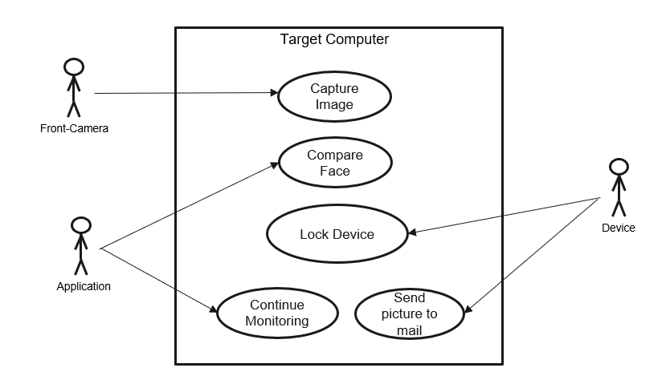
Figure 5.4.1 Use Case Diagram

5.4.2 SEQUENCE DIAGRAMS:
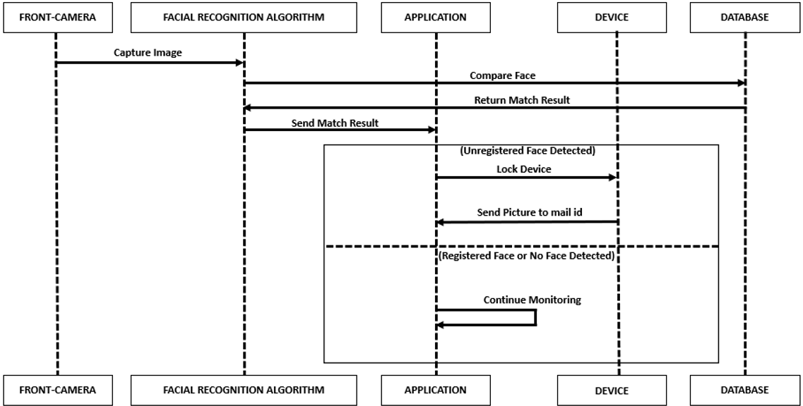
Figure 5.4.2 Sequence diagram

5.4.3 CLASS DIAGRAM:
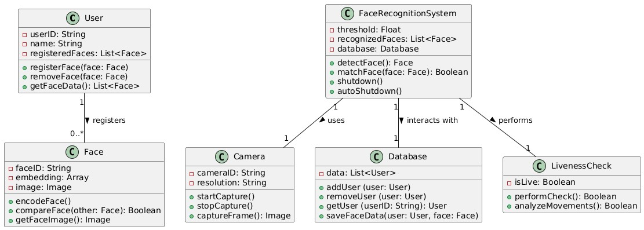
Figure 5.4.3 Class Diagram

5.4.4 ACTIVITY DIAGRAM:
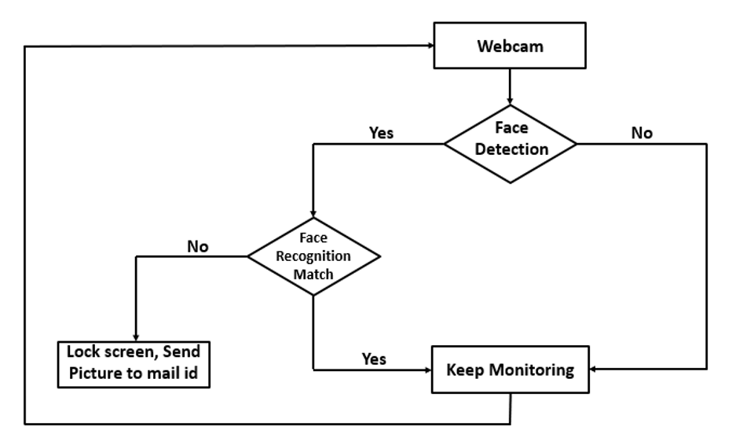
Figure 5.4.4 Activity Diagram

CHAPTER 6

SYSTEM REQUIREMENTS

6.1 SYSTEM REQUIREMENTS
6.1.1 HARDWARE REQUIREMENTS:
- Processor: Dual-core processor (Intel i3 or equivalent) or higher.
- RAM: Minimum of 4 GB RAM (8 GB recommended for better performance).
- Storage: At least 500 MB of free disk space for Web application installation and data storage.
- Webcam: A functional webcam with a minimum resolution of 720p (HD) for
effective face detection and recognition

Graphics Card (GPU):
Recommended:
NVIDIA GTX 1050 or higher (for GPU-accelerated facial recognition and AI processing)
AMD Radeon RX 560 or higher
Purpose: Ensures stable operation, especially if the system runs high-performance components like a dedicated GPU.
Minimum:
Integrated graphics (e.g., Intel UHD or Iris Plus)
Purpose: A dedicated GPU helps speed up facial recognition processing and AI tasks, though integrated graphics may suffice for basic use cases.

6.1.2 SOFTWARE REQUIREMENTS:

Operating System
The Web application should be compatible with major operating systems, including:
Windows 10 or later.

Dependencies and Libraries
Facial Recognition Libraries: OpenCV, Dlib for face detection and recognition.
Database: local disk storage for storing registered facial data.
Additional Software
The Web application may require additional software components, such as:
Drivers for the webcam.
Any necessary runtime environments (e.g., Java Runtime Environment).
Purpose: To ensure that facial recognition data and logs are securely encrypted when stored or transmitted.
Libraries: OpenCV, java, android studio and face recognition modules

CHAPTER 7

SYSTEM IMPLEMENTATION
7.1 INPUT DESIGN
To design a facial recognition security system using webcams, consider integrating a software framework like OpenCV for image processing and recognition. Implement an auto-shutdown feature by monitoring user presence, allowing the system to power down when no faces are detected, enhancing energy efficiency and security. System
Components
- Webcam: A high-resolution camera for capturing video feeds.
- Microcontroller: Raspberry Pi or similar device to process the video input.
- Software: OpenCV for facial recognition and Java for programming.
- Power Supply: Ensure a reliable power source for continuous operation.
Facial Recognition Implementation
- Data Collection: Gather images of authorized users to create a training dataset.
- Model Training: Use OpenCV's LBPH (Local Binary Patterns Histograms) or deep learning models for training the recognition system.
- Real-time Processing: Implement a loop to continuously capture video frames and detect faces.
User Interface
- Web Web application: Create a simple web interface for monitoring and controlling the system.
- Notifications: Implement email notifications for unauthorized access attempts or system status updates.
Testing and Validation
- Field Testing: Conduct tests in various lighting conditions and angles to ensure reliability.
- User Feedback: Gather input from users to improve the system's functionality and user experience.
Future Enhancements
- Database Integration: Connect to a cloud database for storing user data and logs.
- Advanced Algorithms: Explore deep learning techniques for improved accuracy and speed.
- Multi-Factor Authentication: Consider adding additional security measures, such as PIN codes or biometric sensors. Project Timeline
- Phase1: Research and planning (weeks 1-2)
Identify requirements, select components, and outline the project scope.
- Phase2: Development (weeks3-6)
Set up the hardware, install necessary software, and begin coding the facial recognition algorithms.
- Phase3: Testing (Weeks7-8)
Perform extensive testing to ensure the system works under various conditions and refine the auto-shutdown feature.
- Phase4: Deployment (Weeks9-10)
Deploy the system in a real-world environment, monitor performance, and make adjustments as needed.
- Phase5: Maintenance and Updates (Ongoing)
Regularly update the software for security patches and improvements based on user feedback.

Budget Considerations
- Hardware Costs: Estimate expenses for the webcam, microcontroller, and power management components.
- Software Licensing: If using any proprietary software, factor in licensing fees.
- Development Time: Consider the cost of labour for development and testing phases.
Documentation and Support
- User Manual: Create a comprehensive guide for users detailing installation, operation, and troubleshooting.
- Technical Support: Establish a support channel for users to report issues or seek assistance.
Potential Challenges
- Lighting Conditions: Ensure the system can adapt to different lighting scenarios to maintain accuracy.
- Privacy Concerns: Address any privacy issues related to facial recognition technology and ensure compliance with regulations.
- Hardware Limitations: Be aware of the limitations of the chosen hardware and plan for potential upgrades in the future.

Conclusion
This facial recognition security system project aims to enhance security while providing an efficient and user-friendly experience. By leveraging modern technology and thoughtful design, the system can effectively monitor user presence and respond accordingly. Continuous improvement through user feedback and technological advancements will ensure the system remains relevant and effective in addressing security needs.

Next Steps
- Prototype Development: Begin building a prototype to test the feasibility of the design.
- User Testing: Involve potential users in testing to gather insights and make necessary adjustments.
- Iterative Improvements: Use feedback from testing to refine the system before full deployment.
Collaboration Opportunities
- Partnerships: Explore collaborations with tech companies for hardware and software support.
- Research Institutions: Engage with academic institutions for research on advanced algorithms and techniques in facial recognition.

Final Thoughts
The successful implementation of this project could lead to significant advancements in security systems, paving the way for smarter and more efficient solutions in various environments, from homes to businesses

7.2 Output Design for Facial Recognition Security System
- System Overview
The facial recognition security system will utilize webcams to monitor an area for authorized personnel. The system will automatically shut down when no authorized faces are detected for a specified period, enhancing security and energy efficiency.
- Key Functional Outputs
- Real-Time Facial Recognition: The system will continuously analyse video feeds to identify faces.
- User Notifications: Alerts will be sent to users for unauthorized access attempts or system status changes.
- Auto-Shutdown Activation: The system will initiate a shutdown sequence if no faces are detected after a defined timeout period.
- Manual Override: Users can manually override the auto-shutdown feature through a user interface. 3. User Interface (UI) Design
The user interface will be designed for ease of use and accessibility. It will include the following components:
- Dashboard: A main screen displaying:
- Live video feed from the webcam.
- Status indicators (e.g., "System Active," "Face Detected," "Shutdown Timer").
- Notifications area for alerts and messages.
- Settings Menu: Options for users to configure:
- User management (add/remove authorized faces).
- Notification preferences (email).
- Manual Control: Buttons for:
- "Test Recognition" to verify the facial recognition functionality.
- Notification System
The notification system will provide real-time updates to users. Notifications can be sent via:
  - Email Alerts: Inform users of unauthorized access attempts or system status changes.
  - Mobile Notifications: Push notifications through a mobile app or SMS for immediate alerts.
  - On-Screen Alerts: Pop-up messages on the UI for real-time updates.
5. Data Logging and Reporting The system will maintain logs of:
  - Access Attempts: Record successful and unsuccessful face recognition attempts with timestamps.
  - System Events: Log system status changes, including shutdowns and restarts.
  - User Activity: Track user interactions with the system for auditing purposes.
6. Security Measures
To ensure the security of the system:
- Data Encryption: Encrypt sensitive data, such as user images and logs.
- Access Control: Implement user authentication for accessing the system settings and logs.
- Regular Updates: Schedule regular software updates to patch vulnerabilities.
7. Testing and Validation Outputs
- Performance Metrics: Measure the accuracy of facial recognition (true positives, false positives, false negatives).
- User Feedback: Collect feedback from users during testing to refine the UI and functionality.
- System Reliability: Test the auto-shutdown feature under various conditions to ensure reliability.
8. Future Enhancements
- Integration with IoT Devices: Allow the system to interact with other smart devices (e.g., alarms, lights).
- Advanced Analytics: Implement machine learning algorithms for improved recognition accuracy and user behaviour analysis.
- Mobile App Development: Create a mobile Web application for remote monitoring and control of the system.

Conclusion
This output design outlines the key components and functionalities of the facial recognition security system with an auto-shutdown feature. By focusing on user experience, security, and reliability, the system aims to provide an effective solution for monitoring and protecting designated areas. The next steps involve prototyping, testing, and refining the design based on user feedback and performance metrics.

7.3Input and Output Design for Facial Recognition Security System

- System Overview
The facial recognition security system will utilize webcams to monitor an area for authorized personnel. The system will automatically shut down when no authorized faces are detected for a specified period, enhancing security and energy efficiency.

- Input Design 2.1. Hardware Inputs
- Webcam:
- Type: High-resolution USB webcam (e.g., Logitech C920).
- Function: Captures real-time video feed for facial recognition.
- Microcontroller/Computer:
- Type: Raspberry Pi, Arduino, or a standard PC.
- Function: Processes video input, runs facial recognition algorithms, and manages system operations.
- Power Supply:
- Type: Reliable power source (e.g., AC adapter, battery backup).
- Function: Powers the webcam and processing unit.
2.2. Software Inputs
- Facial Recognition Library - Type: OpenCV, Dlib, or a similar library.
- Function: Provides algorithms for detecting and recognizing faces from the video feed.
- User Database:
- Type: A secure database (e.g., MongoDB).
- Function: Stores authorized user images and associated metadata for recognition.
- Configuration Files:
- Type: JSON or XML files.
- Function: Contains settings for timeout durations, notification preferences, and user management.
- Output Design
  - Hardware Outputs • Display Monitor:
      - Type: LCD or LED monitor.
      - Function: Shows the live video feed, system status, and notifications.
      - Alarm System:
      - Type: Buzzer or siren.
      - Function: Activates during unauthorized access attempts or system alerts.
      - Relay Module:
      - Type: Smart relay or power switch.
      - Function: Controls the power supply to the system for the auto-shutdown
feature.

  - Software Outputs
    - Real-Time Notifications:
    - Type: Email notifications.
    - Function: Alerts users about unauthorized access attempts or system status changes.
    - User Interface (UI) Outputs:
    - Type: Web-based or desktop Web application.
    - Function: Displays live feed, system status, and allows user interaction for settings and manual controls.
    - Logging and Reporting:
    - Type: Log files or database entries.
    - Function: Records access attempts, system events, and user activity for auditing and analysis.

- Integration of Input and Output
The system will continuously process input from the webcam and user database to perform facial recognition. Upon detecting a face, the system will check against the authorized user list and provide appropriate outputs, such as notifications or visual feedback on the monitor. If no authorized faces are detected within the specified timeout, the system will initiate the auto-shutdown sequence, ensuring both security and energy efficiency.
Conclusion
This input and output design provides a structured approach to developing a facial recognition security system with webcams and an auto-shutdown feature. By integrating hardware and software components effectively, the system aims to deliver reliable performance and user-friendly interaction. The next steps involve implementation, testing, and refinement based on real-world usage and feedback.

7.4Physical Design for Facial Recognition Security System
7.4.1System Components
Hardware Components
- Webcam: High-resolution USB webcam (e.g., Logitech C920).
- Microcontroller/Computer: Raspberry Pi, Arduino, or a standard PC.
- Power Supply: AC adapter or battery backup.
- Relay Module: Smart relay or power switch for auto-shutdown.
- Display Monitor: LCD or LED monitor for user interface.
- Alarm System: Buzzer or siren for alerts.
- Casing/Enclosure: Protective housing for the components.
7.4.2 Physical Layout Component Placement
- Webcam:
- Location: Mounted at eye level on a wall or above a door frame to capture faces entering the monitored area.
- Angle: Tilted slightly downward to optimize face detection and minimize obstructions.
- Microcontroller/Computer:
- Location: Placed in a secure, ventilated area (e.g., a nearby shelf or cabinet) to prevent tampering.
- Accessibility: Ensure easy access for maintenance and updates.
- Display Monitor:
- Location: Positioned in a visible area (e.g., on a wall or desk) where users can easily view the live feed and notifications.
- Mounting: Wall-mounted or on a stand, depending on space and user preference.
- Power Supply:
- Location: Near the microcontroller/computer to minimize cable clutter.
- Cable Management: Use cable ties or conduits to organize and secure power cables.
- Relay Module:
- Location: Close to the power source and microcontroller to facilitate easy integration.
- Accessibility: Ensure it is accessible for manual overrides if necessary.
- Alarm System:
- Location: Mounted near the entrance or in a central location to maximize audibility.
- Visibility: Consider a visible placement to deter unauthorized access.
- Casing/Enclosure:
- Material: Use durable materials (e.g., plastic or metal) to protect components from damage.
- Ventilation: Ensure adequate airflow to prevent overheating of electronic components.
7.4.3. User Interaction Design
User Interface (UI)
- Location: Integrated into the display monitor for user interaction.
- Functionality: Allows users to configure settings, view logs, and manually control the system.
- Location: Near the display monitor for manual control (e.g., shutdown, restart).
- Design: Clearly label ed buttons for ease of use.
User Access
- Location: Ensure that the system is installed in a secure area where only authorized personnel can access it.
- Visibility: The system should be visible to deter unauthorized access while maintaining privacy for users.

Aesthetic Considerations
- Colour Scheme: Choose colours that blend with the environment (e.g., neutral colours for office settings).
- Design Style: it for a modern, sleek design that complements the existing decor.
- Lighting: Consider ambient lighting around the system to enhance visibility without causing glare on the webcam or monitor.
Safety and Compliance
- Electrical Safety: Ensure all components are properly grounded and comply with electrical safety standards.
- Privacy Considerations: Clearly communicate to users that facial recognition is in use, and ensure compliance with local privacy regulations.
Prototype and Testing
- Prototype Assembly: Assemble the components according to the physical design layout.
- Testing: Conduct tests to ensure all components function correctly in their designated locations, and make adjustments as necessary.

Conclusion
This physical design outline provides a comprehensive approach to setting up a facial recognition security system with webcams and an auto-shutdown feature. By carefully considering component placement, user interaction, aesthetics, and safety, the system can be both functional and visually appealing. The next steps involve building the prototype, testing the system, and refining the design based on user feedback and performance metrics.

7.5 Logical Design for Facial Recognition Security System

System Architecture
7.5.1. Components
- Webcam: Captures real-time video feed.
- Microcontroller/Computer: Processes video input and runs facial recognition algorithms.
- Facial Recognition Software: Utilizes libraries like OpenCV or Dlib for face detection and recognition.
- Database: Stores authorized user images and metadata.
- User Interface (UI): Displays live feed, notifications, and settings.
- Notification System: Sends alerts for unauthorized access attempts.
- Power Management Module: Controls the auto-shutdown feature.
Data Flow Diagram (DFD)
7.5.2. Level 0 DFD (Context Diagram)
- External Entities:
- Interacts with the system through the UI.
- Database: Stores user data and logs.
- Facial Recognition System: Main process that includes all functionalities.
- Data Flows:
- User inputs settings and receives notifications.
- Webcam captures video feed and sends it to the facial recognition software.
- Facial recognition software queries the database for authorized users.
- Notifications are sent to the user based on recognition results.
Level 1 DFD
- Processes:
1. Capture Video Feed
- Input: Webcam
- Output: Video frames to Facial Recognition Module
2. Facial Recognition Module
- Input: Video frames
- Output: Recognition results (authorized/unauthorized) to Notification System and UI
3. Notification System
- Input: Recognition results
- Output: Alerts to User and logs to Database
4. Auto-Shutdown Control
- Input: Recognition results (no face detected)
- Output: Shutdown command to Power Management Module
5. User Interface
- Input: User commands/settings
- Output: Display live feed, notifications, and settings

7.5.3. Process Descriptions
3.1. Capture Video Feed
- Function: Continuously captures video frames from the webcam.
- Output: Sends frames to the Facial Recognition Module for processing.
3.2. Facial Recognition Module
- Function: Analyses video frames to detect and recognize faces.
- Steps:
      - Face Detection: Identify faces in the video frames.
      - Face Recognition: Compare detected faces against the database of authorized users.
      - Output: Generate recognition results (authorized or unauthorized).
3.3. Notification System
- Function: Sends alerts based on recognition results.
- Types of Notifications:
- Authorized Access: Log the access and notify the user.
- Unauthorized Access: Trigger an alarm and notify the user immediately.
3.4. User Interface
- Function: Allows users to interact with the system.
- Features:
- Live video feed display.
- Settings for timeout duration and user management.
- Manual control options (shutdown, restart).
4. Data Storage
- User Database: Stores images and metadata of authorized users (e.g., name, ID).
- Log Database: Records access attempts, system events, and user interactions for auditing.
5. System Flow
- The webcam captures video frames continuously.
- The Facial Recognition Module processes the frames to detect and recognize faces.
- If a face is recognized:
• The system logs the access and sends a notification to the user.
4. If no face is detected for a specified timeout:
- The Auto-Shutdown Control initiates the shutdown sequence.
- The user is notified before the system powers down.
5. The User Interface allows users to configure settings and view logs.

Conclusion
This logical design outlines the architecture, data flow, and processes involved in a facial recognition security system with webcams and an auto-shutdown feature. By understanding how each component interacts and the flow of data

CODE

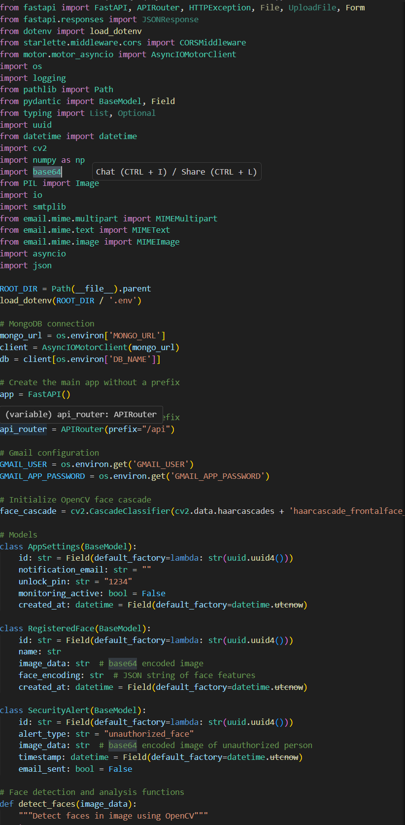
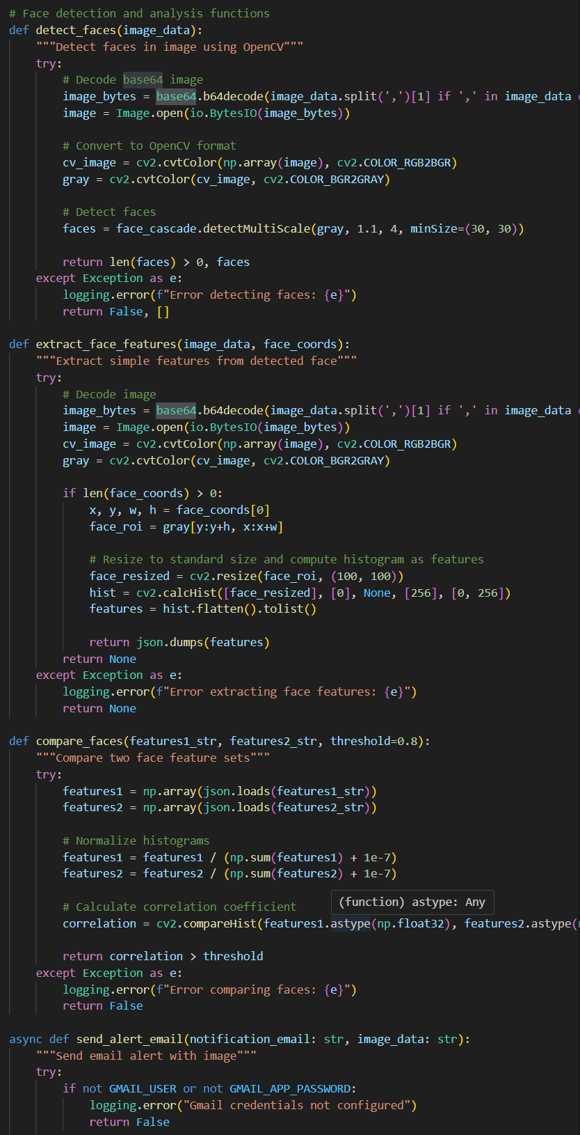
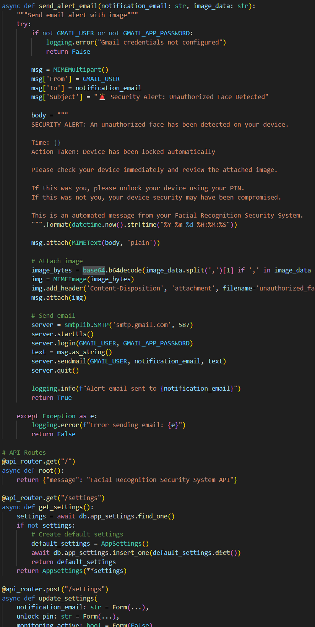
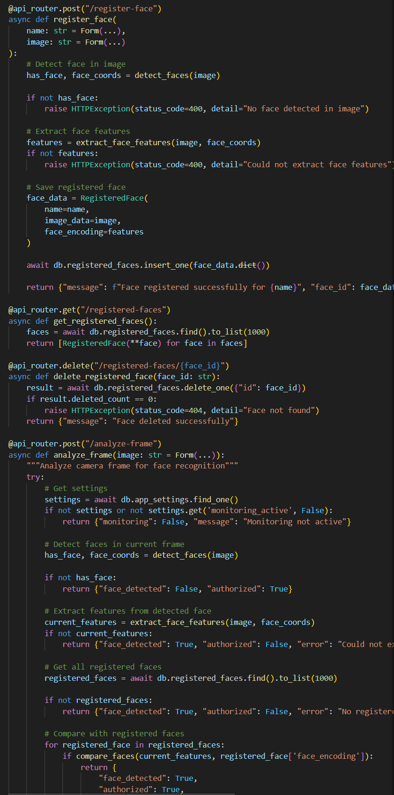
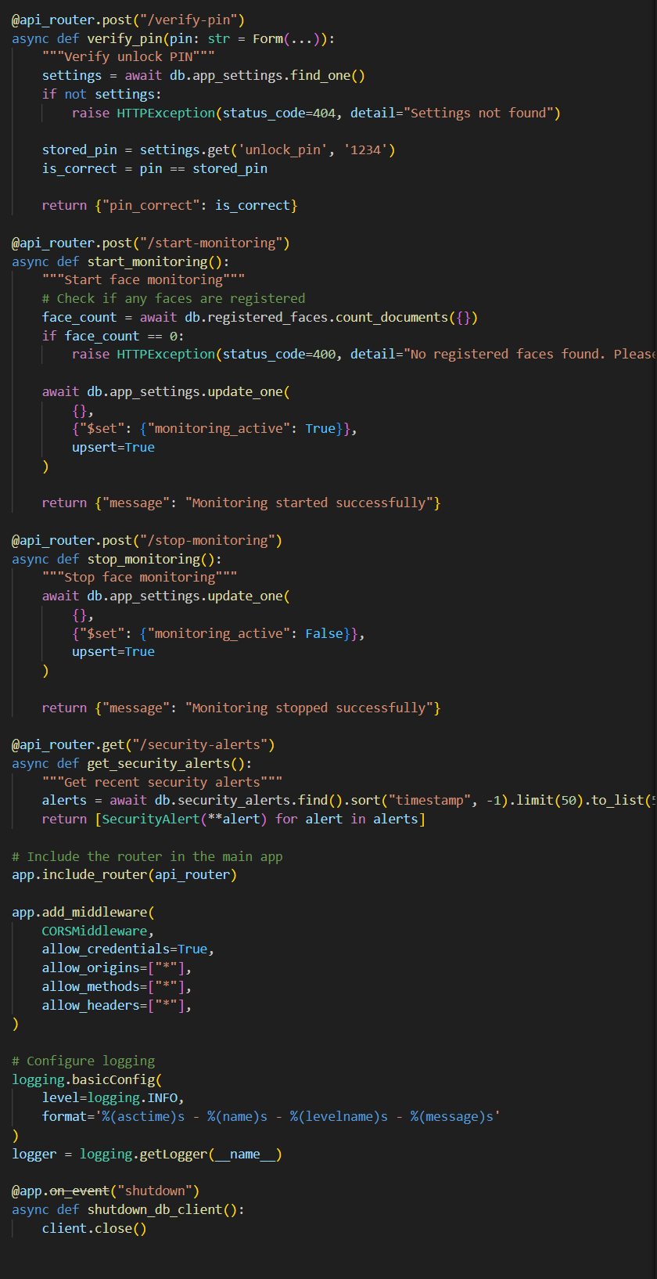
CHAPTER 8

SYSTEM TESTING

8.1 INTRODUCTION:

In the development of the "Secure Sentinel" Web application, a comprehensive testing strategy was implemented to ensure the software's functionality, reliability, and user experience. The testing process was divided into two primary categories: Black Box Testing and White Box Testing.

Black Box Testing focused on evaluating the Web application from an end-user perspective, without any knowledge of the internal code structure. This approach allowed testers to assess the Web application's behavior and output based on various inputs and user interactions. The goal was to verify that the Web application meets its functional requirements and provides a seamless user experience. All test cases in this category passed successfully, indicating that the Web application performs as expected in real-world scenarios.

White Box Testing, on the other hand, involved a detailed examination of the internal logic and structure of the code. This testing method allowed for the verification of individual functions and their interactions, ensuring that the Web application operates correctly at a code level. Test cases were designed to evaluate the handling of valid and invalid inputs, exception management, and the overall robustness of the Web application. The results showed that all functions performed as intended, confirming the integrity of the Web application's logic.

The combination of both testing methodologies provided a thorough evaluation of the "Secure Sentinel" Web application, ensuring that it is not only functional but also reliable and user-friendly. The successful outcomes of all test cases highlight the Web application's readiness for deployment, offering users a secure and efficient face monitoring solution.

8.2 LEVELS OF TESTING

Black Box Testing evaluates the Web application's functionality without examining its internal code structure. Testers focus on inputs and expected outputs, assessing how the Web application behaves in various scenarios. This approach is effective for validating user requirements and ensuring the Web application performs as intended from an end-user perspective. For Secure Sentinel, this includes testing features like face recognition, monitoring functionalities, and user interface interactions.

White Box Testing, in contrast, involves a thorough examination of the Web application's internal workings. Testers analyze the code structure, algorithms, and logic to identify vulnerabilities, ensure code quality, and verify that all paths and conditions are executed correctly. This method is vital for uncovering hidden bugs and ensuring adherence to best coding practices. In the context of Secure Sentinel, White Box Testing focuses on critical functions such as face encoding, webcam monitoring, and system commands.

8.2.1 BLACK BOX TESTING

Black Box Testing focused on evaluating the Web application from an end-user perspective, without any knowledge of the internal code structure. This approach allowed testers to assess the Web application's behavior and output based on various inputs and user interactions. The goal was to verify that the Web application meets its functional requirements and provides a seamless user experience. All test cases in this category passed successfully, indicating that the Web application performs as expected in real-world scenarios.

Test Case ID | Test Cases
BB-01 | Start Monitoring
BB-02 | Stop Monitoring
BB-03 | Add Face
BB-04 | Manage Faces UI
BB-05 | Delete Face

Test Case ID | Description | Input | Expected  Output | Actual Output | Result
BB-01 | Start Monitoring | Click “Start Monitoring” | Monitoring starts | Monitoring started successfully | Pass
BB-02 | Stop Monitoring | Click "Stop  Monitoring" | Monitoring stops | Monitoring stopped successfully | Pass
BB-03 | Add Face | Click " Add Face  " | Opens the Camera to capture the image | Camera feed is opened successfully | Pass
BB-04 | Manage Faces  UI | Click " Manage  Faces " | Opens a window with faces in the directory | A window with faces in the directory opened successfully | Pass
BB-05 | Delete Face | Click " Delete  Face " | Deletes the face beside the button | Face beside the button deleted successfully | Pass

All test cases passed, indicating that the Web application behaves as expected from an end-user perspective.
8.2.2 WHITE BOX TESTING
White Box Testing, on the other hand, involved a detailed examination of the internal logic and structure of the code. This testing method allowed for the verification of individual functions and their interactions, ensuring that the Web application operates correctly at a code level. Test cases were designed to evaluate the handling of valid and invalid inputs, exception management, and the overall robustness of the Web application. The results showed that all functions performed as intended, confirming the integrity of the Web application's logic.

Test Case ID | Test Cases
WB-01 | Function detect_faces
WB-02 | Function compare_faces
WB-03 | Function send_alert_email

Test Case ID | Description | Input | Expected Output | Actual Output | Result
WB-  01 | Function detect_faces | Camera feed input | Monitor the camera feed | Camera feed being monitored successfully | Pass
WB-  02 | Function compare_faces | Registered face inputs | Match the camera feed face with the registered face | Matching the registered face with the camera feed successfully | Pass
WB-  03 | Function send_alert_email | Email alert log input | Send email alert to the entered ID | Email sent to the entered ID | Pass

All test cases passed, confirming that the internal logic and functions of the Web application are working correctly.

CHAPTER-9

OUTPUT SCREENS

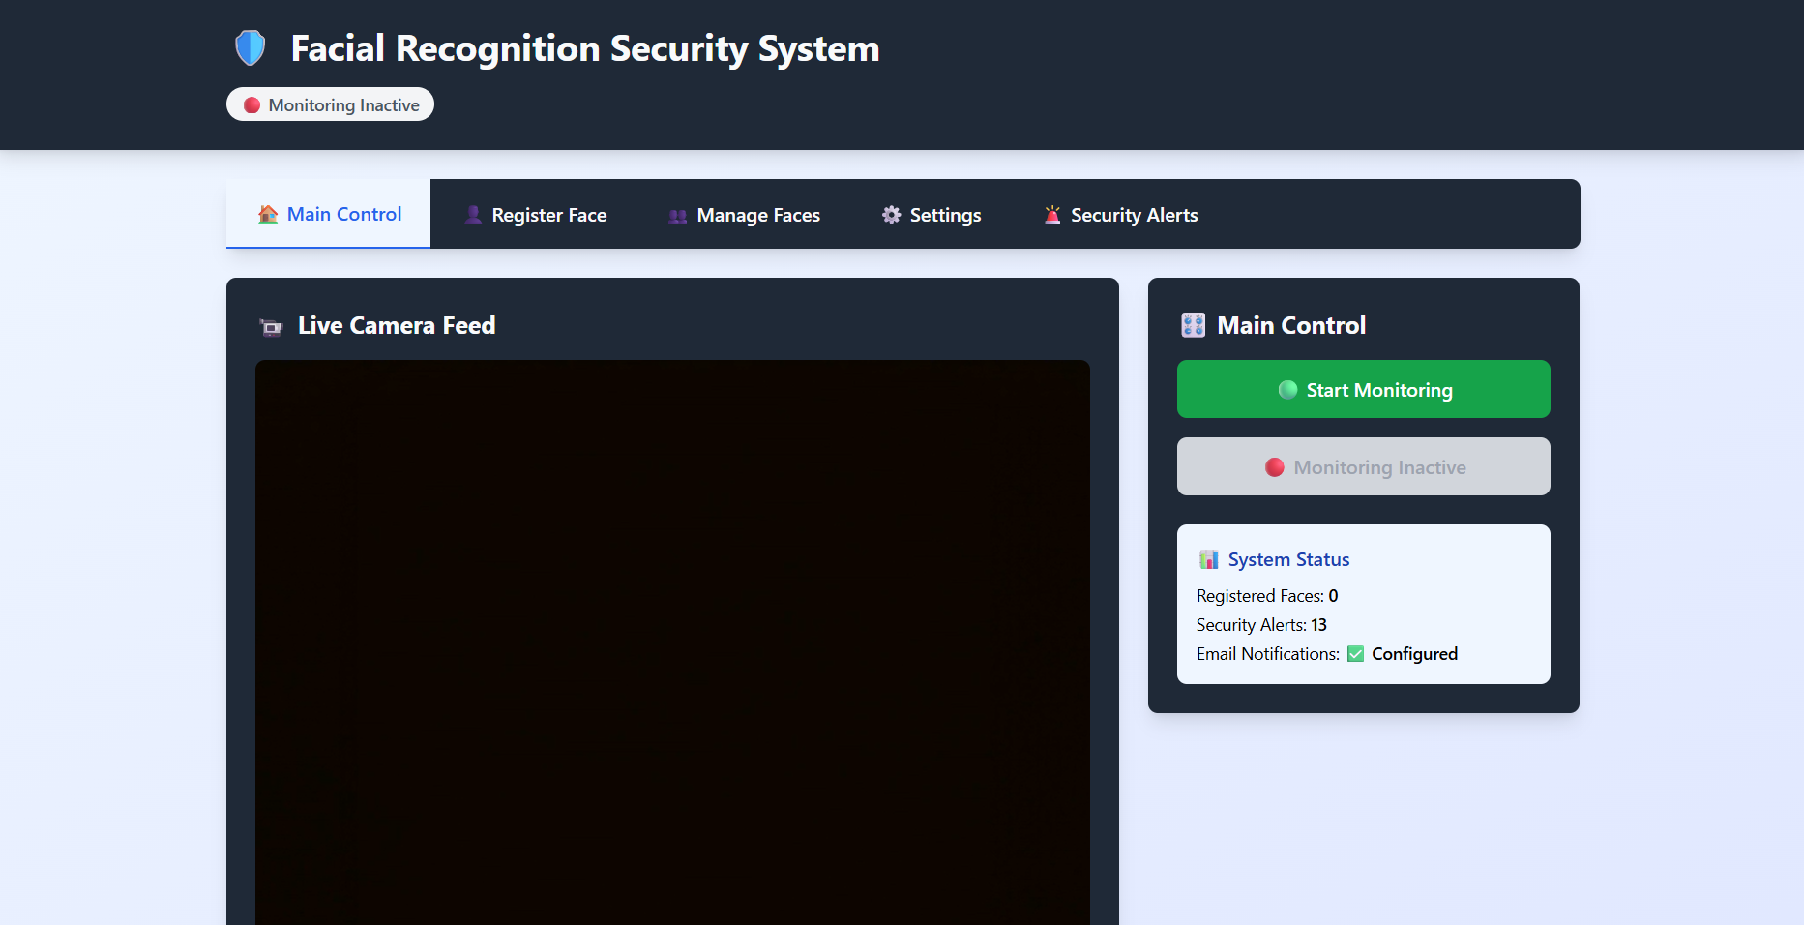
Fig:9.1 Main UI Window


Fig:9.2 Warning Window

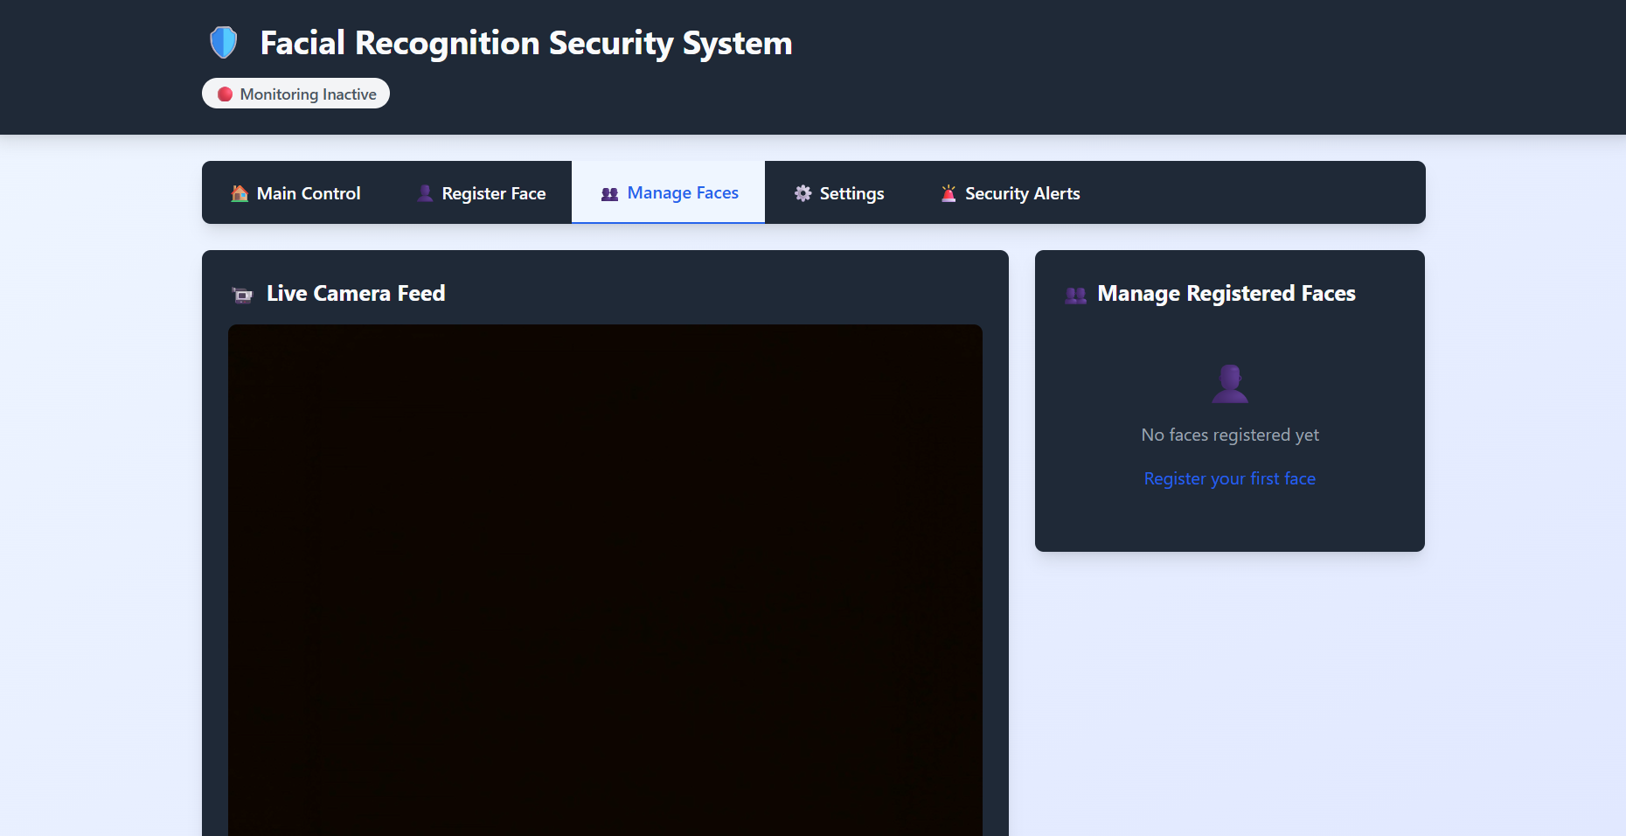
Fig:9.3 Manage Faces Window (Empty)

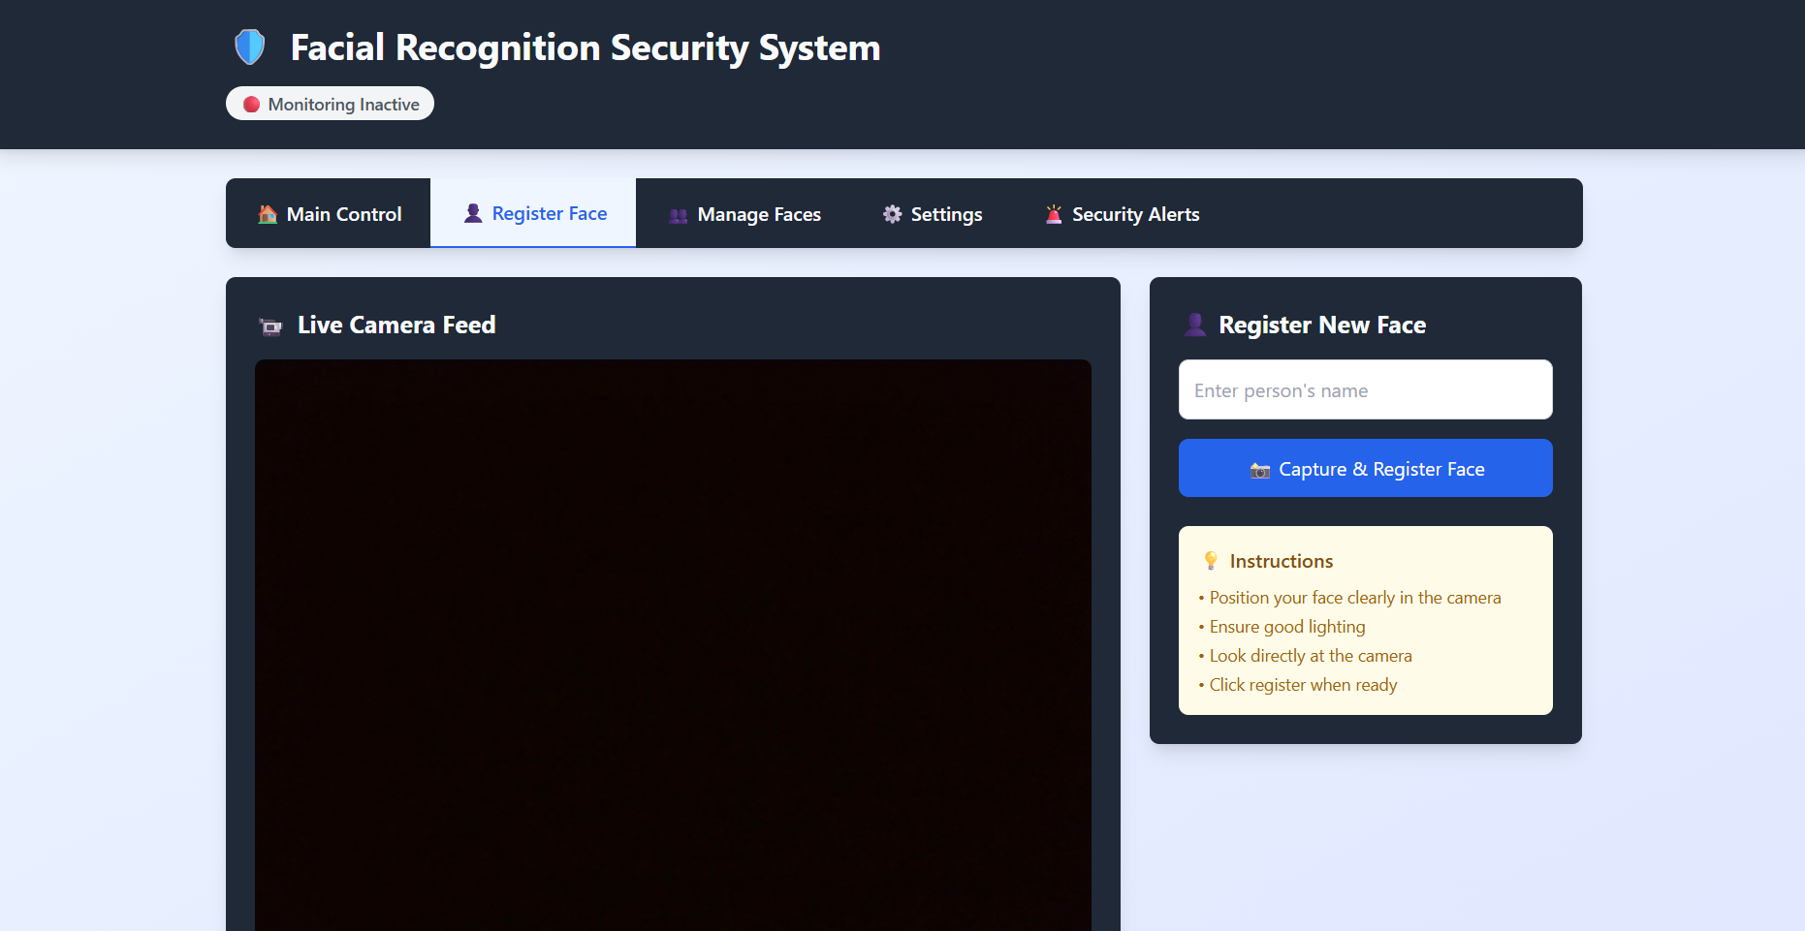
Fig:9.5 Face Capture Window

CHAPTER 10

CONCLUSION AND FUTURE WORK

In conclusion, the proposed security Web application harnesses the power of facial recognition technology to provide a robust and effective solution for ensuring authorized access to devices equipped with a webcam. By continuously monitoring and detecting faces in real-time, the Web application offers immediate protection against unauthorized access, shutting down the device instantly when an unregistered face is detected. This proactive approach significantly enhances the security of sensitive information, safeguarding users from potential breaches.
Additionally, the Web application's advanced algorithm allows for customizable settings, including an auto-shutdown feature that activates when no faces are detected for a specified period. This functionality is particularly beneficial in public spaces or shared work environments, where devices may be left unattended for extended durations.

By ensuring that the device remains secure even when not actively in use, users can enjoy peace of mind knowing that their data is protected. In summary, this facial recognition-based security Web application takes a sophisticated approach to protecting your device and sensitive information, offering a dynamic layer of defence against unauthorized access. By continuously tracking and verifying users in real-time, it ensures that only those with registered facial data can access the system, effectively blocking potential intruders. The immediate shutdown feature upon detection of an unregistered face prevents unauthorized access from occurring, significantly reducing the risk of data theft or security breaches.

Moreover, the Web application’s advanced algorithm that triggers auto-shutdown when no faces are detected for a configurable period adds an extra layer of safety, particularly useful in environments where devices are often left unattended. This feature makes it ideal for use in public or shared spaces, such as offices, airports, or libraries, where the risk of someone accessing an unattended device is higher.
The seamless integration of facial recognition technology with real-time monitoring ensures both convenience and security for users. By offering a robust solution to prevent unauthorized access, this Web application empowers users to confidently leave their devices unattended, knowing that their data is protected. Overall, this security Web application represents an intelligent, reliable, and future-forward solution to safeguarding personal information in an increasingly connected world.

The security Web application leveraging facial recognition technology provides a powerful and proactive solution for safeguarding your device and sensitive information. By continuously monitoring and detecting faces in real-time, it ensures that only authorized individuals can access the device, offering an instant response by shutting down the system when an unrecognized face is detected. The ability to automatically shut down the device when no faces are detected for a specified period further enhances security, particularly in shared or public spaces where devices may be left unattended. This robust, user-friendly security feature gives users peace of mind, knowing their data remains protected from potential security breaches, and reinforces the importance of reliable, intelligent protection in today’s digital environment.

CHAPTER 11
REFERENCES

- M. J. Jones, J. R. Rehg, "A Bayesian framework for robust face detection," International Journal of Computer Vision, 2002.
- OpenCV documentation: https://docs.opencv.org/ (Open Source Computer Vision Library)
- D+ lib library for face detection: https://github.com/davisking/dlib
- R. A. R. Z. J. F. S. Omar, "Real-time face detection system using OpenCV," International Journal of Computer Web applications, 2016.
- TensorFlow documentation: https://www.tensorflow.org/ (for AI-powered face recognition) 6. Face Recognition Java library: https://github.com/ageitgey/face_recognition (easy-to-use library for facial recognition in Java)  "Windows Task Scheduler" for automating tasks (https://docs.microsoft.com/en-us/windows-server/administration/windows-commands/schtasks) — used to trigger auto-shutdown after inactivity.
- Java's os library for implementing shutdown commands: https://docs.python.org/3/library/os.html
- Y. Sun, X. Wang, X. Tang, "Deep Learning Face Representation by Joint IdentificationVerification," CVPR 2014.
- Various research on biometric security measures and their effectiveness in protecting devices:
https://www.sciencedirect.com/science/article/abs/pii/S1877056817312113

