A network associate is adding security to the configuration of the Corp1 router. The user on host C should be able to use a web browser to access financial information from the Finance Web Server. No other hosts from the LAN nor the Core should be able to use a web browser to access this server. Since there are multiple resources for the corporation at this location including other resources on the Finance Web Server, all other traffic should be allowed.

The task is to create and apply a numbered access-list with no more than three statements that will allow ONLY host C web access to the Finance Web Server. No other hosts will have web access to the Finance Web Server. All other traffic is permitted.  
Access to the router CLI can be gained by clicking on the appropriate host.

All passwords have been temporarily set to “cisco”.  
The Core connection uses an IP address of 198.18.196.65  
The computers in the Hosts LAN have been assigned addresses of 192.168.33.1 – 192.168.33.254  
Host A 192.168.33.1  
Host B 192.168.33.2  
Host C 192.168.33.3  
Host D 192.168.33.4  
The servers in the Server LAN have been assigned addresses of 172.22.242.17 – 172.22.242.30  
The Finance Web Server is assigned an IP address of 172.22.242.23.  
The Public Web Server is assigned an IP address of 172.22.242.17

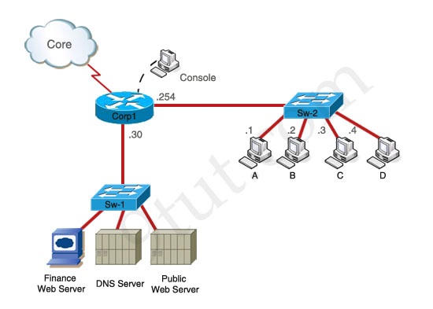

**Corp1>enable**

**Corp1#show running-config**

We learn that interface FastEthernet0/1 is the interface connected to Server LAN network. It is the interface we will apply our access-list (for outbound direction).

**Corp1#configure terminal**

Our access-list needs to allow host C – 192.168.33.3 to the Finance Web Server 172.22.242.23 via web (port 80)

**Corp1(config)#access-list 100 permit tcp host 192.168.33.3 host 172.22.242.23 eq 80**

Deny other hosts access to the Finance Web Server via web

**Corp1(config)#access-list 100 deny tcp any host 172.22.242.23 eq 80**

All other traffic is permitted

**Corp1(config)#access-list 100 permit ip any any**

Apply this access-list to Fa0/1 interface (outbound direction)

**Corp1(config)#interface fa0/1**  
**Corp1(config-if)#ip access-group 100 out**

**Corp1(config-if)#end**  
**Corp1#copy running-config startup-config**

After adding R3 router, no routing updates are being exchanged between R3 and the new location. All other inter connectivity and Internet access for the existing locations of the company are working properly.

The task is to identify the fault(s) and correct the router configuration to provide full connectivity between the routers.

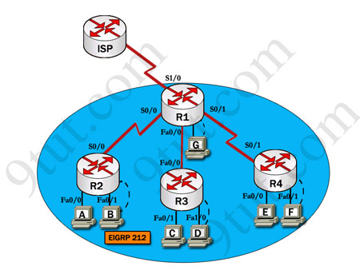

|  |  |
| --- | --- |
| **R1**  **Fa0/0:** 192.168.77.33  **S1/0:** 198.0.18.6  **S0/1:** 192.168.60.25  **S0/0:** 192.168.36.13 | **R2**  **Fa0/0:** 192.168.60.97  **Fa0/1:** 192.168.60.113  **S0/0:** 192.168.36.14 |
| **R3**  **Fa0/0:** 192.168.77.34  **Fa0/1:** 192.168.60.65  **Fa1/0:** 192.168.60.81 | **R4**  **Fa0/0:** 192.168.60.129  **Fa0/1:** 192.168.60.145  **S0/1:** 192.168.60.26 |

We should check the configuration of the new added router first because it does not function properly while others work well. From the command line interface of R3 router, enter the **show running-config** command

From the output above, we know that this router was wrongly configured with an autonomous number (AS) of 22. When the AS numbers among routers are mismatched, no adjacency is formed.

(To solve this problem, we simply re-configure router R3 with the following commands:

**R3>enable** (you have to enter **cisco** as its password here)

**R3#configure terminal**

**R3(config)#no router eigrp 22**

**R3(config)#router eigrp 212**

**R3(config-router)#network 192.168.60.0**

**R3(config-router)#network 192.168.77.0**

**R3(config-router)#no auto-summary**

**R3(config-router)#end**

**R3#copy running-config startup-config**

Check R1 router with the **show running-config** command:

Notice that it is missing a definition to the network R3. Therefore we have to add it so that it can recognize R3 router

**R1>enable** (you have to enter **cisco** as its password here)

**R1#configure terminal**

**R1(config)#router eigrp 212**

**R1(config-router)#network 192.168.77.0**

**R1(config-router)#end**

**R1#copy running-config startup-config**