Project Title
Public Transit Planner: Fleet- and Budget-Constrained Bus Route and Timetable Design
Project Report submitted for the partial fulfilment of grade for the course

Data Structures and Algorithms -3 (25CS2103E)
in

A.Y. 2026-2027

Submitted by
Kartheek Reddy (2520090015)
Dhanush Raj (2520080046)

Team Number: 30
Section: 10

Under the guidance of

Mrs. Chandusha Kanda

Assistant Professor, Department of CSIT
Hyderabad-500090, Telangana, India.

K L (Deemed to be) University
DEPARTMENT OF COMPUTER SCIENCE AND INFORMATION TECHNOLOGY



DECLARATION

The Mini Project Report entitled “Public Transit Planner” is a record of Bonafide work of Kartheek Reddy – 2520090015; Dhanush Raj – 2520080046 submitted in partial fulfillment for the award of B. Tech in Computer Science and Information Technology to the K L University. The results embodied in this report have not been copied from any other departments/University/Institute.

Kartheek Reddy – 2520090015
Dhanush Raj – 2520080046

K L (Deemed to be) University
DEPARTMENT OF COMPUTER SCIENCE AND INFORMATION TECHNOLOGY
CERTIFICATE

This is to certify that the mini project based report entitled “Public Transit Planner” is a bonafide work done and submitted by Kartheek Reddy – 2520090015; Dhanush Raj – 2520080046 in partial fulfillment of the requirements for the award of the degree of BACHELOR OF TECHNOLOGY in Department of Computer Science and Information Technology, K L (Deemed to be University), during the academic year 2026-2027.

Signature of the Supervisor

Signature of the HOD Signature of the External Examiner

ACKNOWLEDGEMENT

The success in this project would not have been possible but for the timely help and guidance rendered by many people. Our wish to express my sincere thanks to all those who has assisted us in one way or the other for the completion of my project.

Our greatest appreciation to our guide, Mrs. Chandusha Kanda, Assistant Professor, Department of Computer Science and Information Technology, which cannot be expressed in words for her tremendous support, encouragement and guidance for this project.

We express our gratitude to Dr. Khaja Shareef, Head of the Department of Computer Science and Information Technology, for providing us with adequate facilities, ways and means by which we are able to complete this project-based Lab.

We thank all the members of teaching and non-teaching staff members, and also who have assisted me directly or indirectly for successful completion of this project. Finally, I sincerely thank my parents, friends and classmates for their kind help and cooperation during my work.

Kartheek Reddy – 2520090015
Dhanush Raj – 2520080046

TABLE OF CONTENTS

S.No. | Contents | Page no.
1. | Abstract | 6
2. | Introduction | 7
3. | Literature survey | 9
4. | Problem Statement and Objectives | 11
5. | Hardware and Software requirements | 12
6. | Implementation | 13
7. | Results & Discussion | 16
8. | Conclusion & Future Scope | 22
9. | References | 23
1.ABSTRACT

Public bus networks must serve thousands of commuters with a limited fleet and a limited daily budget, yet route and timetable decisions are often made without measuring their effect on coverage, waiting time and cost. This project presents the Public Transit Planner, a Java application that turns raw transit data into an evaluated bus service plan. The program first cleans stop, travel-time and demand records, using hashing for de-duplication and Damerau-Levenshtein edit distance for typo repair. It then builds a road graph and finds fastest paths with Dijkstra’s algorithm, selects bus routes with a greedy budgeted maximum-coverage rule (the exact problem is NP-hard; the greedy rule has a (1 − 1/e) guarantee), splits the fleet between routes by dynamic programming, assigns passengers to buses within seat capacity using min-cost max-flow, and generates hourly timetables. Each plan is measured by stop coverage, share of demand served directly, waiting time, door-to-door travel time, fleet utilisation and daily cost. String algorithms (Aho-Corasick, suffix array, KMP), randomised methods (Miller-Rabin, Monte Carlo simulation, reservoir sampling) and parallel prefix sums complete the toolkit. Every algorithm is written by hand without java.util, and a self-test of 7,470 randomised checks passes. A Passenger portal and an Admin portal, served by the program’s own HTTP server, let riders plan trips and let planners test fleet and budget scenarios before publishing a plan.
Team Name: Team 30 (Section 10)
Team Logo (if any): Not applicable
Team Members:
1. Kartheek Reddy, 2520090015
2. Dhanush Raj, 2520080046
Under the guidance of: Mrs. Chandusha Kanda, Assistant Professor, Department of Computer Science and Information Technology
- INTRODUCTION

A city bus service has to answer three connected questions every day: which lines should run, how many buses should each line get, and when should those buses leave. The answers are limited by two hard numbers, the size of the fleet and the daily operating budget. A poor answer leaves whole localities without a bus, packs some routes beyond their seat capacity and lets others run almost empty, so passengers wait longer and the agency spends more for less service.
This project builds the Public Transit Planner, a data-driven tool that answers those questions with numbers instead of guesses. It reads three raw CSV files (stops, road travel times and daily passenger demand between stop pairs), cleans them, models the city as a weighted graph, chooses bus routes, splits the fleet between them, builds an hourly timetable and then evaluates the whole plan with coverage, waiting time, travel time, fleet utilisation and cost. A planner can change the fleet size or budget and immediately see the effect.
Two web portals sit on top of the engine. The Passenger portal tells a rider which bus to take, when it leaves and when it arrives, and shows a live departure board for any stop. The Admin portal, protected by a PIN, lets the transit agency move the fleet and budget sliders, read a plain-English summary of the plan, ask for a recommended fleet size, compare saved scenarios and finally publish a plan to passengers.
The course angle. The project follows the Data Structures and Algorithms-3 (25CS2103E) syllabus and the rule carried over from DSA-1 and DSA-2: every data structure and algorithm is written by hand and no class from java.util is used. Only java.io (reading CSV, writing the report) and java.lang.Thread (parallel scan) are used, plus the JDK’s built-in HTTP server for the portals. Module 2 (string algorithms) cleans and searches stop names, Module 3 (advanced dynamic programming) repairs typos and splits the fleet, Module 4 (network flow) assigns passengers within seat capacity, Module 5 (NP-completeness and approximation) justifies the greedy route choice, and Module 6 (randomised and parallel algorithms) validates waiting times by simulation.
Data. The CSV files are synthetic but Hyderabad-flavoured: real locality names, approximate coordinates and demand from a gravity model. They deliberately contain typos, duplicates, negative numbers and unknown stops so that the cleaning stage has real work to do. Real GTFS or ridership exports with the same columns can be dropped in to plan a real city.
The rest of this report is organised as follows. Section 3 reviews related work, Section 4 states the problem and objectives, Section 5 lists the hardware and software used, Section 6 explains the implementation with code from four core modules, Section 7 presents results and screenshots, and Section 8 concludes with future scope.
- LITERATURE SURVEY

Public transit planning is a well-studied area. The projects and papers below were reviewed to understand what already exists and where this project fits in. Reference numbers point to the References section.
1. General Transit Feed Specification (GTFS) [1]. GTFS is the open data format in which agencies publish stops, routes, trips and timetables. It became a de facto standard because journey planners can read feeds from many agencies without custom code. Our CSV columns (stop, link, demand) are deliberately simple, and the planner can be fed GTFS-derived exports of the same shape. GTFS describes the service; it does not decide it, which is the gap our planner addresses.
2. OpenTripPlanner [2]. OpenTripPlanner is an open-source multimodal trip planner written in Java. It builds a network from GTFS and OpenStreetMap data and answers rider queries through REST and GraphQL APIs, with a map-based client. It plans trips on an existing timetable, whereas our project also designs the routes and timetable that the trip planner would later use. Our Passenger portal covers the same rider-facing role at a smaller scale.
3. Conveyal R5 [3]. R5 is a Java routing engine used for accessibility analysis and for comparing scenarios of changed transit networks. Like our Admin portal, it supports the question “what happens if the service changes?”. R5 evaluates a scenario that a planner supplies; our planner generates the scenario from demand, fleet and budget and then evaluates it.
4. RAPTOR: Round-Based Public Transit Routing [4]. Delling, Pajor and Werneck present RAPTOR, a router that works in rounds and looks at each bus line at most once per round instead of running Dijkstra on a time-expanded graph. It finds journeys by arrival time and number of transfers an order of magnitude faster on London data. Our journey evaluation instead runs Dijkstra on an expanded (stop, route) graph, which is simpler and fast enough for a city with about 30 stops.
5. Bus Network Design (Ceder and Wilson, 1986) [5]. This classic paper formulates the design of bus routes and frequencies as an optimisation problem, with passenger demand between origins and destinations as the input. It shows that route design and frequency setting are linked decisions. Our pipeline follows the same order: candidate routes from demand pairs, then frequencies and fleet split.
6. Evaluation and Optimization of Urban Public Transportation Networks (Mandl, 1980) [6]. Mandl proposed a heuristic for choosing routes on a road network and measuring the total passenger travel time, using shortest paths and a fixed fleet. His objective of minimising passenger time under a limited fleet is the same one used in our evaluation stage, where waiting time and in-vehicle time are both counted.
7. Transit Network Design and Scheduling: A Global Review (Guihaire and Hao, 2008) [7]. This survey classifies the whole planning chain: network design, frequency setting, timetabling, vehicle and crew scheduling. It reports that most real-size versions are NP-hard and are solved with heuristics. This supports our choice of a greedy route selection with a known approximation guarantee rather than an exact search.
8. Approximations for Maximizing Submodular Set Functions (Nemhauser, Wolsey and Fisher, 1978) [8]. The paper proves that the greedy algorithm for maximum coverage gets at least (1 − 1/e), about 63%, of the best possible value. We use this result to justify choosing routes greedily by demand gained per rupee of operating cost under the budget.
9. Algorithmic building blocks [9], [10], [11]. Dijkstra’s shortest-path algorithm, the Edmonds-Karp maximum-flow algorithm and the standard algorithms text by Cormen et al. supply the core methods we implemented by hand: shortest paths for travel times, max-flow and min-cost flow for seat-capacity assignment, and dynamic programming and string algorithms for allocation and name matching.
Research gap. Existing trip planners and routing engines take a fixed timetable as input, and the classic design papers are mathematical models. This project joins the two sides in one small, readable program: it cleans raw data, designs routes under a fleet and budget limit, measures the result, lets a planner compare scenarios, and lets passengers use the published plan, with every algorithm written from scratch.
- Problem Statement and Objectives

Problem Statement: To design bus routes, a fleet split and hourly timetables for a city so that passenger coverage is maximised and waiting and travel times are minimised, within a fixed fleet size and daily budget.
Problem Description: Raw transit data is noisy and the route-selection problem is NP-hard, so planners need an automated, measurable way to build and compare service plans, and passengers need a simple way to use the result.
Objectives:
Purpose of the project. A transit agency has a fixed number of buses and a fixed daily budget, but no quick way to see how a different set of routes or fleet size changes service quality. The planner answers that question with measurable numbers. The objectives that follow from this purpose are:
- Clean and validate raw stop, travel-time and demand data (typos, duplicates, invalid and unknown values) before any planning.
- Model the city as a weighted graph and compute fastest paths between all stops with Dijkstra’s algorithm.
- Select bus routes that cover the most passenger demand within the fleet and daily budget limits.
- Split the fleet between routes and generate hourly timetables whose frequencies follow the demand profile.
- Assign riders to routes within seat capacity and evaluate coverage, waiting time, travel time, utilisation and cost.
- Provide Passenger and Admin web portals and command-line tools so a plan can be explored, compared and published.
- Implement every algorithm by hand (no java.util) and verify correctness with randomised self-tests against slow baselines.
- HARDWARE AND SOFTWARE REQUIREMENTS

Hardware Requirements:
- Processor: any dual-core 2 GHz or faster x86-64 or ARM processor (a normal student laptop is enough).
- Memory: 4 GB RAM minimum, 8 GB recommended (the whole plan for 30 stops is computed in memory in about 1.6 seconds).
- Storage: under 100 MB free disk space for source code, data, compiled classes and the generated report.
- Display: 1280 × 720 or larger screen for the web portals. No GPU and no internet connection are needed because everything runs on localhost.
Software Requirements:
- Language and runtime: Java Development Kit (JDK) 17 or later; developed and tested on JDK 21. Plain javac and java, no build tool.
- Libraries: none. Only java.io, java.lang.Thread and the JDK’s built-in com.sun.net.httpserver are used; no frameworks and no java.util.
- Front end: any modern web browser (Chrome, Edge or Firefox); the portals are plain HTML, CSS and JavaScript in web/index.html.
- Data tools: Python 3 for tools/gen_data.py (optional, regenerates the synthetic CSV files with a fixed seed).
- Operating system: Windows, Linux or macOS (build.bat/serve.bat and build.sh/serve.sh scripts are provided).
- Editor: any text editor or IDE such as VS Code, IntelliJ IDEA or Notepad++.
- IMPLEMENTATION

The engine is a single Java package, transit, of about 30 small classes. The pipeline runs in seven steps: clean the data, find all-pairs shortest travel times, generate candidate routes, choose routes under the fleet and budget limits, split the fleet between routes, assign passengers within seat capacity, and build the timetable and metrics. Table 1 maps the main classes to their tasks, and four core modules are then shown with their code.
6.1 Project structure
Class(es) | Task | Algorithm / syllabus module
DataCleaner, StrMap | Normalise, de-duplicate and repair raw rows | Hash table, Damerau-Levenshtein (M3, M6)
Graph, MinHeap | Fastest travel time between stops | Dijkstra with binary heap
Planner | Routes, fleet split, assignment, timetable, metrics | Greedy max-coverage (M5), DP (M3), min-cost flow (M4)
FlowNetwork, Analysis | Peak-hour feasibility, depot assignment | Edmonds-Karp, Dinic, min-cut, min-cost max-flow (M4)
EditDistance, Alignment | Typo repair, route-overlap detection | Levenshtein/Damerau, Needleman-Wunsch, Smith-Waterman (M3)
StringAlgos, AhoCorasick, SuffixArray | Find stop names in free text, substring search | KMP, Z, Rabin-Karp, Aho-Corasick, suffix array + LCP (M2)
Tsp | Express loop through busiest hubs | Held-Karp bitmask DP vs MST 2-approximation (M3, M5)
Simulator, NumberTheory, Sorting, ParallelScan | Validate waiting time, random primes, threads | Monte Carlo, Miller-Rabin, randomised quicksort, reservoir sampling, parallel prefix sum (M6)
Journey, Server, Json, ReportWriter | Trip planning, web portals, HTML report | Dijkstra on (stop, route) graph; HTTP server
SelfTest, Main | Randomised checks and command-line tools | 7,470 checks against slow baselines
Table 1 Main classes and the algorithms they implement
6.2 Module 1: Data cleaning with edit distance (EditDistance, DataCleaner)
Raw rows are normalised (trimmed, lower-cased), exact duplicates are removed with a hash table, and a name that is close to an existing stop is repaired using the Damerau-Levenshtein distance, which also counts a swap of two adjacent letters as one edit. The allowed distance depends on name length: none for names up to 4 letters, 1 for 5–9 letters and 2 for 10 or more, so short names are never merged by mistake. Rows with invalid numbers, unknown stops or self-loops are dropped and logged. The table is filled in O(n·m) time for names of length n and m.
/** Damerau-Levenshtein (optimal-string-alignment variant): adjacent transposition costs
1. */
public static int damerau(String a, String b) {
int n = a.length(), m = b.length();
int[][] d = new int[n + 1][m + 1];
for (int i = 0; i <= n; i++) d[i][0] = i;
for (int j = 0; j <= m; j++) d[0][j] = j;
for (int i = 1; i <= n; i++)
for (int j = 1; j <= m; j++) {
int c = a.charAt(i - 1) == b.charAt(j - 1) ? 0 : 1;
d[i][j] = Math.min(Math.min(d[i - 1][j] + 1, d[i][j - 1] + 1), d[i - 1][j -
1] + c);
if (i > 1 && j > 1 && a.charAt(i - 1) == b.charAt(j - 2) && a.charAt(i - 2)
== b.charAt(j - 1))
d[i][j] = Math.min(d[i][j], d[i - 2][j - 2] + 1);
}
return d[n][m];
}
6.3 Module 2: Shortest paths with Dijkstra (Graph, MinHeap)
The road network is stored in forward-star (array) form. Dijkstra’s algorithm with a hand-written binary min-heap computes the fastest time from one stop to every other. It runs once per stop, giving the all-pairs travel times used to build candidate routes (shortest paths between the heaviest demand pairs) and to evaluate door-to-door times. Complexity is O((V + E) log V) per source.
public SP dijkstra(int src) {
SP r = new SP(); r.dist = new double[n]; r.parent = new int[n];
for (int i = 0; i < n; i++) { r.dist[i] = INF; r.parent[i] = -1; }
MinHeap h = new MinHeap(); r.dist[src] = 0; h.push(0, src);
while (!h.isEmpty()) {
double d = h.peekPrio(); int u = h.pop();
if (d > r.dist[u]) continue;
for (int e = head[u]; e != -1; e = nxt[e]) {
double nd = d + w[e];
if (nd < r.dist[to[e]]) { r.dist[to[e]] = nd; r.parent[to[e]] = u; h.push(nd,
to[e]); }
}
}
return r;
}
6.4 Module 3: Fleet allocation by dynamic programming (Planner.dpAllocate)
After the routes are chosen, the spare buses are divided between them. dp[r][j] stores the least demand-weighted waiting time when j buses are shared among the first r routes. The cost of giving a route b buses is its waiting time (round-trip time divided by twice the buses) plus a penalty for peak demand that does not fit in the seats. The best split is recovered by walking back through the choice table. Complexity is O(R · F²) for R routes and fleet F.
/** DP over routes: dp[r][j] = least demand-weighted waiting using j buses on the first r
routes. O(R * fleet^2). */
private static int[] dpAllocate(Ctx c, Asg a, int eff) {
int R = c.r.length; double INF = 1e30;
double[][] dp = new double[R + 1][eff + 1]; int[][] ch = new int[R + 1][eff + 1];
for (int i = 0; i <= R; i++) for (int j = 0; j <= eff; j++) dp[i][j] = INF;
dp[0][0] = 0;
for (int r = 0; r < R; r++) {
Route ro = c.r[r];
for (int j = 0; j <= eff; j++) {
if (dp[r][j] >= INF) continue;
for (int bb = ro.minBuses; j + bb <= eff; bb++) {
double cap = 2.0 * fmax(ro, bb) * c.p.busCap * c.p.loadFactor;
double short_ = Math.max(0, a.peak[r] - cap) / Math.max(1, a.peak[r]);
double cost = a.daily[r] * ro.roundTripMin / (2.0 * bb) + 60.0 *
a.daily[r] * short_;
if (dp[r][j] + cost < dp[r + 1][j + bb]) { dp[r + 1][j + bb] = dp[r][j] +
cost; ch[r + 1][j + bb] = bb; }
}
}
}
int bj = 0;
for (int j = 0; j <= eff; j++) if (dp[R][j] < dp[R][bj]) bj = j;
int[] b = new int[R];
for (int r = R; r >= 1; r--) { b[r - 1] = ch[r][bj]; bj -= b[r - 1]; }
return b;
}
6.5 Module 4: Seat-capacity check with Edmonds-Karp max-flow (FlowNetwork)
To check that the plan can carry the peak-hour demand, a flow network is built: source → origin-destination pair → route → sink, with route edges limited by seats per hour. Edmonds-Karp repeatedly finds the shortest augmenting path by breadth-first search and pushes flow along it. Dinic’s algorithm and a min-cut computed from the residual graph are used as cross-checks, and a min-cost version assigns passengers to the cheapest routes. Complexity of Edmonds-Karp is O(V·E²).
// ---- Edmonds-Karp: BFS shortest augmenting paths, O(V E^2) ----
public long edmondsKarp(int s, int t) {
long flow = 0; int[] prevE = new int[n]; int[] q = new int[n];
while (true) {
for (int i = 0; i < n; i++) prevE[i] = -1;
prevE[s] = -2; int qh = 0, qt = 0; q[qt++] = s;
while (qh < qt && prevE[t] == -1) {
int u = q[qh++];
for (int e = head[u]; e != -1; e = nxt[e])
if (cap[e] > 0 && prevE[to[e]] == -1) { prevE[to[e]] = e; q[qt++] =
to[e]; }
}
if (prevE[t] == -1) break;
long f = INF;
for (int v = t; v != s; v = to[prevE[v] ^ 1]) f = Math.min(f, cap[prevE[v]]);
for (int v = t; v != s; v = to[prevE[v] ^ 1]) { cap[prevE[v]] -= f; cap[prevE[v]
^ 1] += f; }
flow += f;
}
return flow;
}
6.6 Build and run
The project compiles with plain javac and needs no external tools:
javac -d out src/transit/*.java
java -cp out transit.Server # website at http://localhost:8080 (Admin PIN 1234)
java -cp out transit.Main demo # full pipeline, writes output/report.html
java -cp out transit.Main selftest # 7,470 randomised checks
java -cp out transit.Main plan 50 # plan with a 50-bus fleet
- RESULTS & DISCUSSION

This section shows the application running and the measured results. Note: the screenshots were captured from the stand-alone offline build of the portals (the same interface with the planner mirrored in JavaScript), because the Java server serves the same pages; its figures differ from the Java engine by under half a percent (for example 58.7% against 58.9% of demand served directly). All tables use the output of the Java engine (output/demo_output.txt).
7.1 Application screenshots
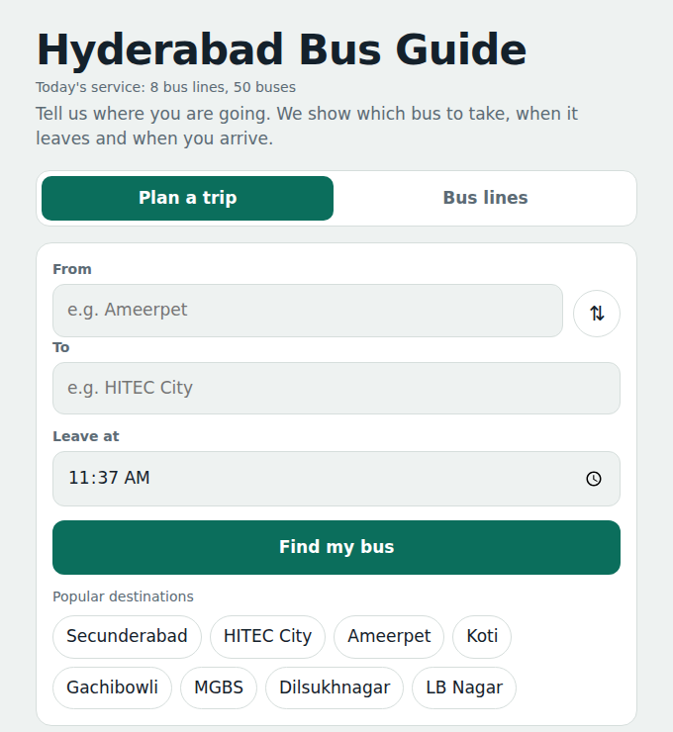
Fig. 1 Passenger portal home: plan a trip or browse bus lines. The page shows today’s service (8 bus lines, 50 buses) and one-tap popular destinations.
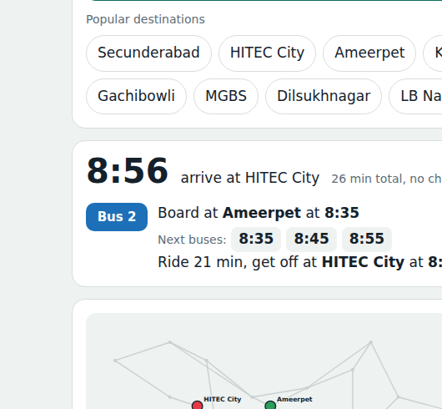
Fig. 2 Trip result for Ameerpet → HITEC City leaving 8:30. The portal names the bus (Bus 2), the next departures and the arrival time (8:56, 26 minutes, no change), and highlights the path on the map.
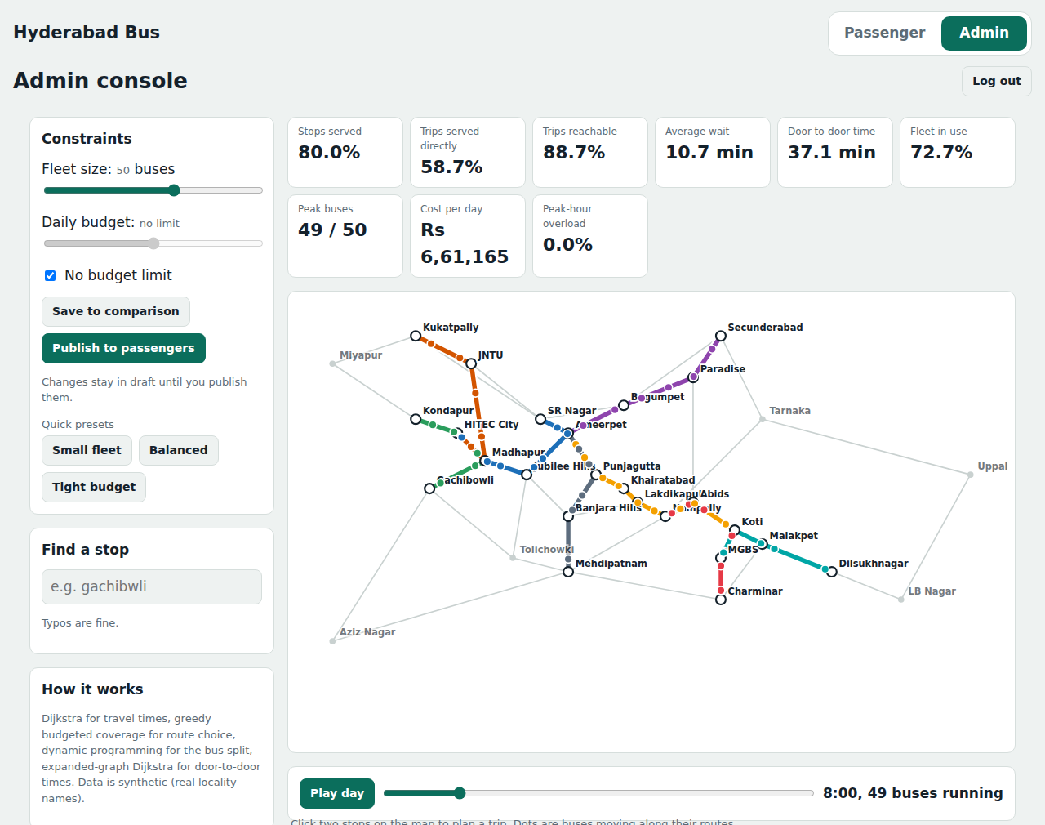
Fig. 3 Admin console after PIN sign-in. Sliders set fleet size and daily budget; colour cards show coverage, waiting time, travel time, utilisation and cost, and the map animates buses along the eight routes.
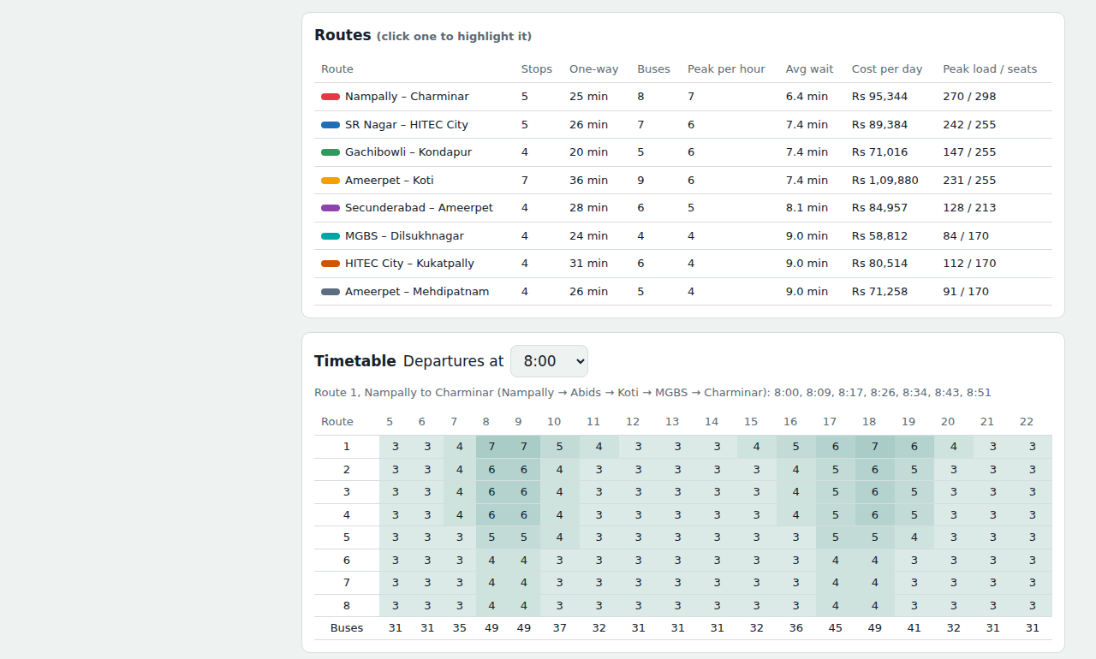
Fig. 4 Admin console: route table (buses, peak frequency, waiting time, cost, peak load against seats) and the hourly timetable heat-table showing buses per hour for every route.
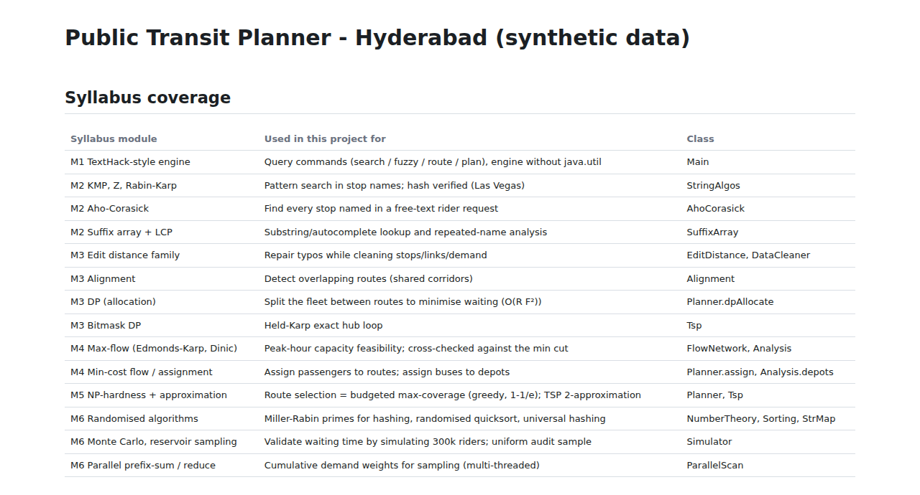
Fig. 5 Generated report (output/report.html): the syllabus-coverage table linking each module of the course to the class that implements it.
7.2 Data cleaning and verification results
The cleaner turned 38 raw stop rows into 30 stops, 52 raw links into 45 road links (network connected) and 226 raw demand rows into 110 undirected origin-destination pairs carrying 42,635 trips a day. Fuzzy matching fixed 2 names (for example “Gachibwli” → “Gachibowli”, edit distance 1), 7 duplicates were merged and 12 invalid rows were dropped. Table 2 summarises the checks on the algorithms.
Check | Result
Randomised self-test of all algorithms against slow baselines | 7,470 checks passed, 0 failed
Max-flow at peak hour (2,660 passengers) | Edmonds-Karp = Dinic = min-cut capacity = 2,660
Monte Carlo waiting time (300,000 random riders) | Simulated 7.57 min (± 0.02) vs analytic 7.57 min
Express loop through 12 busiest hubs (TSP) | Held-Karp exact 229.8 min; MST 2-approximation 288.9 min (ratio 1.257, bound 2)
Route candidates and greedy selection (fleet 50) | 70 candidates generated, 8 routes picked
Typo repair examples | “Secundrabad” → Secunderabad and “Ameerpt” → Ameerpet (distance 1)
Table 2 Verification results of the Java engine
7.3 Scenario comparison
The baseline plan uses a 50-bus fleet with no budget cap. It covers 80.0% of stops, serves 58.9% of demand with a direct bus and makes 88.8% of demand reachable with a change, with an average wait of 10.6 minutes, an average trip of 37.0 minutes, 72.8% fleet utilisation and a cost of Rs 663,357 per day. Table 3 compares it with other fleet sizes and a budget cut.
Scenario | Routes | Direct demand | Avg wait (min) | Avg trip (min) | Utilisation | Cost / day (Rs)
Fleet 30 | 5 | 44.1% | 9.0 | 27.7 | 73.5% | 398,750
Fleet 40 | 7 | 52.1% | 11.5 | 37.7 | 75.1% | 541,103
Fleet 50 (baseline) | 8 | 58.9% | 10.6 | 37.0 | 72.8% | 663,357
Fleet 60 | 10 | 64.4% | 10.1 | 35.4 | 74.0% | 818,918
Fleet 60, budget −30% | 8 | 58.9% | 13.2 | 39.6 | 52.8% | 566,124
Table 3 Scenario comparison from the Java engine
7.4 Discussion
- More buses buy more coverage but at rising cost: going from 30 to 60 buses lifts direct service from 44.1% to 64.4% of demand, while daily cost doubles from about Rs 399,000 to Rs 819,000.
- Average wait does not fall in a straight line. The 30-bus plan has only 5 routes, so riders on those few corridors wait less, but fewer riders have a direct bus; adding routes first widens coverage and only later shortens waits.
- A 30% budget cut on a 60-bus fleet keeps 8 routes but raises the average wait from 10.1 to 13.2 minutes and drops utilisation to 52.8%: the planner cuts frequency, so the buses run partly empty and riders pay in time.
- Some places stay unserved at modest fleet sizes. For example, no bus connects Aziz Nagar to Uppal in the baseline plan, because the budget is spent on busier corridors first. The Admin portal exposes this gap and shows that a larger fleet closes it.
- The Monte Carlo waiting time (7.57 min) matches the analytic value, and three independent max-flow computations agree, which gives confidence that the metrics shown to the user are correct.
- CONCLUSION & FUTURE SCOPE

The project set out to build a planner that designs bus service under a fixed fleet and daily budget and measures the outcome. This was achieved: the Public Transit Planner cleans noisy data, finds fastest paths with Dijkstra, selects routes with a greedy budgeted coverage rule, splits the fleet by dynamic programming, assigns passengers within seat capacity by min-cost max-flow, produces an hourly timetable and reports coverage, waiting time, travel time, utilisation and cost. Verification by 7,470 randomised checks, three agreeing max-flow computations and a Monte Carlo simulation that matches the analytic waiting time shows that the algorithms behave correctly. The Passenger and Admin portals make the result usable by riders and by planners, and all of this is built with hand-written algorithms and no java.util, as the course requires.
Limitations. The data is synthetic; riders who change buses are counted in travel time and waiting time but not in the seat-capacity flow; each route is a fixed two-way line with the same frequency in both directions; cost uses a simple rate (Rs 38 per bus-km and Rs 520 per bus-hour); and the admin PIN and HTTP server are suitable for a demo only.
Future scope
Near term. Load real GTFS and ridership data from a city agency; save published plans and saved scenarios in a database; add fares and support more than one depot in the portal.
Medium term. Include transfer riders in the seat-capacity flow; allow different frequency in each direction; add live bus positions and delay updates; compare the greedy route choice with stronger local-search or integer-programming solutions.
Long term. Extend to multimodal trips (metro, walking, bike share); use demand forecasts that change by day type and season; add secure login, a mobile app and an open API so that other applications can use the published plan.
- REFERENCES

1. General Transit Feed Specification (GTFS). https://gtfs.org/
2. OpenTripPlanner, an open-source multimodal trip planner. https://www.opentripplanner.org/ and https://github.com/opentripplanner/opentripplanner
3. Conveyal R5: Rapid Realistic Routing on Real-world and Reimagined networks. https://github.com/conveyal/r5
4. D. Delling, T. Pajor and R. F. Werneck, “Round-Based Public Transit Routing”, Transportation Science, vol. 49, no. 3, pp. 591–604, 2015. https://www.microsoft.com/en-us/research/publication/round-based-public-transit-routing/
5. A. Ceder and N. H. M. Wilson, “Bus Network Design”, Transportation Research Part B, vol. 20, no. 4, pp. 331–344, 1986.
6. C. E. Mandl, “Evaluation and Optimization of Urban Public Transportation Networks”, European Journal of Operational Research, vol. 5, no. 6, pp. 396–404, 1980.
7. V. Guihaire and J.-K. Hao, “Transit Network Design and Scheduling: A Global Review”, Transportation Research Part A, vol. 42, no. 10, pp. 1251–1273, 2008.
8. G. L. Nemhauser, L. A. Wolsey and M. L. Fisher, “An Analysis of Approximations for Maximizing Submodular Set Functions – I”, Mathematical Programming, vol. 14, pp. 265–294, 1978.
9. E. W. Dijkstra, “A Note on Two Problems in Connexion with Graphs”, Numerische Mathematik, vol. 1, pp. 269–271, 1959. https://doi.org/10.1007/BF01386390
10. J. Edmonds and R. M. Karp, “Theoretical Improvements in Algorithmic Efficiency for Network Flow Problems”, Journal of the ACM, vol. 19, no. 2, pp. 248–264, 1972. https://doi.org/10.1145/321694.321699
11. T. H. Cormen, C. E. Leiserson, R. L. Rivest and C. Stein, Introduction to Algorithms, 4th ed., MIT Press, 2022.

