1.
#include <stdio.h>
#include <stdlib.h>
#include <string.h>

#define MAX_COMMANDS 10
#define BUFFER_SIZE 100

char *history[MAX_COMMANDS];
int history_count = 0;

void add_history(const char *command)
{
if (history_count < MAX_COMMANDS)
{
history[history_count] = malloc(strlen(command) + 1);
strcpy(history[history_count], command);
history_count++;
}
else
{
free(history[0]);

for (int i = 1; i < MAX_COMMANDS; i++)
history[i - 1] = history[i];

history[MAX_COMMANDS - 1] = malloc(strlen(command) + 1);
strcpy(history[MAX_COMMANDS - 1], command);
}
}

void show_history()
{
printf("\n\nCommand History:\n");

for (int i = 0; i < history_count; i++)
printf("%d: %s\n", i + 1, history[i]);
}

void free_history()
{
for (int i = 0; i < history_count; i++)
free(history[i]);
}

int main()
{
char buffer[BUFFER_SIZE];
int current = -1;

printf("Simple Command History\n");
printf("Type 'history' to view commands.\n");
printf("Use UP/DOWN conceptually to navigate history.\n");
printf("Type 'exit' to quit.\n\n");

while (1)
{
printf("shell> ");

if (fgets(buffer, BUFFER_SIZE, stdin) == NULL)
break;

buffer[strcspn(buffer, "\n")] = '\0';

if (strcmp(buffer, "exit") == 0)
break;

if (strlen(buffer) == 0)
continue;

if (strcmp(buffer, "history") == 0)
{
show_history();
continue;
}

add_history(buffer);

current = history_count;

printf("Command executed: %s\n", buffer);
}

free_history();

return 0;
}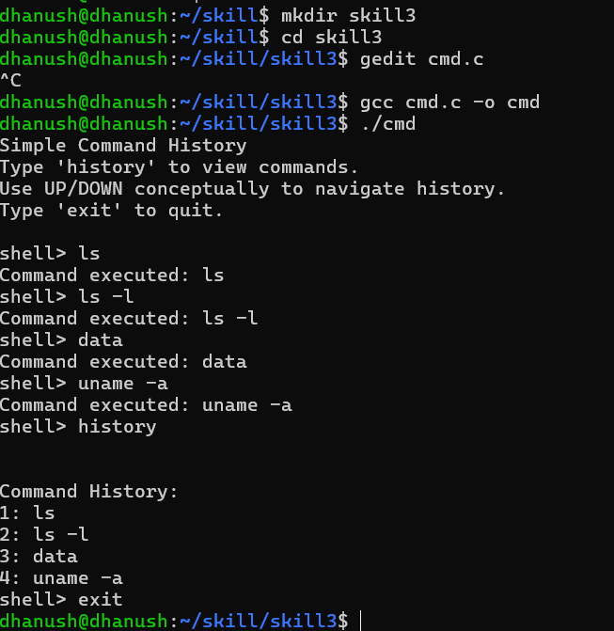

2.
#include <stdio.h>
#include <stdlib.h>
#include <string.h>

typedef struct Node
{
char *command;
struct Node *next;
} Node;

void add_command(Node **head, const char *command)
{
Node *newNode = malloc(sizeof(Node));

if (newNode == NULL)
{
printf("Memory allocation failed\n");
return;
}

newNode->command = malloc(strlen(command) + 1);

if (newNode->command == NULL)
{
free(newNode);
printf("Memory allocation failed\n");
return;
}

strcpy(newNode->command, command);

newNode->next = *head;
*head = newNode;
}

void display_commands(Node *head)
{
printf("\nStored Commands:\n");

while (head != NULL)
{
printf("%s\n", head->command);
head = head->next;
}
}

void free_list(Node *head)
{
Node *temp;

while (head != NULL)
{
temp = head;
head = head->next;

free(temp->command);
free(temp);
}
}

int main()
{
char *buffer;
int size = 20;

Node *head = NULL;

buffer = malloc(size);

if (buffer == NULL)
{
printf("Initial allocation failed\n");
return 1;
}

printf("Enter a command: ");

if (fgets(buffer, size, stdin) == NULL)
{
free(buffer);
return 1;
}

buffer[strcspn(buffer, "\n")] = '\0';

add_command(&head, buffer);

/* Resize buffer */
size *= 2;

char *temp = realloc(buffer, size);

if (temp == NULL)
{
printf("Reallocation failed\n");
free(buffer);
free_list(head);
return 1;
}

buffer = temp;

printf("Enter another command: ");

if (fgets(buffer, size, stdin) != NULL)
{
buffer[strcspn(buffer, "\n")] = '\0';
add_command(&head, buffer);
}

display_commands(head);

free(buffer);
free_list(head);

printf("\nAll dynamically allocated memory released.\n");

return 0;
}

