Server.c
#include <stdio.h>
#include <stdlib.h>
#include <string.h>
#include <fcntl.h>
#include <sys/stat.h>
#include <unistd.h>

#define REQUEST_FIFO "request_fifo"
#define RESPONSE_FIFO "response_fifo"

int main() {
int request_fd, response_fd;
char message[100];
char response[150];

mkfifo(REQUEST_FIFO, 0666);
mkfifo(RESPONSE_FIFO, 0666);

printf("Server started. Waiting for client...\n");

request_fd = open(REQUEST_FIFO, O_RDONLY);
response_fd = open(RESPONSE_FIFO, O_WRONLY);

while (1) {
memset(message, 0, sizeof(message));

if (read(request_fd, message, sizeof(message) - 1) <= 0)
break;

printf("Client message: %s\n", message);

if (strcmp(message, "exit\n") == 0 ||
strcmp(message, "exit") == 0) {
strcpy(response, "Server shutting down.");
write(response_fd, response, strlen(response) + 1);
break;
}

snprintf(response, sizeof(response),
"Server processed: %s", message);

write(response_fd, response, strlen(response) + 1);
}

close(request_fd);
close(response_fd);

unlink(REQUEST_FIFO);
unlink(RESPONSE_FIFO);

printf("Server terminated.\n");
return 0;
}
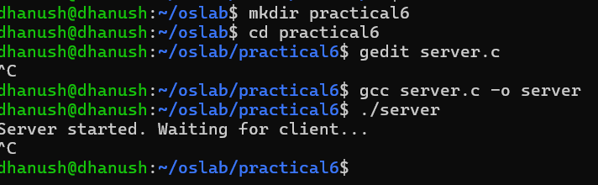
Client.c
#include <stdio.h>
#include <stdlib.h>
#include <string.h>
#include <fcntl.h>
#include <unistd.h>

#define REQUEST_FIFO "request_fifo"
#define RESPONSE_FIFO "response_fifo"

int main() {
int request_fd, response_fd;
char message[100];
char response[150];

printf("Connecting to server...\n");

request_fd = open(REQUEST_FIFO, O_WRONLY);
response_fd = open(RESPONSE_FIFO, O_RDONLY);

while (1) {
printf("Enter message: ");
fflush(stdout);

if (fgets(message, sizeof(message), stdin) == NULL)
break;

write(request_fd, message, strlen(message) + 1);

memset(response, 0, sizeof(response));
read(response_fd, response, sizeof(response) - 1);

printf("Server response: %s\n", response);

if (strcmp(message, "exit\n") == 0 ||
strcmp(message, "exit") == 0)
break;
}

close(request_fd);
close(response_fd);

return 0;
}
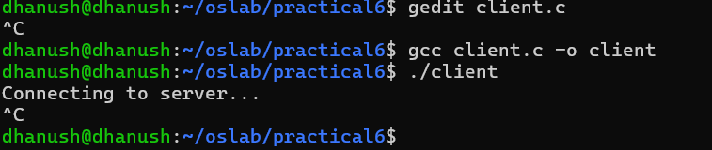
SIGNALS.C
#include <stdio.h>
#include <stdlib.h>
#include <signal.h>
#include <unistd.h>

volatile sig_atomic_t signal_received = 0;

void handle_signal(int sig) {
signal_received = sig;
}

int main() {
struct sigaction sa;

sa.sa_handler = handle_signal;
sigemptyset(&sa.sa_mask);
sa.sa_flags = 0;

sigaction(SIGINT, &sa, NULL);
sigaction(SIGTERM, &sa, NULL);
sigaction(SIGUSR1, &sa, NULL);

printf("Process ID: %d\n", getpid());
printf("Waiting for signals...\n");

while (1) {
pause();

if (signal_received == SIGINT) {
printf("\nSIGINT received: Keyboard interrupt.\n");
signal_received = 0;
}
else if (signal_received == SIGTERM) {
printf("SIGTERM received: Terminating process.\n");
break;
}
else if (signal_received == SIGUSR1) {
printf("SIGUSR1 received: User-defined event.\n");
signal_received = 0;
}
}

printf("Program terminated.\n");
return 0;
}
