#include <stdio.h>

int main() {
char input[100];

while (1) {
printf("shell> ");
fgets(input, sizeof(input), stdin);

printf("You entered: %s", input);
}
return 0;
}
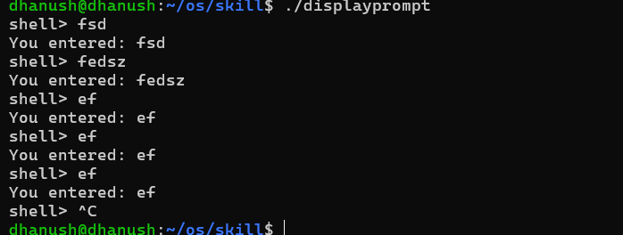

#include <stdio.h>
#include <string.h>

int main() {
char input[100];

while (1) {
printf("shell> ");
fgets(input, sizeof(input), stdin);

input[strcspn(input, "\n")] = '\0';

if (strcmp(input, "exit") == 0) {
printf("Exiting...\n");
break;
}

printf("You entered: %s\n", input);
}

return 0;
}

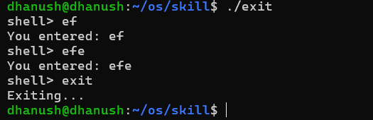
#include <stdio.h>
#include <string.h>

int main() {
char input[100];

while (1) {
printf("shell> ");
fgets(input, sizeof(input), stdin);

input[strcspn(input, "\n")] = '\0';

if (strcmp(input, "exit") == 0) {
printf("Program terminated.\n");
break;
}

printf("Command processed: %s\n", input);
}

return 0;
}

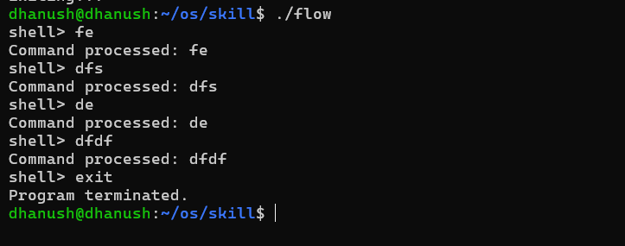

#include <stdio.h>
#include <string.h>

int main() {
char input[100];

while (1) {
printf("shell> ");
fgets(input, sizeof(input), stdin);

input[strcspn(input, "\n")] = '\0';

if (strcmp(input, "exit") == 0) {
break;
}

printf("You entered: %s\n", input);
}

printf("Exiting shell...\n");

return 0;
}

