**Create a web form that accepts a user's name and age Write a Servlet to process the form data and display it**

**back on the browser.**

**EXP:4**

**AIM:**

Create a web form that accepts a user's name and age. Write a Servlet to process the form data and display it back on the browser.

# CODE:

**USER.HTML**

<!DOCTYPE html>

<html>

<head>

<meta charset=*"ISO-8859-1"*>

<title>Insert title here</title>

</head>

<body>

<form action=*"/Daksh_25/Signin"* >

<label for=*"name"* >USER-NAME</label>

<input type=*"text"* name=*name* placeholder=*"Enter the User-name"* required>

<br>

<br>

<label for=*"age"*>AGE

</label>

<input type=*"text"* name=*age* placeholder=*"Enter the Age"* required>

<br>

<input type = *"submit"* value= *"signin"*>

</form>

</body>

</html>

# DISPLAYUSER.JAVA

package com.daksh.servlet;

import java.io.IOException; import java.io.PrintWriter;

import javax.servlet.ServletException; import javax.servlet.annotation.WebServlet; import javax.servlet.http.HttpServlet;

import javax.servlet.http.HttpServletRequest; import javax.servlet.http.HttpServletResponse;

/**

* Servlet implementation class Signin 4*/

@WebServlet("/Signin")

public class Signin extends HttpServlet {

private static final long serialVersionUID = 1L;

/**

* @see HttpServlet#HttpServlet()

*/

public Signin() { super();

// TODO Auto-generated constructor stub

}

/**

* @see HttpServlet#doGet(HttpServletRequest request, HttpServletResponse response)

*/

protected void doGet(HttpServletRequest request, HttpServletResponse response) throws ServletException, IOException {

String a = request.getParameter("name");

int b = Integer.parseInt (request.getParameter("age")); PrintWriter p = response.getWriter();

if(b>=1)

{

}

else

{

}

}

p.println("User-name: "+ a);

p.print("Age: "+ b);

p.print("Invalid credentials!");

/**

* @see HttpServlet#doPost(HttpServletRequest request, HttpServletResponse response)

*/

protected void doPost(HttpServletRequest request, HttpServletResponse response) throws ServletException, IOException {

// TODO Auto-generated method stub doGet(request, response);

}

}

# OUTPUT:

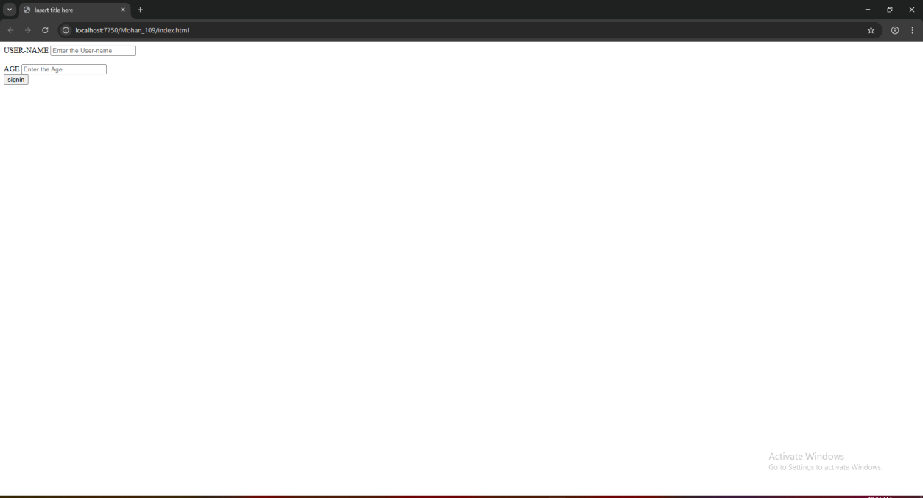

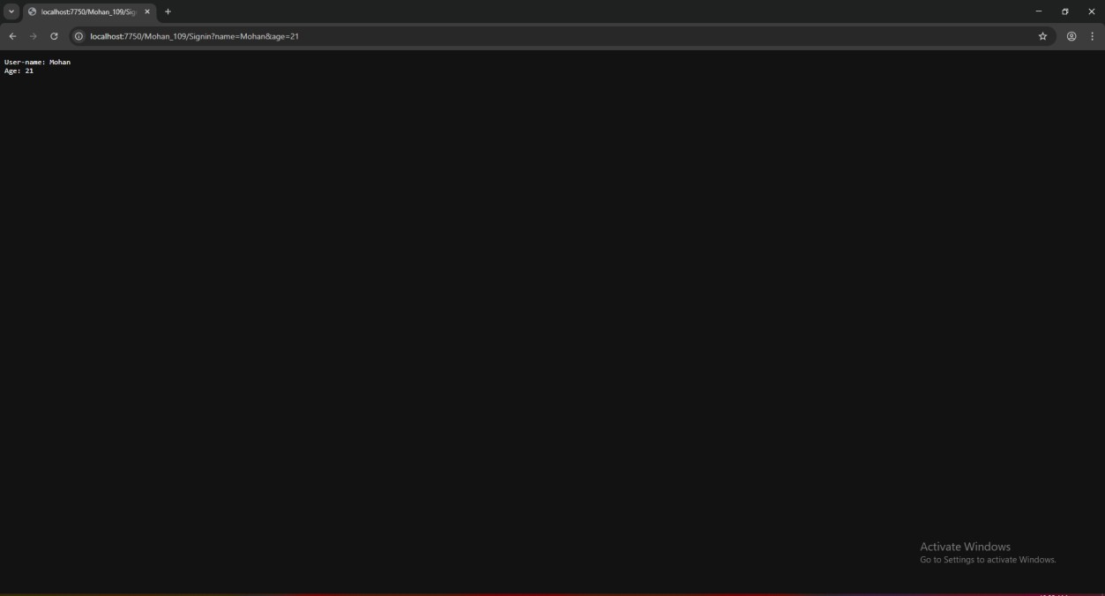

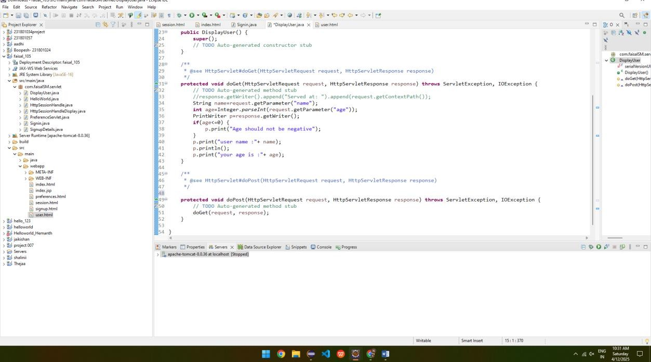

**RESULT:**

Validating the username and age is is done successfully and displayed in the browser.