|  |  |
| --- | --- |
| **EXP : 6** | **Write a Servlet to demonstrate  session tracking using HTTP Session.** |

**AIM:**

To Write a Servlet Program to demonstrate session tracking using HTTP Session.  
Implement a simple login system where the user's session is tracked.

**CODE:**

**Session.html:**

<!DOCTYPE html>

<html>

<head>

<meta charset=*"ISO-8859-1"*>

<title>HTTP SESSION </title>

</head>

<body>

<h1>Form Handle By HTTP Session</h1>

<form action=*"/Daksh_25/HttpSessionHandle"* method=*"POST"* style="margin-left: *50px*">

<label>Username: </label><input type=*"text"* name=*"username"*/><br><br>

<label>Password: </label><input type=*"password"* name=*"password"*/><br><br>

<input type=*"submit"* value=*"Login"* style="margin-left: *130px*"/>

</form>

</body>

</html>

**HttpSessionHandle.java:**

package com.daksh.servlet;

import java.io.IOException;

import java.io.PrintWriter;

import javax.servlet.ServletException;

import javax.servlet.annotation.WebServlet;

import javax.servlet.http.HttpServlet;

import javax.servlet.http.HttpServletRequest;

import javax.servlet.http.HttpServletResponse;

import javax.servlet.http.HttpSession;

/**

* Servlet implementation class HttpSessionHandle

*/

@WebServlet("/HttpSessionHandle")

public class HttpSessionHandle extends HttpServlet {

private static final long serialVersionUID = 1L;

/**

* @see HttpServlet#HttpServlet()

*/

public HttpSessionHandle() {

super();

// TODO Auto-generated constructor stub

}

/**

* @see HttpServlet#doGet(HttpServletRequest request, HttpServletResponse response)

*/

protected void doGet(HttpServletRequest request, HttpServletResponse response) throws ServletException, IOException {

// TODO Auto-generated method stub

response.getWriter().append("Served at: ").append(request.getContextPath());

}

/**

* @see HttpServlet#doPost(HttpServletRequest request, HttpServletResponse response)

*/

protected void doPost(HttpServletRequest request, HttpServletResponse response) throws ServletException, IOException {

String username = "Faisal";

String password = "104";

PrintWriter p = response.getWriter();

String user = request.getParameter("username");

String pass = request.getParameter("password");

if(user.equals(username) && pass.equals(password))

{

HttpSession session = request.getSession(true);

session.putValue("username", user);

response.sendRedirect(request.getContextPath() + "/HttpSessionHandleDisplay");

}

else

{

p.println("fail");

}

}

}

**HttpSessionHandleDisplay.java:**

package com.daksh.servlet;

import java.io.IOException;

import java.io.PrintWriter;

import javax.servlet.ServletException;

import javax.servlet.annotation.WebServlet;

import javax.servlet.http.HttpServlet;

import javax.servlet.http.HttpServletRequest;

import javax.servlet.http.HttpServletResponse;

import javax.servlet.http.HttpSession;

/**

* Servlet implementation class HttpSessionHandleDisplay

*/

@WebServlet("/HttpSessionHandleDisplay")

public class HttpSessionHandleDisplay extends HttpServlet {

private static final long serialVersionUID = 1L;

/**

* @see HttpServlet#HttpServlet()

*/

public HttpSessionHandleDisplay() {

super();

// TODO Auto-generated constructor stub

}

/**

* @see HttpServlet#doGet(HttpServletRequest request, HttpServletResponse response)

*/

protected void doGet(HttpServletRequest request, HttpServletResponse response) throws ServletException, IOException {

PrintWriter p = response.getWriter();

HttpSession session = request.getSession(true);

@SuppressWarnings("deprecation")

String user_name = (String)session.getValue("username");

p.println("Username is " + user_name);

}

/**

* @see HttpServlet#doPost(HttpServletRequest request, HttpServletResponse response)

*/

protected void doPost(HttpServletRequest request, HttpServletResponse response) throws ServletException, IOException {

// TODO Auto-generated method stub

doGet(request, response);

}

}

**OUTPUT:**

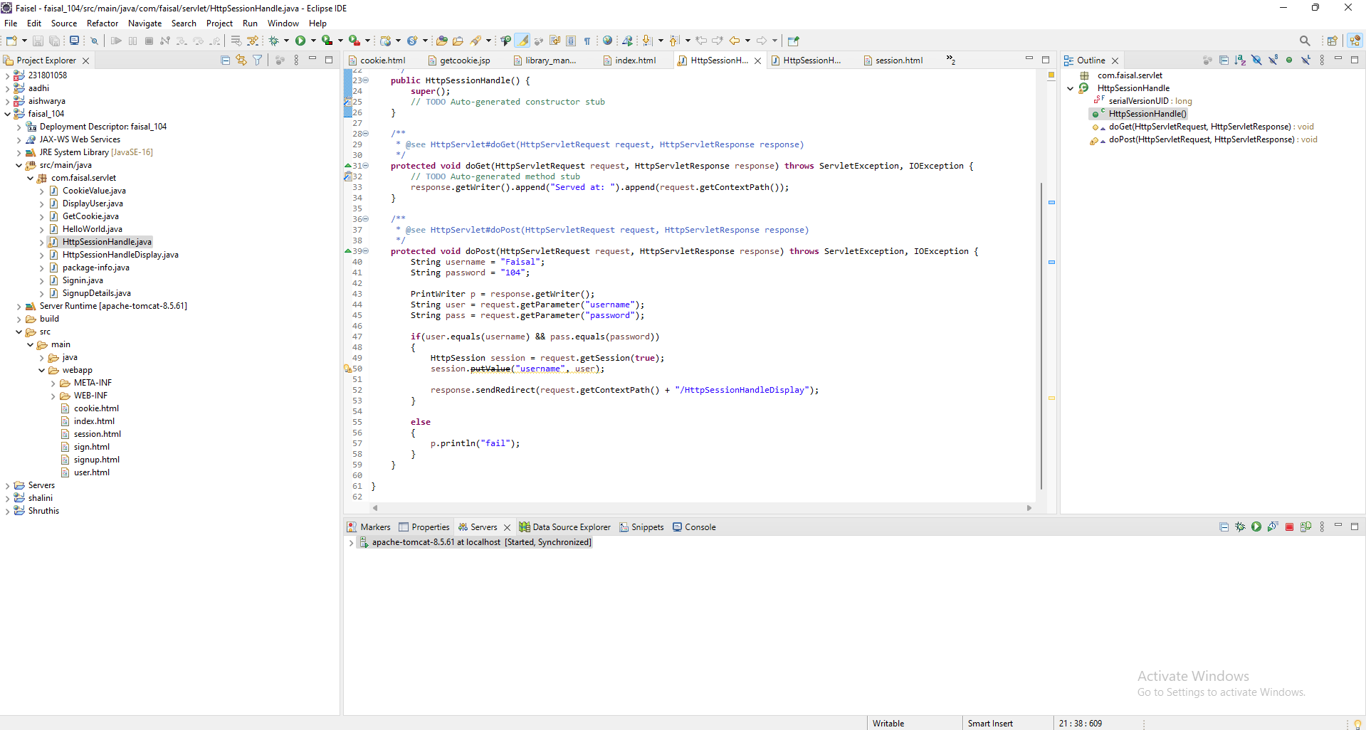

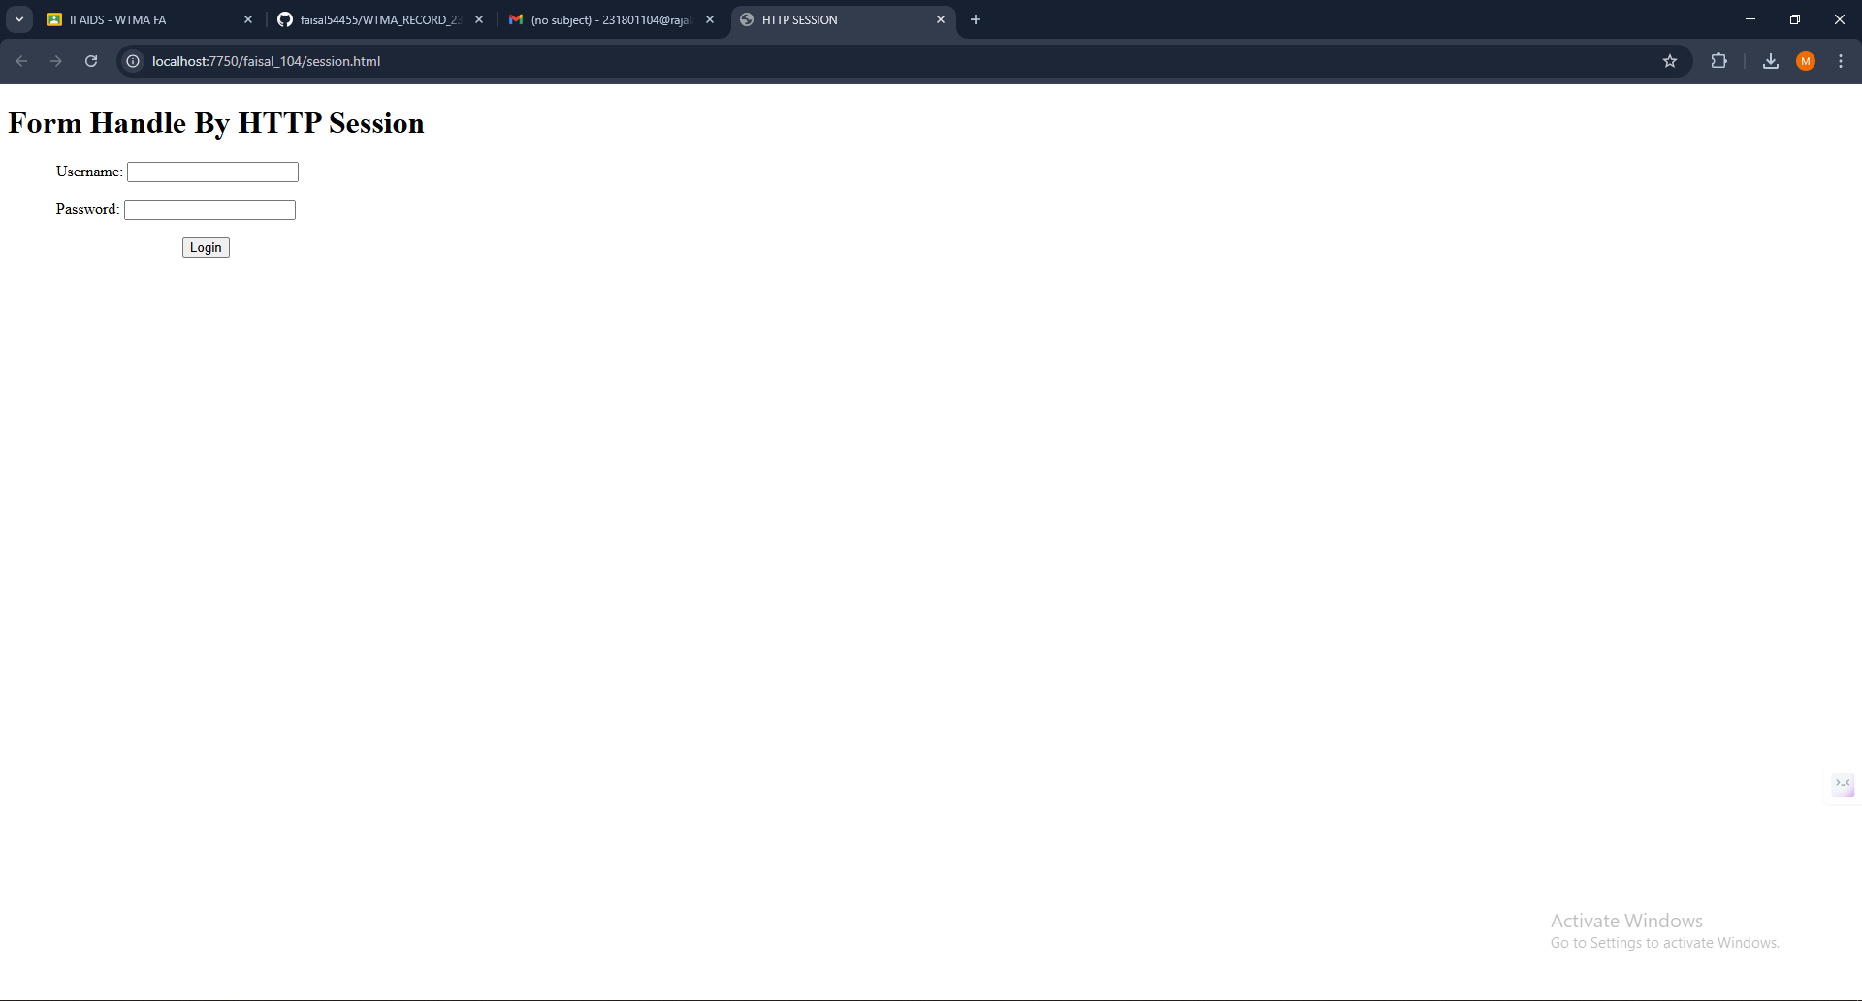

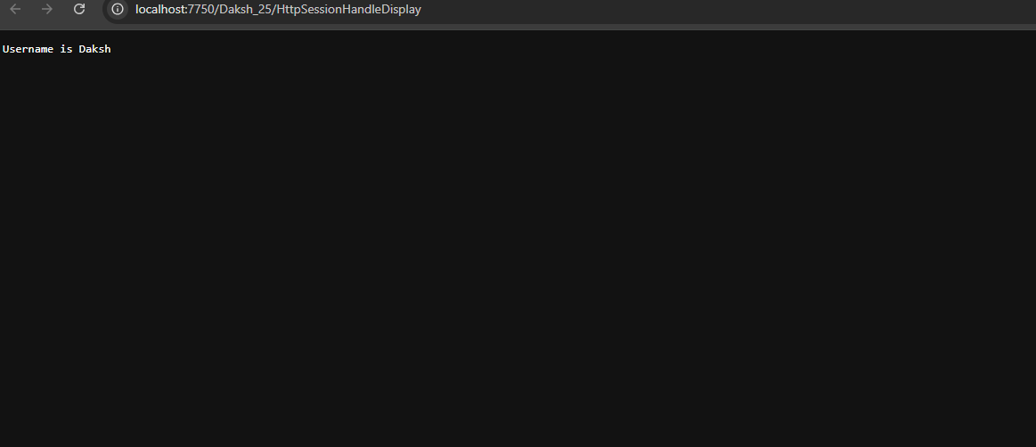

**RESULT:**

Servlet to demonstrate session tracking using HTTP Session Has been Executed Successfully.