OPERATING SYSTEMS LAB PROJECT REPORT
DeadlockGuard
A Predictive Resource Allocation and Deadlock Risk Detection System
Submitted in partial fulfilment of the requirements for the Operating Systems Laboratory Project (40 Marks)
Team Members:
1. ______________________________
2. ______________________________
3. ______________________________
Department of ________________________
Academic Year: 2026

Abstract
DeadlockGuard is a lightweight, real-time deadlock risk prediction and resolution advisory system built on core Operating Systems concepts. Traditional deadlock-handling implementations of the Banker's Algorithm only classify the system state as SAFE or UNSAFE and report a deadlock strictly after it has already occurred. DeadlockGuard extends this classical model by continuously computing a quantitative Deadlock Risk Score (0-100) from live process, resource, and wait-time data, allowing the system to flag dangerously trending resource-allocation states before a true deadlock forms. The system further classifies risk into four actionable bands (LOW, MEDIUM, HIGH, CRITICAL) and generates a concrete recommended action - such as releasing a specific resource or re-prioritizing a specific process - that an operator or scheduler could act on to avoid the deadlock. The project demonstrates Process Management, Resource Allocation, Deadlock Avoidance and Detection, and Synchronization concepts through a working simulator, a scoring engine, and a live visualization dashboard, and is designed to be fully implementable within a 2-3 day development window.

1. Objectives
- To simulate a multi-process, multi-resource system with dynamically changing allocation and request patterns.
- To implement the classical Banker's Algorithm for safe-state checking and the Resource Allocation Graph (RAG) for deadlock detection via cycle detection.
- To design and implement a novel composite Deadlock Risk Score that quantifies how close the system is to deadlock, rather than a binary safe/unsafe verdict.
- To classify system risk into interpretable severity bands and generate an automated recommendation for deadlock avoidance.
- To visualize the resource allocation graph, the live risk score, and system alerts through a simple real-time dashboard.
- To evaluate the system's accuracy and responsiveness through a structured set of test cases covering safe, unsafe, and deadlocked states.

2. Problem Statement
Conventional deadlock-handling mechanisms taught and implemented in Operating Systems courses operate in a binary fashion: a system state is either declared SAFE (Banker's Algorithm) or a deadlock is reported only once a circular wait has already fully formed (cycle detection in the Resource Allocation Graph). This binary approach offers no early warning - by the time a deadlock is detected, the involved processes are already blocked indefinitely and must be forcibly terminated or have their resources preempted, both of which are costly and disruptive.
There is a practical gap between "safe" and "deadlocked": systems frequently pass through a dangerous intermediate zone - many processes waiting, high resource utilization, near-circular dependency chains - well before an actual cycle completes. DeadlockGuard addresses this gap by continuously scoring how close the system is to that dangerous zone and by suggesting a concrete corrective action, giving a scheduler or operator a chance to intervene proactively rather than reactively.

3. Literature / Background Study

3.1 Banker's Algorithm
The Banker's Algorithm (Dijkstra) is a deadlock-avoidance algorithm that determines whether granting a resource request would leave the system in a safe state - that is, whether there exists at least one ordering in which all processes can complete using the currently available resources. It relies on three data structures: the Allocation matrix (resources currently held by each process), the Max/Need matrix (maximum additional resources each process may request), and the Available vector (resources currently free).

3.2 Resource Allocation Graph (RAG) and Cycle Detection
A Resource Allocation Graph models processes and resources as nodes, with request edges (process to resource) and assignment edges (resource to process). For systems with single-instance resource types, a cycle in the RAG is a necessary and sufficient condition for deadlock; for multi-instance resource types, a cycle is necessary but not sufficient, and formal detection requires an algorithm equivalent to the Banker's safety algorithm. DeadlockGuard uses Depth-First Search (DFS) based cycle detection on the wait-for graph derived from the RAG.

3.3 Limitation Addressed by This Project
Both mechanisms above are state-based and binary. Research and industry monitoring tools (e.g., database lock monitors, container orchestration health checks) commonly use trend-based and threshold-based health scores instead of binary flags, because a continuous score supports proactive alerting, prioritization, and graceful degradation. DeadlockGuard applies this same principle - well established in systems monitoring - specifically to the classical OS deadlock model, which is the project's core contribution.

4. System Design and Architecture
The system is organized as a pipeline of independent modules, each mapped to a specific OS concept, so that module ownership can be cleanly divided among team members. The overall data flow is shown below.
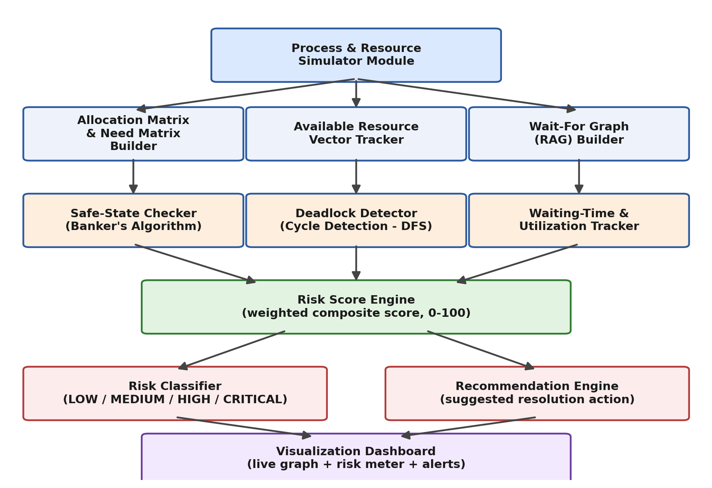

4.1 Module Description
Module | OS Concept | Responsibility
Process & Resource Simulator | Process Management | Generates/simulates processes, resource types, and dynamic allocation/request events.
Allocation & Need Matrix Builder | Resource Allocation | Maintains Allocation, Max, and Need matrices for every process-resource pair.
Available Resource Tracker | Resource Allocation | Tracks the currently free instances of each resource type.
Wait-For Graph Builder | Deadlock Handling | Constructs the RAG / wait-for graph from current requests and allocations.
Safe-State Checker | Deadlock Avoidance | Runs the Banker's safety algorithm to test whether the current state is safe.
Deadlock Detector | Deadlock Detection | Runs DFS-based cycle detection on the wait-for graph.
Waiting-Time & Utilization Tracker | Process Monitoring | Tracks per-process wait duration and overall resource utilization percentage.
Risk Score Engine | Core Contribution | Combines the above signals into a single weighted Deadlock Risk Score (0-100).
Risk Classifier | Core Contribution | Maps the numeric score to LOW / MEDIUM / HIGH / CRITICAL bands.
Recommendation Engine | Core Contribution | Suggests a specific resolution action based on the graph and risk band.
Visualization Dashboard | Presentation Layer | Displays the live graph, risk meter, and alerts for demonstration.

5. Core Algorithms

5.1 Safety Algorithm (Banker's Algorithm)
Work = Available
Finish[i] = false for all processes i
repeat:
find i such that Finish[i] == false and Need[i] <= Work
if no such i exists: break
Work = Work + Allocation[i]
Finish[i] = true
until no progress
if all Finish[i] == true: SAFE
else: UNSAFE

5.2 Deadlock Detection (Cycle Detection on Wait-For Graph)
for each process node P not yet visited:
DFS(P) with recursion-stack tracking
if a back-edge to a node already in the
current recursion stack is found:
report CYCLE -> deadlock exists
record the cycle path for the report

5.3 Deadlock Risk Score (Project's Core Contribution)
The risk score is a weighted composite of four normalized (0-100) factors, each derived from data the system already computes for the algorithms above:
- Waiting-Process Ratio (WPR) - percentage of active processes currently blocked on a request.
- Resource Utilization (RU) - percentage of total resource instances currently allocated (not free).
- Circular Dependency Factor (CDF) - 0 if the wait-for graph has no cycle and no partial chain, 50 if a chain of length >= 2 exists without closing (a "near-cycle"), 100 if an actual cycle is detected.
- Waiting-Time Factor (WTF) - average wait time of blocked processes, normalized against a configurable threshold (capped at 100).
The overall score is:
Risk Score = (0.25 x WPR) + (0.20 x RU)
+ (0.35 x CDF) + (0.20 x WTF)
Risk Score is clamped to the range [0, 100].
The weights above (25 / 20 / 35 / 20) give the highest importance to the Circular Dependency Factor, since a forming cycle is the strongest structural signal of an impending deadlock, while still allowing utilization and wait-time trends to raise the score before a cycle fully closes. The weights are implemented as configurable constants so their sensitivity can be discussed and tuned during the viva.

5.4 Risk Classification Bands
Score Range | Risk Level | Interpretation
0 - 30 | LOW | System healthy; resources circulating normally.
31 - 60 | MEDIUM | Some contention; worth monitoring, no action needed yet.
61 - 80 | HIGH | Strong warning signs (near-cycle / high utilization); intervention advised.
81 - 100 | CRITICAL | Cycle detected or imminent; immediate corrective action required.

5.5 Recommendation Engine Logic
Once a risk band is computed, the Recommendation Engine inspects the wait-for graph and process metadata to propose one concrete action:
- CRITICAL: identify the resource whose release would break the detected cycle with the least disruption (e.g., held by the process with the shortest remaining need) and recommend releasing it, or recommend preempting the lowest-priority process in the cycle.
- HIGH: recommend prioritizing the process that is blocking the largest number of dependent processes, so its request completes and the chain shortens.
- MEDIUM / LOW: no forced action; log an advisory note only.
Example output format used in the dashboard and console:
Resource State
P1 -> R1 (held), R2 (waiting)
P2 -> R2 (held), R3 (waiting)
P3 -> R3 (held), R1 (waiting)
DEADLOCK RISK: 92 [CRITICAL]
Suggested Action:
Release R2 from P2 (breaks the cycle)
OR
Prioritize P1 to complete its request first

6. Technology Stack
Layer | Technology | Reason
Core simulation & algorithms | C or Python | Directly implements matrices, graph structures, and the safety/cycle algorithms taught in OS theory.
Multi-process behaviour | POSIX threads / fork() (C) or threading/multiprocessing (Python) | Demonstrates real process/thread creation and synchronization, satisfying the Thread Programming / Synchronization requirement.
Synchronization primitives | Mutex locks, semaphores | Protects shared allocation/need matrices from race conditions during concurrent updates.
Visualization dashboard | Python (matplotlib / Flask + simple HTML) or a lightweight terminal UI | Provides the live RAG graph, risk meter, and alert panel for the demo.
Logging & test data | CSV / JSON files | Stores test-case scenarios and run logs for the results section.

7. Implementation Plan (2-3 Day Schedule)
The project is scoped so that all core functionality is implementable within 2-3 focused days, comfortably meeting the Review I requirement of 60-70% completion and a working prototype.

Day 1 - Core Data Structures and Safety Algorithm
- Define process/resource simulation model (number of processes, resource types and instance counts).
- Implement Allocation, Max, and Need matrices and the Available vector.
- Implement and unit-test the Banker's safety algorithm (SAFE / UNSAFE).
- Implement basic request/release event generator to drive state changes.

Day 2 - Deadlock Detection and Risk Score Engine
- Build the wait-for graph from current allocation/request state.
- Implement DFS-based cycle detection for deadlock confirmation.
- Implement the Waiting-Time and Resource Utilization trackers.
- Implement the Risk Score Engine (WPR, RU, CDF, WTF) and the Risk Classifier bands.
- Implement the Recommendation Engine logic.

Day 3 - Dashboard, Testing, and Documentation
- Build the live visualization dashboard (graph view + numeric/gauge risk meter + alert log).
- Run the full test-case suite (Section 8) and record results.
- Finalize documentation, user manual, and prepare the demo scenarios for Review II.

7.1 Suggested Module Division (Team of Three)
Member | Owns
Member 1 | Process/Resource Simulator, Allocation/Need/Available matrices, Banker's safety algorithm.
Member 2 | Wait-for graph construction, DFS cycle detection, Waiting-Time & Utilization tracker.
Member 3 | Risk Score Engine, Risk Classifier, Recommendation Engine, Visualization Dashboard.

8. Test Cases and Expected Results
Test ID | Scenario | Expected Outcome
TC-01 | All processes' Need <= Available at start | Safety algorithm reports SAFE; Risk Score in LOW band.
TC-02 | Single process requests more than Available | Request denied/queued; Risk Score rises into MEDIUM as waiting time increases.
TC-03 | Three processes each hold one resource and wait for another in a cycle (as in the example) | Cycle detected by DFS; Risk Score in CRITICAL band (~90+); recommendation generated.
TC-04 | High resource utilization (>85%) but no cycle | Risk Score reaches HIGH band due to RU and WPR even though CDF = 0, demonstrating early warning before a cycle forms.
TC-05 | Resource released as per recommendation | Cycle breaks; Risk Score drops back into LOW/MEDIUM band on next evaluation cycle.
TC-06 | Concurrent threads updating matrices simultaneously | No race conditions or corrupted matrix state (validated via mutex-protected updates).

9. Performance Evaluation Metrics
- Detection latency: time between cycle formation and the system flagging CRITICAL risk.
- Early-warning lead time: how many evaluation cycles before an actual deadlock the score first crosses into HIGH.
- False-positive rate: proportion of HIGH/CRITICAL flags that do not lead to an actual deadlock within the observation window.
- Overhead: additional CPU/time cost of running the Risk Score Engine per evaluation cycle compared to running the safety algorithm alone.

10. User Manual (Summary)
- Configure the number of processes, resource types, and instances per type in the simulator's configuration file.
- Run the simulator to start generating allocation/request events (or feed a scripted test scenario from Section 8).
- Launch the dashboard to view the live wait-for graph, the numeric Risk Score, and its color-coded band.
- When the risk band reaches HIGH or CRITICAL, read the Suggested Action panel and apply it (in simulation, trigger the suggested release/priority change) to observe the score recover.
- Review the run log (CSV/JSON) for a full history of state transitions, scores, and actions - useful for the Review II performance discussion.

11. Conclusion and Future Scope
DeadlockGuard demonstrates that classical, syllabus-standard Operating Systems algorithms - the Banker's Algorithm and RAG-based cycle detection - can be extended with a simple, explainable weighted scoring model to provide early, actionable warnings instead of a binary safe/unsafe or post-hoc deadlock report. The project remains fully groundable in taught OS theory, keeping every design decision defensible in a viva, while the composite risk score and recommendation engine give it a distinct identity beyond a standard Banker's Algorithm assignment.
Future extensions could include: adapting the score weights automatically based on observed historical false-positive rates, extending the model to distributed multi-node resource managers, or integrating the risk score as a live input to a priority-aging CPU scheduler so that starvation risk and deadlock risk are managed jointly.

12. References
1. A. Silberschatz, P. B. Galvin, G. Gagne, "Operating System Concepts," - Chapters on Deadlocks and Process Synchronization.
2. E. W. Dijkstra, "Cooperating Sequential Processes," - origin of the Banker's Algorithm concept.
3. A. S. Tanenbaum, "Modern Operating Systems," - Resource Allocation Graphs and deadlock detection algorithms.
4. Course lecture notes and laboratory guidelines - Operating Systems Laboratory Project document.

