Operating Systems Case Study
VMware Photon OS:
Architecture, Resource Management, Security, and Container/Virtualization Support in a Cloud-Native Linux Operating System

Submitted by: Dhanush R – 24BIT0178
Programme / Branch: B.Tech. Information Technology
Semester: Fall Semester 2026-27
Course Code and Name: BITE303L - Operating Systems
Institution: Vellore Institute of Technology, Vellore
Submitted to: Krishnamoorthy N
Date of Submission: 24/10/2026

1. Abstract
Photon OS is a minimal, open-source Linux distribution created by VMware, now maintained under Broadcom, for running containers and cloud-native workloads. It is optimised for VMware infrastructure such as ESXi, but it also runs on public clouds such as Amazon EC2, Microsoft Azure and Google Compute Engine. It is not derived from another distribution. It uses the RPM package format, the tdnf package manager (Tiny DNF), the systemd init system, and a family of purpose-built Linux kernel flavours called linux, linux-esx, linux-secure and linux-rt.
This case study examines Photon OS against the concepts of an Operating Systems course. It covers the system and kernel architecture, process and thread management, CPU scheduling, memory management, file systems, storage and device management, security, networking, and virtualization and container support. It also explains which responsibilities belong to the Linux kernel and which belong to Photon OS-specific components such as systemd, tdnf and the Photon Management Daemon. The study compares Photon OS with Flatcar Container Linux and Ubuntu Server, and discusses advantages, limitations, real-world applications and recent developments. The main finding is that Photon OS gains much of its value from what it leaves out. A small package set, a hypervisor-tuned kernel and a hardened configuration make it a compact and predictable base for appliances and container hosts, although the same narrow focus limits its use as a general-purpose desktop or server system.

2. Introduction
An operating system sits between the hardware and the programs that users run. It allocates the CPU, memory, storage and network devices to competing programs, enforces protection between them, and provides services such as file access and process control. Modern servers rarely run one operating system on one physical machine. Most workloads run inside virtual machines or containers on shared infrastructure, and this has created demand for operating systems that are small, fast to boot, easy to patch and secure by default.
Photon OS was designed for this setting. Its project description calls it an open-source Linux container host optimised for cloud-native applications, cloud platforms and VMware infrastructure (“Photon OS: Linux Container Host”). Instead of shipping thousands of desktop and server packages, it delivers just enough of a Linux operating system to run containers efficiently on vSphere, Azure, Google Compute Engine and Amazon EC2 (“Project Photon OS”). It is also the base operating system of VMware appliances such as the vCenter Server Appliance (“Overview of the vCenter Server Appliance”).
Photon OS is a good subject for an Operating Systems case study for three reasons. First, it uses the standard Linux kernel, so the textbook mechanisms for process management, scheduling, virtual memory, file systems and protection can be studied in a real system. Second, it adds its own design decisions on top of that kernel, including kernel flavours for different deployment targets, a hardened build configuration, an RPM-based update mechanism and an optional A/B partition scheme. Third, it makes the relationship between an operating system and a hypervisor easy to see, because the linux-esx kernel and the VMware guest tools exist only to cooperate with the virtualization layer below.

2.1 Objectives of the Study
- To understand the architecture and design goals of Photon OS and how it differs from a general-purpose Linux distribution.
- To identify which operating system functions are performed by the Linux kernel and which by Photon OS components such as systemd and tdnf.
- To study how Photon OS manages processes, threads, CPU time and memory, including resource control with control groups.
- To examine file system, storage, device and networking support, with attention to virtual hardware.
- To analyse the security features of Photon OS, such as kernel hardening, SELinux, secure boot and signed packages.
- To study virtualization and container support and to compare Photon OS with Flatcar Container Linux and Ubuntu Server.
- To evaluate the advantages, limitations and practical applications of Photon OS and its recent development.

2.2 Scope of the Study
The study focuses on Photon OS 5.0, the current major release, together with the earlier releases needed to explain its evolution. It concentrates on the x86_64 and ARM64 builds. Because Photon OS uses the mainline Linux kernel, general kernel mechanisms are explained with reference to the Linux kernel documentation, and Photon OS-specific behaviour is taken from the official Photon OS wiki, documentation and announcements. Where a statement is a general property of Linux rather than a Photon OS feature, the report says so. The report does not benchmark Photon OS. Its comparisons rely on published documentation and are therefore qualitative.

3. History and Evolution
Photon OS began as a VMware project for a lightweight Linux host for containers. VMware’s own account of the project says that Photon OS has been developed since the 1.0 release in 2015, that all of its packages are built by the Photon team, and that it is not derived from another distribution (Openwall). A later VMware blog describes the project as first open sourced in 2016 (“Project Photon OS Update”). In this report, 2015–2016 is therefore treated as the period of the first public releases.
Early releases targeted a narrow purpose: a small virtual machine image that ran Docker well on ESXi. Over the following releases the distribution grew in three directions. It gained more kernel flavours and platform support, including ARM64 for devices such as the Raspberry Pi. It gained stronger security features, including the hardened linux-secure kernel, secure EFI boot, TPM support and SELinux. It also gained better lifecycle tooling, such as the Photon Management Daemon, the Network Configuration Manager and, in release 5.0, an A/B partition update scheme.

3.1 Important Milestones
Date | Development | Importance
2015–2016 | Photon OS 1.0 released as a container-host operating system | Established the project and its focus on running containers on VMware platforms
November 2017 | Photon OS 2.0 | Added the security-hardened linux-secure kernel, secure EFI boot, Python 3, the Network Configuration Manager and the Photon Management Daemon
February 2019 | Photon OS 3.0 updates announced, with ARM64 support | Extended Photon OS to bare-metal and ARM platforms such as the Raspberry Pi 3
February 2021 | Photon OS 4.0 | Introduced the real-time linux-rt flavour, SELinux support and support for the Raspberry Pi 4
May 2023 | Photon OS 5.0 general availability | Introduced Linux kernel 6.1 LTS, cgroups v2, kernel live patching, rootless containerd, XFS and Btrfs installer support and A/B partitions
March 2024 | Planned end of support for Photon OS 3.0 | Showed a finite support life for each major release
March 2026 | Expected end of support for Photon OS 4.0 (subject to change) | Left Photon OS 5.0 as the main supported release
June 2026 | Photon OS 5.0 kernel packages rebuilt on the Linux 6.12 series | Showed that 5.0 continues to receive newer long-term kernels through updates
Table 1. Important milestones in the development of Photon OS. Sources: Photon OS Wiki; VMware blogs (see References).

3.2 Release-by-Release Comparison
The version history shows how the kernel and the feature set evolved together. Each major release adopted a newer long-term-support kernel and added at least one security or manageability capability.
Release | Kernel series | Notable additions
2.0 | 4.9 LTS | linux-secure kernel (KSPP-based), secure EFI boot, Python 3, Network Configuration Manager, Photon Management Daemon, Project Lightwave integration
3.0 (Rev2) | 4.19 LTS | ARM64 and Raspberry Pi 3, RPM-OSTree deployment, TPM support, LVM root partition, glibc 2.28 and systemd 239
4.0 | 5.10 LTS | linux-rt real-time kernel, SELinux (permissive or enforcing), network-config-manager, Raspberry Pi 4, ARM images
5.0 | 6.1 LTS at GA; 6.12 in later updates | cgroups v2 by default, kernel live patching, rootless containerd, XFS and Btrfs in the installer, ARM64 for linux-esx, A/B partitions, Photon OS Container Builder
Table 2. Kernel series and major additions by Photon OS release. Sources: What Is New pages of the Photon OS Wiki; Security Update advisories.

3.3 Independence and Stewardship
The decision to build every package itself gives the Photon team control of the release pipeline and the patch schedule, which matters for a distribution whose main selling point is security and predictability. The team has used that control to publish security advisories quickly. For example, VMware reported that its kernel update for the TCP SACK vulnerabilities followed public disclosure by three days, and its Docker update for the runC container escape followed it by one day (Openwall). Following Broadcom’s acquisition of VMware in November 2023, the project’s repository history shows Broadcom engineers as reviewers and testers, so Broadcom is now the corporate steward of the project.

4. System Architecture
Photon OS follows the layered structure of most Linux systems. Hardware, or virtual hardware provided by a hypervisor, sits at the bottom. A Linux kernel flavour manages that hardware. On top of the kernel are user-space libraries and management components, and applications run above those. What distinguishes Photon OS is the choice of components in each layer rather than the layering itself.

4.1 Main Components of Photon OS
- Virtual or physical hardware: Photon OS is designed first for virtual hardware on ESXi, Workstation and Fusion, and for cloud virtual machines. It also supports bare metal on x86_64 and ARM64.
- Linux kernel flavours: linux, linux-esx, linux-secure and linux-rt are four builds of the same kernel source, each configured for a different deployment target.
- System libraries and utilities: The GNU C library (glibc), coreutils, OpenSSL and related packages provide the programming interface and the commands used by applications and administrators.
- systemd: The init system and service manager. It starts as the first user-space process, mounts file systems, starts services in dependency order and supervises them.
- tdnf and RPM: The package manager and the package format used for installation, update and removal of software.
- Management tools: The Photon Management Daemon (PMD-nextgen) and the Network Configuration Manager provide programmatic and command-line management of packages, users and network settings.
- Applications and containers: Docker, containerd, runc, Kubernetes components, databases and appliance services run on top of this base.

4.2 Architecture Diagram
Figure 1 shows how these components are arranged. Arrows indicate that each layer uses the services of the layer below it.
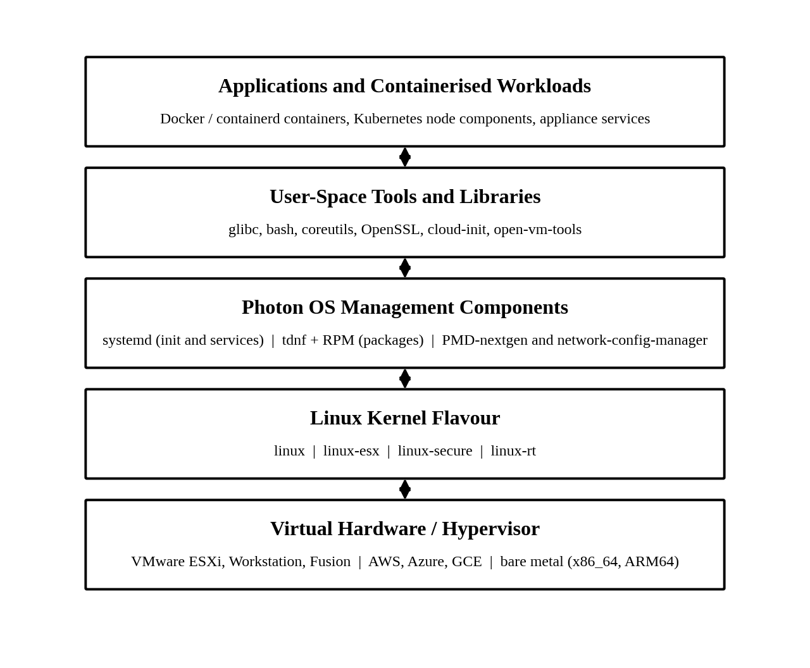
Figure 1. Simplified system architecture of Photon OS.

4.3 Boot Sequence and Role of systemd
When a Photon OS machine starts, the firmware (UEFI or BIOS) hands control to a bootloader. The bootloader loads the selected kernel flavour and an initial RAM file system (initramfs) into memory. The kernel initialises the hardware, mounts the root file system and starts the first user-space process, which is systemd with process ID 1. From that point systemd starts the other services in the order given by their dependencies and keeps supervising them while the system runs (Figure 2).
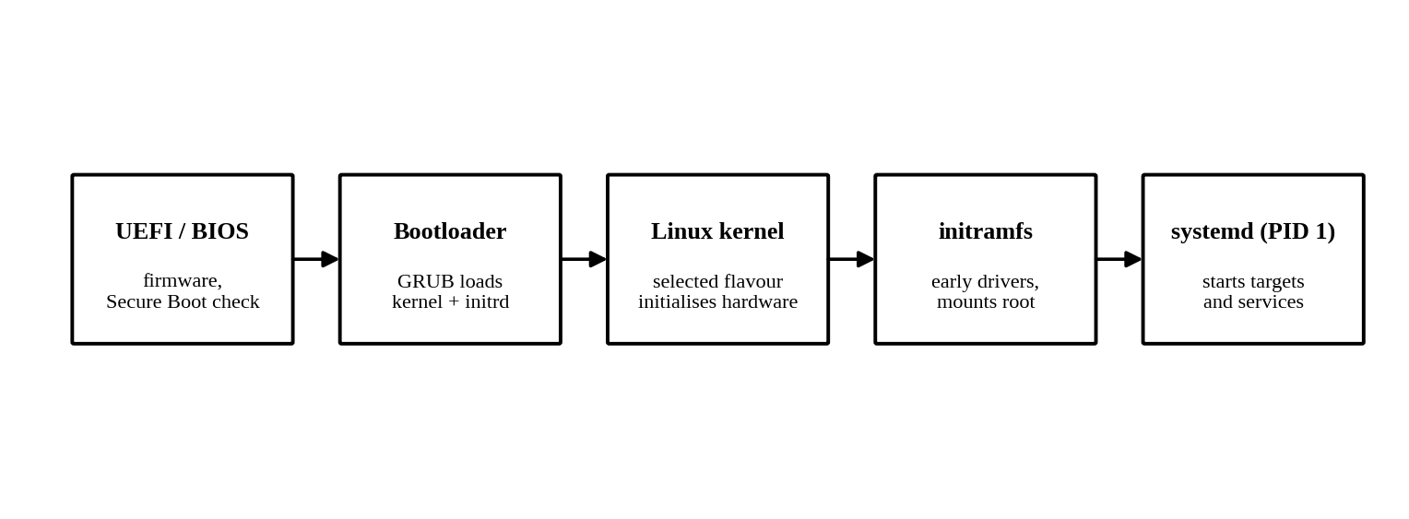
Figure 2. Simplified boot sequence of Photon OS.
Photon OS has used systemd since its early releases, and release 3.0 carried systemd 239 and release 5.0 carries systemd 253 (“What Is New in Photon OS 3.0 Rev2”; “Photon OS, the VMware Distro”). This is the opposite choice to distributions that avoid systemd, but it suits Photon OS well. Services are described by unit files, started on demand and tracked in control groups, which fits the container and appliance workloads that Photon OS hosts. Because systemd places every service in its own control group, it can also report and limit the CPU and memory used by each service.

4.4 Package Management with tdnf
Photon OS uses the RPM package format with its own package manager, tdnf. The Photon OS documentation describes tdnf as the default package manager for installing new packages and as a C implementation of the DNF package manager (“Tiny DNF (tdnf) Wiki”). Its command syntax is a subset of DNF, so administrators familiar with Fedora or RHEL can use it easily. The C implementation removes the need for a Python runtime during package operations, which helps keep the base image small.
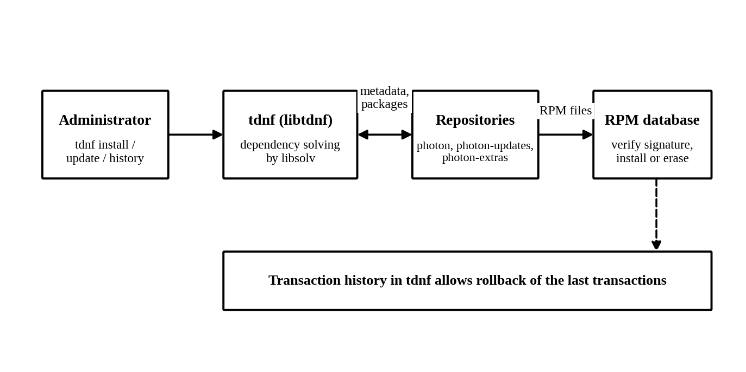
Figure 3. Package installation and update workflow in tdnf.
Repository definitions are stored in /etc/yum.repos.d/, and the default repositories are photon, photon-updates and photon-extras. Packages are verified with the VMware RPM GPG key before installation. Table 3 lists the main commands.
Command | Purpose
tdnf install <pkg> | Install a package together with its dependencies
tdnf remove <pkg> / tdnf erase <pkg> | Remove a package; unused dependencies are not removed unless configured
tdnf upgrade / tdnf distro-sync | Upgrade installed packages, or synchronise them with the repository versions
tdnf search, tdnf info, tdnf provides | Find packages, show package details, and find which package provides a file or capability
tdnf repolist / tdnf makecache | List enabled repositories; refresh cached repository metadata
tdnf history and tdnf history rollback | Show recorded transactions and return to an earlier package state
Table 3. Common tdnf commands. Source: Photon OS Documentation, “tdnf Commands.”

4.5 Management Tools
Photon OS 5.0 adds the Photon Management Daemon Next Generation (PMD-nextgen) and the Network Configuration Manager. The Network Configuration Manager was introduced as a replacement for the older netmgr and provides common tasks such as setting IP addresses, routes, interface state and DNS through command-line and programming interfaces (“What Is New in Photon OS 4.0”). Together these tools let an administrator or an automation system configure a machine without editing many separate files by hand.

4.6 Editions and Installation Options
Photon OS is distributed in several forms: a bootable ISO that supports manual installation or PXE and kickstart automation, a pre-installed OVA for VMware platforms, and images for Amazon EC2, Google Compute Engine and Microsoft Azure (“Downloading Photon OS”). The ISO includes minimal and full installation options. Reported sizes for the three editions of release 5.0 show how small the base system is (Table 4).
Edition | Reported size | Intended use
Minimal | About 538 MB | Basic system and runtime packages for running containers
Developer | About 4.3 GB | Extra packages for developing and testing containerised software
Real Time | About 683 MB | PREEMPT_RT patched kernel for real-time applications
Table 4. Editions of Photon OS 5.0. Source: DesdeLinux, “Photon OS, the VMware Distro to Run Containerized Applications.”
These figures come from a third-party description of the release and should be treated as indicative. The important point is that the minimal edition is far smaller than a typical general-purpose server installation, which gives it less to patch and less to attack.

5. Kernel Architecture
The kernel is the part of the operating system that runs in privileged mode and controls the hardware. Photon OS uses the Linux kernel, which is a monolithic kernel: the core services run in one address space in kernel mode, and drivers and some other features can be added as loadable modules. This design gives fast communication between kernel subsystems at the cost of less isolation between them than a microkernel provides (Silberschatz et al.).
An application that needs a kernel service does not call the kernel code directly. It issues a system call such as read, fork or mmap, which switches the CPU from user mode to kernel mode, runs the kernel code and returns. This is how, for example, a container runtime asks the kernel to create a new process in new namespaces.

5.1 Main Functions of the Kernel
- Process management: creates, schedules and terminates processes and threads, and provides signals and inter-process communication.
- Memory management: maintains virtual address spaces, page tables, the page cache and swap.
- File system management: provides the Virtual File System (VFS) layer, over which ext4, XFS, Btrfs and others are implemented.
- Device management: controls devices through drivers and handles interrupts.
- Networking: implements the protocol stack, sockets, routing and packet filtering.

5.2 Kernel Architecture Diagram
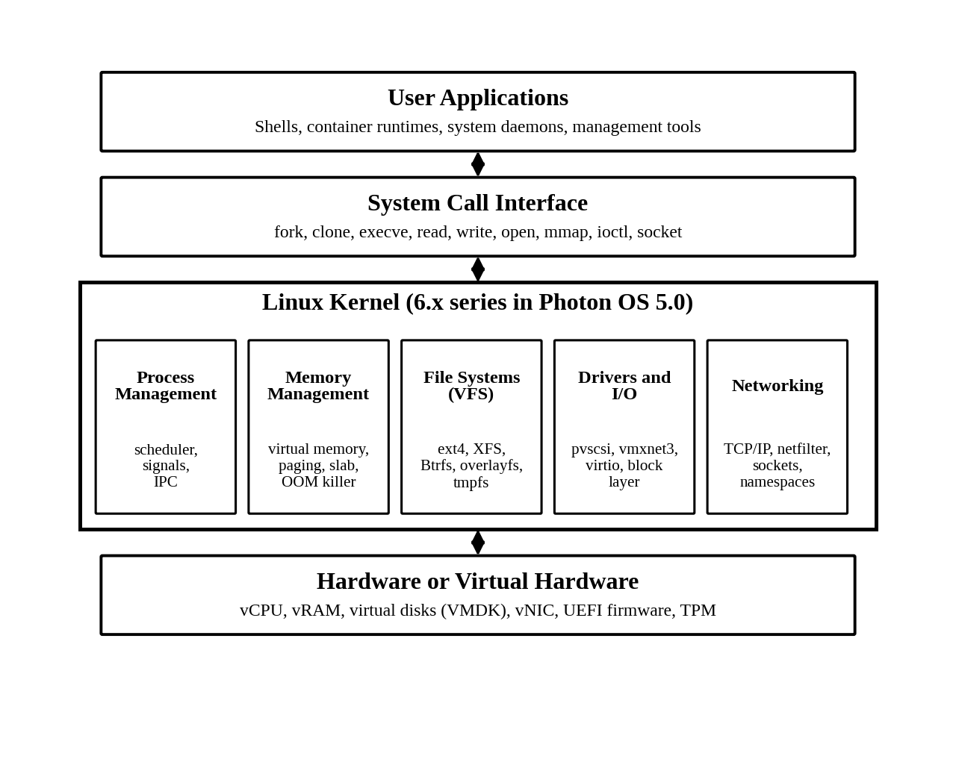
Figure 4. Architecture of the Linux kernel as used by Photon OS.

5.3 Kernel Flavours
The most distinctive kernel-related feature of Photon OS is that it ships several builds of the same kernel source. The release announcement for Photon OS 5.0 lists four flavours (“Announcing Photon OS 5.0”):
- linux: the generic flavour for general use. In release 5.0 it also absorbs the linux-aws flavour that existed in earlier releases.
- linux-esx: a kernel tuned for the VMware hypervisor, used by CRX and pod virtual machines.
- linux-secure: a security-hardened kernel for edge deployments.
- linux-rt: a low-latency kernel used by telecommunications vRAN appliances.
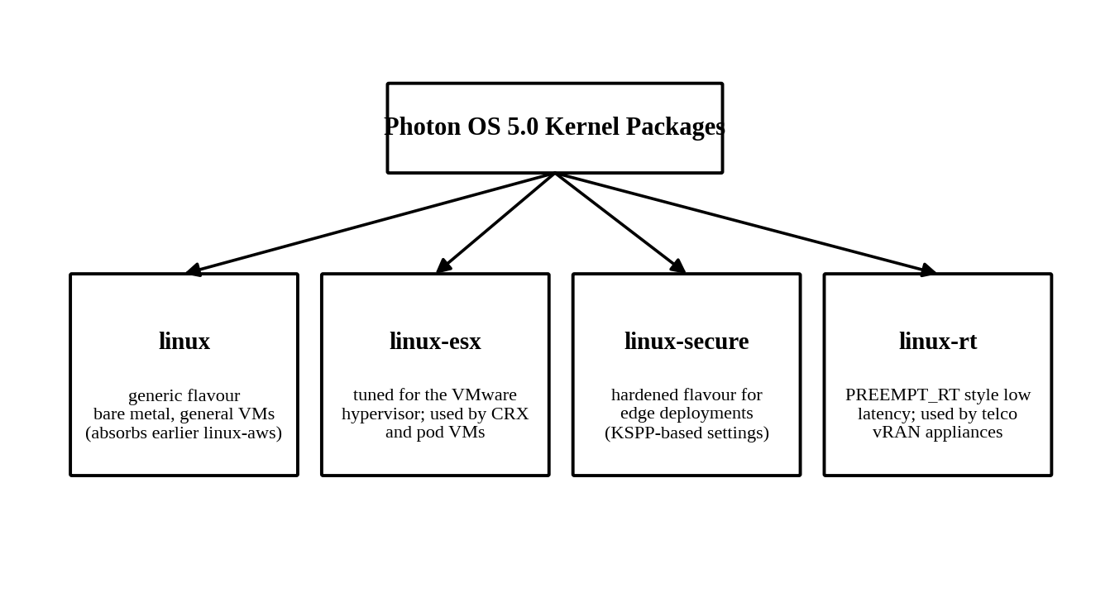
Figure 5. Kernel flavours available in Photon OS 5.0.
The flavour choice is a real engineering trade-off between size, generality and specialisation. The compressed sizes of the kernel RPM packages in the Photon OS security advisories show this clearly (Table 5). The linux-esx kernel is far smaller than the generic one because it needs support for only the virtual devices that ESXi presents, rather than the full range of physical drivers. A smaller kernel loads faster and has less code that can contain vulnerabilities.
Kernel version | linux | linux-esx | linux-secure | linux-rt
5.10.162 (Photon OS 4.0) | – | 14 MB | 26 MB | 29 MB
6.1.56 (Photon OS 5.0) | – | 17 MB | 30 MB | 34 MB
6.12.92 (Photon OS 5.0 update) | 52 MB | 19 MB | – | –
Table 5. Compressed size of kernel RPM packages by flavour. A dash means the advisory consulted did not list that flavour. Sources: Photon OS Security Updates 4.0-318, 5.0-111 and 5.0-92-864.

5.4 Division of Responsibility: Kernel and Photon OS Components
It is useful to separate what the kernel does from what Photon OS-specific components do. Table 6 summarises the division. It shows, for example, that the kernel schedules tasks while systemd decides which services exist and when they start.
Responsibility | Performed by | Layer
Scheduling tasks and threads on CPUs | Linux scheduler | Kernel
Virtual memory, paging and swap | Linux memory manager | Kernel
Mounting and accessing file systems | VFS and file system drivers | Kernel
Isolation of containers | Namespaces, cgroups v2, SELinux | Kernel
Starting and supervising services | systemd | User space
Installing, updating and removing software | tdnf and RPM | User space
Network and user configuration | systemd-networkd, Network Configuration Manager, PMD-nextgen | User space
Hypervisor cooperation (balloon, time sync, shutdown) | VMware kernel drivers and open-vm-tools | Kernel and user space
Table 6. Responsibilities of the kernel and of Photon OS components.

5.5 Kernel Live Patching
Photon OS 5.0 introduced live kernel patching, which allows administrators to apply a fix to a running kernel without rebooting (“Announcing Photon OS 5.0”). Normally a kernel update takes effect only after a reboot, and the advisories for Photon OS kernels state this explicitly. Live patching replaces vulnerable functions in memory, which reduces downtime for services that cannot easily be restarted, such as a hypervisor management appliance.

6. Process and Thread Management
A process is a program in execution. Photon OS relies on the Linux kernel for all process and thread management, so the mechanisms are those of Linux. What Photon OS adds is the way the system is organised around processes: systemd as the first process, and containers as groups of isolated processes.

6.1 Process Management
The kernel represents each process with a data structure called task_struct, which plays the role of the process control block described in operating systems textbooks. It stores the process ID, state, scheduling information, memory map, open files and credentials. A new process is created with fork() or clone(), and exec() replaces its program image. When the process finishes, it calls exit() and remains as a zombie entry until its parent reads its exit status.
A process moves between the states shown in Figure 6. A process that is created is admitted to the ready queue, and the scheduler dispatches it to a CPU. It returns to the ready state if its time slice ends or a higher-priority task preempts it. It enters the waiting state when it needs I/O or another event and returns to ready when the event completes.
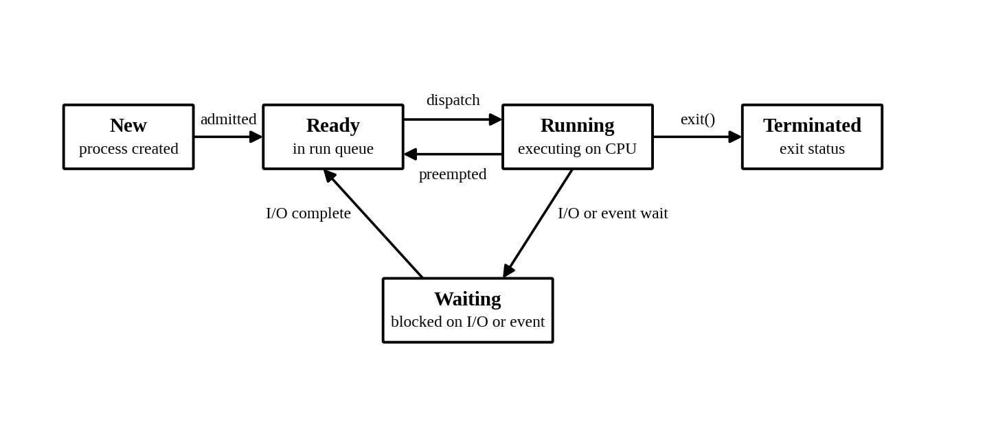
Figure 6. Process state transition diagram.

6.2 Thread Management
A thread is a unit of execution inside a process. In Linux, threads are created with clone() using flags that make the new task share the address space, open files and signal handlers of its creator. The kernel therefore treats threads and processes as the same kind of schedulable entity, with different degrees of sharing. This one-to-one mapping between user threads and kernel tasks is the model used by the POSIX threads library in glibc. Because each thread is scheduled by the kernel, a multithreaded service such as a database can run its threads on several CPU cores at the same time.

6.3 Role of systemd in Process Management
systemd runs as process ID 1, the ancestor of all user-space processes. It also adopts orphaned processes and collects their exit status, which prevents zombies from accumulating. In addition, systemd places each service in a control group, so it can find every process that belongs to a service, including processes that the service started itself. This makes service shutdown reliable, because stopping a service can terminate the whole group rather than only the main process.

6.4 Containers as Processes
A container is not a separate operating system. It is a group of ordinary Linux processes running in their own namespaces and control groups. From the host, the processes inside a container appear in the normal process list, with their own process ID numbering inside the namespace. This is why Photon OS can run many containers with little overhead: the kernel creates and schedules container processes in the same way as other processes.

7. CPU Scheduling
CPU scheduling decides which runnable task executes on a CPU core and for how long. Textbooks describe algorithms such as first-come first-served, shortest job first, round robin, priority scheduling and multilevel feedback queues (Silberschatz et al.). Linux, and therefore Photon OS, combines ideas from several of them in a class-based scheduler.
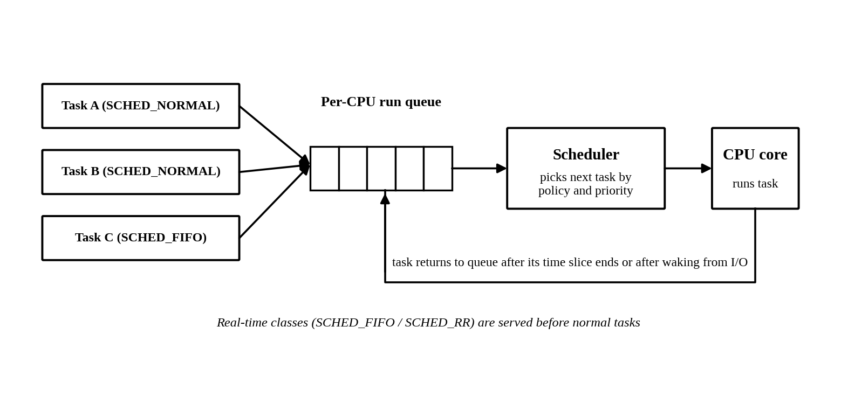
Figure 7. CPU scheduling in the Linux kernel.

7.1 Scheduling Classes and Policies
The Linux scheduler groups policies into classes that are examined in strict order. Real-time tasks are served before normal tasks, so a runnable real-time task always runs ahead of an ordinary one. Table 7 lists the main policies.
Policy | Class | Behaviour and typical use
SCHED_NORMAL | Fair | Default for ordinary tasks; CPU time is shared in proportion to weight set by the nice value
SCHED_BATCH | Fair | For non-interactive batch work; avoids frequent preemption
SCHED_IDLE | Fair | Runs only when nothing else needs the CPU
SCHED_FIFO | Real-time | Fixed priority; runs until it blocks or yields, without time slicing
SCHED_RR | Real-time | Fixed priority with round-robin time slices among equal priorities
SCHED_DEADLINE | Deadline | Tasks declare runtime, deadline and period; used for hard timing needs
Table 7. Linux scheduling policies. Source: Linux Kernel Documentation, scheduler section.

7.2 The Fair Scheduler
Normal tasks are handled by the fair scheduler. Photon OS 5.0 was released with Linux 6.1, whose fair scheduler is the Completely Fair Scheduler (CFS). CFS keeps track of how much CPU time each task has received and always prefers the task that has received the least relative to its weight. Later Linux kernels replaced CFS with the EEVDF (Earliest Eligible Virtual Deadline First) scheduler. Because Photon OS 5.0 kernel updates have moved to the 6.12 series, newer Photon OS 5.0 systems use this newer algorithm. Both have the same goal of sharing CPU time fairly while keeping interactive tasks responsive.

7.3 Real-Time Scheduling in Photon OS
Photon OS 4.0 introduced the linux-rt kernel for low-latency and real-time applications, together with user-space packages such as tuned, tuna and stalld that help configure the system for real-time workloads (“What Is New in Photon OS 4.0”). The real-time flavour is intended for cases such as virtualised radio access network (vRAN) appliances, where missing a timing deadline degrades the service (“Announcing Photon OS 5.0”). The linux-rt kernel reduces the time during which the kernel cannot be preempted, so a high-priority task can start on time. Mainline Linux has included the PREEMPT_RT preemption model since version 6.12.

7.4 Two Levels of Scheduling in Virtual Machines
When Photon OS runs as a guest on ESXi, scheduling happens at two levels. The Photon OS kernel schedules tasks onto the virtual CPUs (vCPUs) that it can see. Underneath, the hypervisor schedules those vCPUs onto physical cores. The guest therefore cannot assume that a vCPU runs continuously, and over-allocating vCPUs can reduce performance. This explains why the linux-esx kernel is tuned for the hypervisor and why the ESXi administrator and the guest operating system must be configured together.

7.5 CPU Control with Control Groups
Besides the scheduler, Linux lets an administrator set CPU limits by group. Photon OS 5.0 uses control groups version 2 (cgroups v2), in which the CPU controller offers a relative weight and a maximum bandwidth for a group of processes. This allows one container or one systemd service to be limited so that it cannot starve others. This is the same mechanism that container platforms use for CPU limits.

8. Memory Management
Memory management is also a kernel responsibility in Photon OS. The kernel gives each process a private virtual address space, translates virtual addresses to physical addresses with page tables, and decides which pages stay in RAM. Figure 8 shows this arrangement.
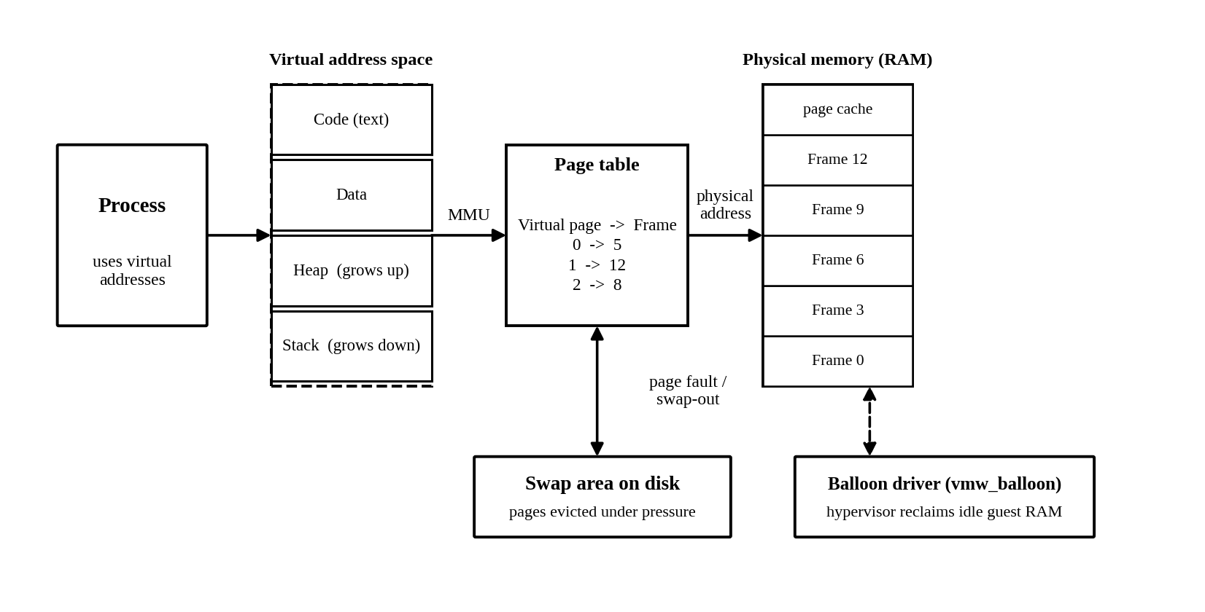
Figure 8. Virtual memory management in Linux, with swap and the VMware balloon driver.

8.1 Virtual Memory and Paging
Each process sees its own address space divided into regions such as code, data, heap and stack. The memory management unit (MMU) in the CPU uses the page table to translate a virtual page to a physical frame. If the page is not present in RAM, the CPU raises a page fault and the kernel loads it, from a file or from swap. Because each process has its own mapping, one process cannot read another’s private memory, which gives the protection described in operating systems courses. Address space layout randomisation, enabled in the hardened kernel configuration, adds further protection by making the placement of regions unpredictable.

8.2 Allocation, Page Cache and Swap
Inside the kernel, physical pages are managed by the buddy allocator, and small objects are allocated from caches built by the slab allocator. Unused RAM is used as a page cache for files, so repeated reads are served from memory. When memory becomes short, the kernel reclaims cache pages first and, if swap is configured, writes less-used anonymous pages to swap. As a last resort, the out-of-memory (OOM) killer ends a process to recover memory. Container platforms rely on memory limits in cgroups v2 so that the OOM action is directed at the container that exceeded its limit rather than at the whole host.

8.3 Memory in a Virtualized Photon OS
A Photon OS guest on ESXi cooperates with the hypervisor to share physical memory between virtual machines. The VMware balloon driver (vmw_balloon) lets the hypervisor ask a guest to give back RAM that it is not using. The guest inflates a balloon by allocating pages and handing them to the hypervisor. When the pressure ends, the balloon deflates. This is possible only because the guest kernel includes a driver for the virtual device, which illustrates why the linux-esx flavour includes VMware-specific support.

8.4 Memory Footprint of Photon OS
The DistroWatch entry for Photon OS states that its default installation often needs less than 100 MB of memory to run (“Photon OS”). This is consistent with the small package set and the absence of a graphical desktop. The figure should not be read as a guarantee. As with any Linux system, real memory use depends on the services and containers that are started, and the page cache will use available RAM regardless of the distribution.

9. File System Support
A file system organises data into files and directories and keeps track of where the data is stored. Linux presents all file systems through the Virtual File System (VFS) layer, so applications use the same system calls whichever file system is underneath. Photon OS therefore inherits the file system support of its kernel.

9.1 Supported File Systems
File system | Role in Photon OS
ext4 | Widely used general-purpose journaling file system; a common choice for the root file system
XFS | High-performance file system for large files and volumes; supported by the Photon OS 5.0 installer
Btrfs | Copy-on-write file system with snapshots and checksums; supported by the Photon OS 5.0 installer
overlayfs | Union file system that layers a writable layer over read-only image layers; the basis of container image storage
tmpfs, procfs, sysfs | Memory-backed and virtual file systems that expose temporary data and kernel information
Table 8. File systems relevant to Photon OS. Source: Photon OS 5.0 announcement; Linux Kernel Documentation.
The installer of Photon OS 5.0 added support for XFS and Btrfs, and Photon OS 3.0 Rev2 had earlier added a Logical Volume Manager (LVM) root partition (“Announcing Photon OS 5.0”; “What Is New in Photon OS 3.0 Rev2”). LVM adds a layer between disks and file systems so that volumes can be resized or combined.

9.2 Directory Organisation
Linux uses a single directory tree that begins at the root directory, /. Other file systems are mounted at points in this tree. The tree follows the common Filesystem Hierarchy Standard: /etc holds configuration, /var holds changing data such as logs and package caches, /usr holds most programs, and /home holds user files. File permissions control who can read, write or execute each file.

9.3 Update-Friendly Storage Layouts
Photon OS includes two features that change how the root file system is updated. Photon OS 3.0 Rev2 added deployment through RPM-OSTree, an image-based approach in which the operating system is installed as a versioned tree (“What Is New in Photon OS 3.0 Rev2”). Photon OS 5.0 added an A/B storage partition system for seamless updates and rollback. In this approach an updated system image is written to the inactive partition while the system runs from the active one. The machine then boots into the new partition, and it can return to the old one if the update fails (Figure 9).
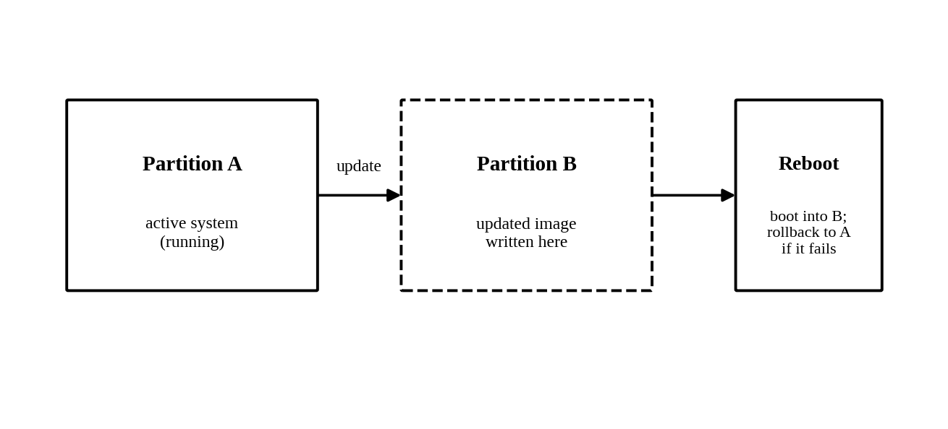
Figure 9. A/B partition update with rollback.
Image-based updates reduce the risk that a failed update leaves a system unbootable, which is valuable for appliances that are not managed manually.

10. Storage and Device Management
The kernel talks to hardware through device drivers. Drivers may be built into the kernel or loaded as modules, and the udev device manager (part of systemd) creates device nodes and applies rules when devices appear. Photon OS follows this standard Linux model but changes which drivers are present depending on the kernel flavour.

10.1 Storage Management
A disk is divided into partitions, formatted with a file system and mounted into the directory tree. The commands lsblk and df show block devices and used space, and tools such as fdisk and LVM manage partitions and volumes. The Photon OS installer can partition disks automatically or according to a kickstart file, which is used for unattended installation of many machines.

10.2 Virtual Devices and Drivers
Most Photon OS machines are virtual, so most of their devices are emulated or paravirtualized. Typical examples are the VMware paravirtual SCSI controller (vmw_pvscsi), the VMXNET3 network adapter and the VMware balloon driver. Paravirtualized devices are faster than fully emulated ones because the guest driver knows that it is running in a virtual machine and talks to the hypervisor more directly. On KVM-based clouds the equivalent virtio drivers are used. The linux-esx flavour keeps the set of drivers small by including support for the virtual hardware that ESXi presents.

10.3 Guest Tools
Photon OS includes open-vm-tools, the open-source implementation of VMware Tools. It provides clean shutdown from the hypervisor, time synchronisation, reporting of the guest’s IP address and other integration functions. It is a user-space companion to the kernel’s VMware drivers.

10.4 Hardware Platforms
Photon OS supports x86_64 and ARM64. ARM64 support began with release 3.0, which added images for the Raspberry Pi 3, and release 4.0 added the Raspberry Pi 4 and ARM images for OVA and AMI formats (“Project Photon OS Update”; “What Is New in Photon OS 4.0”). Release 5.0 added ARM64 support for the linux-esx flavour. This allows the same operating system to be used on servers, edge devices and small single-board computers.

11. Security Features
Security is a stated design goal of Photon OS. The project describes the operating system as secure from the start, using Kernel Self-Protection Project recommendations, packages built with hardened security flags and a policy designed to govern the system securely (“Project Photon OS”). The security model can be described as layers, each of which reduces the damage if another fails (Figure 10).
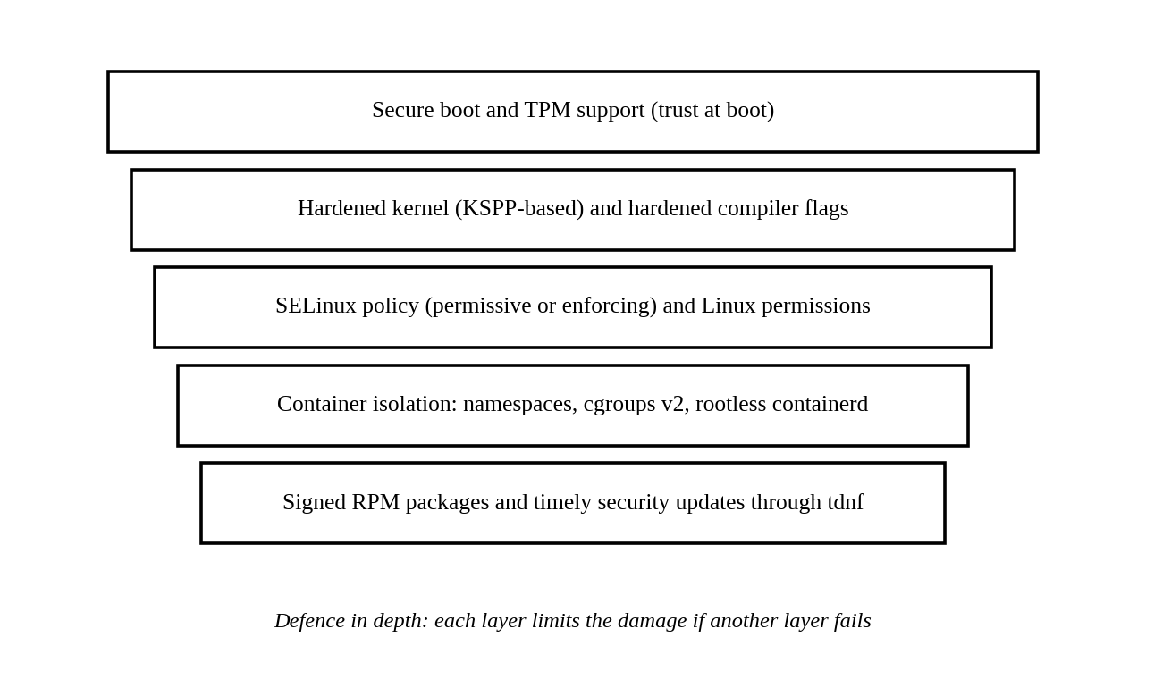
Figure 10. Layers of defence in Photon OS.

11.1 Hardened Kernel and Build
The Kernel Self-Protection Project (KSPP) is an upstream effort to make the kernel resist attacks on itself by enabling protections such as stricter memory permissions and randomisation. Photon OS 2.0 introduced the linux-secure kernel, configured according to KSPP recommendations and including most of the PaX patches (“What Is New in Photon OS 2.0”). Photon OS also builds packages with hardened compiler flags, which add protections such as stack protection to user-space programs.

11.2 Secure Boot and TPM
Photon OS 2.0 added secure EFI boot so that the machine boots with validated trust, and release 3.0 Rev2 added Trusted Platform Module (TPM) support with the tpm2 software stack (“What Is New in Photon OS 2.0”; “What Is New in Photon OS 3.0 Rev2”). Secure boot checks the signature of boot components before they run, and a TPM can store keys and record measurements of the boot process.

11.3 Access Control and SELinux
Standard Linux discretionary access control uses user IDs, group IDs and permission bits. Photon OS 4.0 added SELinux, a mandatory access control system in which a policy defines what each process may access, regardless of the owner of the process. Photon OS appliances can enable SELinux in permissive mode, which logs violations, or enforcing mode, which blocks them. A default policy is supplied and can be customised, and SELinux is also supported for containers (“What Is New in Photon OS 4.0”).

11.4 Container Security
Photon OS 5.0 improved container runtime security. Rootless containerd support lets containers run as unprivileged users, so a container escape does not automatically give root access to the host (“Photon 5.0 Beta Is Now Available”). Namespaces and cgroups v2 isolate and limit containers, and SELinux can further restrict what container processes may do.

11.5 Package Integrity and Patch Response
tdnf verifies signed RPM packages, and the Photon OS wiki publishes security advisories listing the CVEs fixed by each update and the exact package builds. Patch speed matters because most real attacks use known vulnerabilities. Table 9 summarises examples that the Photon OS team gave of its response time to three disclosed vulnerabilities in 2019.
Vulnerability | Public disclosure | Photon OS update released | Delay
TCP SACK PANIC (kernel) | 17 June 2019 | 20 June 2019 | 3 days
runC container escape (CVE-2019-5736) | 11 February 2019 | 12 February 2019 | 1 day
sudo privilege escalation (CVE-2019-14287) | 14 October 2019 | 17 October 2019 | 3 days
Table 9. Photon OS response time for three disclosed vulnerabilities. Source: Openwall oss-security post by the Photon OS team, October 2019.
These figures were reported by the project itself and cover only three cases, so they show intent and capability rather than a guarantee. They also show that a package-based update model with a single team owning the pipeline can respond within days. Photon OS 5.0 additionally offers kernel live patching so that a kernel fix can be applied without waiting for a maintenance window.

11.6 Limits of the Security Model
Security features do not remove the need for good administration. A hardened operating system can still be compromised through weak passwords, exposed services or unpatched application containers. SELinux in permissive mode does not block anything, and the hardened linux-secure flavour is intended for specific deployments rather than all systems. The strength of Photon OS security therefore depends on how the administrator chooses and configures these options.

12. Networking Support
Networking in Photon OS is built on the Linux kernel network stack. The kernel implements sockets, TCP and UDP, IP routing and netfilter packet filtering, and it communicates with network adapters through drivers. User-space tools configure the stack, as Figure 11 shows.
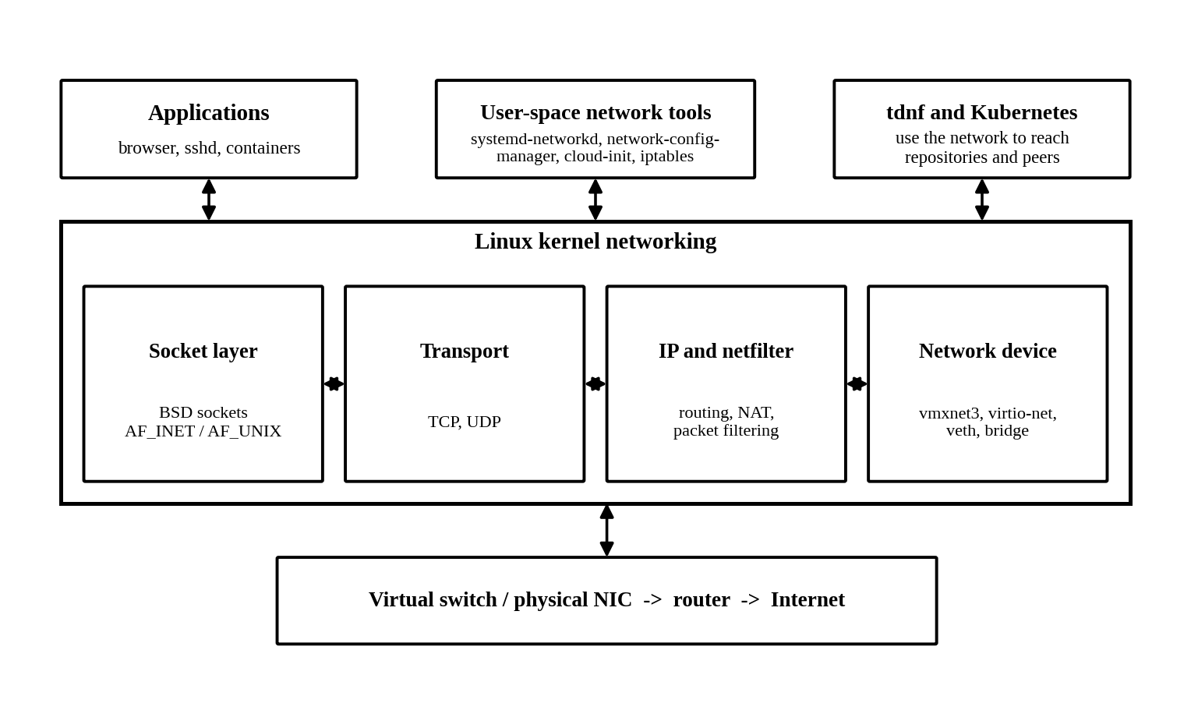
Figure 11. Networking in Photon OS.

12.1 Kernel Networking
An application opens a socket and uses system calls to send and receive data. The kernel passes data through the transport layer (TCP or UDP), the IP layer, where routing and netfilter apply, and finally the network device driver. For a virtual machine, the driver is usually VMXNET3 or virtio-net, which hands packets to the virtual switch of the hypervisor and from there to the physical network.

12.2 Network Configuration in Photon OS
Photon OS uses systemd-networkd to configure interfaces from configuration files, and the Network Configuration Manager provides a command-line and programming interface for the same tasks, such as addresses, routes, DNS and interface state. Release 5.0 extended it to configure more network device parameters and to set up WireGuard virtual private network interfaces (“Announcing Photon OS 5.0”; “What Is New in Photon OS 5.0”). On cloud platforms, cloud-init applies the network and user settings supplied by the platform when the instance first boots. Packet filtering is handled with iptables, and an administrator must explicitly allow the ports that services need.

12.3 Container Networking
Each container normally receives its own network namespace, which gives it separate interfaces, routing tables and firewall rules. A virtual Ethernet pair (veth) connects the container namespace to a bridge on the host, and NAT rules let containers reach external networks. Kubernetes adds an overlay or routed network between nodes, but the kernel primitives it uses are the same.

12.4 Networking and Software Updates
The network also supports the maintenance of Photon OS. tdnf downloads repository metadata and packages over HTTP or HTTPS, so a working network connection is needed to install or update packages from online repositories. For isolated systems, a local mirror or the ISO repository can be configured instead.

13. Virtualization and Container Support
Photon OS is both a guest of virtualization and a host of containers. Virtual machines emulate a complete computer with its own kernel. Containers share the host kernel and isolate only user-space environments, which makes them much lighter. Photon OS is built to support both.

13.1 Photon OS as a Virtual Machine Guest
Photon OS runs on VMware ESXi, Workstation and Fusion, and in the public clouds Amazon EC2, Microsoft Azure and Google Compute Engine, using ready-made images (“Downloading Photon OS”). On VMware platforms, the linux-esx kernel and open-vm-tools provide the paravirtual drivers, balloon memory management and guest integration described in Sections 8 and 10. The linux-esx flavour is also used by CRX and pod virtual machines, which are lightweight virtual machines created to run containers inside the vSphere platform (“Announcing Photon OS 5.0”).

13.2 Container Support
Photon OS includes the Docker daemon in its container-oriented design and works with orchestrators such as Kubernetes (“Project Photon OS Update”). A typical stack consists of the Docker engine, which uses containerd, which in turn starts containers with runc. All of them depend on kernel isolation features.
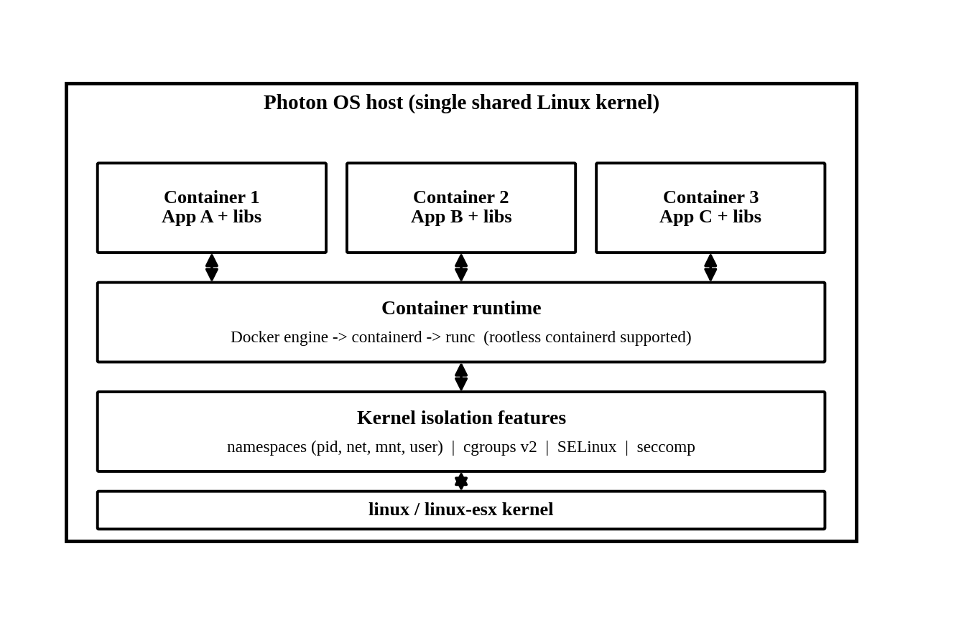
Figure 12. Container stack on a Photon OS host.
The most important isolation features are listed in Table 10.
Kernel feature | What it provides | Example in containers
Namespaces (pid, net, mnt, user, ipc, uts) | Separate views of system resources | A container sees its own process IDs, network interfaces and mount points
Control groups v2 | Accounting and limits for CPU, memory, I/O and process count | A container is limited to a set amount of memory
SELinux and seccomp | Mandatory access control and system call filtering | A container process is blocked from unsafe operations
overlayfs | Layered file system | Image layers are shared and a thin writable layer is added per container
Table 10. Kernel features that support containers.

13.3 Resource Management with cgroups v2
Photon OS 5.0 enables control groups version 2 by default (“Photon OS 5.0 Beta Is Now Available”). Unlike version 1, which had a separate hierarchy for each controller, cgroups v2 uses a single unified hierarchy, which simplifies accounting and makes interactions between controllers easier to predict. The main controllers manage CPU time, memory, block I/O and the number of processes. systemd and container runtimes use these controllers to place limits on services and containers, which is the practical form of resource management in Photon OS.

13.4 Photon OS Container Builder and Kubernetes
Photon OS 5.0 introduced the Photon OS Container Builder, a tool for building lightweight Photon OS container images (“What Is New in Photon OS 5.0”). Photon OS base container images have also been published for use as the foundation of application images. The Photon OS repositories contain Kubernetes packages that can be installed with tdnf, and the operating system can serve as a Kubernetes node.
A point worth noting is that Photon OS is not a hypervisor. It does not replace ESXi or KVM. It is a guest or container host that runs on top of them, and it can host virtual machines only if suitable virtualization software and hardware support are installed.

14. Advantages of Photon OS

14.1 Small and Fast
The minimal edition contains only what is needed to run containers, and the default installation is reported to need under 100 MB of memory. A small system boots quickly and has fewer packages to update. This suits appliances and large fleets of virtual machines.

14.2 Optimised for VMware Environments
The linux-esx kernel, VMware drivers and open-vm-tools give Photon OS close integration with ESXi. For organisations that already run vSphere, the same vendor supplies the hypervisor and the guest operating system, which simplifies support.

14.3 Security by Default
Kernel hardening, hardened compiler flags, secure boot, TPM support, SELinux, rootless containers and live patching together form a deep set of protections. The availability of a dedicated hardened kernel flavour is unusual among small distributions.

14.4 Strong Lifecycle Management
tdnf provides transaction history and rollback. The A/B partition and RPM-OSTree options provide image-based updates with rollback. The Photon team builds all packages and publishes advisories, so patches are predictable.

14.5 Choice of Kernel for the Job
The four kernel flavours allow one operating system to serve general use, virtual machines, hardened edge systems and real-time telecommunications workloads. Few distributions in this size class offer a real-time kernel as an official option.

14.6 Familiar Tooling
Because Photon OS uses RPM, systemd and a DNF-compatible command syntax, administrators who know Fedora or RHEL can learn it quickly. It also uses glibc, so most Linux software built for glibc runs on it.

15. Limitations of Photon OS

15.1 Narrow Purpose
Photon OS is a container host and appliance base, not a desktop operating system. The main repositories do not provide a graphical desktop environment, and DistroWatch lists it as a distribution without a desktop. Users who need a general desktop or a wide range of applications are better served by other distributions.

15.2 Strong Tie to VMware
The best-tuned kernel and drivers target VMware platforms. Photon OS does run on other clouds, but the integration advantages are smaller there. Because VMware is now part of Broadcom, the long-term direction of the project depends on that company’s priorities.

15.3 Smaller Ecosystem
The package collection and community are much smaller than those of Ubuntu or Fedora. Fewer third-party tutorials and packages exist, so administrators may need to build software from source or use containers for it.

15.4 Finite Support Life for Each Release
Each Photon OS major release has a planned end of support, for example March 2024 for release 3.0 and an expected March 2026 for release 4.0, which is subject to change. Organisations must plan upgrades, and appliances built on an old release need a migration path (“Announcing Photon OS 5.0”).

15.5 Perceived Activity Level
DistroWatch classifies the Photon OS entry as dormant, as recorded in its page last updated in February 2026 (“Photon OS”). This probably reflects the long gap since the last new major release rather than a lack of maintenance, because security updates for release 5.0 continued to be published in 2026. Even so, prospective users should check the current support status before committing to it.

15.6 Hardened Options Need Administration
Some security features must be chosen and configured. SELinux can run in permissive mode, and the secure kernel flavour is not the default for all installations. The benefit depends on the administrator using them correctly.

16. Real-World Applications

16.1 VMware Appliances
Photon OS is the operating system inside the vCenter Server Appliance, which is described in VMware documentation as an instance of vCenter Server running in a Photon OS guest operating system (“Overview of the vCenter Server Appliance”). Many other VMware products are also delivered as appliances that run Photon OS. In this role the operating system is invisible to most users, and its predictability and small size are the reasons for its use.

16.2 Container Hosts and Kubernetes Nodes
Photon OS is designed as a host for Docker and other container runtimes and can serve as a node for container orchestration platforms. The CRX and pod virtual machines of vSphere use the linux-esx kernel to run containers on the hypervisor platform (“Announcing Photon OS 5.0”).

16.3 Telecommunications and Real-Time Workloads
The linux-rt kernel is used by telecommunications vRAN appliances that need predictable low latency, and the Photon OS site names virtual radio access network deployments as a use of its real-time support (“Project Photon OS”).

16.4 Edge and IoT Devices
The linux-secure kernel is described as a hardened kernel for edge deployments, and ARM64 support lets Photon OS run on small boards such as the Raspberry Pi. The Photon OS datasheet also lists edge and IoT environments as targets (“Project Photon OS Datasheet”).

16.5 Learning Operating System Concepts
Photon OS is a good teaching system. Its small size makes it easy to study how a kernel flavour, an init system and a package manager fit together. A student can compare linux and linux-esx, inspect control groups, enable SELinux and observe an update and rollback with tdnf in a virtual machine.

17. Comparison with Similar Operating Systems
Photon OS is best compared with other operating systems for container hosts. Flatcar Container Linux is the most direct comparison, because it is an immutable minimal Linux for containers. Ubuntu Server is included as the general-purpose Linux commonly used for the same task. Table 11 compares the three.

17.1 Comparison Table
Feature | Photon OS | Flatcar Container Linux | Ubuntu Server
Origin and owner | VMware, now Broadcom; independent distribution | Fork of CoreOS Container Linux; developed by Kinvolk and now Microsoft; CNCF incubating project | Canonical; based on Debian
Main purpose | Container host and appliance base, optimised for VMware | Minimal immutable OS for containers and Kubernetes nodes | General-purpose server operating system
Package manager | tdnf with RPM | No traditional package manager; software runs in containers | APT with dpkg, plus snap
Init system | systemd | systemd | systemd
Update model | tdnf transactions with rollback; optional A/B partitions and RPM-OSTree | Automatic A/B partition updates with rollback | Package upgrades; LTS releases every two years
Root file system | Writable by default | Read-only /usr; writable overlays for changes | Writable
Provisioning | Kickstart, cloud-init, OVA images | Ignition configuration at first boot | cloud-init, autoinstall
Kernel options | Four flavours: linux, esx, secure, rt | Single kernel built for container hosting | Generic kernel, with other flavours available
Mandatory access control | SELinux supported | Immutable /usr as a main control | AppArmor by default
Typical use | VMware appliances, container hosts, telecom and edge | Cloud-native Kubernetes clusters | Web servers, databases, cloud workloads
Table 11. Comparison of Photon OS, Flatcar Container Linux and Ubuntu Server. Sources: Photon OS documentation; FOSDEM 2022 Flatcar talk; Ubuntu release cycle documentation.

17.2 Update and Configuration Philosophy
The main difference is how each system treats change. Flatcar is built on immutable infrastructure: its main features are A/B partitions for automatic updates and rollback and Ignition for declarative configuration at first boot (Lüke). Its root file system is meant to be replaced rather than modified. Ubuntu Server is the opposite: it is a mutable system that the administrator changes over time with APT. Photon OS lies between them. It is a normal mutable RPM system by default, so an administrator can install packages with tdnf, but it also provides the A/B and RPM-OSTree options if immutable updates are wanted.

17.3 Size and Focus
Photon OS and Flatcar are both small and narrow in purpose, while Ubuntu Server is a broad system with a very large repository. The small systems have less to patch and expose fewer services, but they leave more work to containers, because software that is not in the small repository must be containerised. Ubuntu Server handles that case by providing a very large package collection.

17.4 Hypervisor Integration
Photon OS has the strongest integration with VMware platforms because it is built by the same vendor, with the linux-esx kernel, VMware drivers and guest tools. Flatcar and Ubuntu run well on VMware too, but they are not tuned for it in the same way. For an organisation that standardises on vSphere, this is Photon OS’s greatest advantage. For one that runs mainly on other clouds, Flatcar’s vendor-neutral design may fit better.

17.5 Overall Analysis
No system is best for every situation. Photon OS is the stronger choice for VMware appliances and for teams that want an RPM-based minimal system with several kernel flavours. Flatcar is stronger for teams that want a fully immutable fleet of Kubernetes nodes with automatic updates. Ubuntu Server is stronger when a broad package ecosystem, long community history and general-purpose use matter more than minimal size.

18. Recent Developments and Future Scope

18.1 Recent Developments
The most notable recent developments concern the kernel and the support life of the releases. Photon OS 5.0 was released with the Linux 6.1 LTS kernel and the repository now carries newer kernel builds. A Photon OS security update page edited in August 2026 lists linux and linux-esx packages for the 6.12 series, with a build date in June 2026 (“Security Update 5.0 92 864”). This move to a newer long-term kernel brings the newer scheduler and the mainline PREEMPT_RT support, as discussed in Section 7.
The support schedule is also changing. Photon OS 3.0 reached its planned end of support in March 2024, and release 4.0 had an expected end of support in March 2026, subject to change. This leaves release 5.0 as the main supported line (“Announcing Photon OS 5.0”). During the research for this report, no announcement of a Photon OS 6.0 release was found in the sources consulted, so the next major version cannot be discussed here.
The stewardship of the project has also changed. Broadcom completed its acquisition of VMware in November 2023, and Broadcom engineers now appear in the project’s code review history. The continuing publication of kernel and package security updates suggests that the project remains maintained, although the changed ownership is a factor for long-term planning.

18.2 Future Scope
- Newer major release: A release that adopts a newer base, newer systemd and glibc and further hardening would be the natural next step once announced.
- More image-based operation: The A/B and RPM-OSTree features in Photon OS 5.0 point toward more fully image-based, immutable operation, similar to the model of Flatcar.
- Wider ARM64 support: ARM64 support has grown from single-board computers to the linux-esx flavour, and this will matter as ARM servers and edge devices become more common.
- Tighter container security: Rootless containers, SELinux and cgroups v2 can be combined further to reduce the privilege of container workloads.
- Edge and real-time use: The linux-rt and linux-secure flavours position Photon OS for telecommunications and edge systems, where low latency and hardening are both needed.

18.3 Overall Analysis
Photon OS shows that the operating system matters less as a visible product and more as a dependable component. Its recent history is one of steady kernel updates and security fixes rather than of dramatic new features. Its future depends on continued support from its corporate owner and on its ability to remain relevant as container platforms and image-based operating systems mature.

19. Conclusion
This case study examined VMware Photon OS as a real example of how operating system concepts are applied in a cloud-native setting. Photon OS uses the standard Linux kernel for process and thread management, CPU scheduling, virtual memory, file systems, device drivers and networking, and so the principles from the Operating Systems course apply directly. Its own contribution lies in the choices it makes around the kernel: four kernel flavours for different deployments, systemd for service management, tdnf for RPM package management, a hardened build, and image-based update options.
The study also showed the value of separating the kernel’s responsibilities from those of other components. The kernel schedules tasks, manages memory and isolates containers, while systemd, tdnf and the management daemons control services, software and configuration. Seeing these roles in a single small system made the layered structure of an operating system easier to understand. The linux-esx kernel and the balloon driver also showed how an operating system cooperates with a hypervisor instead of treating the hardware as its own.
The comparison with Flatcar Container Linux and Ubuntu Server showed that no single design is best. Photon OS is strongest for VMware appliances and for teams that want a small, secure RPM-based host with the option of real-time or hardened kernels. It is weaker as a general-purpose system, and its reliance on VMware and a finite support life for each release require planning. Overall, Photon OS demonstrates that an operating system can be made more secure and efficient by narrowing its purpose and choosing its components with care.

20. References
“Announcing Photon OS 5.0 – General Availability.” VMware Cloud Foundation Blog, VMware by Broadcom, 2 May 2023, blogs.vmware.com/cloud-foundation/2023/05/02/announcing-photon-os-5-0-general-availability/.
Berton, Luca. “Flatcar Container Linux: Immutable Kubernetes Nodes Guide.” Luca Berton, lucaberton.com/blog/flatcar-container-linux-immutable-kubernetes-nodes/.
“Downloading Photon OS.” Photon OS Wiki, GitHub, github.com/vmware/photon/wiki/Downloading-Photon-OS.
Linux Kernel Organization. “The Linux Kernel Documentation.” Linux Kernel Documentation, docs.kernel.org/.
Lüke, Kai. “Immutable Infrastructure with Flatcar Container Linux.” FOSDEM 2022, archive.fosdem.org/2022/schedule/event/flatcar_container_linux/.
“Overview of the vCenter Server Appliance.” vSphere 6.7 Installation and Setup, VMware, docs.vmware.com/en/VMware-vSphere/6.7/com.vmware.vcenter.install.doc/GUID-022D8664-FD06-4FC1-88B7-D076B9D5DEE9.html.
“Photon 5.0 Beta Is Now Available.” VMware vSphere Blog, VMware, blogs.vmware.com/vsphere/?p=35080.
“Photon OS.” DistroWatch.com, distrowatch.com/photonos.
“Photon OS, the VMware Distro to Run Containerized Applications.” DesdeLinux, blog.desdelinux.net/en/photon-os-vmware-distro-to-run-containerized-applications/.
“Photon OS: Linux Container Host.” GitHub, VMware, github.com/vmware/photon.
“Project Photon OS.” Photon OS, VMware, vmware.github.io/photon/.
“Project Photon OS Datasheet.” Photon OS, VMware, vmware.github.io/photon/assets/files/photon-os-datasheet.pdf.
“Project Photon OS Update.” VMware Open Source Blog, VMware, 27 Feb. 2019, blogs.vmware.com/opensource/2019/02/27/project-photon-os-update/.
“Security Update 4.0 318.” Photon OS Wiki, GitHub, github.com/vmware/photon/wiki/Security-Update-4.0-318.
“Security Update 5.0 111.” Photon OS Wiki, GitHub, github.com/vmware/photon/wiki/Security-Update-5.0-111.
“Security Update 5.0 92 864.” Photon OS Wiki, GitHub, Aug. 2026, github.com/vmware/photon/wiki/Security-Update-5.0-92-864.
Silberschatz, Abraham, Peter Baer Galvin, and Greg Gagne. Operating System Concepts. 10th ed., Wiley, 2018.
“Tiny DNF (tdnf) Wiki.” GitHub, VMware, github.com/vmware/tdnf/wiki.
“tdnf Commands.” Photon OS Documentation: Administration Guide, VMware, vmware.github.io/photon/docs-v5/administration-guide/managing-packages-with-tdnf/standard-syntax-for-tndf/commands/.
“Ubuntu Release Cycle.” Ubuntu, Canonical, ubuntu.com/about/release-cycle.
“VMware Photon OS.” oss-security Mailing List, Openwall, 23 Oct. 2019, www.openwall.com/lists/oss-security/2019/10/24/1.
“What Is New in Photon OS 2.0.” Photon OS Wiki, GitHub, 2 Nov. 2017, github.com/vmware/photon/wiki/What-is-New-in-Photon-OS-2.0.
“What Is New in Photon OS 3.0 Rev2.” Photon OS Wiki, GitHub, github.com/vmware/photon/wiki/What-is-New-in-Photon-OS-3.0-Rev2.
“What Is New in Photon OS 4.0.” Photon OS Wiki, GitHub, github.com/vmware/photon/wiki/What-is-New-in-Photon-OS-4.0.
“What Is New in Photon OS 5.0.” Photon OS Wiki, GitHub, github.com/vmware/photon/wiki/What-is-New-in-Photon-OS-5.0.

