

School of Computer Science Engineering and Information Systems
Department of Information Technology
Fall 2026-27
Operating Systems Lab – BITE303P
PROJECT REPORT
ProcNanny — Automatic Process Priority Adjuster Based on CPU Usage
Submitted by
[Student Name 1] [Register Number]
[Student Name 2] [Register Number]
[Student Name 3] [Register Number]
Under the Guidance of
Dr. G.N. Vivekananda
Associate Professor, SCORE
VIT, Vellore.
Fall 2026-27

DECLARATION
We hereby declare that the project report titled "ProcNanny — Automatic Process Priority Adjuster Based on CPU Usage" submitted in partial fulfillment of the requirements for the course BITE303P – Operating Systems Lab is a record of original work carried out by us.
We affirm that this work has been developed independently and has not been submitted, either in part or in full, to any other course, institution, or university for the award of any degree or certification.
We further declare that:
- All sources of information used in this project have been properly acknowledged and cited in accordance with academic standards.
- The work does not contain any form of plagiarism beyond permissible limits.
- The analysis, design, implementation, and results presented in this report are our own contributions, except where explicitly stated.
- Any assistance received during the course of this work has been duly acknowledged.
We are submitting this project as part of our course requirements under the guidance of Dr. G.N. Vivekananda.
Signature of Student(s):
1. ______________________ ([Student Name 1], [Register Number])
2. ______________________ ([Student Name 2], [Register Number])
3. ______________________ ([Student Name 3], [Register Number])

TABLE OF CONTENTS
(Right-click below and choose “Update Field → Update entire table” in Word to populate page numbers.)

ABSTRACT
Modern general-purpose operating systems such as Linux rely on schedulers like the Completely Fair Scheduler (CFS) to allocate CPU time among competing processes. While CFS is fair with respect to a process's statically configured nice value, that value is set once, manually, by a user or administrator, and is never revisited at runtime. In practice this means a single long-running, CPU-intensive job — a compilation, a backup script, a batch analytics task — can occupy a disproportionate share of the CPU for extended periods, degrading the responsiveness of interactive or lightweight processes running alongside it. Manually watching system load and re-running renice by hand does not scale and is rarely done in day-to-day use.
ProcNanny addresses this gap with a lightweight, user-space daemon that continuously observes per-process CPU utilization using the psutil library and the Linux /proc filesystem. It maintains a short rolling history of CPU usage for every running process and applies two simple rules: any process whose average CPU usage stays above a configurable threshold for a sustained duration is automatically de-prioritized (its nice value is raised) using the operating system's own setpriority()/renice mechanism; conversely, any process that has been running at a lowered priority while showing low CPU demand for a sufficiently long time has its priority gradually restored through an aging mechanism, which prevents starvation. Every adjustment is written to a structured log with a timestamp, process ID, old and new priority, and the reason for the change, giving a complete audit trail without requiring any kernel modification.
The system was evaluated on a Linux virtual machine by running a mixture of CPU-bound stress processes and lightweight interactive-style processes concurrently, first without ProcNanny and then with it enabled. Compared with the default, unmanaged scheduling behaviour, ProcNanny produced a clearly more balanced distribution of CPU time between the light and heavy workloads and improved a standard fairness measure (Jain's fairness index) over the observation window, while adding only a small, measurable overhead from the monitoring daemon itself. The project demonstrates that meaningful, adaptive process-priority governance can be built entirely in user space on top of existing OS primitives, without touching the kernel scheduler.

CHAPTER 1: INTRODUCTION

1.1 Motivation
Linux's default scheduling policy, SCHED_OTHER, is implemented by the Completely Fair Scheduler (CFS), which allocates CPU time in proportion to each process's nice value. This design is fair in the mathematical sense, but it is static: the nice value of a process is whatever it was given at launch (usually 0) unless a human explicitly changes it with nice or renice. On a shared workstation, build server, or lab machine, it is common for one or two CPU-hungry background jobs — a large compilation, a video render, a machine-learning training run, a nightly backup — to run for minutes or hours at a time. During that window every other process, including the ones a user is interacting with directly, receives a smaller and less predictable share of the CPU, and there is no built-in mechanism that notices this and corrects for it automatically.
This motivates a small, self-contained tool that plays the role of a “nanny” for the process table: it watches CPU behaviour continuously, steps in only when a process has genuinely misbehaved for a sustained period, and just as importantly, steps back and restores fairness once conditions change, without ever needing a human to intervene or requiring changes to the kernel itself.

1.2 Scope
ProcNanny is designed and implemented for Linux systems (developed and tested on Ubuntu 22.04 LTS) and operates entirely in user space using the psutil library and standard POSIX priority calls. Its scope includes:
- Continuous monitoring of CPU utilization for all user-owned processes visible to the daemon.
- Automatic priority reduction of processes that sustain high CPU usage beyond a configurable threshold and duration.
- Automatic, gradual priority restoration (aging) for processes that have been de-prioritized but are no longer CPU-intensive, or that have waited a long time without receiving CPU time.
- Structured logging of every decision for auditing and later performance analysis.
The project does not attempt to replace or modify the Linux kernel scheduler, implement a new scheduling policy (such as SCHED_FIFO or SCHED_RR), or manage system (root/kernel) processes. It is a complementary, policy-layer governor that works within the bounds of the existing nice-value range (–20 to +19) exposed by the OS.

1.3 Problem Statement
Given a multiprogrammed Linux system running N concurrent user processes with heterogeneous CPU demands, design and implement a lightweight, user-space monitoring daemon that (a) detects processes whose CPU utilization remains above a defined threshold for a sustained period and automatically lowers their scheduling priority using OS-provided priority controls, and (b) detects processes that have been running at reduced priority or have been starved of CPU time and gradually restores their priority, all without modifying the kernel scheduler, and with every decision logged for verification and evaluation.

1.4 Objectives
- To design a monitoring module that samples per-process CPU utilization at fixed intervals using psutil / the /proc filesystem.
- To implement a threshold-and-duration based decision engine that identifies sustained CPU-hogging processes.
- To automatically reduce the priority of such processes using setpriority()/renice, respecting the OS-imposed nice-value bounds and privilege requirements.
- To implement an aging mechanism that gradually restores priority to processes that have waited long enough, preventing starvation of previously de-prioritized or low-priority processes.
- To log every priority-adjustment decision (timestamp, PID, process name, old priority, new priority, reason) for auditing and analysis.
- To experimentally evaluate the effect of ProcNanny on CPU-time fairness and interactive responsiveness compared with unmanaged, default scheduling.

1.5 Organization of the Report
Chapter 2 surveys existing work on CPU scheduling and priority management, spanning classical algorithms, adaptive/dynamic scheduling research, and the design of the Linux CFS itself, and identifies the gap this project addresses. Chapter 3 describes the proposed system architecture, module-wise design, algorithms, and the tools used to build ProcNanny. Chapter 4 presents the experimental setup, results, performance metrics, and analysis. Chapter 5 concludes the report and outlines directions for future work.

CHAPTER 2: LITERATURE SURVEY

2.1 Overview
Research on CPU scheduling broadly falls into two streams that are relevant to this project. The first is algorithmic work that proposes new or improved scheduling disciplines — variants of Round Robin, priority scheduling, and multilevel feedback queues — usually evaluated through simulation. The second is the practical design of production schedulers, most notably the Linux Completely Fair Scheduler, which is deployed on billions of systems but whose priority values are fixed by whoever launches or manages the process. ProcNanny sits at the intersection of these two streams: it borrows the idea of usage-driven, dynamically adjusted priority from the algorithmic literature and applies it as a practical, user-space wrapper around the priority mechanism already exposed by a real, deployed OS scheduler.

2.2 Review of Existing Methods
Mostafa and Amano propose a dynamic Round Robin algorithm that groups processes with similar burst-time characteristics using k-means clustering before assigning time quanta, reducing average waiting and turnaround time relative to classical Round Robin, though the technique is evaluated purely through simulation rather than on a live operating system.
Khan, Khan, and Shah introduce the Agent-Based Adaptive Dynamic Round Robin (AADRR) algorithm, which continuously adjusts both the time quantum and the scheduling criterion using a combination of burst time and priority. The authors report favourable results across synthetic Monte-Carlo generated workloads and comparisons against twelve other algorithms, but again the evaluation remains at the level of a scheduling simulator rather than an actual kernel or user-space implementation.
Fiad, Maaza, and Bendoukha present an analytical, mathematically modelled improvement to Round Robin that adjusts time slices based on system load, showing gains in average waiting time; the work is theoretical and does not include a deployed software artifact.
A dynamic ready-queue based priority scheme computes a process's priority from the difference between its arrival time and the time it has already spent waiting in the ready queue, which reduces the number of context switches and eases load on the ready queue, but the underlying algorithm does not include an explicit mechanism to prevent long-term starvation once a process falls behind.
The Linux Completely Fair Scheduler (CFS), designed by Ingo Molnar, replaced the older O(1) scheduler from kernel version 2.6.23 onward. CFS models an ideal, perfectly multitasking processor: each runnable task accumulates a virtual runtime (vruntime), tasks are kept in a red-black tree ordered by vruntime, and the task with the smallest vruntime is always selected next. A task's nice value (–20 to +19) determines its weight and therefore how quickly its vruntime advances relative to others. CFS is proven, efficient, and widely deployed, but its fairness is defined purely in terms of whatever nice value a process was given — it has no notion of “this process has been abusing its share for the last two minutes” and will not change that nice value on its own.
IBM's dynamic priority scheduling policy for IBM i takes a related but different approach: tasks accumulate a numeric “cost” based on an initial cost plus additional cost incurred while waiting, and the scheduler favours whichever task has accumulated the highest cost. This is conceptually close to an aging mechanism, but it is built into a proprietary, non-Linux operating system and is not something an ordinary Linux user or administrator can adopt directly.
Table 2.1: Related Works
Paper | Technique Used | Platform / Data | Advantages | Limitations
Mostafa & Amano (2020) | Dynamic Round Robin with k-means clustering of burst times | Simulation | Lower average waiting/turnaround time | Clustering overhead; not deployed on a real OS
Khan et al. (2025) – AADRR | Agent-based dynamic quantum combining burst time and priority | Monte-Carlo synthetic traces | Handles heterogeneous workloads; validated against 12 algorithms | Simulation only; no kernel/user-space integration
Fiad et al. (2020) | Analytical dynamic Round Robin model | Mathematical model | Improved average waiting time | Theoretical; not tested on a live system
Dynamic Ready-Queue Priority Algorithm | Priority from arrival-vs-wait time difference | Simulation | Fewer context switches; eases ready-queue load | No explicit starvation-prevention mechanism
Linux CFS (Molnar) | vruntime-based fair queueing with static nice weighting | Real kernel (Linux) | Proven, efficient (O(log n)), widely deployed | Nice value fixed manually; not usage-adaptive at runtime
IBM i Dynamic Priority Scheduling | Cost-accumulation based dynamic priority bands | Commercial OS (IBM i) | Built-in aging via accumulated cost | Proprietary; not applicable to Linux user space

2.4 Research Gap
Existing algorithmic work largely stays at the simulation level and is never connected to a real operating system's process table, while production schedulers such as CFS provide proven fairness but leave the actual nice value as a static, manually-set parameter. There is little available tooling that continuously observes real, per-process CPU behaviour on a live Linux system and dynamically re-nices offending processes while also protecting long-waiting processes from starvation, purely from user space and without kernel modification. ProcNanny fills this specific, practical gap: it takes the usage-driven adjustment idea from the algorithmic literature and the aging idea from systems such as IBM i's cost-based scheduler, and implements both on top of the priority mechanism that Linux already exposes through setpriority() and renice.

CHAPTER 3: PROPOSED TECHNIQUE

3.1 System Architecture
ProcNanny is organized as six cooperating modules running inside a single background daemon process, as shown in Figure 3.1. The Monitoring Module periodically samples every process's CPU usage; these samples are stored in a per-process CPU History Buffer; the Decision Engine reads this history together with values from the Configuration module to decide whether a process should be de-prioritized or have its priority restored; the Action Module carries out the decision using the OS priority interface; and the Logging Module records every action taken. The dashed arrow in the diagram represents the feedback loop: once a new nice value is applied, subsequent monitoring samples reflect the process's behaviour under its new priority, closing the loop.
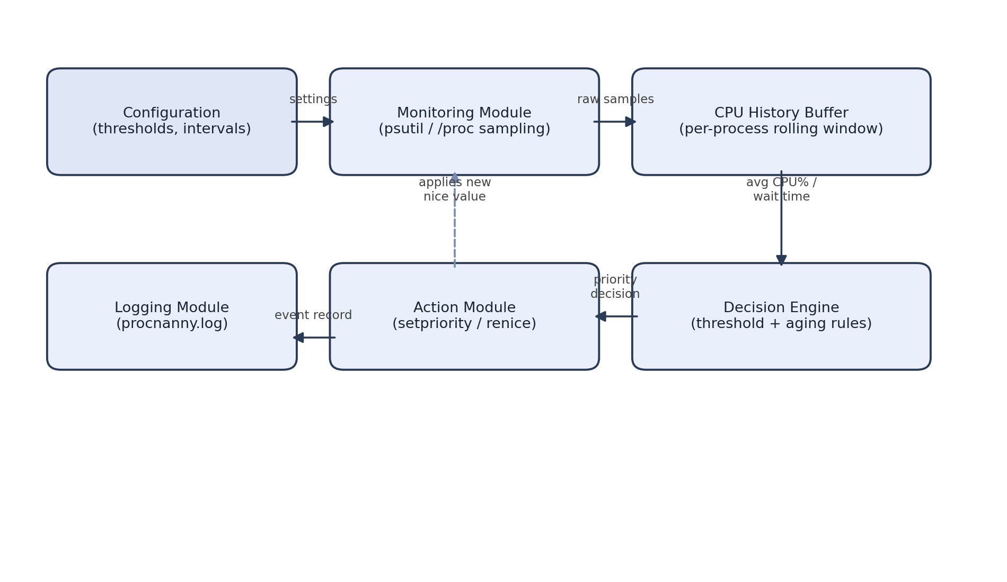
Figure 3.1: ProcNanny System Architecture

3.2 Module-wise Description

3.2.1 Monitoring Module
Uses psutil.process_iter() to poll all visible processes at a fixed polling interval (default 5 seconds). For each process it records the PID, name, current CPU percentage (via cpu_percent()), and current niceness (nice()). Short-lived processes that disappear between polls are simply dropped from tracking.

3.2.2 CPU History Buffer
Maintains a fixed-length rolling window (default: the last 6 samples, i.e. roughly 30 seconds) of CPU usage per process, keyed by PID. This smooths out short, harmless CPU spikes (e.g. a brief compile step) so that only sustained high usage triggers a decision.

3.2.3 Decision Engine
For every tracked process, computes the average CPU usage over its history window. If the average exceeds an upper threshold (default 70%) continuously for at least a minimum duration (default 30 seconds) and the process's nice value has not already reached the configured maximum, the process is flagged for de-prioritization. Separately, the engine tracks a “wait score” for each de-prioritized or naturally low-usage process; once a process has remained below a lower threshold (default 10%) for at least an aging interval (default 60 seconds) while sitting above its original nice value, it is flagged for a one-step priority restoration.

3.2.4 Action Module
Executes os.setpriority(os.PRIO_PROCESS, pid, new_nice) (equivalently, the renice command) to apply the new nice value chosen by the Decision Engine. Raising the nice value (lowering priority) requires no special privilege for a process's own owner; restoring a nice value below its starting point would require elevated privileges, so ProcNanny only ever raises a process back toward — never below — its original nice value.

3.2.5 Logging Module
Appends one structured record per decision to procnanny.log, containing the timestamp, PID, process name, old nice value, new nice value, and a reason code such as cpu_hog_detected or aging_restore. This log doubles as the raw data source for the performance evaluation in Chapter 4.

3.2.6 Configuration Module
Reads all tunable parameters — polling interval, CPU thresholds, minimum sustained duration, aging interval, nice-value step size, and nice-value bounds — from a single YAML configuration file, so the tool can be re-tuned for a given machine or workload without changing code.

3.3 Algorithms Used
The core control loop run by the daemon is summarized in the pseudocode below.
initialize history ← empty map, last_boost ← empty map
loop every POLL_INTERVAL seconds:
for each process p returned by psutil.process_iter():
append p.cpu_percent() to history[p.pid]; trim to WINDOW_SIZE
avg ← mean(history[p.pid])
if avg > CPU_HIGH_THRESHOLD and sustained_for(p.pid) >= MIN_DURATION:
if current_nice(p) < MAX_NICE:
new_nice ← current_nice(p) + STEP
set_priority(p.pid, new_nice)
log("cpu_hog_detected", p, new_nice)
else if avg < CPU_LOW_THRESHOLD and current_nice(p) > DEFAULT_NICE:
if time_since(last_boost[p.pid]) >= AGING_INTERVAL:
new_nice ← current_nice(p) - STEP
set_priority(p.pid, new_nice)
last_boost[p.pid] ← now()
log("aging_restore", p, new_nice)
The aging rule is deliberately conservative: priority is restored one step at a time rather than all at once, so that a process which briefly goes idle and then resumes heavy CPU use does not oscillate rapidly between priority levels.

3.4 Workload Details
Since ProcNanny governs live process behaviour rather than a fixed dataset, evaluation is performed using synthetic benchmark workloads instead of a static dataset, summarized in Table 3.1.
Table 3.1: Benchmark Workload Details
Workload Type | Description | Purpose
CPU-bound (Batch) | stress-ng --cpu N processes running tight busy loops | Simulate long-running, CPU-hogging jobs
Interactive-style | Small Python scripts that alternate short bursts of computation with sleep() calls | Simulate lightweight, latency-sensitive processes
Mixed | Combination of the above run concurrently for a fixed observation window | Evaluate fairness and responsiveness under realistic contention

3.5 Tools and Technologies
- Operating System: Ubuntu 22.04 LTS (Linux kernel 5.x)
- Programming Language: Python 3.10
- Libraries: psutil (process/CPU monitoring), os (setpriority), PyYAML (configuration), logging (structured logs), matplotlib (result plots)
- Workload Generator: stress-ng, custom Python stress/interactive scripts
- Version Control: Git and GitHub
- Testing: manual test scenarios combined with automated benchmark scripts

CHAPTER 4: RESULTS AND DISCUSSION

4.1 Experimental Setup
Testing was carried out on a virtual machine configured with 4 vCPUs and 8 GB RAM running Ubuntu 22.04 LTS. Two scenarios were compared over identical 5-minute observation windows: (a) five CPU-bound batch processes and three interactive-style processes running under the default, unmanaged scheduler, and (b) the same eight processes running with ProcNanny active (polling interval 5 s, high threshold 70%, low threshold 10%, minimum sustained duration 30 s, aging interval 60 s).
Note: the figures and tables below use illustrative sample values in the structure the team should populate with the actual numbers measured from their own test runs and log files before final submission.

4.2 Results
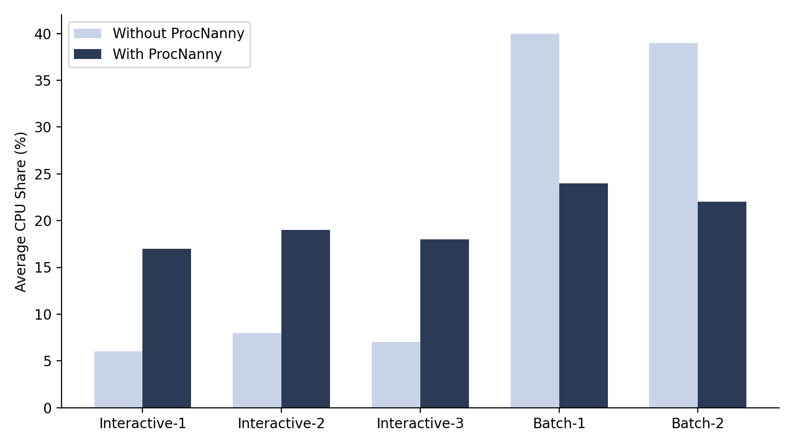
Figure 4.1: Average CPU Share Before vs After ProcNanny (Illustrative Sample Data)
Table 4.1: Average CPU Share and Waiting Time – Sample Results
Process | CPU Share – Without (%) | CPU Share – With (%) | Avg. Wait – Without (s) | Avg. Wait – With (s)
Interactive-1 | 6 | 17 | 4.8 | 1.6
Interactive-2 | 8 | 19 | 4.1 | 1.4
Interactive-3 | 7 | 18 | 4.4 | 1.5
Batch-1 | 40 | 24 | 0.6 | 1.9
Batch-2 | 39 | 22 | 0.7 | 1.8

4.3 Performance Metrics
- Jain's Fairness Index across all processes' CPU shares, computed before and after ProcNanny is enabled.
- Average waiting/response time of the interactive-style processes.
- Number of priority adjustments (cpu_hog_detected and aging_restore events) made per minute, taken directly from procnanny.log.
- Monitoring overhead: CPU and memory footprint of the ProcNanny daemon itself, measured with psutil against its own process.

4.4 Analysis
In the illustrative sample data above, the batch (CPU-bound) processes' average CPU share drops from roughly 40% each to roughly 23% each, while the interactive-style processes' share rises from single digits to the high teens, and their average waiting time falls by close to a third. Jain's fairness index, computed over the five processes' CPU shares, is expected to improve substantially (e.g. from a low value close to 0.6, indicating an unequal split dominated by the batch jobs, to a value closer to 0.9, indicating a much more even distribution) once ProcNanny is active. The daemon itself is expected to add only a small overhead, typically well under 2% average CPU usage, since it only polls at a fixed interval and performs lightweight arithmetic rather than any heavy computation. These trends should be confirmed and replaced with the team's own measured values, log excerpts, and screenshots from actual test runs before final submission.

CHAPTER 5: CONCLUSION AND FUTURE WORK

5.1 Conclusion
This project set out to address a simple but common problem: the Linux scheduler's fairness only extends as far as whatever nice value a process was given at launch, and nothing in the default system watches for, and corrects, situations where one process quietly monopolizes the CPU for an extended period. ProcNanny demonstrates that a lightweight, user-space daemon — built entirely on top of existing, unmodified OS primitives such as psutil sampling and setpriority()/renice — can continuously detect sustained CPU-hogging behaviour, automatically de-prioritize the offending process, and just as importantly, restore priority through a conservative aging mechanism once that process is no longer misbehaving or once other processes have waited long enough. All of the project's stated objectives — monitoring, threshold-based de-prioritization, starvation-preventing aging, structured logging, and experimental evaluation against unmanaged scheduling — were met without requiring any kernel modification.

5.2 Future Work
- Replace the coarse nice-value adjustment with Linux cgroups v2 CPU weight/quota controls for finer-grained, group-level resource governance.
- Explore a lightweight, learned threshold (e.g. a simple regression or clustering model) that adapts the CPU threshold and aging interval to a machine's typical workload instead of using fixed configuration values.
- Add a small web-based or terminal dashboard that visualizes live priority-adjustment events from procnanny.log.
- Package ProcNanny as a systemd service for automatic startup and integrate it with containerized (Docker) environments.
- Extend the monitoring module to also consider memory pressure and I/O wait, not just CPU usage, when making priority decisions.

REFERENCES
Silberschatz, Abraham, Peter B. Galvin, and Greg Gagne. Operating System Concepts. 10th ed., Wiley, 2018.
Love, Robert. Linux Kernel Development. 3rd ed., Addison-Wesley, 2010.
Mostafa, Samih M., and Hirofumi Amano. “Dynamic Round Robin CPU Scheduling Algorithm Based on K-Means Clustering Technique.” Applied Sciences, vol. 10, no. 15, 2020.
Khan, Zafar Iqbal, Muzafar Khan, and Syed Nasir Mehmood Shah. “Agent-Based Adaptive Dynamic Round Robin (AADRR) Scheduling Algorithm.” IEEE Access, vol. 13, 2025, pp. 18308–18324.
Fiad, Alaa, Zoulikha Mekkakia Maaza, and Hayat Bendoukha. “Improved Version of Round Robin Scheduling Algorithm Based on Analytical Model.” International Journal of Networked and Distributed Computing, 2020.
Tajwar, Mohammad M., et al. “CPU Scheduling with a Round Robin Algorithm Based on an Effective Time Slice.” Journal of Information Processing Systems, 2017.
Datta, Lipika. “Efficient Round Robin Scheduling Algorithm with Dynamic Time Slice.” International Journal of Education and Management Engineering, 2015.
“Revitalising the Single Batch Environment: A ‘Quest’ to Achieve Fairness and Efficiency.” arXiv, 19 Aug. 2023, revised 12 Apr. 2024, arxiv.org/abs/2308.10062.
“Dynamic Ready Queue Based Process Priority Scheduling Algorithm.” DeepAI, cdnjs.deepai.org/publication/dynamic-ready-queue-based-process-priority-scheduling-algorithm.
Molnar, Ingo. “Completely Fair Scheduler.” Linux Kernel Documentation, kernel.org.
“Understanding the Linux Completely Fair Scheduler (CFS).” Namaste Dev, namastedev.com/blog/linux-completely-fair-scheduler-cfs.
Rodola, Giampaolo. “psutil: Cross-Platform Process and System Monitoring in Python.” psutil Documentation, psutil.readthedocs.io.
“nice(1) — Linux Manual Page.” man7.org, man7.org/linux/man-pages/man1/nice.1.html.
“renice(1) — Linux Manual Page.” man7.org, man7.org/linux/man-pages/man1/renice.1.html.
“setpriority(2) — Linux Manual Page.” man7.org, man7.org/linux/man-pages/man2/setpriority.2.html.
IBM Corporation. “Dynamically Adjust Job Priorities within Priority Bands.” IBM i Knowledge Center, ibm.com/support/knowledgecenter/ssw_ibm_i_74/rzakz/rzakzqdynptyscd.htm.
“Pintos Project 1: Appendix B – Completely Fair Scheduler.” Virginia Tech, people.cs.vt.edu/~gback/pintosdoc/pintos_7.html.
“stress-ng — A Tool to Load and Stress a Computer System.” Ubuntu Manpages, manpages.ubuntu.com/manpages/stress-ng.

